Student Name: Jay Johnson – Student ID: 1920319

Module code: (BMSW6102_BIRM)

Assessment Title: Developing Innovation
and
Creativity for Business Advantage

Lecturer's name: Mr. Khaza Ahmed

Contents
Introduction 2
Innovative Idea name 3
Why is Size me up innovative 4
Looking for a gap within the retail market space. 7
Competitive advantage 10
SWOT - Strengths, Weaknesses, Opportunity, Treats 12
Marketing considerations / Marketing plan 13
Marketing Plan 14
Simple Budget sheet template 18
Unique selling Point for the Size-me-up software application 19
Recommendations 20
Conclusion 21
References 22

Introduction

For this assignment research will be conducted in the areas of emerging innovation and reviewing trends of consumer needs and wants. The report will demonstrate emerging customer buying habits through e-commerce and ways organisations can combat revenue losses through data acquisition and customer buying habits whilst maintaining customer retention using new or existing innovative technologies. The report will show a new product or service being offered through innovation and evidence of this need through customers. According to (Sutcliffe 2011), The growth strategy of Europe 2020 placed down a vision of a sustainable, SMART economy that can deliver high levels of productivity, employment opportunities and better social cohesion. reports have shown an increase in digital buying, (E-Commerce), with an increased interest in this area. The report will review various opportunities of an innovative idea and how to deliver a more direct and personal service to new and existing stakeholders, whiles holding a strong position in the e-commerce marketplace.

Innovative Idea name

Thought was focused on a mobile application and desk top website/app that customers can use easily and efficiently. The idea will save customers time and money purchasing goods within the e-commerce retail space and promote a unique personal shopping experience. The innovative idea was brought together by reviewing customer spending habits, trends, and behaviors with consideration to customer needs and expectations. Research has shown that e-commerce has increased with many organisations on the high street implemented new ways of working by adopting innovation to keep up with customer demands and services, such as communications, retail, and hospitality to name a few. The innovative idea will need to reduce costs to stakeholders but also increase profits and remain sustainable. Details of the idea are displayed below.

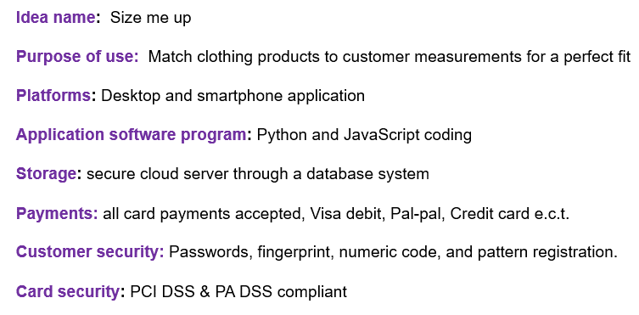

According to (Leisinger 2017), Innovation helps to increase the trust of the audiences that the organisation is targeting, and coupled with transparency, data security and privacy, this will be a critical business function moving into the future.

Why is Size me up innovative

With more organisations investing in new technology and strategies to meet customer needs and wants, solutions are required to not only meet the needs of customers but to also create something new or improve on existing products or services. By offering customers more sources and channels to navigate in their shopping journey, this will create a new space in an already heavily dominated industry.

Size-me-up displays various clothing products that are filtered down by customer measurements. On the main start up page, customers provide sizing details such as small, medium, or large or manual numerical input for tailored measurements. The application data base holds all product size information through retail outlets and will instantly display all desired available clothing items in the customers actual size with no need to change sizing on each item. Size-me-up also retains customer data for future purchases, offers, rewards and discounts. Size me up, contains all product sizing data from worldwide retails clothing sources and offsets the customer measurements against international product sizing to mitigate mistakes and returns. The reason for this is a size 10 in Europe may differ from a size 10 in the USA or China and can be very beneficial to customers due to having a direct comparison of continental size data that the system works out for the customer before any purchase.

This is where the size me up program will hold great value, innovation, and sustainability by conducting due diligence on all clothing products beforehand and displaying this data to customers before they purchase any goods. According to (Hasen and Grosse-Dunker 2013), Sustainable orientated innovation is defined as a commercial introduction of an existing product that has been improved or a new product brought to market. This also includes services and systems that will benefit social and environmental factors over the previous version's innovative sustainability plan. Based on the above notes two diagrams have been showcased below to demonstrate the difference in sizing and how mistakes can be made if solely working on a generic basis of S/M/L measurements, and why this innovative idea is simple in operation but very effective in the reduction of, waste, cost, time, mistakes, and frustration.

Diagram 1
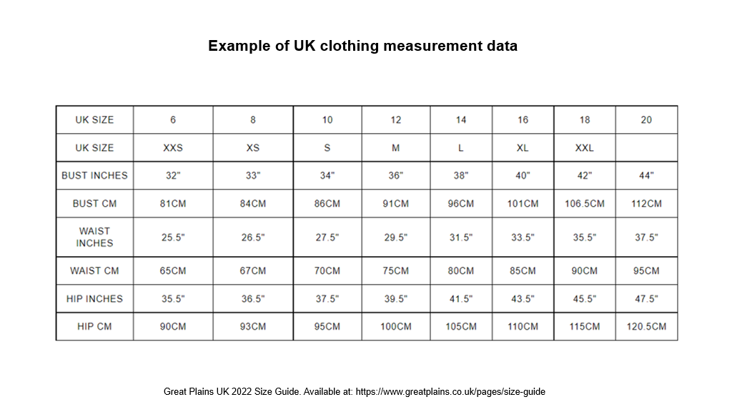

Diagram 2
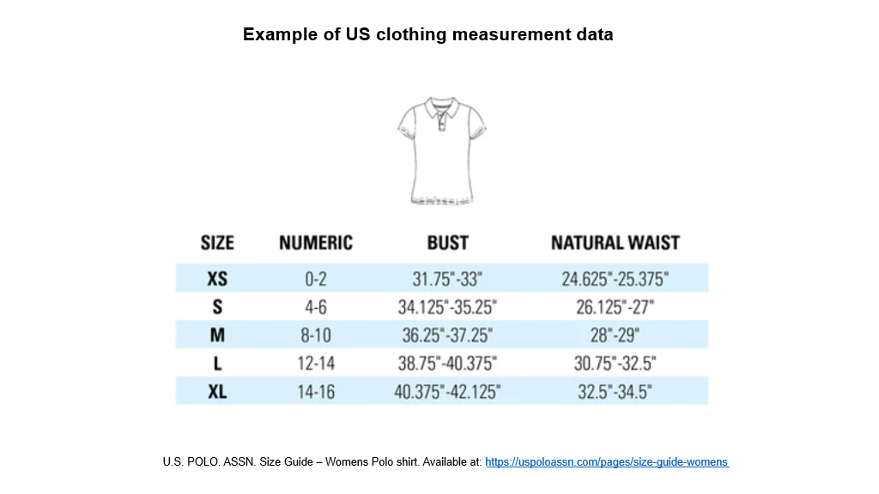

As per above charts, a small waist size in the US is 26.125 inches, whereas in the UK the waist size is 27.5 inches with a difference of 1.5. This is where the size me up application will have great benefits with customers as this information will have been displayed before the purchase.

Looking for a gap within the retail market space.

The report has shown that the initiation of the idea is there, and that the customer would benefit with this service. However, one would need to establish the needs and wants of the customer to see if the idea is viable to commit to regarding time and expense. The Trott model (2008) will be used as a foundation of needs and wants of the customer but also benefiting the organisation. Below is an example of the Trott (2008) model that displays the process from idea formulation right up to the manufacturing of the product with technology push and market pull. Trott (2008) model of innovation.

Diagram 3 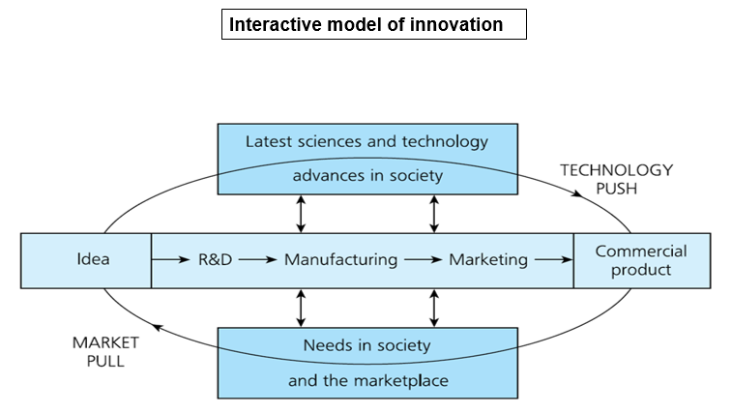
This model is based on innovation that according to Trott, will occur based on interactions within the marketplace. To prove this point, the report will demonstrate trends and behavioural changes within the retail market, with consideration to what technologies are being used that can be utilized as part of the technology push, and how changes in behaviours and trends can help tailor a unique service to customers that make up the market pull segment. It is also very important to factor in risk mitigation and responsible and ethical implementation of new products and services, that will build trust and good reputations with all stakeholders.
According to (Fichter 2009), Managers have been utilizing well-known methods with the desire of decreasing uncertainty around innovation. This is achieved through information gathering of company-external sources that include User innovation, open innovation, and innovation communities. The diagram below clearly demonstrates changes within the retail space and how customers feel and think of these new changes, and if they would continue with these new shopping methods. Diagram 4 displays behavioural changes in customers shopping habits since the Covid-19 pandemic, and why investing in new technologies or improving existing products or services may be of great benefit and gives justification for the innovative idea.

Diagram 4 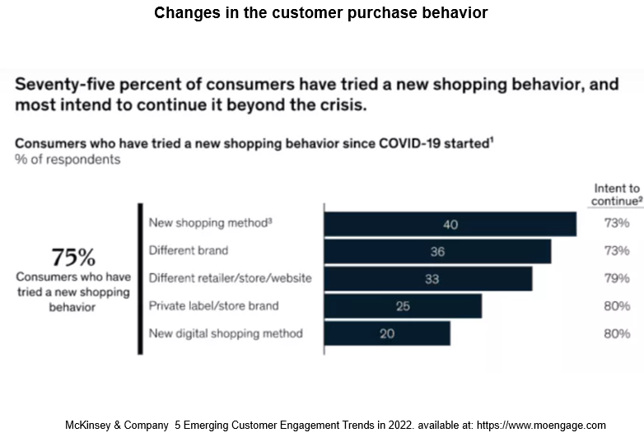
The bar chart suggests that customers are open to change and happy to try new ideas. There is more focus on digital platforms with an example being, the mobile phone implements various features such as video cameras, voice recording, internet usage, and new communications applications such as, Facebook, Tik-Tok, Whats-App, video calls emails, etc, and these are improvements to the mobile phone over time.

Below in diagram 5, is the retention rate of customers that have been offered various sources or channels through E-commerce. More channels present more methods of shopping to customers with a higher retention rate.

Diagram 5 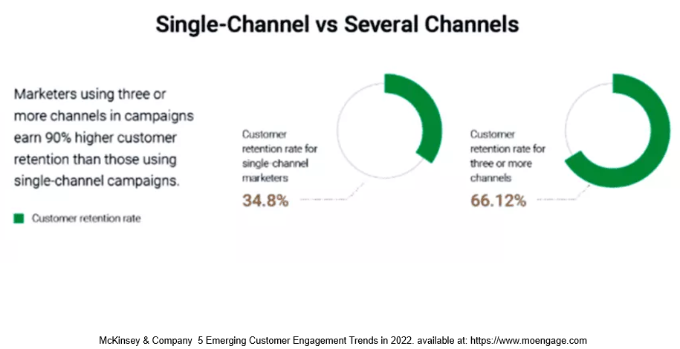

Based on the above information, there is an evident trend in E-commerce purchasing and a strong possibility that the trend will increase in the future. With such an increased use in digital platforms, organisations will race to be the competitive leader and should consider good ethical practice and responsible methods of delivery. According to, (Owen et al. 2012), Concepts of RRI- (Responsible Research and Innovation), had originated from written and verbal communication in the areas of emerging technologies and ethical practice that was involved in contested fields of innovation.

Competitive advantage

Focus will be on competitive advantage and the features of the size-me-up application. Below are examples that will give good reason for why any organisation should invest into this idea that will not be too costly or time consuming.

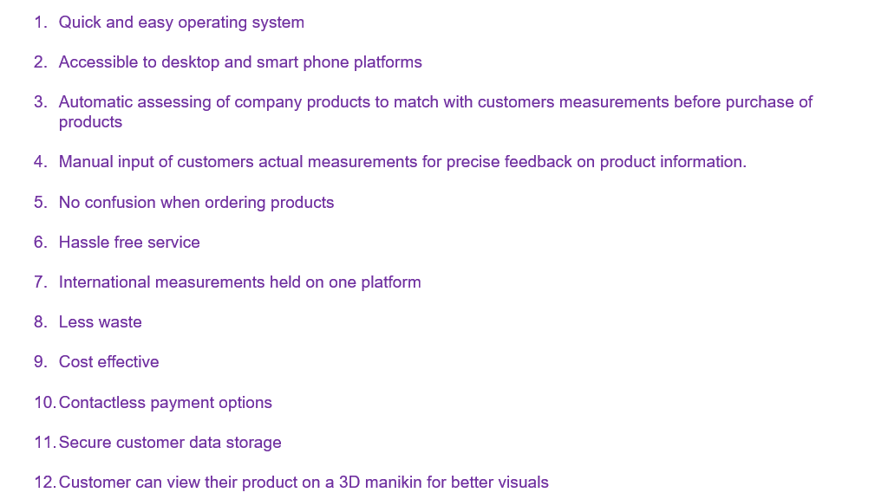

Below in diagram 6 is an example of various technologies that are used today to offer the customer different channels of purchasing goods and services that are quick and easy to operate and hassle free. Customers have shown that change is not always a negative thing and can be embraced benefiting both the customer and the organisation with increase revenue growth. (Chakravorti and Siesfeld 2015), state that social innovation is challenging to define, and more so regarding scope of business growth. Considering business growth from a view of social innovation can be considered easier, especially within the field of emerging markets and can be characterized by a rapidly expanding middle class and increased consumer spending

Diagram 6
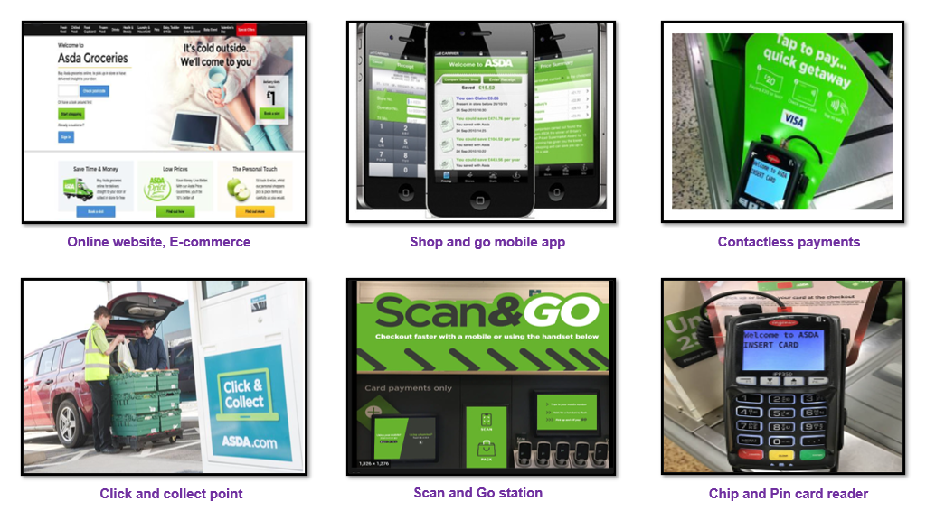

From research that has been conducted in the market of clothing retail purchases through e-commerce clearly shows that companies only use the S/M/L signage, but as shown earlier in the report, the UK use only one size guide for each letter, whereas in the US, their medium will have multiple measurements that may not be clear when customers are ordering goods through E commerce from other regions, and this is what the competitive advantage is using the size-me-up service. Customers will save on time, waste, cost, frustration and have a more personal shopping experience without having to do anything different to what other service providers already offer customers in today’s retail markets through e-commerce.

SWOT - Strengths, Weaknesses, Opportunity, Treats

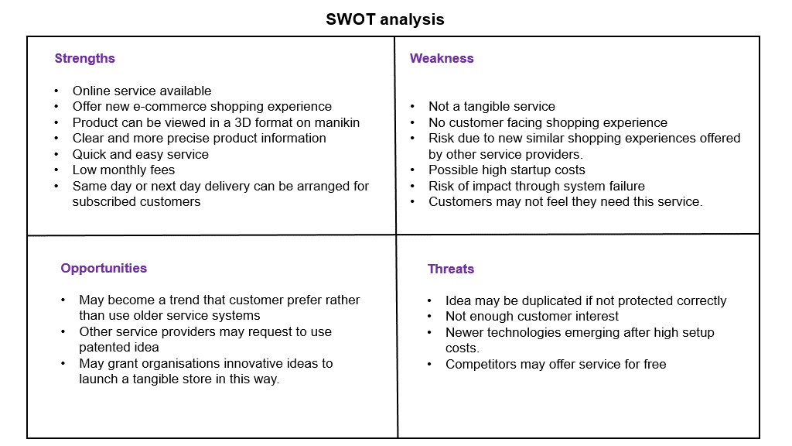

Above is a swot analysis tool that can be used to determine all strengths, weaknesses, opportunities, and threats to the organsation. The Swot analysis tool has been used to assess the size-me-up application and give focus to core competencies that may need to be addressed, or to keep an eye throughout the scope of product initiation through to the manufacturing of the product. According to (Coman and Ronen 2009), the swot analysis may have a few flaws but is still regarded as a major strategic tool that can display all strengths and weaknesses in core competencies and core concerns. Based on the above analysis, there are areas that suggest innovative opportunities that could impact customers in a positive way, however there are some disadvantages that could impact on start-up costs and little to non-ROI – Return on investment. The rationale to build and provide this service is based on the trends of the customers purchases habits and behaviours relating to retail, but also by considering emerging technologies that customers either prefer or quickly adapt to.

Marketing considerations / Marketing plan

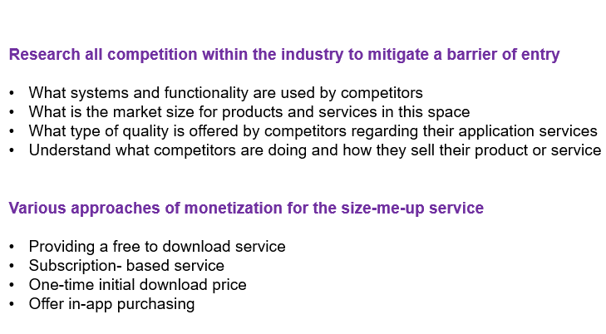
- Unique branding
The size me up service will provide a unique branding image that is simple but easy to recognize and rememberable. The image will use a selected color pallet that customers will remember, very similar to how Coca-Cola use their branding and color use.

- Easy to use and visually pleasing service
The size me up application will be easy to use without clutter or over complicated user instructions. The idea will provide simple input controls, colorful, and attractive to the eye that customers will appreciate and be happy to return to for future purchases. Ease methods of payments will also be offered such as VISA/ Credit card, Pay-pal, etc. to provide the customer with a quick payment method.

- Customer feedback and review.
Great emphasis will also be on feedback from customers as this will build a solid foundation with customer retention and reputation and give direction to new marketing methods. Feedback from customers will also provide innovation for new ideas and possible new additions to the service already provided. Also, by utilizing feedback from customers, concerns, gripes, and complaints will be picked up on and the problem approached.
Above are fundamental areas of focus that have considered competitors marketing approaches and services on offer. Having good knowledge in these key areas will give ideas on how to approach this market. According to (Kleijnen, de Ruyter and Wetzels, 2007), A mobile application service provides customers with a real time, on-demand access to various content that provides customers with valuable information.

Marketing Plan
Considering all the above points, a marketing plan will be required to reach all stakeholders and promote the application service and raise capital. The target audience for marketing, are all people with desktop and smart devices that use e-commerce for clothing. Below are available options that will be considered to market and store customer data

- Google play to download or purchase apps, Google adds that display advertising, Service offering, product listings, Videos to web users. This service can also place ads in the search engine and results, that will display adds in google search but also non-search websites, videos, and mobile applications.

- Facebook – through people and friends, Facebook marketing that is a monthly paid service. Twitter, TikTok adds and Braze - mobile marketing software.

- Launch Rock.com – Build a launch site with easy-to-use applications with drag and drop features that will save on high startup Below is an example of the Launch Rock marketing website that also caters to mobile applications.

Diagram 7
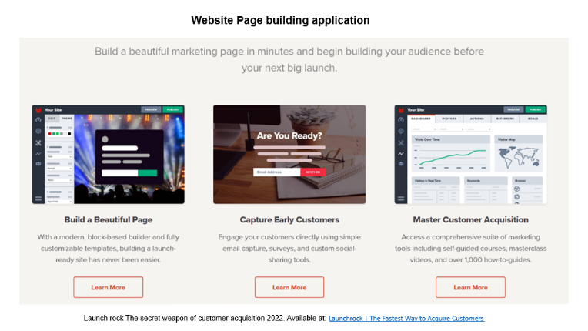

These are a few options that will market the product or service to gain traction and raise funds. Below are the software options that would be chosen for the Size-me-up website and mobile application.
The software for the website page will use Python programming due to working with high intensity volumes of data at any time and the program is easier to learn more so than other programming languages. Below is the key benefit of the program language that will be used.

According to (Yamamoto, 2003), Mobile technologies have the ability to integrate various activities in all marketing areas and due to this, the mobile device has been used in enterprises that support the integrated marketing approach.

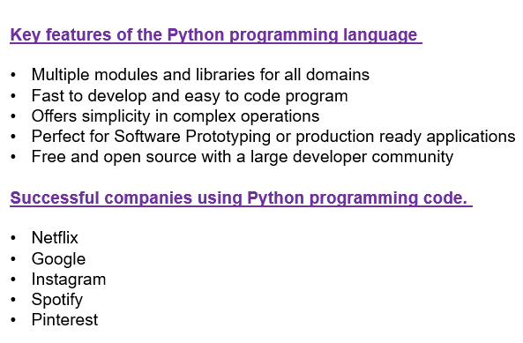

(JavaScript to use for mobile application use)
The programming language to be used for mobile application will be JavaScript due to the great speed and general stability on mobile applications and is best suited to mobile applications use, whilst Python is best suited to mass data usage with no slow down and used for multiple tasks.
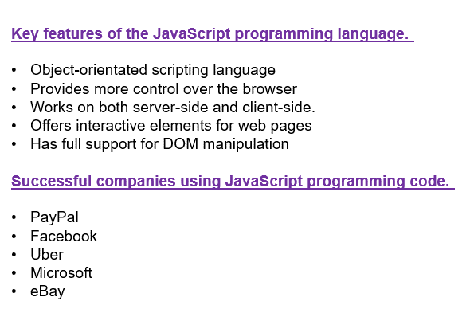

According to (Eklund 2002), Through a dense brand interaction, Mobile CRM will be expected to demonstrate a noticeable difference and create differences with a higher customer spending approach as to create changes regarding the service towards obtaining loyalty through customers.

Below is an example of a simple budge sheet that considers the expenses of the project throughout the scope. By utilizing these platforms and technologies that already exist such as Facebook, TikTok and Launch rock,.com, this will promote the business idea and save on high startup costs with networking being a fundamental factor to consider. Incentives can also be adopted to draw customer interest and as there is a free download of the application, there is no impact to customers regarding costs.

Simple Budget sheet template
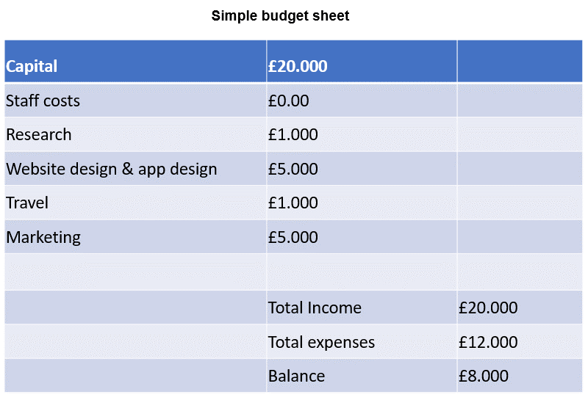

As (cf. e.g. Ma and Morris 2017) puts it, there are various methods of innovation that have supported the process of idea generation but also further development plans. Innovation methods used such as classical brainstorming techniques and design thinking are considered as the “innovation sprint” or gaming approach.

Unique selling Point for the Size-me-up software application
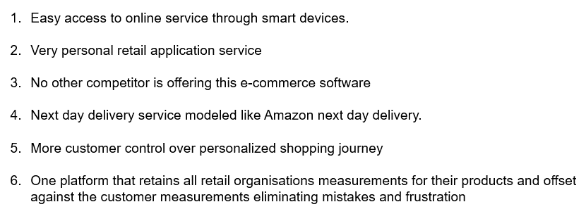

The size-me-up idea is not a brand-new product, rather an improvement to existing software and customers shopping experiences that is more streamlined to customer needs and wants and on a more personal level with the customer. The design is based around customer trends and behaviors, to generate more customer interest, convenience and acceptance offering new retail methods. According to (Fichter 2009), Managers have been utilizing well-known methods with the desire of decreasing uncertainty around innovation. This is achieved through information gathering of company-external sources that include User innovation, open innovation, and innovation communities. Below are key areas of the unique selling point of the Size-me-up software

Recommendations

The recommendation would be to consider the strongest developing areas of the retail market and what the most successful organisations are doing regarding customer retention, marketing, and technologies in an ethical way. Reports have shown that by offering new channels, this presents new options and features that customers have grown to appreciate and creates a better retention rate for the organisations. Evidence suggests that e-commerce and their technological use has increased in many areas of society with no evidence of declining anytime soon and gives room to innovate and build strong relations and revenues. As (Moir 2001), puts it, any management and innovation responsibility to society are tied to three core theories that are made up of social contracts theory, Stakeholder theory and Legitimacy theory.

Conclusion

Looking over all lectures learnt, and research applied, the Size-me-up application was a wise choice due to considering the customer and the organisational interests. Consideration has been given to current and changing customer trends and behaviors within the e-commerce retail sector. Evidence has given me ideas of what customers may need and if they need to adopt new methods of retail. The conclusion was a software package that offers customers a more streamlined shopping experience without any more effort from the customer, and at reasonable charging pricing that is in line with other competitors. The application is more personal and offers customers a similar service as any other big organization without trying to be too different.

References

Adams, R., Bessant, J. and Phelps, R. (2006) “Innovation management measurement. A review,” International Journal of Management Reviews, 8(1), pp. 21–47.

Chakravorti, B. and Siesfeld, T. (2015) “Business growth for good: Why context matters,” Stanford Social Innovation Review.

Coman, A. and Ronen, B. (2009) “Focused SWOT: diagnosing critical strengths and weaknesses,” International Journal of Production Research, 47(20), pp. 5677–5689.

Fichter, K. (2009) “Innovation communities: The role of networks of promotors in open innovation,” R&D Management, 39(4), pp. 357–371.

Hansen, E. G., Bullinger, A. C. and Reichwald, R. (2011) Innovation contests for sustainability-oriented product innovation: Findings from a worldwide shoe innovation contest. CSM, Centre for Sustainability Management.

Kleijnen, M., De Ruyter, K. and Wetzels, M. (2007) “An Assessment of Value Creation in Mobile Service Delivery and the Moderating Role of Time Consciousness,” Journal of Retailing, 83(1), pp. 33–46. doi: 10.1016/j.jretai.2006.10.004.

Leisinger, K. (2017) Responsible Research & Innovation: Science with and for society (with special consideration of the “leaving no one behind” aspect of the agenda 2030).

Ma, M. and Morris, L. (2017) “The agile innovation Sprint,” International Management Review, 13(1), pp. 92–98.

Moir, L. (2001) “What do we mean by corporate social responsibility?,” Corporate Governance, 1(2), pp. 16–22.

Owen, R., Macnaghten, P. and Stilgoe, J. (2012) “Responsible research and innovation: From sci-ence in society to science for society, with society,” Science and Public Policy, 39(6), pp. 751–760.

Yamamoto, G. T. (2003) Bütünleşik Pazarlama (Integrated Marketing). Istanbul: Literatur Yay.

(No date a) Societyinside.com. Available at: http://societyinside.com/sites/default/files/Principles%20for%20Responsible%20Innovation%20Short%20February%202018_0.pdf. (Accessed: November 1, 2022).

(No date b) Destinationcrm. Available at: http://www.destinationcrm. (Accessed: November 19, 2022).

