  Component One: Student Journal (learning log) 750 words +/- 10%  Contribution to Overall Module Assessment: 25% | Student No: | 2246571
 | Module Title: | Operating Hotel Facilities
 | Module Code: | BMIH4006
 | Lecturer: | Daniel Payne
**Reflective Journal Entry - Gibbs Model of Reflection**

My time in the housekeeping department at Best Western Whitehouse Hotel in Watford was a transformative experience, providing valuable insights into the intricate workings of maintaining a clean and orderly environment in a hotel setting. Using the Gibbs Model of Reflection, I will delve into the tasks undertaken, emotional experiences, skills acquired, and the broader impact of this placement on my understanding of the hospitality industry.

Task and Responsibilities:
I regularly checked the cleanliness of rooms after guests' departure, ensuring that no traces of smoke were left, and there was no damage. Delegating cleaning tasks to the staff and conducting thorough checks before guests entered their allocated rooms (Raghubalan & Raghubalan, 2016) were additional responsibilities. These tasks were pivotal in maintaining the hotel's reputation for cleanliness and providing a welcoming environment for guests.

Contribution to Guest Service:
The tasks I performed had a direct impact on the overall guest service experience. Ensuring rooms were impeccably clean and free from any damage contributed to the guests' satisfaction and comfort during their stay. The meticulous room inspections and delegation of cleaning tasks played a crucial role in the overall guest service experience. Attention to detail in cleanliness aligned with the hotel's commitment to exceeding guest expectations (Mullins & Dossor, 2013).

Feelings and Emotions:
The emotional spectrum ranged from the satisfaction of presenting pristine rooms to guests, coupled with the pressure of maintaining high standards. Collaborating with the housekeeping team fostered camaraderie, but challenges in a fast-paced environment occasionally induced stress.

Challenges and Surprises:
One of the notable challenges was managing the workload during peak times (Quick, 2020). The demand for quick turnovers between guest check-ins and check-outs required efficient coordination with the housekeeping team to meet tight deadlines. Unexpected surprises, such as last-minute room changes or urgent cleaning requests, tested adaptability and problem-solving skills. Overcoming these challenges became an exercise in resilience and effective time management.

Evaluation of Performance and Skills:
Reflecting on my performance in the housekeeping department, I recognized strengths in communication, time management, and problem-solving. Effectively delegating tasks to the housekeeping staff and maintaining clear communication channels ensured a smooth workflow (Bridger, 2018). Time management skills were crucial during peak periods, and problem-solving skills were honed in addressing unexpected challenges. Areas for improvement include refining organizational skills to enhance overall efficiency.

Impact on Understanding of Housekeeping Role:
This placement deepened my understanding of the housekeeping department's pivotal role in guest satisfaction (Raghubalan & Raghubalan, 2016). Beyond cleanliness, it ensures guests feel welcomed and valued. The meticulous tasks performed contribute directly to the hotel's success, shaping guest perceptions.

Key Lessons Learned:
Lessons extended beyond operational aspects. Attention to detail emerged as a powerful tool in creating memorable guest experiences. Effective communication, adaptability, and collaboration became essential for success in a dynamic environment (Cottrell, 2019). The housekeeping department, often behind the scenes, emerged as a linchpin in the intricate machinery of guest satisfaction. The attention to detail, commitment to cleanliness, and the collaborative spirit within the team exemplify the depth and complexity of the industry.

Influence on Perception of the Hospitality Industry:
The experience significantly altered my perception of the industry. The housekeeping department, often behind the scenes, emerged as a linchpin in the intricate machinery of guest satisfaction. The collaborative spirit and commitment exemplify the industry's depth.

Personal and Professional Development:
Professionally, the placement refined communication, time management, and problem-solving skills. Personally, it instilled responsibility, attention to detail, and adaptability. Challenges equipped me with resilience and the ability to thrive in a fast-paced environment, valuable skills that extend beyond the hospitality sector.

Conclusion:
In conclusion, my housekeeping placement at Best Western Whitehouse Hotel has been a great opportunity of learning and growth. It provided insights into housekeeping's pivotal role, honed practical skills, and significantly altered my perception of the hospitality industry. This experience serves as a stepping stone for future success, armed with a deeper understanding of industry nuances and a refined skill set that extends beyond housekeeping.

Component Two: Health and Safety Guide
Contribution to Overall Module Assessment: 25%
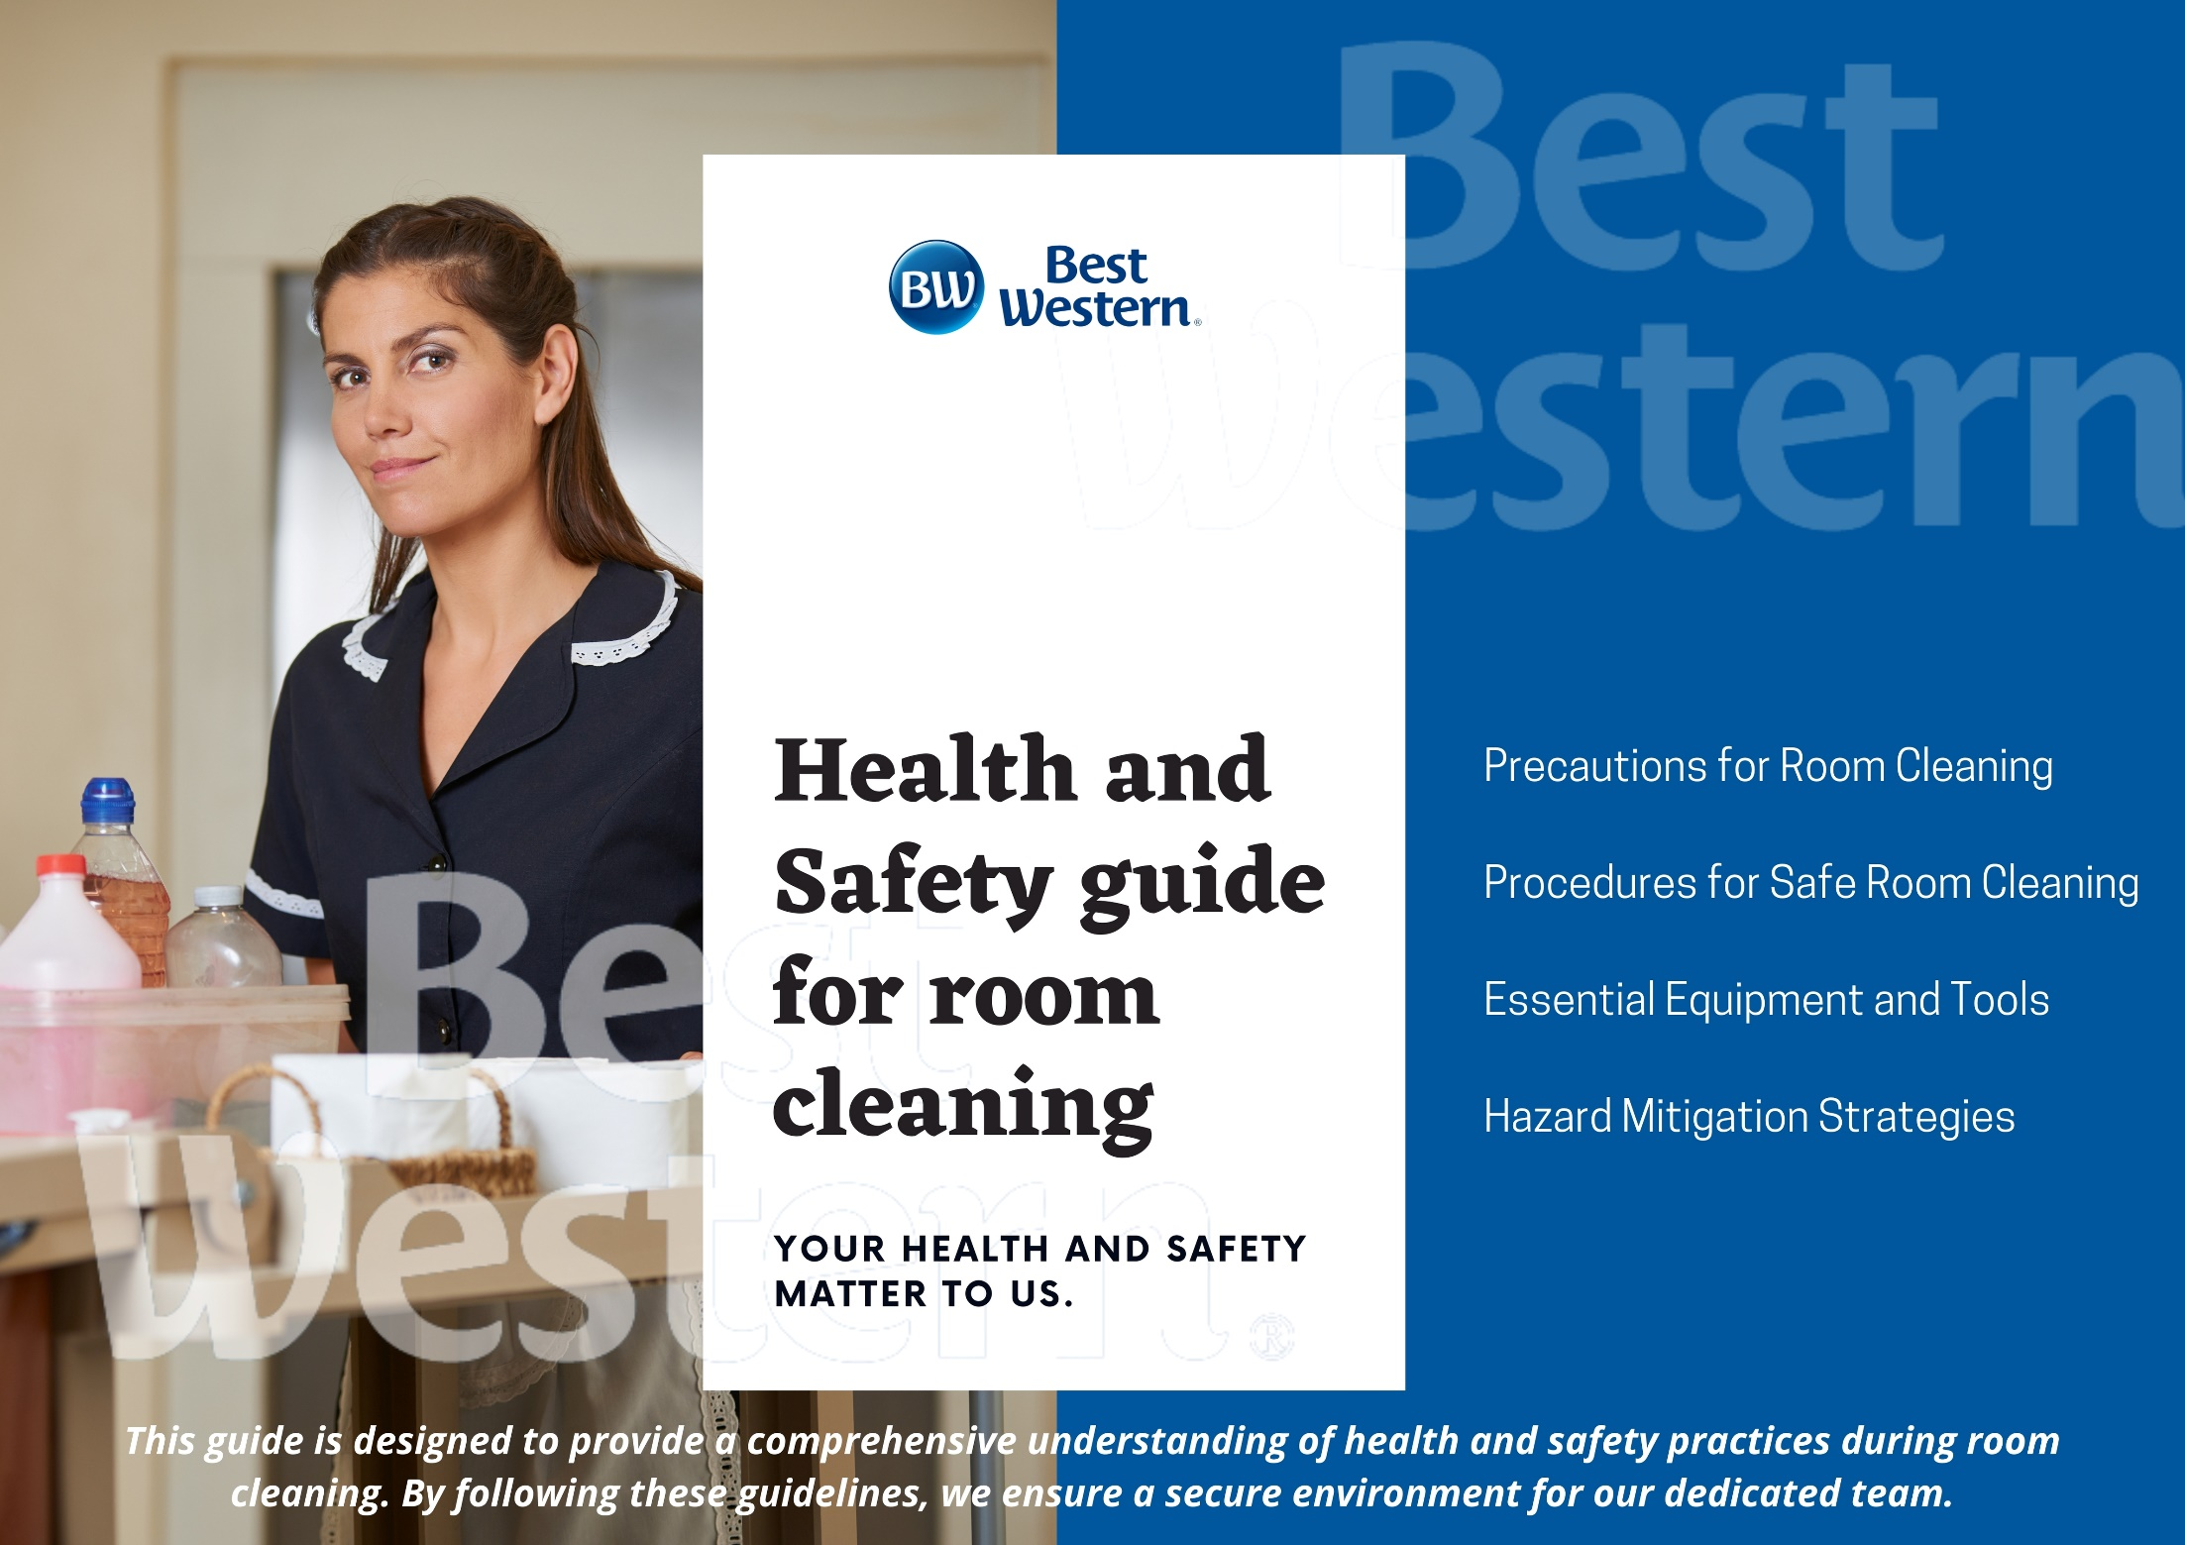
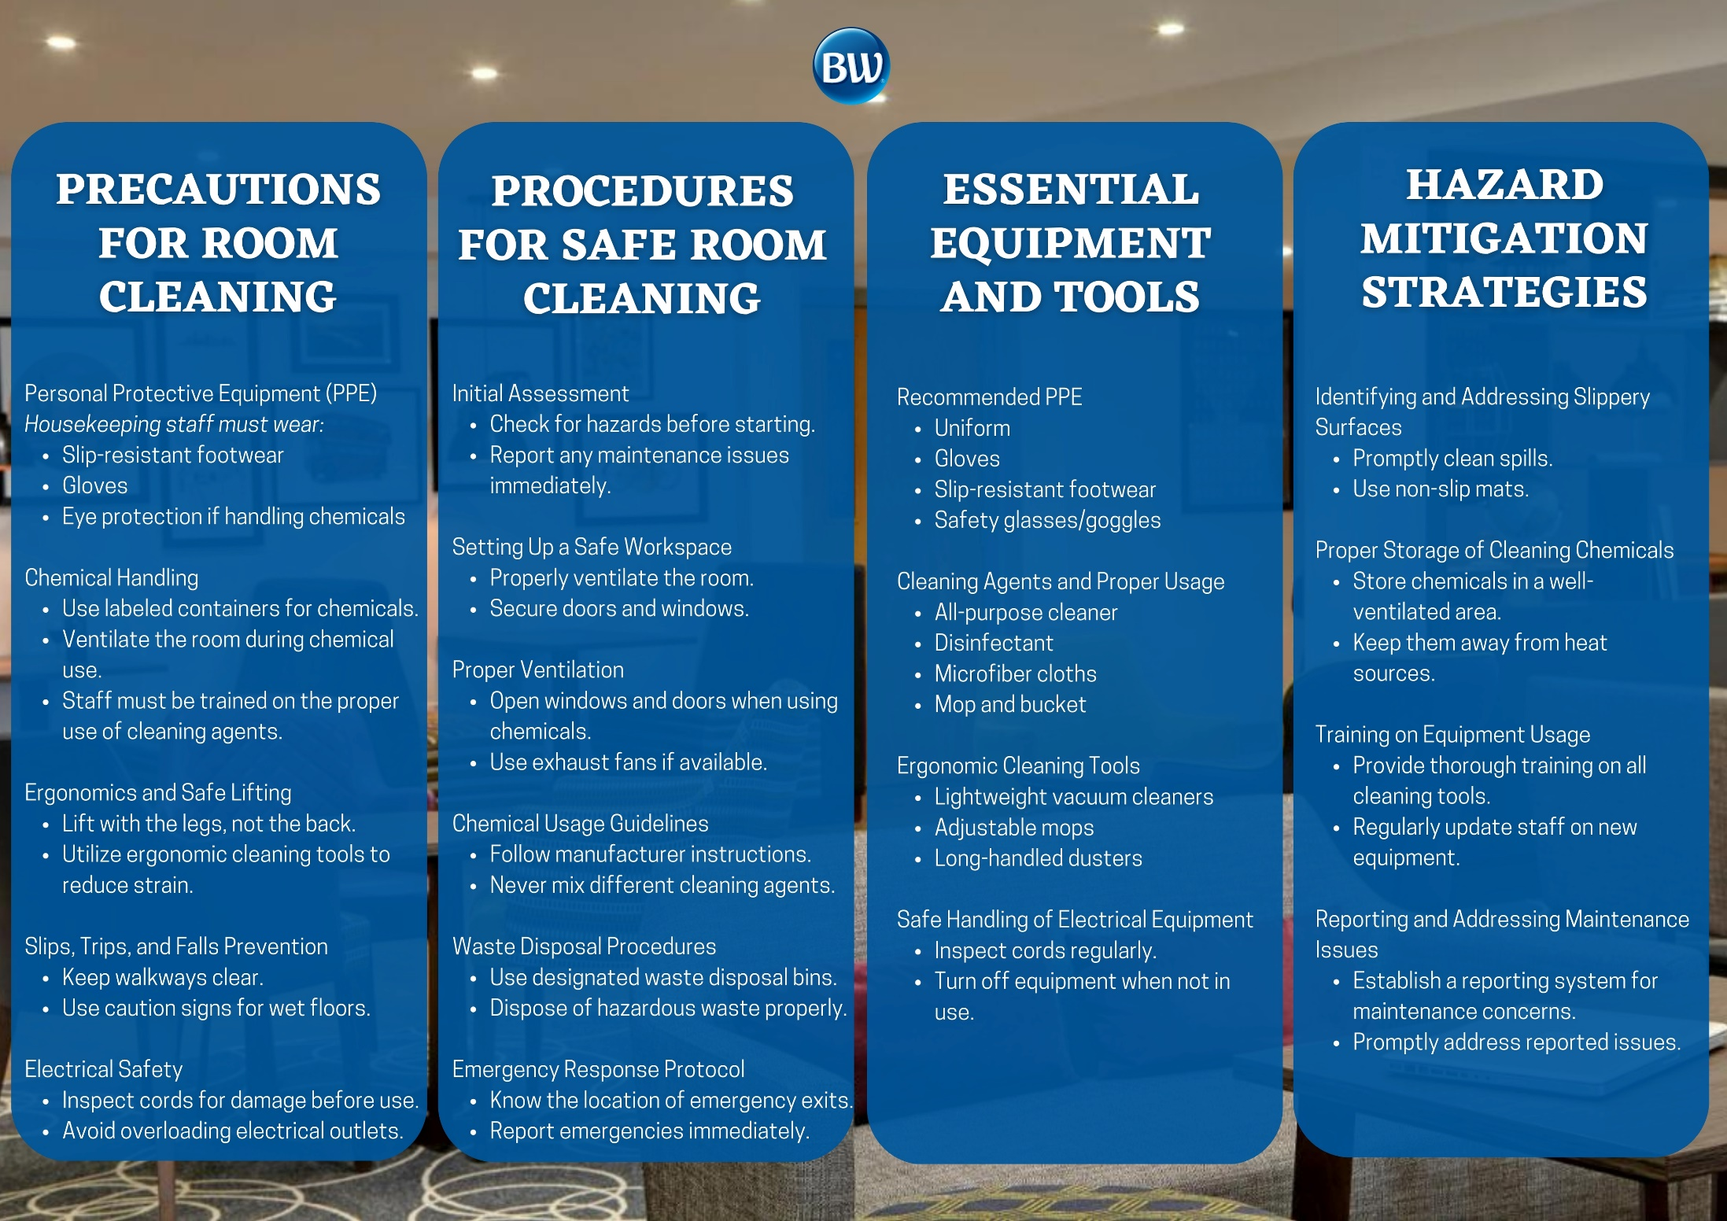

Reference List

- Bridger, E. (2018) Employee engagement: a practical introduction. 2nd ed. HR Fundamentals. London: CIPD and Kogan Page.
- Cottrell, S. (2019) The Study Skills Handbook. 5th ed. London: Red Globe Press.
- Leiter, M. P. and Bakker, A. B. (2010) Work Engagement: A Handbook of Essential Theory and Research. Hove [England]: Psychology Press.
- Mullins, L. and Dossor, P. (2013) Hospitality Management and Organisational Behaviour. 5th ed. Harlow: Pearson.
- Raghubalan, G. and Raghubalan, S. (2016) Hotel Housekeeping - Operations And Management. 3rd ed. India: Oxford University Press.
- Quick, L. (2020) Managing Events. Real Challenges, Real Outcomes. London: SAGE Publications Ltd.

Websites:
- The Caterer
- www.hotelowner.co.uk
- www.bighospitality.co.uk
- www.sureclean.com
https://sureclean.com.sg/safety-precautions-to-be-observed-when-cleaning/#:~:text=Wear%20protective%20gear%2C%20such%20as,cleaning%20products%20you%20are%20using.www.bha.org.uk

