File Handling
Application Design and Development

8/6/2010
Swansea Metropolitan University
Mike Dacey

File Handling

Note: The following examples can be build in both WindowForms and WPF application. File can also be used in ASP.Net applications, although this is less common because websites multiple users and usually the data is best stored in a database.

First we’ll build a simple text editor application.
Create a Windows Form application, add a RichTextEditor to this form and dock it.

RichTextBox
Property | Value
Name | richTextBox
Text
Mulitline | true
WordWrap | true
Dock | DockStyle.Fill

Add File Menu with Open, Close and Save in the submenu.
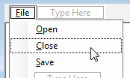

Visual Studio provides us with some common dialog boxes. Drag the SaveFileDialog from the Toolbox onto the form also drag the OpenFileDialog on the form.

Here’s how the save dialog box looks.
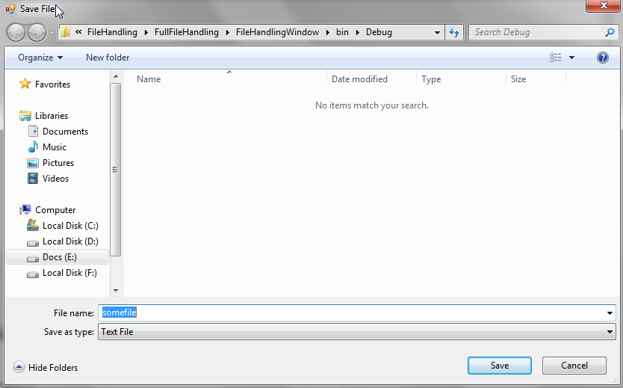

Double click on the Open and Save menu items.

Starting with the save menu item, we first reset all the save dialog box options using the Reset method.
private void saveToolStripMenuItem_Click(object sender, EventArgs e)
{
string filePath;

saveFileDialog1.Reset();
}

Next we can specify the title of the dialogbox

private void saveToolStripMenuItem_Click(object sender, EventArgs e)
{
string filePath;

saveFileDialog1.Reset();

saveFileDialog1.Title = "Save File";
}

You can specify the default file extensions, etc to help the user identify the file type they are saving.

private void saveToolStripMenuItem_Click(object sender, EventArgs e)
{
string filePath;

saveFileDialog1.Reset();

saveFileDialog1.Title = "Save File";

saveFileDialog1.FileName = "somefile.txt";
saveFileDialog1.Filter = "Text File|*.txt";
saveFileDialog1.DefaultExt = "txt";
}

You may want to prompt the user that if a new file will be created CreatePrompt or if they are about to overwrite a file OverwritePrompt.

private void saveToolStripMenuItem_Click(object sender, EventArgs e)
{
string filePath;

saveFileDialog1.Reset();

saveFileDialog1.Title = "Save File";

saveFileDialog1.FileName = "somefile.txt";
saveFileDialog1.Filter = "Text File|*.txt";
saveFileDialog1.DefaultExt = "txt";

saveFileDialog1.CreatePrompt = true;
saveFileDialog1.OverwritePrompt = true;
}

We can set the InitialDirectory, we use the applications current working directory.

private void saveToolStripMenuItem_Click(object sender, EventArgs e)
{
string filePath;

saveFileDialog1.Reset();

saveFileDialog1.Title = "Save File";

saveFileDialog1.FileName = "somefile.txt";
saveFileDialog1.Filter = "Text File|*.txt";
saveFileDialog1.DefaultExt = "txt";

saveFileDialog1.CreatePrompt = true;
saveFileDialog1.OverwritePrompt = true;

saveFileDialog1.InitialDirectory = Directory.GetCurrentDirectory();
}

Now show the dialog box and check if they click OK. You can read the file name entered by the user from the FileName property (this includes the file path and extension).

private void saveToolStripMenuItem_Click(object sender, EventArgs e)
{
string filePath;

saveFileDialog1.Reset();

saveFileDialog1.Title = "Save File";

saveFileDialog1.FileName = "somefile.txt";
saveFileDialog1.Filter = "Text File|*.txt";
saveFileDialog1.DefaultExt = "txt";

saveFileDialog1.CreatePrompt = true;
saveFileDialog1.OverwritePrompt = true;

saveFileDialog1.InitialDirectory = Directory.GetCurrentDirectory();

if (saveFileDialog1.ShowDialog() == DialogResult.OK)
{
filePath = saveFileDialog1.FileName;

// Write text to file here
}
}

We can do a similar thing for opening a file, using the OpenFileDialog. For the Open menu item add the following code:

private void openToolStripMenuItem_Click(object sender, EventArgs e)
{
string filePath;

openFileDialog1.Reset();
openFileDialog1.Title = "Open File";

openFileDialog1.FileName = "somefile.txt";
openFileDialog1.Filter = "Text File|*.txt|All files (*.*)|*.*";
openFileDialog1.FilterIndex = 2;

openFileDialog1.CheckFileExists = true;
openFileDialog1.CheckPathExists = true;

//openFileDialog1.InitialDirectory =
// Directory.GetCurrentDirectory();

openFileDialog1.RestoreDirectory = true;

if (openFileDialog1.ShowDialog() == DialogResult.OK)
{
filePath = openFileDialog1.FileName;

// Read text from file here
}
}

FilterIndex=2 displays the filter *.* when the dialog is first shown.

WPF also allows you to use these common dialogs, they are in the Microsoft.Win32 namespace. For example,

// Configure save file dialog box
Microsoft.Win32.SaveFileDialog dlg = new Microsoft.Win32.SaveFileDialog();
dlg.FileName = "Document"; // Default file name
dlg.DefaultExt = ".text"; // Default file extension
dlg.Filter = "Text documents (.txt)|*.txt"; // Filter files by extension

// Show save file dialog box
Nullable<bool> result = dlg.ShowDialog();

// Process save file dialog box results
if (result == true)
{
// Save document
string filename = dlg.FileName;
}

We’ll add a couple of methods to load the text from the file and another to save the text to the file.

using System;
using System.Collections.Generic;
using System.ComponentModel;
using System.Data;
using System.Drawing;
using System.Linq;
using System.Text;
using System.Windows.Forms;

using System.IO; // FileStream, etc

namespace FileHandlingWindow
{
public partial class Form1 : Form
{
public Form1()
{
InitializeComponent();
}

private void saveToolStripMenuItem_Click(object sender, EventArgs e)
{
string filePath;

saveFileDialog1.Reset();

saveFileDialog1.Title = "Save File";

saveFileDialog1.FileName = "somefile.txt";
saveFileDialog1.Filter = "Text File|*.txt";
saveFileDialog1.DefaultExt = "txt";

saveFileDialog1.CreatePrompt = true;
saveFileDialog1.OverwritePrompt = true;

saveFileDialog1.InitialDirectory = Directory.GetCurrentDirectory();

if (saveFileDialog1.ShowDialog() == DialogResult.OK)
{
filePath = saveFileDialog1.FileName;

// Write text to file here
SaveFile(filePath);
}
}

private void openToolStripMenuItem_Click(object sender, EventArgs e)
{
string filePath;

openFileDialog1.Reset();
openFileDialog1.Title = "Open File";

openFileDialog1.FileName = "somefile.txt";
openFileDialog1.Filter = "Text File|*.txt|All files (*.*)|*.*";
openFileDialog1.FilterIndex = 2; // "All files(*.*)" filter when first shown

openFileDialog1.CheckFileExists = true;
openFileDialog1.CheckPathExists = true;

//openFileDialog1.InitialDirectory = Directory.GetCurrentDirectory();
openFileDialog1.RestoreDirectory = true;

if (openFileDialog1.ShowDialog() == DialogResult.OK)
{
filePath = openFileDialog1.FileName;

// Read text from file here
OpenFile(filePath);
}
}

private void SaveFile(string filePath)
{
}

private void OpenFile(string filePath)
{
}
}
}

We can read the lines of text from the RichTextBox one at a time, ready to write them to the file. A Lines property provides an array containing the lines and we can loop through them.

private void SaveFile(string filePath)
{
foreach (string textLine in richTextBox.Lines)
{
}
}

Saving a text file.

We have to first open a file, this gives us access to a stream of bytes which we can read and also allows us to create a stream of bytes to write back to the hard drive. When opening a file, you should be only open it with the access rights you require. So if you don’t intend to write to the file you should only open it to read.

FileMode.Open opens a file if it exists.
FileMode.OpenOrCreate opens a file if it exists or creates a new file.
FileMode.Create overwrites an existing file or creates a new file.

The classes we require are found in the namespace System.IO which we must add at the top of the file.

using System.IO; // FileStream, etc

We create a file stream and open the file:

FileStream fs = new FileStream(filePath, FileMode.Create);

We also need to close the stream when we are done.

fs.Close();

private void SaveFile(string filePath)
{
FileStream fs = new FileStream(filePath, FileMode.Create);

foreach (string textLine in richTextBox.Lines)
{
}

fs.Close();
}

We can write different types of data to this file, so there are a number of additional classes we can use to read and write from the FileStream. To save text we use a basic StreamWriter and create it with the FileStream.

StreamWriter wr = new StreamWriter(fs);

You can write any value you need to using Write() to write continuously to a line

wr.Write (textLine);

or WriteLine() to write a line

wr.WriteLine(textLine);

We also have to close it.

wr.Close();

So we can write each line of text to the file like this...

private void SaveFile(string filePath)
{
FileStream fs = new FileStream(filePath, FileMode.OpenOrCreate);
StreamWriter wr = new StreamWriter(fs);

foreach (string textLine in richTextBox.Lines)
{
wr.WriteLine(textLine);
}

wr.Close();
fs.Close();
}

Reading from a Text File

Again we will repeat the same method we used for saving the file, but now we used a StreamReader class to read the text. This class has a property EndOfStream which is false when there is more data to read and a method ReadLine() to read a line from the text file. So we’ll create a while loop to read each line until EndOfStream returns true.

private void OpenFile(string filePath)
{
FileStream fs = new FileStream(filePath, FileMode.Open);
StreamReader rd = new StreamReader(fs);
string textLine;

while (rd.EndOfStream == false)
{
textLine = rd.ReadLine();
}

rd.Close();
fs.Close();
}

Unfortunately, ReadLine() removes the end of line so the text won’t appear on its own line when we write into the text box. We’ll format the string to append the newline character to the end of the string. However, just in case the text box already contains text, we will clear its contents using the Clear() method.

private void OpenFile(string filePath)
{
FileStream fs = new FileStream(filePath, FileMode.Open);
StreamReader rd = new StreamReader(fs);
string textLine;

richTextBox.Clear();

while (rd.EndOfStream == false)
{
textLine = rd.ReadLine();
richTextBox.AppendText(String.Format("{0}\n", textLine));
}

rd.Close();
fs.Close();
}

That’s it, run the application, type the text, save it and open the file again.

Directory and Path Classes

Both these classes are found in the System.IO namespace.

The Directory class exposes static methods for creating, moving, and enumerating through directories and subdirectories.
Methods includes

Exists(directoryPath) checks if directory exists
CreateDirectory(directoryPath) creates directory and subdirectories
Delete(directoryPath) deletes empty directory
GetCurrentDirectory() gets the current working directory of the application
GetRootDirectory(directoryPath) returns the volume information, root information, or both for the specified path.
GetParent(directoryPath) retrieves the parent directory of the specified path, including both absolute and relative paths.
SetCurrentDirectory(directoryPath) sets the application's current working directory to the specified directory.

The Path class performs operations on String instances that contain file or directory path information. These operations are performed in a cross-platform manner.

GetDirectoryName(filePath) returns the directory information for the specified path string.
GetFileName(filePath) returns the file name of the specified path string.
GetExtension(filePath) returns the extension of the specified path string.
ChangeExtension(filePath) changes the extension of a path string.
GetFileNameWithoutExtension(filePath) returns the file name of the specified path string without the extension.
GetTempFileName() creates a uniquely named, zero-byte temporary file on disk and returns the full path of that file.
GetTempPath() returns the path of the current user's temporary folder.
GetFullPath() returns the absolute path for the specified path string.
Combine(strings) combines two or more strings into a path.

These are static methods, so use them like this:

string filePath = @"C:\mydir\myfile.ext"; Verbatim String Literal
string fileName;

fileName = Path.GetFileName(filePath); returns myfile.ext

Here’s another example, create a new file path using the current directory:

string dirPath = Directory.GetCurrentDirectory();
string filePath = Path.Combine(dirPath, "screenshot.bmp");

Regular String Literals

You are probably already aware of the limitation with using double quotes ( “ ) in strings.
Say we want to print .....

Mike said “Hello” and walked away

If create a string....

string message = “Mike said “Hello” and walked away”;

.... you immediately get an error because this is interpreted as two strings with some rubbish in between......

string message = “Mike said “
Hello
” and walked away”;

We use the quote-escape-sequence to fix this i.e. double quote double quote (“”) represent a single printed double quote.

string message = “Mike said ““Hello”” and walked away”;

Regular string literals in C# can also contain escape-sequences, a backslash \ causes the next character to be specially interpreted e.g.
\t = tab
\r = carriage return
\n = new line
etc.

So for example,

“Hello,\r\nThis is Mmike calling\tagain”

would look like this if printed.

Hello,
This is Mike calling again
^ Tab added here

Unfortunately, if we write our own file paths we might write..

string filePath = “c:\temp\stuff\mikesfile.txt”;

..see the problem?? \t \s \m all get interpreted.

Verbatim String Literals

A verbatim string literal consists of an @ character followed by a double-quote character, zero or more characters, and a closing double-quote character. In a verbatim string literal, the characters between the delimiters are interpreted verbatim, the only exception being a quote-escape-sequence. In particular, simple escape sequences and hexadecimal and Unicode escape sequences are not processed in verbatim string literals.

This is quite neat, to write a file path without escape sequences we can precede the string with an @.

string filePath = @“c:\temp\stuff\mikesfile.txt”;

Verbatim strings can also span multiple lines, so we can write ...

string description = @“A verbatim string literal consists of an @ character
followed by a double-quote character, zero or more
characters, and a closing double-quote character. In a
verbatim string literal”;

Note: If this is all too much, then the alternatives are to use double backslashes i.e.

string filePath = “c:\\temp\\stuff\\mikesfile.txt”;

or even simpler, just use forward slashes.

string filePath = “c:/temp/stuff/mikesfile.txt”;

Using the Clipboard

Storing information to files is not the only way we can import or export data to & from the application. The clipboard also allows us to Cut, Copy and Paste data using the clipboard. Begin by adding the top-level menu Edit with the submenu items Cut, Copy and Paste.
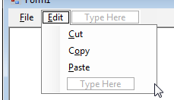

Double click the Cut, Copy and Paste menuitems.

private void cutToolStripMenuItem_Click(object sender, EventArgs e)
{

}

private void copyToolStripMenuItem_Click(object sender, EventArgs e)
{

}

private void pasteToolStripMenuItem_Click(object sender, EventArgs e)
{

}

A class called Clipboard provides a number of methods for storing and retrieving data during edits. To copy, data use the SetDataObject to save an object in the clipboard. The object in question can be anything e.g. text, bitmaps, etc.

private void copyToolStripMenuItem_Click(object sender, EventArgs e)
{
// Copy text from the text box into the clipboard
Clipboard.SetDataObject(richTextBox.SelectedText);
}

To perform a Cut operation is identical but we also clear the selected text.
private void cutToolStripMenuItem_Click(object sender, EventArgs e)
{
// Copy text from the text box into the clipboard
Clipboard.SetDataObject(richTextBox.SelectedText);
richTextBox.SelectedText = "";
}

To paste data back into our window is a little more difficult because we don’t know the type of data that was copied neither do we know which application a came from. So first we recover the data object as an IDataObject, and then we check the type of data to see if it’s text that we can add to the textbox.

IDataObject data = Clipboard.GetDataObject();

if (data.GetDataPresent(DataFormats.Text))
{
}

If it’s text we read it and place it wherever the cursor is positioned and overwriting any text that may still be selected in the text box.

private void pasteToolStripMenuItem_Click(object sender, EventArgs e)
{
IDataObject data = Clipboard.GetDataObject();

if (data.GetDataPresent(DataFormats.Text))
{
richTextBox.SelectedText = (string)data.GetData(DataFormats.Text);
}
else
{
// We can only paste text into a RichTextBox, anything else we ignore
}
}

Hmmm: I’ve over complicated this a bit because you may want to copy more complicated data, not just text as in this example. Actually, the RichTextBox has a number of methods which work with the clipboard directly and for editing purposes, such as:

richTextBox.Cut();
richTextBox.Copy();
richTextBox.Paste();
richTextBox.SelectAll();
richTextBox.DeselectAll();
richTextBox.Undo();
richTextBox.Redo();
richTextBox.ClearUndo();
richTextBox.SelectedText = ""; // Clear selected text

Menu Enhancements

There are four enhancements that can be added to menus to convey information to users.

•Check marks can be used to designate whether a feature is turned on or off (such as whether a ruler is displayed along the margin of a word-processing application) or to indicate which of a list of files is being displayed (such as on a Window menu).
•Shortcut keys are keyboard commands to access menu items within an application.
•Access keys allow keyboard navigation of menus (pressing the ALT key and the underlined access key chooses the desired menu or menu item).
•Separator bars are used to group related commands within a menu and make menus easier to read.

To add a check mark to a menu item at design time

•With the menu item selected within the Menu Designer, click the area to the left of the menu item. A check mark appears, indicating the Checked property has been set to true.
– or –
•With the menu item selected within the Menu Designer, set the Checked property to true in the Properties window.
Note In lieu of setting the Checked property, you can set the RadioCheck property. When the RadioCheck property is set to true, a small dot (•) is displayed next to the menu item, indicating it is selected. For more information about the radio check marks and menus, see MainMenu Component.
To add a check mark to a menu item programmatically

•Within the method where you set the properties of the menu item (such as Text), add code to set the Checked property to true:

myMnuItem.Checked = True

// C#
myMnuItem.Checked = true;

// C++
myMnuItem->Checked = true;

To add a shortcut key to a menu item at design time

•Select the menu item within the Menu Designer. In the Properties window, set the Shortcut property to one of the values offered in the drop-down list.

To add a shortcut key to a menu item programmatically

•Within the method where you set the properties of the menu item (such as Text), add code to set the Shortcut property to one of the values of the Shortcut enumeration:

myMnuItem.Shortcut = System.Windows.Forms.Shortcut.F6

// C#
myMnuItem.Shortcut = System.Windows.Forms.Shortcut.F6;

// C++
myMnuItem->Shortcut = System::Windows::Forms::Shortcut::F6;

To add an access key to a menu item

•When setting the Text property (either in the Properties window, in the Menu Designer, or in code), enter an ampersand (&) prior to the letter you want to be underlined as the access key. For example, typing F&ormat as the Text property of a menu item will result in a menu item that appears as Format.
To navigate to this menu item, press ALT to give focus to the menu bar, and press the access key of the menu name. When the menu opens and shows items with access keys, you only need to press the access key to select the menu item.

To add a separator bar as a menu item

•In the Menu Designer, right-click the location where you want a separator bar, and choose New Separator.
-or-
•When setting the Text property (either in the Properties window, in the Menu Designer, or in code) of the menu item, enter a dash (–) to make that menu item a separator bar.

Let’s add some shortcut keys to our Edit menu. First change the text for each menu item to show the shortcut key
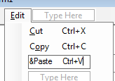

Now select each menuitem again and with the menuitem selected choose ShortcutKeys from the Properties window.
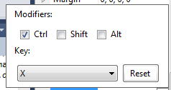
Run and try using the keys instead of selecting Cut, Copy and Paste from the menu.

Comma Separated Value (CSV) Files

You can split the text into separate parts by specifying a separator, for CSV files these are commas. For example, say we want to store the values apple, pear and orange. In a CSV file they could be stored as a single line

apple, pear, orange

Run Excel and type the following values into the worksheet as shown:
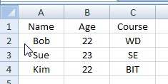

Now save the worksheet as a (save as) CSV file...
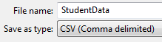

If you open the file with Notepad, here is what you will see...

Name,Age,Course
Bob,22,WD
Sue,23,SE
Kim,22,BIT

In the next example, we will import this file into our application, make changes to the data and then write it back. We’ll display the data in a DataGridView, so in effect we will create a primitive spreadsheet.

Create a window form application and add DataGridView

DataGridView
Property | Value
Name | studentDataGrid
AllowUserToAddRows | true
AllowUsersToDeleteRows | true
ReadOnly | false
Dock | DockStyle.Fill

Add a File Menu, add Import & Export submenus.
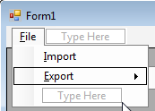

Double click on the Import and Export menuitems.

using System;
using System.Collections.Generic;
using System.ComponentModel;
using System.Data;
using System.Drawing;
using System.Linq;
using System.Text;
using System.Windows.Forms;

namespace FullCSVFileHandling
{
public partial class Form1 : Form
{
public Form1()
{
InitializeComponent();
}

private void importToolStripMenuItem_Click(object sender, EventArgs e)
{

}

private void exportToolStripMenuItem_Click(object sender, EventArgs e)
{

}
}
}

Add the Open and Save dialog boxes, in the same way we did before...

using System;
using System.Collections.Generic;
using System.ComponentModel;
using System.Data;
using System.Drawing;
using System.Linq;
using System.Text;
using System.Windows.Forms;

using System.IO;

namespace FullCSVFileHandling
{
public partial class Form1 : Form
{
public Form1()
{
InitializeComponent();
}

private void importToolStripMenuItem_Click(object sender, EventArgs e)
{
string filePath;

openFileDialog1.Reset();
openFileDialog1.Title = "Open File";

openFileDialog1.FileName = "somefile.csv";
openFileDialog1.Filter = "CSV File|*.csv|All files (*.*)|*.*";
openFileDialog1.FilterIndex = 2; // "All files(*.*)" filter when first shown

openFileDialog1.CheckFileExists = true;
openFileDialog1.CheckPathExists = true;

openFileDialog1.RestoreDirectory = true;

if (openFileDialog1.ShowDialog() == DialogResult.OK)
{
filePath = openFileDialog1.FileName;

// Read text from file here
OpenFile(filePath);
}
}

private void exportToolStripMenuItem_Click(object sender, EventArgs e)
{
string filePath;

saveFileDialog1.Reset();

saveFileDialog1.Title = "Save File";

saveFileDialog1.FileName = "somefile.csv";
saveFileDialog1.Filter = "CSV File|*.csv";
saveFileDialog1.DefaultExt = "csv";

saveFileDialog1.CreatePrompt = true;
saveFileDialog1.OverwritePrompt = true;

saveFileDialog1.InitialDirectory = Directory.GetCurrentDirectory();

if (saveFileDialog1.ShowDialog() == DialogResult.OK)
{
filePath = saveFileDialog1.FileName;

// Write text to file here
SaveFile(filePath);
}
}

private void SaveFile(string filePath)
{
}

private void OpenFile(string filePath)
{
}

}
}

We’ll begin by opening the CSV file. Most types of files start with a file header describing the contents of the file, followed by the file data itself. Just illustration purposes, we’ll read the column names and pretend this could have been a more interesting file header. So we add two functions one to read the header and the other to read the data.

private void OpenFile(string filePath)
{
FileStream fs = new FileStream(filePath, FileMode.Open);
StreamReader rd = new StreamReader(fs);

ReadCSVFileHeader(rd);
ReadCSVFileData(rd);

rd.Close();
fs.Close();
}

To header consists of a comma separated line of the names, like this:

Name,Age,Course

We need to split this list into the strings “Name”, “Age” and “Course”.
The string class has a method called Split() which allows you to provide the character on which the string should be split and returns an array of strings split at this separator character.

string text;
string[] textParts;

text = rd.ReadLine(); // Read the line of text from the file

textParts = text.Split(','); // Split the line at the commas

Say text contains “Name,Age,Course” then
textParts[0] contains “Name”
textParts[1] contains “Age”
textParts[2] contains “Course”

We add columns to the DataGridView like this....

foreach (string columnName in textParts)
{
column = new DataGridViewTextBoxColumn();
column.Name = columnName;
column.AutoSizeMode = DataGridViewAutoSizeColumnMode.AllCells;
studentDataGrid.Columns.Add(column);
}

Here’s the final function...
private void ReadCSVFileHeader(StreamReader rd)
{
string text;
string[] textParts;
DataGridViewColumn column;

if (rd.EndOfStream == false)
{
text = rd.ReadLine();

textParts = text.Split(',');

studentDataGrid.AutoGenerateColumns = false;
studentDataGrid.Columns.Clear();

foreach (string columnName in textParts)
{
column = new DataGridViewTextBoxColumn();
column.Name = columnName;
column.AutoSizeMode =
DataGridViewAutoSizeColumnMode.AllCells;

studentDataGrid.Columns.Add(column);
}
}
}

Reading the CSV data is very similar, but in this case we store the values in each cell in the row.

private void ReadCSVFileData(StreamReader rd)
{
string text;
string[] textParts;

while (rd.EndOfStream == false)
{
text = rd.ReadLine();

textParts = text.Split(',');

int rowIndex = studentDataGrid.Rows.Add();
int cellIndex = 0;

foreach (string colValue in textParts)
{
studentDataGrid.Rows[rowIndex].Cells[cellIndex++].Value
= colValue;
}
}
}

Writing the header and data is very similar, we read the cells from the DataGridView and write the data to the file.

Here’s the function...

private void SaveFile(string filePath)
{
// Create a stream and a writer
FileStream fs = new FileStream(filePath, FileMode.Create);
StreamWriter wr = new StreamWriter(fs);

WriteCSVHeader(wr);
WriteCSVData(wr);

// Finish writing to the file and close down
wr.Flush();
wr.Close();
fs.Close();
}

Here’s the function to write the column names to the file...

private void WriteCSVHeader(StreamWriter wr)
{
int columnCount = studentDataGrid.Columns.Count;
int columnIndex;

if (columnCount > 0)
{
DataGridViewColumn column;

for (columnIndex = 0; columnIndex < columnCount-1; columnIndex++)
{
column = studentDataGrid.Columns[columnIndex];
wr.Write(column.Name);
wr.Write(",");
}
column = studentDataGrid.Columns[columnIndex];
wr.WriteLine(column.Name);
}
}

.... and to write the rows of data.

private void WriteCSVData(StreamWriter wr)
{
int rowCount = studentDataGrid.Rows.Count;
int columnCount;
int rowIndex;
int columnIndex;

if (rowCount > 0)
{
for (rowIndex = 0; rowIndex < rowCount-1; rowIndex++)
{
DataGridViewRow row = studentDataGrid.Rows[rowIndex];

columnCount = row.Cells.Count;
if (columnCount > 0)
{
DataGridViewCell cell;

for (columnIndex = 0; columnIndex < columnCount - 1; columnIndex++)
{
cell = row.Cells[columnIndex];
if (cell.Value != null)
{
wr.Write(cell.Value.ToString());
}
wr.Write(",");
}
cell = row.Cells[columnIndex];
if (cell.Value != null)
{
wr.WriteLine(cell.Value.ToString());
}
}
}
}
}

That’s it, run the application.

The StreamWriter can actually write a number of data types to a file. For example, let’s extend the example by adding the number of rows to the header. Change the .csv file to add a count of the rows e.g.

4
Name,Age,Course
Bob,22,WD
Sue,23,SE
Kim,22,BIT

We can modify the read and write header functions to read and write the integer value. First we write the row count to the file....

private void WriteCSVHeader(StreamWriter wr)
{
int columnCount = studentDataGrid.Columns.Count;
int columnIndex;

if (columnCount > 0)
{
DataGridViewColumn column;

// Write the number of rows to the header
wr.WriteLine(studentDataGrid.Rows.Count);

// Write all thee column names into the first line
// of the CSV file.
for (columnIndex = 0; columnIndex < columnCount-1; columnIndex++)
{
column = studentDataGrid.Columns[columnIndex];
wr.Write(column.Name);
wr.Write(",");
}

// Write the last value, don't add a comma following it
// and move to the next line.
column = studentDataGrid.Columns[columnIndex];
wr.WriteLine(column.Name);
}
}

...then we read it back....

private void ReadCSVFileHeader(StreamReader rd)
{
string text;
string[] textParts;
DataGridViewColumn column;

if (rd.EndOfStream == false)
{
int rowCount;

text = rd.ReadLine();
rowCount = int.Parse(text);

text = rd.ReadLine();

textParts = text.Split(',');

studentDataGrid.AutoGenerateColumns = false;
studentDataGrid.Columns.Clear();

foreach (string columnName in textParts)
{
column = new DataGridViewTextBoxColumn();
column.Name = columnName;
column.AutoSizeMode = DataGridViewAutoSizeColumnMode.AllCells;
//column.Tag = m;
//column.DataPropertyName = m.Name;
studentDataGrid.Columns.Add(column);
}
}
}

I’m not actually going to use the rowCount, but you can see how you can add any data you need to the header.

Note: You can make this a little more interesting and store types of data. Say we create a CSV file that looks like this ...

STUDENT, Name=Bob, Age=22, Course=SE
STUDENT, Name=Sue, Age=24, Course=BIT
LECTURER, Name=Karl, Age=28

After we Split the line, we can look at the first string to find the type of object being loaded......

// Read from the file till it reaches the end
while (rd.EndOfStream == false)
{
// Read a line from the file and convert
// it to upper case
text = rd.ReadLine();
text.ToUpper();

// Split the line into seperate
// text parts, where the commas
// where in the original line
textParts = text.Split(separators);

// The first part contains the type of
// object to load
switch (textParts[0].Trim())
{
case "STUDENT":
LoadStudent(textParts);
break;
case "LECTURER":
LoadLecturer(textParts);
break;
}
}

..... and you would load it something like this ...

public void LoadStudent(string[] textParts)
{
string[] valueStr;
string name = “”;
int age = 0;
string course = “”;
Student student;

// The text following STUDENT contains
// attributes i.e. Name, Age, Course
for (int i = 1; i < textParts.Length; i++)
{
// Split the remaining string where equals
// sign character is
valueStr = textParts[i].Split(‘=’);

// Read the attribute name and it,s value
switch (valueStr[0].Trim())
{
case "NAME":
// Parse the value string to
// get the attribute value
name = valueStr[1];
break;
case "AGE":
age = int.Parse(valueStr[1]);
break;
case "COURSE":
course = valueStr[1];
break;
}
}

// Add a new student
student = new Student(name, age, course);

// Add to a students list
students.Add(v);
}

Notice a trick here, convert the string to all upper case using ToUpper() before using a switch statement because you don’t have to worry about mixed case being stored in the file.

The StreamWriter and StreamReader handle text files, but BinaryWriter and BinaryReader allows you to handle binary files instead.

BinaryWriter wr = new BinaryWriter(fs);

wr.Write(22);
wr.Write(“Hello World”);
wr.Write(true);
wr.Write(7.55);

wr.Flush();
wr.Close();

Likewise, when reading..

BinaryReader rd = new BinaryReader(fs);

// Check if end of file reached i.e. file is not empty.
if (rd.PeekChar() != -1)
{
int cnt = rd.ReadInt32();
string text = rd.ReadString();
bool b = rd.ReadBoolean();
double d = rd.ReadDouble();
}

rd.Close();

However, there is a better method for storing more complex data like this, and that is serialization.

File Serialization

In this example, we will switch to a WPF application.
Create a WPF Windows application.
Start by adding a DockPanel.

<Window x:Class="FullFileSerializationWPF.MainWindow"
xmlns="http://schemas.microsoft.com/winfx/2006/xaml/presentation"
xmlns:x="http://schemas.microsoft.com/winfx/2006/xaml"
Title="MainWindow" Height="350" Width="525">
<DockPanel>
<Grid>

</Grid>
</DockPanel>
</Window>

Add a menu, use the IsMainMenu property to indicate this is the applications main menu. MenuItems can then be added. To make submenu, place the MenuItems inside the top-level MenuItem. Here we want a top-level “File” menu item, with a submenu containing “New”, “Open” and “Save”. I’ve named the New, Open and Save MenuItems because we want to program against them. Likewise, the “Edit” menu.

<Window x:Class="FullFileSerializationWPF.MainWindow"
xmlns="http://schemas.microsoft.com/winfx/2006/xaml/presentation"
xmlns:x="http://schemas.microsoft.com/winfx/2006/xaml"
Title="MainWindow" Height="350" Width="525">
<DockPanel>
<Menu IsMainMenu="True">
<MenuItem Header="_File">
<MenuItem Name="newMenuItem" Header="_New" />
<MenuItem Name="openMenuItem" Header="_Open" />
<MenuItem Name="saveMenuItem" Header="_Save" />
</MenuItem>
<MenuItem Header="_Edit">
<MenuItem Name="addMenuItem" Header="_Add Student"/>
</MenuItem>

</Menu>
<Grid>

</Grid>
</DockPanel>
</Window>

Before we continue, we need to dock the menu and the Grid, to the top and bottom of the window respectively.

<Window x:Class="FullFileSerializationWPF.MainWindow"
xmlns="http://schemas.microsoft.com/winfx/2006/xaml/presentation"
xmlns:x="http://schemas.microsoft.com/winfx/2006/xaml"
Title="MainWindow" Height="350" Width="525">
<DockPanel>
<Menu IsMainMenu="True" DockPanel.Dock="Top">
<MenuItem Header="_File">
<MenuItem Name="newMenuItem" Header="_New" />
<MenuItem Name="openMenuItem" Header="_Open" />
<MenuItem Name="saveMenuItem" Header="_Save" />
</MenuItem>
<MenuItem Header="_Edit">
<MenuItem Name="addMenuItem" Header="_Add Student"/>
</MenuItem>
</Menu>
<Grid DockPanel.Dock="Bottom">

</Grid>
</DockPanel>
</Window>

Now in the XAML editor, click on the Open menu item to select it, making sure the Property window is displaying it....


Now click the lightning strike button to bring up the events and double click on the Click event.
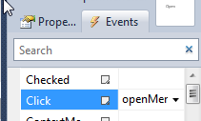
Repeat for the New, Save and Add Student menu items so you should have the code for all menu items...

using System;
using System.Collections.Generic;
using System.Linq;
using System.Text;
using System.Windows;
using System.Windows.Controls;
using System.Windows.Data;
using System.Windows.Documents;
using System.Windows.Input;
using System.Windows.Media;
using System.Windows.Media.Imaging;
using System.Windows.Navigation;
using System.Windows.Shapes;

namespace FullFileSerializationWPF
{
/// <summary>
/// Interaction logic for MainWindow.xaml
/// </summary>
public partial class MainWindow : Window
{
public MainWindow()
{
InitializeComponent();
}

private void newMenuItem_Click(object sender, RoutedEventArgs e)
{

}

private void openMenuItem_Click(object sender, RoutedEventArgs e)
{

}

private void saveMenuItem_Click(object sender, RoutedEventArgs e)
{

}

private void addMenuItem_Click(object sender, RoutedEventArgs e)
{

}

}
}

Notice the XAML also gets updated....

<Window x:Class="FullFileSerializationWPF.MainWindow"
xmlns="http://schemas.microsoft.com/winfx/2006/xaml/presentation"
xmlns:x="http://schemas.microsoft.com/winfx/2006/xaml"
Title="MainWindow" Height="350" Width="525">
<DockPanel>
<Menu IsMainMenu="True" DockPanel.Dock="Top">
<MenuItem Header="_File">
<MenuItem Name="newMenuItem" Header="_New"
Click="newMenuItem_Click" />
<MenuItem Name="openMenuItem" Header="_Open"
Click="openMenuItem_Click" />
<MenuItem Name="saveMenuItem" Header="_Save"
Click="saveMenuItem_Click" />
</MenuItem>
<MenuItem Header="_Edit">
<MenuItem Name="addMenuItem" Header="_Add Student"
Click="addMenuItem_Click" />
</MenuItem>

</Menu>
<Grid DockPanel.Dock="Bottom">

</Grid>
</DockPanel>
</Window>

Add a class called Player.
using System;
using System.Collections.Generic;
using System.Linq;
using System.Text;

namespace FullFileSerializationWPF
{
public class Player
{
// Attributes
private string _name;
private int _age;
private string _position;

// Constructors
public Player()
{
_name = "";
_age = 0;
_position = "";
}

public Player(string name, int age, string position)
{
_name = name;
_age = age;
_position = position;
}

// Properties
public string Name
{
get
{
return _name;
}
set
{
_name = value;
}
}

public int Age
{
get
{
return _age;
}
set
{
_age = value;
}
}

public string Position
{
get
{
return _position;
}
set
{
_position = value;
}
}
}
}

We will store the applications data on a List, so we modify the application to create a list of Players. When the user picks New from the menu, reset the application state data i.e. we clear this list, because this is new data we are creating.

using System;
using System.Collections.Generic;
using System.Linq;
using System.Text;
using System.Windows;
using System.Windows.Controls;
using System.Windows.Data;
using System.Windows.Documents;
using System.Windows.Input;
using System.Windows.Media;
using System.Windows.Media.Imaging;
using System.Windows.Navigation;
using System.Windows.Shapes;

namespace FullFileSerializationWPF
{
/// <summary>
/// Interaction logic for MainWindow.xaml
/// </summary>
public partial class MainWindow : Window
{
private List<Player> _players = new List<Player>();

public MainWindow()
{
InitializeComponent();
}

private void newMenuItem_Click(object sender, RoutedEventArgs e)
{
_players.Clear();
}

private void openMenuItem_Click(object sender, RoutedEventArgs e)
{

}

private void saveMenuItem_Click(object sender, RoutedEventArgs e)
{

}

private void addMenuItem_Click(object sender, RoutedEventArgs e)
{

}

}
}

We’ll create a dialog box to be displayed when the user click the Add Student menu item. The AddStudentDialogBox looks like this:
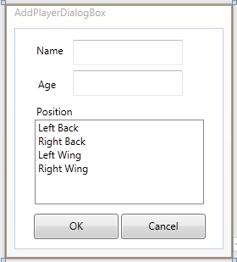

The XAML looks like this (remember to double click the buttons):

<Window x:Class="FullFileSerializationWPF.AddPlayerDialogBox"
xmlns="http://schemas.microsoft.com/winfx/2006/xaml/presentation"
xmlns:x="http://schemas.microsoft.com/winfx/2006/xaml"
Title="AddPlayerDialogBox" Height="300" Width="269" Closing="Window_Closing">
<Canvas>
<Label Content="Name" Canvas.Left="21" Canvas.Top="14" />
<TextBox Name="nameTextBox" Width="130" Height="30" Canvas.Left="69" Canvas.Top="14" />
<Label Content="Age" Canvas.Left="23" Canvas.Top="54" />
<TextBox Name="ageTextBox" Width="130" Height="30" Canvas.Left="69" Canvas.Top="50" />
<Label Content="Position" Canvas.Left="21" Canvas.Top="86" />
<ListBox Name="positionListBox" Width="200" Height="100" Canvas.Left="24" Canvas.Top="108">
<ListBoxItem Content="Left Back"/>
<ListBoxItem Content="Right Back"/>
<ListBoxItem Content="Left Wing"/>
<ListBoxItem Content="Right Wing"/>
</ListBox>
<Button Name="okButton" Content="OK" IsDefault="True" Width="100" Height="30" Canvas.Left="23" Canvas.Top="219" Click="okButton_Click" />
<Button Name="cancelButton" Content="Cancel" IsCancel="True" Width="100" Height="30" Canvas.Left="126" Canvas.Top="219" Click="cancelButton_Click" />
</Canvas>
</Window>

You should now have code that looks like this
using System;
using System.Collections.Generic;
using System.Linq;
using System.Text;
using System.Windows;
using System.Windows.Controls;
using System.Windows.Data;
using System.Windows.Documents;
using System.Windows.Input;
using System.Windows.Media;
using System.Windows.Media.Imaging;
using System.Windows.Shapes;

namespace FullFileSerializationWPF
{
/// <summary>
/// Interaction logic for AddPlayerDialogBox.xaml
/// </summary>
public partial class AddPlayerDialogBox : Window
{
public AddPlayerDialogBox()
{
InitializeComponent();
}

private void okButton_Click(object sender, RoutedEventArgs e)
{
DialogResult = true;
}

private void cancelButton_Click(object sender, RoutedEventArgs e)
{
DialogResult = false;
}

}
}

Return the dialog box results..

namespace FullFileSerializationWPF
{
/// <summary>
/// Interaction logic for AddPlayerDialogBox.xaml
/// </summary>
public partial class AddPlayerDialogBox : Window
{
public AddPlayerDialogBox()
{
InitializeComponent();
}

private void okButton_Click(object sender, RoutedEventArgs e)
{
DialogResult = true;
}

private void cancelButton_Click(object sender, RoutedEventArgs e)
{
DialogResult = false;
}

}
}

To validate whether the dialog box results are correct before closing the dialog box, we need a Window_Closing event handler. Click on the Window and in the Properties window, click the events button (looks like a lightning strike) and double click the Closing event.

namespace FullFileSerializationWPF
{
/// <summary>
/// Interaction logic for AddPlayerDialogBox.xaml
/// </summary>
public partial class AddPlayerDialogBox : Window
{
public AddPlayerDialogBox()
{
InitializeComponent();
}

private void okButton_Click(object sender, RoutedEventArgs e)
{
DialogResult = true;
}

private void cancelButton_Click(object sender, RoutedEventArgs e)
{
DialogResult = false;
}

private void Window_Closing(object sender, System.ComponentModel.CancelEventArgs e)
{
}
}
}

We check each control in the dialog box. The nameTextBox must contain a name, the ageTextBox must contain a positive number and the positionListBox must have a selected position. If any of these aren’t true, we display a message box warning the user and set the e.Cancel property to false to prevent the dialog box closing.

namespace FullFileSerializationWPF
{
/// <summary>
/// Interaction logic for AddPlayerDialogBox.xaml
/// </summary>
public partial class AddPlayerDialogBox : Window
{
public AddPlayerDialogBox()
{
InitializeComponent();
}

private void okButton_Click(object sender, RoutedEventArgs e)
{
DialogResult = true;
}

private void cancelButton_Click(object sender, RoutedEventArgs e)
{
DialogResult = false;
}

private void Window_Closing(object sender, System.ComponentModel.CancelEventArgs e)
{
int age;

if (DialogResult == true)
{
if (nameTextBox.Text == "")
{
MessageBox.Show("Name must be entered");
e.Cancel = true;
}
else if (int.TryParse(ageTextBox.Text, out age) == false
|| age < 0)
{
MessageBox.Show("Age must be a positive whole number");
e.Cancel = true;
}
else if (positionListBox.SelectedIndex < 0)
{
MessageBox.Show("Position must be selected");
e.Cancel = true;
}
}
}
}
}

Finally add a method to read the data when passed a Student object.

using System;
using System.Collections.Generic;
using System.Linq;
using System.Text;
using System.Windows;
using System.Windows.Controls;
using System.Windows.Data;
using System.Windows.Documents;
using System.Windows.Input;
using System.Windows.Media;
using System.Windows.Media.Imaging;
using System.Windows.Shapes;

namespace FullFileSerializationWPF
{
/// <summary>
/// Interaction logic for AddPlayerDialogBox.xaml
/// </summary>
public partial class AddPlayerDialogBox : Window
{
public AddPlayerDialogBox()
{
InitializeComponent();
}

public void GetData(Player player)
{
ListBoxItem listItem;
player.Name = nameTextBox.Text;
player.Age = int.Parse(ageTextBox.Text);
listItem = (ListBoxItem)positionListBox.SelectedItem;
player.Position = (string)listItem.Content;
}

private void okButton_Click(object sender, RoutedEventArgs e)
{
DialogResult = true;
}

private void cancelButton_Click(object sender, RoutedEventArgs e)
{
DialogResult = false;
}

private void Window_Closing(object sender, System.ComponentModel.CancelEventArgs e)
{
int age;

if (DialogResult == true)
{
if (nameTextBox.Text == "")
{
MessageBox.Show("Name must be entered");
e.Cancel = true;
}
else if (int.TryParse(ageTextBox.Text, out age) == false
|| age < 0)
{
MessageBox.Show("Age must be a positive whole number");
e.Cancel = true;
}
else if (positionListBox.SelectedIndex < 0)
{
MessageBox.Show("Position must be selected");
e.Cancel = true;
}
}
}
}
}

The WPF ListBox methods are pretty much identical to those for the ListBox used in Windows Form.

Back to the main window, and open this dialog box when the user clicks the Add Student menu item. We show it using ShowDialog(), which returns true if the user has successfully completed entering the data & clicked OK. Then we create a new Player, ask the dialog box to store the data in it using the GetData() method we just created. Finally we add the player to the list of Players, which forms the applications state which we want to save to a file and reload from a file.

using System;
using System.Collections.Generic;
using System.Linq;
using System.Text;
using System.Windows;
using System.Windows.Controls;
using System.Windows.Data;
using System.Windows.Documents;
using System.Windows.Input;
using System.Windows.Media;
using System.Windows.Media.Imaging;
using System.Windows.Navigation;
using System.Windows.Shapes;

namespace FullFileSerializationWPF
{
/// <summary>
/// Interaction logic for MainWindow.xaml
/// </summary>
public partial class MainWindow : Window
{
private List<Player> _players = new List<Player>();

public MainWindow()
{
InitializeComponent();
}

private void newMenuItem_Click(object sender, RoutedEventArgs e)
{
_players.Clear();
}

private void openMenuItem_Click(object sender, RoutedEventArgs e)
{

}

private void saveMenuItem_Click(object sender, RoutedEventArgs e)
{

}

private void addMenuItem_Click(object sender, RoutedEventArgs e)
{
AddPlayerDialogBox db = new AddPlayerDialogBox();
db.Owner = this;
bool? result;

result = db.ShowDialog();
if (result == true)
{
Player player = new Player();
db.GetData(player);
_players.Add(player);
}
}

}
}

Serialization is the process of converting complex objects into stream of bytes for storage. Deserialization is its reverse process, that is unpacking stream of bytes to their original form.

To make an object serializable we have to apply the Serializable attribute to the class and any classes for objects it may have as attributes. Let’s make the Player class Serializable.....

using System;
using System.Collections.Generic;
using System.Linq;
using System.Text;

using System.Runtime.Serialization; // [Serializable()], [NonSerialized()], etc

namespace FullFileSerializationWPF
{
[Serializable()]
public class Player
{
// Attributes
private string _name;
private int _age;
private string _position;

Sometimes a class may have attributes that store temporary values which you don’t want to save in the final, these can be marked with the NonSerialized attribute.

[NonSerialized()]private int _calculatedTotal;

Since this is just an example, we will create a file called “quicktext.tmp” in the applications working directory and then load it again.
Using a StringBuilder, we build the files path..

StringBuilder sb = new StringBuilder();

sb.Append(Directory.GetCurrentDirectory());
sb.Append("quicktest.tmp");

... we open the file using this path ...
FileStream fs;

fs = new FileStream(sb.ToString(), FileMode.OpenOrCreate);

.... then create a BinaryFormatter which will serialize the Players list (_players) and write the data to the file for us.
BinaryFormatter bf;

bf = new BinaryFormatter();
bf.Serialize(fs, _players);

To read it back, the BinaryFormatter will read the data from the file, deserialize it and restore the data.
BinaryFormatter bf;

bf = new BinaryFormatter();
_players = (List<Player>)bf.Deserialize(fs);

Now we can complete the Save and Open file operations....
using System;
using System.Collections.Generic;
using System.Linq;
using System.Text;
using System.Windows;
using System.Windows.Controls;
using System.Windows.Data;
using System.Windows.Documents;
using System.Windows.Input;
using System.Windows.Media;
using System.Windows.Media.Imaging;
using System.Windows.Navigation;
using System.Windows.Shapes;

using System.IO;
using System.Runtime.Serialization.Formatters.Binary;

namespace FullFileSerializationWPF
{
/// <summary>
/// Interaction logic for MainWindow.xaml
/// </summary>
public partial class MainWindow : Window
{
private List<Player> _players = new List<Player>();

public MainWindow()
{
InitializeComponent();
}

private void newMenuItem_Click(object sender, RoutedEventArgs e)
{
_players.Clear();
}

private void openMenuItem_Click(object sender, RoutedEventArgs e)
{
StringBuilder sb = new StringBuilder();
FileStream fs;
BinaryFormatter bf;

sb.Append(Directory.GetCurrentDirectory());
sb.Append("quicktest.tmp");

fs = new FileStream(sb.ToString(), FileMode.Open);
bf = new BinaryFormatter();

_players = (List<Player>)bf.Deserialize(fs);
fs.Close();
}

private void saveMenuItem_Click(object sender, RoutedEventArgs e)
{
StringBuilder sb = new StringBuilder();
FileStream fs;
BinaryFormatter bf;

sb.Append(Directory.GetCurrentDirectory());
sb.Append("quicktest.tmp");

fs = new FileStream(sb.ToString(), FileMode.OpenOrCreate);
bf = new BinaryFormatter();

// Write data here
bf.Serialize(fs, _players);

fs.Close();
}

private void addMenuItem_Click(object sender, RoutedEventArgs e)
{
AddPlayerDialogBox db = new AddPlayerDialogBox();
db.Owner = this;
bool? result;

result = db.ShowDialog();
if (result == true)
{
Player player = new Player();
db.GetData(player);
_players.Add(player);
}
}

}
}

We can now display the data in a WPF DataGrid.
Begin by adding the DataGrid to the window.

<Window x:Class="FullFileSerializationWPF.MainWindow"
xmlns="http://schemas.microsoft.com/winfx/2006/xaml/presentation"
xmlns:x="http://schemas.microsoft.com/winfx/2006/xaml"
Title="MainWindow" Height="350" Width="525">
<DockPanel>
<Menu IsMainMenu="True" DockPanel.Dock="Top">
<MenuItem Header="_File">
<MenuItem Name="newMenuItem" Header="_New" Click="newMenuItem_Click" />
<MenuItem Name="openMenuItem" Header="_Open" Click="openMenuItem_Click" />
<MenuItem Name="saveMenuItem" Header="_Save" Click="saveMenuItem_Click" />
</MenuItem>
<MenuItem Header="_Edit">
<MenuItem Name="addMenuItem" Header="_Add Student" Click="addMenuItem_Click" />
</MenuItem>
</Menu>
<Grid DockPanel.Dock="Bottom">
<DataGrid Name="playersDataGrid"
HorizontalAlignment="Stretch"
VerticalAlignment="Stretch" />
</Grid>
</DockPanel>
</Window>

Next we need to load the list of Players into the DataGrid.

using System;
using System.Collections.Generic;
using System.Linq;
using System.Text;
using System.Windows;
using System.Windows.Controls;
using System.Windows.Data;
using System.Windows.Documents;
using System.Windows.Input;
using System.Windows.Media;
using System.Windows.Media.Imaging;
using System.Windows.Navigation;
using System.Windows.Shapes;

using System.IO;
using System.Runtime.Serialization.Formatters.Binary;

namespace FullFileSerializationWPF
{
/// <summary>
/// Interaction logic for MainWindow.xaml
/// </summary>
public partial class MainWindow : Window
{
private List<Player> _players = new List<Player>();

public MainWindow()
{
InitializeComponent();
}

private void newMenuItem_Click(object sender, RoutedEventArgs e)
{
_players.Clear();
playersDataGrid.ItemsSource = null;
playersDataGrid.ItemsSource = _players;
}

private void openMenuItem_Click(object sender, RoutedEventArgs e)
{
StringBuilder sb = new StringBuilder();
FileStream fs;
BinaryFormatter bf;

sb.Append(Directory.GetCurrentDirectory());
sb.Append("quicktest.tmp");

fs = new FileStream(sb.ToString(), FileMode.Open);
bf = new BinaryFormatter();

_players = (List<Player>)bf.Deserialize(fs);
fs.Close();

playersDataGrid.ItemsSource = null;
playersDataGrid.ItemsSource = _players;
}

private void saveMenuItem_Click(object sender, RoutedEventArgs e)
{
StringBuilder sb = new StringBuilder();
FileStream fs;
BinaryFormatter bf;

sb.Append(Directory.GetCurrentDirectory());
sb.Append("quicktest.tmp");

fs = new FileStream(sb.ToString(), FileMode.OpenOrCreate);
bf = new BinaryFormatter();

// Write data here
bf.Serialize(fs, _players);

fs.Close();
}

private void addMenuItem_Click(object sender, RoutedEventArgs e)
{
AddPlayerDialogBox db = new AddPlayerDialogBox();
db.Owner = this;
bool? result;

result = db.ShowDialog();
if (result == true)
{
Player player = new Player();
db.GetData(player);
_players.Add(player);
playersDataGrid.ItemsSource = null;
playersDataGrid.ItemsSource = _players;
}
}

}
}

Multiple Document Interface (MDI)

MDI provides management of multiple documents in Windows, with a single parent window displaying a number of child windows. For example, Visual Studio, Word, Excel, etc. The traditional MDI approached open a number of windows and cascaded or tiled them.

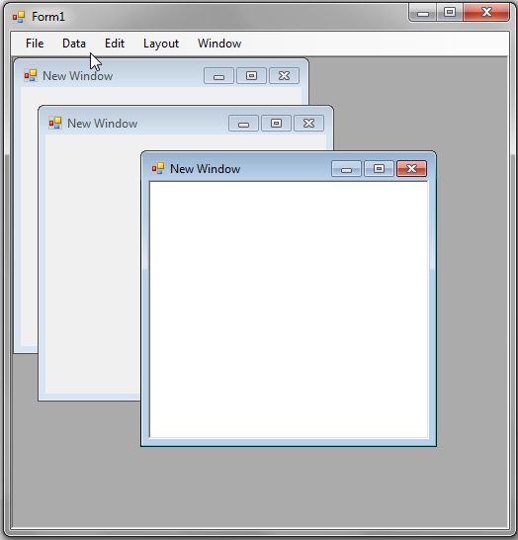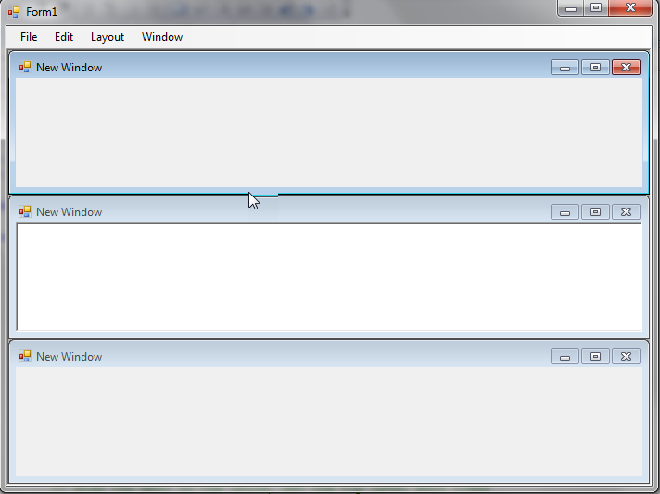

There is much discussion on the merits of MDI, with most people agreeing that the new approach is to create a Tabbed interface. For example, here is Visual Studio displaying multiple documents, the tab of active document is highlighted.

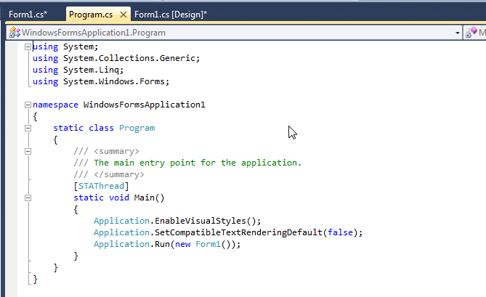

WPF currently doesn’t support MDI, although a number of implementations have been posted on the web. Microsofts argument seems to be that it is fairly easy to create your own MDI and there is no single approach to their implementation. Even Microsofts own applications use different approaches e.g. here’s Excels approach to display spreadsheets in a workbook.

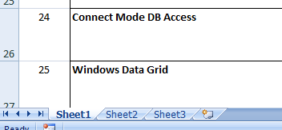

Here is the code for Window Forms using the traditional MDI.

First create two forms, one for the parent container and the other to act as a child form. Alter the constructor for the first form to set the property IsMdiContainer to make it a container for MDI child windows.

public Form1()
{
InitializeComponent();

// Set this property on form
// Make the form an MDI container for MDI child windows.
IsMdiContainer = true;
}

Add a menu to create and show the second form.
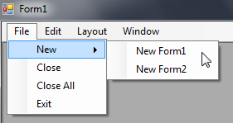

Now add code for this menu item. To make them children of this parent window, we set the MdiParent property to this window then show it & bring it to the front of all the children windows being shown.

private void newForm2ToolStripMenuItem_Click(object sender, EventArgs e)
{
Form2 newWindow = new Form2();

// Title
newWindow.Text = "New Window";

// Normal, Minimized, Maximized
newWindow.WindowState = FormWindowState.Normal;

// Make this form an MDI child window
newWindow.MdiParent = this;

newWindow.Show();
newWindow.BringToFront();
}

If we want to find the active child window, an ActiveMdiChild property is provided which the parent window can use to recover this child window. For example, say Form2 contains a RichTextBox then we can identify the child window being edited (the active window) and read the text from it as follows:

// DON’T ENTER THIS CODE, I’M JUST ILLUSTRATING THE PRINCIPLE
Form2 activeChildForm = ActiveMdiChild as Form2;

if (activeChildForm != null)
{
RichTextBox richTextBox = activeChildForm.ActiveControl as RichTextBox;
if (richTextBox != null)
{
// Read the text from the active window
}
}

You can now show the child form as many times as you wish. Typically, MDI parents also provide a Layout menu to allow the layout of the children to be changed.

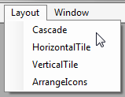

Create the code for each of these menu items and use the LayoutMdi() method to arrange the windows.

private void cascadeToolStripMenuItem_Click(object sender, EventArgs e)
{
LayoutMdi(MdiLayout.Cascade);
}

private void horizontalTileToolStripMenuItem_Click(object sender, EventArgs e)
{
LayoutMdi(MdiLayout.TileHorizontal);

}

private void verticalTileToolStripMenuItem_Click(object sender, EventArgs e)
{
LayoutMdi(MdiLayout.TileVertical);

}

private void arrangeIconsToolStripMenuItem_Click(object sender, EventArgs e)
{
LayoutMdi(MdiLayout.ArrangeIcons);
}

Finally add Close and CloseAll menuitems, then provide the code for closing the current window or all the windows.

private void closeAllToolStripMenuItem_Click(object sender, EventArgs e)
{
foreach (Form form in MdiChildren)
{
form.Close();
}
}

private void closeToolStripMenuItem_Click(object sender, EventArgs e)
{
Form activeChildForm = ActiveMdiChild as Form;
if (activeChildForm != null)
{
activeChildForm.Close();
}
}

In the child form, add a menu. This menu will just be used to illustrate a point, so we will not provide any code for the menu items.

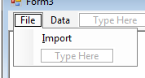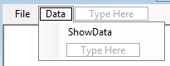

The result when you open the child, is two more menu items appended to the parent menu bar and a menu bar appears on the child window.

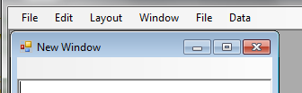

Get rid of the child’s menu bar and items by hiding it.
menuStrip1.Visible = false;

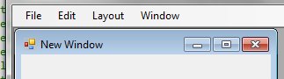

Next we’ll merge the File menuitem from the child with that of the parent, by specifying MatchOnly so the item will only be merged if both the parent’s and child’s menu items have the same name. We also have to tell it the position we want to place the child’s menuitem, since the File menu has been placed in the left most position the index value is 0.

menuStrip1.Visible = false;
fileToolStripMenuItem.MergeAction = MergeAction.MatchOnly;
fileToolStripMenuItem.MergeIndex = 0;

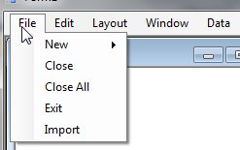

We want to move the Import menuitem to the second position in the submenu, leaving New at position 0 we place Import at position 1.

menuStrip1.Visible = false;
fileToolStripMenuItem.MergeAction = MergeAction.MatchOnly;
fileToolStripMenuItem.MergeIndex = 0;

importToolStripMenuItem.MergeAction = MergeAction.Insert;
importToolStripMenuItem.MergeIndex = 1;

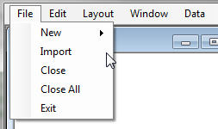

Next let’s move Data into the second position on the main bar, leaving File at position 0 we place Data at position 1.

menuStrip1.Visible = false;
fileToolStripMenuItem.MergeAction = MergeAction.MatchOnly; fileToolStripMenuItem.MergeIndex = 0;

importToolStripMenuItem.MergeAction = MergeAction.Insert;
importToolStripMenuItem.MergeIndex = 1;

dataToolStripMenuItem.MergeAction = MergeAction.Insert;
dataToolStripMenuItem.MergeIndex = 1;

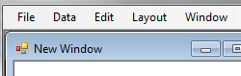

This is the constructor for the child window

using System;
using System.Collections.Generic;
using System.ComponentModel;
using System.Data;
using System.Drawing;
using System.Linq;
using System.Text;
using System.Windows.Forms;

namespace MDITest
{
public partial class Form2 : Form
{
public Form2()
{
InitializeComponent();

menuStrip1.Visible = false;
fileToolStripMenuItem.MergeAction =
MergeAction.MatchOnly;
fileToolStripMenuItem.MergeIndex = 0;

importToolStripMenuItem.MergeAction = MergeAction.Insert;
importToolStripMenuItem.MergeIndex = 1;

dataToolStripMenuItem.MergeAction = MergeAction.Insert;
dataToolStripMenuItem.MergeIndex = 1;
}
}
}

Integrating MDI in WPF

http://www.blog-dotnet.com/post/WPF-and-MDI-Another-alternative.aspx

The main problem remains: WPF does not (yet) provide build-in mechanisms for classic MDI management (besides from tab pages). So in order to use MDI (in my case I want to transform a WinForms-based MDI application into a WPF-based one), it is necessary to use a WinForms-based MDI parent window. The real question is how can you create a WPF window as a "real" MDI child.

Since all efforts failed so far, I decided to use a WinForms-based child window and search for ways to embed a WPF window within that window. There is a ElementHost-Control (WinForms) which can host WPF controls within a WinForms window. I intended to create WPF windows or pages and not WPF user controls, so I kept looking. Fortunately I found the Frame-Control (WPF) which can host content such as pages and that can be hosted within other WPF controls.

So putting it all together I created:
1.WinForms MDI parent window (MDIParent)
2.WinForms MDI child window (MDIChild) with a ElementHost-Control
3.WPF user control (ucPageWrapper) embedding a Frame-Control

