Jenna M Evans


2219820
ECYW6008
Placement 3 Level 6.
The impact of places, people and spaces.

Community Profile of
Ammanford
As part of my level six placement, I had to undertake a detailed community profile of the area I was currently undertaking my placement studies in and the importance of the community of the people, places and spaces and what recommendations we could include to improve the lives of the young people within Ammanford.
Carmen Martinez states that “The more we increase the active participation and partnership with young people, the better we serve them. … And the more comprehensively we work with them as service partners, the more we increase our public value to the entire community.”

Background of Ammanford
With 5,400 residents, Ammanford, originally known as Cross Inn, is the third-largest town in Carmarthenshire. Ammanford's age distribution is somewhat younger than Carmarthenshire's average. Ammanford's unemployment and deprivation rates are somewhat higher than those of Wales and Carmarthenshire. The town however promotes a vibrant community despite the area's poverty. A sculpture honouring the miners and the town's past is in the town centre today. The peaceful rural community underwent industrial transformation in the nineteenth century as the mining industry attracted workers. Both during the day and at night, the town core is home to numerous individual businesses. Ammanford has begun its 21st year as a Fair-Trade town, making it the first in Wales and a Guinness World Record holder. (Gov.wales, 2019)

Purpose and youth voice
The purpose of this community profile is to reflect on the experiences and needs of the young people who use youth club and to understand the strengths of the service and to hear the young person’s voice and to be able to help further and develop what is available to the young people and help with funding and advocating for the young people who attend drop in and who are NEET within the Ammanford area. Youth voice is key element to make a meaningful community profile as young people know what they would like to within the community and will understand what is working well and what challenges they may face and what they would change. We listened to the youth who attended drop in and ensured decisions and developments were from their lived experiences. Including the youth voice promotes inclusion, empowerment and participation and this gives them a sense of confidence and freedom to be feel valued and connected.

Before involving the young people in this profile, I asked for their consent and treated all individuals equally and respectfully and encouraged the group to do the same. I made the method a less informal way of getting their feedback as I would question and have informal conversations within the placement setting in youth club with the
same group of people on a weekly basis. There was between six to eight young people’s views.

We would like enforce empowerment and a non-judgemental approach and active participation within the group and their views to be expressed on their community we would use informal conversations and group discussions.

Any initiative that involves young people can be planned and developed using the Ladder of Participation concept, which was created by Roger Hart. (Hart, 1992)
While the top five steps represent genuine participation, the bottom three steps represent youth involvement that is not. (Youth work Wales)

About the Youth Club
Streets Youth club is located within central of Ammanford and his easily accessible and is open on Tuesday and Wednesday evenings along with day drop ins on a Wednesday where it is manned with several youth workers. Street’s youth club has been going for a several years and it is open access club where young people can attend a safe, informal and warm place and to be able to access many services or support from youth workers such as education and employment, money issues, substance misuse and offending behaviour, homelessness, relationships and mental health and to make friends and socialise and take part in activities.

Who are the young people?
Young people who attend the drop in are ages of sixteen to twenty-five years-old and often the main issues these young people experiences are NEET or having homelessness issues or will be suffering from social exclusion. The young people involved within the community profile are often NEET for a couple of months and will go into work and often not last in employment and will come back around for support. Often the young people presenting will also have personal issues going on such as relationship breakdowns, mental health issues or barriers for them to go into work.

Young peoples lived experiences
I talked to the young people about what their week would entail, and they would frequently stay up late and sleep in, creating a lack of pattern. After that, they would watch television or use their phones to browse the internet. Unless they went out for a stroll with friends. There was a clear lack of routine and boredom within the young people’s lives.

According to the young people's experiences within placement, they would not stay in a job for very long because the senior employees would belittle them or irritate them. In addition to transportation barriers, they frequently struggle to maintain a job due to lack of routine and fundamental life skills. A few young people also mentioned that their jobs or education will be at risk due to home instability. In addition to lacking the experience necessary for work opportunities, many of the young people stated that their mental health and anxiety had a significant impact on their ability to pursue further education and employment. They expressed often they would apply for jobs and often not hear back or if they did it would be a lack of experience and not given the chance. This would deflate their confidence and often put them off applying in future.

Some also mentioned lengthy application forms or complicated ones that would also put them off applying or needing certain qualifications for the job role.

Interests, abilities, and strengths

The young people’s strengths where they displayed resilience to setbacks and were open to informal discussions and learning.
They would enjoy cooking and socialising within youth club which displayed good living skills which they could take into everyday life. The young people also showed strength as they would all happily communicate with one another and showed the ability of being able to communicate effectively as part as a team during group activities as well as problem solving skills.

I felt I undertook the positive youth development frame work as it’s a planned, prosocial approach that engages young people within their communities, schools, organizations, peer groups, and families in a manner that is productive, constructive, recognizes, utilizes, and enhances young people’s strengths and promotes positive outcomes for young people by providing prospects, fostering positive relationships, and providing the support needed to build on their leadership strengths.

Community and environment

The young people expressed they felt safe coming to drop in as it was a non-judgemental place where they could discuss their issues. They expressed there was not many places within Ammanford where they could just call in and feel comfortable and see the same group of people every week. They also stated they had access to bus routes to get in or sometimes their youth worker would pick them up to bring them in. They felt a sense of belonging as often it was the same group of people and felt a community vibe.

Challenges and barriers
We discussed as a group what could be affecting them from getting into employment or education or accessing services they need, and some said it was down to their mental health and confidence. Along with the education and employment systems in place and how it works and how they do not give some young people the chance. Some also said transport was causing them an issue to get to their current commitments and affording to being able to drive and pay for insurance one young person stated he couldn’t attend work due to his car being off the road which resorted in him asking for lift’s which put a strain on relationships.

A multiple amount of young people also stated qualifications were sometimes a barrier getting into employment or education as quite often they would need a maths or English GCSE.

Support networks
We Discussed around support and who help’s them it was mainly family members or friends however some had dedicated youth workers who they would engage with on a weekly basis and praised them for their ongoing support. The young people’s development is shaped by interconnected systems from surroundings such as families to broader societal structures like culture as the Bronfenbrenner’s ecological system theories explains. (Guy-Evans, 2025)

What helps the young people engage and what doesn’t
I had an open discussion around what makes the young people want to engage and they said that food and activity’s always help them attend youth club and because they know and feel comfortable with staff. They are non-judgemental and great fun. However, they do not like to be pestered when they are not in the right mood to attend it got to be on their terms and when there ready. They stated they feel more relaxed to talk when they are getting involved in an activity or if the youth club had arranged a day trip.

Young peoples hopes and aspirations
We spoke about the hopes for the future, and the young people have expressed their hope’s to have further opening hours of youth club and to be able to have the chance to get employment with the hope’s employers take a chance on them with help of their youth workers guiding them. Young people expressed they would like to see more placement opportunities and agencies getting involved in offering these. Some expressed their hope to return to education with some confidence building skills within youth club or more apprenticeship opportunities.

Key themes
Current themes were lack of confidence, mental health and lack of stability on housing which resulted in negative engagement or failed attempts to get into employment or education. along with many job applications coming back stating there wasn’t any experience.

Recommendations
Young people recommended having a drop-in session once a month with some employment options where they could chat to employers about the roles and options. Key recommendations from the young people were applying for some possible further funding to help with day’s out for youth club or even holding a residential away trip where they could possibly go to a different county

Ethical considerations
We discussed before starting consent to engage within the community profile along with confidentiality all the young people who engaged were over the age of eighteen so could give consent themselves. I made sure I worked within a trauma informed way and safeguarding the individuals and informed them if there were any safeguarding concerns, I would need to discuss with my line manager.

Conclusions
In conclusion I feel I captured the young people’s voice in a way they felt comfortable to be open and honest and what they aspirations would be for the future. I felt I used Roger Hart’s ladder of participation throughout (Hart, 1992), along with Positive youth development framework (Youth.gov, 2019) within the drop-in sessions to promote the progression of the young people and how the young people’s life can be shaped by the ecological systems theory (Guy-Evans, 2025). I give the young people a chance to have their voices heard within the community as it is utmost important that the changes were made with their best interests at heart.

Photos of youth drop in session’s
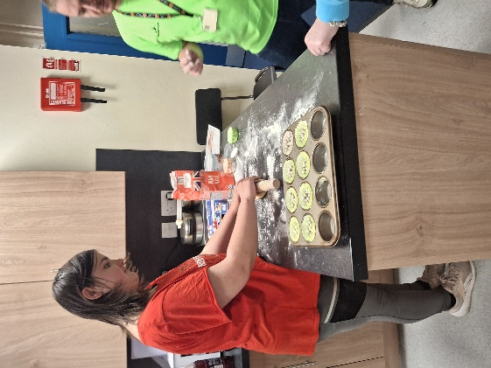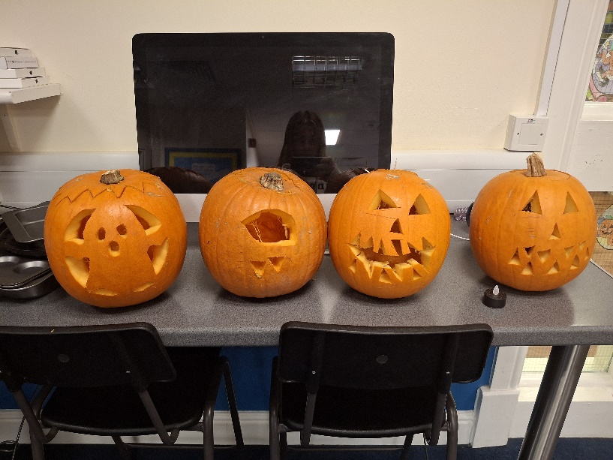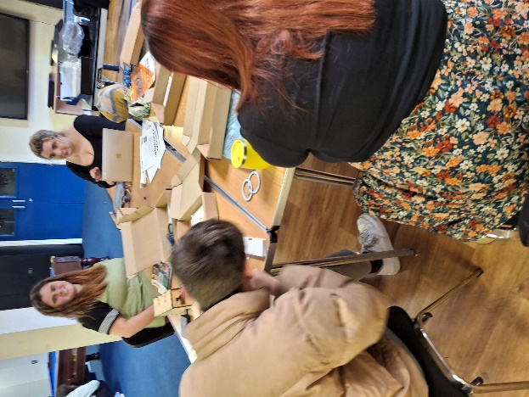

Swot Analysis
This Swot analysis provides an overview of the organisation internal strengths and weaknesses and the external opportunities and threats facing the youth club I undertook my placement where young people presented not in education or employment (NEET). The purpose of the SWOT is to analyse strategic planning by identifying areas of practice and challenges we can face and the wider policy, funding and socio-economic situation in which the service manages.
The youth club delivers a voluntary informal based youth work supporting young people who are NEET who need help to build their confidence, routine and readiness for progression. The SWOT framework will highlight the key strengths of the service which can be increased to respond to opportunities whilst recognising the risks and restrictions that impact the outcomes and overall service delivery. This analysis will advise for future service development and priorities.
Strengths  - Very experience youth workers with variety of skills  - Trauma informed practice embedded  - Funding to do activities within youth club and day trips  - Good working relationships with external providers  - Practice the policy principles of the National youth work principles  - External providers coming in to deliver workshops or support  - Provides an open access support that adapts to everyone, and youth led voice by embedding the NOS standards. (Education workforce council, 2019)  - Strong trusted relationships with the young people build through consistently  - Having a safe inclusive place to come together to have a sense of belonging  - Holistic approach  - Diverse range of activities  - Regular attendance and good group of members  - Strong links with schools and services  - Ongoing reflective practice | Weaknesses  - Lack of secure funding  - Too much paperwork takes away from the face-to-face work  - Limited to what you can do by risk assessments  - Limited budgets for activities  - Difficulty engaging some young people experiencing low motivation, anxiety or disengagement from services  - Irregular attendance due to unstable housing, mental health needs or caring responsibilities  - Limited capacity for targeted support
Opportunities  - Alignment with the council’s youth strategies, early help and youth employment plans  - Increased policy emphasis on early intervention of NEET  - Availability of youth employment through providers that help get into work  - Increased funding by proving outcomes and distance travelled models  - Potential to strengthen relationships with college and training providers  - Opportunities to develop employer partnerships offering work experience  - Multi agency working with housing and addressing barriers to NEET  - Use of digital tools to support engagement and communication and learning new skills | Threats  - On going funding security due to not meeting demands of the funders criteria  - Cost of living crisis  - Fragmentation of youth, employment and mental health services due to the demands and staffing  - Increasing complexity of needs from the young people which youth workers are not equipped to deal with  - Rising levels of anxiety and disengagement from the young people which is affecting getting into education and employment  - Housing insecurity is a major threat due to young people not having a safe base to feel secure to flourish  - Staff burnout due complex caseloads and administration.

In conclusion
The findings within the SWOT analysis highlight the importance of the youth club as a safe and accessible space for NEET young people who face barriers to engagement, they also display a strong foundation of trauma informed youth work. despite challenges within the service the strengths from the holistic support from youth workers can mean positive progress for the young people. Positive and continued investing will be paramount for positive impacts within the service and being able to maintain the service as whole.
Summary of my own learning
Whilst starting level six it was daunting as students, we had to step it up another level and with work demands, meeting funder’s outcomes and balancing home life was a challenge. However, I felt passionate about my role within the youth service and how it can make a difference on the young people’s lives we work and that’s why I wanted to adapt my skills and learn from other youth workers from different sectors.
From my placement from level four which was school based and then progressing on to level five into my current role where we are more targeted support based around youth homelessness it felt only fair that I undertake a more informal and group work within a youth drop in to compare the differences within departments and how youth workers adapt in current roles and the strengths and weaknesses of all youth work sectors.
Franklin D. Roosevelt once stated that “we cannot always build the future for our youth, but we can build our youth for the future.” (Roosevelt, F, 2025)

During my time on placement within a youth club drop in setting I gained valuable knowledge into informal education and youth work practice through engaging the young people in a range of sessions such as cooking, playing board games, making a Bluetooth speaker out of wood, jewellery making, Christmas crafts all within a safe relaxed environment where the young people learnt in a natural calm environment without the structure of formal education. within my time at the youth club i embedded the youth work national occupational standards (NYA, 2019) within my practice.
I also imbedded the trauma informed approach (Bainborough and Ord, 2021)
along with my knowledge of ACES (Help children live better, 2024). Where I would identify how young people displayed behaviour that they would need additional support for and where I would also undertake the six key principles of trauma informed approach which is safety, trust, choice, collaboration, empowerment, cultural, consideration.
The national occupational standards for youth work (NYA, 2019) emphasise the importance of developing and maintain effective relationships with young people one of my main focuses within my time at practice was the importance of building trusted relationships by spending time getting to know everyone and listening and enjoying the practical activities with them they feel more relaxed engaging in conversation when they are engrossed in enjoyable activities. This was a more effective way of building up a rapport as more structured approach can be intimidating for the young people and it takes longer to get them to engage. This helped me understand the difference between roles within the youth service as within my current role in the youth service I take a more targeted approach however it still is informal it comes across more formal as its more directed to them where youth club is in a more open access environment. This helped me understand that the young people coming back to drop in every week felt it was a safe and supportive environment and the youth workers made it feel like this which helped the young people express themselves and participate in a voluntary way.
Whilst at youth club I found myself relating back to the NOS: Enabling young people to learn and develop through informal education (NYA, 2019) where we would undertake activities such as cooking which focuses around the healthy living skills that young people need in life to develop and thrive whilst living alone, this also helped them problem solve and engage with other young people and promote social interaction and sharing responsibility’s. this is vital for young people for going into employment as this helps with their teamwork skills.
The sessions we delivered demonstrated how informal education can promote learning that is experimental and reflective so the young people can reflect and improve and help gain confidence and independence.
As a youth club we encourage the NOS: support young people’s participation and active involvement (NYA, 2019) as we would encourage the young people to inspire the session direction and make decisions as a group of what they would like to do. this was when we embedded the participatory approach and enforced our youth work values such as the five pillars of youth work which is Educative, Expressive, Participative, Inclusive and empowering. Even though there could be a power imbalance between young people and adults we would make sure there was compromise and flexibility and adapt the young people’s needs.
My practice would interline with NOS: work collaboratively with others to support young people (NYA, 2019) as within youth club we would often engage with other services such as Cyfle Cymru, Social services, Parenting groups, LRC, I would work with them by supporting them to deliver and manage group dynamics and ensuring the activities were consisting of youth work values and their had a voice and was heard. My experience developed my working relationships and understanding of professional boundaries, information sharing and confidentiality and understanding of the roles we were undertaking within a multi-agency context. I would also undertake the role of advocating on behalf of some of the young people who did not feel confident enough to speak up especially when agencies introduced outcome driven approaches which sometimes would intimidate the young people.
As a youth worker I would also manage conflict resolution within the group and openly discuss any issues, I would do this in an approach where it was equal and not taking sides of either. This would take me on to where I would work in accordance with NOS: work in ways that promote equality, diversity and inclusion (NYA, 2019). I became more aware that I would need to adapt the activities to everyone on their tailored needs and confidence and social needs. This would help me take a more reflective and ethical approach to the sessions making sure it was done in an inclusive practice way.

Whilst reflecting within the placement I go on to touch upon NOS: reflect on, develop and improve youth work practice (NYA, 2019). As I would be constantly reflecting after sessions and take part in supervision sessions with my supervisor where would meet regularly discuss my time at youth club, I would bring topics to the sessions and discuss what I did and continued the ongoing reflection and observations. I would critically assess my own practice and recognise strengths and identify area’s that I would need further development on. this was pinpointed to managing group dynamics and increasing my confidence in leading activities independently which will get better over time of doing this.
I would also redirect myself back to my personal development plan and adjust what I needed to work on or if I had achieved these outcomes for my personal development.
Overall, the placement enhanced my professional development as an developing youth worker and strengthened my understanding of how the NOS informed practice helps with effective youth work (NYA, 2019) and has helped me understand the importance of informal education as a key method to supporting young people in their person, social and emotional development as this is completely different role I undertook for this years placement so it was a very different dynamic to engross myself into practice to benefit myself as a up and coming youth worker.

References
Gov.wales. (2019). Ammanford. [online] Available at: https://www.carmarthenshire.gov.wales/business/development-and-investment/town-centres/ammanford/. (accessed 12th January 2026)
Hart, R. (1992). Roger Hart’s Ladder of Children’s Participation – Me first. [online] www.mefirst.org.uk. Available at: https://www.mefirst.org.uk/resource/arnsteins-ladder-of-participation/. (accessed 12th January 2026)
Youth.gov (2019). Positive Youth Development | Youth.gov. [online] Youth.gov. Available at: https://youth.gov/youth-topics/positive-youth-development. (accessed 12th January 2026)
Guy-Evans, O. (2025). Bronfenbrenner’s Ecological Systems Theory. [online] Simply Psychology. Available at: https://www.simplypsychology.org/Bronfenbrenner.html. (accessed 13th January 2026)
National Youth Agency. (n.d.). National Occupational Standards for Youth Work. [online] Available at: https://nya.org.uk/document/national-occupational-standards-for-youth-work/. (accessed 13th January 2026)
YOUTH WORK IN WALES: PRINCIPLES AND PURPOSES. (n.d.). Available at: https://www.cwvys.org.uk/wp-content/uploads/2022/10/YOUTH-WORK-IN-WALES-2022-ENGLISH.pdf. (accessed 15th January 2026)
Quote, B. (2025). 60 Youth quotes that’ll tell you more about the young ones. [online] Be Inspired from Famous Quotes | Bliss Quote. Available at: https://www.blissquote.com/2019/11/youth-quotes.html. (accessed 16th January 2026)
Bainborough, E. and Ord, J. (2021). Trauma Informed Practice: A solution to some of the problems of targeted youth work. [online] Youth & Policy. Available at: https://www.youthandpolicy.org/articles/trauma-informed-practice/. (accessed 17th January 2026)
Help Children Live Better (2024). What are ACEs? [online] Help Children Live Better. Available at: https://helpchildrenlivebetter.co.uk/what-are-aces/. (accessed 17th January 2026)
‌

