Internet Technology and Security
Name: James Harris
Student Number: 1902641
Course: Computer Architecture and Networks
Module Name: Internet Technology and Security
Date: 23/12/2019

Table of Contents

Introduction ……………………………………………………………………………………………………………………………………. 3
Requirements ………………………………………………………………………………………………………………………………….. 3
Implementation …………………………………………………………………………………………………………………………….3/5
Validation………………………………………………………………………………………………………………………………………….6
HTML Document………………………………………………………………………………………………………………………………..6
Css Document……………………………………………………………………………………………………………………………………6
Evaluation Part A……………………………………………………………………………………………………………………………6/7
Usability Meaning …………………………………………………………………………………………………………………………….6
Accessibility Meaning ……………………………………………………………………………………………………………………6/7
Search Engine Optimisation Meaning ……………………………………………………………………………………………… 7
Evaluation Part B……………………………………………………………………………………………………………………………7/8
Usefulness Used ……………………………………………………………………………………………………………………………….7
Accessibility Used ……………….…………………………………………………………………………………………………………… 8
Search Engine Optimisation Used …….……………………………………………………………………………………………… 8
References ………………………………………………………………………………………………………………………………………. 8

Introduction
Within this report it will show the target audience I was aiming for whilst creating my website as well as show the guidelines which I had to follow during the creation of the webpage such as the usability, accessibility and the search engine optimisation. This will also display where I received the given information which I have put into my website as it relates to the subject. The given information on the website is based on a hobby that I do which is playing Call of duty black ops 2. Within this there is a specific section in the game called zombies and this website tells you all the information you need to know about it.
Requirements
The task was to create a website which had been hand coded with a minimum of five pages with relevant pieces of information and pictures that related to the website’s topic these were the main requirements for the website. But as well as the website had to be either a personal interest or hobby, favourite band or a town/city. When deciding what to make it of, I decided to do a hobby on a game I play lots and know well. So, therefore I made this website in order to help anyone who is a new or old zombies’ player on Call of Duty Black ops Two with useful tips and tricks in order to complete anything the game might throw at you. This ranges from the map, bosses, Easter eggs, perks and the most important page the Home page. The target audience for this webpage is anyone who plays call of duty black ops 2, ages from 15 plus. If you love zombies than this will help you with everything you need to know. The reason for this certain subject is that I play the game on my time off and I believe it could help me and fellow players to do stuff if you forget anything that might be vital to the game.
Implementations
Home Page
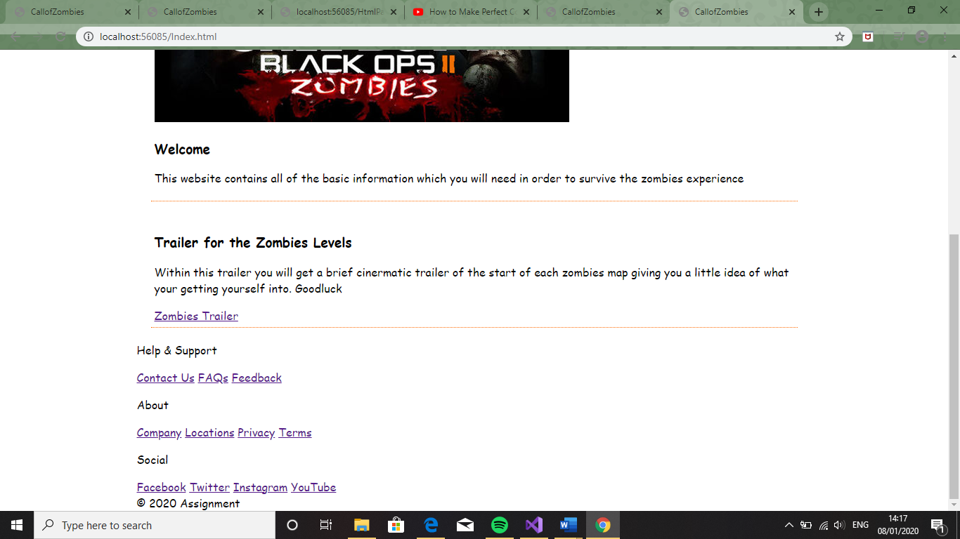

Perks Page
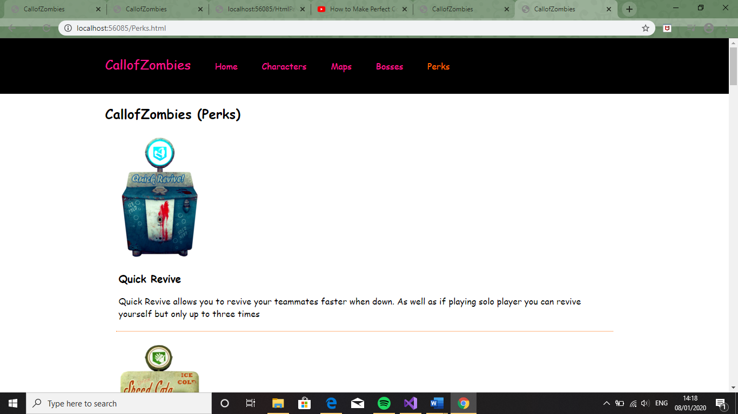
Maps Page
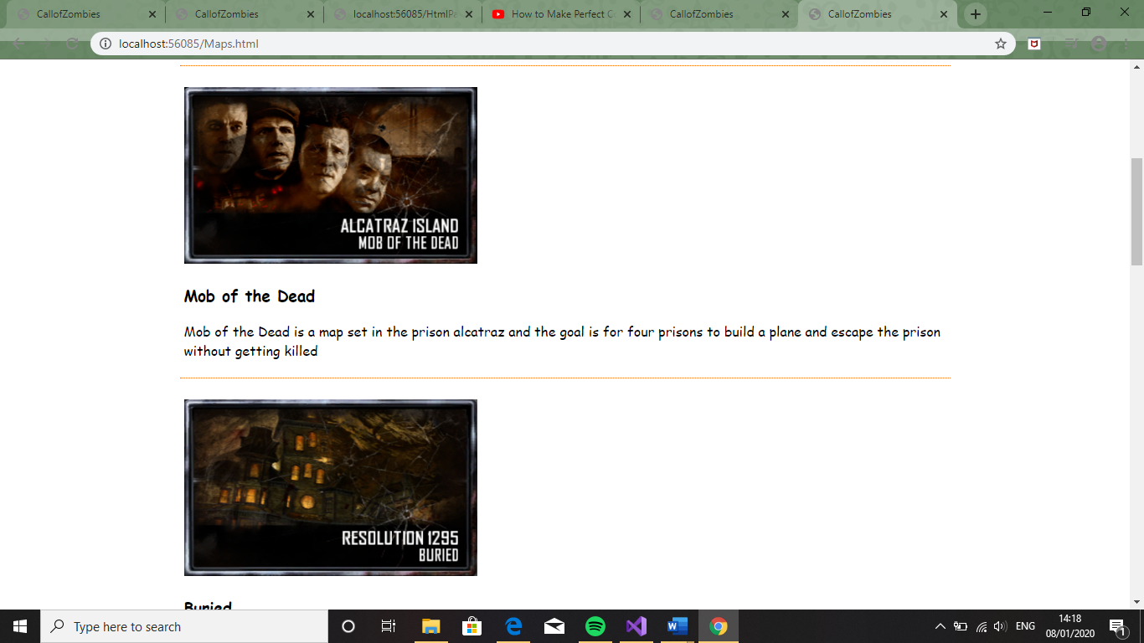

Bosses Page
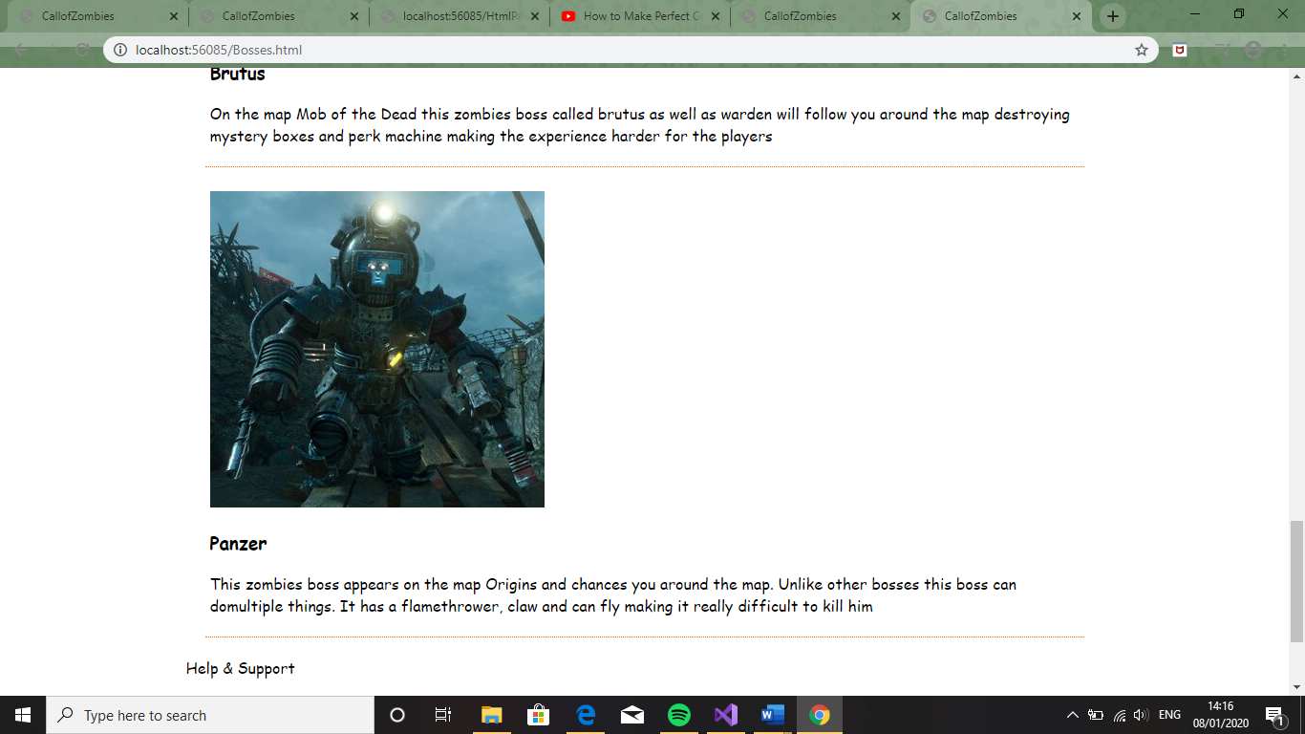
Characters Page
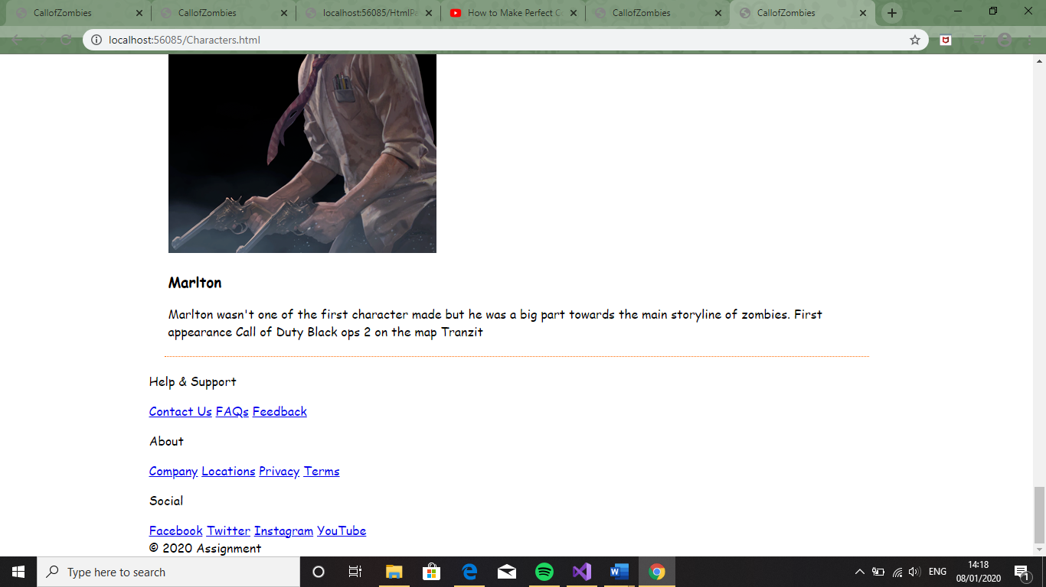

Validation
HTML Document
When validating my HTML page, I got one error which kept occurring unclosed div tags. So, once I saw this I went back to my code and took out the ones which weren’t linked to anything. But after doing this all of my website on that page moved from the middle to the left hand side of the page so I put the divs back in to make it so everything was centred in the middle of the page making it so every single page that I made all looked the same as well as the way I wanted to design my website. [1]
Css Document
The Css file when I was checking for any errors like the html it had only one problem which kept coming up over and over again which was to do with the very start of the document saying html, body { and said that I needed to decide upon with one type of language to use for the Css document. I didn’t change this as I have always put html, body { at the start of my websites and it always runs as expected so I didn’t want to take a risk and accidently ruin my completed website. [1]
Evaluation Part A
Usability Meaning
Usability means how easy it is for the users to navigate and use the software. This is very important in web development as if it is extremely difficult to navigate through the website it might cause the user to go onto a different page which is easier to use. By making a website usable for all users it will make more users use the site this is why it might be better to use more simple formats in order for a user to have a good understanding of where everything is and how to get to different areas on the web page easily. This means adding stuff such as headings that give clear indication to the separate sections of the webpage. Also good contrast of colours from text to background this means not using something such as light green text on a bright yellow background the reason for doing this is because it will make it extremely difficult for the users to read the text on the webpage as well it will make the website look a lot worse compare to something with black background with red text making it extremely easy for the user to see everything on the web page. [2]
Accessibility Meaning
There are four main principles that a website must follow in order to lay down its foundations for the accessibility of the website. The four main principles are perceivable, operable, understandable and robust without these your website unlikely to become popular [reference]. Firstly, perceivable means the information and user interface components must be able to get presented to users in a way that they perceive. This is very important as if the user can’t see the information on the webpage then less people are going to use your website making your website stand out less compared to others with information which is visible. Operable means can it be used. If the website can’t be accessed through for example phones as most people now do searches on phones rather than computers. For example, the way the page is displayed on the computer screen might be displayed differently on a mobile phone as if you had the same layout on your phone as the computer the text could end up jumbled and might not make sense. As well the webpages need to run on different types of search engines such as Google, Firefox and Bing as not everyone uses one search engine because of this it might require you to use more code likewise change a bit of the pre-existing code which is already there. As some search engines don’t support some formats of code by not making these changes text might not appear as well pictures might be missing making the website look terrible compared to one on another browser which could have everything on it. Understandable is another main point if your information doesn’t make sense or is to complex it might cause the user not to use the website as it might not read well to them or too confusing for them to read. Therefore, you need to be clear and straight to the point with information. Finally, the last principle is robust means is the data strong and won’t get old. If the data become out of date it might cause users not to use the site again. [3]
Search Engine Optimisation Meaning
Search Engine Optimisation means the amount of people who are clicking onto your website making sure that your website stays on the first set of search results when the user searches up the topic. For example, if I went on Google and searched apple pie recipe the most clicked on website will appear at the top and then will then follow by the second highest clicked one and so on so forth. So, depending on how many people have visited your website will determine where your website will be in when searching for the given topic. Things that can help with more people clicking on your website can be having relevant and reliable information as well as have a title when searched it links in most with the given topic such as if you were promoting a restaurant if the name of the restaurant is in the title your website is mostly likely to come up first as long as no one else has the same name for another restaurant then it will depend on how many people visit the other website will determine where your website is on the search engine. [4]
Evaluation Part B
Usability Used
I believe that my website is extremely easy for the user to navigate through. Firstly, I have given the user bold headings in order the user to see the clear information being displayed for them. I have given clear title names for each one of the pages making it extremely simple for the user to find the selected information that they wish to view. I have chosen colours which suit the theme of the web pages as well as make it easy for the user to read the information and titles across all the pages. By using white as the main background colour as it makes everything on the page easily to read. The navigation bar is black so it stands out from the rest on the page. The content is relevant to the theme of the webpage as well all the information is one hundred percent accurate due to the fact that I’ve played the game its theme on as well as watched the videos on step by step guide on how to do this stuff. Another thing I’m happy I did to my website was included the zombie’s trailers for each of the maps as it makes the experience seem more realistic with the interesting cinematic effects. If I was tasked to create another website like this, I would include more pages such for other zombie games such as black ops one, three and four as they include more bosses and stuff which might be useful in this game due to the fact might change your playstyle such as them being more passive rather than being an aggressive player. These alternate games would preferably have their own pages, but they could be added onto the pre-existing pages due to the fact it is just a deeper insight to the information already there. As well I wish I went into a greater detail for how to do the stuff such as give direction and a map with everything on it making it even easier for the user to play the game but I have already given the user enough information to survive. Also I wish I included special effects such as when you hover over an image the image would flip into a different one but still relevant to the topic making it so the user has interaction the website making it seem like there more involved. Another factor which I wish I added would be a friend page this page would be used to communicate with other players around the world allowing the users to interact with one another making my website a new platform to communicate on and make new friends. This could include the ability to communicate with other players for help or questions they might have as well as find new people to play with just in case they haven’t got any online at the time. Another thing I wish I added was the videos I watched to give the user another person’s step by step review on how to do stuff just in case they might explain everything better than me.

Accessibility Used
The website I have created has all the four main principles needed for a website. Firstly, it can change its display depending on which device the user is on or how they have put it onto their PC. As well my website works on multiple search engines making it so no matter the user is using to find the information for my website everything will be displayed allowing the user to get the full use of the website. The website is very easy for the user to gain any access to the information as all the text is quick and straight to the point also contains an image and heading to enhance the understanding on what they’re looking at. The information isn’t likely to change as the information which was made for this game initially is about five years old and the company are currently working on newer games so won’t have time to edit it.
Search Engine Optimisation Used
I have given my website a very appropriate name to the information which is provided within the website itself. I made it so the name had no spaces due to the fact it will make my website have a more unique name as well as it will allow me to clearly display the name of the group within a small amount of space rather than the name being extremely too big. I have also made sure all the information I used by testing out to see if all the data used is within the game. I checked this by loading up the game at home and testing the information which I have said to see if it works making it, so I don’t give anything false to the user. Hopefully by providing reliable information this should cause more people to select my website over others due to the fact of the information being correct and straight to the point.
References
[1] | “Nu HTML Checker,” [Online]. Available: https://validator.w3.org/nu/#textarea. [Accessed 7 January 2020].
[2] | “Wikipedia,” [Online]. Available: https://en.wikipedia.org/wiki/Usability. [Accessed 7 January 2020].
[3] | “W3C,” [Online]. Available: https://www.w3.org/WAI/GL/WCAG20/. [Accessed 7 January 2020].
[4] | S. Ward, “small business,” 7 December 2019. [Online]. Available: https://www.thebalancesmb.com/search-engine-optimization-2948419. [Accessed 7 January 2020].

marking criteria and Student FEEDBACK

This section details the extent to which the assessment criteria are demonstrated by you, which in turn determines your mark. The marks available for each category of skill are shown. Lecturers will use the space provided to comment on the achievement of the task(s), including those areas in which you have performed well and areas that would benefit from development/improvement.

Common Assessment Criteria Applied (Assignment 1) | Marks available | Marks  awarded
1. Engagement with Literature Skills

Provides a good discussion of the concepts but the supporting related research is missing and generally demonstrates limited engagement with relevant reference sources. Expand the scope of reference sources consulted to further improve your research work. (Grade mark: 54.00%) | 25 | 13.5
2. Knowledge and Understanding Skills

Demonstrates a satisfactory understanding of the standards used to design and implement a website. As mentioned below, aim to improve your understanding of the basic CSS and HTML concepts. A good evaluation of the website based on the specified criteria has been provided, but I would have liked to see further evidence of tools used to support the evaluation of your website according to the three concepts. (Grade mark: 65.00%) | 20 | 13
3. Cognitive and Intellectual Skills

4. Practical Application Skills

A satisfactory attempt featuring a simple website with some well-thought-out content. The main area for improvement is learning how to use the CSS grid system to achieve better and responsive layouts. Also ensure that your HTML elements are properly nested and closed. Pay attention to your colour combinations. Note that some colour combinations do not work well together. The combination of red and black is a colour combination that should be avoided as these are two overpowering colours and generally cause eye strain for users. See more: https://bit.ly/304yHcA. Generally, I would have liked to see some more variation of the content and concepts used. (Grade mark: 50.00%) | 50 | 25
5. Transferable Skills for Life and Professional Practice

The report is of a good standard. Generally, aim to improve your writing style and be careful with the use of similar sounding words. See your report for suggested improvements. (Grade mark: 50.00%) | 5 | 2.5

Assignment Mark (Assessment marks are subject to ratification at the Exam Board. These comments and marks are to give feedback on module work and are for guidance only until they are confirmed. ) | Late Submission Penalties (tick if appropriate) |  | 54%
 | Up to 1 week late (40% Max) |  | 54%
 | Over 1 week late (0%) |  | 54%

