Student Name- Abigail Ashman
Student Number – 2204992
Tutor – Paul Duerinckx
Course – Documentary Photography and Visual Activism
Module - ADAD5003


Table of Figures
Figure 1 – Moon and Half-Dome, Yosemite, California, 1960, Ansel Adams
Figure 2 – Unknown name, Robert Adams
Figure 3 – Wall, East of Nogales, Arizona, 2014, Richard Misrach

“Yosemite Valley had, during his [Ansel Adams] decades of photographing it as wilderness, a golf course, a luxury hotel, several camp sites, stores, a school, churches, and even a beauty parlour. Adams cropped it out in the name of Beauty, of formalism, of composition, but all his heirs learned to leave it out too and thus was nature photography created. And what he cropped-out, his fellow Americans learned not to see, leaving the American landscape as a chequerboard of scenic wonders and blank spots.”
Rebecca Solnit, Landscape and Amnesia, in Creative Camera (Aug/Sept. 1998). p. 35
Using both historical and contemporary examples, discuss the attempts made by contemporary photographic artists (such as the New Topographics) to photograph the ‘blank spots’ of the landscape?

Rebecca Solnit’s criticises Ansel Adams’ approach to landscape photography for ignoring the way humans have impacted nature. She claims he presents an untouched nature by disregarding the parts of Yosemite Valley built up by humans, such as, “a golf course, a luxury hotel, several camp sites, stores, a school, churches, and even a beauty parlour”. (Solnit, 1998) By excluding these elements Adams has helped feed an idealised, untouched vision of nature for the viewers of his work. To contrast this practise, many contemporary photographers such as those associated with the ‘New Topographics’ have adopted a new style of photographing landscapes by including the urbanised environment. According to the Tate ‘New Topographics’ is a term created by William Jenkins in 1975 which describes “a group of American photographers…whose pictures had a similar banal aesthetic, in that they were formal, mostly black and white prints of the urban landscape.” (Tate, 2017) These contemporary photographers choose to focus their attention on the “blank spots” described by Solnit, in doing this they create an almost unsettling picture of the landscape and the way in which it has been shaped and altered by humans. This essay discusses the attempts made by photographic artists to photograph the “blank spots” in landscapes created by the traditional landscape style used by artists such as Ansel Adams.
Ansel Adams is often awarded the title of “one of the most famous black and white landscape photographers” (Max Foster Photography, 2014), his well-known photos include those he took of Yosemite National Park such as Moon and Half-Dome. Which depict his signature landscape style of the natural, wilderness photographed with high contrast in black and white.
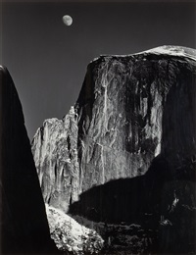

Figure 1
Adams was well known for including no signs of human interaction within his work in the wilderness, something he would later be criticised for. His purposeful exclusion of these human impacts implies that he disproved of the urbanisation of the natural world, although, his personal involvement in places such as Yosemite National Park, and subsequent use of its developed infrastructure, contradicts this stance. Adams’ work seems to present an illusion of untouched nature, tricking viewers into believing that these areas are untouched by humans, Megan Mcwenie further implies these ideas in her essay “If they [Adams] can make people see the parks as “wilderness,” audiences are liable to forget the very human communities that often exist in them, communities in which Adams was an active member” (Mcwenie, 2004).
Ansel Adams deliberately leaving out all signs of human impact in his landscape photography, creates a romanticised image within the minds of his viewers, it fosters a selective blindness to how humans are impacting the beauty of the natural world. Solnit states that “…what he cropped-out, his fellow Americans learned not to see, leaving the American landscape as a chequerboard of scenic wonders and blank spots.” (Solnit, 1998) thus emphasising the idea that in his work Adams paints an idealised, untrue picture of these beautiful landscapes. The “blank spots” left by Adams reinforce a contradiction between ‘landscapes’ and ‘modified territories’, which is harmful because it reinforces a binary way of thinking that suggests that nature is purer and more beautiful when untainted by humans and spaces altered by human interaction are uninteresting or inferior. This viewpoint is not only reductive but also problematic, it ignores the significant relationship between human life and the environment.
Lewis Baltz was one of the leading photographers of the ‘New Topographics’ movement, which sought to redefine landscape photography by shifting from idealised untouched nature to the realistic urbanised areas often left overlooked. Baltz focused his work on the “blank spots” ignored by Adams, concentrating on the characteristics of urbanised environments such as industrial parks and building sites. In contrast with Adams’ romanticised depictions of wilderness, Baltz emphasised the stark geometric shapes along with the sterile quality of human-altered landscapes. His minimalistic style and neutral tones stripped these spaces down to their basic shapes, textures and lines which seemed to create a lack of feeling. Paired with his sharply defined compositions, this approach conveyed a deliberate sense of detachment, avoiding any emotional resonance. Instead, his images portrayed these spaces as purely functional and impersonal, devoid of any emotion. A quote from Baltz himself communicates the idea of emotional detachment seen in his work “I hope that these photographs are sterile and that there’s no emotional content.” (Blatz, 2023). This relates to the nature of not only the spaces he photographed but also his intent to how the viewer will perceive and question them. The emotional detachment forces the viewers to confront the monotony and emptiness of urbanised spaces and challenges the traditional ideas of beauty in landscape photography.
Another significant figure within the ‘New Topographics’ movement was Robert Adams, who similarly challenged the traditional style of landscape photography penned by Ansel Adams. Robert Adams focused on urbanised spaces and how they effected the environment, highlighting how modern human life reshaped the natural landscape in subtle ways that had a big impact. His work like those in his book ‘The New West’, depict mundane suburban environments in a very simplistic way, his style in this work is very plain with minimal dramatisation, which creates an honest portrayal of the way that modern urban life interacts with the natural landscape. Unlike Ansel Adams’ work, Robert Adams’ photos bridge a gap between humanised spaces and the wilderness, showing that the two can coexist in harmony.
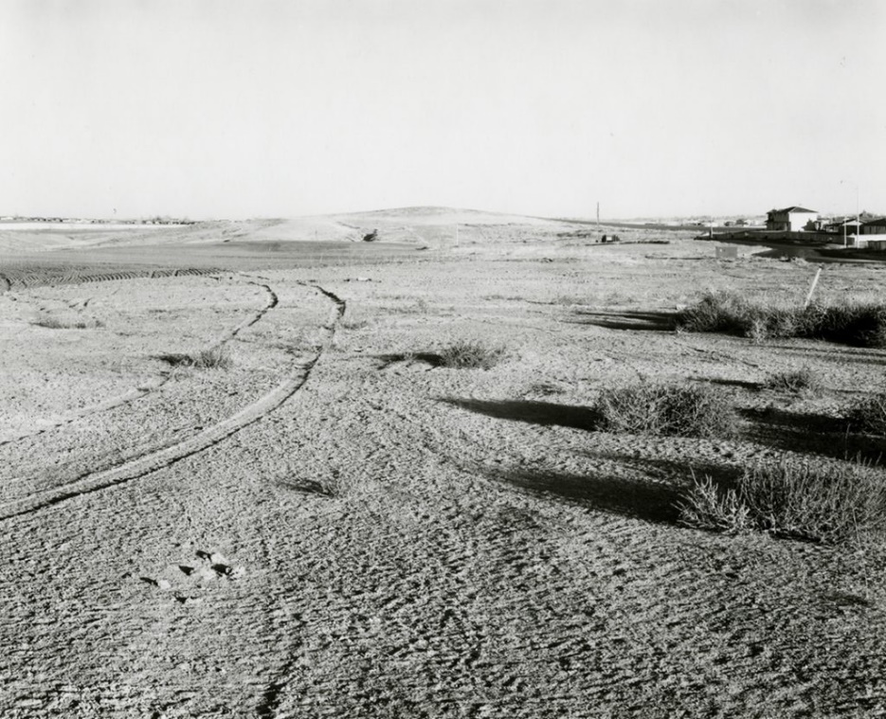

Figure 2
This image by Robert Adams perfectly depicts this idea of combining the natural scenery with the trace of human impact. Rather than ignoring or cutting out the evidence of human presence on the landscape, Robert Adams works to integrate the two contrasting parts, illuminating how modern human existence leaves an indistinguishable mark on the natural environment.
Edward Burtynsky’s work as a contemporary photographer also focussed on the “blank spots” left by Ansel Adams and other traditional landscape photographers. His large scale, detailed, colourful photographs document landscapes that have been transformed by industry, such as mines, quarries, and oil fields. Burtynsky’s work blends together captivating visuals through detailed line work along with striking colours. This focus made his work a direct counterpoint to Ansel Adams’ romanticised approach of traditional landscape photography. Edward Burtynsky’s work entitled Manufactured landscapes, depicts the unassuming beauty of industrial landscapes with their often vivid, chemical induced, colours, while also quietly addressing their environmental impacts. In doing this, Burtynsky coerces the viewer into questioning the balance between the stark beauty of his work with the harm the industrial world is causing, it helps the viewer think about the balance between the beauty of modern life and how it is impacting the natural world around us. Burtynsky himself states that "Our dependence on nature to provide the materials for our consumption and our concern for the health of our planet sets us into an uneasy contradiction. For me, these images function as reflecting pools of our times." (Flowers Gallery, 2022) which emphasises the idea of his art serving to encourage the viewers to think about the environmental impacts of the industrial society. By highlighting the marks of human activity, Burtynsky is helping to reframe the narrative, by illustrating how contemporary photographic artists engage with the “blank spots” which have been historically ignored by traditional approaches to landscape photography.
Solnit’s critique of Ansel Adams’ style, when considered in relation to Edward Burtynsky’s work, highlights the issue of ignoring urbanised spaces and fostering selective vision, where people overlook the human impact on spaces that are already urbanised. This blindness enforces the idea that protecting nature only means focussing on areas that appear to be untouched, while ignoring the degradation occurring elsewhere. This could be hazardous and potentially extremely damaging to our planet.
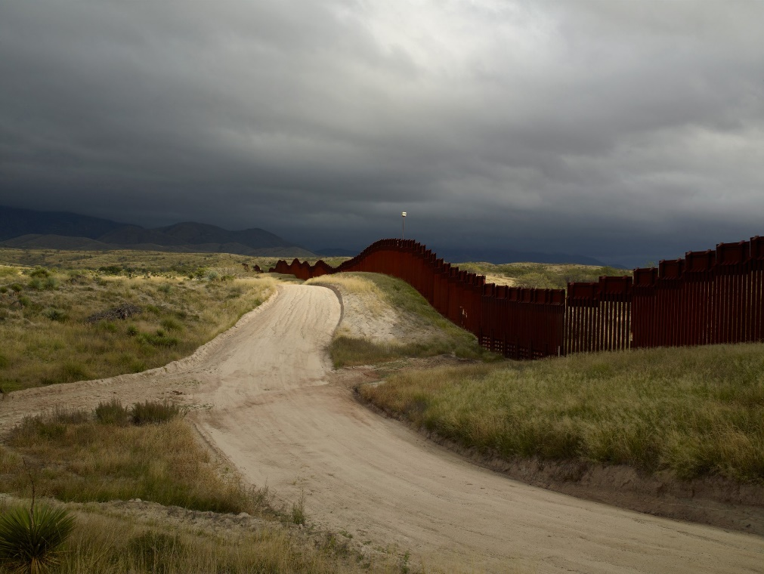
Richard Misrach is another example of a contemporary photographer that aligns his style with the ‘New Topographics’, his landscapes show signs of human impact in a more subtle way than Burtynsky. Society are so accustomed to seeing urbanisation and its effects on the natural environment that they often overlook or fail to recognise subtler signs of their impact on the natural world, Misrach’s work seems to have this effect.

Figure 3
Unlike Burtynsky’s large scale, bold depictions of industrial and urban transformations, Misrach follows a much quieter aesthetic. The rolling hills in this picture along with the way that the fence and dirt track follow its movement almost disguise the urbanisation. His use of soft lighting, paired with the expansive compositions along with the sense of stillness, invites viewers to reflect on the gentle balance between nature and humanity. As seen in the image above, Misrach focuses on human impacts as they weave through wide open spaces, not overpowering but instead integrated into the surrounding area. Which creates a beautiful representation of human urbanisation and the natural world being integrated in harmony together. One journalist described Misrach’s work as “pictures that explore the complex conjunction between mankind and nature” (Pacegallery.com, 2023).
Another photographer who seemed to align some of his work to the ‘New Topographics’ approach was Michael Kenna, his style uses long shutter speeds to create very smooth often bleak surfaces. He also very subtly includes touches of humanisation in his work, like his images of vast expanses of water with piers or wooden paths that jut out into the water. Kenna’s use of long exposures create a dreamlike effect that seems other worldly, his work often includes vast expanses of bleak, natural surfaces featuring an isolated element such as bridges or wooden post. Creating this strange almost ethereal contrasted image. Kenna’s unique way of combining humanised things within natural environments shows how he includes “blank spots” of landscapes left by Ansel Adams.
Baltz and his fellow ‘New Topographics’ photographers, along with other contemporaries such as Robert Adams and Burtynsky, collectively worked to reshape landscape photography and move away from the traditional style made by Ansel Adams. Their concentration on the “blank spots” of the wilderness, described by Solnit as being signs of human urbanisation that were deliberately excluded in traditional landscape work, included focussing on, industrial parks, suburban developments, and oil fields was a stark contrast to Ansel Adams’ idealised, traditional landscapes. The divide between untouched nature and human-altered spaces is challenged by these new approaches, and there’s a new more balanced view towards landscapes that includes the interaction between human and natural systems. In doing so, these photographers create another narrative, one that forces the viewers to face the impact that humans have on the environment, along with the idea that untouched landscapes and urbanised spaces can be viewed in harmony with one another and don’t need to be viewed as separates. This approach of photographing the “blind spots” not only brings to light the selective blindness that the traditional style of landscape photography can cause, but also highlights the issue of the future of earth and how humans living their modern life are effectively destroying it. It encourages the viewers to think on how their life is impacting the environment and changing the beautiful landscapes that shape our world.

References
Rebecca Solnit, Landscape and Amnesia, in Creative Camera (Aug/Sept. 1998). p. 35
Tate (2017). New topographics | Tate. [online] Tate. Available at: https://www.tate.org.uk/art/art-terms/n/new-topographics#:~:text=New%20topographics%20was%20a%20term,prints%20of%20the%20urban%20landscape
‌ Max Foster Photography. (2014). Ansel Adams: The Most Famous Black and White Landscape Photographer. [online] Available at: https://www.maxfosterphotography.com/gallery/ansel-adams-black-and-white-landscape-photographer/#:~:text=Ansel%20Adams%20is%20often%20credited,in%201902%20in%20San%20Francisco.
Mcwenie, M. (2004). Seeing Nature: Ansel Adams in the Human and Natural Seeing Nature: Ansel Adams in the Human and Natural Environments of Yosemite
Paper, L. and (2023). A Study of Robert Adams and Lewis Baltz Within the New Topographics Movement. [online] Medium. Available at: https://medium.com/full-frame/a-study-of-robert-adams-and-lewis-baltz-within-the-new-topographics-movement-d132ded009f1
‌ Flowers Gallery. (2022). Edward Burtynsky. [online] Available at: https://www.flowersgallery.com/artists/145-edward-burtynsky/
Pacegallery.com. (2023). Richard Misrach | Pace Gallery. [online] Available at: https://www.pacegallery.com/artists/richard-misrach/ [Accessed 12 Dec. 2024].
‌

‌

‌

‌

