11/23/2025
Medilink pharmacy
IWD : Database Design and Development
Assignment 01
Module Name: Introduction to Web and Database Concepts
Module Code: ACCA4023
Student Name: Zacharias Lambrou
Student ID: 2435234
Group: 2

Lecturer’s Name: Suneth Fernando

Table of Contents
Introduction 4
Entity Relationship Diagram (ERD): 5
Data Structure Development 7
Logical Design 9
Table Creation in MS – Access 9
1. Medicine table 9
2. Rental_Details Table 9
3. Bike Details table 10
4. Staff table 10
5. Tracking table 11
Testing and Validation 11
3rd Normal Form tables 11
3rd Normal Form – Customer Table 11
3rd Normal Form – Suppliers Table 11
3rd Normal Form – Medicines Table 11
3rd Normal Form – Prescription Table 11
3rd Normal Form – Prescription item Table 11
3rd Normal Form – Sales Table 11
MS- Access 11
Forms Creation 11
Queries Development 16
Report Creation 19
Forms Creation 21
Validation and Testing 22
Refection 22

Introduction

This project is about designing a database for a small chain community pharmacies called MediLink Pharmacy. Right now, they manage everything manually, like stock, prescriptions, and customer details, which can easily lead to mistakes and wasted time.
The goal of this system is to move everything into a Microsoft Access database so that all information is organised properly and easy to manage. This should help everyone involved from the business to improve accuracy, make it easier to track stock and sales, and also allow the business to generate useful reports when needed without much hassle
Overall, the system is designed to make the pharmacy run more efficiently and reduce human error.
Finally, in 3NF, I removed any remaining unnecessary dependencies by splitting the data further into separate tables like Customers, Suppliers, and Medicines.
This makes the database more organised and prevents issues like duplicate data or update errors.

Entity Relationship Diagram (ERD):
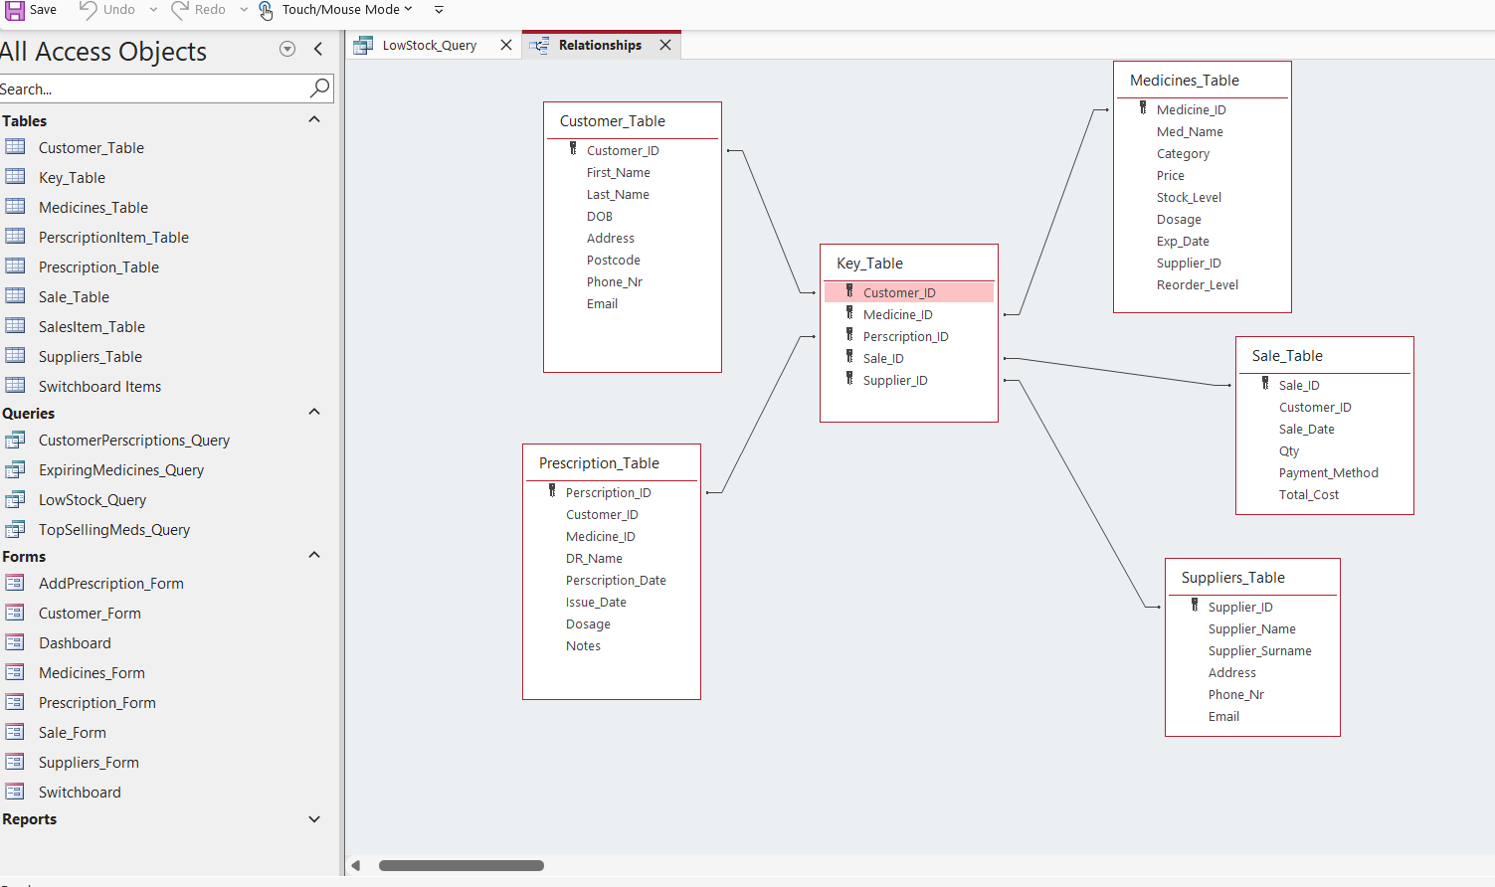
Fig 1: ERD showing relationships between Medicines, Suppliers, Customers, Prescriptions, and Sales.

ERD Explanation
The ERD (Entity Relationship Diagram) below, shows how all the tables are connected. Each table has a primary key, which is used to uniquely identify each record. Foreign keys are used to link tables together.
For example, the Medicines table includes a Supplier_ID, which connects it to the Suppliers table. This creates a one-to-many relationship, meaning one supplier can provide many medicines.
The diagram helps visualise the structure of the database and ensures that relationships are set up correctly before building the system.

Scenario Analysis (Entities + Relationships)
When analysing the system, I identified the main parts (entities) that the database needs. These are the Medicines, Suppliers, Customers, Prescriptions, and Sales.
Each of these has its own information. For example, Medicines include things like name, category, price, and stock level. Suppliers include contact details, and Customers store personal info like name and phone number.
The entities are connected. For example, one supplier can provide many medicines (1 to many), and one customer can have multiple prescriptions. (1 to many) Also, medicines can appear in many sales, and customers can make multiple purchases.(many to many)
These relationships are important because they show how data links together and how the system will work overall.

1. One-to-One Relationship
A one-to-one relationship means that one record in a table is connected to only one record in another table. For example, in some systems a staff member might have one staff profile, and that profile belongs to only that one person.
Although my case study did not specifically require a strong one-to-one relationship, understanding this type of relationship helped me recognise when information should not be duplicated across tables.

2. One-to-Many Relationship
A one-to-many relationship (1:M) is the most common type in my database design.
This means that one record in a table can be linked to many records in another table, but each of those records links back to only one original record.
For example:
One customer can have many medications
One medication can be supplied to many customers
Customers details can update many times
These relationships were essential in my ER diagram because they allowed me to connect the tables correctly using foreign keys.

3. Many-to-Many Relationship
A many-to-many relationship happens when several records in one table can link to several records in another table.
In most real database systems, many-to-many relationships are not allowed directly, so they are broken down into two one-to-many relationships using a separate linking table.
In my case study, there was no direct many-to-many relationship required. However, understanding this concept helped me avoid incorrect connections and ensured that my design stayed normalised.

Data Structure Development
After creating the ERD, I built five tables in Microsoft Access. Those tables are Medicines , ASuppliers , Customers , Prescriptions and sales . Each table was created with the correct fields and data types, such as text, number, and date.
I made sure each table had their unique primary key, and I linked the tables using foreign keys( to establish relationships) Referential integrity was applied to prevent invalid data from being entered. All data types were carefully selecterd ( eg Currency for price, Date/Time for dates etc)
For example, a sale cannot exist without a valid customer or medicine. This helps keep the data accurate and consistent. Lastly the Constrains where adding required fields for essential attributes, the validation rules ( for example Qty >0) and no duplicate primary key is allowed .
Entity Relationship (ER) modelling was one of the most important steps when I started designing the database. Before creating any tables in Microsoft Access, the ER model helped me to understand the structure of the system by breaking the case study into clear entities, attributes and relationships. This made the whole development process easier, more organised, and less confusing. Firstly, the ER model helped identify the main entities in the scenario, such as Customers, prescriptions, medications, suppliers and sales . Without this step, it would have been difficult to know exactly what tables were needed. By drawing the ER diagram, I could establish which pieces of information belonged and which ones needed to be separated into their own tables.
Secondly, the ER modelling process was also very helpful as it makes it clear about the relationships between the entities. For example, one rider can have many rentals, and each rental is linked to one bike. The diagram also helped identify how suppliers were connected to the medication item process. Understanding these one-to-many relationships early made it much easier to set up the correct foreign keys when building the tables in Access.
Another way, ER modelling helped was by preventing data duplication. When I created the ERD, it was clear to me where information needed to be stored only once. For example, customer information belongs only in the Customer_table, and perscription information belongs only in the Perscripttion_table. This became very useful later during normalisation, as the ERD already guided me towards a structure that avoided repeating data.
I’ve used ER model as a blueprint for building the database. Instead of guessing or creating tables randomly, I used a visual plan in front of me. When I started creating tables, forms and queries in MS Access, referring to the ER diagram ensured I was following the correct structure.
Lastly, it made it easier to identify errors before building the database. For example, if a relationship was unclear or an attribute did not belong in a certain entity, I could correct it in the diagram before putting it into Access. This saved a lot of time and prevented potential problems. In summary, ER modelling helped by providing a clear understanding of the system, guiding the structure of the tables, showing the correct relationships, avoiding data duplication, and creating a plan that made building the final database much easier and more accurate.

Logical Design
Table Creation in MS – Access

Medicine table

Design View Screenshot
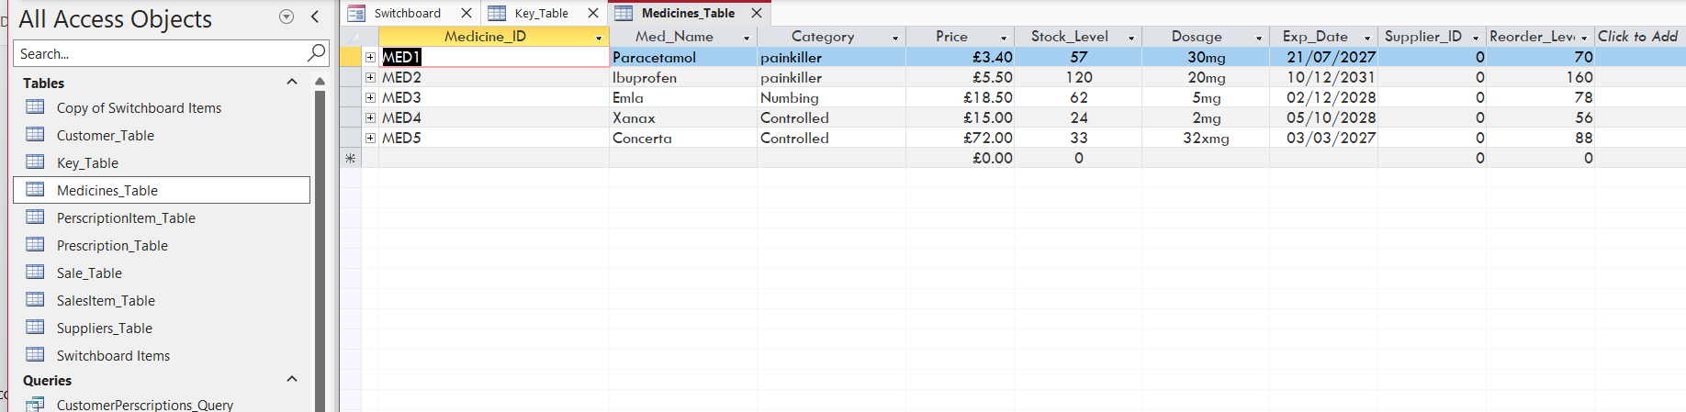
Datasheet View Screenshot
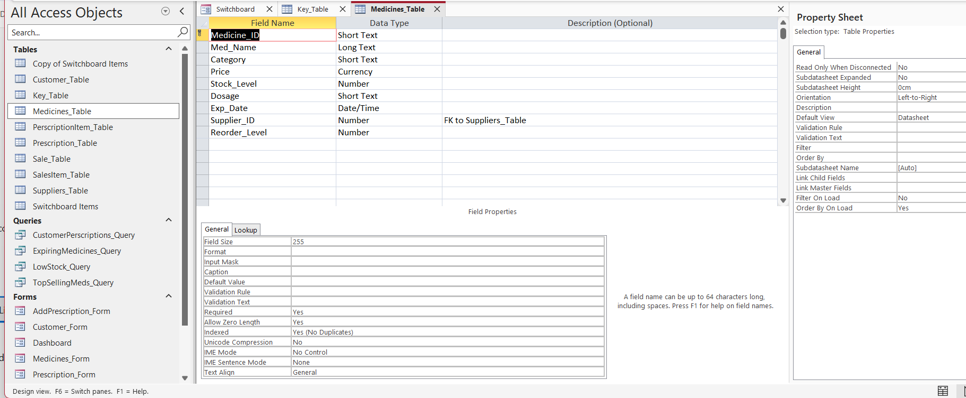

MS- Access

Forms Creation
1. Adderscription_Form

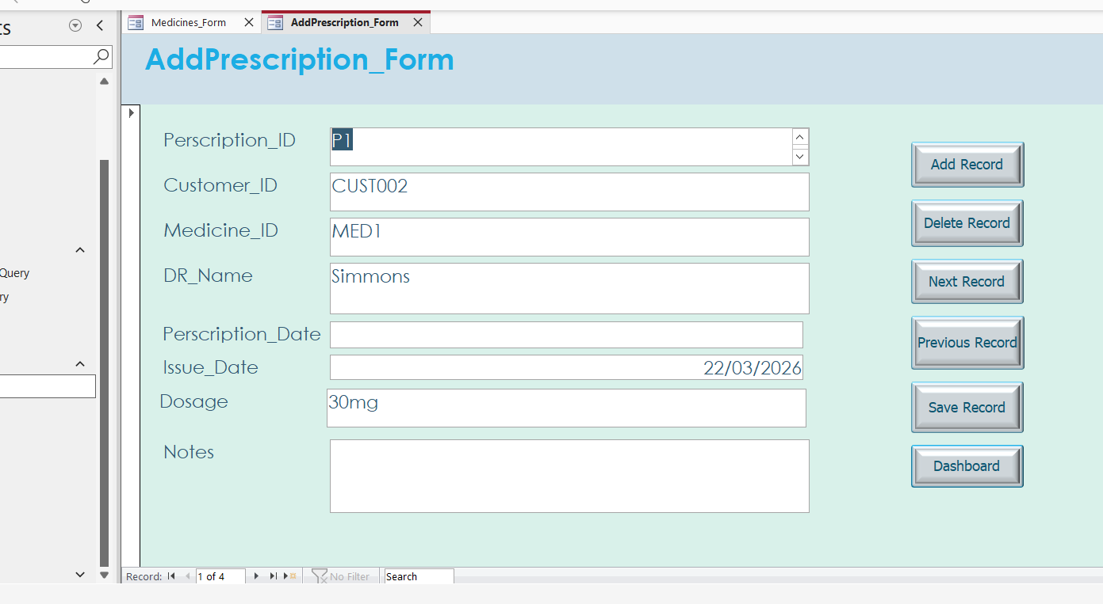
This form was built to add prescription information stored in the Perscription_table.
The form includes Perscription_ID, Customer_ID and Medicince_ID fields.
It provides a simple method for pharmacist to add new prescriptions or update the condition of existing customers in the system.
Using a form in this way it prevents errors that might happen when editing the table directly.

- Customer_Form

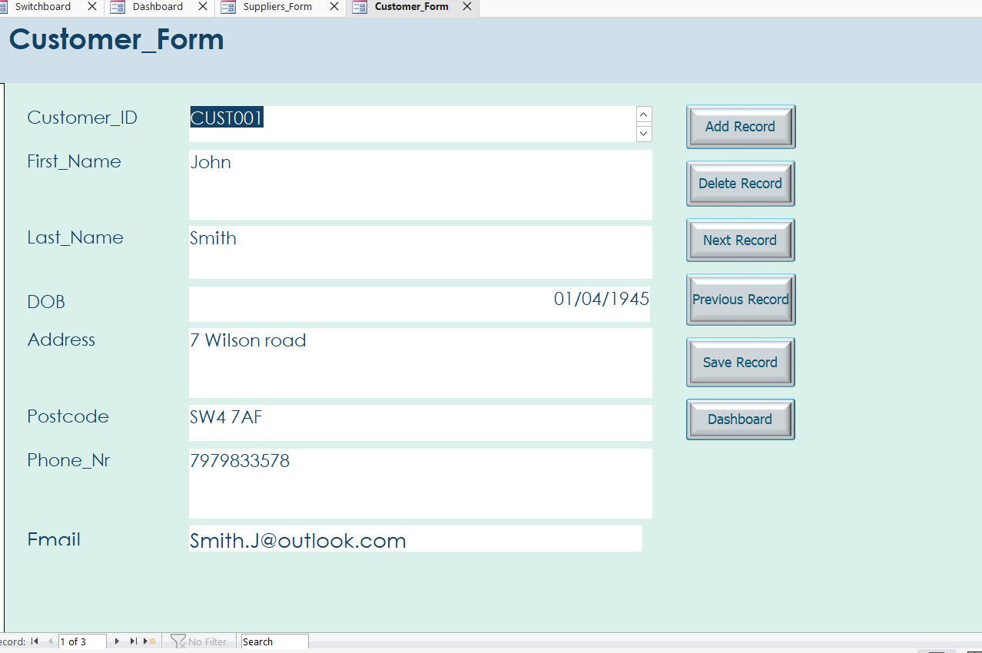

This form was created based on the Customers_table.It allows the user to add or update rider information such as name, telephone number, address and email.
I used the Form Wizard to generate the layout and then adjusted the field positions for clarity.
This form ensures that rider information is entered consistently without needing to open the table directly.

3. Medicines_Form

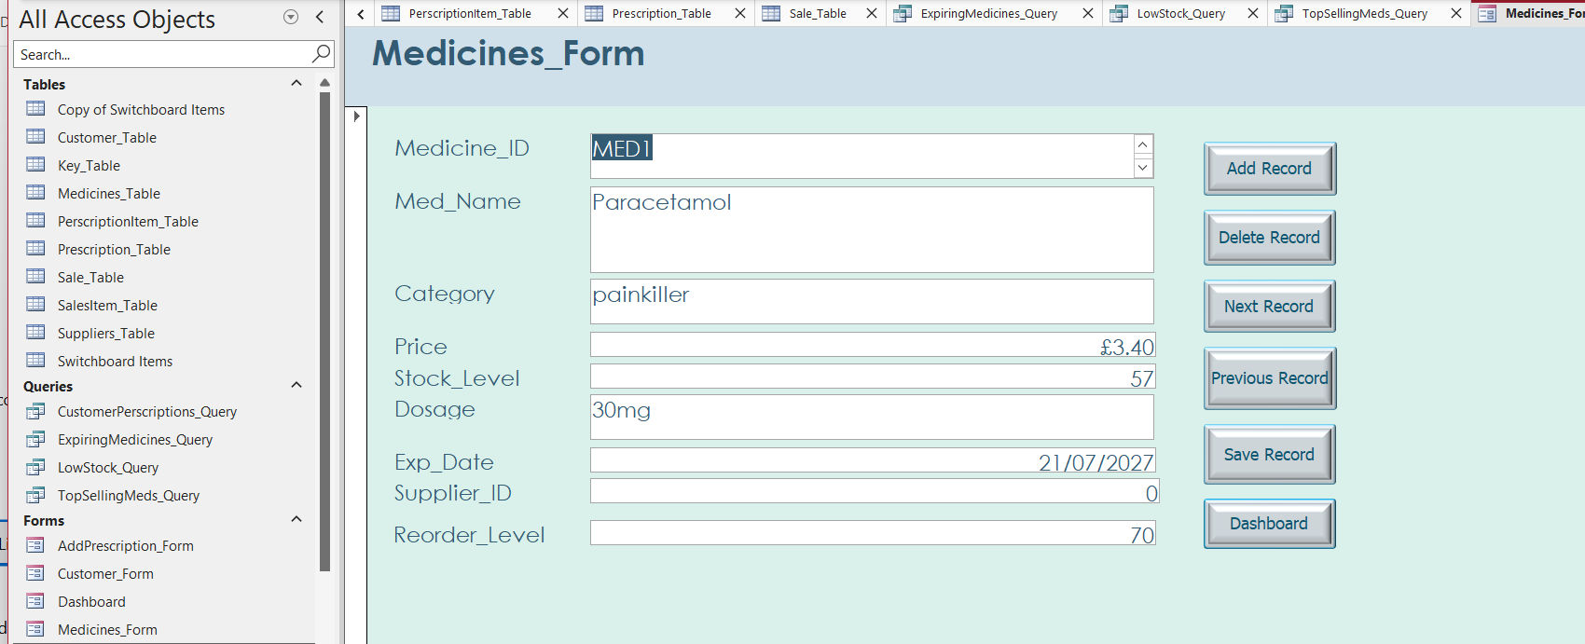

- Suppliers_Form
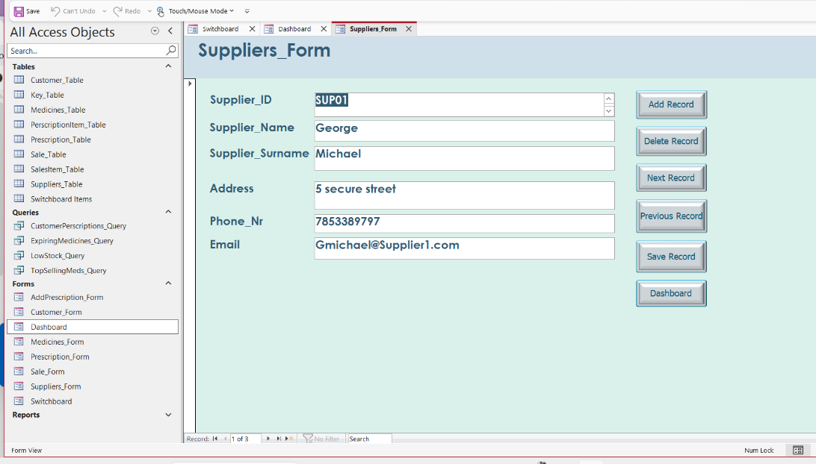
The Suppliers form shows each supplier's main details including Suppliers_ID, name, phone number, email and address.
This form helps maintain accurate suppliers records and allows new suppliers to be added easily.
The layout ensures that all supply-related fields are grouped together in a clear and user-friendly format.

- Sale_Form

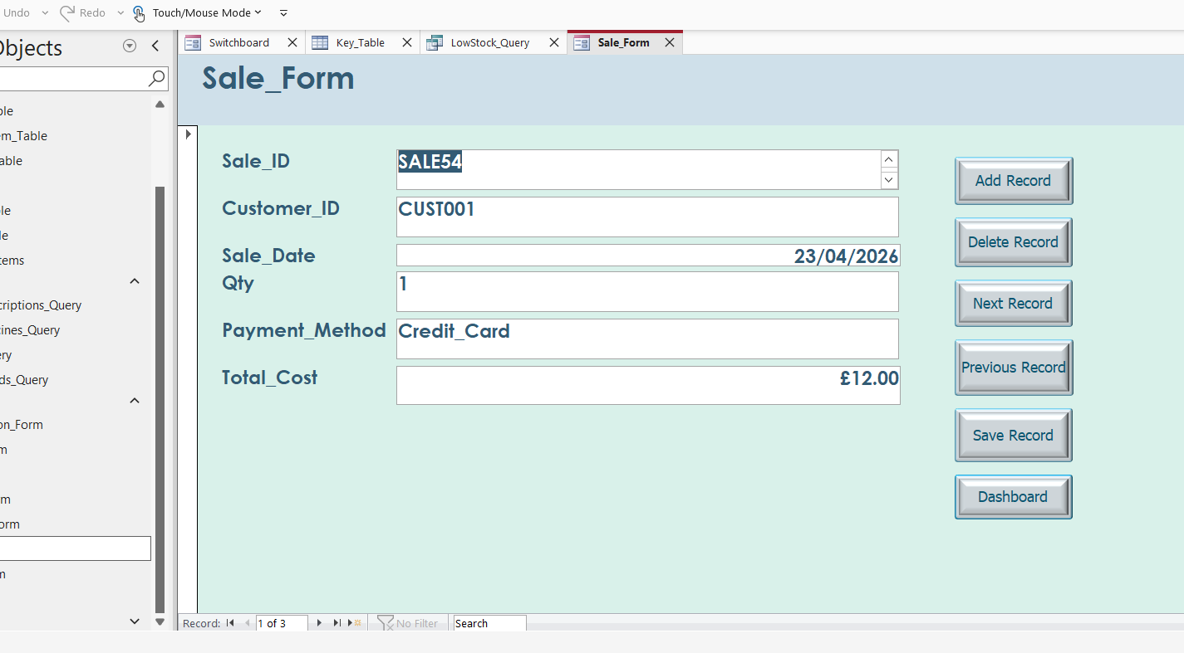

Queries Development
I created several queries to test how useful the system is.
For example, I made a query to find medicines that are low in stock, which would help the pharmacy know when to reorder.
Another query shows total sales per customer, which can help identify regular customers.
I also created a query to show the most sold medicines, which could be useful for business decisions.
These queries show that the system can provide useful insights, not just store data.

SQL VIEW
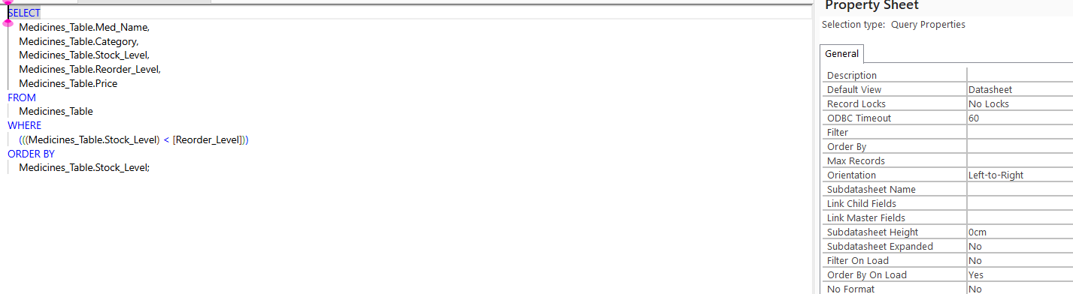

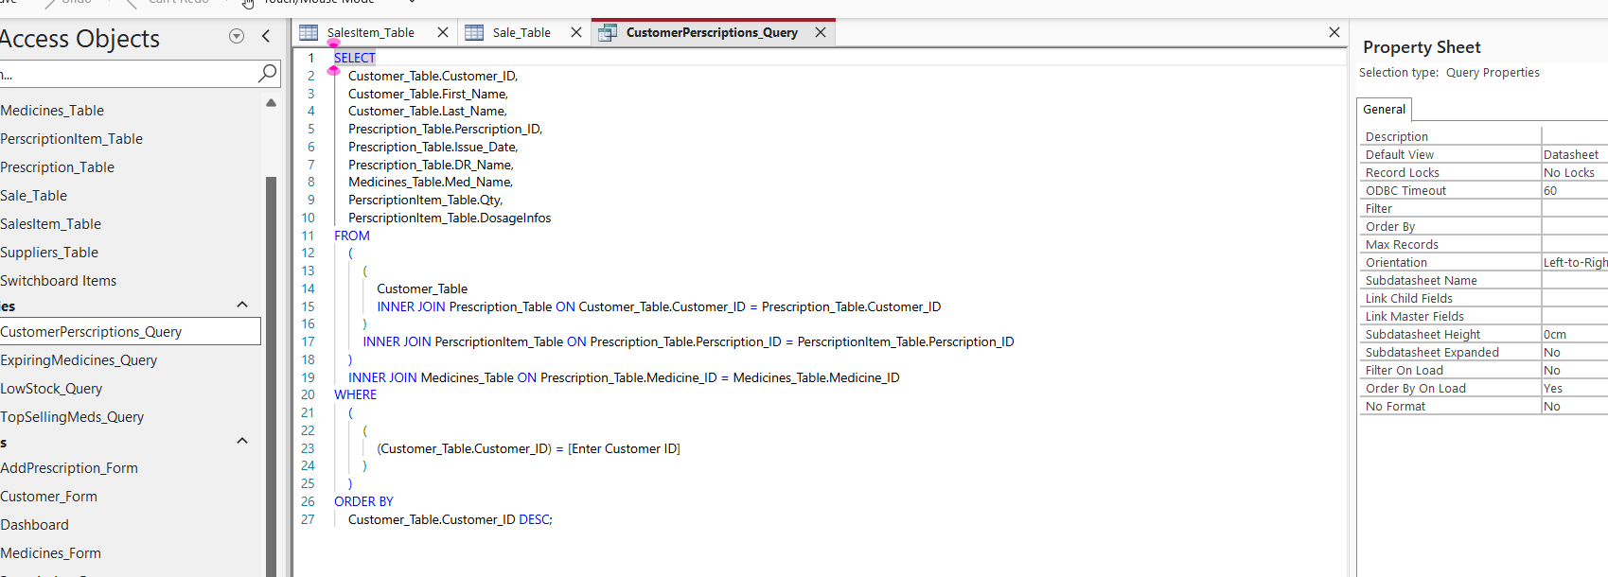

DATASHEET VEW

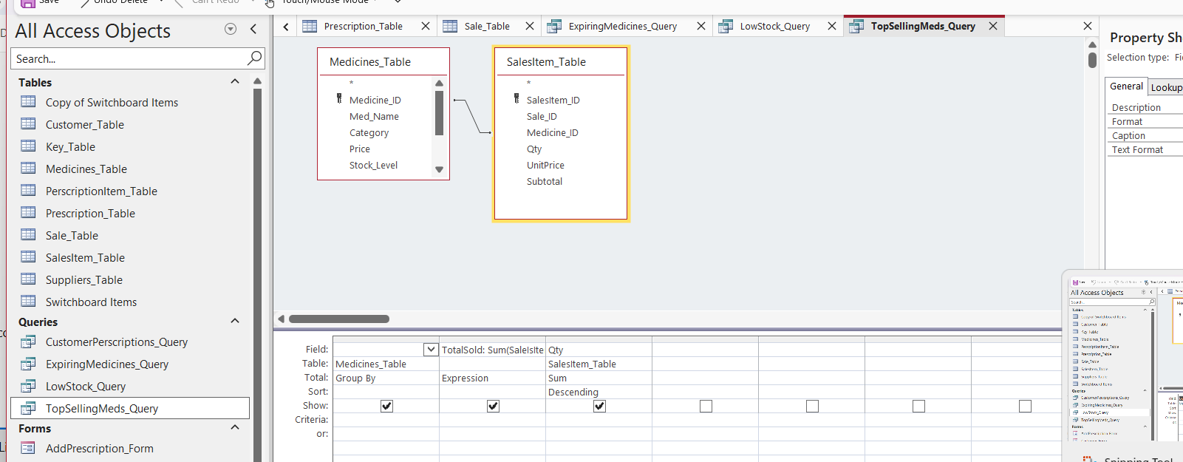

DESIGN VIEW
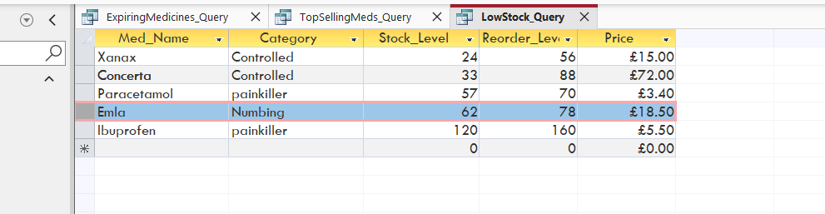

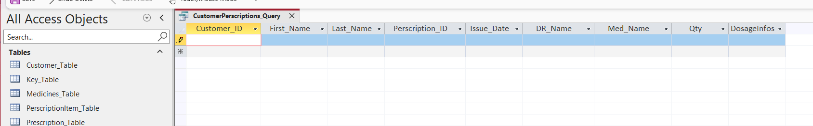

Report Creation

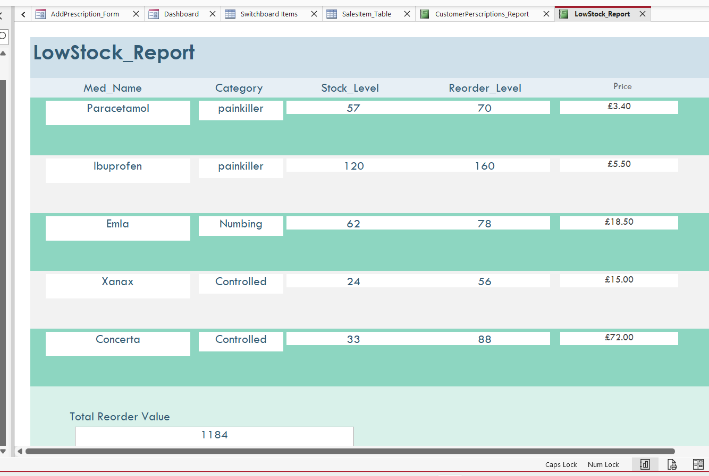

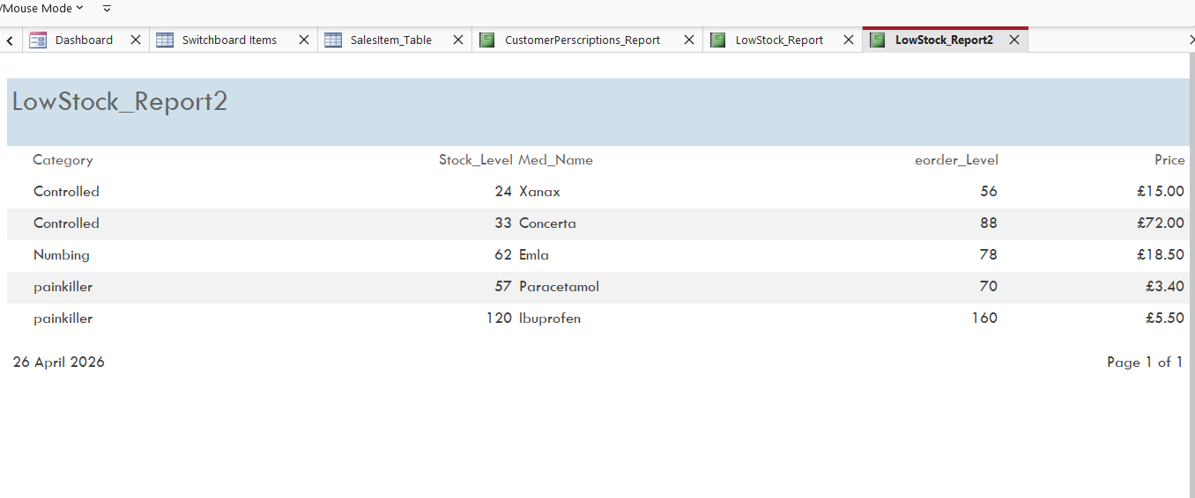

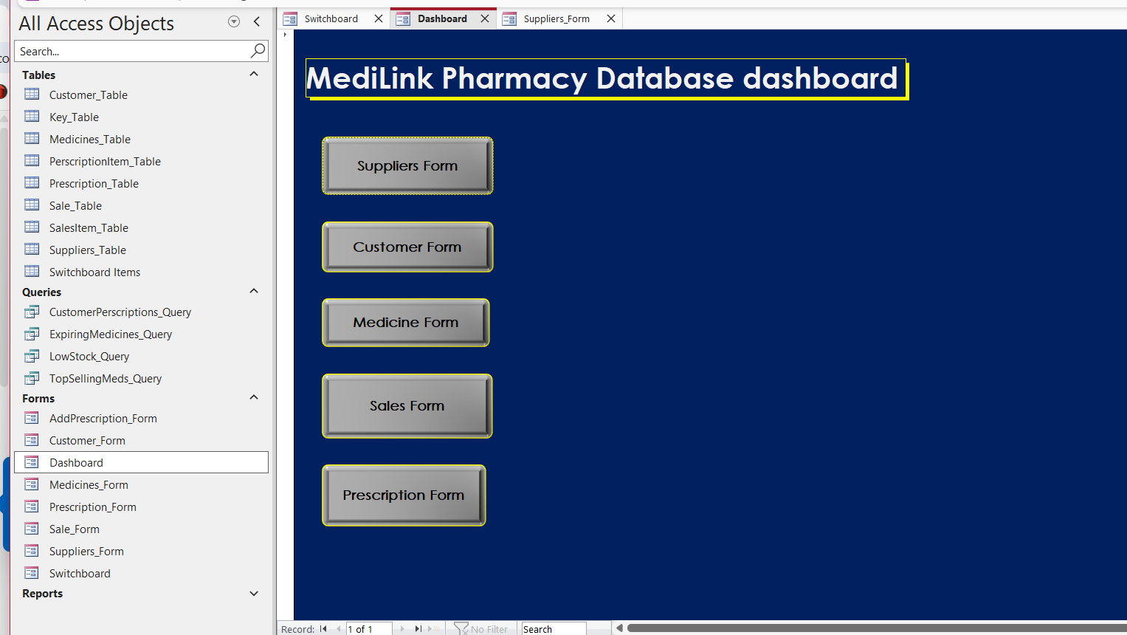

Forms Creation

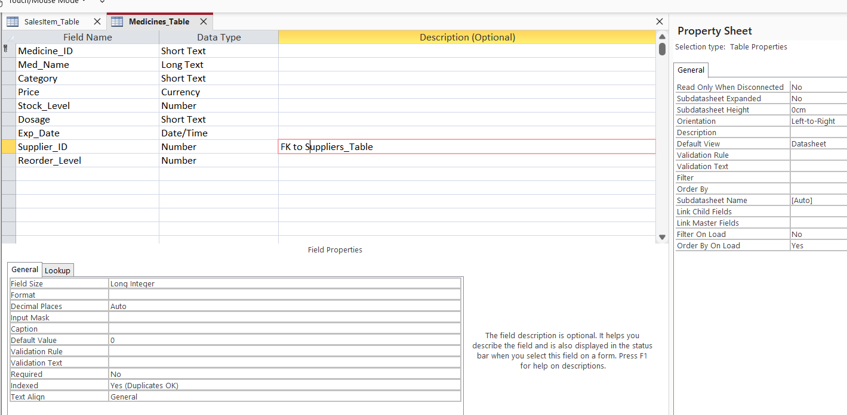
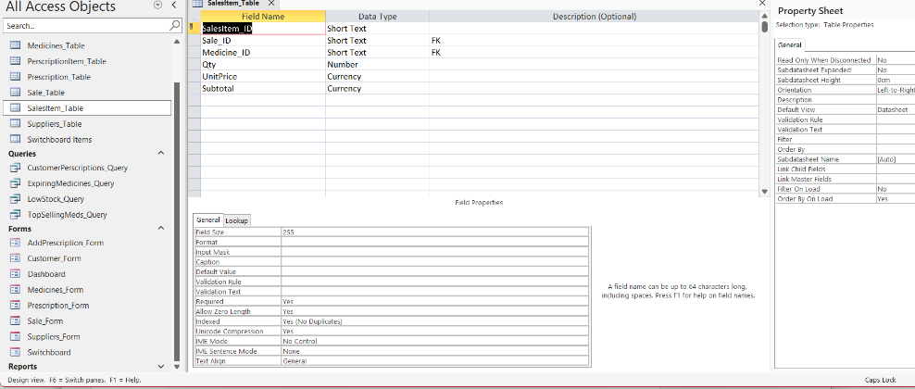

Validation and Testing
To make sure the system works properly, I tested it by entering different types of data and checking if errors were handled correctly.
For example, I tried entering invalid data like negative quantities, and the system prevented it.
I also checked that relationships between tables worked correctly and that queries returned accurate results.
Overall, the testing showed that the database meets the requirements and works as expected.

Refection
Overall, I think the database works well and meets the main requirements of the system. It improves organisation and reduces the risk of errors compared to manual methods.
One challenge I faced was understanding how to correctly link tables and apply normalization, as it required careful planning.
If I had more time, I would improve the system by adding features like automated stock alerts and a more advanced reporting system.
This project helped me understand how databases are designed and how important structure and relationships are in real-world systems.
I decided to keep suppliers and medicines separate so if a supplier’s phone number changes you only update it once. I used junction tables for prescriptions and sales because one prescription or sale can have several different medicines.
Building this took longer than I thought because of my dyslexia – I kept mixing up spellings in field names and had to double-check everything. My ADHD meant I worked in short bursts and sometimes lost track of where I was, but breaking it into small tasks helped. The hardest part was getting the normalisation right at the beginning.
If I could improve it I would add nice data entry forms instead of using the raw tables, make the stock update automatically, and create proper printed reports with the company logo. Maybe add a simple login for different staff members too.

