

Assignment 2: Menu Engineering

Augusta-Roxana Toth (2226559)
Food and Beverage Operations
BMIH4002
LEVEL 4
Module Lead: Ffion Cumberpatch
Word Count:465

Part 1: Restaurant Concept
A restaurant concept is a type of idea that describes a restaurant’s identity. It can be a concept that refers to a certain type of cuisine or style and the overall design. Inspiration for a restaurant concept can come from various places, such as individual experiences or heritage (Gray, 2020). Trinity Hotel is the new hotel, located in the centre of Derby, a 4-star hotel that opened a new restaurant in the city. Cuizinex is a restaurant inside the hotel with a lot of plants and lights. Its ambient and relaxing look will give you a memorable atmosphere but also a perfect meal.
One of the reasons that encourage people to go to a restaurant is to have the opportunity to discover dishes that are more elaborate than the usual fast food. It is also an opportunity to taste new flavours, to test products that you rarely or never had the opportunity to consume. Our restaurant, because it has a varied menu, attracts as many people as possible. A change of setting and habits is also an excellent justification. You will be delighted both by taste and visually. At home you don't have the opportunity to make a nice presentation for the dishes and especially at the end of the tasting you don't have to clean the table and wash the dishes.
The inspiration for the name "Cuizinex" comes from the French dictionary, derived from the word "Cuisine", which means kitchen, simple, elegant with style and refinement so I would describe in a few words the concept of our restaurant.
This restaurant includes a multitude of dishes, adapted to new trends. The interest in plant-based and vegan cuisine is expected to continue growing in 2023. This is because people are becoming more conscious of how their food choices can be good for the planet. There is also a growing number of people willing to try new flavours, and new tastes adapted with ingredients brought from all continents, to satisfy the taste buds when I try these dishes on the menu, which are not very sophisticated at an appropriate price.
The restaurant features an interactive kitchen, where you can enjoy our signature dishes while settling into a relaxing environment. The target audience is businesspeople who cross our threshold of the hotel, but especially city tenants. Those who want to spend time with their family at a dinner exquisite, for a friend group who want to socialize. This menu is also suitable for parties, anniversaries, conferences or weddings.
The secret behind this menu, is the quality of the products, inviting flavours, actualising new trends to have calories exposed, allergens but also with a wide variety of vegetables and fruits, which have been subjected to thermal changes or not, to be suitable both for vegetarians but also for vegan.

Part 2: Menu Design
CUIZINEX Restaurant


Our Menus
-allergen information
-suitable for vegetarians
-suitable for Vegan
- CONTAINS: Soya, Sulphur Dioxide/Sulphites, Cereals Containing Gluten (Barley, Oats, Wheat)
MAY CONTAIN: Eggs, Milk, Sesame Seeds, Cereals Containing Gluten (Rye)
The food in this selection is carefully curated to provide a memorable meal.
Breakfast 8 a.m-11 a.m. 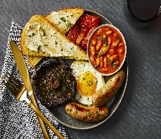
- Fresh fruit salad (per portion) (93 kcal) £12,50
Natural yoghurt, passion fruit/contain milk.
- Smoothies - Exotic Mix (per glass) (32 kcal) £6,39
mango, pineapple, passion fruit, orange
- Smoothies - Kale & coconut (per glass) (50 kcal) £6,39
Kale & coconut, mango, apple, natural yoghurt
- Full English - with a fried egg (1,008 kcal) £18,99
Bacon, Cumberland sausage, roasted tomato, hash browns, black pudding, mushrooms, baked beans, fried egg.
- Granola (382 kcal) £6,79
Natural yoghurt, fruit compote, fresh berries
- Vegetarian breakfast - no egg (262 kcal) £14,99
Vegetarian sausages, roasted tomato, sauteed spinach, baked beans, hash browns, mushrooms.
- Toasted breakfast club sandwich (1,064 kcal) £12,99
Cumberland sausage, bacon, fried egg, tomato, avocado, ketchup mayonnaise

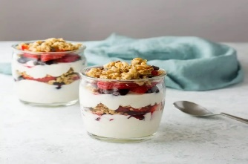

Starters 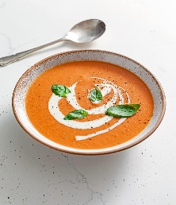
- Creamy tomato and basil soup (420 kcal) £9,99
Sourdough bread and butter
- Spring vegetable soup with herby dumplings (278 kcal)  £9,99
Sourdough and butter
- 3 bean chilli non carne (547 kcal)   £12,50
- Topped nachos, crushed avocado, red onion, and coriander.

Mains 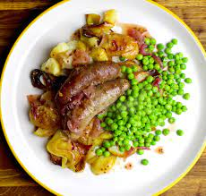
- Keralan fish curry (1,319 kcal) £25,66
Coconut curry sauce, sea bass, roasted cauliflower, potato, lentils, cumin seed rice, crispy onions.
- Pan Seared Chicken Breast (1,252 kcal) £24,99
Served with Fries, Salad and Bearnaise Sauce
- Pork & leek sausage & mash (1,096 kcal) £24,99
Red onion gravy, spring onion mash, tender stem broccoli
- Quorn sausage & mash (788 kcal) £22,99
Red onion gravy, spring onion mash, Tenderstem broccoli
Salads 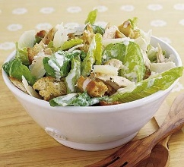
- Falafel salad (975 kcal) £15,32
Quinoa, crispy chickpeas, avocado, roasted cauliflower, ribbons of carrot and mooli, watercress and sweet potato.
- Chicken Caesar Salad (945 kcal) £12,55
Smoked Chicken, Ciabatta Croutons, Anchovies, Shaved Parmesan
Desserts 
- Sticky toffee pudding (824 kcal)  £10,99
Clotted cream & toffee roasted apple.
- Salted caramel dairy-free ice cream (231 kcal) £8,90
salted caramel dairy-free ice cream.
- Crème brûlée (per portion) (240 kcal) £9,50
cinnamon sugar, fresh berries
- White chocolate chip cookie sundae (776 kcal) £8,90
Banana, toffee sauce, salted caramel ice cream.
Hot drinks 
- Americano Large (75 kcal) £6,20
- Hot Chocolate Large (156 kcal) £5,55
- Soya drink (79 kcal) £4,50
For tea & coffee
- Moroccan Mint tea (0 kcal) £3,20
Smiths pyramid tea bag (serves one)
- Sri Lanka Decaffeinated Tea (0 kcal) £4,99
Smiths pyramid tea bag (serves one)
- FLAT WHITE (155kcal) £3,25
- AMERICANO (75kcal) £3,25
- ESPRESSO DOUBLE (57kcal) £3,25
- FLOATER COFFEE (241kcal) £3,25

Cold drinks


- Water (0 kcal) £3,25
- Orange juice (25 kcal) £4,50
- Strawberry juice (32 kcal) £5,50
- Frobishers Fruit Juice (45kcal) £3.25
- Belvoir Raspberry Lemonade (67kcal) £3.25
- Pepsi (250ml) (95kcal) £3.10
- Diet Pepsi (250ml) (0kcal) £2.95
- Coca-Cola (330ml) (97kcal) £3.20
- Diet Coke and Coke Zero (330ml) (0kcal) £3.10

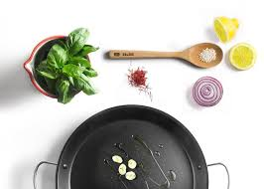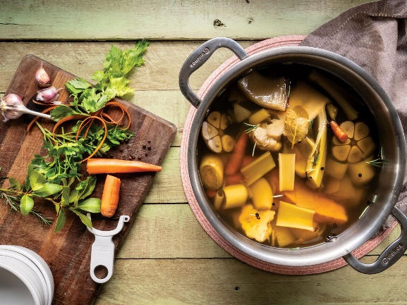

References
- Bemporat, T. (2021). 6 Ways to Come Up with New Restaurant Menu Ideas. Available at: https://www.lightspeedhq.com/blog/new-restaurant-menu-ideas/ (Accessed 10 May 2023).
- Food Standards Agency (2021). Precautionary allergen labelling. Available at: https://www.food.gov.uk/business-guidance/precautionary-allergen-labelling/ (Accessed 10 May 2023).
- Gray, R. (2020). The secret tricks are hidden inside restaurant menus. Available at: https://www.bbc.com/future/article/20171120-the-secret-tricks-hidden-inside-restaurant-menus/ (Accessed 15 May 2023).
- Hullinger, J. (2016). 8 Psychological Tricks of Restaurant Menus. Available at: https://www.mentalfloss.com/article/63443/8-psychological-tricks-restaurant-menus/ (Accessed 15 May 2023).
- Insanelygoodrecipes, (2022). 25 Traditional British Recipes. Available at: https://insanelygoodrecipes.com/british-recipes/ (Accessed 15 May 2023).
- Kathleen, (2021). What is the physiological need to eat? Available at: https://fromhungertohope.com/what-is-the-physiological-need-to-eat/#:~:text=There%20are%20two%20main%20physiological%20needs%20to%20eat%2C,of%20hunger%20and%20the%20sense%20of%20being%20satisfied/ (Accessed 16 May 2023).
- Mundasad, S. (2014). Food allergy laws enforced in restaurants and takeaways. Available at: https://www.bbc.co.uk/news/health-30395142/ (Accessed 10 May 2023).
- McKevith, B. (2004). Successful ways to modify food choice: lessons from the literature. Available at: https://www.academia.edu/5267099/Successful_ways_to_modify_food_choice_lessons_from_the_literature/ (Accessed 10 May 2023).
- Ozdemir, B., Caliskan O. (2014). A review of literature on restaurant menus: Specifying the managerial issues. Volume 2, Issue 1, June 2014, Pages 3-13 Available at: https://www.sciencedirect.com/science/article/pii/S1878450X13000231/ (Accessed 13 May 2023).
- Rosie, (2016). The choice architecture of restaurant menus and how to support healthy eating. Available at: https://social-change.co.uk/blog/2016-01-14-the-choice-architecture-of-restaurant-menus-and-how-to-support-healthy-eating/ (Accessed 10 May 2023).
- Shrauner, D. (2023). Creating a Restaurant Menu Step-by-Step Guide. Available at: https://www.ckitchen.com/blog/2023/5/creating-a-restaurant-menu-step-by-step.html/ (Accessed 13 May 2023).

