AC1.1 Evidence based practise relates to a systematic approach to decision-making process that merges the best-found evidence with critical thinking, creating decisions that are justified and evaluated (Barends and Rousseau, 2018; Barends, Rousseau and Briner, 2014). In people practice, EBP direct HR away from personal opinions to evidence-based information to be used in the decision-making process. For Technivara, as long-established leadership and paper-based systems are increasing the changes of subjective decisions being taken, it’s very important to shift towards an EBP approach to maximise the company’s potential (Gifford, Young and Barends, 2023).
According to CIPD (2025a), an efficient EBP should be based on four sources of evidence:
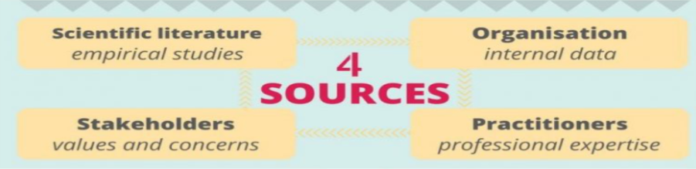
The sources are increasing objectivity, but it’s important to recognise their limitation as well; scientific evidence finds effective practice, but it can lack relevance for Technivara, organisational data brings relevant context, but it can lack accuracy due to low-quality data, expertise can bring insights but risks bias and stakeholder reviews build ethical decision but can be subjective.
The process following 6 steps of evidence processing:
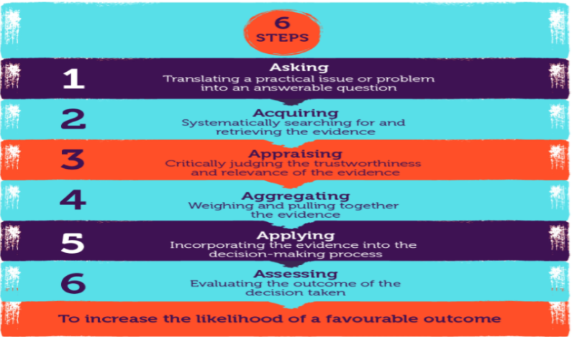
Following the 6 steps helps decision-making by creating a structured approach in questioning, evaluation and applying the evidence found, but it can become time-consuming and can be dependent on analytical skills.
The strength of EBP comes from the critical thinking approach, giving practitioners the opportunity to evaluate limitations, relevance and benefits before taking decisions. Models such as rational decision-making model (Adam, Kuchta, and Stanek, 2022) are supporting EBP by empowering evidence gathering, problem definition, option evaluation and outcomes review, but it can be challenged by the bounded rationality model, which implies people have limited access to data and limited time, the two models together balancing each other in supporting a realistic and time efficient EBP.
Nevertheless, even if EBP has its own challenges, such as limited data access, time constraints and implementation barriers, when applied effectively, it improves consistency, credibility and the overall decision’s outcome.
A way Technivara could use EBP is in modernising their HR system. As Sue admits, the decision-making process is weakened by old paper-based practises, and by using EBP, they could combine organisational proof (performance data, turnover and employees’ feedback) with external successful models and scientific research to justify the benefits of investments in a digital HR system. This improvement would enhance workforce planning and reduce the risk of human error, supporting sound decisions during business growth (CIPD, 2025b).
A second way Technivara could use EBP is to create flexible working practises. As the business grows, traditional working methods may narrow attraction and retention, whilst hybrid or working-from-home approaches may create more interest, improving the recruitment process and staff’s satisfaction. Applying EBP would imply reviewing flexible working research, analysing feasibility and exploring internal data and feedback to create a balanced outcome-driven evaluation that could support the benefits of flexible working (CIPD, 2017).
In conclusion, EBP is a valuable approach in the decision-making process and whilst is requires time, capability and cultural readiness, the critical effective thinking and use of evidence helps the company reduce risks and have better outcomes in their transition towards efficient organisational strategy.

AC1.2 To recognise or diagnose organisational challenges or opportunities, professionals should use the correct analysis tools and methods that enhance an evidence-based decision-making process. Multiple tools can be used in people practice, including force field analysis, PESTLE, Porter’s Five Forces, Ansoff matrix and many others, however, this section evaluates SWOT analysis as a tool and people analytics as a suitable method for Technivara.
SWOT analysis is an environmental analysis tool used to discover an organisation strengths, weaknesses, opportunities and threats (CIPD, 2025c), being particularly useful for Technivara, where they are experiencing growth whilst struggling to find the right ways to work. By using SWOT, the People Practice Team could develop a better understanding of the organisation’s status and people-related aspects that might bring future success. For example, strengths may include skilled staff and financial growth, weaknesses may be related to outdated paper-based practices and traditional leadership, opportunities may come as modernised systems and working practises and threats could include loss of talent and skills shortages, altogether creating a bigger picture of both challenges and opportunities the company has.
The advantages of a SWOT analysis are its flexibility and simplicity, whilst encouraging structured discussions, critical thinking, and group brainstorming, reducing reliance on individual opinions (Peterdy, 2023). If used correctly, SWOT can align EBP by balancing organisational evidence, external information and stakeholders' perspective. However, it can be subjective without giving cause-and-effect explanation and risks fortifying existing assumptions, especially in organisations like Technivara, where strong senior management are having a big influence. Therefore, for SWOT to function, it should be supported by sturdy analysis methods.
A good analysis method to support SWOT is people analytics, which includes workforce data examination to find patterns, opportunities and risks (CIPD 2025d). At Technivara, this method could be used to examine performance data, skills gaps, turnover and retention rates, financial status or recruitment challenges, providing evidence to challenge or support SWOT findings, studies showing 75% of HR professionals approaching performance are using people data (Houghton and Green, 2018) and proved success in staff’s satisfaction after improvements on performance management systems, only 5% of staff preferring the old ways (CIPD, 2021). The strength of people analytics stays in its ability to support decision’s quality by decreasing bias and showing clear facts, enabling HR professionals to present data-driven insights to senior management. Although it is a powerful method, it has its own limitations as well, its effectiveness depending on analytical skills and data quality, but also on cultural readiness, a proper use of it requiring investments in systems improvement and skills development. (CIPD,2024)
In conclusion, people analytics and SWOT analysis together could provide a balance approach to recognise and diagnose issues, challenges, and opportunities Technivara might face, helping the People Practice teams to challenge assumptions and reduce risks.

AC1.3 Critical thinking is an objective analysis that comes as a core ability in EBP that reinforces rational, objective and well-reasoned decision-making. It implies a process of analysing and evaluating information to create justified ideas rather than following assumptions, traditions or personal opinions (Howlett, 2019). Critical thinking is a very useful tool for Technivara, where long-time outdated working practices are increasing the risk of subjective and biased decisions.
One key of critical thinking is rational and objective thinking, requiring individual to develop logical arguments and conclusions based on evidence rather than authority emotions (Cottrell, 2023). In practice, that means the People Practise Team should challenge the supposition that current people practises are effective just because they worked in the past and build a reason-supported argument based on organisational evidence and research to inform and debate with senior leaders.
A second principle is based on checking the source validity and questioning the evidence, as critical thinkers analyse and evaluate the credibility, reliability and relevance of data before using it (Hanscomb, 2023). At Technivara, this means inspecting HR data, checking the quality of engagement surveys and comparing data against external sources, as it’s very important not to take information at face value, as this might conduct to misinformed quick fixes, but to filter it in order to make logical, appropriate and unbiased decisions.
Bias awareness, conscious or unconscious, is another important principle as it can affect how evidence is interpreted and manipulated to prioritise specific viewpoints (Haber, 2020). It is very important to recognise critical thinking in others and withing yourself to make evidence-based decisions. In Technivara, where bias can come from prioritising information that supports old practises while dismissing evidenced data that supports change, applying unbiased critical thinking requires management to recognise their own biases, challenge it and actively finding perspectives that support a balanced debate.
To support unbiased thinking, people practitioners should distinguish between opinion and fact. In debates, people practitioners must create clear separation between measurable evidence (such as error rates, compliance risk and processing time) and anecdotal opinion. For Technivara, comparing like to like to evidence-based sources and considering new methodologies can strengthen debates and prevent deceptive comparisons (Hanscomb, 2023).
Finally, critical thinking requires good skills of managing the ambiguity and complexity of data, especially where evidence may conflict or be incomplete. At Technivara, rather than looking for certainty, practitioners should gather evidence from multiple sources and trial conclusions before implementation, this approach supporting constructive challenge and building stronger points during debates (Fasko and Fair, 2021).
In conclusion, applying the critical thinking principles helps Technivara people professionals to create rational and objective debates, challenges assumptions and supports evidence-based decisions that are aligned with business growth.

AC1.4 Effective decision-making is mandatory to achieve feasible outcomes in people practice. At Technivara, where decision-making had been very traditional and led by the funder, structured decision-making processes can help decrease subjectivity, reduce risk and guarantee decisions are ethical and inclusive. Two suitable decision-making processes that Technivara could use to ensure effectiveness are The Best Fit approach and De Bono’s Six Thinking Hats.
The Best Fit process is focusing on finding solutions that align with the organisation’s strategy, context and culture, rather than general “best practice” solutions (Buchanan and Huczynski, 2020). In people practice this approach is focusing on recognising what works best on one organisation, accepting that the same approach might not work the same for another one, this being very relevant for Technivara, where long-lasting culture and a very active traditional funder can highly influence the changes (Armstrong & Taylor, 2023; Adair, 2022).
For example, when evaluating the HR digitalisation process, a best fit approach would mean that Sue is considering organisational data like workforce capability, employees' readiness and cost implications. External evidence can be taken into consideration, such as HR technology studies, but it must be balanced with internal limitations and workforce views. This approach determines effectiveness but assuring decisions are practical and applicable, this making them more likely to be approved by senior management, them having the final say in the decision-making process for investment. However, a limitation this approach is facing is the reinforcement of existing practices if not sufficiently challenged, this showing even more need for robust critical thinking.
A second process is De Bono’s Six Hats (De Bono, 1985), which provides a simple and structured method of exploring decisions from different viewpoints, each “hat” representing a differed way of thinking:
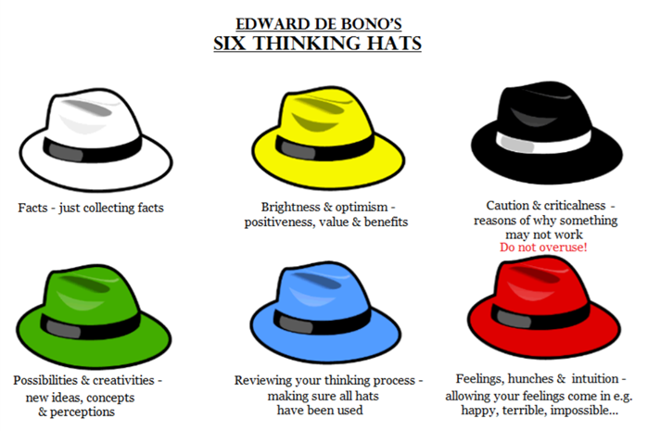
This process can be very useful for Sue, as her experience is limited to old practises. She could use the Six Thinking Hats during people practice meetings about staffs' performance management. For example, the white hat could support the team to focus on data regarding performance and skills gap, the black hat could find potential risks (such as staff resistance), the green hat could provide creative solutions (such as pilot programs or phased implementation) and the blue hat would assure discussions are staying structured and outcome-focused, while the yellow hat would explore the employee’s benefits, long-term value and investment returns of improved performance management (Mulder, 2019). Using this process will help the team develop wider thinking skills, while not improving their ways can affect their performance and credibility, and negatively impact the decision-making process.
In conclusion, both processes could help the People Practise Team at Technivara make balanced and defensible decisions, encouraging critical evaluation, contextualisation and collaborative debate, all together improving the likelihood of sustainable outcomes.

AC1.5 Ethical decision-making is a necessity to an effective people practice as it can influence organisational culture, leadership style and credibility and the overall employee trust. Ethical practises are a core behaviour, requesting people professionals to use moral judgement, to challenge inappropriate behaviour and act as role models for integrity and fairness (CIPD, 2025e). At Technivara, where decision-making process is led by the founder and his own limits, applying ethical principles provides a way to evaluate people-focused decision beyond personal views. Two Ethical perspectives relevant to Technivara being utilitarianism and deontological ethics.
Utilitarianism is an ethical theory build around outcome, suggesting decisions should be analysed by their consequences, aiming to achieve the best benefits for the most people (Armstrong and Taylor, 2023). In people practise, this framework fosters strategic decisions such as changes to working practises, cost reduction and organisational restructuring, aligning the decision-making process with business-focused efficiency and supporting the business objective, which may appear appealing to Technivara’s board as the organisation is growing.
For example, when debating the modernisation of their now paper-based HR system, a utilitarian approach would be to focus on long-term benefits such as better efficiency, errors reduction and stronger people analytics, even if the People Practise Team member might feel anxious about the changes. This perspective is supporting organisational sustainability; however, its limitations are related to the disregard of minorities, which can potentially lead to unfairness, facilitating loss of trust and affecting employee's wellbeing.
In contrast, the deontological perspective is focusing on the moral duty principles rather than the outcome, decisions being considered right if they respect employees’ rights and feelings, regardless of consequences. In people practise this perspective brings fairness, honesty and equality, which are mandatory for employees’ trust and morale (Brewster, Mayrhofer, & Morley, 2020).
At Technivara, a deontological approach would influence how performance management and disciplinary processes are handled. For example, if dismissing an employee due to consistent low performance might increase the overall performance, from a deontological standpoint, the employee should be treated fairly and with respect, being given all the necessary support before dismissal, the process itself being transparent and treated with dignity. This perspective decreases reputational and legal risks and help build a healthy culture based on trust and fairness, however, its limitations are related to lack of flexibility, especially when s quick action is required to meet urgent needs (Hopper, 2020).
Assessing both ethical perspectives is highlighting the importance of a balanced approach rather than fallowing a single “right” way of working, ethical practises helping People Practises to weight outcomes and duties, looking at stakeholders' impact and sustaining professional integrity. At Technivara, mixing utilitarian and deontological approaches could support ethical decision-making by ensuring efficiency and growth are achieved without compromising respect, fairness and organisational values.

AC3.1 As Technivara is expending, it’s important to evaluate both financial and non-financial performance to assess effectiveness, financial measures indicating economic stability while non-financial measures providing insights into operational quality (Stobierski, 2020a).
A financial measure Technivara could use is income statement, a tool that's showing revenue, costs and profitability focusing on profit and loss over a period of time (Stobierski, 2020b; Stobierski, 2021).
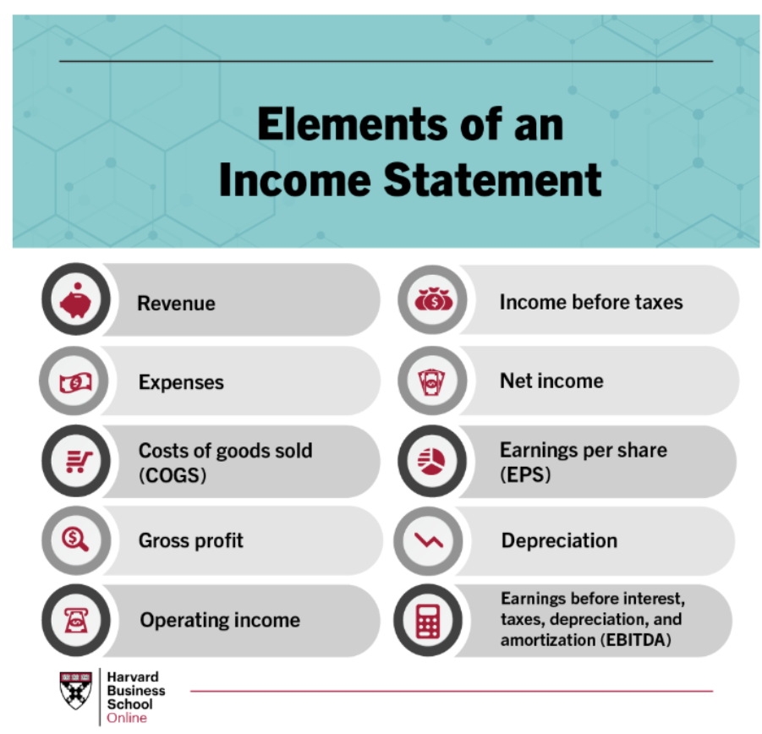
Although it has its limitations, such as the disregard of employees’ capability and historical focus only, the usefulness of this measure stays in its comparability and objectivity, enhancing performance benchmarks, allowing a direct link between profitability and operational initiatives, supporting an evidence-based decision-making process.
Technivara could utilise this method to prove the importance of L&D programmes in order to support the required improvements. By following ITAP leaders example, as they conducted an evaluation of the financial impact of training, highlighting a £2.89 million growth within the first year of implementation of new training programmes, the return of investment being calculated at 385% (Laroche and Martin, 2000). People Practice Team could build evidence-based proof to support their senior leadership during the decision making-process by bringing proof of already financially successful improvements, creating credibility and trust, and improving the chances of approval of new business growth ideas.
A non-financial measure that Technivara could use is employee engagement, usually assessed by collecting feedback to scale staffs’ cognitive and emotional commitment to work.
It is important for Technivara to focus on engagement as it can influence wellbeing, productivity and performance, being an indicator of personnel health (Young and Grifford, 2021; Lamb, 2018). Despite engagement surveys being dependent on employees' participation and honesty, and them providing correlation rather than causation, their strength stays in their capability to reveal qualitative insights, high engagement levels correlating with lower turnover and higher performance, worldwide research showing engaged staffs outperformed the less engaged one with 18% higher productivity, 23% higher profitability and 78% in lower absenteeism (Harter et all., 2024).
The People Practise Team could collect feedback by doing by-annual surveys or short “pulse” ones, the focus being on tools that show percentages of disengaged, neutral and engaged staff, using the results as evidence of HR initiatives effectiveness or proof of improvements’ need when pitching their development plans with higher leadership (CIPD, 2025f).
By measuring engagement rates while using ROI for calculating financial implications, Technivara could develop decision-making processes to improve workforce sustainability and enhance long-term performance, increasing profits and supporting business growth.

AC3.2 People practice adds value by aligning organisation objective with stakeholders’ activity, enhancing staff performance, capability and engagement.
Value creation appears when HR practises are producing both direct impacts, such as higher productivity, lower turnover, faster recruitment and improved policies and procedures; and indirect impacts, such as organisation culture based on trust and fairness, improved wellbeing and staffs’ engagement. The impacts being either short-term, such as supporting staff during disciplinary hearing or offering them opportunities to be heard, to long term, such as changing organisational values and creating trust (Brewster, Mayrhofer & Morley, 2020; Armstrong & Taylor, 2023)

At Teachnivara, the People Practise team can add value by initiating new L&D programmes that are aligned with the business growth, improving workforce planning and performance management, and creating wellbeing strategies that generate trust and engagement, giving people a voice and building loyalty.

Measuring the impact of people practises is ensures that activities are meeting their objectives, justifying investment, identifying gaps and supporting evidence-based decision-making process, their evaluation helping companies to weight the positive and negative impacts and adapt practices to maximise value. By measuring people practice outcomes, Technivara would not only support operational effectiveness, but also ensure employees’ satisfaction (Houghton, 2024).

A method Technivara could use measure the people practice team value is by using the Return On Investment (ROI) method:
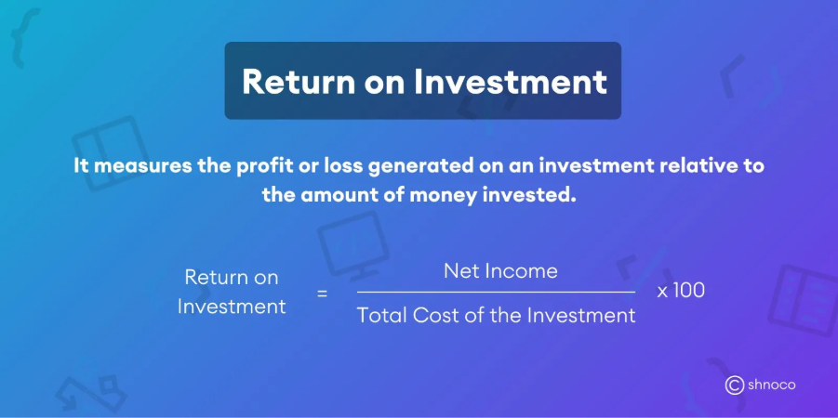
With the company growing and HR investments becoming mandatory, by using ROI, Technivara could assess the effectiveness of already put in place systems to support the need of new ones, enhancing the team’s credibility and increasing chances of approval, as this method provides quantifiable and clear financial facts that are particularly relevant for senior leadership during business growth (Houghton, 2024).
A second way they could measure people practice value is by implementing a Cost-Benefit Analysis (CBA), as this is a method that’s comparing costs and benefits, including non-financial and financial outcomes:
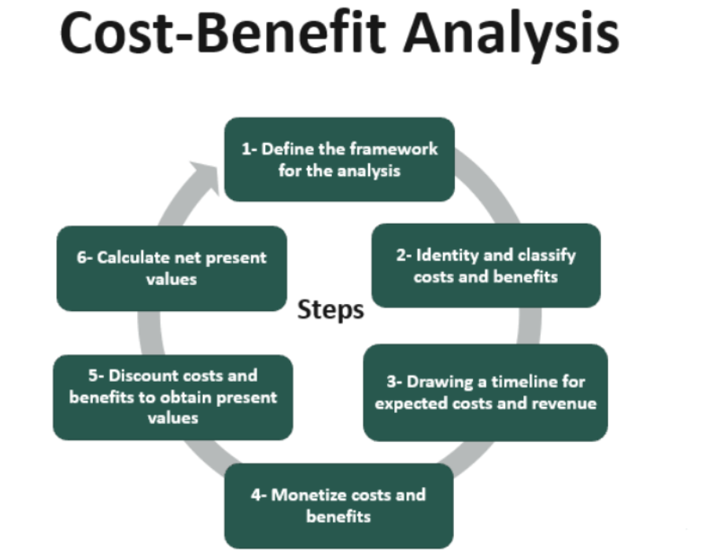
Technivara could use this method when assessing the need of a new HR system by comparing the cost of implementation and of additional training programmes with the financial benefits the new system will bring, such as improved productivity, faster task completion, reduced error rates and improved employee capability. CBA captures a large scale of impacts, both short-term and long-term, which is crucial, as system implementation will be dependent on employees’ adaptability as well, which may slow the translation into financial returns (Stobierski, 2019; Hayes, 2025).
By combining both methods, Technivara People Practice Team could bring value by providing a strategic evidence-based decision-making framework, following business objectives whilst enhancing employee experience.

AC2.1
Turnover and recruitment take up for Technivara 2024
 | Total in Department 2024 | Leavers for 2024 | Leavers as a % against total in each Department | Positions vacant | Vacancies as a % against total in each Department | Positions filled | Positions filled as a % of total in each Department
Audio technical Department | 26 | 6 | 23% | 8 | 31% | 3 | 12%
Offices and Administration | 15 | 4 | 15% | 5 | 19% | 5 | 19%
Research and Development | 8 | 1 | 4% | 4 | 15% | 4 | 15%
Quality control | 4 | 2 | 8% | 3 | 12% | 3 | 12%
Dispatch | 15 | 4 | 15% | 6 | 23% | 6 | 23%
Engineering | 35 | 8 | 31% | 8 | 31% | 3 | 12%
Casting Department | 6 | 3 | 12% | 5 | 19% | 2 | 8%
Sales & Marketing | 12 | 4 | 15% | 3 | 12% | 3 | 12%
Human Resources | 4 | 1 | 4% | 1 | 4% | 1 | 4%
Design | 12 | 3 | 12% | 5 | 19% | 2 | 8%

AC2.2
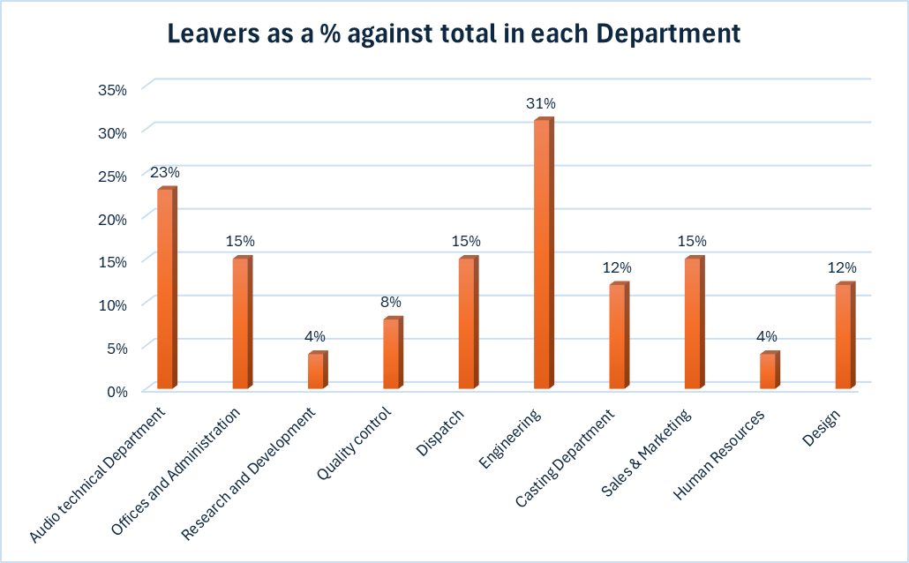
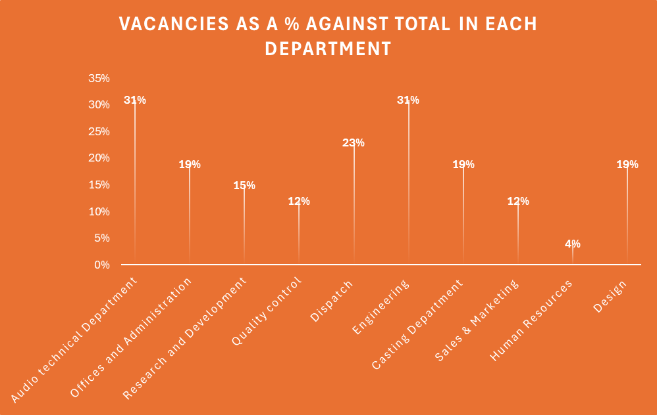
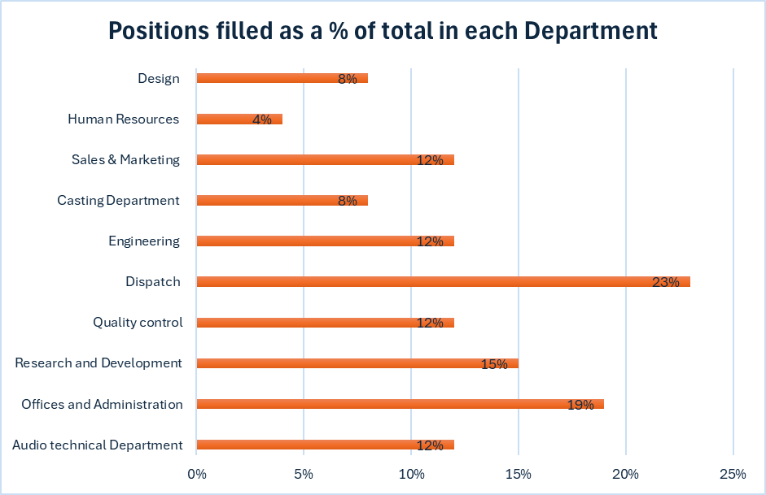

AC2.3 Evaluation of L&D actions is playing an important role in creation of effective training strategy that goes beyond subjective perception of effectiveness and builds an informed, evidence-based training, improving its design, delivery and the overall impact.
Analysing data allows themes, patters and trends to be discovered across new starters experience, highlighting the areas of strengths but also of improvements, which is crucial in aligning it with organisational priorities. For Technivara, evaluating data from L&D is crucial, as it can clearly show the positive practises but also lacking areas (Hayden, 2025).
Analysing the results of the evaluation shows that the strengths in L&D are related to facilitator’s capability:
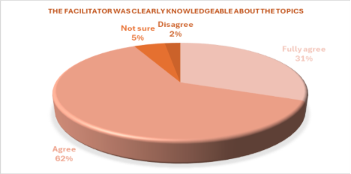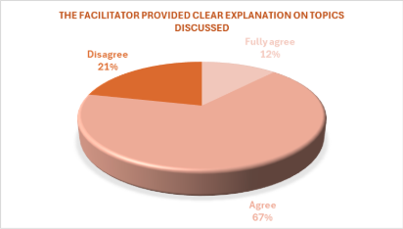
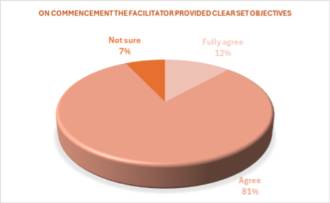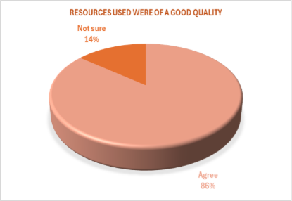

As 93% of respondents agreed that facilitator have strong knowledge of topics, 93% agreed that they’ve been presented clear objectives, 86% agreed that the resources used were at high quality, and 76% agreed that clear explanations were provided, it shows that the company had made good investments in subject matter expertise and training materials, which are key components in building learner confidence and credibility of L&D practises.

Despite these positive strengths, data shows weaknesses in the learner-centred process:
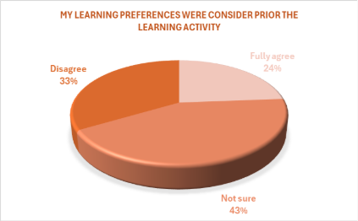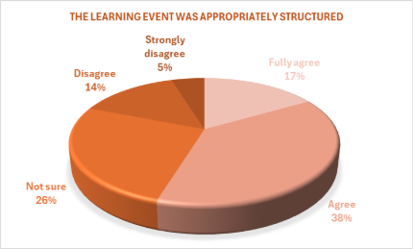

Only 24% agreed that their learning preferences were taken into consideration and 76% being either neutral or disagreeing with it. This idea being supported by the responses regarding the learning structure, where 55% respondents agreed that it was appropriate, while 45% were either neutral or disagreed.
Learner possibility to engage and actively participate during training is one of the most significant weaknesses found during data evaluation:

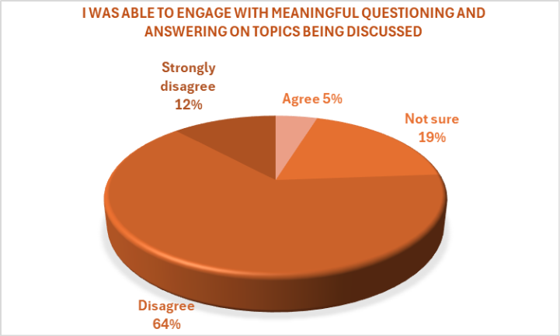

Only 5% respondents agreeing to being able to engage during training, while 76% disagreeing and 19% being neutral, showing low opportunities for interaction or reflection.

The most critical findings are related to learning outcomes and their transferability into practice.
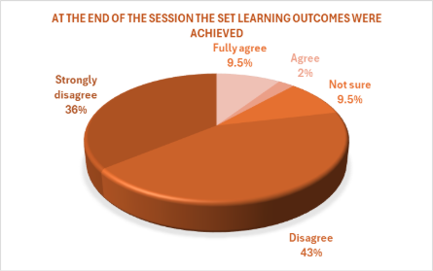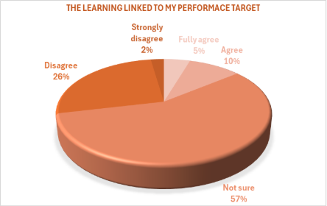
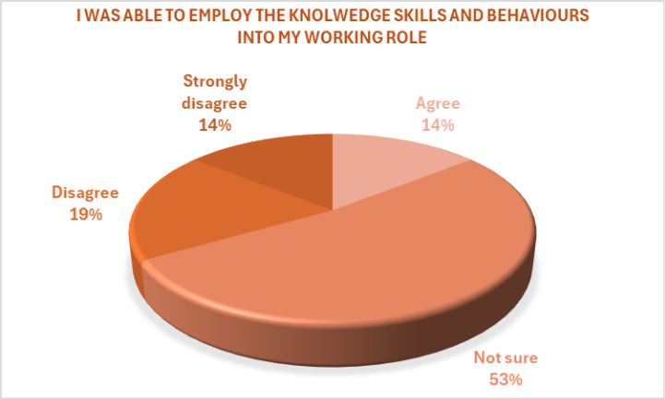
Only 11.5% of respondents agreeing that learning outcomes were achieved by the end of the training course, while 88.5% were neutral or disagreed. Similarly, only 15% of participants agreed that the learning was clearly linked to the performance target and only 14% feeling able to use the knowledge and skills developed during training in their day-to-day role responsibilities.
As an effective and appropriate training must be grounded in learners needs, the lack of it leading to reduced engagement and increased turnover, my first recommendation to Technivara would be to implement a learner needs analysis process (CIPD, 2025g; CIPD, 2025h).
LNA is a systematic and ongoing process that identifies the gaps between an individual's knowledge and skills, and the knowledge and skills required to reach organisational goals. Introducing a LNA will balance training relevance with learner needs and organisational objective. The benefits of this approach including a more targeted learning that is aligned with performance expectations, a UK study showing 1% increase in trained workers brings a 0.6% increase in value-added per worker (Dearden, Reed and Van Reenen, 2005), employee satisfaction and better use of L&D budget.
A risk is related to time employees will require to complete the analysis data, however, as Technivara are already collecting training feedback, there will be no additional time, but the consequences of not implementing an LNA, such as increased retention and lower productivity, could have a bigger negative impact long-term.
When it comes to costs, as Technivara has the data collection system already in place, they will only include the wages of the people involved in analysing and finding solutions for a better L&D system. Assuming me, as a People Practise Advisor, can train and assist the People Practise Manager and the L&D manager over a 5-day period you can find below a breakdown of costs:
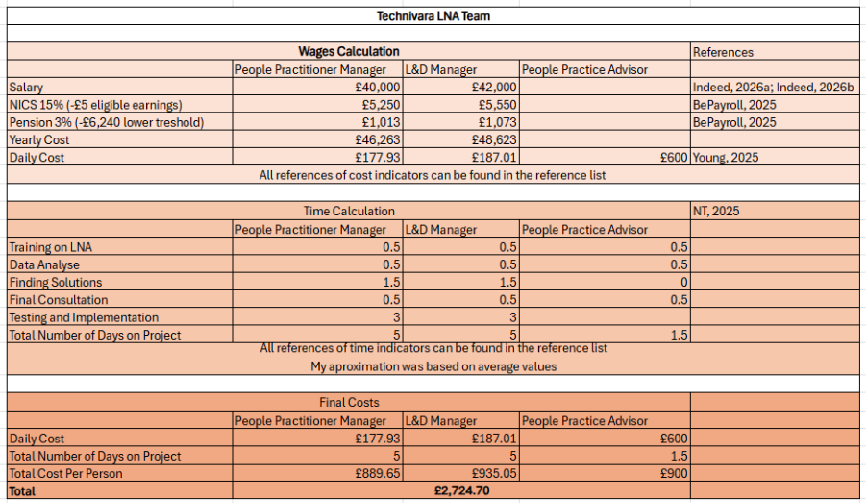
The second recommendation would be to redesign the training delivery to include more interactive and experimental techniques. Intervention methods can come as group discussion, problem-solving activities or case studies integrated into training, and they can increase interaction and enhance engagement, building learner confidence and playing a very important role in retention (CIPD, 2025g).
Active learning is more effective in supporting fairness perception, engagement, learning applicability and the overall wellbeing, Governmental review (Fitzhugh and Daniels, 2025) showing effective training has a similar impact on wellbeing to a 1% increase in wages, while the lack of it is negatively impacting motivation and commitment, affecting retention and increasing turnover (CIPD, 2025i).
As Technivara already has capable facilitators, the cost of implementing new intervention methods will be minimal, but not investing in training delivery, Technivara could lose staff motivation, increasing turnover and creating more financial challenges. Assuming Technivara has 3 Trainers and the L&D manager in their team, and I can train them on how to practice intervention methods and support them in introducing the methods in their training, please see cost breakdown below:

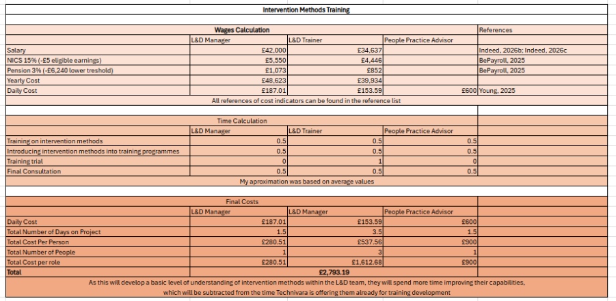
As the findings are indicating substantial gaps in learning transferability, this being a primary indicator of success in training effectiveness, a third recommendation is to improve the after-learning support methods to strengthen learning transfer.
A model Technivara’s L&D team could use it the Learning-Transfer Evaluation Model (Thalheimer, 2018), as the LTEM is designed to be relevant not only for learning transferability, but also for learning interventions and decision-making competences development, following 8 levels:
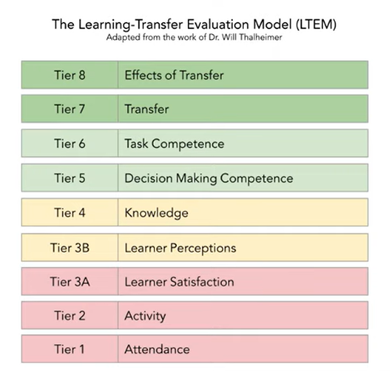
In practise, following this model will imply creating alignment between training content and role requirements, introducing after-training evaluations to measure and support learner understanding, and develop activities to reinforce learning.
The L&D team will need to be trained on this model, assuming me, as a People Practise Advisor can train them, the costs will be similar to the ones for the previous training I’m providing.
This action can be put in place with minimal financial costs, while the investment return is realised through reduction in skills gap and improved capability, all increasing performance, study showing that training investments were linked to an 20-25% productivity increase (Schwarz et all, 2925).
While there are other ways to improve the L&D team’s skills, such as external trainings, qualifications or apprentices, my suggestions will bring quick improvements during a short period of time and minimal costs, the total investment for Technivara being £8,311.08, but the benefits of this investment will have an impact not only on productivity due to increased capability, engagement due to perception of fairness, or the overall organisational culture due to clearer objectives and qualified staff, but will also reduce the risks of Health and Safety incidents, bad reputation and high turnover.
In conclusion, data evaluation shows that although L&D delivery was made by knowledgeable facilitators that used quality resources, it needs improvement in its design, learner engagement and transfer of learning into role, which can be done by structured learning needs analysis, delivery redesign and transfer of learning into workplace.

References:
Adair, J. (2022). Decision making and problem solving: Break through barriers and banish uncertainty at work (5th ed.). Kogan Page Ltd
Adam, K., Kuchta, D. and Stanek, S. (2022) Rational Decisions in Organisations: Theoretical and Practical Aspects. Abingdon: Routledge.
Armstrong, M. and Taylor, S. (2023) Armstrong’s Handbook of Human Resource Management Practice. 16th edn. London: Kogan Page
Barends, E. & Rousseau, D.M. (2018) Evidence-based management: How to use evidence to make better organisational decisions. New York & London: Kogan Page.
Barends, E., Rousseau, D. and Briner, R. (2014) Evidence Based Management: The basic principles, Centre for Evidence-Based Management Amsterdam. Available at: https://cebma.org/assets/Uploads/Evidence-Based-Practice-The-Basic-Principles.pdf (Accessed 07/12/2025)
Be Payroll Ltd (2025) How much does an employer pay for an employee in the UK? Available at: https://bpayroll.co.uk/how-much-does-an-employer-pay-for-an-employee-in-the-uk/#:~:text=%F0%9F%93%88%20Employer%20National%20Insurance%20Contributions,year%20(previously%20%C2%A39%2C100 (Accessed 21/01/2026)
Brewster, C., Mayrhofer, W. and Morley, M. (2020) Studying human resource management. 3rd edn. London: CIPD.
CIPD (2017) News analysis: Should more organisations offer remote working? Available at: https://www.cipd.org/uk/about/news-archive/news-analysis-remote-working/ Accessed (08/12/2025)
CIPD (2021) Solving business problems with people analytics: Novartis. Available at: https://www.cipd.org/uk/knowledge/case-studies/novartis/ (Accessed 24/01/2026)
CIPD (2024): People analytics: Guide for people professionals. Available at: https://www.cipd.org/uk/knowledge/guides/analytics-practitioner-guide/#what-is-people-analytics (Accessed 08/12/2025)
CIPD (2025a) Evidence-based HR: Make better decisions and step up your influence. Available at: https://www.cipd.org/uk/knowledge/guides/evidence-based-profession/ (Accessed 07/12/2025)
CIPD (2025b) Technology, AI and the future of work. Available at: https://www.cipd.org/uk/knowledge/factsheets/emerging-future-work-factsheet/#how-ai-and-other-technologies-are-changing-jobs-and-hr (Accessed 18/12/2025)
CIPD (2025c) SWOT Analysis. Available at: https://www.cipd.org/uk/knowledge/factsheets/swot-analysis-factsheet/ (Accessed 08/12/2025)
CIPD (2025d) People Analytics Available at: https://www.cipd.org/uk/knowledge/factsheets/analytics-factsheet/#_ga=2.170353952.1246059219.1635951255-1362614769.1635951255 (Accessed 08/12/2025)
CIPD (2025e) Ethical practice and the role of people professionals. Available at: https://www.cipd.org/uk/knowledge/factsheets/ethics-role-hr-factsheet/ Accessed (10/12/2025)
CIPD (2025f) Employee engagement and motivation. Available at: https://www.cipd.org/uk/knowledge/factsheets/engagement-factsheet/#assessing-and-measuring-employee-engagement (Accessed: 10/01/2026)
CIPD (2025g) Learning and development tools. Available at: https://www.cipd.org/uk/knowledge/tools/learning-and-development/ (Accessed: 20/01/2026)
CIPD (2025h) Learning and development: How to develop and deliver effective learning. Available at: https://www.cipd.org/uk/knowledge/guides/learning-and-development/ (Accessed: 20/01/2026)
CIPD (2025i) Methods of delivering learning interventions. Available at: https://www.cipd.org/uk/knowledge/factsheets/learning-methods-factsheet/ (Accessed 22/01/2026)
Cottrell, S. (2023) Critical thinking skills: Effective analysis, argument and reflection. 4th edn. London: Bloomsbury Academic.
De Bono, E. (1985). Six Thinking Hats: An Essential Approach to Business Management. Little, Brown, and Company
Dearden, L., Reed, H. and Van Reenen, J. (2005) The impact of training on productivity and wages: evidence from British panel data. (CEP Discussion Papers 674). London School of Economics and Political Science. Centre for Economic Performance. Available at: https://researchonline.lse.ac.uk/id/eprint/779/ (Accessed 21/01/2026)
Fasko, D. and Fair, F. (eds.) (2021) Critical thinking and reasoning: Theory, development, instruction, and assessment. Leiden: Sense Publishers.
Fitzhugh, H. and Daniels, K. (2025) A rapid review of reviews on the nature of the relationship between learning and development and employee engagement, wellbeing, attraction and retention. Norwich: University of East Anglia / Government Skills. Available at: https://www.gov.uk/government/publications/learning-and-development-employee-engagement-and-wellbeing/a-rapid-review-of-reviews-on-the-nature-of-the-relationship-between-learning-and-development-and-employee-engagement-wellbeing-attraction-and-retent? (Accessed 21/01/2026)

Gifford, J., Young, J. and Barends, E. (2023) Building an evidence-based people profession. Available at: https://www.cipd.org/uk/views-and-insights/thought-leadership/insight/evidence-based-profession/ (Accessed 07/12/2025)
Haber, J. (2020) Critical thinking. Cambridge, MA: MIT Press.
Hanscomb, S. (2023) Critical thinking: The basics. 2nd edn. London: Taylor & Francis Group.
Harter, J., Tatel, C., Agrawal, S., Blue, A., Plowman, S., Asplund, J., Yu, S. and Kemp, A. (2024) The Relationship Between Engagement at Work and Organizational Outcomes. Q12® Meta-Analysis: 11th Edition. Available at: https://www.gallup.com/workplace/321725/gallup-q12-meta-analysis-report.aspx (Accessed 10/01/2026)
Hayden, D. (2025) Learning evaluation, impact and transfer. Available at: https://www.cipd.org/uk/knowledge/factsheets/evaluating-learning-factsheet/ (Accessed 15/01/2026)
Hayes, A. (2025) Cost-Benefit Analysis Explained: Usage, Advantages, and Drawbacks. Available at: https://www.investopedia.com/terms/c/cost-benefitanalysis.asp (Accessed 13/01/2026)
Hopper, S. (2020) How can change and transformation be more ethical? Available at: https://www.cipd.org/uk/views-and-insights/thought-leadership/insight/transformation-ethical/ (Accessed 10/12/2025)
Houghton, E. (2024) People analytics: Guide for people professionals. Available at: https://www.cipd.org/uk/knowledge/guides/analytics-practitioner-guide/#what-is-people-analytics (Accessed 12/01/2026)
Houghton, E. and Green, M. (2018) People analytics: Driving business performance with people data. Available at: https://www.cipd.org/en/knowledge/reports/people-data-driving-performance/ (Accessed 24/01/2026)
Howlett, W. (2019) Critical thinking. Podcast. Available at: https://www.cipd.org/uk/knowledge/podcasts/critical-thinking/ (Accessed 09/12/2025)
Indeed (2026a) Practice Manager salary in United Kingdom. Available at: https://uk.indeed.com/career/practice-manager/salaries (Accessed 21/01/2026)
Indeed (2026b) Learning and development manager salary in United Kingdom. Available at: https://uk.indeed.com/career/learning-and-development-manager/salaries?from=top_sb (Accessed 09/12/2025)
Lamb, P. (2018) The Engagement Myth. Available at: https://www.cipd.org/uk/knowledge/podcasts/engagement-myth/ (Accessed 10/01/2026)
Laroche, L. and Martin, S. (2000) Demonstrating the bottom-line impact of HR: A competencies case study. Available at: https://www.hrreporter.com/news/hr-news/demonstrating-the-bottom-line-impact-of-hr-a-competencies-case-study/308168?utm (Accessed 09/01/2026)
Mulder, P. (2019) Six Thinking Hats by Edward De Bono, a decision-making tool. Available at: https://www.toolshero.com/decisionmaking/six-thinking-hats-de-bono/ (Accessed 09/12/2025)
National Training (2025) How to conduct a learning needs analysis. Available at: https://nationaltraining.edu.au/how-to-conduct-learning-needs-analysis/#:~:text=2.,early%20can%20streamline%20the%20process (Accessed 21/20/2026)
Peterdy, K. (2023) SWOT Analysis A framework to understand and analyse a company’s Strengths, Weaknesses, Opportunities, and Threats. Available at: https://corporatefinanceinstitute.com/resources/management/swot-analysis/ (Accessed 08/12/2025)
Schwarz, S., Du, J., Nduka, U. and Zhang, L. (2025) ‘The impact of staff and manager training on firm productivity: Differential and interaction effects’, British Journal of Industrial Relations DOI: https://doi.org/10.1111/bjir.70020 - DOI
Stobierski, T. (2019) What is cost-benefit analysis and how to do it. Available at: https://online.hbs.edu/blog/post/cost-benefit-analysis (Accessed 13/01/2026)
Stobierski, T. (2020a) 13 Financial performance measures managers should monitor. Available at: https://online.hbs.edu/blog/post/financial-performance-measures (Accessed 08/01/2026)
Stobierski, T. (2020b) How to read and understand an income statement. Available at: https://online.hbs.edu/blog/post/income-statement-analysis (Accessed 08/01/2026)
Stobierski, T. (2021) How to prepare an income statement. Available at: https://online.hbs.edu/blog/post/how-to-prepare-an-income-statement (Accessed 08/01/2026)
Thalheimer, W. (2018) The learning-transfer evaluation model: Sending messages to enable learning effectiveness. Available at: https://www.worklearning.com/ltem/ (Accessed 22/01/2026)
Young, H. (2025) A complete guide to HR outsourcing costs. Available at: https://startups.co.uk/people/management/hr-outsourcing-costs/ (Accessed 21/01/2026)
Young, J. and Gifford, J. (2021) Employee engagement: an evidence review. Scientific summary. London: CIPD Available at: https://www.cipd.org/globalassets/media/knowledge/knowledge-hub/evidence-reviews/employee-engagement-scientific-summary-1_tcm18-89565.pdf (Accessed 10/01/2026)

