UNIVERSIT OF WALES TRINITY SAINT

DAVIDS

MODULE: MANAGING ENTERPRISE IN THE 21ST CENTRY
NATALIE JAYNE SAHI
1915519
11/12/2020
MARKETING BUSINESS PLAN
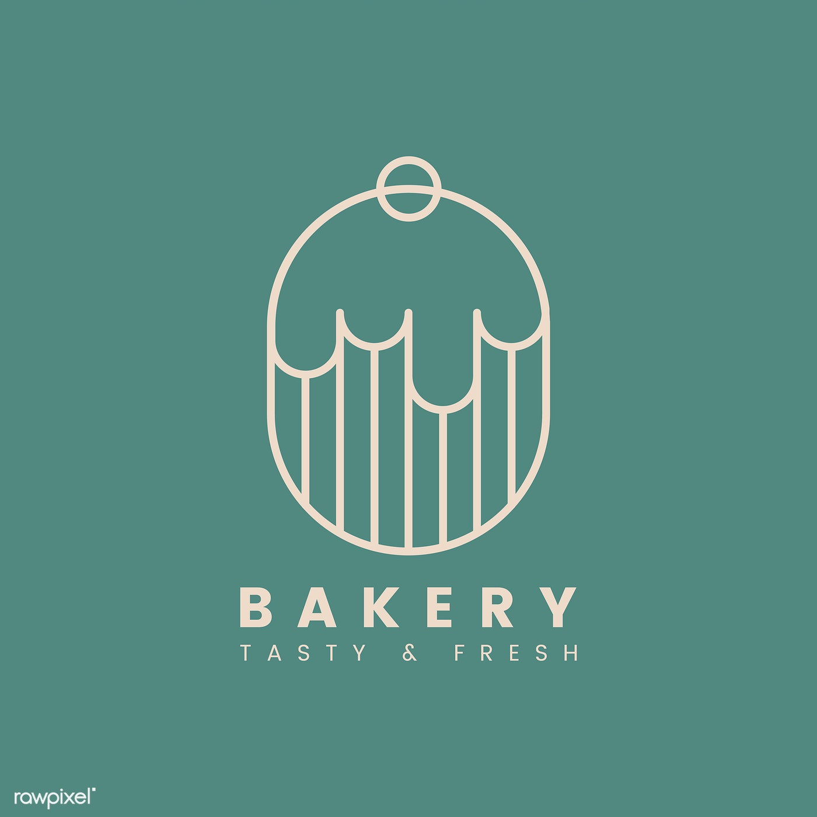
Nat’s Gluten Free Bakery

TABLE CONTENT

COMPANY DISPRIPTION …………………………………………………………………………….

MISSION STATEMENT

OBJECTIVES AND AMINS

INTORDUCTION

PRODUCT/SERVICE……………………………………………………………………………………..

MARKETING ACTIVITY PLAN

PHYSICAL RESOURCES…………………………………………………………………………………

LOCATION AND PREMISIES

MACHINERY AND EQUITMENT

PLANT AND MACHINERY

EQUIPMENT

OPORATING IT SYSTEMS

FINANCIAL RESOURCES…………………………………………………………………………………

FINANCIAL PLAN

PROJECT START – UP COSTS

HUMAN RESOURCES……………………………………………………………………………………..

MANAGEMENT TEAM WITH ROLES AND RESPONSIBILITES

SWOT ANALYSIS

REFERENCES…………………………………………………………………………………………………..

Mission Statement
The mission of Nat’s Bakery is to provide our customers who have an issue and allergy to Gluten, promoting gluten free baked goods provides fresher and safer products in the market to meet customer’s needs and standards, with the potential developing unique food products brings a greater advantage, as this will be the first business to establish gluten free baked goods, we have a passion to extend my business through different marketplaces, especially targeting towards the tourism places which attracts a higher volume of potential customers.
Objectives and Aims
KRUSH (2015) Outlines the marketing functions of firms that continues to evolve, approaching the right style of marking skills allows my business to analysis potential sources of competitive advantage due to the unique product my business provides. My main objective and Aim are to develop a positive established business by giving value to our customers and in order to retain their custom, developing a strong marketing department will perform the following activities to achieve these goals.
1.0
To run a strong marketing campaign.
2.0
Keeping in view the changing trends of the market acting pro – activity.
INTRODUCTION
Gluten Allergy’s has become one of the main problems within many societies, this means there is a potential demand for people who are unable to digest foods which contains gluten, due to the lack of fresh gluten free baked goods means a percentage of people who suffer with allergy’s miss out, www..bbc.co.uk reached the vast amount of gluten free avoiders today has estimated to 8.5million people in the UK, a gluten free diet has been proven to be a healthier option, the market today which produces gluten free foods has become a vast industry which means a fast growing section within the food industry, the concept behind the idea of Nat’s bakery is to establish the business services on providing fresh baked foods with free gluten, it is the main reason behind this business to become established as there is no other bakers that exist within the area, proving these special products gives my business a wider advantage and opportunity to succeed.
PRODUCT DESCRIPTION
The market today is crowded with pastry and bakery shops, other businesses become more concerned with the quantitative provision of products more than the quality desire and standards, my bakery focuses on the quality and benefits that provides specific products suitable to people who suffer coeliac disease, due to the health benefits of ingredients used within gluten free foods has become awareness to societies towards the health benefits when consumed, this is where the idea begun to provide high quality bakery goods at a reasonable price, and in return providing these special products.
- OPPORTUNITY
Gelatine – Free baked goods are one of the products that consumers need all the time, especially in public places that are frequently visited, such as shopping and social meetings and gatherings, the location in Cardiff city centre has been chosen in order to fulfil two needs, and it is for the marketing position and geographical position, the marketing position is a centre point for the business to target the most possible segment of shoppers and walkers, in contrast to the geographical position by choosing the city of Cardiff is also the presence of larger Muslim Community, this is considered a demand within the muslin community due to the Islamic Religion which prohibits food containing gelatine.

PRODUCT/SERVICES
The Marketing Strategy festa (2016) we have the 4P’s for our (product, Price, Promotion and Place) conducting this method evaluates relative importance towards improving the bakery’s operation. See Appendix 1.



TARGET MARKET
RINGLE (20216) The reserch within the quesstinaaire pie chart has verifed personal prefernces when purchasing gluten free food, (IPA) Importance – Performace Analysis was conducted to determain the status related to the product and quailty, the results verify’s an overall verificaction of personal prefernces, below the pie chart indicates and observes 41% of our tarket maket eat’s gluten free foods due to their allergy, 25% of people prefer to consum gluten free to reduce gluten intake and 16.7% due to health reasons not related to any allergy, a small percentage of 8.3% of people will purchase gluten free foods if other food products are unvailable.

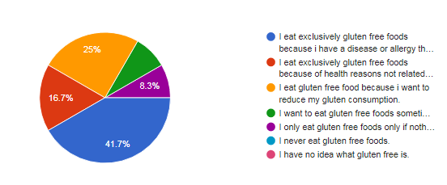

PHYSICAL RESOURCES
Location and Premises
The location of Nat’s Bakery will based in the City Centre of Cardiff, the premises is located on Queens street the building will cost around £2000 a month, the building was previously a bakery which means all fixtures are included with the rent price, locating and centralising my bakery business in the city centre is the best decision I have made as I take into consideration the importance of marketing towards one of the most significant steps to becoming noticeable and successful. I have made the decision to open my business in the heart of the city centre where people mostly meet or gather for shopping or socialising which means I have the potential towards a wider audience of customers. See Appendix 2.
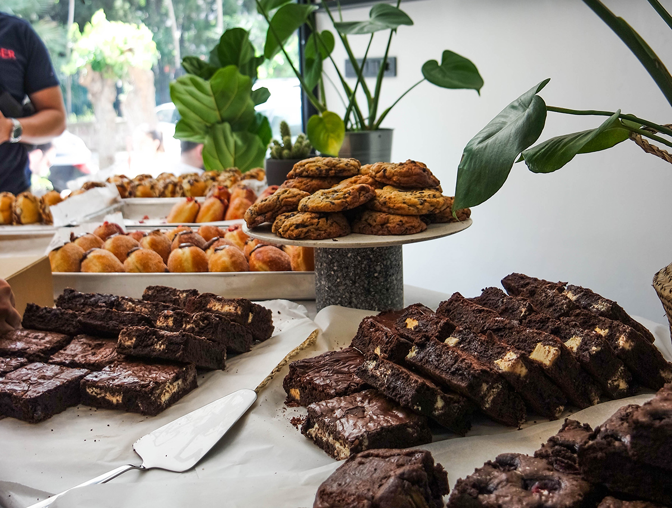

MACHINERY AND EQUPMENT
Nat’s Bakery does not require expensive machinery and equipment towards the production process, due to the premises being fully equipped with fixtures means I am able to purchase the latest machinery tolls needed towards the production process, the following graph below outlines a list of machinery costs and equipment.
Clay Oven Machine | £2000
Cake and Dough Mixers | £300
Coffee Machine | £1000
Chillers (Fridge) | £1500
Utensils | £100
Bread Slicer | £200
Baking Trays | £250

Plant and Machinery
All Bakery products will be produced within the bakery premises this will become cost effective as I will purchase raw materials from a supplier and convert the raw materials into physical plant, the physical plant will be conducted on premises, this process allows my business to reduce the amount of products being purchased from other suppliers as we aim to produce fresh baked foods within the facility on the premises, producing all food and baked products on the premises allows me to maintain all the standards checks on the production process more easily.
Equipment
The equipment being used within the bakery is the latest machinery equipment, operating to aim towards a high-quality products with the best equipment allows the production process to operate more efficiently and effectively to bake raw materials, majority of the equipment is technology operated, due to the advanced equipment operating techniques become easier within the work place.
Operating IT system
Clark (1998) Implements the benefits of an IT system towards operational aspects of the business, with the use of inbuild software means a variety of elements will be processed automatically through the computer which saves time costs for my business to operate accordingly. Aiming to connect with our customers, suppliers and organising payroll and work schedules through technology has seen an increase in operational workplace IT systems, my business will aim to use a management system tool with all the features my business requires. www.business.com outline why using modern technology solutions brings a strong gain for the business to develop especially in small businesses.
- Maintenance Staff Management
- Payroll Management
- POS Invoicing
- Time and Attendance Management
- Sales Tracking
- Ordering Management
- Food and Beverages Costing
- Delivery Orders
- Online Payments Print Receipts
- Order Tracking
- Credit Card & Loyalty card processing
Technology
Kiang (2000) verifies the benefits of capital marketing online, product advertisement is one of the main channels I will be using towards a direct marketing approach, My business will aim towards a delivery service system to become part of the service we provide allowing us to deliver our products, the mobile application is to receive orders and payments for online purchases, the payments will be taken via third party to ensure the payment is secure, there are a number of option towards to paying process, PAYPAL, Apple Pay or Bank transfer direct to the bakery’s business account.
Financial Resources
Nat’s Bakery Investment will be through personal savings, investing my personal savings have provided a wider advantage towards my investment through the bakery, investing my personal savings means financing towards a budget plan made easier, personally investing means I am in control of the choices I make, working towards my success and goals within the business has a greater advantage towards my personal investment, as an independent sole trader I will not be liable to pay back bank loans or rely on investor’s funds, having full ownership of my business means I will receive 100% of future profits.
Financial Plan
Creating my financial plan is where all of the business planning comes together, I have analysed and identified the Market and Target, along with pricing the business costs, this will allow me to estimate my total costs of the Bakery setup costs, estimating the overall costs is an important aspect towards my business to analysis outgoings and profits, it is extremely important to know the start-up costs of the my bakery business to verify what expenses are needed to fund before customer sales.
Project Start-up Costs
The table below verifies a clear description and sample of the ongoing and onetime costs of items that is required towards opening my own business. The chart below will provide a detailed start-up cost towards equipment for production as well as the operational aspects of the business
COST ITEMS | MONTHS | COST/MONTH | ONETIME COST | TOTAL COST
Advertising Marketing | 3 | £ 150.00 | £1,000 | £1,450
Employees Salary | 4 | £ 2,500 | - | £ 5,000
Rent Lease Payment | 4 | £2000 | - | £6,000
Business Insurance |  | - | £ 1,500 | -£ 1,500
Business Rates |  |  | £ 2,000 | £2,000
Utility Bills | 12 | £ 350 | - | £ 4,2000
Stock Supply | 12 | £2,500 | - | £ 30,000
Radio Licence |  | £ 200 | £ 800 | £800
Machinery and Equipment |  |  | £ 5,350 | £ 5,350
Computer Software |  |  | £ 8,00 | £ 800

HUMAN RESOURCES
Management Team with roles and responsibilities
Bakery Chef
The pastry Chef is the head of pastries bakery, including baking and making desserts, breads pies along with other baked foods, the pastry chef is a certified chef gaining many years of experience working in hotels restaurants and worked and a bakery as an expertise baker, he will work alongside another member of staff who is an apprentice baker, the apprentice will aim to gain the skills and experience he needs to produce unique products that will be available at the bakery, the chef has a complete understanding of the ingredients and how to bring the taste to a final form, the pastry chef will manage and supervise all the production activities to ensure the production process is operated smoothly.
Manager
Managerial will have the roles and responsibilities of all the operations within the business, the manager has a master’s in Human Resources management, with gaining a long term experience Working at M&S coffee shop means their skills and experience gained will be beneficial towards my business in terms of overseeing all the operations and managing the workforce.
Customer Assistant
Customer assistants will be required to undertake workplace training to gain the knowledge and understanding of the products and ingredients produced within the production process, it is an extremely important factor towards employees awareness and importance of the ingredients and products being disrupted, the job description requires sales assistants to greet and serve customers, advising and assisting customers and handling complaints, the following will give a more clear description of responsibilities of a sales assistant.
- Greeting and serving customers as they enter the Bakery
- Advising and assisting customers.
- Handling complaints or forwarding serious issues to the manager on duty.
- Conducting customers transactions.
- Replenishing the supply of stock on the display and shelves
- Assisting with store deliveries
SWOT ANALYSIS
Competition in the market is one of the most important aspects for me to improve how we operate compared to other bakers, analysing the competitive environment from a positive window means I have to contribute towards developing my reputation to become established, analysing other bakery’s production has shown a vast amount of choice of products available, which makes their products more popular as opposed to customized products which is aimed at a majority of people, however I will continue to maintain the personalization of the business identity with the option to provide my products to meet everyone’s demand, taking into consideration the business environment and the impact that may occur, conducting a SWOT analysis Srdjevic (2012) means my business is able to view the strengths, weaknesses, opportunities and threats with a clear visualisation on my business operation. See Appendix 3.
APPENDIX
PRODUCT Appendix 1.
Nat’s Bakery provides a wide selection of baked goods, and the product quality is essential for the success of the business, in order to ensure product quality, the bakery will emphasize on quality ingredients which are starch containing foods that are Gluten – Free, the following grains are.
- Topioca Flour
- Teff Flour
- Buckwheat Flour
- Quinoa Flour
- Coconut Flour
Innovation is an extremely important aspect factor in the growth and success of my business, the bakery will continually work to develop and test new recipes which can potentially attract a wider audience of customers, by creating new products at Nat’s Gluten Free Bakery will not only grow as a business but will also increase the profits of sales.
PLACE
The first location of Nat’s Bakery will be in the Cardiff city centre, opening as a small business as a sole trader gives me the opportunity towards developing and expanding in neighbouring towns and cities, potential success of the overall business will allow the business to increase, the internet is an extremely efficient method of expanding my business, targeting online publicity means my products becomes accessible to a much wider range of customers to view everything offered by the bakery. My aim to retrieve a higher volume of customers means evolving towards the trends of technology, proving a service where customers can place Online orders for collection or delivery.
PRICE
Once the business first opens its key objectives will include strong market share, achieving these goals will eventually allow the business to become profitable, keeping these goals in mind, the business will chose prices which are competitive with other bakeries, this will be a greater advantage towards my bakery staying in business with prices that not higher over competitors, the advantage towards analysis price comparing means I am most likely attracting a higher volume of customers, balancing and values my products means I must not come below the market price, so the business is still able to retrieve as much income while remaining competitive, the outcome of market shares will then be able to pay outgoing costs and within time receive a profit.
PROMOTION
Customer satisfaction is the first step towards customers awareness as my business will be locally based, the marketing activities would not be through the expensive tolls, since we can target a trace our customers easily from everywhere via social media and Instagram/Facebook. We will take the social media platforms as the main marketing methods that would be used in our advertisements, as the social media have the low costs with more expands which has the technical features that helps to target a wider audience of people, social media allows us to be in direct contact with our customers and keep them updated with our new products and promotions, promotions will be selected to customer who register to the company email, in return receiving monthly discounts of 10%, social media platforms allows my business to connect and review customers feedback more easily. The Social participants is another principle towards our community which in return enhances the relationship with people, we will take every opportunity as possible to join any social activities that happens locally.

Bricks/e–commerce Appendix 2.
The business will be combined as a Bricks and e – commerce business, this simply means my business has a physical and online retail presence, BARKER (2019) that smaller brick and motar businesses are experiencing a online retail presence which offers quicker and inexpensive operations with a unique approach towards e – commerce, this approach is my main aim to establish a wider market presence by providing a more optional service online, there are a number of elements that will be provided.
- Birthday and Celebration Cakes
- Party Buffets
- Requested Personalised Products
- Delivery Service
- Collection Service

SWOT ANALYSIS Appendix 3.
STRENGTHS | WEAKNESSES | OPPORTUNITIES | THREATS
Excellent Location | The capability dealing with high purchase requests | Aiming to promote and produce products suitable for all communities  - Gelatine Free  - Gluten Free  - Vegan / Plant Base | Slow economy growth after COVID Pandemic
Expertise in Gluten Free baking methods | Competitors offering same products lower price | Delivery Services  Personal delivery  UBER eats  Deliveroo  Just eat | Competitors promoting similar products at lower prices
Hand crafted and fresh foods from scratch everyday | No nearby parking | Loyalty Members receiving 10% discounts on a monthly basis | Market demands
Workplace training at Nat’s bakery | Lack of financial Resources | Promoting Meal Deals | Economy Market
Monthly promotions |  | Expanding city’s / towns business throughout other | Increase of prices of raw materials
All Raw materials produced on premises

Appendix 4. Profit and loss
STRART UP COSTS (Nat’s Gluten Free Bakery)
Revenue | JAN | FEB | MAR | APR | MAY | JUN | JUL | AUG | SEP | OCT | NOV | DEC | YTD
^{Estimated product sales} | ^{£ 3,000} | ^{£ 3,800} | ^{£ 5,500} | ^{£5,000} | ^{£6,000} | ^{£9,000} | ^{£11,000} | ^{£10,000} | ^{£ 12,500} | ^{£13,000} | ^{£5,000} | ^{£8,000} | ^{£91,800}
^{Service revenue} |  |  |  |  |  | ^{£250} | ^{£ 350} | ^{£100} |  |  | ^{£1,245} | ^{£1.360} | ^{£3,305}
^{Cost of goods sold} | ^{£1,500} | ^{£4,000} | ^{£5,500} | ^{£2,800} | ^{£5,800} | ^{£6,400} | ^{£5,995} | ^{£2,820} | ^{£3,200} | ^{£4,000} | ^{£3,000} | ^{£6,000} | ^{£51,015}
^{Gross Profits} | ^{£2,000} | ^{£4,000} | ^{£6,500} | ^{£2,200} | ^{£4,200} | ^{£6,100} | ^{£7,205} | ^{£8,180} | ^{£8,700} | ^{£8,500} | ^{£5,000} | ^{£8,000} | ^{£70,585}
Expenses | JAN | FEB | MAR | APR | MAY | JUN | JUL | AUG | SEP | OCT | NOV | DEC | YTD
^{Salaries and wages} | ^{£2,500} | ^{£2,500} | ^{£3,500} | ^{£5,000} | ^{£5,000} | ^{£5,000} | ^{£9,000} | ^{£9,000} | ^{£9,000} | ^{£9,000} | ^{£9,000} | ^{£9,000}
^{Marketing Advertisement} | ^{£150} | ^{£150} | ^{£150} | ^{£150} |  |  |  |  |  |  |  |  | ^{£600}
^{Sales Commissions} |  |  | ^{£50} | ^{£50} | ^{£220} | ^{£150} |  |  |  | ^{£100} | ^{£50} | ^{£50} | ^{£820}
^{Rent} | ^{£2,000} | ^{£2,000} | ^{£2,000} | ^{£2,000} | ^{£2,000} | ^{£2,000} | ^{£2,000} | ^{£2,000} | ^{£2,000} | ^{£2,000} | ^{£2,000} | ^{£2,000} | ^{£24,000}
^{Utilities bills} | ^{£200} | ^{£250} | ^{££260} | ^{£215} | ^{£215} | ^{£215} | ^{£250} | ^{£300} | ^{£300} | ^{£250} | ^{£200} | ^{£180} | ^{£2,770}
^{Online Plat form} | ^{£60} | ^{£60} | ^{£60} | ^{£60} | ^{£60} | ^{£60} | ^{£60} | ^{£60} | ^{£60} | ^{£60} | ^{£60} | ^{£60} | ^{£720}
^{Internet/Phone} | ^{£35} | ^{£35} | ^{£35} | ^{£35} | ^{£35} | ^{£35} | ^{£35} | ^{£35} | ^{£35} | ^{£35} | ^{£35} | ^{£35} | ^{£420}
^{Insurance}
^{Travel} | ^{£200} |  |  | ^{£200} |  |  |  |  | ^{£200} |  |  |  | ^{£600}
^{Legal Accounting} | ^{£700} |  |  |  |  |  |  |  |  |  |  |  | ^{£700}
^{Office Supplies} | ^{£80} | ^{£80} | ^{£50} | ^{£50} | ^{£100} | ^{£50} | ^{£50} | ^{£50} | ^{£80} |  |  |  | ^{£590}
^{Interest Expenses}
^{Total Expenses} | ^{£2,420} | ^{£1,570} | ^{£1,600} | ^{£1,755} | ^{£1,625} | ^{£1,590} | ^{£1,440} | ^{£1,620} | ^{£1,390} | ^{£1,390} | ^{£1,320} | ^{£1,290} | ^{£19,160}
^{Income Tax Expenses} | ^{£420} | ^{£2,430} | ^{£4,900} | ^{£445,00} | ^{£2,575} | ^{£4,560} | ^{£5,615} | ^{£6,740} | ^{£7,080} | ^{£7,110} | ^{£3,680} | ^{£6,710} | ^{£52,265}
^{NET INCOME} | ^{£2,996} | ^{£1,594} | ^{£2,401} | ^{£3,851} | ^{£156} | ^{£676} | ^{£1,488} | ^{£1,75} | ^{£253} | ^{£1,891} | ^{£2,270} | ^{£1,213} | ^{£2,246}

Implementing a prof and loss projection of my bakery is a good exercise to understand and communicate when the bakery will begin to break even and see how much sales and profits will grow. The top portion of the model to the left, Revenue is a good way to forecast sales, month by month for the first year, the lower portion then applies estimated expenses for the first year. The lower portion then applies estimated expenses for the same period of time to drive the business profitability

REFERENCES
BARKER, T., 2019. TOOLS FOR DRIVING BUSINESS. The Shooting Industry, 64 (9), pp. 38 – 41.
http://www.business.com/artical/how-technology-benefits-small-business.
https://www.bbc.co.uk/news/magazine-37292174.
Kiang M. Y. Raghu T. S., Shang K. H. M. (2000) Decision support systems, 27 (4), pp. 383 – 393.
KRUSH, M. T,. SOHI, R. S. and SAINI, A., 2015. Dispersion of Marketing’s Influence and business unit outcomes. Journal of the Academy of marketing science, 44 (1), pp. 32 – 51.
RINGLE, C. M. and SARSTEDT, M,. 2016. Gain more insight from your PLS – SEM results. Industrial Management & Data systems, 116 (9), pp. 1865 – 1886.
Srdjevic, z., Bajectic, R. & Srdjevic, B. Identifying the criteria set Multicriteria Decision Making Based on SWOT/PESTLE Analysis: A case study Reconstructing A water Intake Structure. Water Resource Manage 26, 3379 – 3393 (2012). https://doi-org.ezproxy.uwtsd.ac.uk/10.1007/511296-012-0077-2.
The ® revolution of wine marketing m ix: From the 4P’sto the 4Es festa G. Cuome M. T. Metella G. festa A. (2016) Journal of Business Research, 69 (5), pp. 1550 – 51.

