
RESEARCH & CASE SCENARIO DATA SECURITY
Student University of Wales Trinity St David, Swansea, Wales


2104756@student.uwtsd.ac.uk

Contents
Abstract 3
I. Introduction 3
Task 1 3
II. Physical Security [1-7] 3
A. Physical Locks 3
B. Key card Locks 3
C. Fingerprint Scanners 4
III. Real-time intrusion detection 4
A. Threat Detection 4
B. Perimeter Detection 4
C. Damage Prevention 5
IV. Security Technologies 5
A. Firewalls 5
B. VPN’s 5
C. Data Loss Prevention 6
Task 2 6
I. Risk Management 6
A. Avoidance 7
II. Policies 8
A. Password management 8
B. Data Protection 9
C. Authorization / Access Control 9
Conclusion 9
References 10

Abstract

This report will be discussing the importance of understanding the key issues that come with protecting information, deciding what kinds of protection a computer network will need, adapting to current trends to lower the chances of a future data breach. Designing an appropriate security system with the inclusion of a proper instruction detection system.

Introduction
The report will go into detail about the different types of security and the different levels of security that may suit a specific organization depends on its operations. This section will list the different types of locks and describe the pros and cons of said locks for different purposes. This report will also cover intrusion detection and what levels of security are put in place to detect threats both internally in the company’s network and externally outside of the building which may have attackers try to breach the premises. Lastly, the report will discuss different security technologies like VPNs, Firewalls, and access controls.

Task 1

Physical Security [1-9]
Physical security is the first line of defense for a network, it is possible to access a network remotely, but this has been proven to be difficult. To combat any possible data leaks or network damage you would need to have a decent physical security system [1] like…
- Physical locks (RFID tags, lock, and key)
- Real-time intrusion detection (metal detectors, security cameras)
- Damage prevention (fire alarms, fire detectors, smoke alarms)
There are 5 levels of physical security, this first level is minimum security. This level includes security systems such as door and window locks and an alarm system to try and prevent any unauthorized access if possible. [2]
The second level of security is low security, this is an improvement from the first level, and it includes armoured doors, lighting, and iron bars covering windows. Most supermarkets and small businesses have this level of security and it's more than adequate. [2]
After low security comes medium security, this level of security covers both indoor threats and outdoor threats so this is ideal for big supermarkets, and warehouses. It can detect damage caused to windows or the surroundings by using cameras and motion detectors which will then sound an alarm to the nearest law enforcement. [2]
The last level for most businesses is high-level security, this level monitors everyone’s actions to act upon and predict actions that may break the law or a company’s policy. Employees must use biometric locks (fingerprint scanners) to pass through doors. This level of security is considered overkill and only high-priority/dangerous areas must have this level of security like prisons and medical centers. [2]

Physical Locks
Certain areas of buildings require higher levels of access than others due to the equipment placed in said rooms or if any environmental hazards may or may not cause harm to the individual who enters the room. [3]
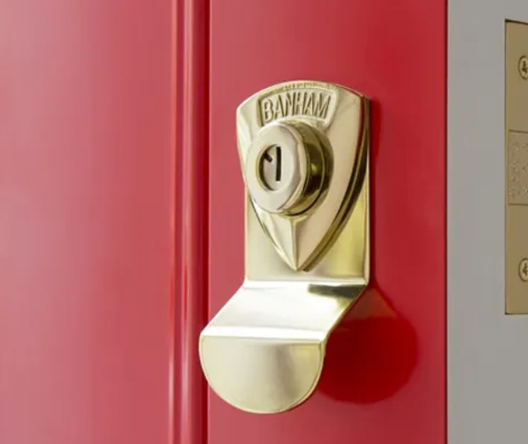
Figure 1 Image of door lock [4]

Key card Locks
The next type of lock is the key card lock, this is mainly used in many businesses because it allows the organization to assign certain rooms to certain people instead of giving them an individual key. [3] This kind of lock cannot be picked unless the thief gained access to the key card, or they have cloned the card itself which is a possibility of attack. [5]
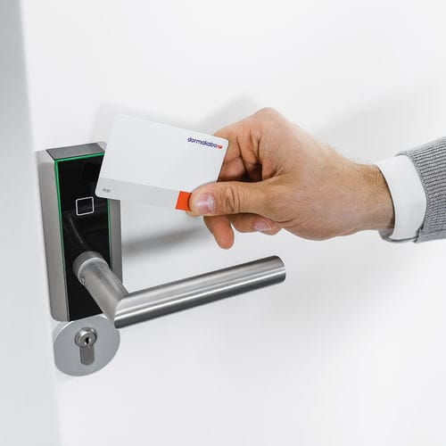
Figure 2 Holding an NFC card against a door [6]

Fingerprint Scanners
Fingerprint scanners aren’t a common type of authentication for most businesses, but they are some of the most secure methods of authentication for a company. [7] there are different types of fingerprint scanners…
- Optical
- Capacitance
- Ultrasonic
- Thermal
The most secure fingerprint scanner on the market is the ultrasonic fingerprint scanner, [8] this scanner works by shooting out a pulse of sound waves onto the tip of your finger when it's pressed against the scanner, this information is then bounced back to the receiver which then looks through its database to determine whether the fingerprint is valid or not.
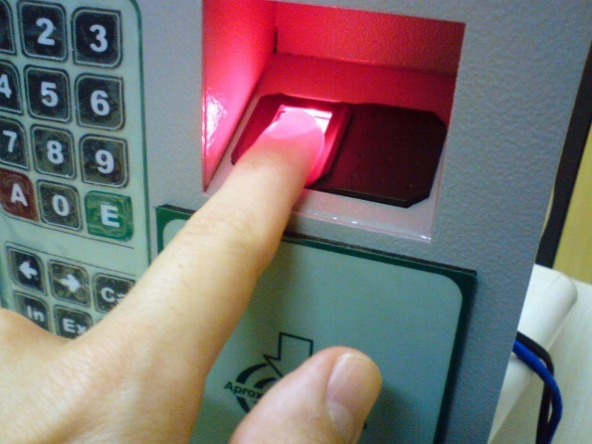
Figure 3 Finger pressed on a fingerprint scanner [9]

Real-time intrusion detection [10-14]
The next level after locks is the real-time intrusion detection system, there are 2 levels to the intrusion detection system, and they are… [10]
- Threat detections System
- Perimeter detection system
The purpose of a real-time detection system is to detect and prevent any suspicious activity that may arise day or night. [10]

Threat Detection
Threat detection can be used for both network threat detection and on-site threat detection to capture any weak points that may cause a breach. The purpose of this method of detection is it analyzes the entire network of devices and the premises to identify any possible risk of a compromised work environment. [11] This needs to be carried out swiftly because as soon as attackers break in, they will attempt to gather and or erase sensitive data immediately as soon as they have gained access. If a company's data has been compromised the attacker will usually ask for a ransom, if the company does not reply within the attacker's timeline, then they will publish the information online which is catastrophic for any organization. [11]

Perimeter Detection
Depending on the organization physical security could be an afterthought or a top priority, this is understandable for a small office that will mainly use card readers to enter and leave the building. [12] But for a large organization then there will need to be extensive devices like cameras, metal detectors, and barbed-wired fences. Larger organizations are targeted more when it comes to physical attackers compared to smaller organizations who are often more targeted on a network level. Smaller organizations are targeted more often on a network level due to the manpower and overall scale. This means security isn’t up to proper standards and does not have the resources to deal with a cyber-attack properly, [12] this leaves the business with outdated software and possible vulnerabilities which an attacker could take advantage of. Large or medium-sized organizations are prone to physical attackers (thefts, vandalism) so they will need to detect and possibly prevent harm or damage to staff members and equipment. Not having proper safeguards in place could lead to a lawsuit which could bankrupt a small business and will leave a deep hole in a large or medium-sized organization's wallet. [12]

Damage Prevention
All organizations will have policies in place for employees to follow to mitigate or prevent any possible accidents and damage. [13] Multiple different types of devices are used to save equipment went a fault occurs, the first being smoke detectors which are placed in smaller areas with lots of different devices or in a room where there is a major possibility that a fire could occur. [13] This device also sends an alert to a security team which then will respond appropriately to the situation. The second damage prevention device would be a fire extinguisher, which is placed inside the same room as smoke detectors, depending on what is in the room there would be a specific kind of fire extinguisher… [13]
- Water [13]
- Foam [13]
- CO2 [13]
- Powder [13]
Water fire extinguishers are mainly used on wood, paper, and cardboard. The next fire extinguisher is foam which is used on flammable liquids. [13] A powder fire extinguisher is used for cooking oil specifically which is mainly stored in a kitchen of a building and may spread to other areas. Lastly, CO2 is used on liquids and electrical fires which is used and stored in an I.T room. [13]
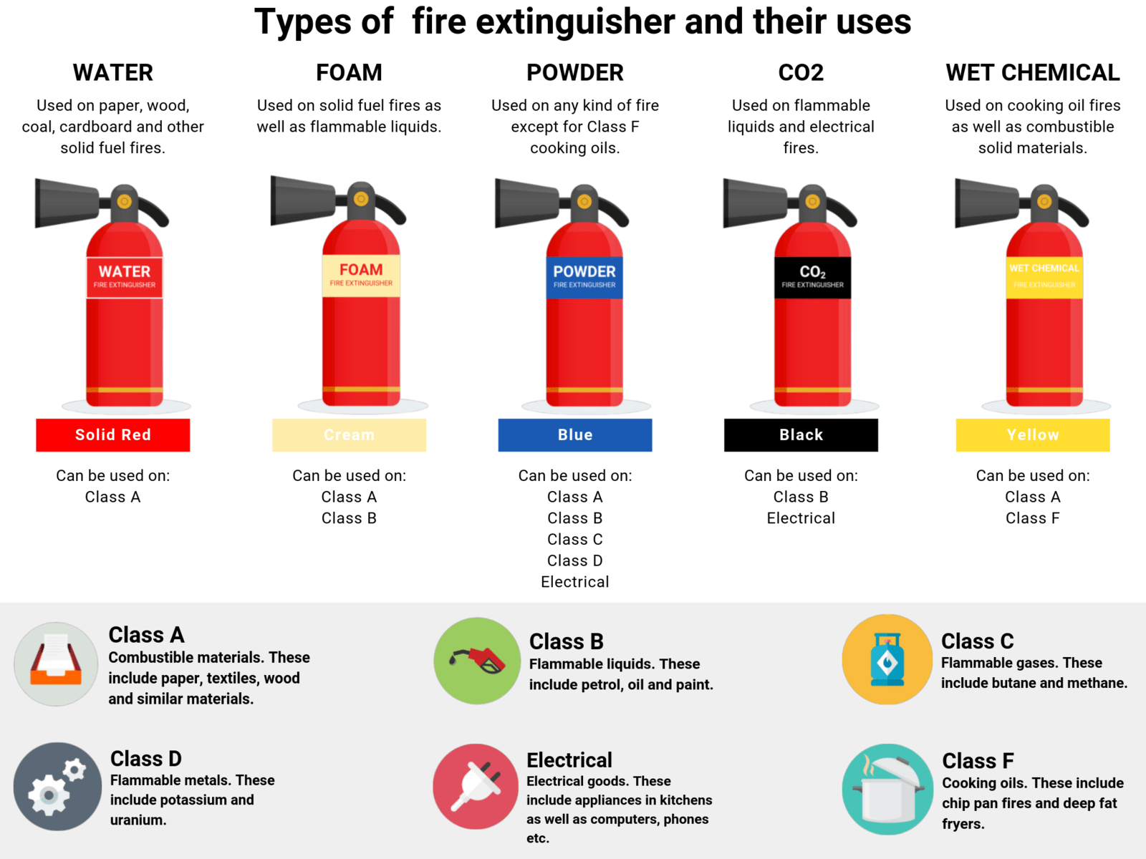
Figure 4 Types of fire extinguishers [14]

Security Technologies [15-21]
Security technologies mean many different things including… [15]
- Firewalls [15]
- VPN’s [15]
- Data Loss Prevention [15]
New inventions and ideas are used to build a better future by implementing new security measures to make breaching a network more difficult for attackers. Understanding and implementing these new ideas require a high level of understanding of new technologies and security measures beforehand. [15]

Firewalls
A firewall is like a barbed wire fence but for the internal network of an organization, its main purpose is to filter content that comes in and out preventing or mitigating attacks. [16] The filters differ from organization to organization depending on the policies in place. Having a well-implemented and secure firewall will not only keep data safe as it leaves and enters it will also filter out bad content like malicious sites. Firewalls can be described as a barrier, no matter how secure a network may appear to be there will also be gaps and or exploits that can slip past. [16]
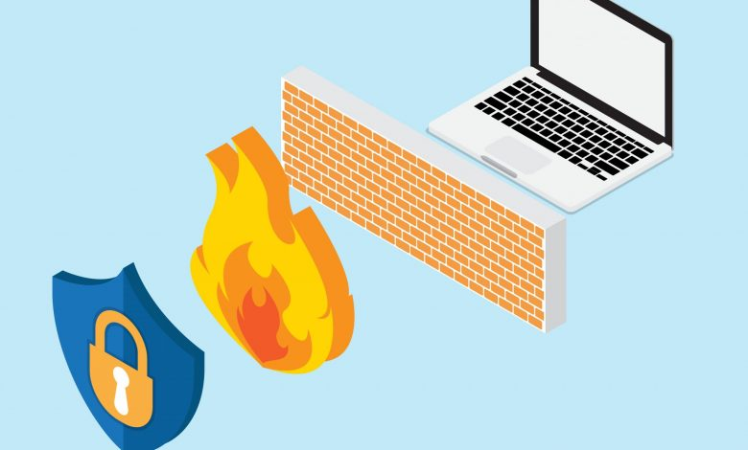
Figure 5 Image of a firewall [17]
The most computer already has preinstalled antivirus protection and depending on a company's policy they may have installed a third-party client which may benefit them more than a traditional and preinstalled antivirus such as Microsoft Defender. [16] This antivirus software comes preinstalled on Windows 10 and 11 and it even comes preinstalled on Windows servers 2016 or newer so there is a small chance that there might be a possible compatibility issue. Without a firewall, there will be no safeguards in place and the organization's network will be flooded with malicious software causing the network to go down or data may get stolen. [16]

VPN’s
VPNs have many different uses, they can be used to encrypt your traffic so packets can’t be captured and analysed for any sensitive data. [18] This works by routing all data through the provider's servers (VPN company servers) this would be a great way to bypass any regional restrictions by routing to a different country (censorship). [18] Organizations can also use this by routing traffic through their servers monitoring any traffic between the host and the destination and making sure it is not being monitored by an unauthorized third party. [19] An organization would use a VPN mainly to connect directly to the company's local servers and the server would believe that the host is connected within the premises. [18]
VPNs are one of the cheapest services to boost an organization's security because most providers offer a small monthly bill every month depending on the size of the company but for large organizations, this isn’t an issue. Having a secure tunnel for data to transmit and be received allows an organization to operate efficiently and without compromises.
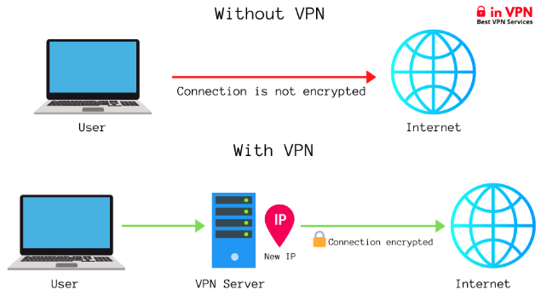
Figure 6 Image of the benefit of a VPN [19]

Data Loss Prevention
Data and information are a topic that companies either love to talk about or think of as an after though, either way protecting customers' data and business data should be the highest priority when it comes to security. [20]
Companies all over the world suffer from ransomware attacks, malware, and trojans and company computers can become infected with a piece of software called a “worm”. [20] Even the most secure system around the world do suffer vulnerabilities and or exploits which leaves them open for data loss and or data corruption. [20]
The way to mitigate data loss is to have copies of data spread out evenly without sacrificing security and costs to maintain data. [20] Larger organizations prefer to keep their data on their servers due to the sensitivity of the data and their ability to afford the hardware, which results in a faster work environment due to increased data transfer speeds of local servers with access to full control over the data and the devices that handle and store sensitive documents. [20]
Smaller organizations do not have the budget for on-site servers so their best option would be an online cloud service provider like Google Cloud or Amazons AWS. These are great options for s small businesses because they create backups every so often and they spread your data out over multiple data centers to optimize efficiency and for availability. [20]
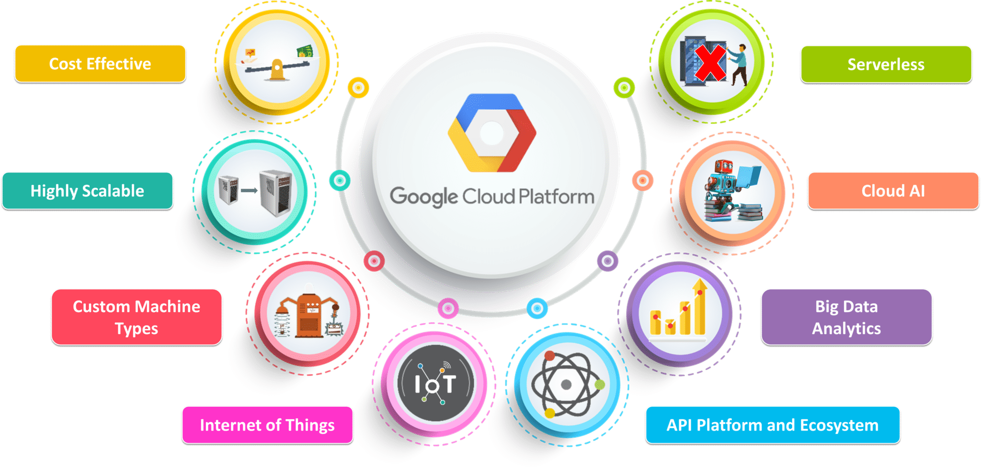
Figure 7 image of GCP and benefits [21]

Task 2

Risk Management [22-27]
Risks are a part of everyday life and learning to adapt and overcome these risks is vital for security and well-being, Risk management involves controlling and analysing possible risks and attacks that may affect a company. A cyber-attack on an organization can result in data loss, loss of service, and stolen data. [22]
A data breach not only affects the organization but depending on the business can also affect the customers as well, for example, if a company has experienced several data breaches, then the public will know to stay away from them because they now have little trust in the business. [22]
To lower the chances of a data breach and knowing how to act when a breach does happen is very important, and some actions need to be taken to get the business back to normal. [22]
According to the UK GDPR, all companies should report the data breach to the supervisory authority within 72 hours [23] and if a company does not report the breach within the time frame, they are then fined £8.7 million [23]
Understanding the severity of different threats can help pinpoint which areas need to be focused on while other areas may not need as much attention. [22]

Avoidance
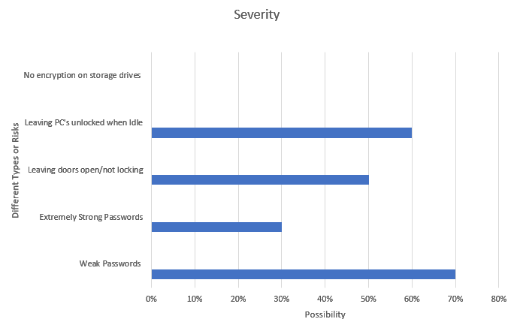
Figure 8 Graph of different types of risks
In this table, I have listed some Risks that a business may face and the higher the severity results in a greater possibility of that risk being exploited, for example, a weak password can be very damaging and it's one of the most common ways that a system gets compromised, so it is labelled as “High” severity. [24]

Weak Passwords / Strong Passwords
To overcome the weak password, issue an organization may set up a service called a “Password Manager” there are lots of different companies that provide a secure password manager, but may vary in quality. [24] Many businesses may prefer to have a local database of their passwords but in most cases, they would choose a third party, one of the most reputable password managers on the market is called “Bitwarden”, [25] Over the years they have built a reputation for being lightweight and open source, it allows any individual and organizations to view the code of the service to check for any malicious content. [24]
Bitwarden as a service is completely free for personal users but for an organization, there is a small fee of $5 per month, per user. In the long run, using a third-party password manager would save an organization some money due to maintenance costs, developing and updating the software, and having a separate server to store the data on. [25]
Creating and storing passwords in the password manager not only allows the organization to pass around passwords securely but they have the option to make them very complicated which will make brute force attacks extremely difficult or near impossible. [25]

Identifying security threats
Making an excel table and listing each type of attack and the possibility of said attack can help the organization put their funding towards the more important aspects, it's very difficult or in some cases impossible to protect all assets so an organization will need to sacrifice or focus more on the servers and computers than the motion detection system for example. [26]
For big organizations, the biggest threats to look out for are phishing, malware, and an internal data breach, phishing is the most common when it comes to security threats and most of them are very difficult to spot. [26]
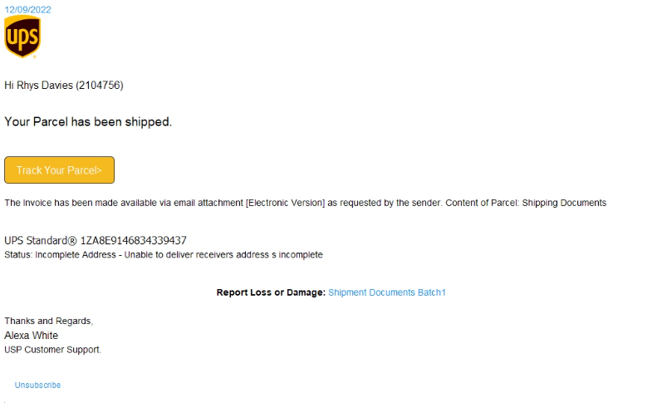
Figure 9 Image of a phishing email
Malware isn’t as common but it can damage computer systems if it has entered the network, the way computers get infected with this type of malicious software is when a user downloads and runs an attachment that was sent to them through an email or they click on a link and it takes them to a malicious site in which the malware will automatically download and install itself onto the user’s computer which then starts the infection. [26] A way to prevent this from occurring is to not click on links directly but to message the sender using another trusted platform asking them if they did send the email. [26]
An internal data breach can mean one of two things, the first type of an internal data breach means that an employee has purposely weakened the network allowing themselves or a third-party attacker to then steal personal data or the employee has gotten access to highly sensitive data, stealing it, and then posting the information online. This issue can be solved by restricting access to certain systems depending on the role of the employee. [26]

Software & Hardware Failure
Nothing lasts forever, the same applies to technology. Now and then there will be downtime and there is nothing that can be done to completely prevent it although it is possible to have a backup just in case the main system goes down so that can be used while the system is being fixed. [27]
- Software Failure
To prepare for a software outage an organization would need to have a backup system in place when the main system goes down, to predict when a program or service may crash is by monitoring its vitals by checking the performance statistics and regression tests which will show you if there are any anomalies present. [27]
Most organizations may prefer to build their software to monitor software faults and generally, this is acceptable, but the software package will need regular maintenance to keep stable, reaching out to a third party will not only take away most of the maintenance aspects but may end up being cheaper by using another organizations software services. [27]
Depending on what software goes down can leave an organization extremely vulnerable. The firewall may go down allowing malicious actors to enter the network effortlessly, or the database that handles potentially thousands of records could go down resulting in customers being unable to access their personal information. [27]

- Hardware Failure
Hardware is one of the worst types of fault to get because if the actual hardware is damaged then it would cost a significant amount to repair or replace. If the main server goes down, then the entire organization may come to a halt because the employees cannot access their files on the local server, or they cannot access the network because the main hub has gone down. [27]
To try and predict when a server may go down is doing the same thing when predicting when software may go down by monitoring the server's vitals for example if the server is still running at full speed or it keeps dropping the connection every so often. [27]

Policies [28-29]
Every organization has its Policies which could involve their privacy policy for how they secure their data or a workplace policy that covers rules which each employee must follow in order not to cause any damage to equipment or themselves. [28]
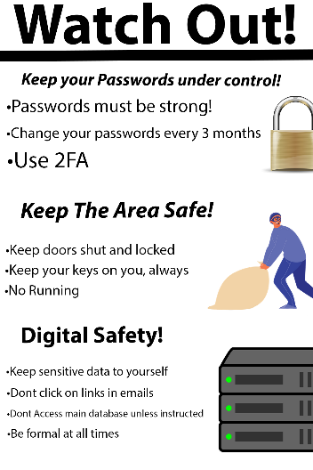
Figure 10 Poster about digital security

Password management
For storing and creating passwords there will need to be a set of rules in place because not every employee is great at creating passwords so creating a set of rules that they will need to follow will prevent them from making poor passwords. [28]
- Passwords must be strong and unique [28]
- Users must change their passwords every 3 months [28]
- Use 2-factor authentication [28]
Updating passwords every 3 months is generally recommended because the password could have already been leaked before and has been added to a list in which attackers will brute force logins. And is good security practice to update logins regularly to make the attacker's job harder. [28]
Using 2-factor authentication is the best way to keep attackers out without needing to have a super complicated password, it works by either sending a code to your phone and you enter it on the login page (not secure), or you enter a 2-factor key also known as YubiKey which is required for a user to enter the computer, and they have logged in successfully (very secure). [28]

Data Protection
Passwords shouldn’t always be the first and only line of security for most computing systems because of the risks that come with them, there are lots of different methods of authentication that an organization can choose depending on their budget and or their threat level. [29]
- Keep Sensitive Data to yourself [29]
- Access to sensitive data is restricted to authorized individuals [29]
- Don’t leave any computers unlocked when you aren’t present [29]
As mentioned previously 2 factor authentication is a great way to secure a computer or an online service that a user may rely on, it is known that having a security key (YubiKey) can completely prevent phishing attacks. This is because when an individual logs into a computer the system will display a message asking for the key to be plugged into the USB port, if they don’t have access to the key, they cannot log in. [29]
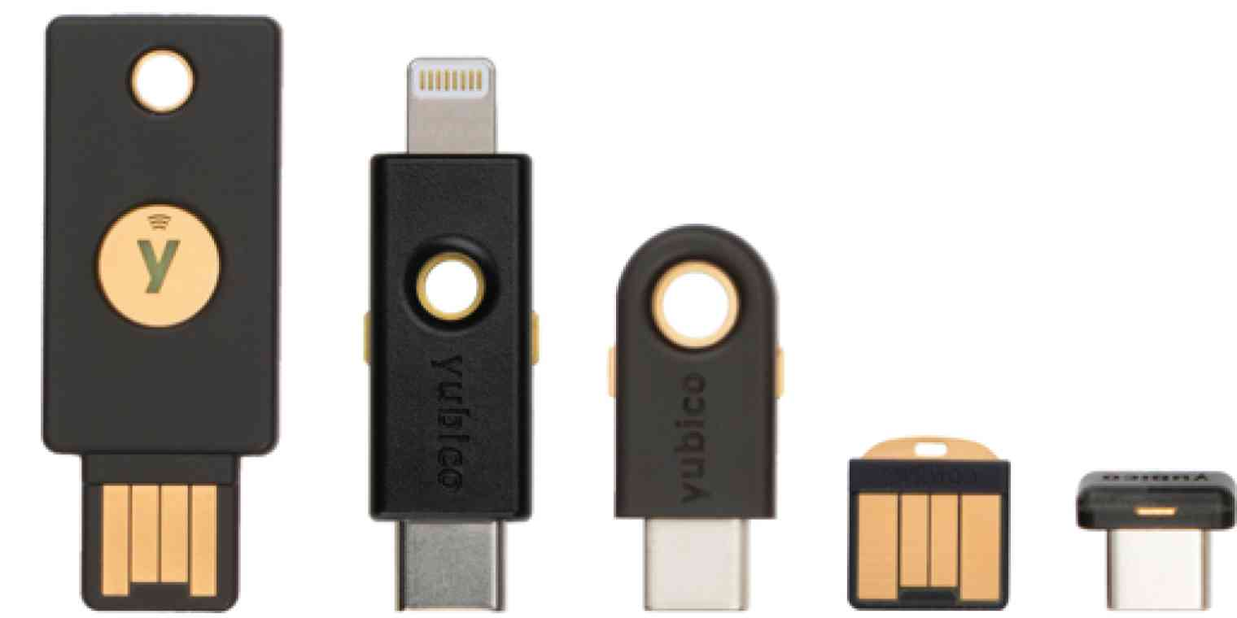
Figure 11 Image of YubiKeys [30]
Phishing attacks can be very difficult to spot and having a YubiKey will prevent a phishing attack, the only downside is that they can be inconvenient because a user will need to carry around their key with them wherever they want to access a computer. [29]
The pros outweigh the cons for the security aspect so implementing one in a business will improve physical security greatly. Some lower leveled computers that do not contain vital information or are not connected to the internet may not need to have a security key so a username and password will be more than sufficient for basic computers. [29]

Authorization / Access Control
One of the biggest potential threats to a business could be one of its employees, the threat may occur when a rogue employee gains access to a restricted area by accident or on purpose. [29]
- Mandatory Access Control (MAC)
The sole purpose of MAC is to limit access to certain buildings, rooms, and even doors. Some employees/visitors can be trusted more than overs but in today's age, nobody can be trusted so as a precaution I.T admins will place restrictions on employees' badges/keys to stop them from accessing rooms they are not assigned to. [29]
This is mainly used for new hires or for visitors who are new to the area and may end up entering a room or accessing a computer they are not authorized to do so. [29]
- Role-Based Access Control (RBAC)
This level of restriction depends on the role of the individual, the organization or the IT team will assign each employee customized permission for them to access certain files and systems. Giving a new hire full access to the company's main database or full access to the network would be a very bad idea because of the potential risks such as an internal data breach or downtime from a misconfiguration. For basic file configuration, the IT team can set read and write permissions which gives them control over what they can and cannot do. [29]

Conclusion
This report has covered multiple areas of security and how they can aid an organization in terms of security and potentially save money from potential breaches and stolen data. The report has discussed physical security which includes information about the different types of locks and the different levels of security ranging from low to maximum security. Security technologies such as firewalls, VPNs, and Data Loss prevention technologies such as the cloud. The last section discussed Risk management and Policies which both include topics about securing systems with passwords and access controls.
In conclusion, investing in security technologies and good hardware will not only sustain a healthy business in terms of reputation but will also save money from a potential meltdown in the near future.

References

[1] | L. J. F. a. L. J. Fennelly, Effective physical security, Amsterdam, 2017.
[2] | C. G. P. C. a. D. S. C. J. Brooks, Cybersecurity essentials, 1st, Ed., Hoboken, 2018.
[3] | K. B. a. M. N. E. Harris, Door Locks, Wall Stickers, Fireplaces: Assemblage Theory and Home (Un)Making in Lewisham’s Temporary Accommodation, vol. 52, 2020.
[4] | “How to Choose A "Smart Lock" For Your Front Door,” [Online]. Available: https://www.banham.co.uk/doors-locks/locks/how-choose-smart-lock/. [Accessed 26 November 2022].
[5] | Keycards, vol. 65, Logding hospitality, 2009, p. 54.
[6] | “C-LEVER COMPACT - Electronic lock by dormakaba: ArchiExpo,” [Online]. Available: https://www.archiexpo.com/prod/dormakaba/product-52803-334749.html. [Accessed 29 November 2022].
[7] | V. I. I. a. J. S. Baras, Authentication of area fingerprint scanners, vol. 94, 2019, p. 230.
[8] | B. Deng, Ultrasound fingerprint scanners amplify security, London, 2015.
[9] | “IFSEC Global | Security and Fire News and Resources,” 30 July 2021. [Online]. Available: https://www.ifsecglobal.com/global/biometric-security-systems-guide-devices-fingerprint-scanners-facial-recognition/. [Accessed 29 November 2022].
[10] | L. W. a. T. V. S. Raza, SVELTE: Real-time intrusion detection in the Internet of Things, vol. 11.
[11] | E. Bertino, Data protection from insider threats, San Rafael Calif: Morgan & Claypool, 2012.
[12] | Z. G. L. M. J. W. a. L. Y. C. Y. S. Li, Simulation Study on Multi-Frequency Signal Detection in Perimeter Intrusion Detection System by Matlab, Vols. 530-531, 2014, p. 296.
[13] | W. M. W. Lam, “Attack-prevention and damage-control investments in cybersecurity,” Information economics and policy, vol. 37, pp. 42-51, 2016.
[14] | “Fire Extinguisher Types,” 2 September 2021. [Online]. Available: https://cpdonline.co.uk/knowledge-base/health-and-safety/types-fire-extinguishers/. [Accessed 1 December 2022].
[15] | A. K. N. S. a. D. M. W. S. Cheruvu, Demystifying Internet of Things Security Successful IoT Device/Edge and Platform Security Deployment, Berkeley, CA: Apress, 2020.
[16] | S. Y. a. S. Carnovale, Cyber security and supply chain management : risks, challenges and solutions, Hackensack, New Jersey: World Scientific Publishing, 2021.
[17] | “Is it Necessary to Have a Strong Firewall For Businesses?,” PC Tech Magazine, 20 October 2021. [Online]. Available: https://pctechmag.com/2021/10/having-a-strong-firewall-for-businesses/. [Accessed 7 December 2022].
[18] | H. J. M. D. M. a. A. M. E. Whitman, Green, Guide to network security, International ed. Australia: Course Technology Cengage Learning, 2013.
[19] | “Privacy, VPN, Streaming, P2P & Other Tech Guides - inVPN,” [Online]. Available: https://cybersynchs.com/vpn-101/. [Accessed 8 December 2022].
[20] | A. A. J. a. W. N. I. A.-O. A.-O. B. Husham Ali, “Data loss prevention (DLP) by using MRSH-v2 algorithm,” International journal of electrical and computer engineering, vol. 10, p. 3615, 2020.
[21] | “What is Google Cloud Platform (GCP)?: GCP Services,” 28 September 2022. [Online]. Available: https://www.edureka.co/blog/what-is-google-cloud-platform/. [Accessed 8 December 2022].
[22] | R. R. P. a. U. S. Murthy, “The Impact of Cybersecurity Risk Management Examinations and Cybersecurity Incidents on Investor Perceptions and Decisions,” Auditing : a journal of practice and theory, vol. 40, pp. 73-89, 2021.
[23] | “Personal data breaches,” ICO.Information Commissioner's Office, [Online]. Available: https://ico.org.uk/for-organisations/guide-to-data-protection/guide-to-the-general-data-protection-regulation-gdpr/personal-data-breaches/. [Accessed 9 December 2022].
[24] | R. H. S. a. R. Warner, “Why don’t we defend better? : data breaches, risk management, and public policy,” no. First edition. Boca Raton, 2019.
[25] | S. Bhattacharya, “Bitwarden Expands Capabilities for Managed Service Provider,” Open Source for You, 2021.
[26] | B. A. J. a. D. Frelinger, Emerging threats and security planning : how should we decide what hypothetical threats to worry about?, Santa Monica: CA: RAND, 2009.
[27] | N. K. M. J. a. A. G. C. Shekhar, “Reliability Prediction of Computing Network with Software and Hardware Failures,” International journal of reliability, quality, and safety engineering, vol. 27, p. 2, 2020.
[28] | K. J. Andreasson, Cybersecurity : public sector threats and responses, Boca Raton: Fla: CRC Press, 2012.
[29] | E. Bertino, Data protection from insider threats, San Rafael, CA: Morgan & Claypool, 2012.
[30] | “What is a YubiKey and how does it work?,” Yubico, 24 July 2020. [Online]. Available: https://zapier.com/blog/what-is-a-yubikey/. [Accessed 10 December 2022].

