AlbaTravel: An Integrated Digital Platform for Accommodation, Transport, and Local Travel Services in Albania

1. Introduction
The rapid digitalisation of the tourism industry has significantly transformed how travellers plan, search, and book their journeys. Modern platforms such as Booking.com and Airbnb provide global access to accommodation services, offering convenience, transparency, and real-time availability. However, these platforms are primarily designed for global markets and do not fully address the specific needs of emerging tourism destinations such as Albania.
Albania has experienced substantial growth in tourism in recent years due to its natural landscapes, cultural heritage, and increasing international recognition. According to the World Tourism Organization, digital platforms play a critical role in enhancing accessibility, improving user experience, and supporting tourism development. Despite this growth, Albania’s tourism ecosystem remains digitally fragmented.
Travellers visiting Albania often rely on multiple sources, including separate booking platforms, social media, and informal recommendations, to organise accommodation, transport, and local activities. This fragmented approach leads to inefficiencies, reduced trust, and limited visibility for smaller local businesses. Research indicates that integrated digital systems improve user satisfaction, increase transparency, and support local economies [1][2].
This project proposes the development of AlbaTravel, a centralised web-based platform designed specifically for Albania. The platform will integrate accommodation booking, transport discovery, and local travel services into a single, user-friendly system, addressing current gaps and improving the overall travel planning experience.

2. Problem Statement
Despite the rapid growth of tourism in Albania, several challenges remain within its digital tourism infrastructure:
- Fragmented travel planning, where users rely on multiple platforms to organise accommodation, transport, and activities, reducing efficiency and convenience [1]
- Limited digital presence for small businesses, as many family-run accommodations lack the tools to promote their services online effectively [4]
- Poor visibility of transport options, particularly coach and intercity routes, which are not centralised [5]
- Lack of trust and transparency, as informal sources may provide inconsistent or unreliable information
- Limited localised content, where existing platforms do not fully represent Albania’s regions and local experiences
Research highlights that integrated tourism platforms improve accessibility, user experience, and economic development [2][6]. Therefore, there is a clear need for a centralised, Albania-focused platform such as AlbaTravel.

3. Aim
To design and develop a web-based platform that integrates accommodation booking, transport information, and local travel services into a single, user-friendly system for Albania.

4. Objectives (SMART)
- To analyse tourism system gaps in Albania by reviewing at least 10 academic and industry sources within the first 3 weeks.
- To design a user-friendly interface using Figma, including at least five key pages, by week 5.
- To develop a functional web application using HTML, CSS, JavaScript, and PHP/Node.js by week 10.
- To design and implement a relational database (MySQL) including key entities by week 6.
- To implement transport aggregation functionality by week 11.
- To test system usability and performance by week 12.
- To evaluate the system by comparing it with existing platforms.

5. Innovation
AlbaTravel introduces several innovative features tailored to Albania:
- Transport aggregation with route search and external booking links
- Integration of local experiences and hidden destinations
- Increased visibility for small businesses
- Smart travel planning combining destinations
- Bilingual platform supporting English and Albanian

6. Justification for Bilingual System
The inclusion of a bilingual interface is essential for improving accessibility and usability. English supports international tourists, while Albanian ensures accessibility for local users and service providers. Research shows that multilingual platforms significantly improve user engagement and accessibility [7]. Therefore, bilingual functionality is a critical system requirement.

7. Proposed System
User Features
- Register and log in
- Search accommodation
- View property details
- Make booking requests (simulated)
- Leave reviews
- Search transport routes
- Redirect to external websites
- Explore destinations
Admin Features
- Manage properties
- Manage transport routes
- Manage users and bookings
- Update content

8. System Requirements
Functional Requirements
The system must:
- allow user registration and login
- enable property search and filtering
- display accommodation details
- allow booking requests
- support transport route search
- redirect users to external providers
- allow admin management of system data

Non-Functional Requirements
The system should:
- be responsive across devices
- ensure secure authentication
- load efficiently
- provide a user-friendly interface
- support bilingual functionality
- ensure data consistency

9. Methodology
The project will follow a structured development approach:
- Requirements analysis
- System design (wireframes and database design)
- Development (frontend and backend)
- Testing (functional and usability testing)
- Evaluation

10. UML Diagrams

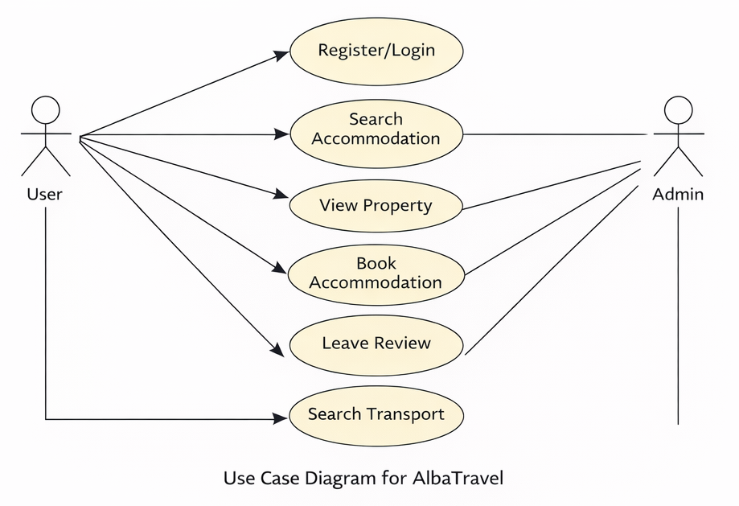
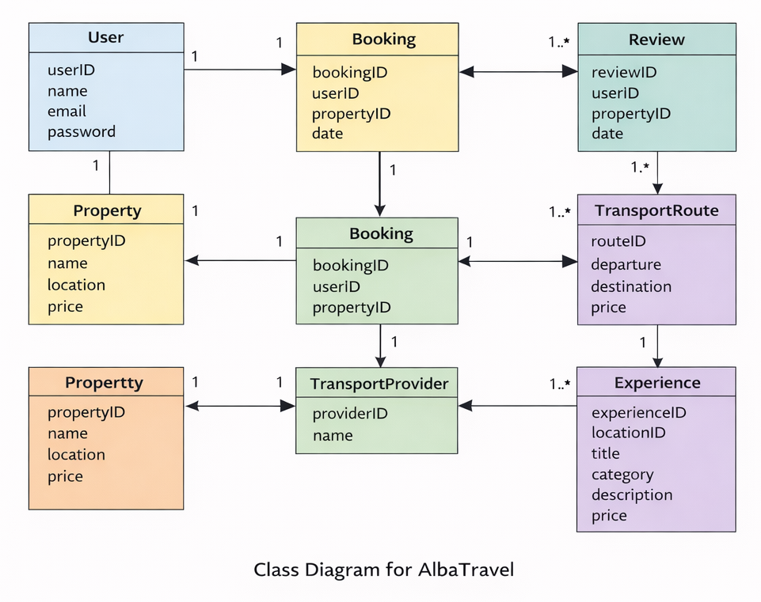

11. Database Design
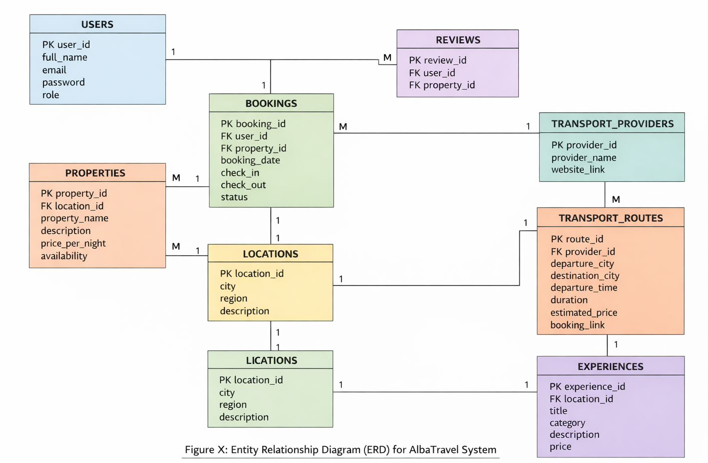

12. Testing Strategy
The system will be tested to ensure functionality and usability.
- Functional testing will verify system features
- Usability testing will evaluate user experience
- Performance testing will ensure efficiency
- Database testing will validate data storage

13. Project Scope
The system will:
- provide a working prototype
- simulate booking functionality
- redirect users to external services
The system will not include:
- real payment systems
- live API integration

14. Expected Outcomes
- A functional prototype
- A structured database
- A user-friendly interface
- A complete academic report

15. Significance
The project addresses real gaps in Albania’s tourism system, supports local businesses, improves travel planning, and demonstrates technical and analytical skills.

16. Feasibility Study
- Technical feasibility: achievable using web technologies
- Economic feasibility: low-cost tools
- Operational feasibility: easy to use
- Time feasibility: achievable within academic timeframe

17. Limitations and Future Improvements
Limitations
- No real payment integration
- No live API connections
- Prototype only
Future Improvements
- Mobile application
- Real-time data integration
- AI recommendations
- Map integration
18. Ethical Considerations
- GDPR compliance
- secure data storage
- transparency in external links
- fair representation
- accessibility
- academic integrity

19. Conclusion
AlbaTravel provides an innovative solution to the fragmented tourism system in Albania by integrating accommodation, transport, and local services into a single platform. The project demonstrates strong technical and analytical capabilities while addressing real-world challenges. It has the potential to enhance user experience, support local businesses, and contribute to the digital development of Albania’s tourism sector.

20. References (IEEE Style)
[1] UNWTO, Tourism and Digital Transformation, 2022.
[2] OECD, Digitalisation in Tourism Services, 2021.
[3] Buhalis, D., “Technology in Tourism,” Tourism Management, 2020.
[4] European Commission, SMEs and Digitalisation, 2022.
[5] World Bank, Transport Connectivity and Tourism, 2021.
[6] Statista, Online Travel Booking Market, 2023.
[7] Google, Travel Insights Report, 2022.

