Module Code: ACDA5004
Module Name: Project Management and Research Methods
Student Name and ID: Connor Dewi Ellement – 180345
Project Team Name: Diverse Digital

Contents
1) Purpose 2
2) Objectives 2
3) Scope 2
3.1) In: 2
3.2) Out: 2
4) Constraints 3
5) Authority 4
6) Resources 5

Purpose
We have been tasked by the company, BRD Sports and its CEO Ben Room, to create them a new fully functional website to replace their current one, that is 11 years old and outdated. The desired outcome of the project is that we can meet Ben and BRD’s request and create them a fresh and new website that is more up to date. We would like the website to be innovative and accessible to all.

Objectives
The website will be coded and designed for BRD Sports by the projects due date, we will measure this and keep track of it using team progress sheets and by using a schedule to meet deadlines by. This website will include innovative website development techniques, we will measure this by doing appropriate research into innovated techniques in Web Development and including features we think work well with the project. The website will be accessible for anyone to be able to use, as well as be responsive so that it is fully functional on any device it is being viewed on, we will make sure the website is tested appropriately and regularly. The website will be engaging to the viewer, with a sleek design that will show professionalism, we will measure this by showing to website to potential users and ask them questions about the design and noting their answers.

Scope

3.1) In:
Designing, Testing, market analysis, innovation research, Requirement gathering, Resource management, scheduling, team support, team meetings, progress reports, surveying, consultation, E-commerce

3.2) Out:
Portfolio analysis, training, server hosting, website maintenance after project end

Constraints
Jordan James said this about constraints in project management, “Project constraints are certain things that restrict your project and affect how you manage it. Unfortunately, these constraints are an inevitable part of any project and even though you can discover and categorise them, you can’t ignore them” (James, 2015).
Budget – There is a possibility that out budget could halt our progress at some point, as for right now, we believe there won’t really be anything that we need to purchase, but potential costs could pop up in future (For example, a software that needs to be purchased). An image showing the planned budget is below.
Scheduling/Time keeping – We currently have a schedule and timeline for when we want to get our work completed (shown in the Gantt chart below), however, spanners can always get thrown into the works when it comes to keeping to deadlines. Anything could happen in the duration from this project from file corruption to technological failures, so we will have to keep on top of it all, and make sure there are backups in place, and that other members of the team are able to pick up some slack if one member is struggling. Tara Duggan had this to say about effective scheduling, “Effective project scheduling plays a crucial role in ensuring project success. To keep projects on track, set realistic time frames, assign resources appropriately and manage quality to decrease product errors” ([1] Duggan, 2018).
Risk – Risks can either be positive or negative to a project. They can offer potential shortcuts to success, or pathways straight to failure. Risks are sometimes necessary however despite the outcome. For example, us not making the deadline for the project would leave Ben and BRD Sports without a website and a presence online leading to less traffic for the organisation.
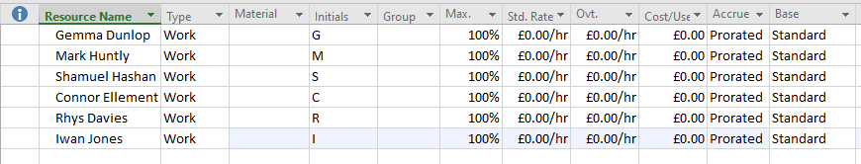

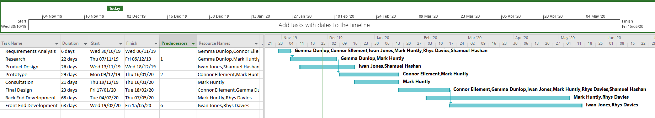
Figure 1 – Budgeting

Figure 2 – Schedule

Figure 3 –
Gantt Chart

Authority
Project Sponsor: The project sponsor for our project is the CEO of BRD Sports, Ben Room. We can do the coding, implementation and design, however ultimately, the final say is down to Ben if he likes the website or if he wants part or all of it changed. We are planning regular consultation meetings with him, to keep on top of this, to reduce the risk of needing to re-do large parts of the project.
Project Manager: The project manager for my group, Diverse Digital, is Gemma Dunlop. She is responsible for delegating the work we must do as a group to individuals to ensure the work is spread out equally. She is also responsible for staying on top of the group members to ensure deadlines are hit. Along side this, she is also a very creative person in the field of art, so she will be helping a lot with the design process.
Project Organization Chart/Structure:
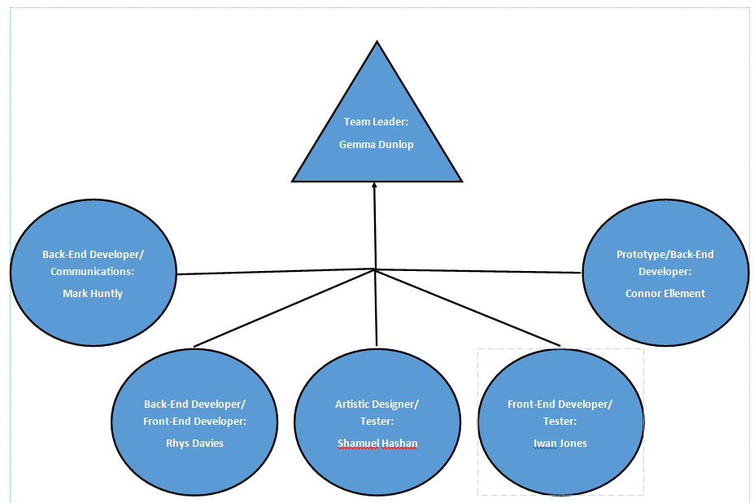

I have discussed with my group about our stakeholders, and we have come up with the following as our stakeholders: The Project Team (aka Gemma, Mark, Myself, Shamuel, Rhys and Iwan), Ben Room (The CEO of BRD Sports), BRD Sports staff, BRD Sports customers/users, Web App viewers, Sue Maw (Our project management lecturer) and James Williams (Our group project lecturer)

Resources
Looking at our resources, most of the equipment we are using, is equipment that is available to us. We are mixing between using personal laptops and computers, as well as the computers provided in University. As mentioned previously, we intend on trying to keep this project as free as humanly possible, however, we have discussed potential future equipment we might need to purchase, but we are confident we can acquire it via other ways.

References
Duggan, T. (2018, April 13). What Is the Importance of Project Scheduling & Its Role in Business Projects? Retrieved from AZ Central: https://yourbusiness.azcentral.com/importance-project-scheduling-its-role-business-projects-9503.html
James, J. (2015, October 06). How to define Constraints in project managment. Retrieved from Activia Training: https://www.activia.co.uk/blog/how-to-define-constraints-in-project-management

