12/30/2019
Academic and employability skills
BMSW4001_LON
Aikaterini Mitrousi (1906173)
Lecturer: Lloyd Beharry
Table of contents

Introduction…………………………………………………………2
Employability skills……………………………………………….2
Communication……………………………………………………2
Hard skills…………………………………………………………….3
Soft skills………………………………………………………………3
Team work ………………………………………………………….3
Time management……………………………………………….3
Swot analysis……………………………………………………….3
Pdp ………………………………………………………………………4
Plagiarism…………………………………………………………….5
Summarise……………………………………………………………6
Paraphrasing…………………………………………………………6
Conclusion……………………………………………………………6
Appendix………………………………………………………………6
References ………………………………………………………....11

Introduction

According to Wikipedia skill is the ability to complete a task. Every person has skills, that gain through academic learning or through experience, but the employers are always looking something beyond those skills. They are looking for good communication skills, trustful, positive attitude teamwork. In my previous job as on of my tasks was on hiring new stuff ,we had a two stage recruitment policy the first was the interview ,when I had ta talk with them if they had the right skills that we required for the job and the second was the trial shift ,where we could see if the person was working good in a team and had good communication skills .

Employability skills
Employability it is having professional soft skills and attitude in every workplace, the reason that I choose the university is to become more employable for the job market in the future. Employability skills are the general skills or soft skills that gives the ability to communicate and work as a team in a company. (Doyle, 2019).When I start my first job in London in 2012 ,I had to improve a lot team working ,because the difficulties of the languages as well I was feeling that I could not perform as good ,as the rest of the team too many misunderstanding happening in communication ,due to my language ,and too many complains ,customers could not communicate with me ,the result was the team helping me getting in the right way always.

Communication

Communication skill is the ability to understand and give instruction, it can help any aspect in our life from professional to friendship and family. Good verbal and written communication skills can deliver the information’s quickly and understandably. Listening it is an important part of communication as well as people prefer to focus more on what they have to say rather than on what they must listen.
communication is valued in workplace, speaking with the right vocabulary, present your ideas work well in a group. On this aspects my course will help me ,with my presentation and my group assignments, using the right vocabulary for my assignments will improve my language speaking as well in term of business orology .Another important fact that I would like to add about communication is that in the top 10 most in-demand skills communication is first with 57.9%. (Beqiri, 2017).

Hard skills
Hard skills are teachable and practical abilities that you gain through experience, university, online courses, readings, hard skill mean that you are good for a specific job (Gerencer, 2019).To be successful in the workplace you have to combine both hard and soft skills as well.

Soft skills

Soft skill are the social skills that must do more with who the people are rather than people do, how well people can interact well with each other one of the most important (soft) skill is communication. having just hard skills it is not enough for the workplace for every employer to be succeed in the workplace, he should have strong soft skills as well.
A set of soft skills is always separate the successful candidate from the other job seekers because the employers are looking for people who are focused ,organized ,with leadership skills and who can bring new ideas to the company, solve problems ,save time and be creative. (Pahwa, 2019). On this course I will gain more experience, and I will be more confident using my soft skills not only in my academic area but in my workplace as well.

Team work

Teamwork skills are the abilities to work well in a team to achieve a common goal, having team work skills it depend on your ability to communicate well and, if you are a good listener and a responsible person. (Anon., n.d.). In my previous job working as a supervisor in a restaurant I had to be a shift leader ,in order to demonstrate an excellent shift with my team ,we had to work all together, but everyone had to work on its own task, helping each other ,communicate with each other, motivating your team it is very important as their performance is increasing, I was always showing respect to my team, and there was always time for celebration.

Time management

Time management is a big issue for most of the people, as we have so much things to do during the day, and there is not time to make those things happens. There are many ways to improve your time management skills like by organizing your days and weeks in advance.
Prioritize which task is most important to do first and which is less to after. Never let things that must be done for today, to be done for another day. An everyday to do list it is very important as well because in thin way you will not forget your tasks. (Arvidsson, 2016). My course by giving me the deadline for the assignment is helping me with the time management as with the in class exercises as well.

Swot analysis

Before setting my short term and long term goals I would like to specify which areas needs improvement for me and on which skills I am doing well.

Quick learner  Excellent organisation skills  Working well in a team  Positive attitude  Decision maker | Low self-esteem.  Not good on presentations, not feeling very confident talking in front of people.  Not confident with English language  Easy to give up if I feel unhappy
  Strength
  Weaknesses
The government gives the chance to people to study.  Learning new skills  Getting a degree is an opportunity that will gain to better job for me in the future | balance between work and personal commitments  wages are less during the time of studies  there are no too many opportunities to find a well-paid job because you are a student.
  Opportunities
  Threats
Table made from Student Aikaterini Mitrousi.

Personal development plan

What are my big goals? | Which goal needs to happen first | When do I want to achieve that |  |  | How can I improve my chances to meet my goals |  |  |  |  | Where can I go for support
Getting a degree for an Event manager | Complete the certificate-Skills for the workplace-Level 4 | By the end of September |  |  | Being punctual, and focused on my goal | Do not fail | University  Talking with lectures
Be more confident on presenting in front of people | Starting as first step be more familiar and confident with the presentations | By the end of July |  |  | Practising in front of people that I feel confident to talk |  |  |  |  | Lecturer and the university
Improving my English language in spoken and written | By the end of the academic year |  | Not enough time to spent on reading, and using the vocabulary | Reading newspapers, books, listening radio and news |  |  |  | Instructor, and on-line recourses
Maximos baptism | Booking the date | Summer time |  |  | Check other dates and places for in door celebrations |  |  |  | Event manager  Good mother

Table made by student Aikaterini Mitrousi

Plagiarism

Plagiarism is being rewarded for someone else words or ideas. In universities if an assignment is plagiarised it is failed and the person it is in a suspension. There are differed ways of plagiarism.
Direct plagiarism when you pay someone to writ the whole assignment for you, or when you use the whole paragraph from the book or from the online web without paraphrasing it in your own words,
Paraphrased plagiarism using someone else work just making some changes
Mosaic plagiarism using words phrases and sentences without quotation marks
Accidental plagiarism missing citations, sources are cited incorrectly (Valdes, 2019).
We spoke in class as well about the importance of plagiarism on how to avoid, we had a brief about summarising and paraphrasing and did different exercises in class to practice more.
We had a workshop as well, talking about plagiarism and the negative aspects of it.

Summarise
It is a written short brief through the whole text that can make you understand the whole meaning. The summary must contain the main point which should be described by your own words, using the right vocabulary. Information that do not support the main meaning of the text do not have to be included to the text. (Anon., 2011). We had too many in class exercise about summarising and we got feedback from the lecturer in one on those as well. Summarising it will be very important in our workplace especially when we must present or talk about new product or new information for the company that we are not familiar.

Paraphrasing
Is one of the most important academic skills, it is the ability for someone to paraphrase the ideas and the information of the source on his own words using not too many words from the original text, and the right citations. (Anon, 2017). It can help you with reading ,so you don’t have to memorise ,good for improving your english language levels as you need to use different word ,sunonums ,use of vocubulary is a must .
Conclusion
Setting up new goals was my desire when I starter this course ,and I wanted to achieve this short term goals after I finish my assignments, in the first term I gain confidence in my writing ,as I already did 3 assignment , improve my English ,in written and communication and I had my first presentation, although it was not in front of my classmate ,felt that I manage to do something greater than my willing’s.
Academic skills are not only good for the workplace but are helping me getting ready to build the right skills to be ready to go there and with my experience to be in the right place that will suit me most.
Appendix
Appendix a: In class exercise about paraphrasing on 12/11/2019. We were given a text that we had to paraphrase, feedback was given by the lecturer.
Appendix b: In class exercise about summarising on 11/12/2019.we were given a text that we had to summarise, feedback was given by the lecturer.

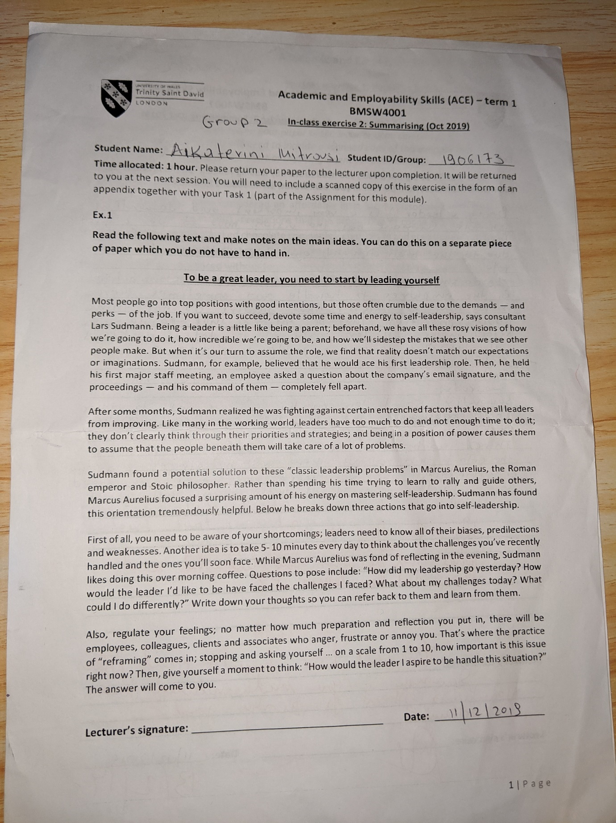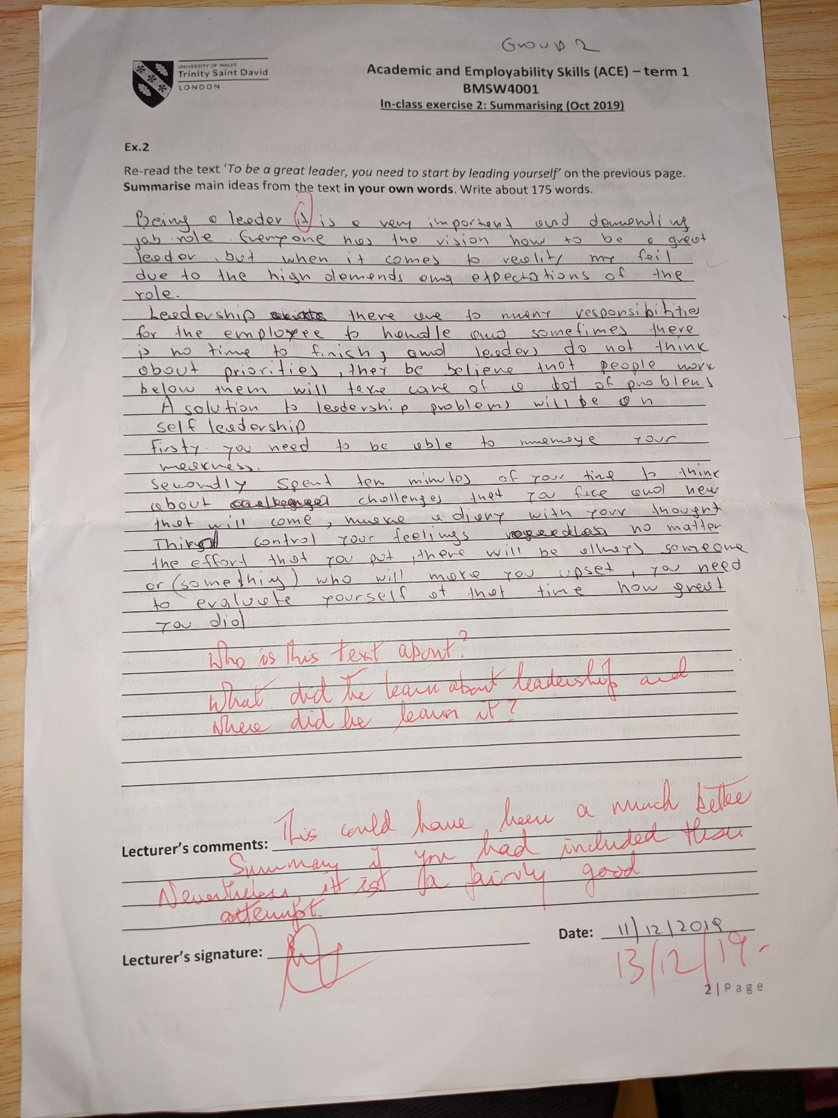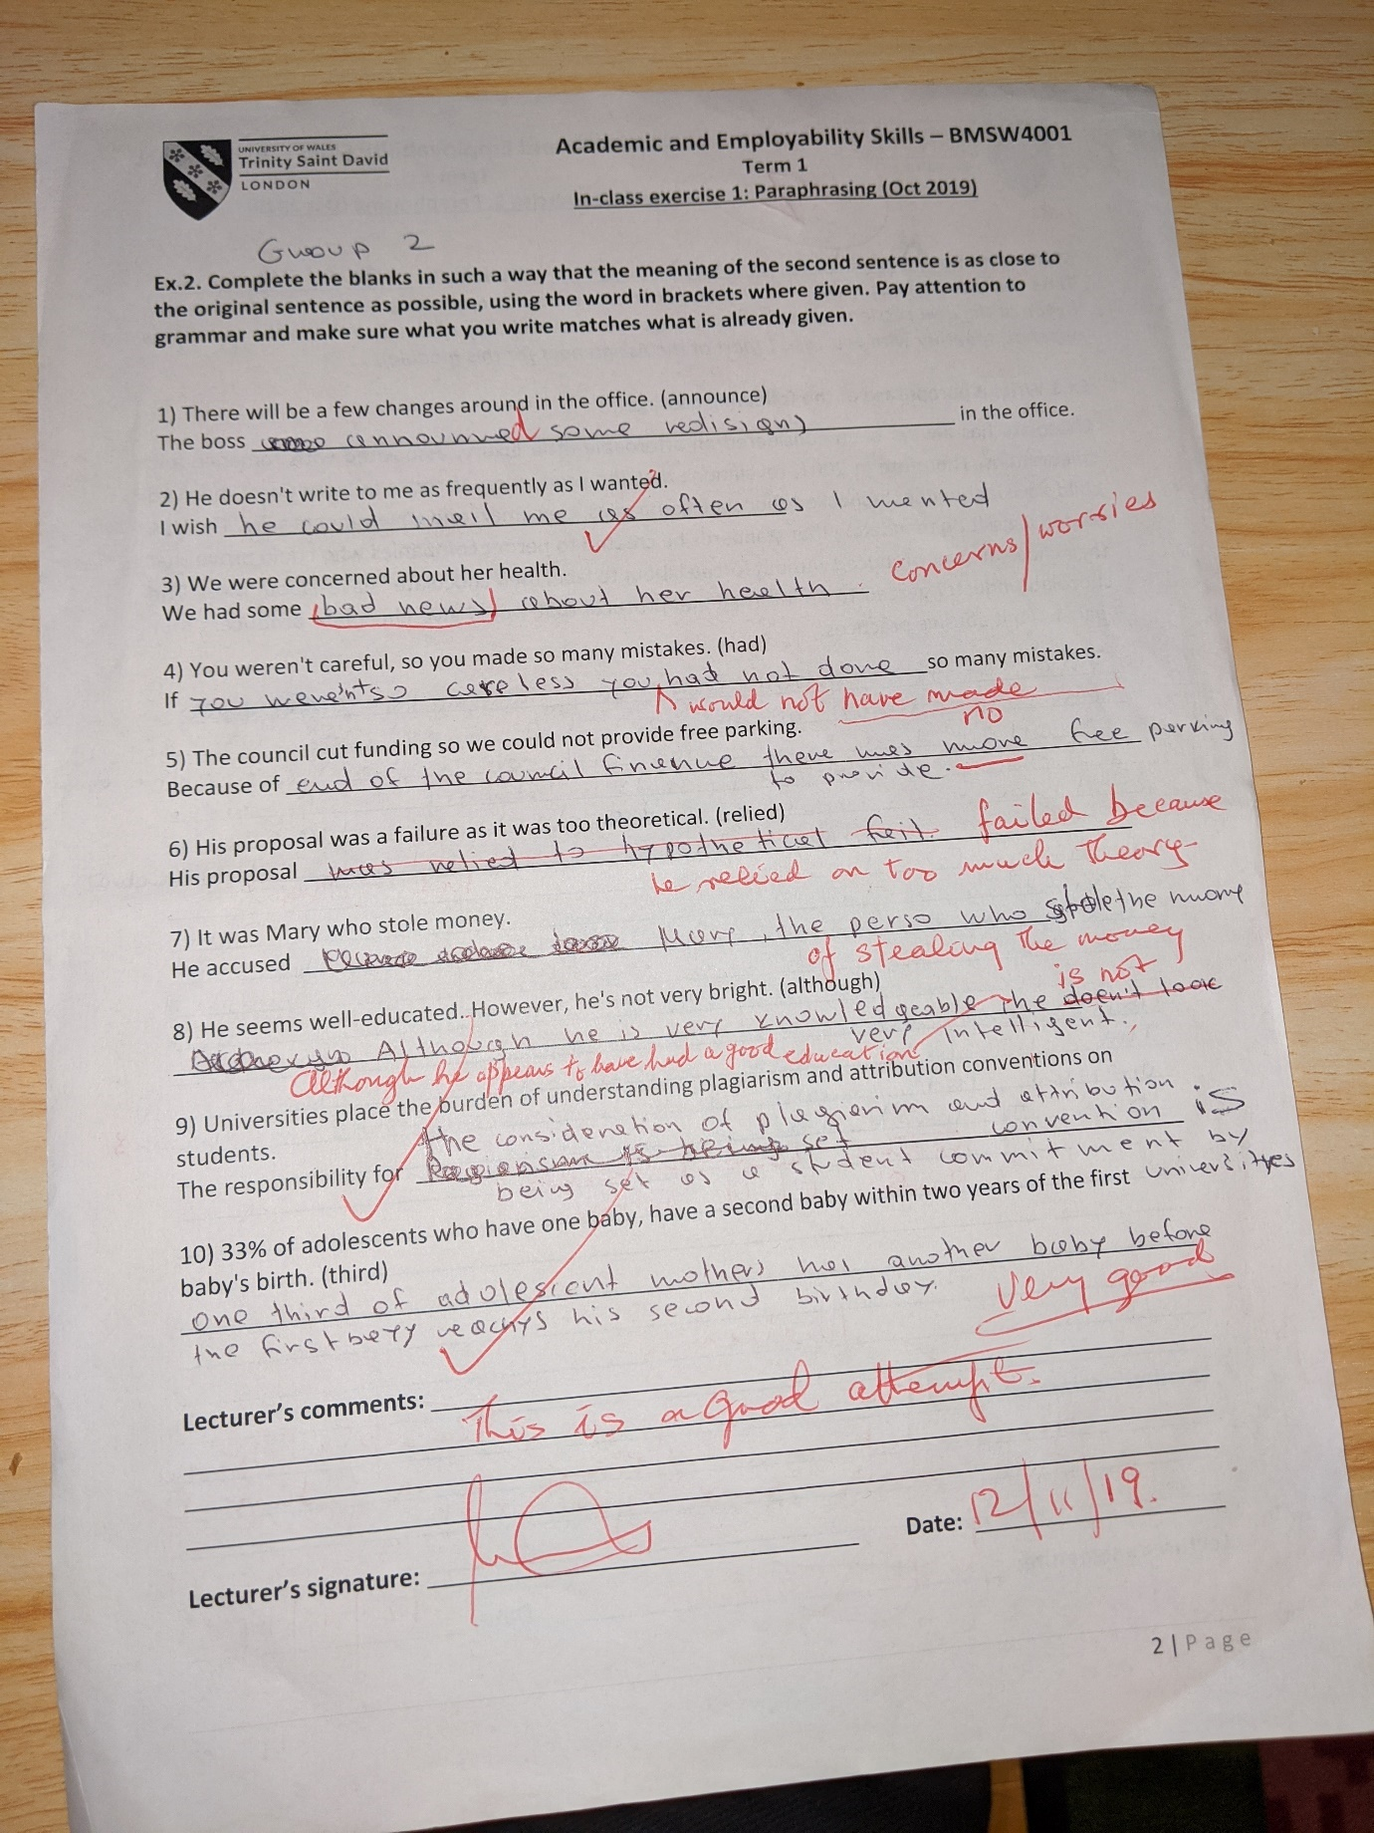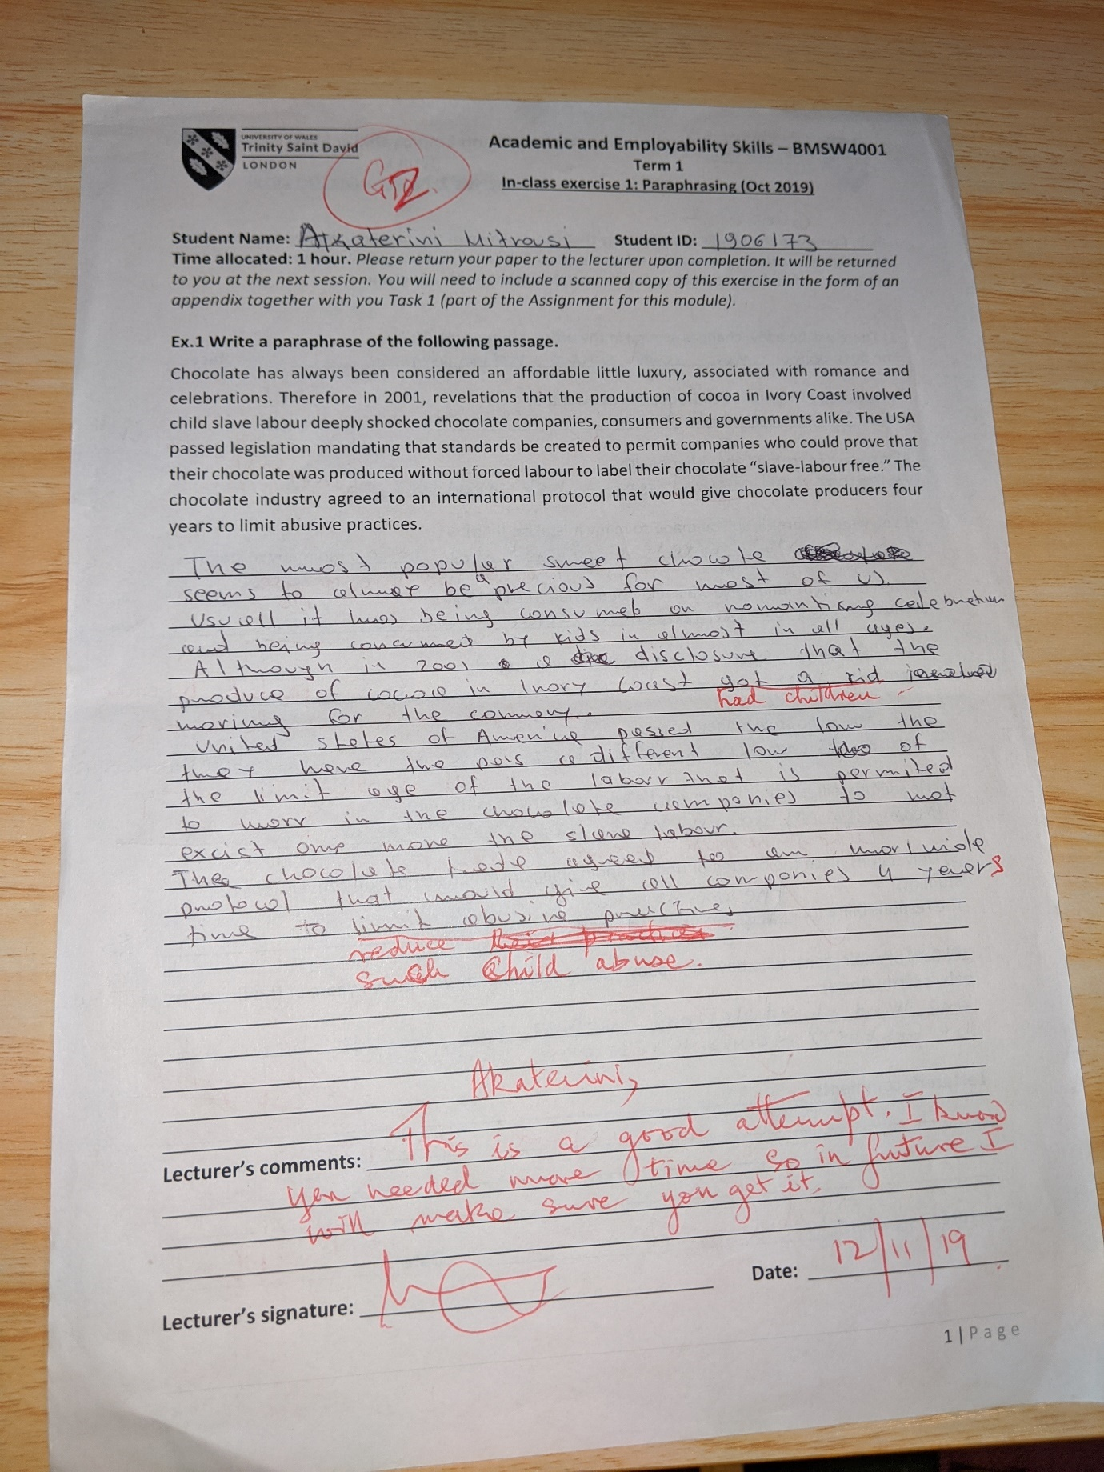

References

Anon., 2011. bbc.co.uk1. [Online]
Available at: en07unde-l1-f-hints-for-summarising-written-text
[Accessed 30 December 2019].
Anon., 2017. plagiarism.org. [Online]
Available at: https://www.plagiarism.org/article/how-to-paraphrase
[Accessed 30 December 2019].
Anon., n.d. iedunote. [Online]
Available at: https://iedunote.com/nonverbal-communication
[Accessed 24 December 2019].
Anon., n.d. indeed.com. [Online]
Available at: https://www.indeed.com/career-advice/career-development/teamwork-skills
[Accessed 30 December 2019].
Arvidsson, N., 2016. recruiter.com. [Online]
Available at: https://recruiter.com/i/7-ways-busy-to-improve-your-time-managment-skills/
[Accessed 30 December 2019].
Beqiri, G., 2017. virtualspeech. [Online]
Available at: https://virtualspeech.com/blog/importance0of-communication-skills
[Accessed 30 December 2019].
Doyle, A., 2019. the balancecareers. [Online]
Available at: https://www.thebalancecareers.com/employability-skills-list-and-examples-4143571
[Accessed 30 December 2019].
Gerencer, T., 2019. zety.com. [Online]
Available at: http://zety.com/blog/hard-skills-soft-skills
[Accessed 30 December 2019].
Pahwa, A., 2019. feedough.com. [Online]
Available at: https://www.feedough.com/soft-skills-definition-importance-list-examples/
[Accessed 30 Dcember 2019].
Valdes, O., 2019. thoughtco.com. [Online]
Available at: https://www.thoughtco.com/plagiarism-definition-1691631
[Accessed 30 December 2019].

