

Student Name:Carmen Craciun
Student ID:2112672
Module Name:Independent project
Module Code:BMHP6020
Supervisors Name:Jolly Nwankwo

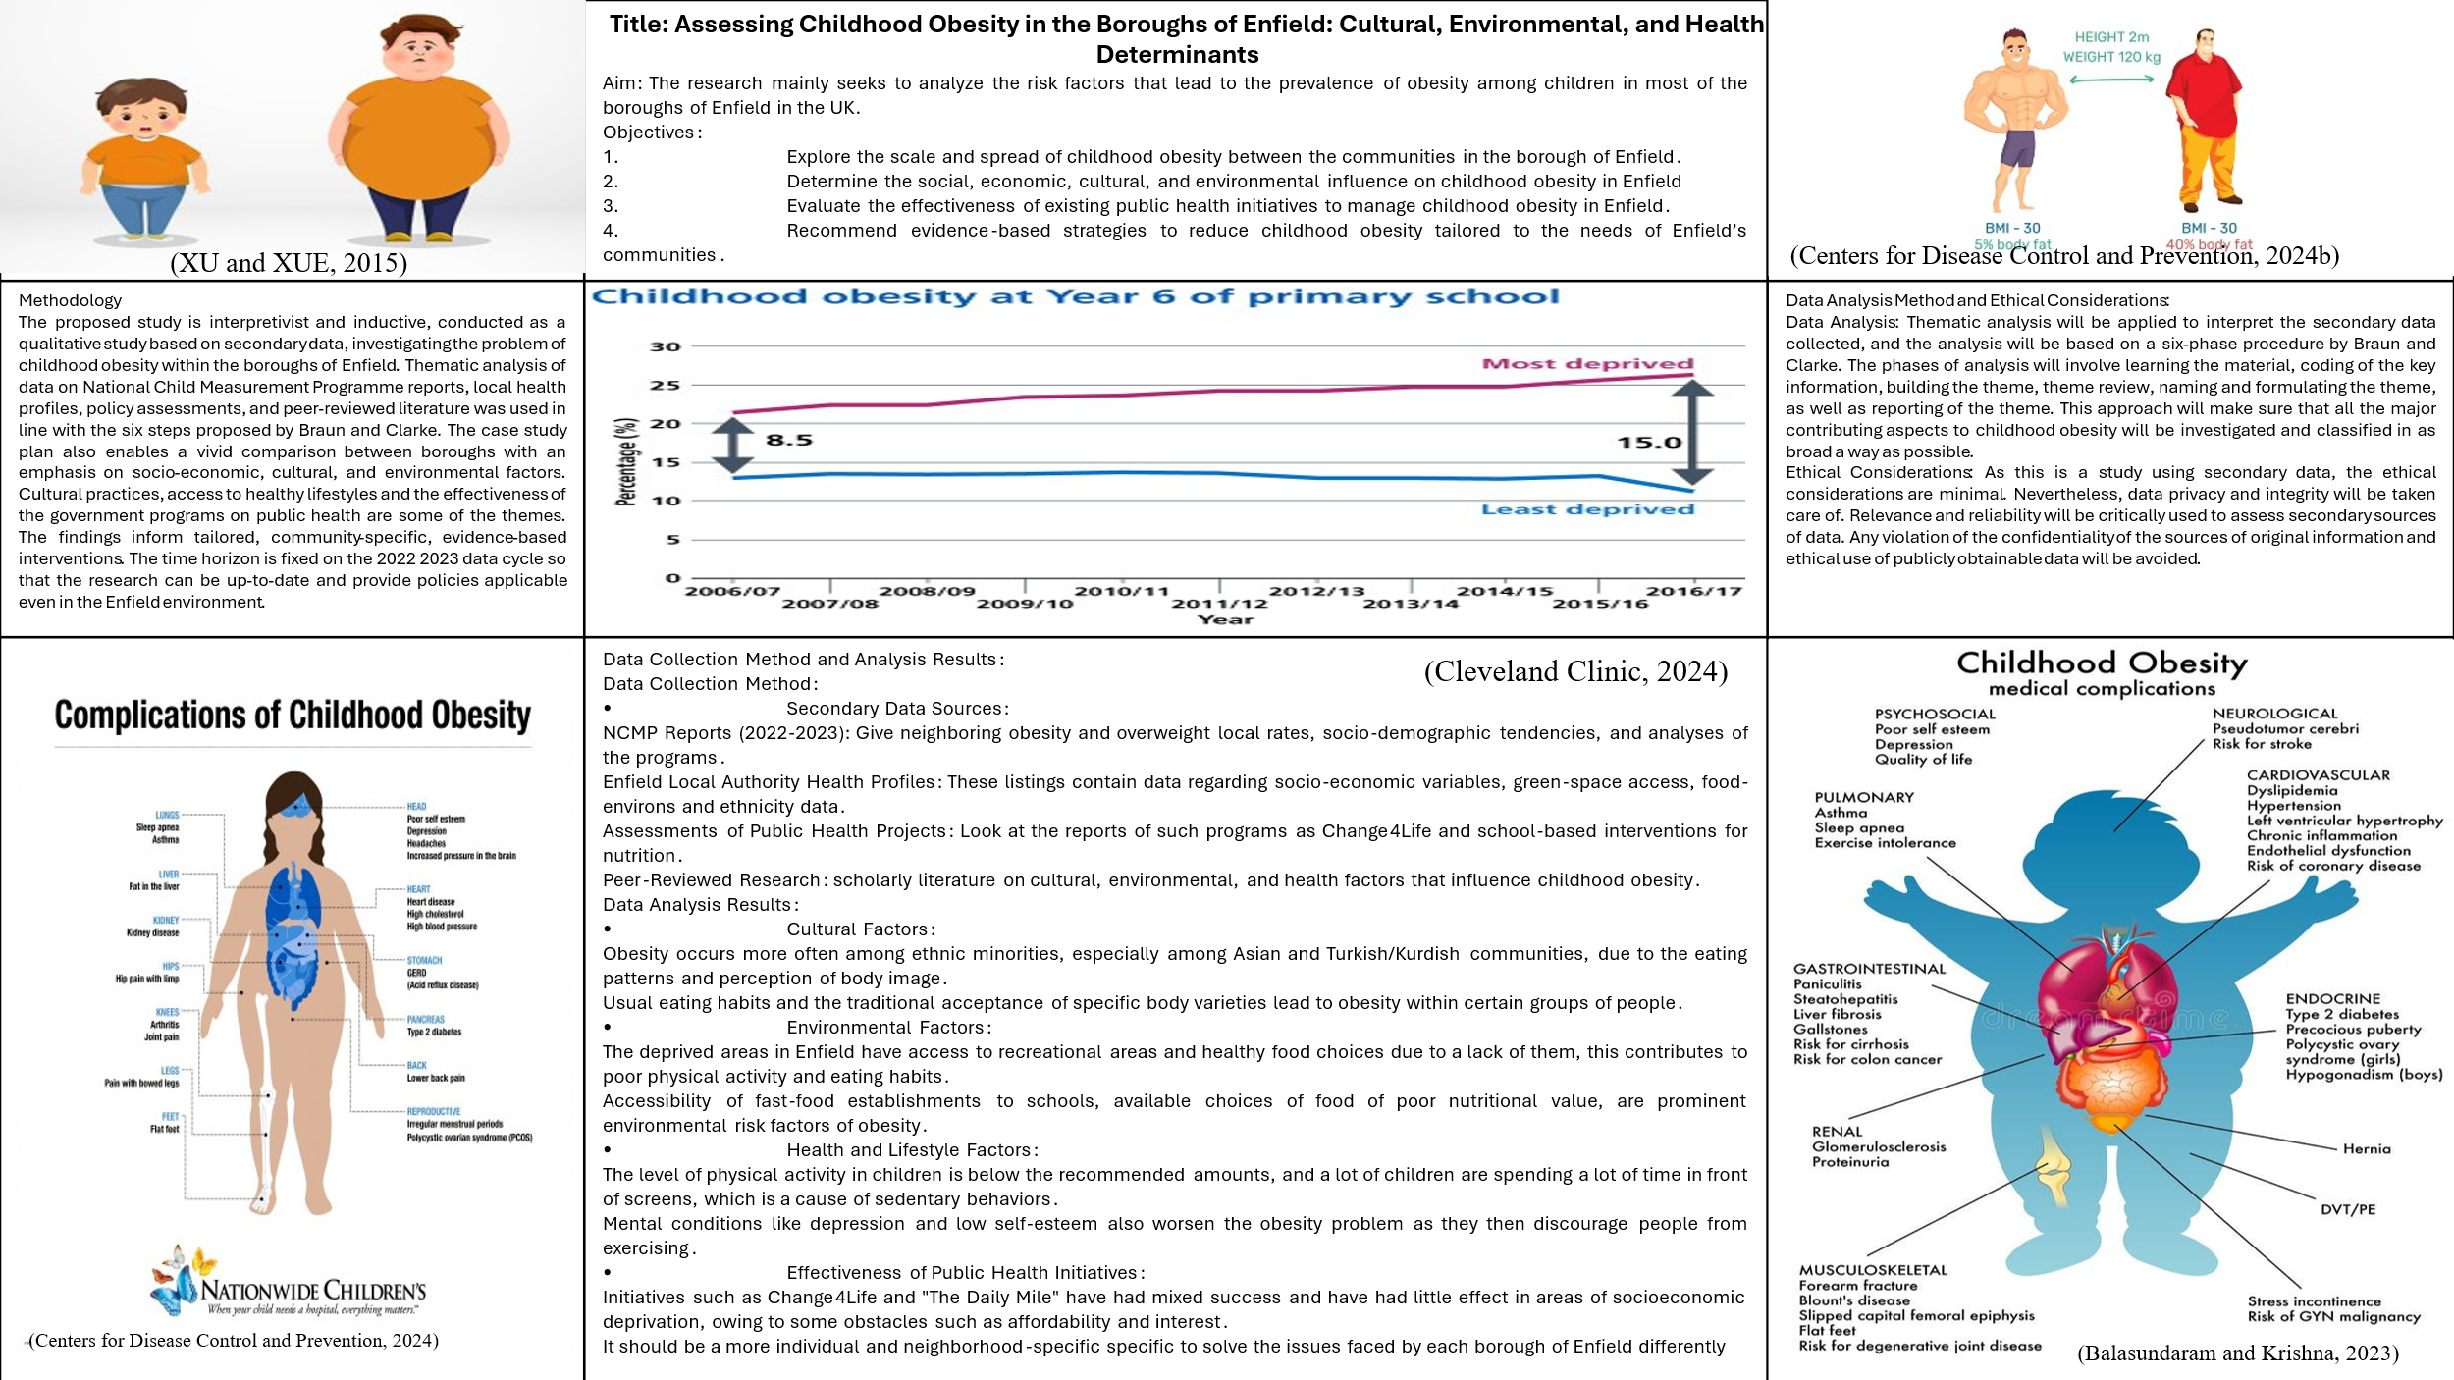
Title: Assessing Childhood Obesity in the Boroughs of Enfield: Cultural, Environmental, and Health Determinants
Aim: The research mainly seeks to analyze the risk factors that lead to the prevalence of obesity among children in most of the boroughs of Enfield in the UK.
Objectives:
- Explore the scale and spread of childhood obesity between the communities in the borough of Enfield.
- Determine the social, economic, cultural, and environmental influences on childhood obesity in Enfield
- Evaluate the effectiveness of existing public health initiatives to manage childhood obesity in Enfield.
- Recommend evidence-based strategies to reduce childhood obesity tailored to the needs of Enfield’s communities.
Methodology
The proposed study is interpretivist and inductive, conducted as a qualitative study based on secondary data, investigating the problem of childhood obesity within the boroughs of Enfield. Thematic analysis of data on National Child Measurement Programme reports, local health profiles, policy assessments, and peer-reviewed literature was used in line with the six steps proposed by Braun and Clarke. The case study plan also enables a vivid comparison between boroughs with an emphasis on socio-economic, cultural, and environmental factors. Cultural practices, access to healthy lifestyles and the effectiveness of the government programs on public health are some of the themes. The findings inform tailored, community-specific, evidence-based interventions. The time horizon is fixed on the 2022 2023 data cycle so that the research can be up-to-date and provide policies applicable even in the Enfield environment.
.
Method of Data Collection and Analysis:
Collection of Data: The secondary data to be used in the study is based on reports such as the National Child Measurement Programme (NCMP), versions of Enfield Local Authority Health Profiles, and analysis of currently existing interventions in the area of public health. Other peer-reviewed studies and the issues of childhood obesity and community-specific data in Enfield will be reviewed.
Data Analysis: Thematic analysis: The secondary data shall be analysed using a thematic approach. This will entail open and axial coding about key themes, including cultural practices, environmental factors, and health-related behaviors. Thematic analysis will assist in consolidating the knowledge and making conclusions connected with the problem of obesity patterns among the children in the boroughs of Enfield.
Data Analysis Method and Ethical Considerations:
Data Analysis: Thematic analysis will be applied to interpret the secondary data collected, and the analysis will be based on a six-phase procedure by Braun and Clarke. The phases of analysis will involve learning the material, coding of the key information, building the theme, theme review, naming and formulating the theme, as well as reporting of the theme. This approach will make sure that all the major contributing aspects to childhood obesity will be investigated and classified in as broad a way as possible.
Ethical Considerations: As this is a study using secondary data, the ethical considerations are minimal. Nevertheless, data privacy and integrity will be taken care of. Relevance and reliability will be critically used to assess secondary sources of data. Any violation of the confidentiality of the sources of original information and ethical use of publicly obtainable data will be avoided.
Data Collection Method and Analysis Results:
Data Collection Method:
Secondary Data Sources:
NCMP Reports (2022-2023): Give neighboring obesity and overweight local rates, socio-demographic tendencies, and analyses of the programs.
Enfield Local Authority Health Profiles: These listings contain data regarding socio-economic variables, green-space access, food-environs and ethnicity data.
Assessments of Public Health Projects: Look at the reports of such programs as Change4Life and school-based interventions for nutrition.
Peer-Reviewed Research: scholarly literature on cultural, environmental, and health factors that influence childhood obesity.
Data Analysis Results:
Cultural Factors:
Obesity occurs more often among ethnic minorities, especially among Asian and Turkish/Kurdish communities, due to the eating patterns and perception of body image.
Usual eating habits and the traditional acceptance of specific body varieties lead to obesity within certain groups of people.
Environmental Factors:
The deprived areas in Enfield have access to recreational areas and healthy food choices due to a lack of them, this contributes to poor physical activity and eating habits.
Accessibility of fast-food establishments to schools, available choices of food of poor nutritional value, are prominent environmental risk factors of obesity.
Health and Lifestyle Factors:
The level of physical activity in children is below the recommended amounts, and a lot of children are spending a lot of time in front of screens, which is a cause of sedentary behaviors.
Mental conditions like depression and low self-esteem also worsen the obesity problem as they then discourage people from exercising.
Effectiveness of Public Health Initiatives:
Initiatives such as Change4Life and "The Daily Mile" have had mixed success and have had little effect in areas of socioeconomic deprivation, owing to some obstacles such as affordability and interest.
It should be a more individual and neighborhood-specific specific to solve the issues faced by each borough of Enfield differently

References
Balasundaram, P. and Krishna, S. (2023) Obesity effects on child health, PubMed. Treasure Island (FL): StatPearls Publishing. Available at: https://www.ncbi.nlm.nih.gov/books/NBK570613/.
Centers for Disease Control and Prevention (2024a) Childhood Obesity Facts, CDC. Available at: https://www.cdc.gov/obesity/childhood-obesity-facts/childhood-obesity-facts.html.
Centers for Disease Control and Prevention (2024b) Preventing Childhood Obesity: 6 Things Families Can Do, CDC.gov. Available at: https://www.cdc.gov/obesity/family-action/index.html.
Cleveland Clinic (2024) Obesity in Children, Cleveland Clinic. Available at: https://my.clevelandclinic.org/health/diseases/9467-obesity-in-children.
XU, S. and XUE, Y. (2015) ‘Pediatric obesity: Causes, symptoms, prevention and treatment’, Experimental and Therapeutic Medicine, 11(1), pp. 15–20. Available at: https://doi.org/10.3892/etm.2015.2853.

