Assignment 2
Learning in the Digital Era
UNIVERSITY OF WALES TRINITY SAINT DAVID
LONDON CAMPUS
Video Link: Present your Video Link here (Upload your video presentation on You Tube or OneDrive/any other platform of your choice and then share that link here).
Please be sure to give unrestricted access to your video presentation so that your work can be marked by the examiner.
Module Name: Learning in the Digital Era
Module Code: ACCA 4025

Student Name: Dennis Annang
Student ID: 2528418
Group: 3

Lecturer’s Name: Suneth Ferdando

Table of Contents
Introduction 2
Main Body 2
Conclusion 9
References 9

Introduction

This Word document serves as a written report for Learning in the Digital Era (ACCA4025) Assignment 2 and a 4-5minute video presentation. The assignment is structured around three tasks – Self – evaluation of my current skills and learning approach, a Professional Development Plan outlining my SMART goals, and a summary of Unit 4 Topic – Bouncing Forward

Main Body
The following sections present screenshot evidence and brief written explanations for each slide in the video presentation.
Video Link:

Slide 1 COVER PAGE
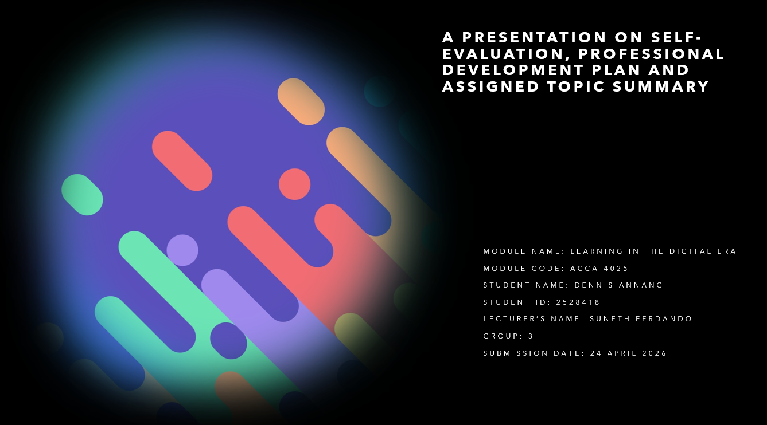
Slide 2 CONTENTS

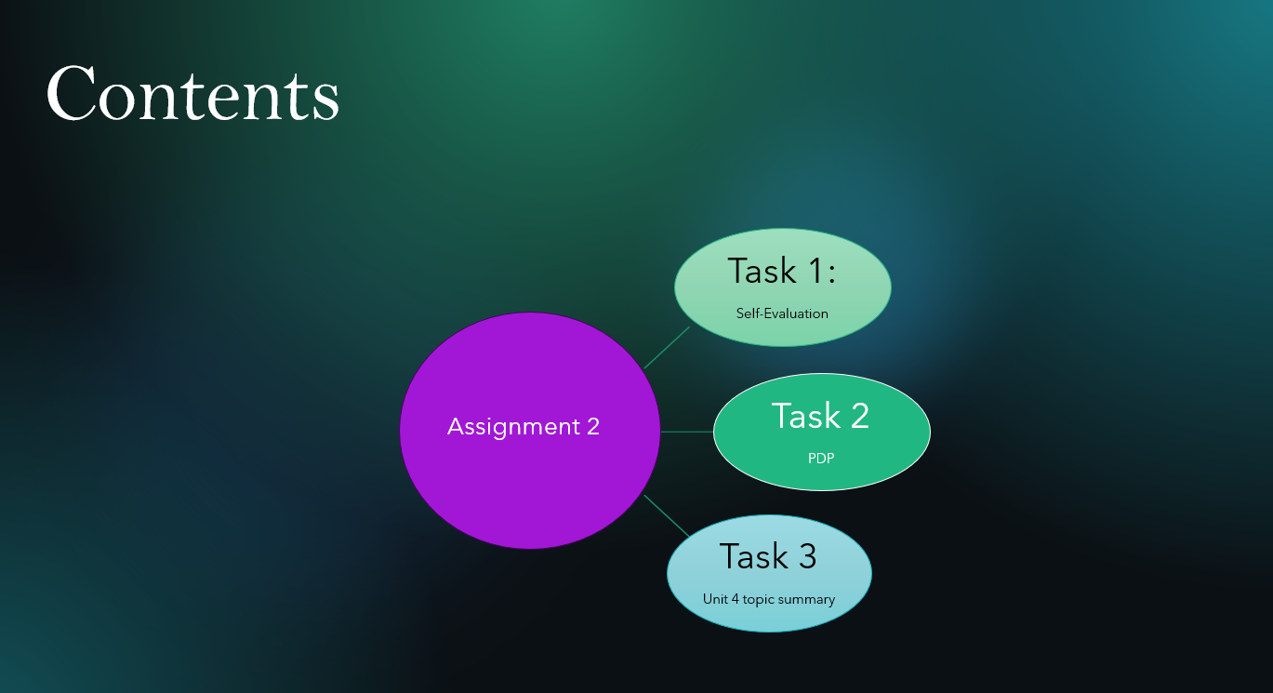

Slide 3 MAIN BODY

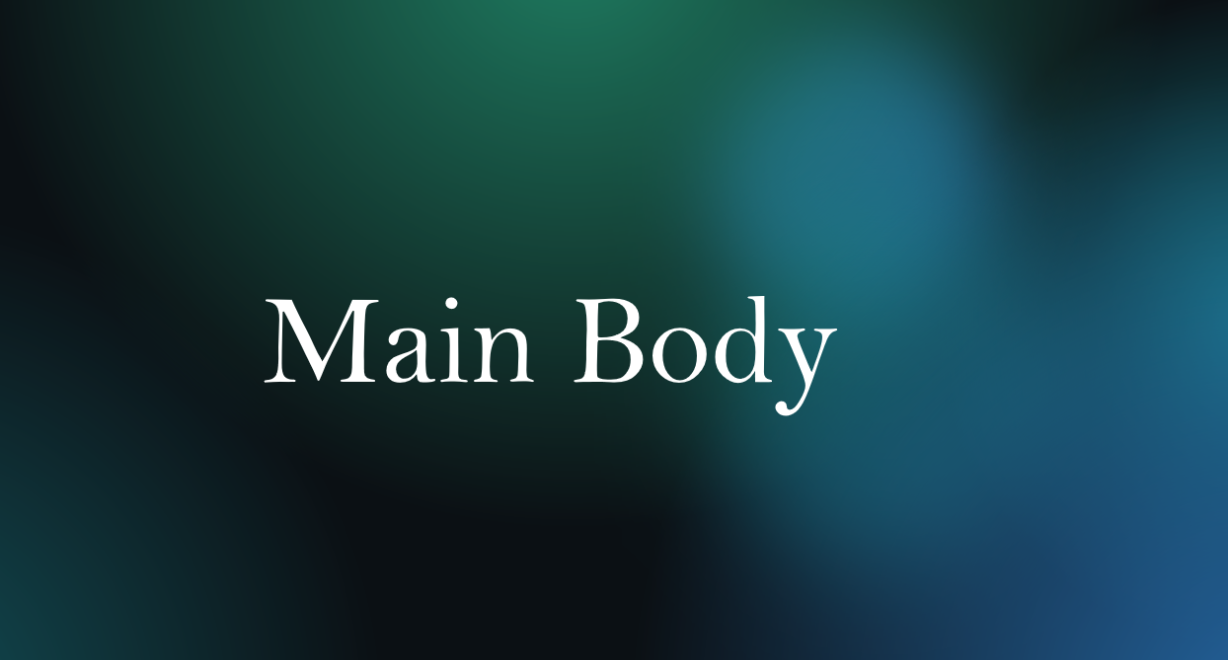

Slide 4 GIBB’s REFLECTIVE MODEL

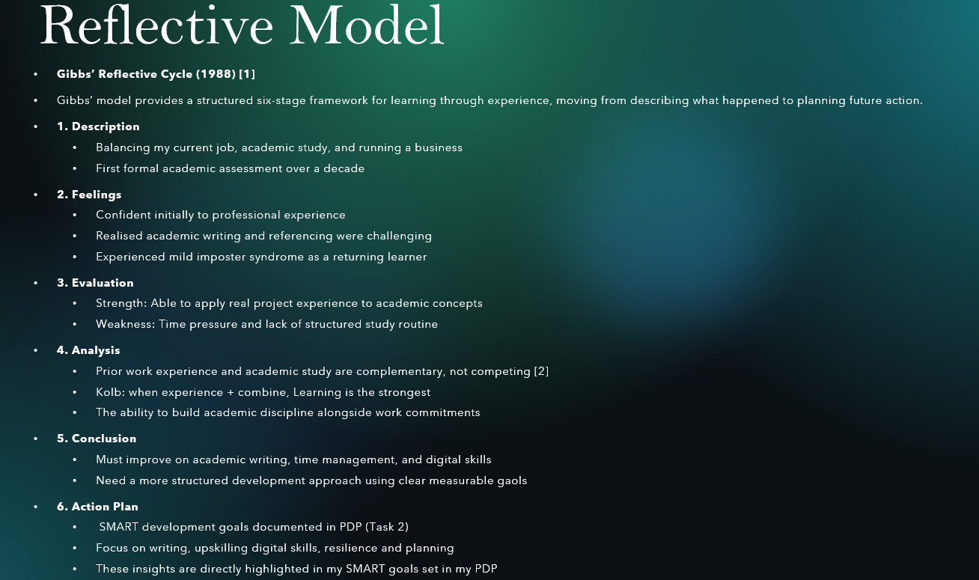

Gibbs’s Reflective Cycle provides a structured six-stage approach to reflection, helping me analyse my experiences and identify areas for improvement [1]. I applied this model to reflect balancing work, study, running my own business, family and other social commitments, which assisted in the development of my SMART goals. I also understood that having prior work experience and academic studies are complementary and not competing against each other [2].

Slide 5 TASK 1: SELF EVALUATION

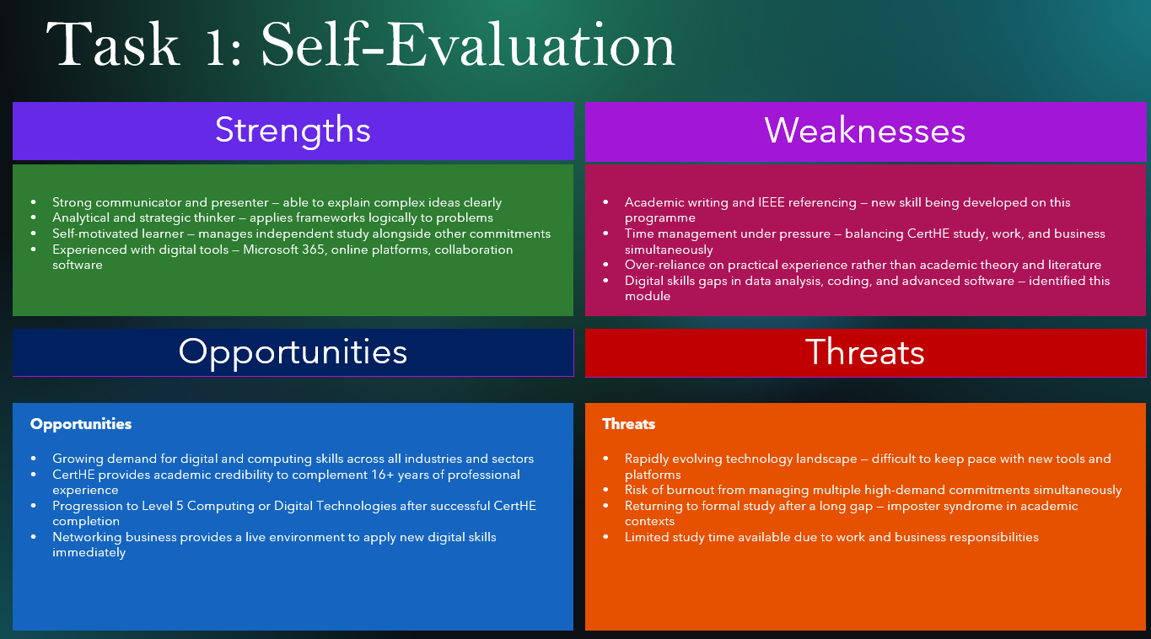

My self-evaluation was based on SWOT Analysis which highlights my internal key strengths, weaknesses, as well as the external opportunities and threats influencing my development. My strengths include, strong communication, strategic thinking, and being a self-motivated learner with confidence in using digital tools. My weaknesses encompass academic writing, IEEE referencing, time management, and gaps in advanced digital skills. The opportunities identified are, progressing to level 5, gaining digital certifications, and applying new skills in my business and career. The main threats identified are, balancing multiple commitments, the fast changing digital landscape, and the risk of burnout while returning to formal study after a long gap.

Slide 6 TRAITS GAINED FROM THE SELF EVALUATION

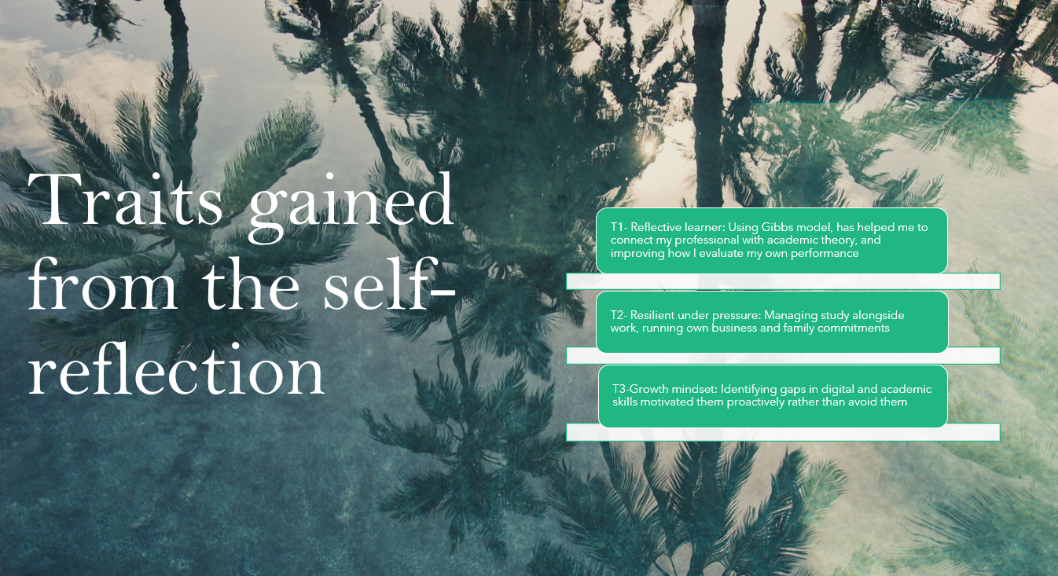

Through reflective learning (using Gibbs to connect theory to practice), I recognised that I am developing as a reflective learner, becoming more resilient under pressure, and adopting a growth mindset by addressing my skill gaps proactively.

Slide 7 PROFESSIONAL DEVELOPMENT PLAN

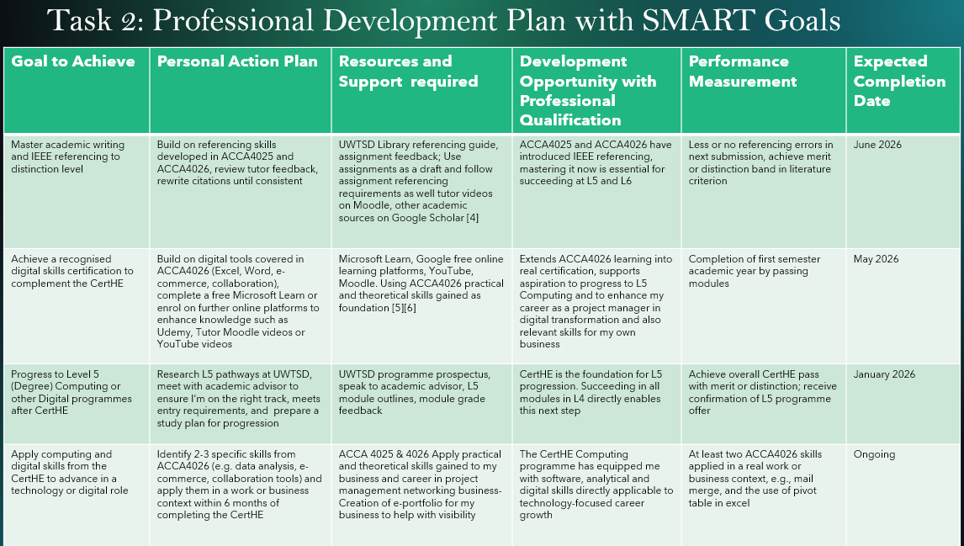

SMART is a recognised framework for setting Specific, Measurable, Achievable, Relevant and time – bound goals [3]. In my assignment, I used this model to structure four development goals. The first goal focuses on improving my academic writing, supported by resources such as UWTSD Library referencing guide, feedback from assignments, tutor videos on Moodle, and academic sources from Google Scholar that explain different referencing styles [4]. The second goal focuses on developing my digital skills through independent learning using free online platforms such as, Microsoft Learn, Google Digital Garage, YouTube, Moodle, supported by the theoretical foundations gained from ACCA4025 and ACCA4026 modules. [5][6]. These goals will support my progression to Level 5 and help me apply computing skills more effectively in both my work and business.
Slide 8 UNIT 4 TOPIC SUMMARY

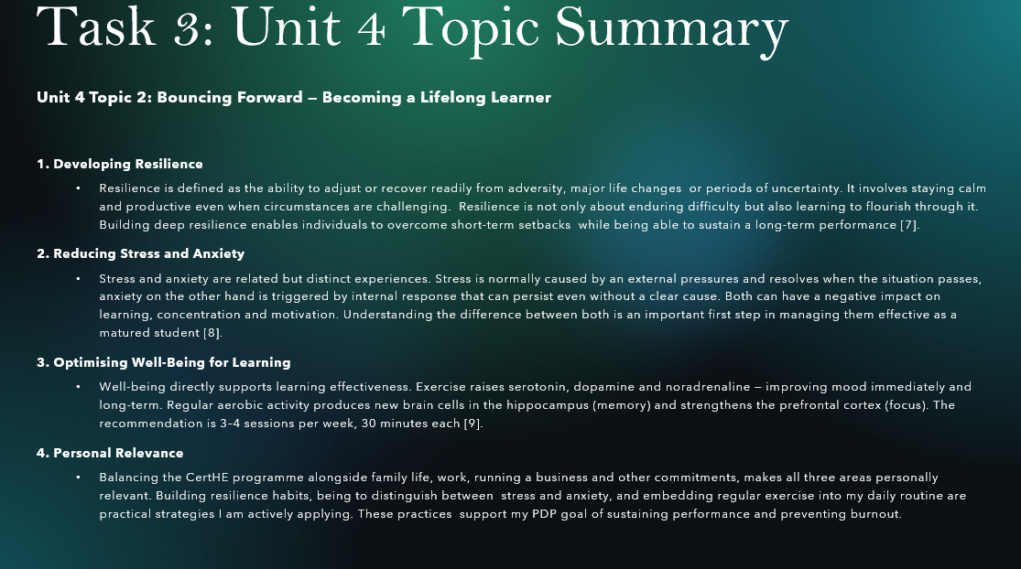

Unit 4 Topic 2 – Bouncing Forward explores four interconnected areas, Resilience defined as the ability to adapt or adjust quickly from adversities and life changes. Personal resilience emphasises remaining calm and productive under uncertainties [7] Second, reducing stress and anxiety, although they are related but distinct. Stress is caused by external factors and normally resolves when the situation is no more or passes, whereas anxiety is triggered by internal factors that are likely to persist without a course [8]. Third, Optimising well-being for learning directly supports learning. 3-4 sessions of 30 minutes exercise is encouraged per week minimum as a way of combating stress and anxiety as it improves your mood immediately and long term [9]. Finally, Personal relevance-balancing the studies alongside other commitments makes all three areas directly relevant. Building resilience, distinguishing between stress and anxiety, and embedding regular exercise are all practical strategies I am applying and reflected in my PDP well-being goal.

Slide 9 CONCLUSION

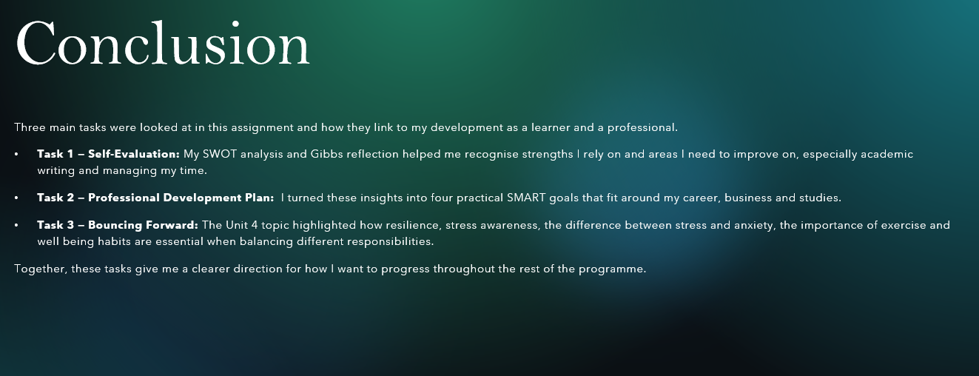

Slide 10 REFERENCES
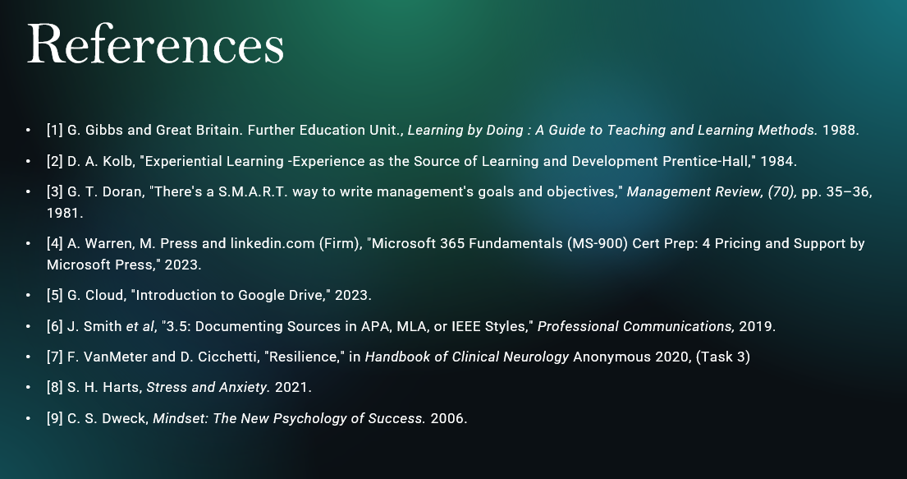

Conclusion
In conclusion, this assignment has enabled me reflect on my capabilities, identify areas for development, and understand how resilience supports effective learning. By completing the three tasks, I gained a clearer understanding of my strengths, weaknesses, opportunities and threats. I have been able to create a structured plan for improving my skills, and explore how well-being and stress management can influence my progress.
Overall, this work has given me a stronger sense of direction for my future studies and personal development.

References

[1] G. Gibbs and Great Britain. Further Education Unit., Learning by Doing : A Guide to Teaching and Learning Methods. 1988.
[2] D. A. Kolb, "Experiential Learning -Experience as the Source of Learning and Development Prentice-Hall," 1984. .
[3] G. T. Doran, "There's a S.M.A.R.T. way to write management's goals and objectives," Management Review, (70), pp. 35–36, 1981. .
[4] A. Warren, M. Press and linkedin.com (Firm), "Microsoft 365 Fundamentals (MS-900) Cert Prep: 4 Pricing and Support by Microsoft Press," 2023. .
[5] G. Cloud, "Introduction to Google Drive," 2023. .
[6] J. Smith et al, "3.5: Documenting Sources in APA, MLA, or IEEE Styles," Professional Communications, 2019. .
[7] F. VanMeter and D. Cicchetti, "Resilience," in Handbook of Clinical Neurology Anonymous 2020, .
[8] S. H. Harts, Stress and Anxiety. 2021.
[9] C. S. Dweck, Mindset: The New Psychology of Success. 2006.

