Pavlo Gladkyi
1918831

University of Wales Trinity Saint Devid
Problem Solving and Decision Making
Submition Date: 11th December 2020
Report
Decline of Royal Mail


Executive Summary.

This report was conducted to examine some key problems that currently influence the Royal Mail plc and directly or indirectly led to their business decline. The author of this report run an investigation to identify the root cause of the occurred problem.
Supported by the knowledge gained from the Problem Solving and Decision Making module, the author used problem-solving methods such as SWOT, PESTLE analysis, Ishikawa diagram, Five Whys and Six Thinking Hats to deep dive into the problem background circumstances.
Conducted research draws attention to the fact that the Royal Mail plc has a dominating position on the postal market in the UK but nonetheless, in many aspects, it loses to its competitors at the technological level.
Further investigation reveals that this technological procrastination created a broader problem for the company that has been aggravated by current COVID -19 pandemic and consequently influenced the future company development vector.

Table of Contents

Executive Summary. 1
1.0 List of Figures. 3
2.0 Introduction. 4
2.1 Current Economic Situation. 5
3.0 Findings. 7
3.1 The Royal Mail problems and the root cause of them. 8
3.2 Scope & Impact. 10
Nature. 10
Scope. 10
Impact. 11
4.0 Options (Potential solution). 11
5.0 Suggestion for solution monitoring and reviewing, discussion about how this solution will be communicated. 12
6.0 Conclusions. 13
7.0 Appendices. 14
7.1 Royal Mail SWOT Analysis. 14
7.2 Royal Mail PESTLE Analysis. 15
7.3 Royal Mail plc ISHIKAWA DIAGRAM. 16
7.4 Royal Mail plc Five Why’s Analysis. 17
7.5 Edward De Bono’s Six Thinking Hats. 18
7.6 Template for Monitoring, Reviewing and Communicating a Decision. 20
Acknowledgements. 22
Reference List. 23

1.0 List of Figures.

Page
Figure

1. UK GDP in August ………………………………………………………………………………………………….. 6
2. Value of internet retail sales in the UK (Jan. 2016 – Jun. 2020) ………………………………. 8
3. Market shares for UK parcel delivery …………………………………………………………………….. 9
4. Action-centred leadership, John Adair ………………………………………………………………….. 11

2.0 Introduction.

This report has been created at the request of Laura James - lecturer of the Problem Solving and Decision Making module (BMSW4004_SWAN), on 16/11/2020.
Pavlo Gladkyi compiled this report as a part of his assignment and submitted it on the required date and time on 11/12/2020 via Turnitin.
As a part of the Problem Solving and Decision Making module assignment, this report is aiming to identify the problems of the company, collect all necessary information and analyse Royal Mail plc current business issues by using provided analytical tools. Decided remedial actions will lead to tangible business improvement.
The creator of this report utilised various research methods that were provided to him by the lecturer of the module and were used to accomplish this report on a sufficient level.
These tools include Root Cause Analysis, SWOT Analysis, PESTLE Analysis, Five Whys, Six Thinking Hats Analysis and Ishikawa Fishbone Analysis. All completed by Pavlo Gladkyi analysis will be available in the report appendices.

2.1 Current Economic Situation.

If you can think productively and constructively, as well as analytically and logically, it will give you a third dimension in all your decision making and problem solving.
John Adair (2013. p.69)

The era of digital technological progress that began in the 1960s (Schulze, 2019) known as the Third Industrial Revolution, brought great opportunities and challenges for the modern world. This progress launched a chain reaction of continues digitalisation in businesses that changed people’s lives and reshaped the global market. Now in the 21st century, the Fourth Industrial Revolution made another step towards a significant game-changer for all aspects of human lives and industry in general (Gleason, 2018, p.2). Technological innovations allow businesses to create highly useful tools for success, where effective problem solving, business consecutive monitoring and analysis are essential elements in the corporate competition race.
Creativity is one of the most important factors which helps modern businesses be more flexible and adaptable for any internal or external threats, recognise opportunities and create possibilities even in an economic or pandemic crisis (Rushe and Sainato, 2020). Robots, artificial intelligence miniaturised sensors, nanotechnologies and quantum computers will provide a substantial field for creative business decisions where only human imagination could be a limiting factor.
Today many businesses suffer from COVID – 19 pandemic. According to Duffin (2020), this contingency has a significant impact not only on the UK GDP but also on the worldwide economy. The author state that due to the severe adverse effects of coronavirus pandemic, major economies will lose at least 2.4 per cent of the value of their gross domestic product (GDP). Additionally, Irwin (2020) confirms that a global pandemic situation will increase the speed of deglobalisation, that started after The Great Recession of 2008 – 2010. He is explaining how uncertainty in international cooperation could lead to limitations in economic interdependence and emphasis on domestic sourcing.
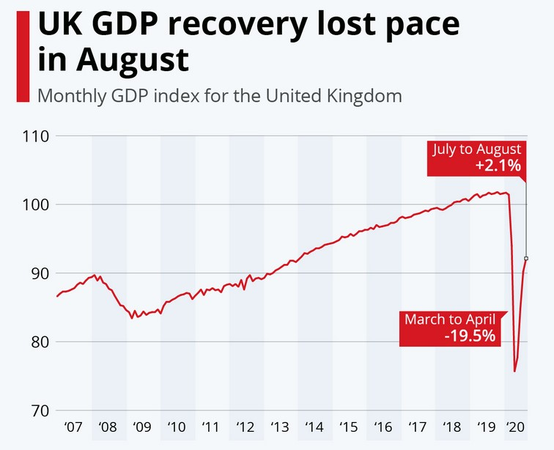
Figure 1: UK GDP in August.

COVID – 19 crisis is changing global market and businesses all over the world, not only financially but also strategically.
Despite this challenging time where economic risks are too high, there is still some hope that the worst scenario for the businesses can be avoided by using effective problem solving and decision-making techniques, macro environment analysis and efficient adaptation to occurred circumstances.

3.0 Findings.

History of Royal Mail plc starts back in the 17th century when Charles the First established British Post Office and later being reorganised by Oliver Cromwell into General Post Office. Moreover, this re-establishment was approved by Charles the Second in 1657. Thus the General Post Office had a rights to operate the ‘Royal Mail’. Despite the fact that The Post Office technically was an independent corporation, but in fact, it still belonged to the state.
From 1984 after several corporate and management changes, the telecommunication sector of the company was privatised and divided into three departments: Royal Mail letters, Parcelforce and Post Office Countries. From that period of time, the Post Office strengthened its position on the international market especially after several strategic acquisitions of the German Parcel, Der Kurier, Williams group, Citipost, Nederlandse Pakket Dienst, General Parcel and other operators in Eastern Europe.
In millennium The British Post Office had a rebranding to Royal Mail, became a public limited company and offer its shares to the public for sale. Furthermore, Royal Mail introduced new products and services to the customers such as Post Office Card Account (stated its presents in banking business). Additionally, in 2005 after the loss of the UK monopoly (Royal Mail loses postal monopoly, 2005), Royal Mail announced a corporate structure changes that divided the company into Royal Mail Letters, Post Office, Parcel Force Worldwide and GLS (General Logistic Systems).
Online shopping trends in 2005 pushed Royal Mail to sign several agreements with retailers and web trading companies which worked on eBay platform.
Next ten years Royal Mail plc was investing in new products and services (Dialogue mail, Global Bank Direct, automated teller machines, intelligent stamps, Door Drops Online, Market Reach, Postcode Address File, etc.). Also, was making long term strategy agreements (ZJS Express, MNG Kargo, British Gas, Amazon, National Trading Standards Scams Team, etc.) and investing in hand-held technologies (over £130 million).
According to Marketline (2020), the UK government in 2013 privatised Royal Mail by relishing overall ownership control and selling a 60 per cent of its stake.
In 2015, Royal Mail decided to increase its Web present and acquired Store Feeder – UK based IT company. As a result of this deal, Royal Mail refreshed own web site and provided new services to the customers (e.g. Mailshot Marker).
From 2015 to 2019 Royal Mail plc brought on market new products and launched new services (e.g. Express 24 Large), acquired Postal Express (US parcel delivery company) and Dicom Canada (Canadian parcels delivery company).

3.1 The Royal Mail problems and the root cause of them.

After Royal Mail plc business case investigation, the author of this report came to several conclusions. Furthermore, deep dive into the company history and the business decisions made in the past revealed several strategic problems that have a substantial impact on the Royal Mail plc current business situation. The author of this report identified that the company was a monopolist on the local UK postal market for centuries, had vast governmental support and felt quite comfortable to invest in business expansion instead of investments in progressive technologies, corporational culture, teamwork-based structure. Ignorance of modern business trends such as KAZEN, Lean management, etc., led to a technological lag behind emerging competitors.
As a result of technological procrastination, Royal Mail plc use mainly manpower for the crucial operational processes, poor or inadequate sources of internal communication and outdated labour control (clock-in system still functions with a pen and paper, rather than automated scan-in badge system). Minimal presence of conveyors and low automatisation on Royal Mail UK sites exacerbates the situation of processing increased volume of parcels.
Additionally, COVID – 19 worldwide pandemic and governmental restrictions for business (lockdowns, social distancing, etc.) elevated online shopping trends, accelerated the negative processes which accumulated over time in the Royal Mail plc and increased this technological abyss of the company.
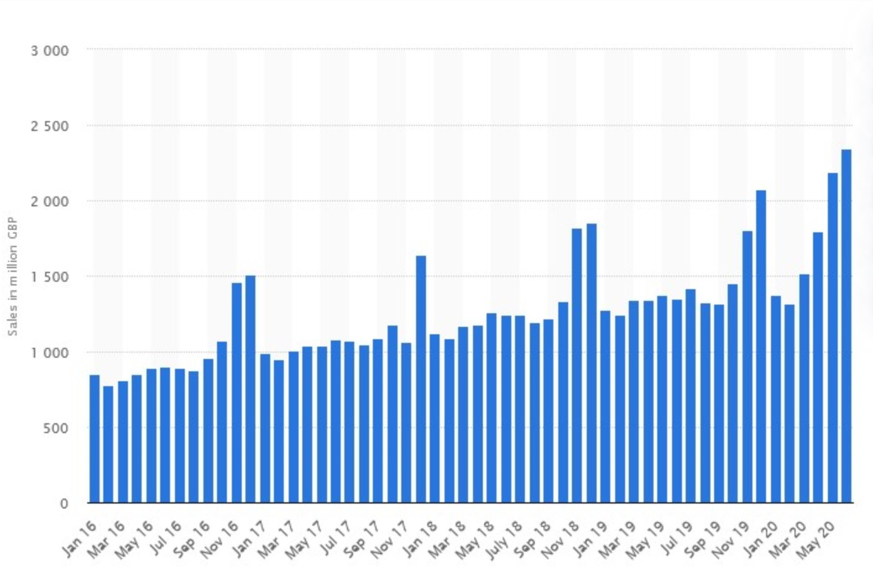

Figure 2: Value of internet retail sales in the UK (Jan. 2016 – Jun. 2020).
Ultimately, as a result of this pandemic impact, Royal Mail plc is reducing postal services due to increased sick leave of the employees, losing its position on a market and suffering to provide quality services to its customer’s (Sweney, 2020).
The next identified problem within the Royal Mail plc is inefficient market trends monitoring and analysis. Royal Mail plc marketing division did not evaluate the threats of electronic communication for the letter business. The era of the internet brought a significant amount of communication tools, and unfortunately for the Royal Mail plc business more effective, fast and completely free.
“Green” modern business trends allow companies to use emails instead of letters, internal social media to enable effective employees interaction and economise on paper and supported expenses. According to Consulting Worldwide (2015), this electronic substitution from digital media reached its peak in 2005 when the letter market in the UK has declined by 37 per cent.
Moreover, the new Data Protection Act (Data Protection Act 2018 CHAPTER 12, 2018) and the implementation of the General Data Protection Regulation (Gov.uk, 2018) also had a tangible impact on Royal Mail plc and letter volume in particular. According to The Week UK (2019), the company lost a considerable eight per cent in letters volume due to marketing mail-outs and had eighteen per cent of the decline in Royal Mail plc shares.
However, Royal Mail plc top management did not react quick enough to conduct business diversification to avoid current problems. Incapability to think out of the box, and tunnel vision created a barrier for developing a coherent contingency plan in a strategically critical for the business time.
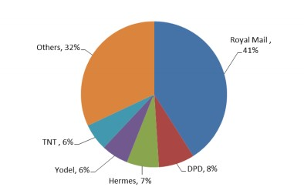
Figure 3: Market shares for UK parcel delivery.
Finally, the author of this report identified some operational and administrative problems. These managerial, strategic miscalculation in company development strategy impact teamwork and communication within the Royal Mail plc. Furthermore, the Royal Mail plc insiders disclosed and confirmed to the author of this report the undeveloped teamwork structure and serious communication issues (e.g. postman have to use their personal mobile devices to coordinate workflow or report immediate matters, no Health & Safety team on the site, no Team leads positions, not established coherent two ways communication between the shifts, no scheduled Risk Assessments, etc.).
After all aforesaid, the author of this report would like to emphasise three major Royal Mail plc problems:
- Technological procrastination (on all levels).
- Workflow organisation and communication (no Teams, not streamlined operational processes, etc.).
- Weak marketing and management.

3.2 Scope & Impact.

Nature.

The Royal Mail plc has an outdated business model where the business does not keep pace with available modern technologies, and the business continues improvement tools such as Lean Management, KIZEN, Gemba, 5S, etc., which apparently were not considered for implementation.
Top management and all involved in the strategic planning of company development are causing this problem.

Scope.

The identified problems have a wide scope of severity and affecting the whole company. However, the Royal Mail plc still has a substantial presence on the UK parcel delivery market. As a result, these problems directly affect their customers, own employees and overall performance of the company (quality, productivity and safety).

Impact.

The identified problems affect the correct accounting of working hours and wages of the employees. Additionally, technological procrastination leads to a large amount of manual labour, loss of cost-effectiveness. Consequently, all these decline the motivation of the employees.
Furthermore, identified problems have a tangible adverse effect on the quality of the provided services for the customers (e.g. no longer letters delivery on Saturdays, etc.).
The author of this report believes that all identified problems have a negative impact on the goodwill of the company, especially in the current COVID – 19 climate where all of their competitors are trying to fulfil maximum of customers expectations.

4.0 Options (Potential solution).

The author of this report identified several potential solutions based on carried out SWOT, PESTLE analysis, Ishikawa Diagram, Five Why’s and Six Thinking Hats analysis.
The Royal Mail plc should create an effective Crisis Response Team desirably from external and internal specialists with significant practical experience of dealing with similar business issues. The members of this team should have excellent practical skills in decision making, problem-solving and creative thinking methods.
Thus, the Crisis Response Team will be responsible for implementing the following solutions:
- Renewal of the entire/partial managerial staff throughout the internal and external recruitment. All candidates should have sufficient experience in lean management and strong action-centred leadership qualities (Chapman, 2020).
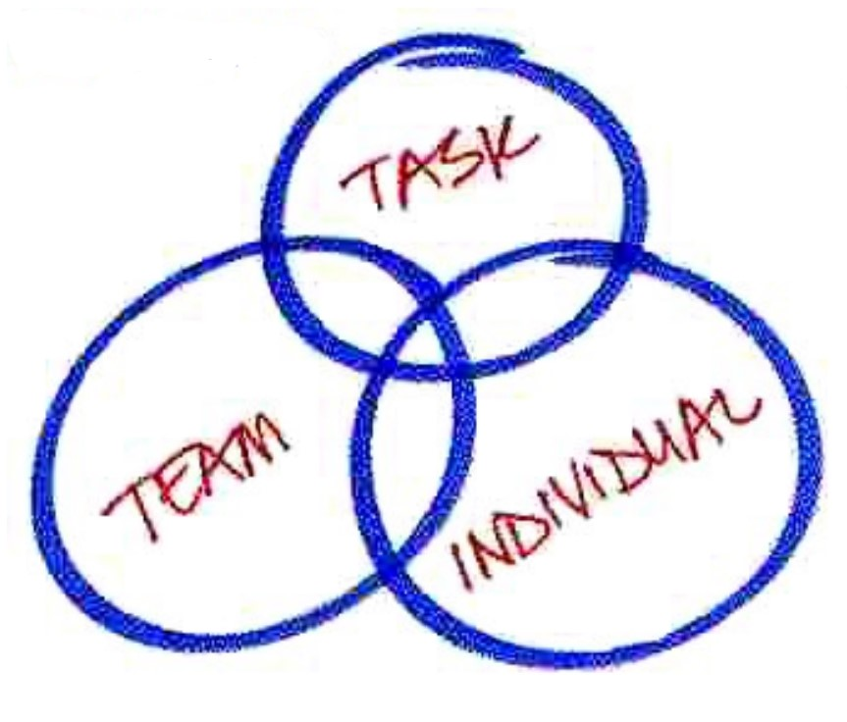

Figure 4: Action-centred leadership, John Adair.

- Essential will be a creation of clear managerial hierarchy and teams within the company. Additionally, have to be created Learning and Development team (standardised training on all operational processes), Health and Safety team (to make sure the company follow the Health and Safety at Work Act 1974 and all additional regulations), Loss Prevention team, etc.
- Investing in total operational and operations support modernisation and digitalisation of the entire company, with the implementation of all available modern technologies to streamline all crucial processes and effective communication establishment (conveyors, scunners, communicators, software, hardware, etc.).
- Use of lean management concept and continues improvement techniques for effective problem solving, elimination of waste to add value for the business, etc.
- All deployed strategic changes within the company should be resilient and continuously monitored.

5.0 Suggestion for solution monitoring and reviewing, discussion about how this solution will be communicated.

The author of this report strongly recommend the Royal Mail plc to continuously monitor implemented improvements by using Problem-solving, Project management and Lean management and other continues improvement tools and techniques. Furthermore, the Implemented solutions could be communicated with all stakeholders via digital communication tools such as internet-based software (Teams, Skype, other available social media), corporate email (Outlook, etc.) or intranet-based communication tools. Additionally, the Crisis Response Team could use verbal and non-verbal ways of communication such as SOS (start of shift) and EOS (end of shift) briefs, information boards, posters, visual management tools, etc. This communication has to be well established, clear and coherent throughout all stakeholders network, to avoid any barriers. Continues reflection on received data or feedback will increase efficiency and effectiveness of the problem-solving and decision-making process.
Please see completed by the author of this report a Template for Monitoring, Reviewing and Communicating a Decision related to Royal Mail plc case study in appendices.

6.0 Conclusions.

Problem-solving as a continuous, systematic improvement is a part of Lean management and paramount ability to any organisation, especially in the current pandemic situation where COVID – 19 put extra strain on businesses around the world.
The main objectives for any company today are to create a robust strategy to overtake pandemic crisis, adjust the new business model for growing modern e-commerce trends and invest in continuous organisational improvement to find a stable position on the market.
The Royal Mail plc current problems are an excellent example of strategic, operational, and administrative mistakes that management of the company ignored for a long time. This vulnerable position for the Royal Mail plc could restrain further company development and ultimately, as a result, will have a negative impact on the goodwill of the company.
In conclusion, the author of this report would like to emphasises that technological procrastination is an unaffordable luxury for modern businesses.

7.0 Appendices.

7.1 Royal Mail SWOT Analysis.
STRENGHTS
- Recognisable brand
- Over 500 years of service in the UK
- Biggest service provider in the UK
- International business
- Collaboration with other companies
- Remedial strategy (Tree Step Plan)
- GLS support (operational, financial)
- Ofcom and Government support (financial)
- Banks support (agreed on basic liquidity covenant on loan facility, COVID Corporate Financing Facility approved by BOE)
- Financial buffer (preserved cash)
WEAKNESSES
THREATS
OPPORTUNITIES
- Slow business adaptivity
- Not competitive online
- Control of COVID – 19 preventive measures (no H&S team on site)
- Poor operational automatization (man power)
- No dividends for shareholders in 2020-21
- No guidance or forecast for created contingency plan (2020-21)
- Technological procrastination
- Manual sortation of Parcels (on some sites)
- No organised teams
- Outdated clock in system (pen and paper)
- Bad/luck of wto way communication

- COVID – 19 pandemic
- Higher absence level of employees
- Increase of operational cost (SD measures, etc.)
- Strong competitors
- Management reduction (2000 roles) or stuff reduction (20%)
- Growing e-commerce market
- Busiest Q4 Peak period
- Volatile fuel charges
- Expected loss in marketing, 2020-21
- Letter volume reduction
- Executive changes (Group CEO departure)
- Reduced consumes spending ability
- Total parcels volume growth
- Incremental logistics costs (parcels volume increasement)
- Available technologies
- GDPR (privacy laws)

- Acceleration of pace of change (business improvements)
- Reduction of manual processing
- Operational automatisation (parcels, letters, hubs, etc.)
- Stronger online presence
- Improving quality of services
- Restoration of the market positions
- Crisis overcoming possibility
- Thechnological update
- Data processing optimasation
- New vector of development (cloud services, etc.)
- Dominated niche in parcels business

7.2 Royal Mail PESTLE Analysis.

- Brexit (traffic reduction between EU and UK, etc.)
- COVID – 19 restrictions & policies (2m/6ft SD, Masks, etc.)
- Government pandemic remedial plan (lockdowns, essential key workers, etc.)

P political

- Financial recession 2019 – 2020
- Economic recession 2008 – 2010
- Population solvency decline (due to COVID – 19)
- Current inflation and business volatility
- Deglobalisation
- Royal Mail shares decline
E economic

- Online shopping trends
- Self-isolation & lockdowns measures
- Reduced job market (accept essential keyworkers)
- Demographic changes (increased life expectancy and immigrants)
- Service quality expectations (Web, Apps, tracking, customers support 24/7, etc.)
- Depression, anxieties, etc. (due to COVID – 19)
S social

T technological
- Fourth Industrial Revolution (technological progress)
- Global digitalisation, robotisation and automation in industry
- Online services evolution
- Other competitors on parcel market (DHL, DPD, UPS, Amazon, etc.)
- Green technologies

- Current virological climate (COVID – 19)
- Reduction of Carbon Footprint trends
- Recycling trends
- Global Warming & Greenhouse effect
- Emphasis on paperless communication (in companies)

E environmental

- COVID – 19 business related requirements
- Brexit uncertainty (new trade agreements with EU after Brexit)
- Immigration law and rules changes (work permit, settled and pre-settled status, etc.)
- GDPR data protection rules
L legal

7.3 Royal Mail plc ISHIKAWA DIAGRAM.

ISHIKAWA DIAGRAM

METHOD
EQUIPMENT
PEOPLE

- Not streamlined processes
- Poor digitalisation
- Outdated workflow tracking
- Management vertical

- Deficiency of conveyors
- Hand handling work
- Luck of communicators for the postman
- No team structure
- Manpower
- Management
- Communication

PROBLEM

Royal Mail plc Decline

- Technological progress
- COVID – 19 pandemic
- Customer preferences
- Modern trends in business
- GDPR
- Post BREXIT uncertainty
- COVID – 19 business restrictions
- COVID – 19 governmental response

ENVIRONMENT
LAW

7.4 Royal Mail plc Five Why’s Analysis.

FIVE WHY’S ANALYSIS

1. Why? – Royal Mail plc was not ready to increase online shopping parcels turnover and decline in letters.
2. Why? – Unforeseeable COVID – 19 pandemic increased parcels volume.
3. Why? – Not sufficient e-commerce market trends monitoring and technological procrastination.
4. Why? – Not proactive top management position.

7.5 Edward De Bono’s Six Thinking Hats.

PROCESS
- Royal Mail plc has to change company development vector.
- Royal Mail plc business facing a crisis.
- New management have to conduct business diversification.


BENEFITS
- The diversification of the Royal Mail plc business will add sustainability and competitiveness.
- All positive changes will be expressed in monetary terms.



- There are several opportunities for Royal Mail plc business improvement.
- Suggestion:
- Implement continues improvement techniques in business
- Streamline all operational processes
- Implement latest technologies (e.g. automatisation, conveyor lines, etc.).
- Changes implementation structure:
- Create a Crisis Respond team
- Agree on Crisis Management Plan and remedial actions
- Establish strong leadership (e.g. site management hierarchy, etc.)
- Provide employees all necessary training (e.g. on lean management, etc.)
- Establish efficient communication and coordination within the company
- Implement all changes in timely manner
- Monitor deployed solutions
- Review/readjust CMP if needed.

CREATIVITY



FEELINGS

- Something what should have been done a long time ago.
- Possible overcoming of crisis and thrive of the company after implemented changes.

FACTS

- Technologies are available.
- How and where to exactly deploy them.
- Open sources of information, the experience of other parcel delivery companies, independent consulting assessment, etc.

CAUTION


- Resistance/Push-back from managers.
- Financial risks in crisis, market volatility.
- Velocity of implementation of changes (Worldwide business).

7.6 Template for Monitoring, Reviewing and Communicating a Decision.

Decision implemented:
- Global managerial changes.
- Total technological upgrade of the company.
- Lean management implementation (e.g. Teamwork, VMS, 5S, MUDA, etc.).

Monitoring the decision:
Resources:
- Crisis Response Team.
- An external consulting company.
- Ops and AM managers, team leads shifts.
- Real-time monitoring, Daily, Weekly, Monthly etc.

Key Indicators:
- Percentage of market shares increases.
- PDCA (Deming Cycle).
- Operational KPI’s (backlog, dwells, idle time, etc.).
- Processed parcels volume KPI’s.
- Customers/employees feedback.
- Flow process analysis.

Targets:
- Increase processed parcels volume.
- Customers satisfaction.
- Streamline of the all operational process.
- Royal Mail plc sites automatisation (conveyors, sensors, software, etc.).
- Recovery of market positions.
- Implementation of Continues improvement philosophy.
- Prepare a strong base of leadership and management.
- Create straightforward two ways communication within and between management/employees.

Data Sources:
- Site managers reports.
- External Consulting reports.
- Real-time KPI’s reports (internal services and tools, etc.).
- Financial Reports.
- Goodwill report.

Reviewing the decision:
After initiation, planning, execution stages, implemented solutions have to be evaluated and reviewed. Deployed problem-solving solutions need to be readjusted if needed.
Right questions for problem evaluation:
- Does CRT plan fit for the purpose to resolve current Royal Mail plc problems?
- Does the implemented solution meeting objectives?
- Are objectives quantifiable?
- Does more research need?
- Is the implemented solution resilient (long, immediate and short-term outcome identified)?
- Do monitoring measurements collected and reported to all stakeholders?
- Does implemented solution cost-effective?
- Has implemented solution resolved the problem?

Communicating the Decision:
Internal Stakeholders  Royal Mail employees.  Royal Mail directors and managers.  Royal Mail plc owners (Daniel Kretinsky, UK government, others shares owners). | External Stakeholders  Royal Mail plc Supplies.  Customers.  Royal Mail plc creditors (BOE, Ofcom and Government, etc.).  Shareholders.

Acknowledgements.

Author of this report is deeply grateful to Laura James, the lecturer of Problem Solving and Decision Making module (BMSW4004_SWAN) for provided support and guidance. Additionally, the author expresses his deep gratitude to all Royal Mail plc insiders, who shared valuable information to help reveal certain issue within the company.

Reference List.

Chapman, A. (2020). John Adair’s Action-Centred Leadership Model - BusinessBalls.com. [online] Businessballs.com. Available at: https://www.businessballs.com/leadership-models/action-centred-leadership-john-adair/ [Accessed 9 Dec. 2020].
Consulting Worldwide, P.& L. (2015). Review of the impact of competition in the postal market on consumers. [online] https://www.citizensadvice.org.uk, https://www.citizensadvice.org.uk/Global/Public/Policy%20research/Documents/Final%20CA%20final%20report%20market%20review%202-07-15.pdf: Citizens Advice, p.2. Available at: https://www.citizensadvice.org.uk/Global/Public/Policy%20research/Documents/Final%20CA%20final%20report%20market%20review%202-07-15.pdf [Accessed 7 Dec. 2020].
Data Protection Act 2018 CHAPTER 12. (2018). [online] Available at: https://www.legislation.gov.uk/ukpga/2018/12/pdfs/ukpga_20180012_en.pdf [Accessed 5 Dec. 2020].
Gov.uk (2018). Data Protection Act 2018. [online] GOV.UK. Available at: https://www.gov.uk/government/collections/data-protection-act-2018 [Accessed 2 Dec. 2020].
‌ Irwin, D. (2020). The pandemic adds momentum to the deglobalisation trend. [online] Washington International Trade Organisation. Available at: https://www.wita.org/blogs/the-pandemic-adds-momentum-to-the-deglobalization-trend/ [Accessed 26 Oct. 2020].
‌ Marketline. (2020). Royal Mail plc - Strategy, SWOT and Corporate Finance Report. [online] Available at: https://store.marketline.com/report/ml2697453sa--royal-mail-plc-strategy-swot-and-corporate-finance-report-2/#product-123417 [Accessed 28 Nov. 2020].
Royal Mail loses postal monopoly. (2005). news.bbc.co.uk. [online] 18 Feb. Available at: http://news.bbc.co.uk/1/hi/business/4274335.stm [Accessed 28 Nov. 2020].
Rushe, D. and Sainato, M. (2020). Amazon posts $75bn first-quarter revenues but expects to spend $4bn in Covid-19 costs. [online] the Guardian. Available at: https://www.theguardian.com/technology/2020/apr/30/amazon-revenues-jeff-bezos-coronavirus-pandemic [Accessed 20 Oct. 2020].
Schulze, E. (2019). Everything you need to know about the Fourth Industrial Revolution. [online] CNBC. Available at: https://www.cnbc.com/2019/01/16/fourth-industrial-revolution-explained-davos-2019.html [Accessed 19 Oct. 2020].

Sweney, M. (2020). Royal Mail may reduce postal services as more staff take sick leave. The Guardian. [online] 27 Mar. Available at: https://www.theguardian.com/business/2020/mar/27/royal-mail-may-reduce-postal-services-as-more-staff-take-sick-leave-coronavirus [Accessed 5 Dec. 2020].
The Week UK. (2019). Can anything halt Royal Mail’s decline? [online] Available at: https://www.theweek.co.uk/99287/can-anything-halt-royal-mail-s-decline [Accessed 2 Dec. 2020].

‌
‌
‌
‌
‌
‌
‌
‌

‌

‌

