Riding the Wave: Integrating Surfing into the Welsh Curriculum

Executive summary

This proposal outlines an eight-week surfing programme designed to align with the Curriculum for Wales and support the holistic development of year 8 pupils. In response to declining physical activity levels, rising screen time, and limited outdoor learning opportunities, the programme offers an engaging alternative to traditional PE by immersing pupils in experiential, adventure-based learning. Grounded in the health and Wellbeing Area of Learning and experience, the programme uses key educational frameworks, including Vygotsky’s zone of proximal Development and Kolb’s Experiential Learning Cycle, to promote competence, confidence, and resilience. The programme will be delivered through partnerships with the school, surf instructors, and RNLI staff to develop physical literacy, wellbeing, environmental awareness, and cross curricular links. A structured progressive approach from land-based skills to water-based wave riding ensures inclusivity for all students. this programme also outlines risk management, ethical considerations, and resource requirements which demonstrates the programmes feasibility and potential long-term benefits of students personal, social and physical development.

Rationale

As part of the new curriculum in Wales there is a shift from traditional school lessons and result based outcomes towards a more holistic approach that focuses on the wider development of the child. Welsh Government (2022) discuss that one of the four purposes is to create ambitious, capable learners. Health and wellbeing Area of Learning (AoLE) is a suitable place to explore this topic within the PE curriculum. Furthermore, part of the Curriculum for Wales gives guidance for how PE has adapted and should be delivered. Welsh Government (2008) Implies there are four main areas to be covered in key stage three Physical education: health fitness and well-being, creative, adventurous, and competitive activities. Although this piece was created in 2008 it still carried value into the new curriculum in 2022 as guidance for PE delivery in Wales. Habyarimana et al. (2025) created a systematic review that displayed findings showing that there has been a global drop in physical activity levels in adolescents, the factors including reduced self-efficacy, motivation, increased screen time and academic workload. This review shows there is a need for schools to find a new way to engage students in physical activities in a setting that potentially they do not have access to phones and technology in. unfortunately there is a lack of opportunities to be educating and learn in the outdoors for students due to numerous barriers in schools. Patchen et al. (2024) state that teachers and school administrators have identified logistical constraints, limited resources, and competing priorities in schools as barriers within school settings that reduce outdoor time in schools. We can gather from this that schools have pressures from various aspects of the school, they may want to spend more time outdoors, but school timetables and facilities may make this very challenging. To fit with the new curriculum, I am proposing a block of surfing lessons to cover a lot of the needs within (CfW) and to combat some of the modern issues provided above within young students and schools. Pérez-Gutiérrez, Castanedo-Alonso, and Cobo-Corrales (2023) Implies that surfing programmes integrated into school PE can promote physical health, well-being, socialisation, and environmental awareness in students. the progressive stages within this programme from land-based balance and coordination to swimming skills and then complete surfing tasks allow for students to progress and develop a sense of confidence, competence, and build resiliency throughout the programme. These are all key skills that have main roles within (CfW) therefore helps to show surfing could be a helpful and effective tool to for schools in Swansea. Nardo (2021) discusses the Lev Vygotsky learning theory and the zone of proximal development which is about setting tasks in the gap between what a learner can do independently and what they can achieve with guidance. This theory suggests a need for teachers to facilitate learning and development through guided interaction. This theory works hand in hand with surfing lessons and presents an opportunity for development to be done through setting achievable goals that can be pushed every lesson but also allowing for teachers to guide students toward their goal. The purposes of using a long-term block of surfing lessons are so students can gain new skills in an environment potentially they won’t get an opportunity to have without the school. This progressive style of learning is achievable and can really build students confidence and motivation to go outdoors and try new activities. This wide range of skills developed through surfing lessons suggest that teachers could achieve cross curricular links without the purpose of this block being Soley to develop physical competence. Polley (2010) implies that surfing lessons offer various educational benefits when integrated as cross curricular learning, particularly works in outdoor frameworks. The variety in lesson plans can meet different educational goals. The National Lottery (2025) To help fund this project a grant can be applied for through the national lottery website who offer a (be active Wales fund).

Aims 150-200

the primary aim of this long-term surfing programme is to enhance students’ physical literacy wellbeing and connection to the environment through meaningful experiential outdoor learning aligned with (CfW). The programme will provide learners with opportunities to develop competence, confidence, and motivation in physical activity whilst also working on personal and social skills.

Objectives

- Develop fundamental movement skills and water confidence.
- Improve pupils’ resilience, confidence, and wellbeing.
- Use cross curricular learning to achieve a variety of skills in the (CfW).
- Promote lifelong physical activity through the concept of physical Literacy
- Strengthen partnerships between school, university and surf school provide to develop community links.

Participants

Rossi and Nick (2021) suggest that Covid 19 and the school closures have been associated with a notable decrease in activity levels among key stage 3 level students, also any children who had been noted with increased levels of physical activity were due to unstructured outdoor activities over school based. Target group for my surfing programme will be key stage 3 students which is the range of ages 11-14 in school, but specifically year 8 students. This is to attempt to combat the issues in covid 19 and try to reengage students in physical activity with a different approach. surfing is very beginner friendly and has lots of progression steps until there is any real danger, thus meaning students of any ability and background can participate. Students will be split into different groups between competent swimmers / surfers and beginners to water activities. To ensure equality and inclusion for all a surf school will be used that can provide all students with wetsuits and surfboards furthermore, transport will be provided through school mini busses to lower costs.

Design

This programme will be one session a week for students and will run 8 weeks in a school term. The sessions will be 60- 90 minutes and will take up a double lesson of PE in the school timetable including travel time to local beach and time for students to change etc. the sessions will include water safety with RNLI to start with and slowly build from water understanding and competency towards catching waves with qualified surf coaches. Each session will start with a safety briefing of the daily conditions for example rips and size of waves for roughly 15 minutes. Then 45 – 60 minutes of activity whether that’s land based activities like learning to pop up and balance or actual water activities. The session will be followed with a reflection on the experience using Kolb’s Experiential Learning Cycle for around 10 – 20 minutes during this time they will keep a journal and log of what they learnt, key information or facts they learnt, and a note of how their body feels after every session mentally and physically. Kolb (1984) a four-stage process that consists of having a concrete experience, then reflective observation which is reflecting on the experience, followed by abstract conceptualisation, which is learning from the experience, and finally active experimentation trying out what you learned. Therefore, we can see that the lesson designs allow for this process to be taken place effectively with time to reflect after sessions and then experiment on what you learned the next week and consolidate learning.

The sessions are staged to scaffold the learning progressively throughout the 8 weeks of learning, session 1-2 will have a focus in the main body of confidence, beach safety, and basic surfing skills like the pop up and paddle technique on land. Weeks 3-5 will have a focus on applying the week 1-2 skills to the actual task in water while catching waves. In weeks 6-7 there will be focus on developing the wave selection and decision making, this will be how do you decide which wave you’re going to catch and what point of the wave you are going to stand up. Week 8 can be a session dedicated to students having fun and showcasing skills they’ve learnt independently. This lesson would be less structure and teacher led and will allow for students to have more autonomy and student led lessons. This surf programme has been based off research from other previously done programmes the main design is based off Bravo et al. (2016) who suggested there was significant success in improving students physical and mental health. The wave Project (2025) are a charity who work with similar aged children to those used in this programme, and they suggest that surf programmes can build confidence, build relationships and help with mental health. This further shows the wide range of benefits from surfing programmes in young children and shows it can effectively be used to achieve cross curricular goals under the health and wellbeing section in (CfW)).

Throughout this project there are many cross curricular links that can be filtered into the programme for example the reflective journals have many links with reflective writing in English which is a very important part of the curriculum. Furthermore, there will be lots of link with the coastline and wave formation which gives room for maybe creating a strong link between geography and this programme. For example, during this 8-week block potentially the geography lessons during this time could be based on waves and how beaches form. As part of the new curriculum in Wales there is a massive weight and importance on trying to create cross curricular links wherever possible that’s why the surfing programme was designed with cross curricular links in mind with health and well-being and other traditional lessons, so it can follow the (CfW) aims of learning.

Risk Assessment / ethics

Appendix A: surfing risk assessment
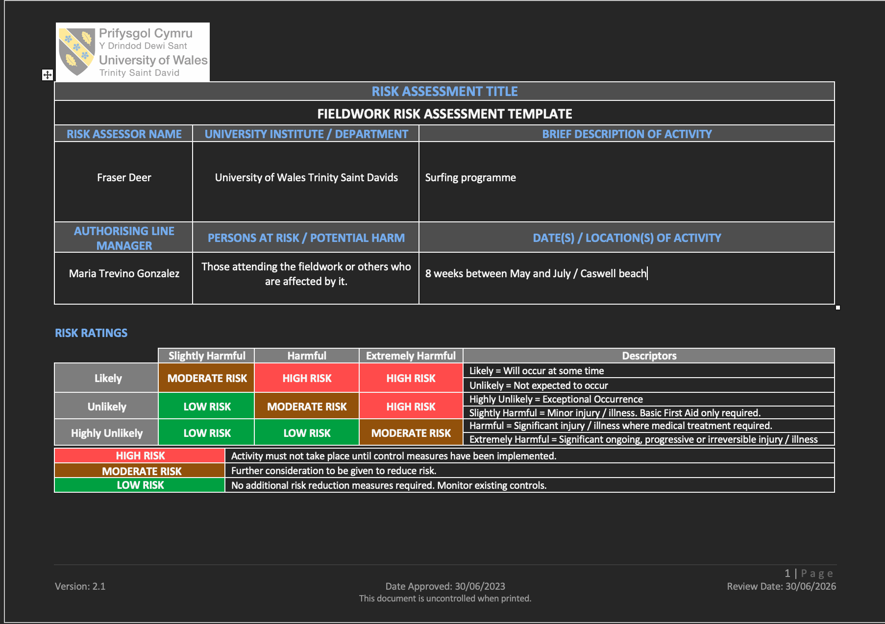

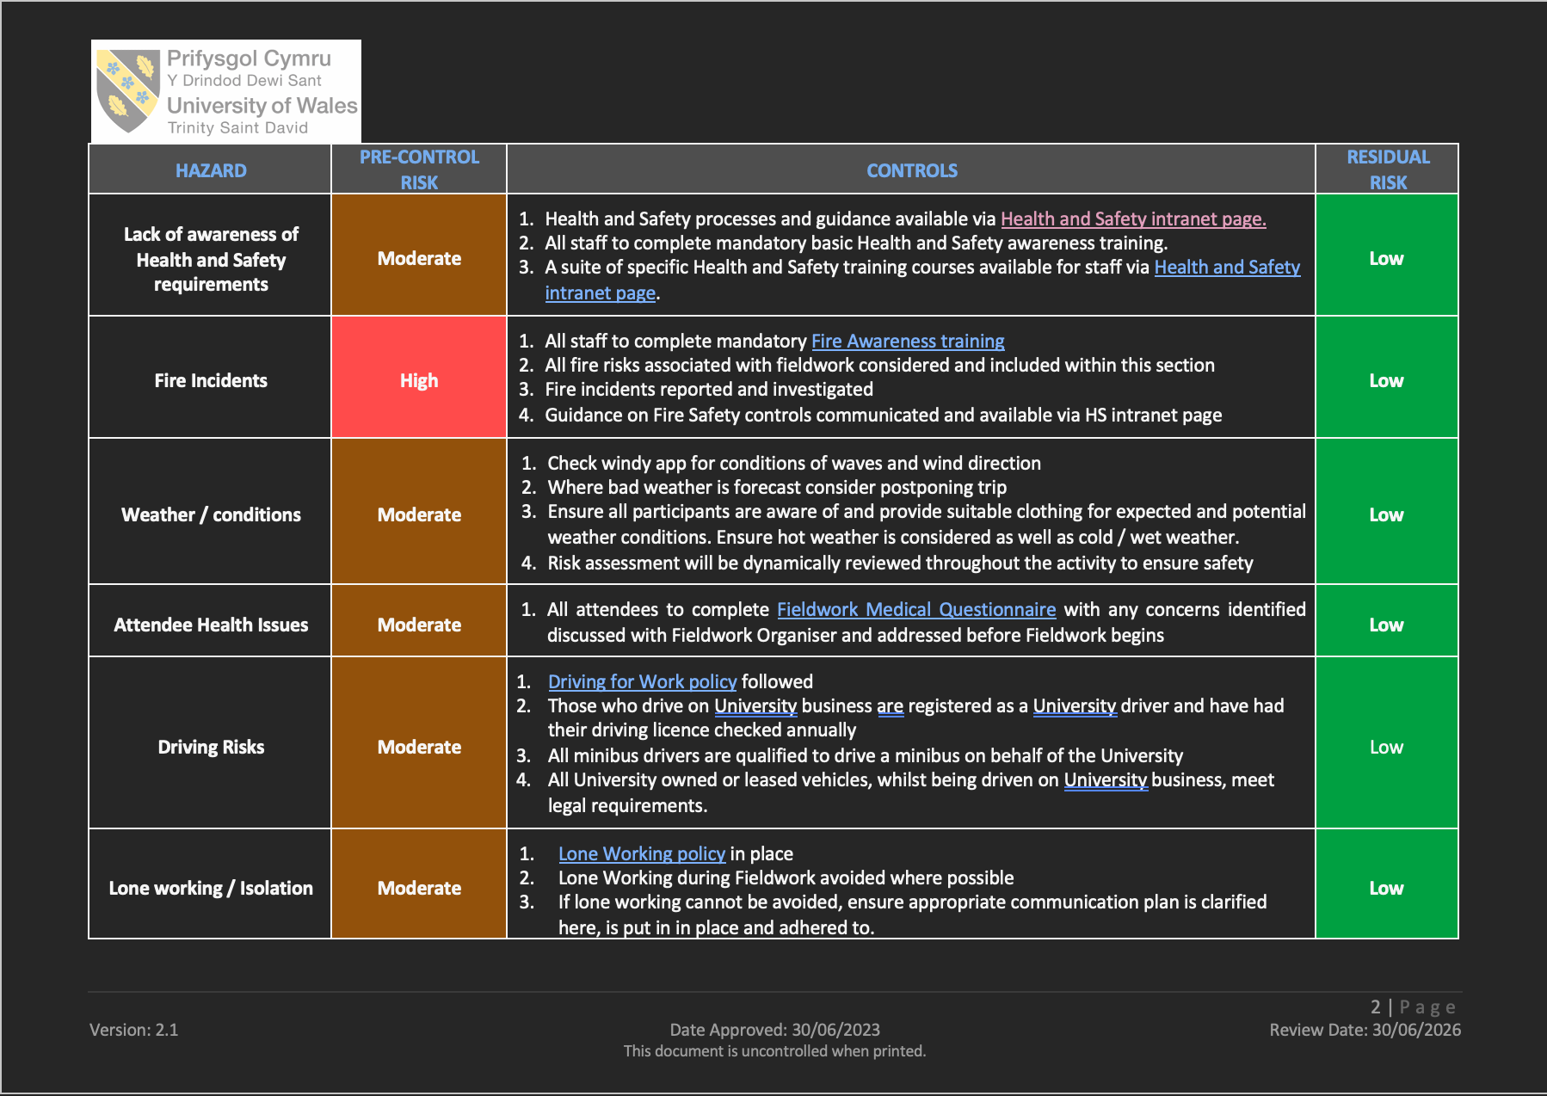

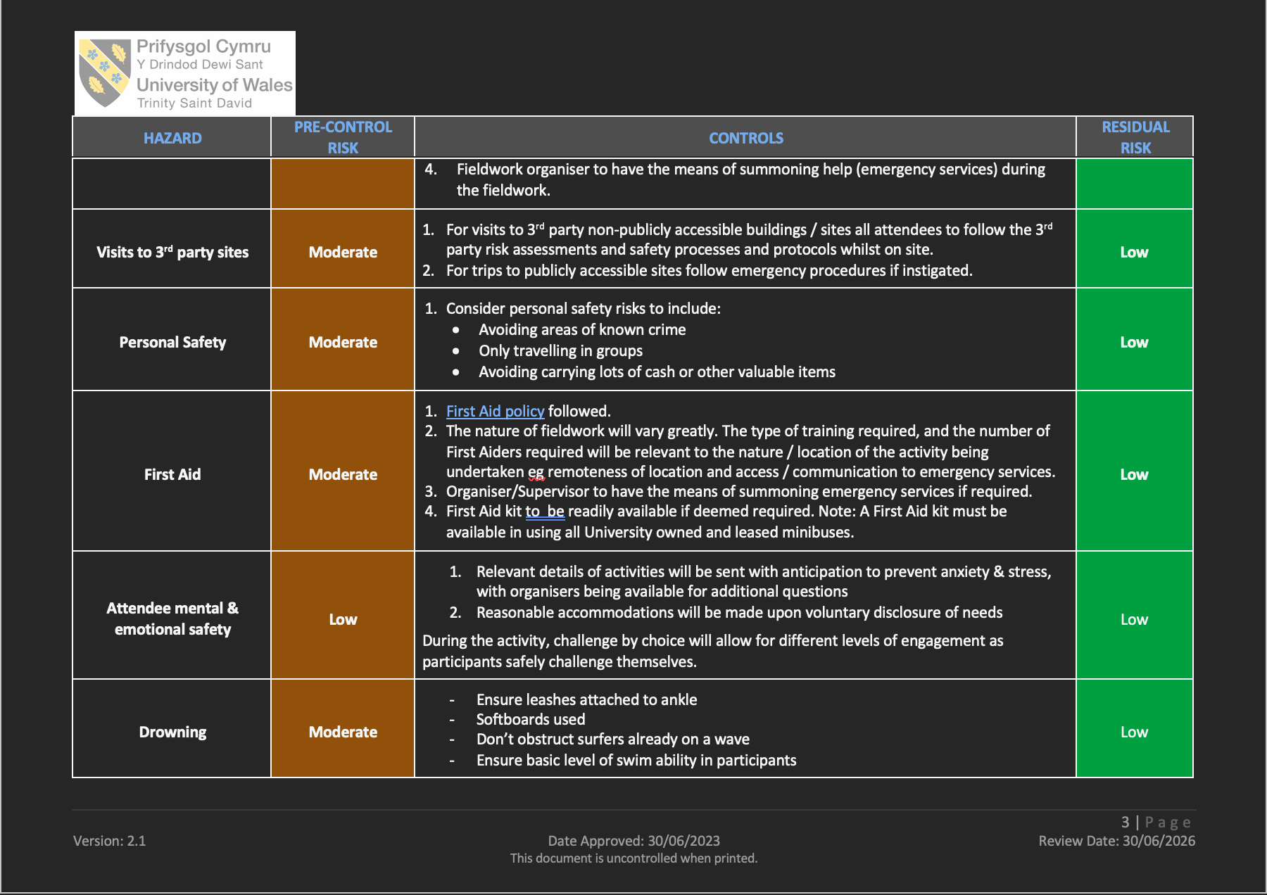
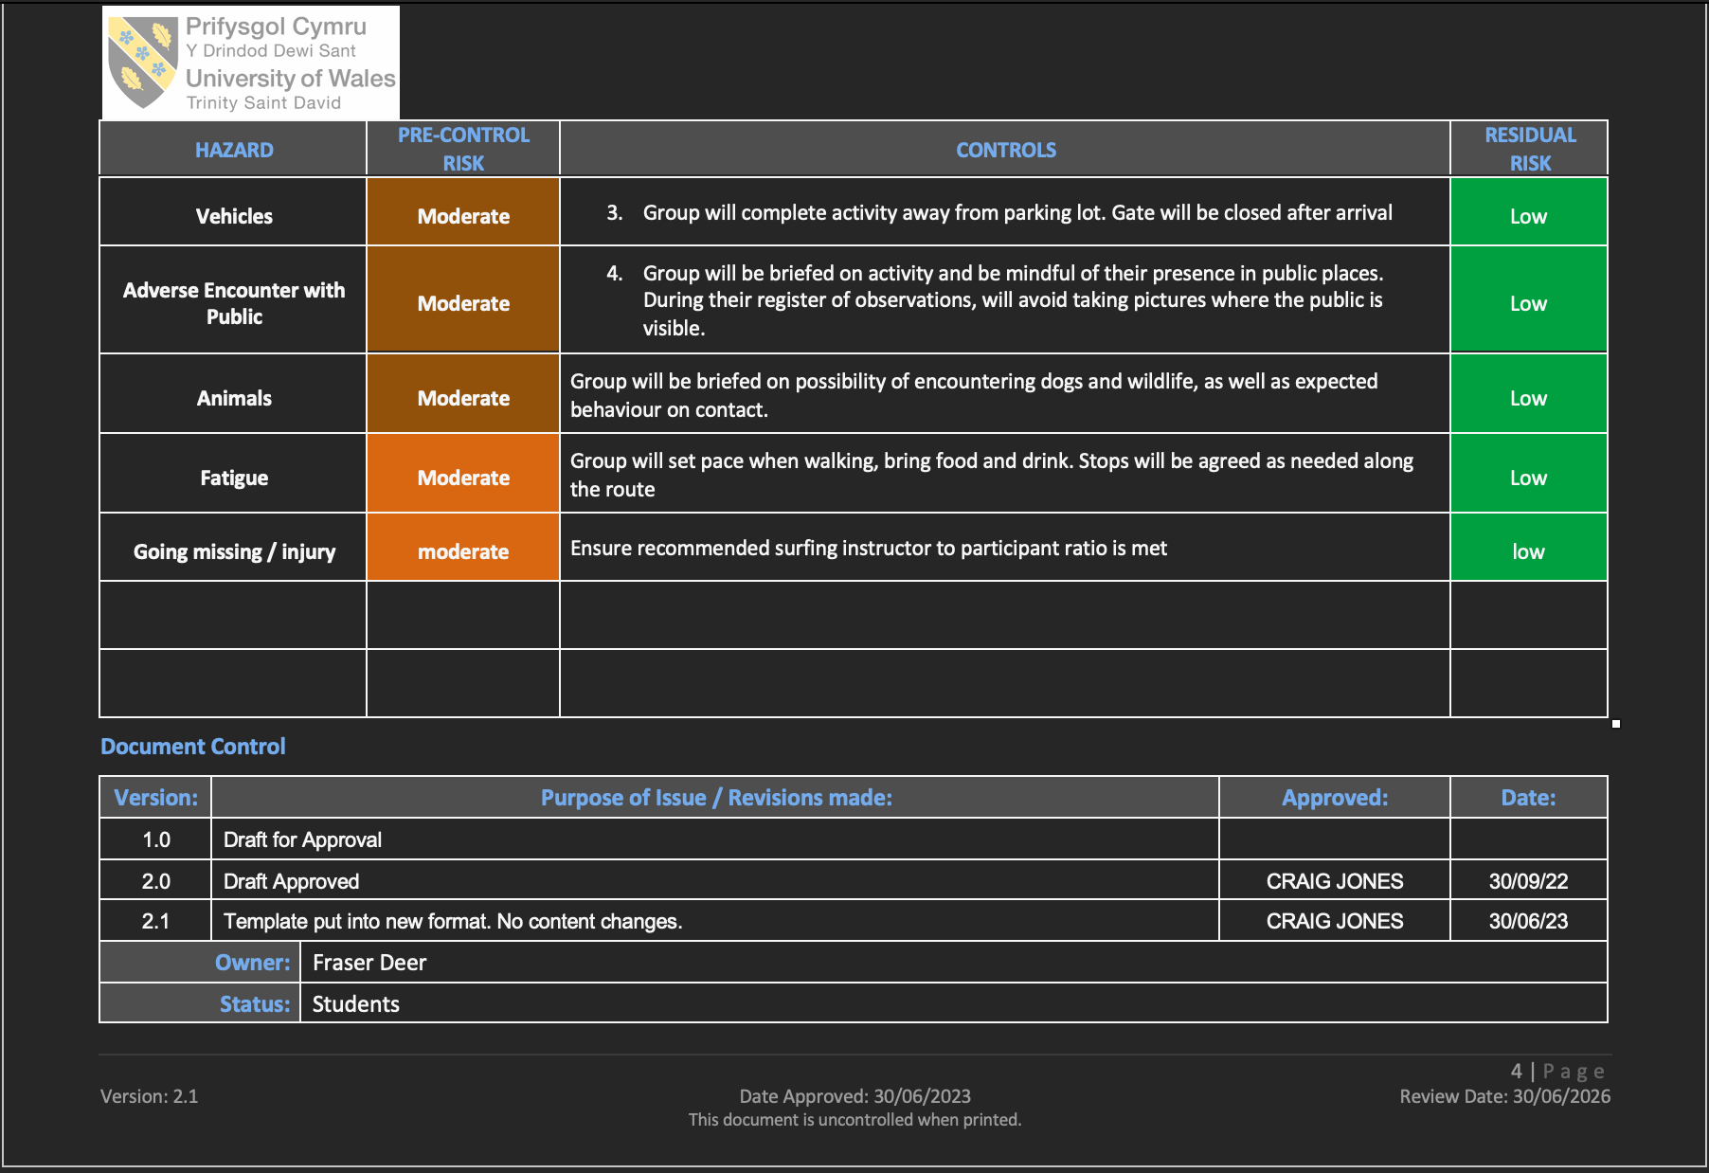

Some of the key hazards for this task include drowning, equipment, and poor weather so it is important that the right mitigation is taken to prevent any issues occurring. All coaches must be surf qualified and have qualified lifeguards on duty while activity is taking place. Before every day of activity, it is important to do assess the weather conditions for students’ safety and to also actively be assessing risks while the activity is taking place. It is important to take ethical consideration before any activity is taken place, as all students are minors on this surf programme it is important to gather informed consent from all parents. Also, it’s important that the data collected is all safely stored and after the activities are completed all the consent and data is destroyed and non-traceable.

Resources

Equipment needed for this surf programme will come from different places, some will be provided by the surf school for example the wetsuits, surfboards, and the leashes for boards. From the school they will need to provide the transport via minibuses and bring first aid kit. As of human resources the school will need to provide qualified pe teachers and someone to drive busses, furthermore, there will need to be qualified surf coaches and RNLI lifeguards. To help fund the costs of travel and surf school part of the school PE budget will be put towards the cost and as mentioned earlier a grant from the national lottery will be applied for. The funding will hopefully be permitted to go towards this project as it is developing children’s mental health and getting them engaged again in physical activity again since covid 19.

Conclusion
This proposal demonstrates how a term-long surfing programme can meaningfully address the aims of the curriculum for Wales while responding to contemporary challenges facing young people and schools. the decline in adolescent age physical activity, rising screen time, and limited access to outdoor experiences highlight the need for innovative, engaging approaches to physical education. Surfing offers a unique combination of physical, social, and emotional benefits, making it a powerful tool for developing confident, resilient, and physically literate learners. The programme’s progressive structure is supported by theories such as Vygotsky’s zone of proximal development and Kolb’s experiential learning cycle ensures that pupils build competence through guided practice, reflection, and achievable challenges. This fosters not only improved physical skills but also enhanced wellbeing, motivation, and confidence in the outdoor environment. The cross curricular potential further strengthens the programme, offering links to English, geography, health and wellbeing, and environmental education, aligning with the holistic vision of the new Welsh curriculum. Some constraints including weather dependency and transport pose potential barriers; however, these can be mitigated through strong planning and assistance from surf school. Funding opportunities such as be active Wales make the project financially feasible. Overall, this surfing programme offers a creative, evidence informed, and highly relevant approach to PE provision in Swansea. Its long-term benefits extend beyond physical competence, helping pupils build lifelong positive attitudes toward physical activity, outdoor learning, and personal wellbeing. This programme has potential to solidify itself into the curriculum and be a model to be used by other schools.

AI acknowledgements
AI Tool (with url) | Date used | Why did you use this tool | Example prompt(s)
https://refworks.proquest.com/library/recent/ | 27/11/25 | Create reference list
https://chatgtp.com/ | 24/11/25 | Help with structure | Help structure an 8-week school surfing programme
https://librarysearch.uwtsd.ac.uk/discovery/researchAssistant?vid=44WHELF_UWTSD:44WHELF_UWTSD_VU1 | 26/11/25 | Research | - School surfing programmes  - Lack of outdoor education due to covid 19

Appendices

Appendix A- surfing risk assessment

- Screenshots of the full risk assessment document for a surfing programme

Reference list

Bravo, M.M., Cummins, K.M., Nessler, J.A. and Newcomer, S.C. (2016) 'Heart Rate Responses of High School Students Participating in Surfing Physical Education', Journal of strength and conditioning research, 30(6), pp. 1721–1726. doi: 10.1519/JSC.0000000000001263 .
David A, K. (1984) 'Experiential Learning: Experience as the Source of Learning and Development', .
Habyarimana, J.d.D., Tugirumukiza, E., Sun, H., Pathirana, A. and Zhou, K. (2025) 'From active play to sedentary lifestyles: understanding the decline in physical activity from childhood through adolescence—a systematic review', Frontiers in public health, 13. doi: 10.3389/fpubh.2025.1636891 .
Nardo, A. (2021) 'Exploring a Vygotskian Theory of Education and Its Evolutionary Foundations', Educational theory, 71(3), pp. 331–352. doi: 10.1111/edth.12485 .
Patchen, A.K., Rakow, D.A., Wells, N.M., Hillson, S. and Meredith, G.R. (2024) 'Barriers to children's outdoor time: teachers' and principals' experiences in elementary schools', Environmental education research, 30(1), pp. 16–36. doi: 10.1080/13504622.2022.2099530 .
Pérez-Gutiérrez, M., Castanedo-Alonso, J. and Cobo-Corrales, C. (2023) 'Implementation of Surfing in Physical Education', Journal of physical education, recreation & dance, 94(4), pp. 51–54. doi: 10.1080/07303084.2023.2173479 .
Polley, S. (2010) Quality lesson plans for outdoor education Singapore: Springer Singapore, pp. 49–51 .
Rossi, L., Behme, N. and Breuer, C. (2021) 'Physical Activity of Children and Adolescents during the COVID-19 Pandemic—A Scoping Review', International journal of environmental research and public health, 18(21), pp. 11440. doi: 10.3390/ijerph182111440 .
The National Lottery (2025) Find funding for your project. Available at: https://www.lotterygoodcauses.org.uk/funding?location%5B%5D=wales&amount= (Accessed: 24 Nov 2025).
The Wave Project (2025) 'Impact Report 2024/25', https://www.waveproject.co.uk/wp-content/uploads/2025/08/The-Wave-Project-Impact-Report-202425.pdf?utm_source=chatgpt.com.
Welsh Government (2022) Developing a vision for curriculum designhttps://hwb.gov.wales/curriculum-for-wales/designing-your-curriculum/developing-a-vision-for-curriculum-design#curriculum-design-and-the-four-purposes .

