From the twilight of Rome to the Dawn of Islam: The World of Late Antiquity (AD 235-632)
Session 5 workshop: Illness and disability in Late Antiquity

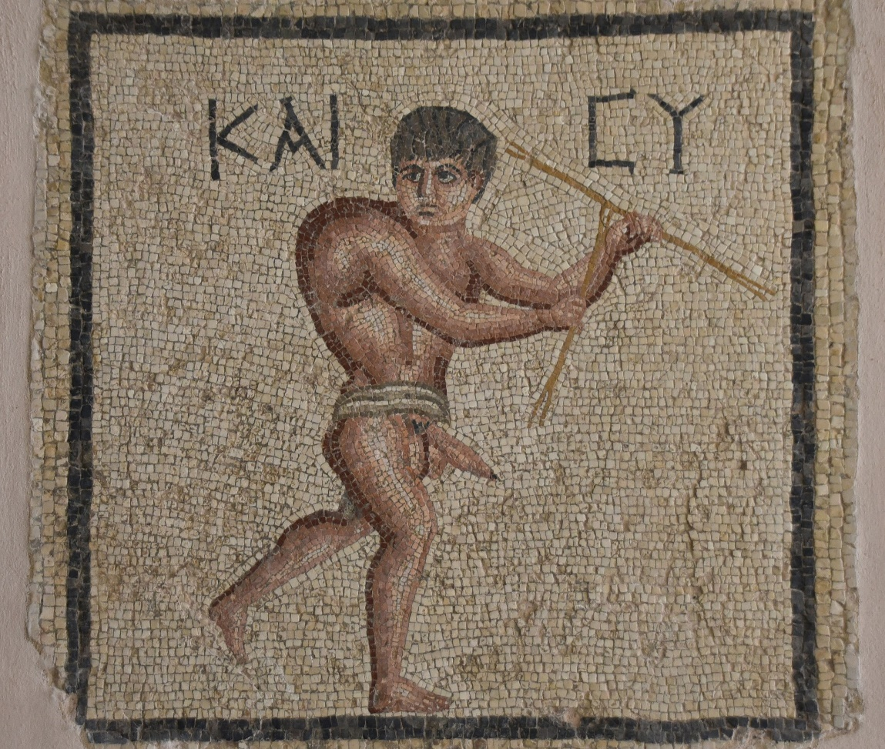
The so-called "lucky hunchback" mosaic from 2nd century AD Antioch (in modern Turkey). The Greek [kai su] says “and you”

“Domitian himself, it is said, dreamed that a golden hump grew out on his back, and he regarded this as an infallible sign that the condition of the empire would be happier and more prosperous after his time; and this was shortly shown to be true through the uprightness and moderate rule of the succeeding emperors.” – Suetonius Life of Domitian 23.2.

In this workshop we will explore artistic depictions of the injured, the infirm and the disabled in the Roman Imperial and Late Antique art; the latter an unfortunately often marginalised (and exploited) segment of wider Roman society. Below are a series of images with connected questions which you should consider as you work your way through the material.

Parody figurines

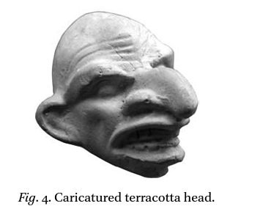
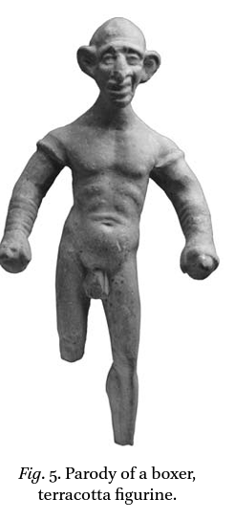
What features seem to be emphasised in these figurines? What functions do you think they might be serving?
Depictions of humpbacks and cleft lips in Roman terracotta figurines
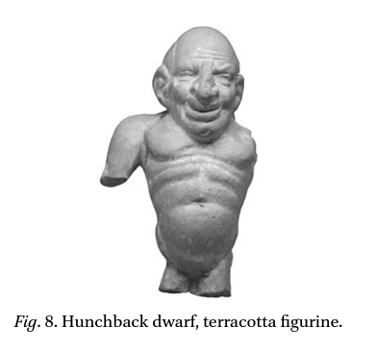
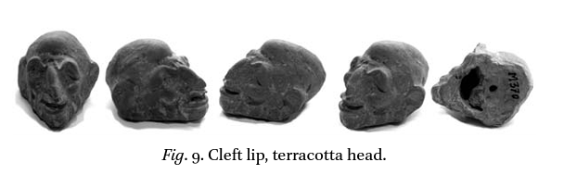
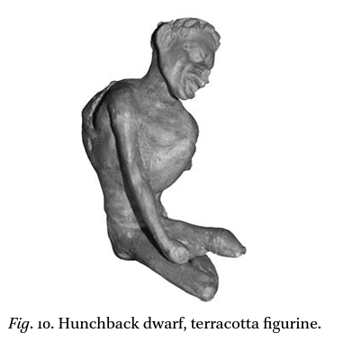
Can we make any deductions about the functions which these objects may have served? Many were found in Smyrna (known for a famous school for ancient medicine) – can we assume anything from this contextual association?
Suffocating figurines and depictions
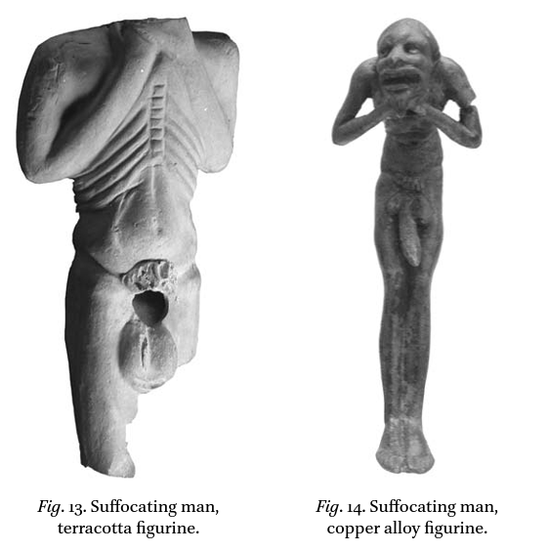
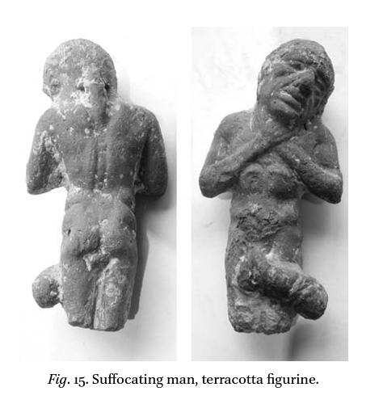
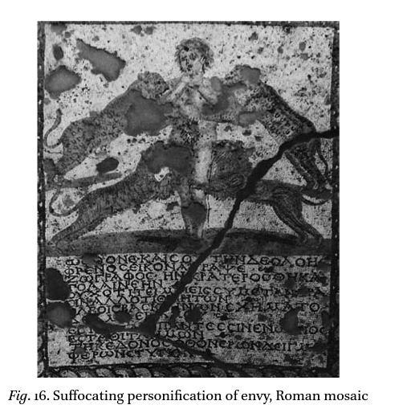
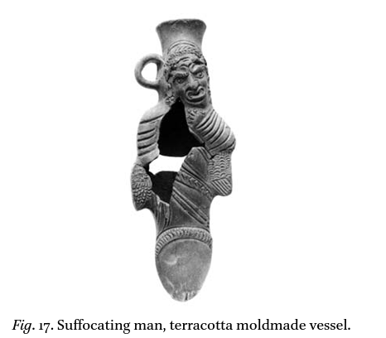
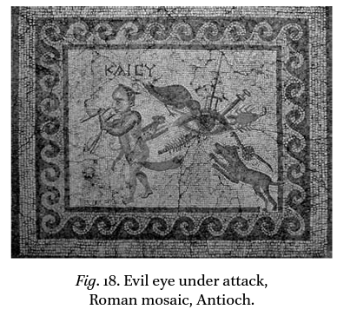
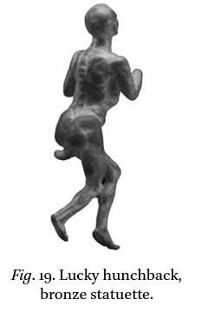
Can the mosaics help us in trying to interpret the meaning of the terracotta figurines? Why might some of the figurines display enlarged phalli?

The injured, ill and disabled in Christian healing imagery

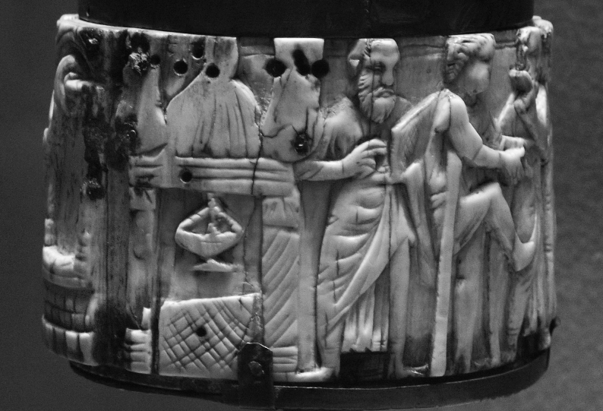
A sixth century ivory pyxis from La Vôute-Chilhac (now in Paris)

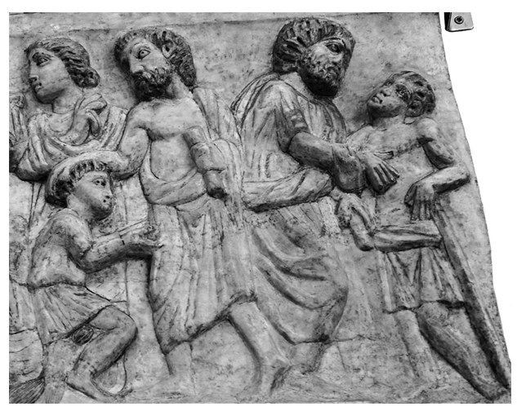
A fragmentary plaque, ca. AD 300-310, Rome, Museo Nazionale
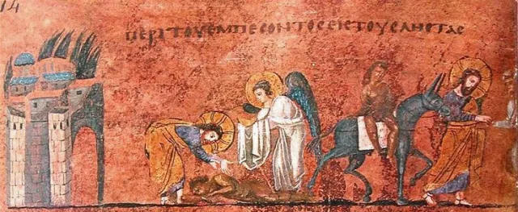
Codex purpureus, (fol. 7 v), preserved in the Diocesan Museum of Rossano, sixth century AD

How are the injured, ill and disabled being depicted in these scenes? Does they seems fairly detailed or not? Do you think they were meant to be symbolic (if so, conveying what messages), or accurate or a mixture of both?

