


Strategic Data Warehousing Solution for NHS England
A board-level report on integrated analytics, dimensional modelling and governance

Student | Abubarkar Dembele
Programme | BSc Applied Computing
Module | ACCA6026 Data Warehousing & Data Mining
Assessment | Component 1: Data Warehousing (50%)
Submission deadline | 31 July 2026, 14:00 • DSA one-week extension applies

Contents

Contents
Contents 2
Executive Summary 3
1.1 OLTP Systems versus a Data Warehouse 3
1.2 Data Warehouse Architecture and ETL 4
1.3 Data Marts for Management Decision-Making 6
1.4 OLTP Normalisation versus Dimensional Modelling 7
2.1 Source System Identification 8
2.2 Star Schema Design, Master Data, Metadata and Aggregates 8
2.3 Data Marts and Schema 9
2.4 Simplified ETL Plan 9
2.5 Data Quality and Governance 10
Conclusion 10
References 11

Executive Summary
NHS England depends on electronic patient records, patient administration, diagnostics, workforce, finance and quality systems that are effective for local transaction processing but do not automatically provide a consistent national analytical view. This report proposes a governed enterprise data warehouse that integrates selected data through secure extraction, staging, cleansing, standardisation and pseudonymisation. The warehouse would retain historical data in dimensional structures and supply executive, operational, financial and clinical-quality data marts. This would support analysis of waiting lists, patient flow, bed occupancy, workforce capacity, treatment cost and outcomes without placing heavy analytical workloads on live clinical systems. The proposed design uses multiple fact tables at clearly defined grains, conformed dimensions, master data, metadata and controlled aggregates. Implementation should be incremental and supported by data stewardship, reconciliation, privacy controls and transparent access decisions. This approach aligns with the national strategy to improve planning, service performance and patient outcomes through safe and effective use of health data [3].
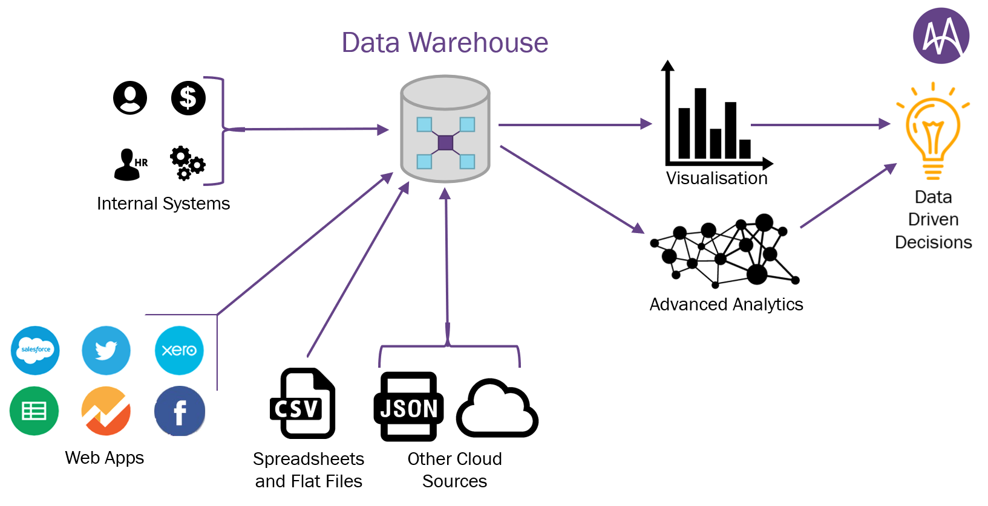

1.1 OLTP Systems versus a Data Warehouse
Online Transaction Processing (OLTP) systems record the immediate operational state of an organisation. Within NHS services, a Patient Administration System records referrals, admissions, transfers and discharges; an Electronic Patient Record stores clinical observations and treatment; a rostering platform records staff shifts; and a finance system records expenditure. OLTP platforms are designed for rapid inserts, updates and lookups, high availability and transaction integrity. Their normalised structures reduce duplication and make it possible to update one operational fact without creating inconsistencies.
A data warehouse serves a different purpose. It integrates selected data from several operational systems, applies common definitions and retains historical snapshots for analysis [1], [2]. Instead of asking whether one patient has an appointment today, a warehouse query might compare referral-to-treatment times, length of stay and treatment cost across regions, services and demographic groups over several years. Data is organised around analytical subjects and business processes rather than individual application screens.
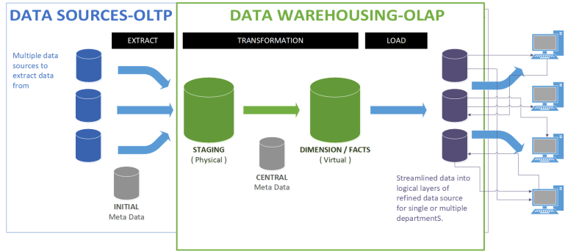
The principal benefit for NHS England is a governed version of performance across organisational boundaries. Local systems may use different identifiers, formats, coding practices and service labels; consequently, separate reports can disagree even when they describe the same activity. Conformed dimensions and approved KPI definitions allow users to compare like with like. Complex analytical workloads are also separated from live care systems, reducing the risk that national reporting affects operational responsiveness. However, a warehouse does not create trustworthy information automatically. Its value depends on accurate source data, declared fact-table grain, transparent metadata, reconciliation and accountable governance.

Table 1. OLTP and data warehouse comparison.
Area | OLTP systems in NHS | Enterprise data warehouse
Purpose | Record referrals, care events, shifts and payments | Analyse trends, performance and relationships
Time focus | Current operational state | Integrated historical record
Design | Normalised relational structures | Dimensional star and constellation schemas
Workload | Short inserts, updates and lookups | Complex joins, aggregation and drill-down
Primary users | Clinical and administrative teams | Executives, analysts and service managers

1.2 Data Warehouse Architecture and ETL
The proposed architecture separates source, integration, storage and presentation layers. Internal sources include EPR, PAS, emergency department, theatre, laboratory, radiology, pharmacy, bed management, incident reporting, workforce, payroll and finance platforms. External reference sources may include Organisation Data Service identifiers, national tariffs, ICD-10 and procedure classifications, demographic data and authorised benchmarks. The Organisation Data Service provides national identifiers and reference information for health and care organisations, making it suitable for organisation master data [6]. Secure interfaces should extract only fields needed for defined analytical purposes.
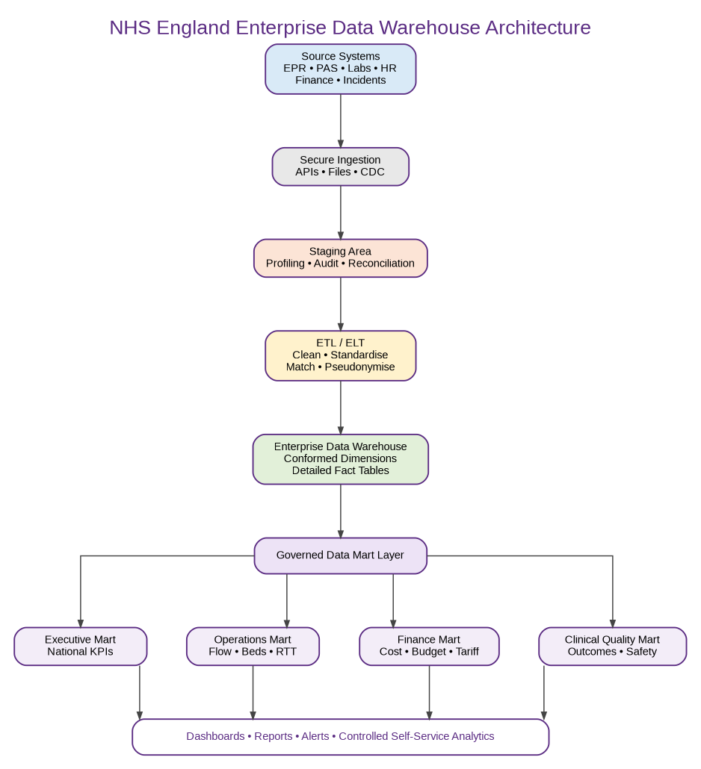
Figure 1. Proposed NHS England enterprise data warehouse architecture.
Extracted records should enter a staging area before loading. Staging supports profiling, source-to-target reconciliation, error quarantine and restartable processing. Transformation standardises dates, organisation codes, staff roles, service names, clinical classifications, units and missing-value conventions. Duplicate or conflicting patient, staff and organisation records are resolved against controlled master data. Where direct identification is unnecessary, patient identifiers should be pseudonymised. Dimensions are loaded before facts so that each measurable event receives valid surrogate keys.
The design should not disrupt daily healthcare operations because the warehouse is separate from live transaction processing. Read-only database views, APIs, change-data capture and incremental extraction reduce source-system load. Larger historical loads can run outside peak periods, while transformations take place in staging or the analytical platform. Extraction windows, resource limits, monitoring, reconciliation totals, exception logs and rollback procedures should be agreed with technical stewards. Open interoperability standards can reduce bespoke integration; for example, HL7 FHIR represents clinical concepts as exchangeable resources and supports API-based access [7].
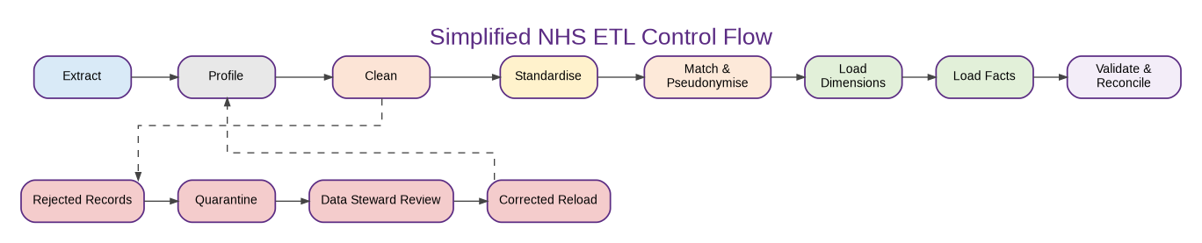
Figure 2. Simplified ETL control flow and exception handling.
A further architectural consideration is latency. Not every NHS measure requires real-time processing. Emergency capacity alerts may justify near-real-time feeds, whereas finance and workforce summaries may be refreshed daily or monthly. Classifying data products by urgency avoids the cost and complexity of treating every source as a streaming system. The board should therefore approve service-level objectives for freshness, completeness and availability for each subject area. This also makes limitations visible: a dashboard should show when its data was last refreshed and whether any source feed failed, so that users do not mistake stale information for the current operational position [3], [5].

1.3 Data Marts for Management Decision-Making
Data marts provide focused analytical views for different management responsibilities while drawing from the same governed warehouse. The Chief Executive requires an executive-performance mart containing national and regional waiting-list position, admissions, discharges, bed occupancy, workforce capacity, quality measures and budget status. Weekly and monthly indicators should permit drill-down to organisation, service and patient cohort. This supports the responsibility of integrated care systems to improve population health, reduce inequalities, enhance productivity and support wider social and economic development [3].
The Finance Director requires a finance mart combining financial and patient-activity facts. Measures would include treatment cost, tariff income, budget, expenditure, variance, agency spend and cost per episode. Dimensions should include date, organisation, service, treatment, cost centre and funding source. Linking activity and cost allows managers to distinguish inefficient expenditure from increased spending caused by higher workload or clinical complexity.
The Medical Director requires a clinical-quality mart containing outcomes, readmissions, mortality indicators, patient-safety incidents, infection measures and satisfaction. Analysis should be possible by diagnosis, procedure, clinician, organisation, service and patient cohort, with stricter access controls for detailed clinical information. An operations mart would support patient-flow teams through admissions, discharge, transfer, bed availability, ward occupancy, theatre utilisation and referral-to-treatment time.
These marts should not become independent, uncontrolled databases. They should be logical or physical presentation layers derived from conformed warehouse data. Shared Date, Organisation, Location, Service and Patient Cohort dimensions maintain consistent definitions. Where sensitive data is used, access should follow purpose limitation and minimum-necessary principles rather than giving every manager access to patient-level detail [8].
Table 2. Proposed NHS management data marts.
Data mart | Primary users | Measures and indicators | Decisions supported
Executive | Chief Executive and board | Waiting lists, occupancy, workforce, cost and quality | National prioritisation and intervention
Finance | Finance Director | Cost, tariff, expenditure, variance and agency spend | Budget control and resource allocation
Clinical quality | Medical Director | Outcomes, readmissions, incidents and satisfaction | Quality improvement and assurance
Operations | Operations and patient-flow teams | Admissions, discharges, beds, RTT and theatre use | Capacity and patient-flow management

The design of each mart should begin with management questions rather than available fields. For example, the executive mart should answer where performance is deteriorating, which organisations are outliers and whether a problem is associated with demand, capacity, workforce or finance. The finance mart should support variance analysis and cost attribution, while the clinical-quality mart should distinguish crude rates from risk-adjusted indicators. Drill-down should be controlled so that aggregated national indicators can be explored without unnecessarily exposing identifiable patient information. This balance between usefulness and proportionality is consistent with data minimisation and purpose limitation [8].

1.4 OLTP Normalisation versus Dimensional Modelling
Normalisation divides operational data into related entities so that each fact is stored once and update anomalies are reduced. A PAS may separate patients, addresses, referrals, appointments, admissions, wards and clinicians. This is suitable for accurate transaction processing, but analytical questions often require many joins and specialist knowledge.
Dimensional modelling starts by selecting a business process and declaring the grain of the fact table [1]. For Patient_Activity_Fact, a defensible grain is one completed care episode. Measures may include waiting time, length of stay, treatment cost, procedure count and readmission indicator. Date, Patient, Organisation, Service, Diagnosis, Procedure, Clinician and Location dimensions provide descriptive context. This denormalised structure is easier for managers and BI tools to understand and supports efficient aggregation. Controlled repetition is accepted because analytical usability and performance are prioritised, while surrogate keys protect the warehouse from changes in operational identifiers.
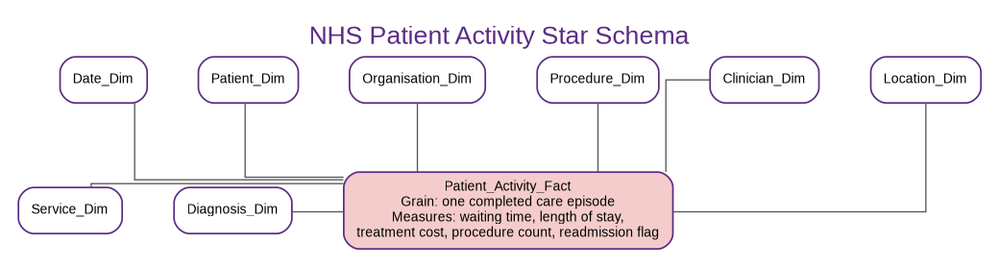
Figure 3. Star schema for NHS patient activity.
The dimensional approach also has limitations that should be acknowledged to the IT Director. Denormalised dimensions can contain repeated descriptive values, and surrogate keys introduce additional ETL responsibilities. Poorly chosen grains or mixed facts can produce double counting, while excessive snowflaking can make the model as difficult to navigate as the operational source. For this reason, the design should be validated through representative business questions, sample dashboard queries and reconciliation with trusted operational reports before wider deployment. Dimensional modelling is not a replacement for source-system integrity; it is a presentation and analytical structure built on governed operational data [1].

2.1 Source System Identification
Internal feeds should include EPR and PAS data, emergency, theatre, laboratory, radiology, pharmacy, bed and ward management, workforce rostering, payroll, sickness absence, finance, procurement and patient-safety systems. External and national reference data may include Organisation Data Service identifiers, national tariffs, ICD-10 and OPCS procedure classifications, demographic and deprivation datasets and authorised performance benchmarks. Each feed requires a named owner, refresh frequency, extraction method, sensitivity rating, retention rule and quality profile. Source selection should be driven by defined analytical purposes rather than copying every available field.

2.2 Star Schema Design, Master Data, Metadata and Aggregates
A single fact table cannot safely mix events recorded at different grains. The warehouse should therefore use a constellation of related stars. Patient_Activity_Fact records one completed care episode. Bed_Occupancy_Fact records one ward snapshot at a defined interval. Workforce_Shift_Fact records one staff shift. Financial_Activity_Fact records one financial transaction, while Clinical_Quality_Fact records one defined quality event. If monthly indicators are stored, they should be placed in a separately named periodic-snapshot fact so that detailed events and summaries are not combined.
Conformed dimensions should include Date, Time, Patient, Staff, Organisation, Hospital, Ward, Location, Service, Diagnosis, Procedure, Referral Source and Outcome. Slowly Changing Dimension Type 2 is appropriate where analysis must preserve historical organisational assignments, service configurations or patient geography; Type 1 can correct clear data-entry errors where history has no analytical value. Master data establishes authoritative identities and controlled values for patients, staff, organisations, services and locations.
Metadata should record the business name, definition, physical source, owner, steward, transformation rule, refresh frequency, sensitivity classification and data-quality rule for every important element. Aggregate tables may store approved monthly activity, average waiting time, occupancy, agency spend, cost per treatment and quality indicators. Every aggregate must reconcile to the detailed facts and carry the exact KPI definition used; otherwise, performance measures may diverge across reports.
Table 3. Proposed fact tables and grains.
Fact table | Declared grain | Illustrative measures
Patient_Activity_Fact | One completed care episode | Waiting time, length of stay, cost, procedures and readmission
Bed_Occupancy_Fact | One ward snapshot per interval | Available, occupied and closed beds
Workforce_Shift_Fact | One staff shift | Paid hours, overtime, absence and agency cost
Financial_Activity_Fact | One financial transaction | Amount, tariff, budget and expenditure
Clinical_Quality_Fact | One defined quality event | Incident count, outcome and severity

Degenerate dimensions may also be useful for operational identifiers such as referral number or episode number when the identifier is required for drill-through but has no descriptive attributes. Role-playing dimensions allow one Date_Dim to support referral date, admission date, discharge date and procedure date. Bridge tables may be required for legitimate many-to-many relationships, such as an episode involving several diagnoses or procedures; however, weighting rules must be explicit to avoid multiplying measures. These techniques preserve analytical flexibility while maintaining a comprehensible model [1].

2.3 Data Marts and Schema
The finance mart should centre on Financial_Activity_Fact and connect to Date, Organisation, Cost Centre, Service, Treatment and Funding dimensions. The operations mart should use Patient_Activity_Fact and Bed_Occupancy_Fact with Date, Hospital, Ward, Service and Referral dimensions. The clinical-quality mart should link quality facts to Date, Organisation, Service, Diagnosis, Procedure and controlled patient-cohort dimensions. The executive mart should use governed aggregate tables produced from detailed warehouse facts. This arrangement supports departmental decisions while preventing independently calculated spreadsheets from becoming competing versions of the truth.

2.4 Simplified ETL Plan
ETL should extract through secure read-only interfaces; profile completeness, uniqueness, validity and referential integrity; standardise dates, organisation codes, clinical classifications, staff roles and units; match and deduplicate patient, staff and organisation records; pseudonymise identifiers; load conformed dimensions before facts; calculate approved aggregates; and reconcile source totals with loaded totals. Rejected records should enter a quarantine table containing the error reason, source key, load identifier and assigned data steward. Incremental loads should maintain audit columns so analysts can trace when and how each record entered the warehouse.
Table 4. Simplified source-to-target ETL specification.
Target table | Principal source | Key transformations
Patient_Dim | PAS and EPR | Validate identifiers, standardise demographics and pseudonymise
Staff_Dim | HR and rostering | Resolve staff IDs and standardise role and organisation
Service_Dim | Clinical master and reference data | Map local service names to controlled values
Patient_Activity_Fact | PAS, EPR and clinical systems | Derive waiting time, length of stay and readmission
Monthly_Performance_Agg | Detailed fact tables | Aggregate by month, region, service and approved KPI definition

The ETL plan should also include operational controls. Each batch requires a unique load identifier, source extract timestamp, record counts, checksums or control totals, start and end times, status and error count. Reconciliation should compare totals before and after transformation and explain accepted differences, such as exclusion of cancelled events. Late-arriving dimensions and facts require defined handling so that activity is not lost merely because descriptive data arrives later. A restartable design should resume from a safe checkpoint rather than duplicating previously loaded records. These controls provide evidence that the warehouse is complete, repeatable and auditable.

2.5 Data Quality and Governance
Governance must assign owners and stewards, maintain metadata and monitor completeness, accuracy, consistency, timeliness, uniqueness and validity. The UK GDPR requires personal data to be accurate, limited to its purpose, retained only as necessary and protected by appropriate security [8], [9]. Controls should include role-based access, least privilege, encryption, audit trails, controlled exports and Data Protection Impact Assessments for high-risk processing. Quality failures require documented escalation, root-cause analysis and correction at source where possible.
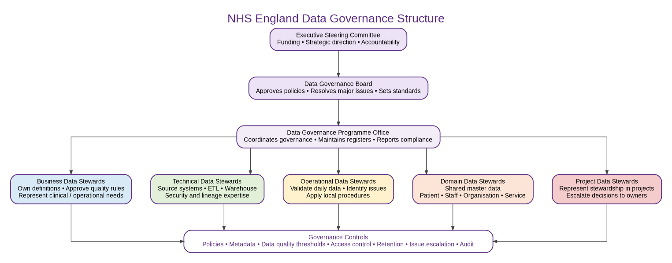
Figure 4. Proposed NHS data governance responsibility structure.
Governance should operate across the full information chain rather than only at the final warehouse. Business data stewards define meaning and acceptable quality; technical stewards explain source systems, interfaces and transformations; operational stewards identify emerging problems in daily use. A governance board resolves cross-organisational conflicts and approves policies, while an executive steering group provides authority and funding. Quality rules should be measurable—for example, valid NHS-number format, permitted code sets, non-negative lengths of stay and completeness thresholds for mandatory fields. Persistent failures should trigger root-cause correction in the source process, not indefinite repair downstream [14].
Implementation should proceed in controlled releases. A first release could combine patient activity, bed occupancy and organisation dimensions for a limited set of nationally agreed indicators. A second release could add workforce and finance, followed by clinical-quality measures after definitions and access controls are agreed. Each release should include data-owner sign-off, user acceptance testing, performance testing, security review, reconciliation and training for dashboard users. Success should be measured not only by technical completion but by reduced manual reconciliation, faster production of trusted reports and demonstrable use of insights in planning decisions.

Conclusion
The proposed enterprise warehouse would give NHS England a consistent national analytical view while protecting live care systems from complex reporting workloads. Its effectiveness depends on clear fact-table grains, conformed dimensions, governed master and reference data, transparent metadata, robust ETL controls and role-specific data marts. An incremental implementation should begin with a limited set of high-value patient-flow, workforce, finance and quality measures, then expand after reconciliation, security review and user acceptance. The national strategy emphasises that better data must support direct care, population health, planning and research while preserving public confidence [3]. Privacy, transparency and data quality are therefore not optional compliance activities; they are central design requirements for a sustainable NHS analytical platform.

References
[1] R. Kimball and M. Ross, The Data Warehouse Toolkit: The Definitive Guide to Dimensional Modeling, 3rd ed. Indianapolis, IN, USA: Wiley, 2013.
[2] W. H. Inmon, Building the Data Warehouse, 4th ed. Indianapolis, IN, USA: Wiley, 2005.
[3] Department of Health and Social Care, “Data Saves Lives: Reshaping Health and Social Care with Data,” Jun. 2022. [Online]. Available: https://www.gov.uk/government/publications/data-saves-lives-reshaping-health-and-social-care-with-data. [Accessed: Jul. 2, 2026].
[4] NHS England, “What are integrated care systems?” [Online]. Available: https://www.england.nhs.uk/integratedcare/what-is-integrated-care/. [Accessed: Jul. 2, 2026].
[5] NHS England, “Data saves lives – key tools and information.” [Online]. Available: https://www.england.nhs.uk/long-read/data-saves-lives-key-tools-and-information/. [Accessed: Jul. 2, 2026].
[6] NHS England Digital, “Organisation Data Service.” [Online]. Available: https://digital.nhs.uk/services/organisation-data-service. [Accessed: Jul. 2, 2026].
[7] HL7 International, “FHIR Overview.” [Online]. Available: https://www.hl7.org/fhir/overview.html. [Accessed: Jul. 2, 2026].
[8] Information Commissioner’s Office, “A guide to the data protection principles.” [Online]. Available: https://ico.org.uk/for-organisations/uk-gdpr-guidance-and-resources/data-protection-principles/. [Accessed: Jul. 2, 2026].
[9] Information Commissioner’s Office, “Principle (d): Accuracy.” [Online]. Available: https://ico.org.uk/for-organisations/uk-gdpr-guidance-and-resources/data-protection-principles/accuracy/. [Accessed: Jul. 2, 2026].
[10] UK Parliament, Data Protection Act 2018, c. 12. [Online]. Available: https://www.legislation.gov.uk/ukpga/2018/12/contents. [Accessed: Jul. 2, 2026].
[11] ACCA6026, “Lecture 2: Data Warehouse, Data Marts and OLAP,” UWTSD course material, 2026.
[12] ACCA6026, “Lecture 3: Dimensional Modelling,” UWTSD course material, 2026.
[13] ACCA6026, “Lecture 5: ETL Planning and Development,” UWTSD course material, 2026.
[14] ACCA6026, “Lecture 6: Data Governance and the General Data Protection Regulation,” UWTSD course material, 2026.

