Reflective review on Employability skills (Report)
Academic and Employability Skills BMSW 4001
Nicoleta Baltaret-STUDENT ID: 2107487
2022
Contents
Introduction: 3
Employability Skills: 3
Digital Skills: 3
Research Skills: 3
Time Management skills: 4
Writing Skills (academic): 4
Presentation Skills: 5
Evaluation: 5
Personal Development plan: 5
Conclusion 6
References 7
Appendix1 8
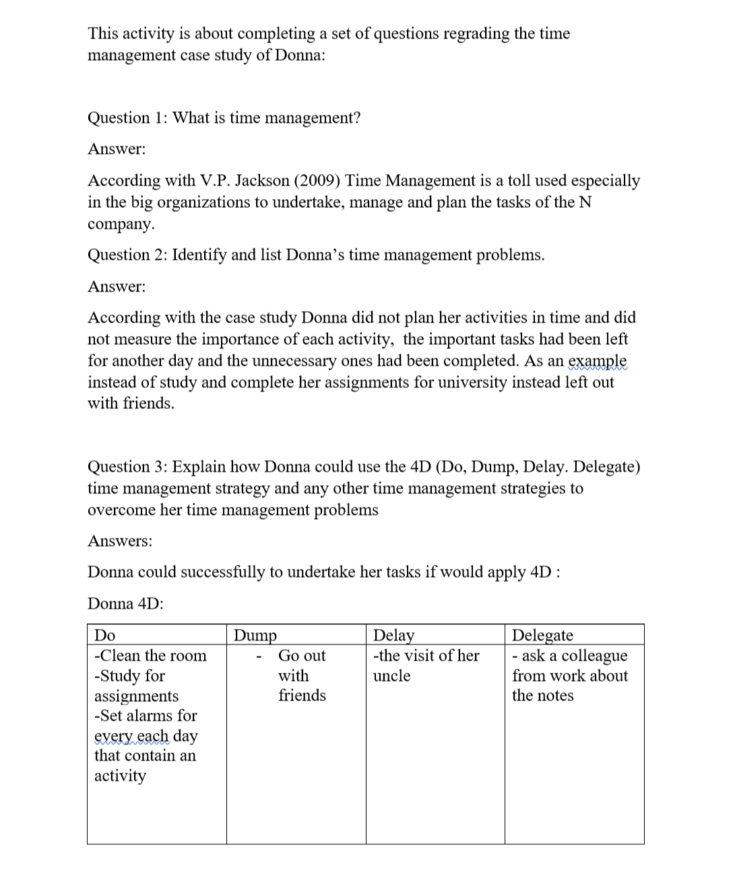 8

Introduction:
The aim purpose of this report is to reflect upon the employability skills and knowledge I gain during the module of ‘Academic and Employability skills’ using different tools such as PDP (Personal Development plan), SWOT Analysis and also explain regarding each skill I gain what tools or methods I learn in order to strength them. As an example, for Time Management, I learn how to use the 4D and for research skills how to use CRAAP Test. Reflective reports are a powerful tool in self-development for any individual as it gives a clear view of its self-development.

Employability Skills:
According with Yorke and Knight (2003) , Employability Skills are defined as the transferable skills that a graduate student needed in order to become 'employable' which make them more likely to pe employed by employers in the career chose, as employers are not only looking for understanding and subject knowledge from the candidates, are also looking for a set of skills that they want from an employee.

Digital Skills:
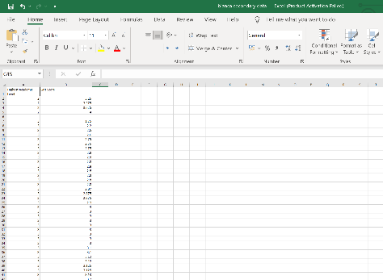
According with Ester Var Laar (2017) digital skills are the individual aptitudes of using computer software apps such as MS office pack. In 2022 Digital skills are demanded for all the employers in any type of industry. As a student during the module I develop my digital skills such as the MS Office Package by using Excel, Word and PowerPoint by learning and exercise for in class tasks. During the classes I had to transform data in to information using CRAAP Test and excel where I develop my aptitudes to use excel and gain more knowledge regrading the program. Further during the course I was needed to do class exercises using Word and also to build a report about Blended learning and classroom learning. Working in Word to complete those it helped me further to gain more knowledge and strength may skills in using the Word document. Coming back to the CRAAP test after I complete it I was required further to do a PowerPoint presentation about it and demonstrate the skills and knowledge I develop during the module which help myself to have a better understanding in using the PowerPoint too. As an example working on PowerPoint I lean how to create now designs, how to use animations, how to create multiple slides and insert images, understand the purpose of the transition tool and explore further by playing with tools such as Charts, Smart art and Shapes.

Research Skills:
The ability of an individual to create new content base on the understanding of the data collection use by Analysing data, documentation of a specific subject from multiple sources in order to evaluate and validate the source data and information accuracy. During the module I had learn how to properly do my own research by given a clear understanding of how to be identified the source and it credibility named secondary research. Further I also learn how to create primary data research by using the CRAAP Test which is also can be use to measure the relevance of a secondary source too. The Definition of CRAAP Test is the tool of data collection evaluation by Currency, Relevance, Authority, and purpose. For example in order to validate and be completely sure about the information accuracy and relevance it can be applied CRAAP Test which will identify when was the information/ data published, it is relevant to the topic needed, who’s the author and way it is credible , it is supported by any evidence, and why the information exist. For a valid report as a student and even further for an organization, the skills of research are very important in order to be avoided false information’s, or obstructed, ensuring credibility and trust to the content and avoiding plagiarism. This skills it was crucial from the beginning in order to build my reports and projects for university as an undergraduate student and further will be very useful in my career. (Folk, 2012)

Time Management skills:
During one of the classes as a student I had been requested by the teacher same as the rest of the class to complete during the lecturer a quiz about time management which can be seen in the Appendix 1. The quiz was base on a case study which help myself to have a better understanding regarding time management and further learning how to use the 4 D theory. The time managements skills it not only gone be useful as an employability skill, this skill help me as a student too as now I know better how to Do, Delay, Dump and Delegate my weekly tasks as a student according with the task priority. As an example of how I am using the time management skills and the 4D theory as a student, I create a table down below with the tasks I need to fulfil and how I manage them within a week period:
Do | Delay | Dump | Delegate
Study minimum 1 hour per day | Ice-skating out post pone till Christmas break | Watch ‘Wednesday’ Movie serial | shopping
Write minim 100 words for university reports
Prepare my daily meals
Go to work
As I was needed to complete my reports for university, I manage my time to not over-load myself and have enough time to complete them according with the deadline. Further I was not necessary to go for the weekly shopping supplies and I delegate them to my husband. Then I will have plenty of time after I finish all my reports and university tasks and it will start the Christmas break. So with that been said learning about time management it was a necessity that make my life easier and more organized. (Sainz, 2019) (Collins, 2018)

Writing Skills (academic):
During the module I develop my skills of academic written as I had been requested to complete academic reports, and also riding some academic reports for my reports research which help me to learn more new words and also to have multiple examples in how to write and academic report. At the beginning it sound a little bit hard for me but now I can do it much easily and it also help me further in the out of the student life as I know now how to write an academic personal statement, to replay with diplomacy to my emails regarding my workplace and elevate my dictionary. (Bacha, 2010)

Presentation Skills:
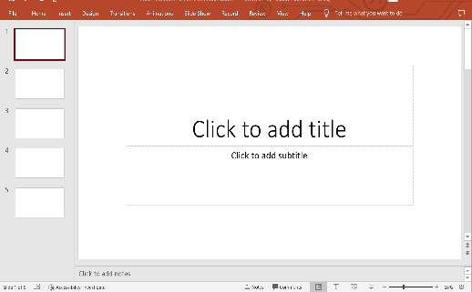
As I previous said during the module I had been designated to create a PowerPoint presentation about CRAAP Test and further to present it in front of the class. With that I develop even more my presentation skills which further I will use them during the university course and then in the future organisation I will need to work for. As an example, possessing the presentation skills and learning how to speak, and act, how to use my body language and my voice tone in order to present lets say the current position of the organization I will work for in the future, in the market industry, or using my presentation skills in order to present new solutions or ideas for a company where I will work for in order to help that specific organization to grow. (Mahdi, 2022)

Evaluation:
After I reflect on my employability skills I achieve during the module, next I have to look further in what skills I still need to improve by using TOWS Analysis. This analysis tool is defined as the extension of SWOT Analysis that is linked the strength, weaknesses, opportunities and the threats of the individual (Weihrich, 1982):
Strengths | Weaknesses
Presentation Skills  Digital Skills  Time Management skills  Research skills | Writing and communication skills  Teamworking skills
Opportunities | Threats
Improve my writing and communication skills in English by interacting and study more at university which further will link to building new networks.  Building new relationships and expand my network it will also help me to improve my team working skills | I am afraid of not being understand regarding my point of view.

As it can be seen in the table above, I link my weaknesses with my opportunities and further I link my threats with mi strengths. Having strong presentation skills and research skills I can argue and explain my point by using relevant sources and body language to minimize my issue of communication skills regarding English language.

Personal Development plan:
Further step in this report after I evaluate and reflect on my employability skills is to create a Personal Development plan, also known as PDP. This self-development tool it help the individual to set goals that it will help him to grow as an individual in to the society.
Goal | Action | Resources | Measurement | Time
Improve my Writing and communication skills | By reading more articles, improving my vocabulary, socialize with others and writing on my reports for university | Text books  Dictionary  Audiobooks  Subjects to write about, colleagues to communicate with | Lecturer review | 6 months
Improve my Teamworking skills | Working more in groups during my study at university, also learn to study in groups. | Group reports and group exercises during the class, a quiet location where I can study with other students | Lecturer Review,  Feedback from colleagues. | 1 year

As the PDP is done in the above table, it can be seen that in 6 months I will be able to improve my communication skills by building connections, focused more on study and become more friendly. Also I will be able to measure it by receiving a feedback/ review from my lecturer in the marking criteria of my future reports where I will be able to see the improvement. Further learning how to work with others by going to study groups in the university location and also working with my colleagues for class activities it will can be measurement by group project marking criteria of the lecturer. I give more time for the teamwork skill to achieve as I cannot know exactly if I will have in the next semester or till the end of the year group projects given by the university but I will try my best to improve them. (Kneale, 2004)

Conclusion
In conclusion I develop more during the module as I strength some of my existing skills such as Writing skills and research skills by learning new methos and theory to improve them. Further during the module I learn new skills and new methodologies such as Time management, presentation skills, how to use CRAAP test and the feedback from the lecturer help me to have a better view of how I should improve myself even more. Then working on this reflective report and applying TOWS analysis it gives me a better understanding regarding my current situation and what other employability skills I still need to improve such as Communication skills regarding English language and my teamwork skills. By creating the Personal Development plan I had next enable myself to set my desire of self improvement and transform it in to an actual plan to improve my communication skills and teamwork skills in a realistic, measurable and a specific amount of time which means I am on the good path, I learn a lot during the module and I still have a plenty room for improvement which will further going to also strength my self confidence and give me more motivation to pursuit.

References
Bacha, N. N., 2010. Developing Learners' Academic Writing Skills in Higher Education: A Study for Educational Reform. Language and Education , 16(3), pp. 161-177.
Collins, B., 2018. Forbs: How To Use The 4 Ds Of Effective Time Management. [Online]
Available at: https://www.forbes.com/sites/bryancollinseurope/2018/06/14/effective-time-management/?sh=55065bb71938
[Accessed 20 11 2022].
Folk, M., 2012. Establishing Credibility in the Information Jungle: Blogs, Microblogs, and the CRAAP Test. In: 1, ed. Online Credibility and Digital Ethos: Evaluating Computer-Mediated Communication. USA: Information Science Reference, p. 23.
Kneale, P., 2004. Motivating Student Personal Development Planning by Making Links with Employability. Planet, 13(1), pp. 20-21.
Knight, Y. a., 2003. Teaching in Higher Education. Employability and Good Learning in Higher Education., 8(1), pp. 03-16.
Laar, E. V., 2017. The relation between 21st-century skills and digital skills: A systematic literature review. Computers in Human Behavior, 72(1), pp. 577-588.
Mahdi, D. A., 2022. Improving Speaking and Presentation Skills through Interactive Multimedia Environment for Non-Native Speakers of English. SAGE Open, 12(1).
Sainz, M. A., 2019. Time management: skills to learn and put into practice. Education + Training, 61(5), pp. 636-645.
Weihrich, H., 1982. The TOWS matrix—A tool for situational analysis. Long Range Planning, 15(2), pp. 54-66.

Appendix1

