Siobhan Thomas
consultancy project M6X02113
Consultancy project initiation document

Executive Summary

This consultancy project has been created to ensure that any traders who are dealt with by Urban Foundry are using the most sustainable materials possible at Urban Foundry events. The long-term improvement that can be provided by this is a sustainable future for events and for Urban Foundry.

Roles mentioned within the document | Who will carry out the role
Project Manager | Siobhan Thomas
Project Reviewer | Mike Davies
Director of Urban Foundry | Dr Benjamin Reynolds

Content List

Executive Summary ………………………………………….. Page 1
- Project Justification ……………………………………. Pages 3 - 4
  - Aims ……………………………………………… Page 3
  - Background ……………………………………… Page 3
  - Objectives ………………………………………... Page 3
  - Rationale …………………………………………. Page 4
  - Benefits …………………………………………... Page 5
  - Possible Constraints and Assumptions …….… Page 5
- Project Approach …………………………………………. Pages 6 - 9
  - Risk Management Strategy …………………… Page 6
  - Proposed Research Strategies ……………….. Page 7
  - Stakeholders ……………………………………. Pages 8-9
- Quality Management Strategy …………………………… Page 10
- Work Breakdown Structure ………………………………. Page 11
  - Project Plan Gantt Chart ………………………. Pages 12 - 13
- Communication Plan ……………………………………… Page 14
- Project Controls and Communication Template ……….. Page 14
- Appendix …………………………………………………… Page 15
- Bibliography ……………………………………………….. Page 16

- Project Justification

1.1 Aim

The aim of the consultancy project is to critically review non-biodegradable waste used by traders at Urban Foundry run events. The project will then give alternative options to traders which are more environmentally friendly at to help sustain events.
1.2 Background

Urban Foundry is a creative regeneration agency based in Swansea who work within the local community to help improve people’s lives, make great places and build better businesses (Urban Foundry, 2018) The company runs two hugely successful outdoor markets which are situated in Uplands and the Marina, along with a new pop-up events venue, Unit Nineteen. The markets and Unit Nineteen rely on the support of local traders to create an opportunity for customers to enjoy local, homemade produce.
As Urban Foundry bases its values on helping local areas and creating a better place for people to live and enjoy, the company is very passionate about only working with traders who uphold the same values. It is at these traders that this project will mainly be focusing, paying attention to their use of biodegradable and non-biodegradable products at events.
1.3 Objectives

For the consultancy project to be successful, it has been set a number of objectives to fulfil:
- Evaluate the current use of biodegradable and non-biodegradable products by traders at Uplands and Marina Markets
- Identify which materials could feasibly be changed for more environmentally friendly options
- Recommend new biodegradable or recyclable options to traders

1.4 Rationale
Environmental impacts within events is a growing research field, with more people now understand that sustainability is an important factor to such a quickly expanding sector. Yet the research is still lacking, and many people are still unaware of the implications that a lack of sustainability has on the planet.
Even though being environmentally friendly doesn’t particularly offer businesses a direct financial advantage, it offers other long-term benefits. Consumers are growing increasingly aware of the detrimental affects that non-biodegradable materials are having on the environment and are choosing more sustainable and environmentally friendly options. Many businesses have started to make small changes such as removing plastic single-use straws from their availability and offering recycling programmes.
According to Surfers Against Sewage (2018), 8 million pieces of plastic pollution find their way into the world’s oceans every day, which means that plastics consistently make up 60-90% of all marine debris. Not only can cutting down use of non-biodegradable plastic help there be less litter, but Livestrong (2018) also state that producing biodegradable plastic products produce 68% less greenhouse gases than is used to make non-biodegradable plastic products.
With all of this in mind, organisations who offer more sustainable and environmentally friendly products can not only help against creating pollution and environmental damage, but it can encourage customers to the business as they would be more likely to buy from an environmentally conscious company.

1.5 Benefits
The benefits of carrying out this project would be the positive environmental impact that would be created by traders changing their non-biodegradable materials and would therefore lower the percentage of non-decomposable materials that go into landfill. It would also contribute to the sustainability of events, which a growing topic as the events sector is experience rapid growth. Many bio-degradable products can be sourced locally or come from companies that have strong ethics so purchasing goods from them could also positively contribute to expanding ethical companies. Any stakeholders that are affected by the markets would also benefit, which have been explored in more depth in section 2.4 of this project.
1.6 Possible Constraints and Assumptions
Often, biodegradable products are more expensive than non-biodegradable, so a possible constraint would be if a trader did not want to spend more on the more sustainable option as a higher expenditure would affect their profit margin. Another constraint could be if traders did not have time to participate in the initial primary research that allows the identification of what materials they are already using. This would affect the project as it would be difficult to offer alternatives without already being aware of what materials they use regularly.
An assumption from this project is that the trader will be willing to change the materials that they are already using and that they are as eager to cut down on landfill waste.

- Project Approach
This report has been designed to give a breakdown structure of the upcoming consultancy project. This will include details on the communication methods, the tasks that will need to be carried out and a timeline in which the work needs to carried out within.
The economic cost for carrying out this consultancy project is minimal as the outcome of the objectives will be to give suggestions to traders, rather than them having to commit to anything costly. Should they wish to follow the suggestions, there may be small charges incurred by the traders as the new materials which they would purchase have a possibility of being higher than they materials they currently use.
Regardless of the extra costs, the positive implications from the traders following the suggestions given would enable them to be:
- More sustainable
- More environmentally friendly
- Able to pave the way for other similar traders who could look to them for advice
2.1 Risks Management Strategy
A large part of enabling this project to work is the involvement of traders. Even though it is minimal involvement, if traders do not wish to participate in the initial questionnaire, the risk could be that it would hinder the progress and another alternative would have to do found.
Should this problem arise, the Project Manager would still be able to continue with the consultancy but with a different method. Should the traders not want to participate, the Consultancy Report would then look at single use materials that are used by a variety of traders and give options on how to reduce that waste. This information would still be very useful for Urban Foundry as it would allow them to discuss the options with the traders in the future.
2.2 Proposed Research Strategy
For the project, both primary and secondary research will be used throughout to gather the most information possible. For the primary research, questionnaires will be given to traders attending the Uplands and Marina Markets. A basic sample of which has been shown in Appendix 1. This questionnaire allows the Project Manager to identify which traders will benefit most from the consultancy and which traders are already using the most ethical products available. The information gathered will also allow the Project Manager to select a small number of traders who will be focused on throughout the project. Another form of primary research which will be included within the project will be the sourcing of new materials. This will be carried out by the Project Manager throughout the project which will aid the suggestions that will come as a consequence of the final report.
The secondary research will mainly include gathering information of the traders’ companies as this can be done using online resources and doesn’t take up the traders’ time. There will also be secondary research surrounding the biodegradable and non-biodegradable products to give a better understanding of the differences and how to find alternative materials.

2.3 Stakeholders
The main stakeholders that will benefit from this consultancy project are:
- Urban Foundry
- The chosen market traders
- The local community
- The local council
- Local environmental groups
- Attendees of the markets

Urban Foundry will benefit as they are passionate about creating better places and by working with traders who uphold similar ethics as them. By ensuring the traders who attend their markets are helping the environment to the best of their abilities, it allows Urban Foundry to continue their mission of creating the best events possible.
The market traders who will be chosen for the project will benefit from the outcomes by being able to provide the more environmentally friendly options to the public, who are rapidly becoming aware of the detrimental effects that landfill is having on the environment.
Since the markets are held in places of residency, the local community would be able to benefit from the use of biodegradable materials as it would decrease the amount of litter that can sometimes be left behind by events, by allowing it to naturally decompose which would create less pollution. This is also true for the local council who would be contributing less environmentally harmful materials into landfill from the markets.
Local environmental groups would also benefit from the changes that could be made by traders as sometimes, litter can blow away so they could rest assured that it would naturally breakdown instead of polluting water or local areas.
Many attendees of the markets believe in supporting local businesses and doing good for the community. They are also becoming more aware of how they can help make events and the environment more sustainable, so they would be a key stakeholder of the outcomes of this project.

- Quality Management Strategy
Throughout this project, Maylor’s (2010) 4D quality management strategy has been applied to ensure all aspects of planning management has been covered. The 4D methodology is shown below. The strategy covers the four main aspects of project management: The definition of the project which was presented to the client in an opening bid presentation, the design of the task which is covered within this document, carrying out the research and problem-solving, and finally the development of the project which will be covered within the final Consultancy Report Document.

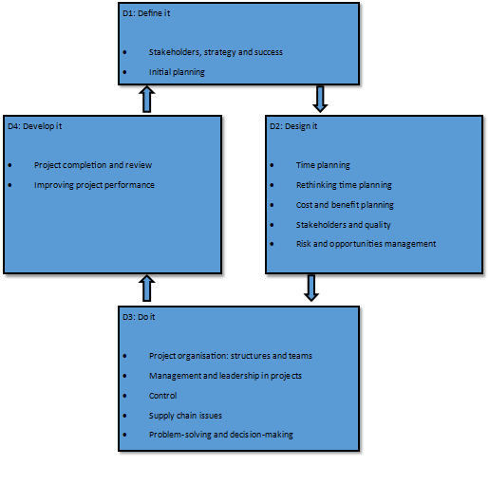

- Work Breakdown Structure
The work that will be carried out throughout the project has been broken down throughout this Project Initiation Document (PID). The PID provides timelines and structure for the consultancy which will allow Urban Foundry to give feedback throughout and enable they are getting the most out of the project. The purpose of the breakdown is also to ensure strategic planning such as risk management and deadlines so that the work will be carried out successfully.

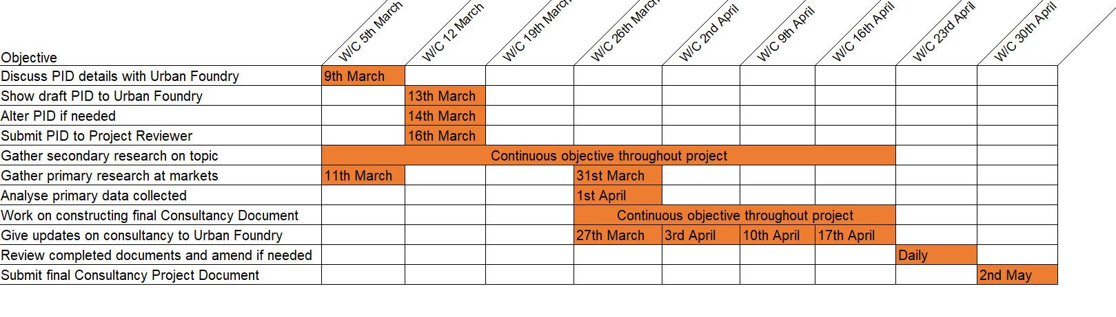
4.1 Project Plan Gantt Chart
This is a Gantt chart which has been created to make sure the project meets deadlines and stays on schedule. The scheduling begins from the date of discussion with Urban Foundry and continues until the submission deadline of May 2nd.
This chart shows the initial staged of the report which include showing this planning document to the company, making any alterations needed after discussing and the submission deadline of March 16th.
Gathering secondary research is going to be done continuously as it can be done by the Project Manager and does not need any meetings or specific dates. The primary research on the other hand will take place at the Marina Market on March 11th and at the Uplands Market on March 31st. This will create the basis of the Consultancy Project Document as the traders who will partake will be chosen that weekend. The document can then be constructed and will continue to be worked on though the following weeks. Whilst the consultancy report is being constructed, weekly updates will be given to Urban Foundry where they will be able to have an input on anything that they wish to change and to discuss any issues that may arise. This will be done through face to face meetings on the agreed dates shown above.
The week prior to the submission deadline will be used to review the project and finalise any details that may need to be included at that point. The completed Consultancy Project Document will then be handed in for reviewing and the recommendations made in the document will be given to the traders for viewing.

- Communication Plan
A communication plan has been agreed with Urban Foundry to help keep the company engaged and updated throughout the project. Weekly meetings have been arranged to enable a dedicated time for the updates and once the project has finished, the organisation will pass the information gathered to the traders which will allow them to make a decision on whether they wish to make the changes suggested.
- Project Controls and Communication Template

Objective | Frequency | Communication method | Object to be completed by | Information to be received by | Alternative communication method
Provide updates on project | Weekly | Face to face meetings | Project Manager (Consultant) | Urban Foundry | Email correspondence
Report any issues that may arise | As needed | Face to face meetings | Project Manager (Consultant) | Urban Foundry /Project Reviewer | Email correspondence
Report any project adjustment needed | As needed | Face to face meetings | Project Manager (Consultant) | Urban Foundry /Project Reviewer | Email correspondence
Discuss any schedule changes | As needed | Email correspondence | Project Manager (Consultant) | Urban Foundry | Face to face meetings
Communicate status of project | Quarterly | Face to face meetings | Project Manager (Consultant) | Project Reviewer | N/A

- Appendix

Appendix 1

Questionnaire for Consultancy Project

- Do you trade at both Uplands and Marina Markets?

Yes No If no, which one do you trade at?

- What products do you sell at your stall?

- Are all the products you use biodegradable?
Yes No

- If the answer to Q4 was no, what products do you use that are not biodegradable?

- If the same materials that you use were able to be replaced by biodegradable products at a similar price to the products you already use, would you consider changing them?
Yes No

- Bibliography

- Livestrong (2018) The Advantages of Biodegradable Products. [Online] Available at: https://www.livestrong.com/article/158244-types-of-biodegradable-products/ [Accessed on 12th March 2018]
- Maylor, H. (2010) Project Management. 4th Ed. Pearson Education Limited: Essex.
- Surfers Against Sewage (2018) Plastic Pollution Figures and Stats. [Online] Available at: https://www.sas.org.uk/our-work/plastic-pollution/plastic-pollution-facts-figures/ [Accessed on 12th March 2018]
- Urban Foundry (2018) Home. [Online] Available at: www.urbanfoundry.co.uk [Accessed on 10th March 2018]

