Executive Summary
This report presents a general background of Nestlé and specific analysis about both external
and internal environments for the company from the aspects of Porter’s five forces and the
company resources with capacities as well separately. Since Nestlé has been facing
challenges due to its subcontracting and outsourcing strategies according to the SWOT
analysis about the company, two new strategies are put up with. Specifically, Growth Strategy
and Best-cost Strategy, which recommend Nestlé adopt self-planting of coffee beans to obtain
stable supply sources and offer low-price products with great differentiation. And a detailed
implementation plan is also given in the end
Executive Summary
This report is to conduct a through strategic analysis of the Accor company. It presents a general background of Accor Hotels and its strategic management tools used in the company. The theoretical part of the report comprises of information about strategic management and the evaluation of the solutions was separated into growth development, SWOT analysis, Ansoff Matrix analysis, PESTE analysis and omnichannel. The report concluding findings indicate that the hotel is preserving a positive reputation and service. Although strategic management tools seemed to be a very import aspect of the development of the company, also they can be considered non beneficial of the same.
Introduction
This report is an assessment of the Accor Hotel Group, which is a hospitality company with operations in different parts of the world. An analysis was made to emphasize its global development, SWOT, and PEST. The conclusion of the report also assesses the company’s function, in relation to the phases of the strategic management tools.
According, Alfred D. Chandler, Jr (1962), “the determination of the basic long-term goals and objectives of an enterprise, and the adoption of courses of action and the allocation of resources for carrying out these goals.” While, Kenneth Andrews,(1980) define strategy as “the pattern of decisions in a company that determines and reveals its objectives, purposes or goals, produces the principal policies and plans for achieving those goals, and defines the range of businesses the company is to pursue, the kind of economic and human organization it is or intends to be, and the nature of the economic and non-economic contribution it intends to make to its shareholders, employees, customers, and communities.” Whereas, John Bryson, (1996) defines strategy as “a pattern of purposes, policies, programs, actions, decisions, or resource allocations that define what an organization is, what it does, and why it does it.
On the other hand, Ansoff H. (1972) described strategic management;
as the new general management role required managers to assume a creative and directive role in planning and guiding the firm’s adaptation to a discontinuous and turbulent future. It required entrepreneurial creation of new strategies for the firm, design of new organisational capabilities and guidance of the firm’s transformation to its new strategic posture. It is this combination of these three firm-changing activities that became known as strategic management (p. 7).
Whereas, Stonehouse and Pemberton (2002), strategic management can be conceptualized as a set of theories and frameworks, supported by tools and techniques, designed to assist managers of organizations in thinking, planning, and acting strategically. While Johnson and Scholes (1984) argued that strategic management;
is concerned with deciding on strategy and planning how that strategy is to be put into effect. It can be thought of as having three main elements within it . . .There is strategic analysis, in which the strategist seeks to understand the strategic position of the organisation. There is a strategic choice stage which is to do with formulation of possible courses of action, their evaluation, and the choice between them. Finally, there is a strategic implementation stage which is to do with planning how the choice of strategy can be put into effect (p. 10).

On the other hand, tools and techniques for strategic management are vital aspects of the strategic management process. Strategy tool is a generic name for any method, model, technique, tool, technology, framework, methodology or approach used to facilitate strategy work (Stenfors, Syrjänen, Seppälä and Haapalinna, 2007). Even Gunn and Williams (2007) described strategy tools as concepts that assist strategic managers in decision making. Whilst, according to Clark (1997), strategic tools can be included in all stages of strategic management process: situation assessment, strategic analysis of options, and strategic implementation.
Main Findings
Accor’s growth model is developed by the implementation of a mergers and acquisition strategy. This is to say according to Sudarsanam (1995), a merger takes place when two or more corporations come together to contribute and share their resources to achieve common objectives. While Sherman and Hart (2006), stated a merger is a combination of two or more companies in which the assets and liabilities of the selling firms are absorbed by the buying firm. According to Gaughan (2002), a merger is a process in which two corporations combine and only one survives and the merged corporation ceases to exist. This is to say sometimes a partnership between two companies tends to happen, where both organizations cease to exist, and a completely new company is developed.
An acquisition on the other hand, Sudarsanam (1995), defines acquisition as an ‘arms-length deal’ where one company purchases the shares of another company, and the acquired company is no longer the owner of the firm. This has helped Accor improved its presence in emerging markets such as in 1984 the first Novotel stone is laid in Beijing, China (2022). Addtionally, according to Gaughan (2002), mergers and acquisitions are friendly transactions in which the senior management of the companies negotiates the terms of the deal, and the terms are then put in front of the shareholders of the target company for their approval. This strategy has also seen the company achieved a 3% net growth rate in 2021, the company’s 2021 development performance was particularly strong in Europe, China, and the Middle East. Europe represented the #1 market for Accor with 153 new hotels signed, representing +20% growth vs 2020. (Accor, 2022).
Thus, the growth development is sourced by the high-quality customer service the company provides, which leads to customer queries are easily resolved, and the guest is satisfied not only with the service, but also with what the hotels have to offer. Therefore, when a guest is enthusiastic about their experience, they become an advocate and spread positive word of mouth about the service of the hotels. As a result, it expands its boundaries and increases its bottom line.
However, the SWOT Analysis is a tested strategic tool which enables an organization such as Accor Hotels to evaluate the company as well as performance to those of its competing companies. Accor Hotels is a leading company in the hospitality and tourism sectors. According to Kotler and Armstrong (2012: 53-54), SWOT analysis is the identification of various factors systematically to formulate a company’s strategy based on the company’s strengths, weaknesses, opportunities, threats to observe the external and internal marketing environment.
While, According Rozmi et al., 2018; Wu, 2020, strengths, weaknesses, opportunities, and threats (SWOT) analysis has become a fundamental tool for organizations to evaluate their position in the market and is widely used to analyze the internal and external environments of organizations during times of indecision. Even as Aldehayyat & Anchor, 2008; Fleisher & Bensoussan, 2003; Lee & Lin, 2008; Shrestha et al., 2004 stated the four components identify either internal or external considerations. Strengths refer to the internal elements of an organization that facilitate reaching its goals, while weaknesses are those internal elements that interfere with organizational success. Opportunities—external aspects that help an organization reach its goals—are not only positive environmental aspects but also opportunities to address gaps and initiate new activities. Threats, on the other hand, are aspects of the organization’s external environment that are barriers or potential barriers to reach its goals.
The Accor hotels SWOT analysis's Strengths includes years of knowledge and expertise in the hospitality sector. Secondly it has welcomed digitalization and now is focusing on sales online which will benefit the customers. Thirdly, according to segmentation, the company is offering their consumers effective and economically budgeting. Additionally, outstanding guest engagement and customer care is one of the hotel's greatest assets as they continually strive to make their guests happy. This seems to be their primary goal, so it guarantees that customers are indeed connected towards the company.
Two out of five guests from each ten hotel companies preferred to make booking to that specific hotel because of attractiveness of loyalty program (Barsky & Nash, 2002; O’Neill et al., 2008). While O’Neill and Carlback (2011) added that loyalty programs having more commercial accounts provided more stable occupancy for the branded properties during recessions when corporate and government guests are looking for value and consistency. Among some of the options offered to visitors are profitable loyalty programs which is according to Accor Plus (2022), be rewarded with ALL Silver status as a member of ALL Accor Live Limitless, Accor’s global lifestyle loyalty programme. Whether the guest travel for business or leisure, every night the guest spend at an Accor property rewards the guest with points towards even more memorable travel experiences.
In contrast, loyalty programs offer, and rewards are varied depending on the hotel. For instance, in Hilton Hotels loyalty program is called Hilton Honors for. Members can enjoy great perks like the lowest room rates, free Wi-Fi, and the ability to manage their reservation and even unlock their door from the Hilton mobile app. On top of that, members earn points any time they make a reservation at a Hilton hotel or use a Hilton credit card. As you earn points, you unlock even more great benefits through Hilton’s elite status tiers. You can then redeem your points for free nights at properties within the Hilton portfolio from more budget-friendly brands like Hampton by Hilton to luxurious resorts from Waldorf Astoria Hotels and Resorts (Wack.M, 2022).
On the other hand, online check-in includes two days before arrival the guest will receive an e-mail invitation to complete your online check-in. the guest will save even more time by using your ALL card. The guest information is pre-populated. On the day of arrival, the guest will receive an SMS with practical information related to your mode of transport (e.g., parking code, nearest public transport). Simplified check-in the hotel team will have carefully prepared for the guest arrival and the room key will be ready. Fast check-out the guest will return the key without having to wait: the guest check-out is complete. (All Accor, 2022) However, the company maintains all points of contact, from booking to check-out, that are supervised and carefully selected for continuous quality improvement.
Although this is a great initiative of the Accor group it has its disadvantages which is according to President’s Identity Theft Task Force 2007, identify theft involves “the misuse of another individual's personal information to commit fraud”. This is to say that hotels are always targeted because of guest identity and financial information. For example, according to Stephens M.2018, in the month of June 2012, the Federal Trade Commission (FTC) filed a lawsuit against Wyndham hotels, claiming Wyndham misrepresented its security measures to prevent intrusions by computer hackers. The FTC claimed Wyndham had subjected consumers' data to an "unfair and deceptive" lack of protection that led to a series of breaches of Wyndham hotels and those of three subsidiaries. The lawsuit describes three attacks on the hotel chain and its franchisees beginning in 2008 that first compromised 500,000 credit card numbers stored by the firm, followed by attacks that breached another 50,000 and 69,000 accounts at other locations.
Therefore, although online check in and fast check out is time efficient, balancing staff workload and was essential during the pandemic due to social distance and to promote safety it has it disadvantages which will make customers feels unsafe and think twice before making a reservation.
A company's weaknesses are specific elements that it should be able improve to enhance its standing even further. The weaknesses of Accor Hotels consist of innovative online businesses such as Airbnb which is according to Investopedia (2022) is an online marketplace that connects people who want to rent out their homes with people who are looking for accommodations in specific locales. Secondly, customers of the brand Accor Hotels struggle to connect to it because it caters to segments. According to Economic Times (N.A) segmentation means to divide the marketplace into parts, or segments, which are definable, accessible, actionable, and profitable and have a growth potential.
Opportunities are ways in which a brand can improve, Accor can establish more courses in different countries to provide graduates with a global hospitality experience, so that each country will benefit from international-level service. According to Accor (2018) the Group is committed to the development of new talent wishing to join AccorHotels. INSPIRE offers many opportunities for tomorrow's leaders, the program is aimed at passionate, motivated, and agile graduates, and enables them to start their career journey with AccorHotels, building their leadership foundation through meaningful experiences. Threats of any company can be issues that have negative effect on its operations. One of the threats towards the business is the global economic situation that may have an impact on sales in the luxury and upscale segments of the company. In contrast, according to IMS Marketing (NA) when marketers use market segmentation it makes planning campaigns easier, as it helps to focus the company on certain customer groups instead of targeting the mass market. Segmentation helps marketers to be more efficient in terms of time, money, and other resources. Market segmentation allows companies to learn about their customers. They gain a better understanding of customer’s needs and wants and therefore can tailor campaigns to customer segments.
In opposition, according to Abbasov. N, 2019 SWOT can’t be used for predicting the success of an organization. Hence, a strength in the company can also be a weakness of the same while an opportunity of a business can be a threat. Another factor that can influence the limitation of the SWOT analysis is the tendency to recognize favourable situations and being bias toward a particular interest.
According to CIPD (2021) A PESTLE analysis studies the key external factors (Political, Economic, Sociological, Technological, Legal and Environmental) that influence an organisation. It can be used in a range of different scenarios and can guide people professionals and senior managers in strategic decision-making. Whereas the Pestle analysis is used as a tool to situational analysis for business evaluation purposes and is one of the most used models in the evaluation of the external business environment that is highly dynamic (Gupta, 2013). Therefore, the benefits of this model for a business are huge (Dwyer & Tanner, 2002). However, limitations should be also noted, and steps should be taken to minimize any loopholes in the outcome derived from the model for effective decision-making purposes (Thomas, 2007).
The implementation of the Pestle in the Accor group is beneficial to the company. Thus, the political factor plays an important role or a challenge in the company. Accor company is a global brand and faced some of the challenges politically due to when it comes to participating in government. Political factors include government regulatory trends, employment legislation, tax policy, tariffs, and so on, which can affect hotel business in many ways. (Mind Tools，2012）While, as on of the economic factor the world's largest hotel operator, AccorHotels create and provide employment opportunities for more than 230,000 hospitality experts in one hundred and ten (110) countries ( Accor,2022).
In contrast, according to Shaw ,A. 2022 describe the disadvantages of the pestle analysis are the company can conduct the analytical study with limited data, and the users oversimplify things while making decisions. Secondly, if there is more data available, then the company would become confused about the details. Thirdly, the focus of the study is on the assumptions rather than the actual risks and threats that they may face. Fourthly, the company must keep conducting the study regularly, not just occasionally it is difficult to predict the upcoming development and that would impact the company.
Therefore, the PESTLE analysis is an excellent means for businesses which be capable of a variety of sources. It includes information on how well the external circumstances might impact a business. Hence, this made it easier for companies to just get ready for any problems brought on by these PESTLE factors and they will be able to find solutions.
The Ansoff matrix outlines four key stages of company growth: market penetration, market development, product development, and diversification (Mukherjee 2016; Lawley & Schure 2017). In the market penetration phase, a company strives to grow by expanding its existing product offerings in the existing market. The second stage of market development happens when organizations want to expand their market outreach to foreign markets. It is often accomplished when companies expand their market offerings across different market segments, when they venture into new areas or regions of the market, or when they intend to expand into new locations (Kim & Mauborgne 2015). The third stage of the Ansoff matrix is the product development stage, which is defined by the creation of new products and services (Lawley & Schure 2017).
Accor’s product development stage includes the expansion of the brand Accor, its development team achieved several milestones in 2021, particularly in China, where new project signings reached an all-time high – leading to more than 520 hotels currently operating in the region and an additional 350 under development. The first destination was signed for Accor’s newest luxury brand, Emblems Collection, for the development of a magnificent flagship hotel in Guizhou province: Guiyang Art Centre Hotel, Emblems Collection. (Accor press, 2022).
Although the Ansoff Matrix is a helpful tool for companies to map out their growth strategies. The companies should be aware of some disadvantages of the Ansoff Matrix. These include the fact that it is difficult to predict the impact of Ansoff matrixes on company sales and profits and that cost-benefit analysis is essential to justify its chosen strategy. (Innovolo, 2022). According to Innovolo (2022) one of the most significant disadvantages of the Ansoff Matrix is that competitors are ignored.
This matrix only shows the strategy keeping in mind the company's product and market. Still, in the real world, competitors are there for every product and the market. Therefore, they play a significant role in deciding whether a company's strategy works. Secondly, the Ansoff Matrix does not consider the cost-benefit analysis of various strategies; this means that if a company is considering a diversification or product development strategy, it needs to weigh the costs and benefits of each option before deciding. In other words, cost-benefit analysis is essential to justify the company's chosen strategy.
After all, every decision a company makes is designed to increase sales and profits. Without cost-benefit analysis, it would be difficult to determine whether a particular strategy will be successful. Thirdly, the Ansoff matrix is a simple way to map out company growth strategies. However, it's tough to predict the impact of Ansoff matrixes on company sales and profits because you can never predict consumer and market reactions with one hundred per cent accuracy.
As a result, all calculations can go for a toss. Therefore, companies should keep this in mind before taking any decisions based on Ansoff matrixes. Ansoff matrixes are a helpful tool, but they should not be relied on blindly. Instead, companies should use them to start further research and analysis. Only then will they be able to make informed decisions about growth strategy. (Innovolo 2022) Therefore, even if the Ansoff matrix is beneficial and a useful tool for any company including Accor when determining their marketing strategy, but it is essential to consider all aspects prior to deciding.
Omnichannel is an effective tool in the Accor company. According to Juaneda-Ayensa et al. (2016), omnichannel is defined as "more than a configuration of channels design or technological systems," as a result of digital transformation experienced by the global retail market. The aim is providing perfect shopping experiences, free of barriers or operational friction presents in the most common shopping processes. This model is made possible by the merger of physical and digital channels through a complex integration of operational, technological, and logistical systems that is complemented by the availability of user-friendly applications for consumer interface (Rigby, 2011).
After years of relying on traditional phone and email channels and seeing ticket volumes increase year over year, Accor Plus was ready for a case management solution that integrated voice support and freed up agents from manual ticketing work. The company decided that Zendesk offered the most complete package with features that could scale with business growth and improve customer satisfaction. Additionally, uses Zendesk to create an omnichannel conversational experience over email, web, help center, as well as social through Facebook and WhatsApp (Zendesk 2022). AREA 17 and Accor joined forces on an iterative design and development process to deliver an omnichannel experience that brings the value proposition of augmented hospitality to life, starting with MVP. (Area 17 2020) Whilst, Marriott International today announced the launch of the Marriott Media Network, an omnichannel cross-platform advertising solution for brand advertisers, enabling curated content experiences and offerings to guests throughout their travel journey. To power its network of owned channels, Marriott is exclusively collaborating with Yahoo, an industry-leading unified stack advertising platform. The Marriott Media Network initially will offer brand advertisers exposure to travelers in the U.S. and Canada, ultimately expanding to travelers globally including more than 164 million members in Marriott Bonvoy, the company’s award-winning travel program. The network is expected to feature premium inventory spanning its owned channels including display, mobile, video, email, and digital out-of-home (in-room television and digital screens) when fully deployed. For brand advertisers, the Marriott Media Network will offer an unprecedented combination of scale and personalized media to an audience of in-demand, high-intent travelers. (Marriott International, 2022).
Despite realizing the benefits of an omnichannel strategy and its marketing tools and resources, marketing departments encounter difficulties in creating seamless guest experience. According Sripur, A. (2022) there is an inability to connect the dots this is to say marketers face a tough time integrating data from different channels to create a seamless customer journey. The inability to connect the dots prevents them from creating a personalized experience for the customer.
Secondly, the inability to reduce churn, competitive sectors find it difficult to retain customers on their platforms, especially when the competitors offer the same products at lower prices. Therefore, creating a differentiation becomes a challenge. Thirdly. customers expect hyper-personalized recommendations. The one-size-fits-all experiences have disappeared. A customer wouldn’t think twice before switching to a competitor’s website if the experiences are not personalized for them. Marketers must think like a customer, an art that most of them are yet to master. Fourthly, the improper utilization of user data. Guest leave behind a trail of data such as contact numbers, email ids, addresses, etc. when they interact with the hotel. This could lead to identity theft. Finally, although omni-channel may present outstanding development opportunities, it come with unprecedented challenges.

Conclusion
The concept of the report will provide the reader a simple but comprehensive view into strategic management tools that were used to contrast and compare their effectiveness. Also, it enhanced understanding to the reader as part of the report applied analysis tools used in strategic management. The results led to a situational analysis where although the strategic tools can be beneficial to any company, also it can be inefficient to the same. The results obtained will give an opportunity to the company to analyze its possible challenges and find ways of improvement. It offers a good framework and basis for their own official analysis and comparison.

Reference
Accor - Our history (2022) available at https://group.accor.com/en/group/who-we-are/our-history
Accor (2022) Accor advances its global development strategy with robust line-up of signings, openings, and the world's most diverse brand portfolio: Accor – Newsroom available at https://press.accor.com/accor-advances-its-global-development-strategy-with-robust-line-up-of-signings-openings-and-the-worlds-most-diverse-brand-portfolio/?
Aldehayyat, J. S., & Anchor, J. R. (2008). Strategic planning tools and techniques in Jordan: Awareness and use. Strategic Change, 17(7‐8), 281-293
All Accor (2022) online check in fast check out. (n.d.). https://all.accor.com/gb/online-check-in-fast-check-out/index.shtml.
Andrew Sherman and Milledge Hart. 2006. Mergers & acquisitions from a to z, second edition. Amacom, USA.
Andrews, Kenneth (1980). The Concept of Corporate Strategy, 2nd Edition. Dow-Jones Irwin
Ansoff, H. I. ‘The Concept of Strategic Management’, Journal of Business Policy, 2, No. 4, Summer, 1972.
Barsky, J., & Nash, L. (2002). Evoking emotion: affective keys to hotel loyalty. The Cornell Hotel and Restaurant Administration Quarterly, 43(1), 39-46.
Be the future (2018). https://group.accor.com/en/Actualites/2018/10/inspire-programme-students-hospitality
Brost, M. A., & Kleiner, B. H. (1995). New developments in corporate diversification strategies. Management Research News, 18(3-5), 24-33. http://dx.doi.org/10.1108/ eb028402.
Bryson, John M. (1995). Strategic Planning for Public and Nonprofit Organizations. Jossey-Bass
Chand, S. (2014, February 24). Advantages and Disadvantages of Market Segmentation. Your Article Library. https://www.yourarticlelibrary.com/marketing/marketing-management/advantages-and-disadvantages-of-market-segmentation/27955
Chandler, Alfred Jr. (1962). Strategy and Structure: Chapters in the History of the American Industrial Enterprise. MIT.
CLARK, D. N. 1997. Strategic management tool usage: a comparative study. Strategic Change, 6(7): 417 – 427.
Dwyer, F. Robert, Tanner, John F.. (2002). Business Marketing: Connecting Strategy, Relationships, and Learning Second Edition (E-Book) . New York: McGraw-Hill.
Fleisher, C. S., & Bensoussan, B. E. (2003). Strategic and competitive analysis: Methods and techniques for analyzing business competition. Prentice Hall.
Gaughan, P., 2002. mergers, acquisitions, and corporate restructurings. New York: Wiley, pp.1-10.
Group Accor, (2022) About Accor, available at https://group.accor.com/en/group/who-we-are/about-us
GUNN, R. and WILLIAMS, W. 2007. Strategic tools: an empirical investigation into strategy in practice in the UK. Strategic Change, 16(5): 201 – 216.
Gupta, B. (2013). Human Resource Information System (HRIS): Important Element of Current Scenario. IOSR Journal of Business and Management, 13, 41-46.
How Airbnb Works. (2022, July 8). Investopedia. https://www.investopedia.com/articles/personal-finance/032814/pros-and-cons-using-airbnb.asp
IMS Marketing (NA) The Importance of Market Segmentation. IMS Marketing. https://www.imsmarketing.ie/business-strategy/the-importance-of-market-segmentation
Innovolo (2022) The Advantages and Disadvantages of the Ansoff Matrix. https://www.innovolo.co.uk/article/the-advantages-and-disadvantages-of-the-ansoff-matrix
Johnson G. and Scholes, K. Exploring Corporate Strategy, Prentice Hall, London, 1984.
Juaneda-Ayensa, E., Mosquera, A., & Sierra Murillo, Y. (2016). Omnichannel Customer Behavior: Key Drivers of Technology Acceptance and Use and Their Effects on Purchase Intention. Frontiers in Psychology, 7, 1117.
Kotler, P., & Keller, K. L. (2016). Marketing Management (15th ed.). Pearson. Retrieved 2020
Lee, K. L., & Lin, S. C. (2008). A fuzzy quantified SWOT procedure for environmental evaluation of an international distribution center. Information Sciences, 178(2), 531-549
Marriott International Introduces Travel Media Network, Powered by Yahoo. (2022, May 16). Marriott International Newscenter (US). https://news.marriott.com/news/2022/05/16/marriott-international-introduces-travel-media-network-powered-by-yahoo
More Rewards. (2022, September 16). Accor Plus. https://www.accorplus.com/benefits/more-rewards/
Namiq Abbasov ( 2019). What are the limitations of SWOT analysis(es), Retrived From-https://www.researchgate.net/post/What_are_the_limitations_of_SWOT_analysises
O’Neill, J. W., & Carlbäck, M. (2011). Do brands matter? A comparison of branded and independent hotels’ performance during a full economic cycle. International Journal of Hospitality Management, 30(3), 515-521.
Omnichannel (2020). Area 17 avaliable at Accor. https://area17.com/work/accor-live-limitless
Pechlaner, H & Smeral, E 2014, Tourism, and leisure: current issues and perspectives of development, Springer, New York, NY.
PESTLE Analysis Factsheets. (n.d.). CIPD. https://www.cipd.co.uk/knowledge/strategy/organisational-development/pestle-analysis-factsheet
Reference
Rigby, Darrell (2011) The Future of Shopping. Harvard Business Review. December 2011. p.64-76.
Rozmi, A. N. A., Nordin, A., & Bakar, M. I. A. (2018). The perception of ICT adoption in small medium enterprise: A SWOT analysis. International Journal of Innovation Business Strategy, 19(1), 69-79.
Shaw, A. A. (2022). Importance of Pestle Analysis, Uses, Advantages & Disadvantages. Business Management & Marketing. https://swotandpestleanalysis.com/importance-of-pestle-analysis-uses-advantages-disadvantages/
Shrestha, R. K., Alavalapati, J. R., & Kalmbacher, R. S. (2004). Exploring the potential for Silvopasture adoption in South-Central Florida: An application of SWOT–AHP method. Agricultural Systems, 81(3), 185-199.
Sripur, A. (2022). 7 Major Challenges in Omnichannel Marketing and How to Fix Them. MoEngage. https://www.moengage.com/blog/7-biggest-mistakes-in-omnichannel-marketing-and-how-to-fix-it/
STENFORS, S., TANNER, L., SYRJÄNEN, M., SEPPÄLÄ, T. and HAAPALINNA, I. 2007. Executive views concerning decision support tools. European Journal of Operational Research, 181(2): 929 – 938.
Stephens, M. (2018). Hotel Liability for Guest Information -What You Need to Know and How to Avoid Liability. Insights. https://insights.ehotelier.com/news/2014/03/17/hotel-liability-for-guest-information-what-you-need-to-know-and-how-to-avoid-liability/
STONEHOUSE, G. and PEMBERTON, J. 2002. Strategic planning in SMEs‑some empirical ﬁndings. Management Decision, 40(9): 853 – 861
Sudarsanam, P.S. (1995) Essence of Mergers and Acquisitions, Great Britain. Prentice Hall International, Upper Saddle River.
Thomas, A.R. (2007) The End of Mass Marketing: Or, Why All Successful Marketing Is Now Direct Marketing. Direct Marketing: An International Journal, 1, 6-16.
Wack, M. (2022). Guide to the Hilton Honors rewards program. Bankrate. https://www.bankrate.com/finance/credit-cards/guide-to-hilton-honors-rewards-program/
What is Segmentation? Definition of Segmentation, Segmentation Meaning. (n.d.). The Economic Times. https://economictimes.indiatimes.com/definition/segmentation
Wu, Y. (2020, February 17). The marketing strategies of IKEA in China using tools of PESTEL, Five Forces Model and SWOT Analysis [Paper Presentation]. International Academic Conference on Frontiers in Social Sciences and Management Innovation, Beijing, China
Zendesk. (2022). Accor Plus drives more revenue with a conversational strategy. https://www.zendesk.nl/customer/accor-plus/#georedirect

Appendices
Appendix 1

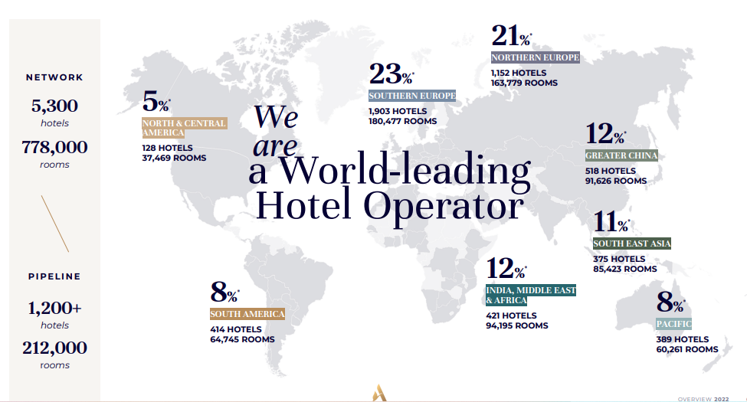
Figure 1: shows the number of hotels in the Accor company.

Appendix 3
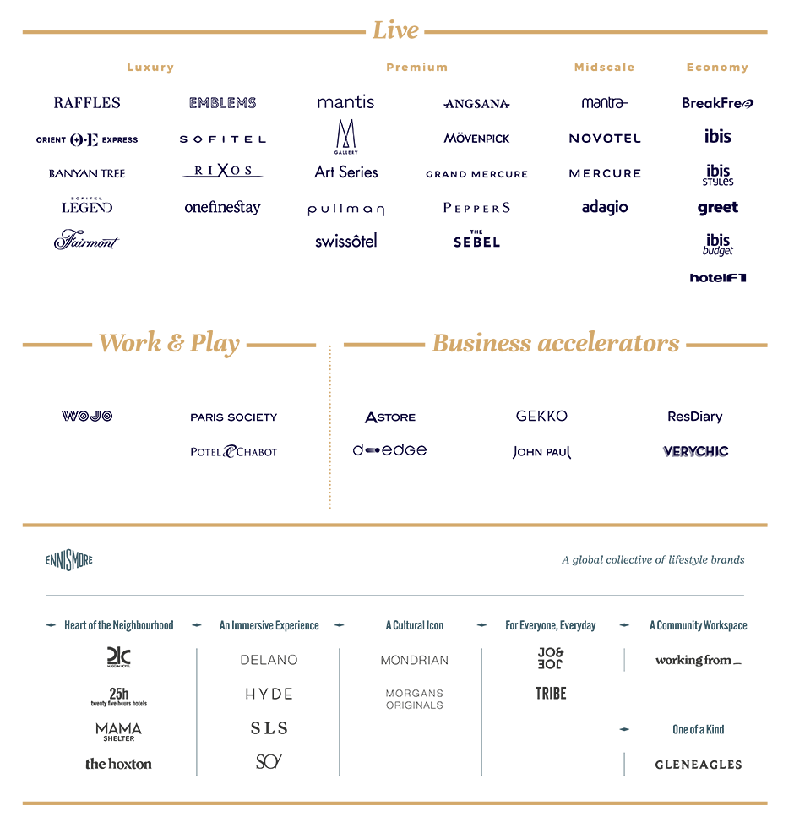

Figure 2 Show the segmentation of hotels in the Accor company

Appendix 3
Background of Accor

Accor is the story of two friends, Paul Dubrule and Gérard Pélisson, who opened their first Novotel in 1967 at a time when no one in France yet believed in this new hotel business model. Through their creativity and boldness, they pushed the boundaries of what is possible ever further. Today their dream of hospitality has become Accor. A wind of conquest still blows over our Group which brings together over 5,300 addresses in 110 countries. Proud heirs of the co-founders' vision, everyday our more than 230,000 talented people continue to invent the hospitality of tomorrow and bring to life their passion for the guest and nurturing passion for service and achievement beyond limits. They are so much more than hotels who are creating innovative lifestyle experiences, whether it is to live, work or play. With more than 40+ hotel brands, 5300 hotels,110 countries. Its vision is to build on the strength of its teams and integrated ecosystem of leading brands, personalized services, and expert solutions, break new ground to reimagine hospitality and inspire new ways to experience the world.(Accor, 2022).

