

Assessment 1
Supporting Paper

Student name: Elizabeth Cuffie
Student ID: 1913507

Module name: Mental Disorders and Psychopathology
Module code: BMHP6006
Lecturer name: Bianca Sanfilippo
Date: due 27th April 2023

Introduction
This supporting paper will talk about dementia in Alzheimer’s diseases. It will discuss The definition, classification within the ICD-10 manual, causes, the types, the ones that are affected, symptoms, signs and diagnosis, ancientness, current treatments of dementia will also be mentioned. In addition, principles / laws for when caring for people with dementia and recommendation for the improvement of dementia in Alzheimer’s disease.

What is dementia in Alzheimer’s disease?

According to (Gale et al, 2018). Dementia is any reduction in your understanding that is powerful enough to interfere with your freedom and everyday functioning . Dementia is best described as a syndrome rather than just one singular disease. Furthermore, in Alzheimer’s Society, (2023). Dementia is a name given to different indicators including memory loss, having difficulties in your thinking, problem solving and language. Its starts when disease has damaged the brain as well as Alzheimer’s disease.
Alzheimer’s is a physical disease which upsets the brain. It manifests in later life or at any time in one’s life The doctor who defines it first is Alois Alzheimer which is why the disease is called Alzheimer’s disease (Alzheimer’s society, 2023).
According to Alzheimer’s research UK, (2022). there are currently 944,000 people living with dementia in the UK, more than ever and this number is foreseen to increase.

Disorder within the ICD-10 Manual
Dementia in Alzheimer’s disease is classified under behave and emotional disorders is within the category:F90 – F98 it is used for diagnosing individuals with mental disorders

Causes
Various diseases can cause dementia, / Alzheimer’s a lot of these diseases are connected with a build-up of proteins in the brain that is not normal. The nerve cells function less because of this build up then eventually die. because of the dead nerve cells, dissimilar part of the brain will shrink. Alzheimer’s is also believed to be the cause of two proteins build-up abnormally which are : amyloid and tau, when amyloid are deposited it is called plaques which spread within the brain cells. The tau deposit causes tangles around the brain cells. .NHS, (2021).

Types of Dementia
According to dementia UK, (2023). there are various types of dementia, they are:
Alzheimer’s disease- this is the common type of dementia and it is made up of 60% of those diagnosed with dementia. Another type is the vascular dementia – about 17% of individual diagnosed with dementia can have vascular dementia, it is the second most common type of dementia in people aged 65 or over and the problem is caused by the blood supply in the brain. Frontotemporal dementia – this is a group of dementia which influence the frontal and temporal lobes of the brain. It can affect how you behave, your language and speech. Mixed dementia – most people with dementia have more than one type of dementia. Lewy body dementia – this is the progressive type that affect your movement.
Symptoms/signs/ diagnosis
According to WHO, (2023).The primary signs and symptoms of dementia/Alzheimer’s are; getting very confused of places that you know, getting lost when you are walking, driving, loosing track of the time, forgetting recent events, having difficulty in keeping up with conversation and finding what word to say next, having difficulty to make decisions, struggling with daily task like personal care and daily activities.
It is best to see you’re your GP if you have any concerns about you’re your memory. When you get diagnosis, that will give you and your loved ones the opportunity to get ready for the future, the treatment and support you will get from healthcare professionals will enable you to live a good life with dementia. The GP will ask you basic questions like personal care eg washing and dressing, shopping, paying your bill or cooking. You will also be asked to do various test like blood test, urine etc and you can be referred to a dementia specialist. NHS, (2020)

Ancientness of dementia and treatments:
in the 2nd century, if you have dementia they will say it is due to having too much black bile. Medieval spirits: in the medieval times, people with dementia were classed as child like who cannot control their senses. And that you have a delayed journey to heaven or hell. It was also believed that they are evil possessed by spirits.
Treatment of dementia at that time was cleansing, locked away and death Midlands Care,(2023).

Current treatments
According to NHS, (2020). There is currently no treatments for dementia, however there are other treatments and medicines that will help with the symptoms. Some medication is acetylcholinesterase inhibitors which can stop enzyme not to break the acetylcholine in the brain and also donepezil which can help for the symptoms of Alzheimer’s disease and another medication called memantine.
There is also non medication treatment like; cognitive stimulation therapy to improve problem solving skills, language ability and memory.
Laws and Principles for when working with people with dementia.
Whenever you are working with people that have dementia make sure you follow policies and procedures. Follow the person centered care approach when providing care and support for dementia patients. NICE, (2018). Follow policies and legislation on data protection Act (2018) human right Act (2010), comply with equality Act (2010). Follow the mental capacity Act code of practice (2005).
Conclusion
Dementia is a killer disease, for anyone working with people that have the condition we need to have the patience, and the courage and to be able to listen to them because dementia makes it difficult for them to perform daily living task as their condition progresses. With more medical research am hoping one day there could be cure to it.

Appendix: Power Point Presentation

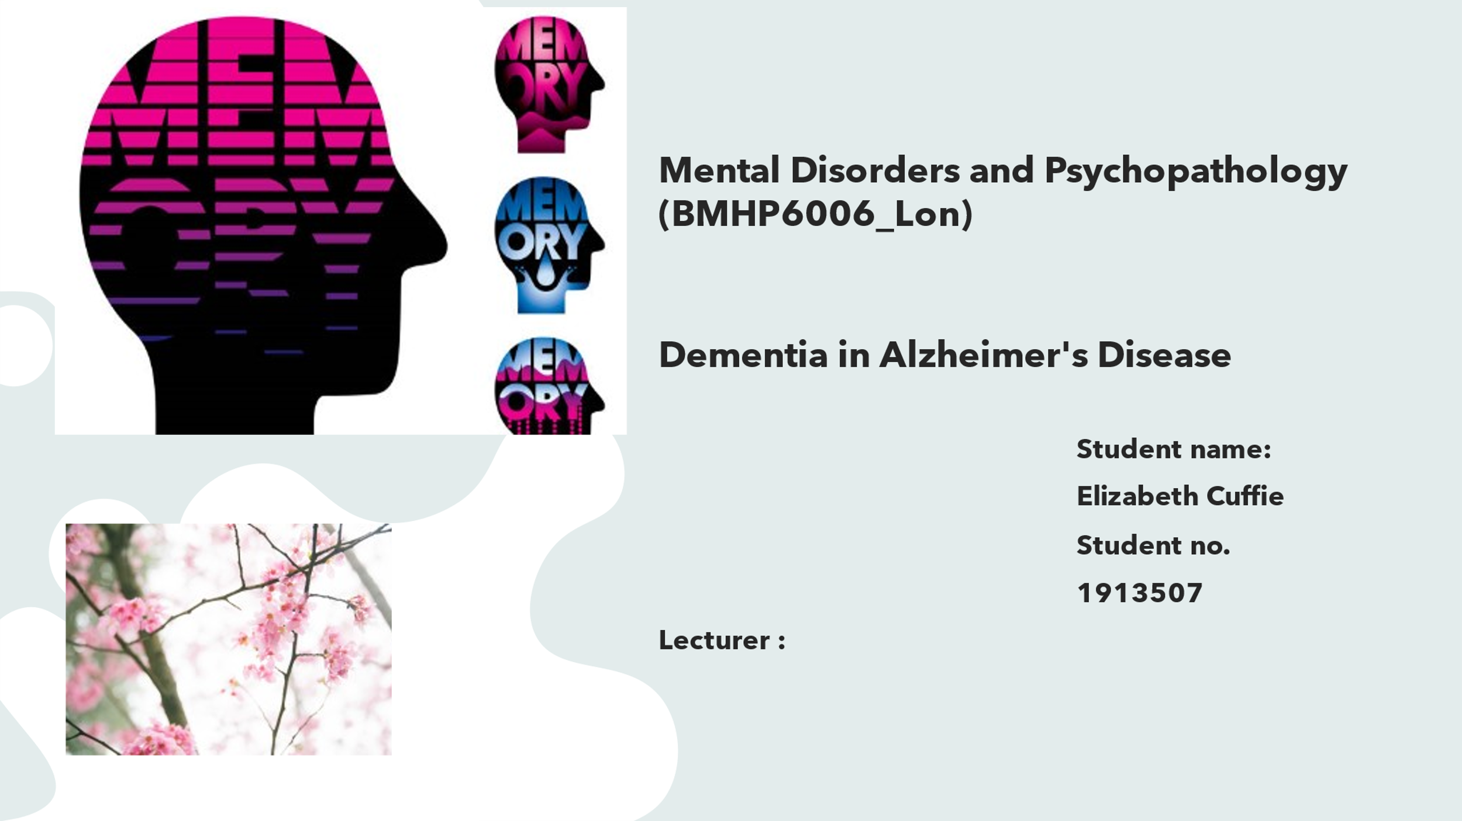

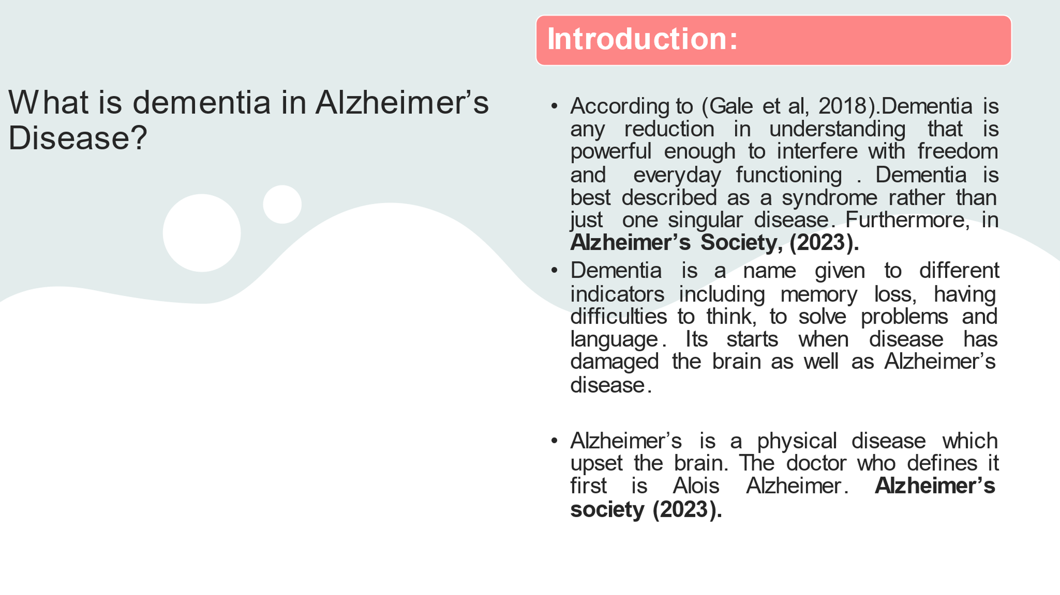
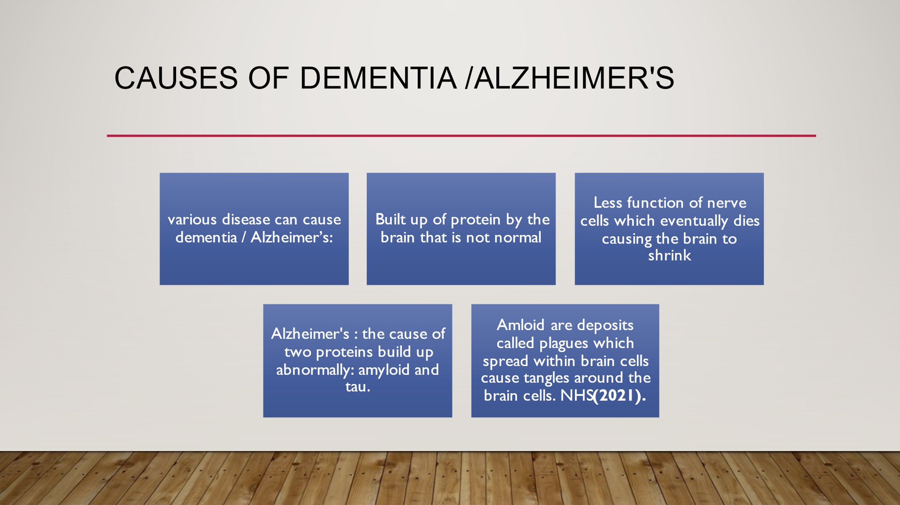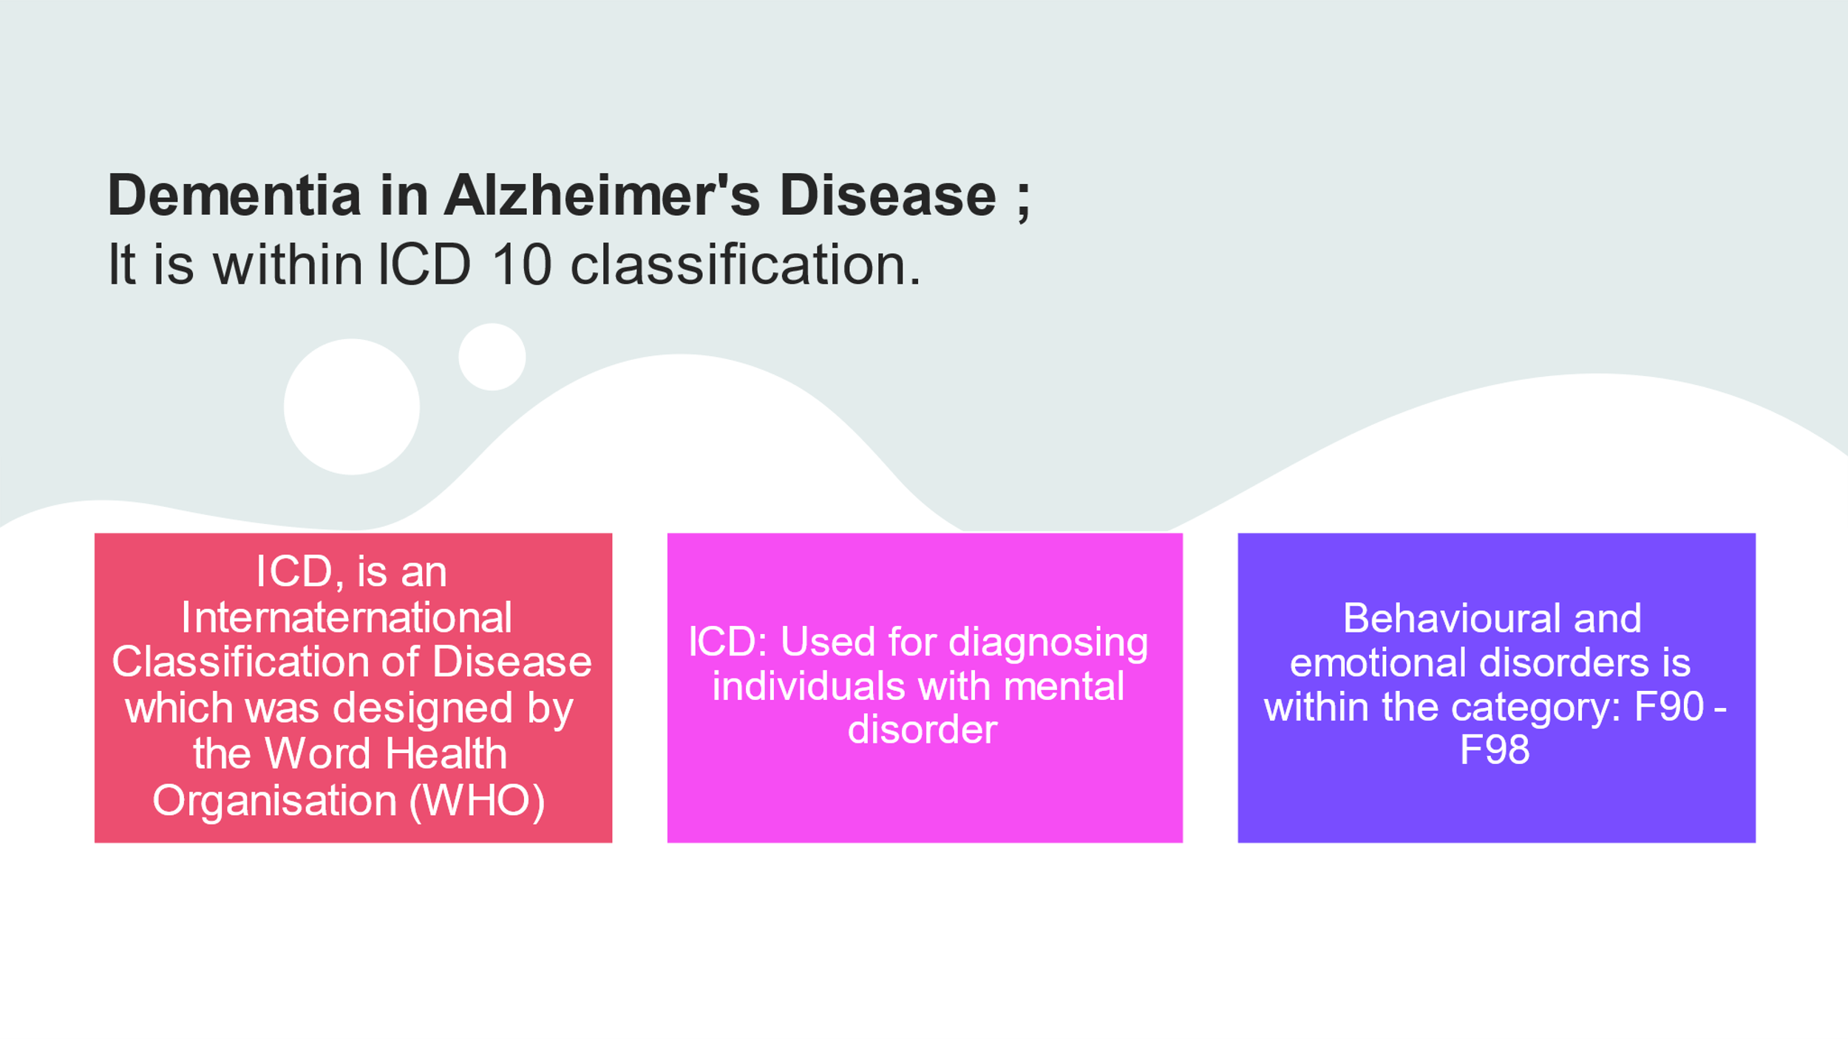

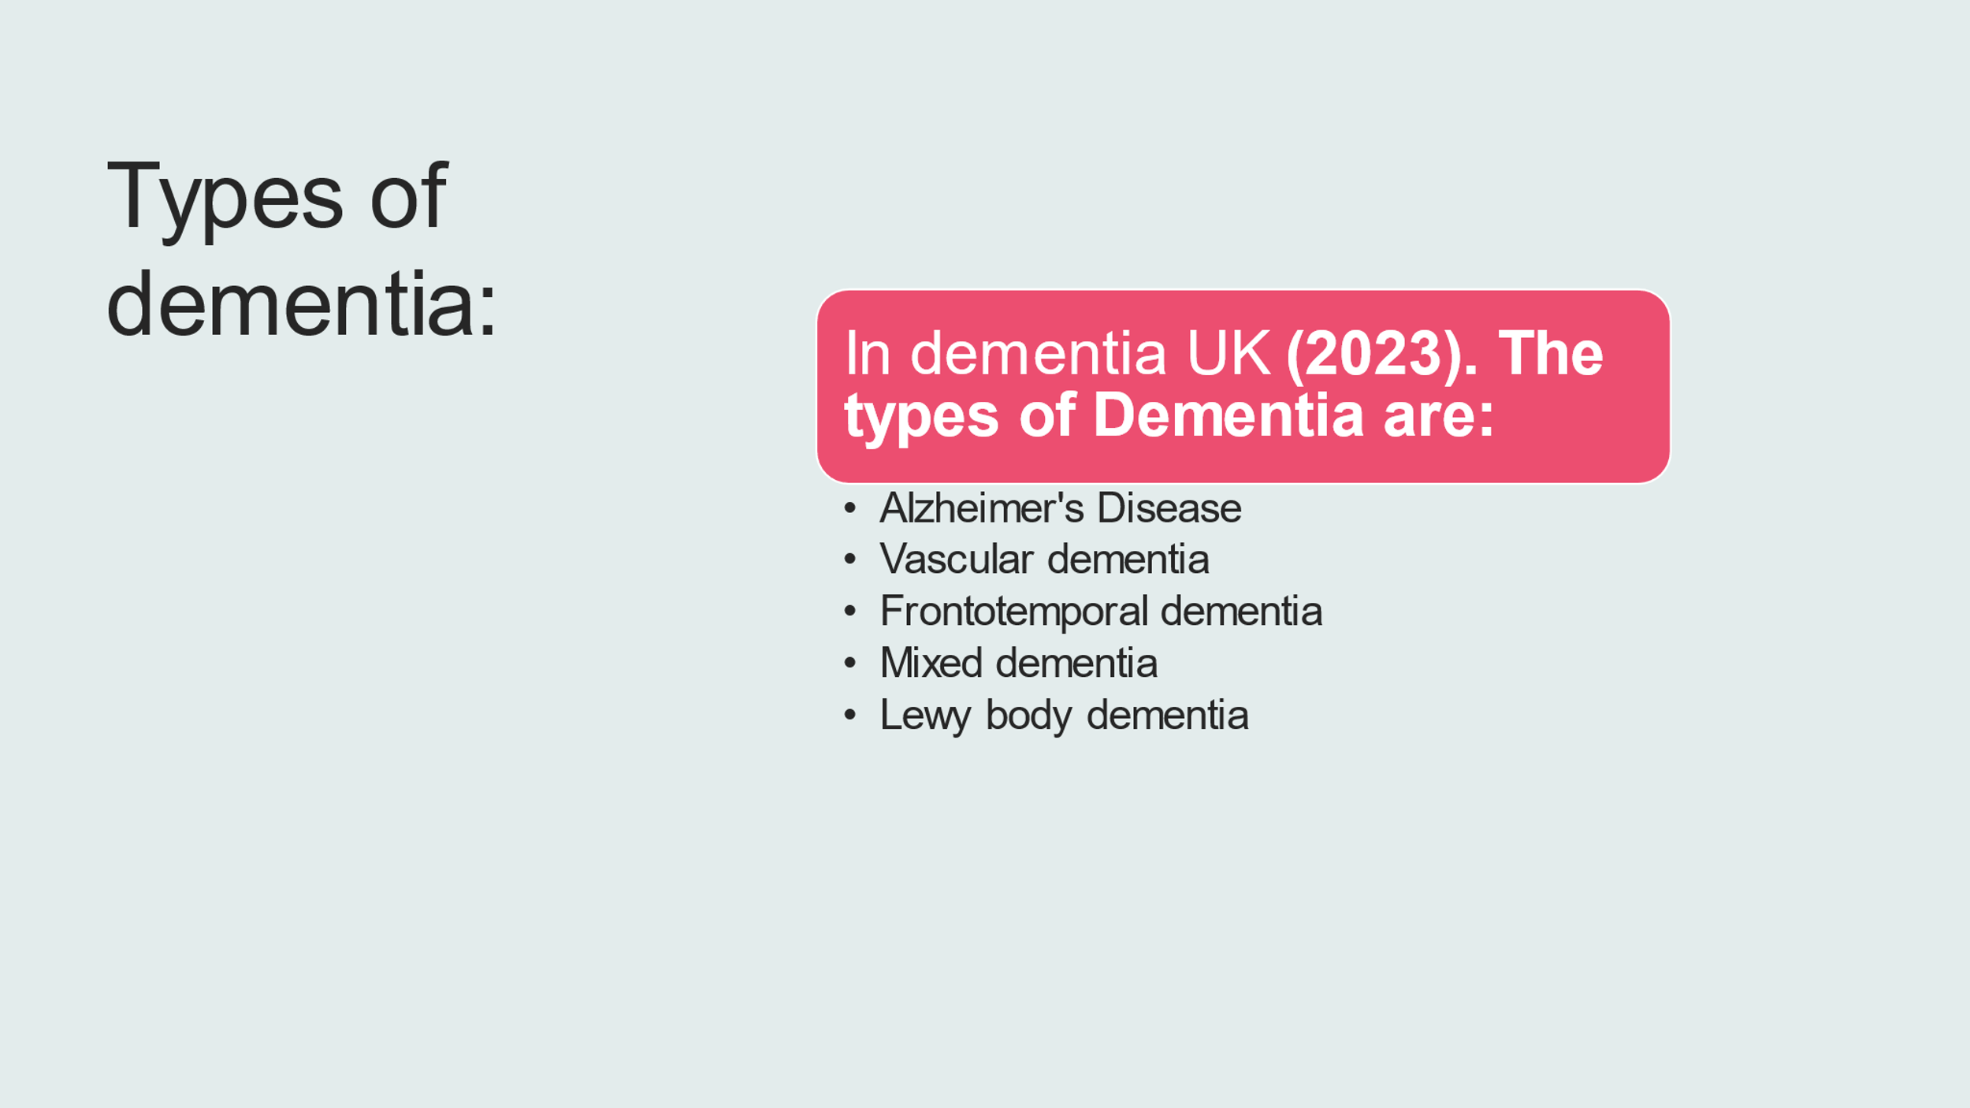

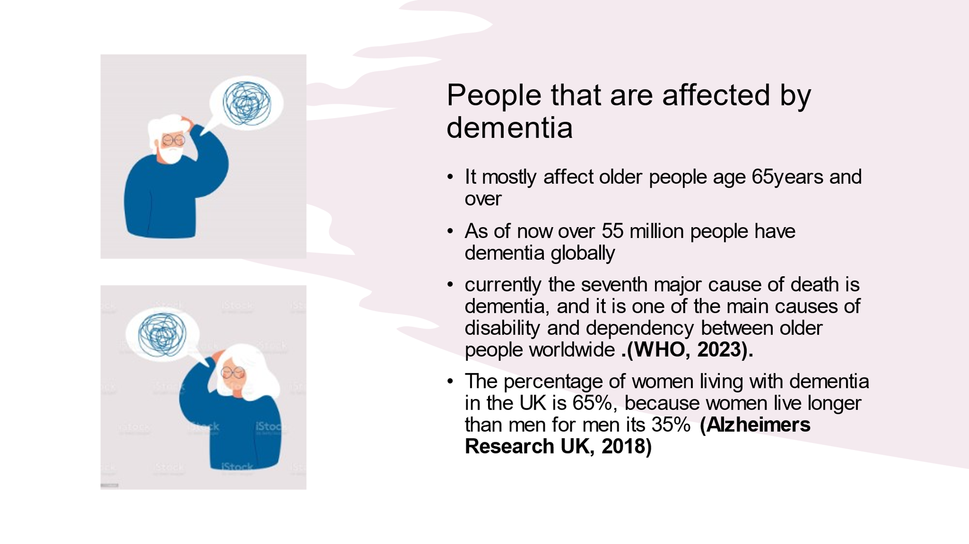

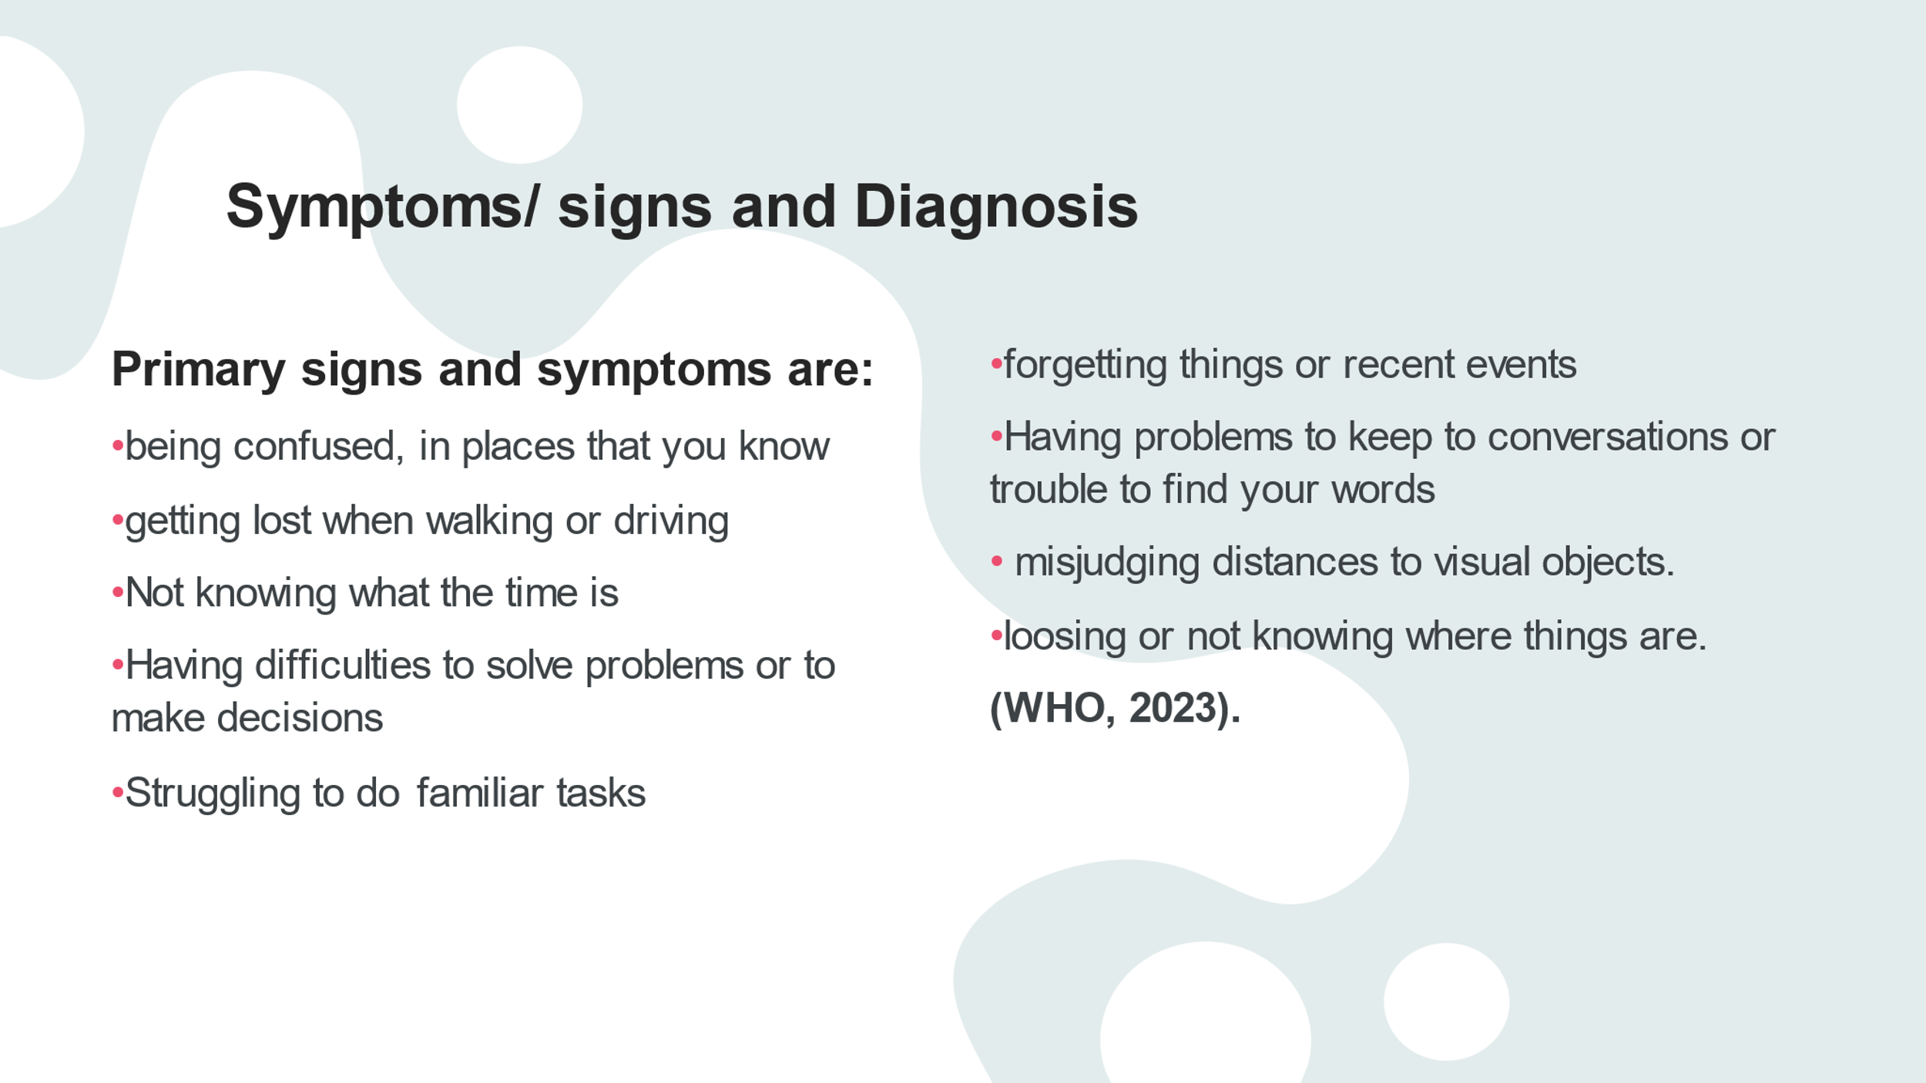

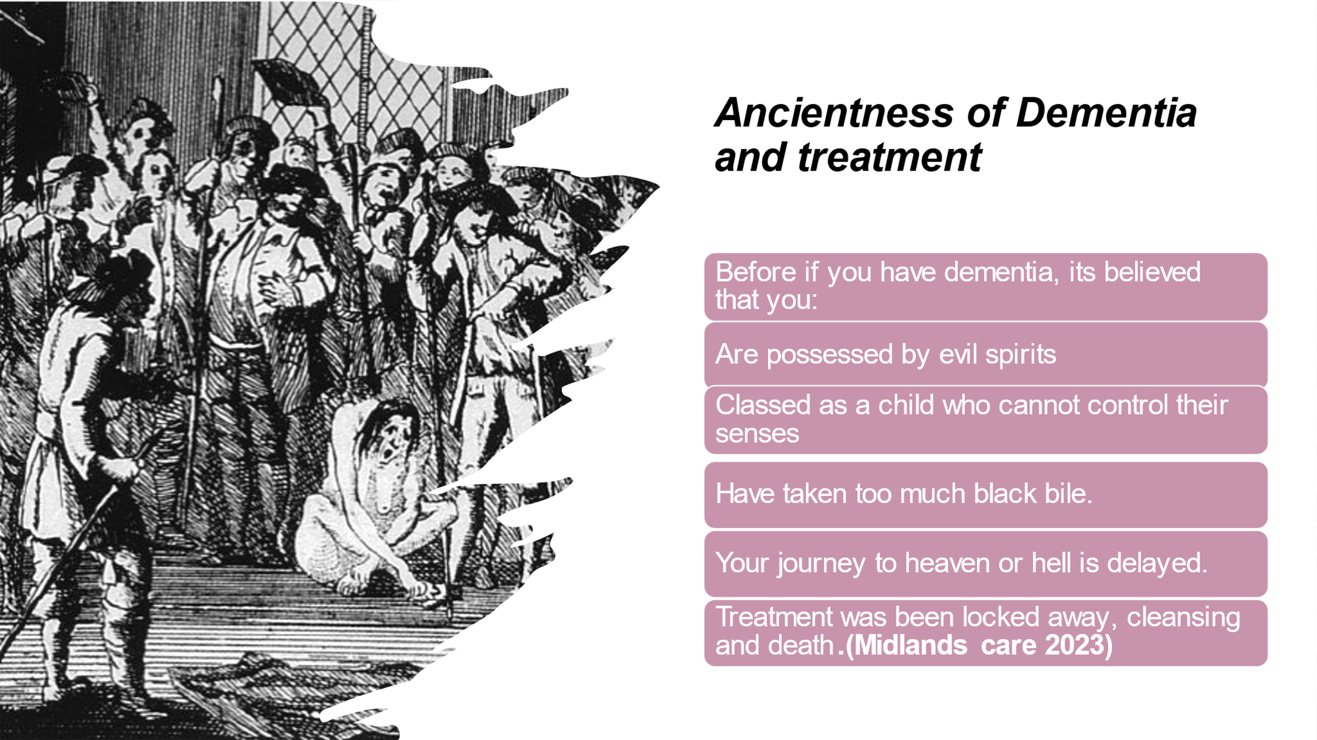

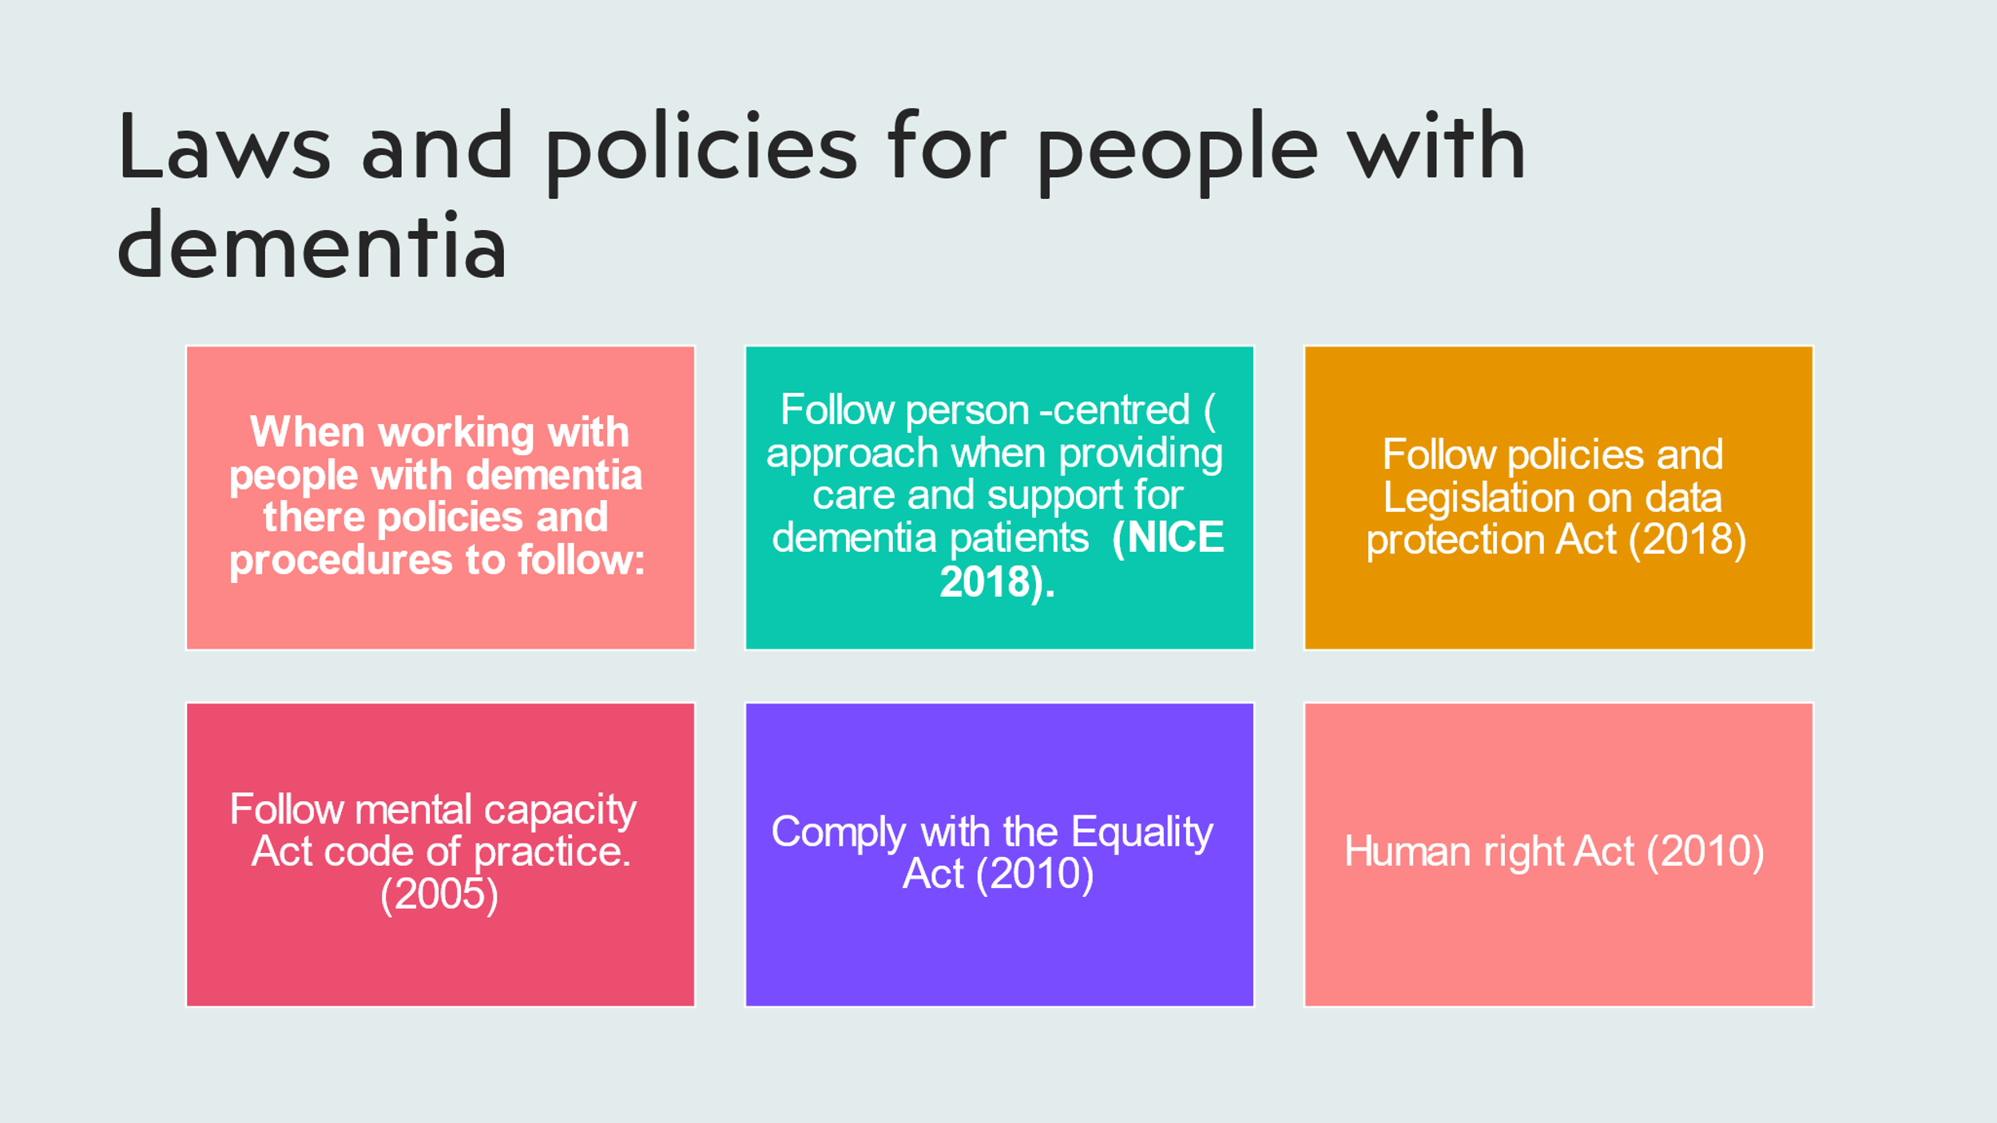

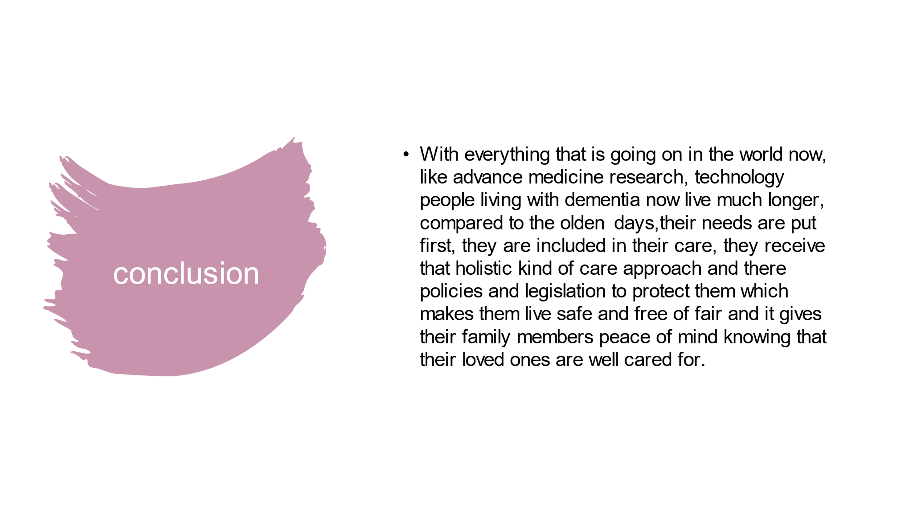

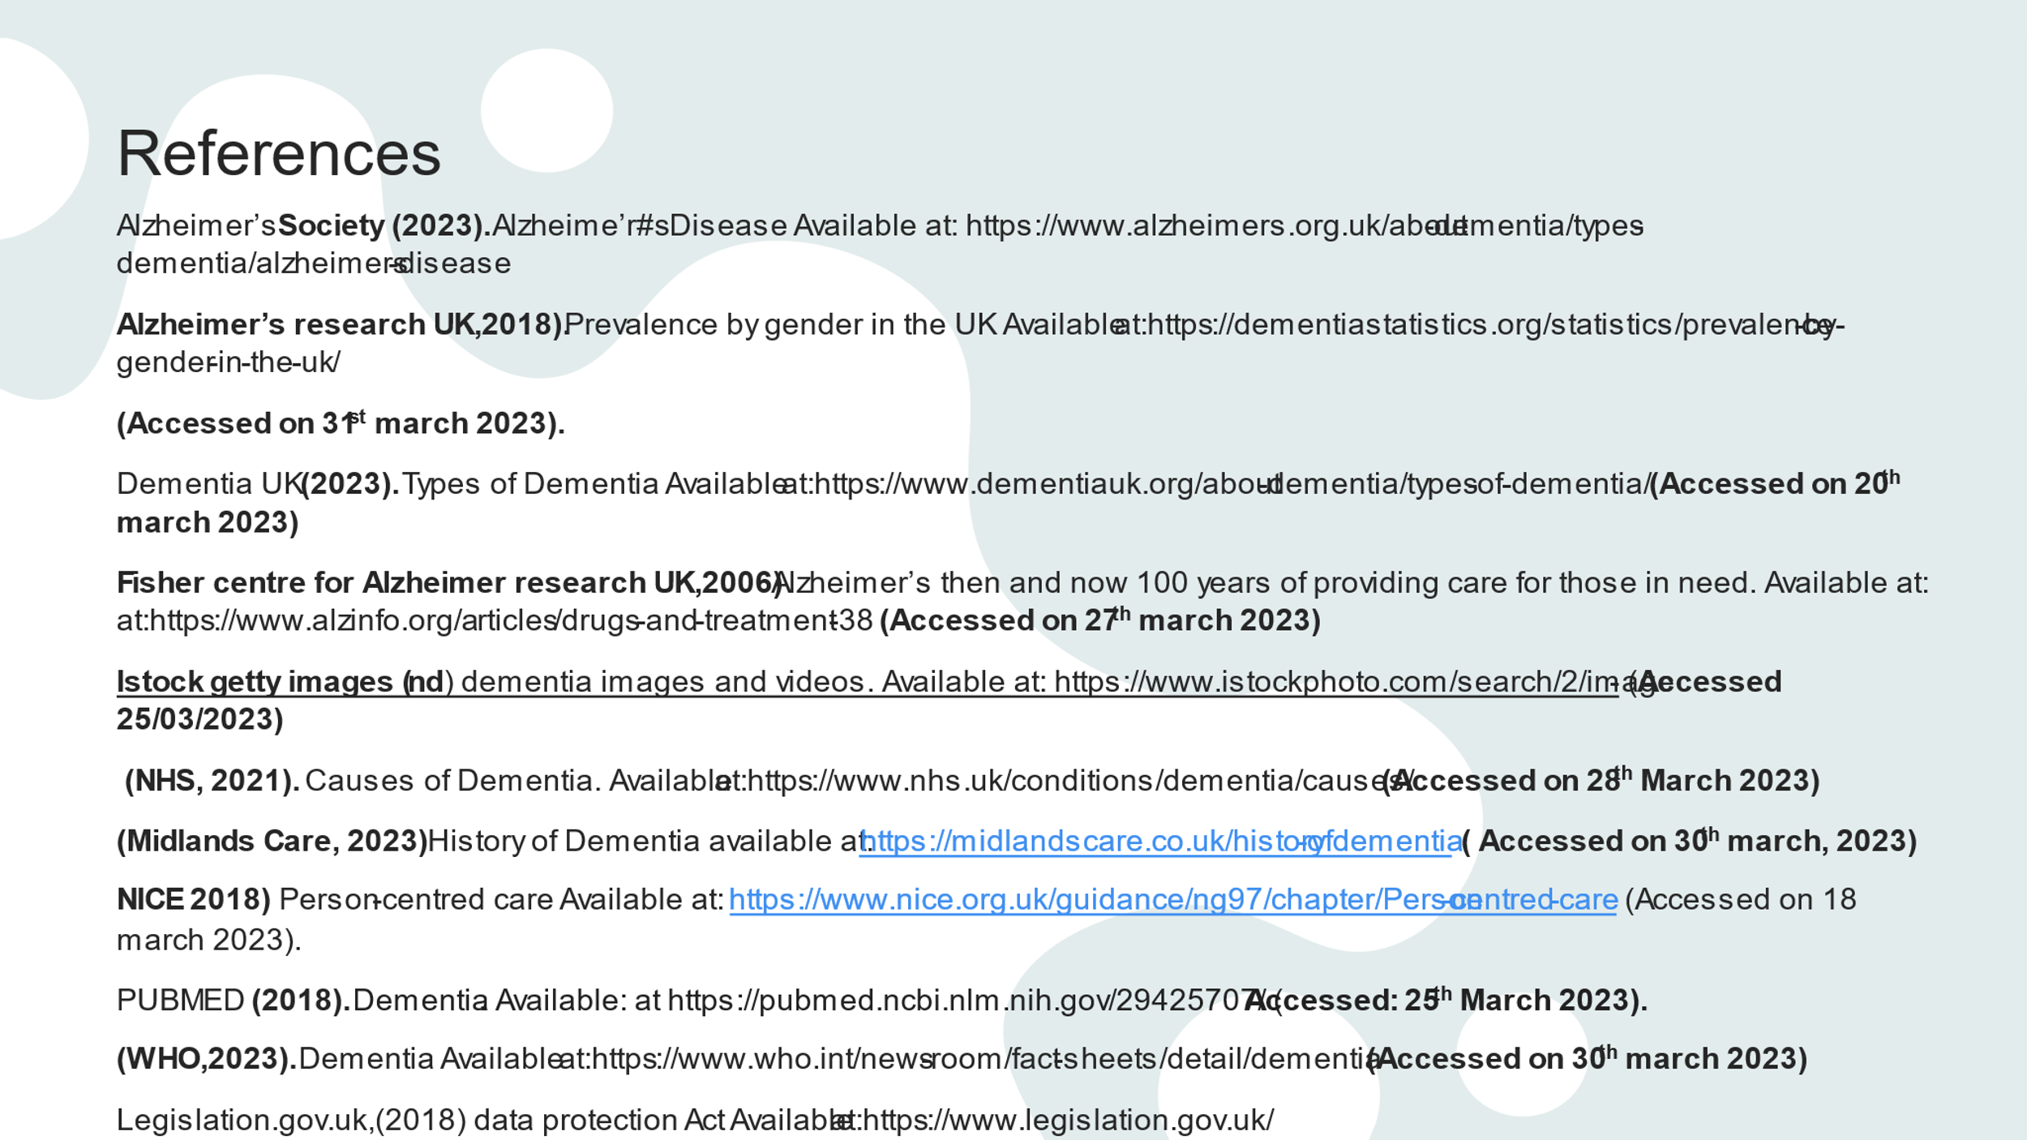
Alzeimer’s research UK (2022). Numbers of people in the UK (Available at: https://dementiastatistics.org/statistics/numbers-of-people-in-the-uk-2 (Accessed on the 20th April 2023
sation (2010) ICD-10 - International Statistical Classification of Diseases and Related Health Problems 10th Revision. Available at: https://icd.who.int/browse10/2010/en#/V NHS, (2020). How to get a dementia diagnosis Available at: https://www.nhs.uk/conditions/dementia/diagnosis/ (date (accessed:25th April 2023)
NHS, (2020). What are the treatments for dementia? Available at:https://www.nhs.uk/conditions/dementia/treatment/#:~:text=Cognitive%20stimulation%20therapy%20(CST)%20involves,language%20ability
WHO - World Health Organi (date accessed: 20th March 2023)

