Assignment 1

Table of Contents
Task 1 2
Addressing table 2
Configure the IP Address 4
Check if the connection is successful 5
Physical and Logical Topology 7
Physical 7
Logical 8

Task 1

Addressing table

Device | Interface | IP Address | Subnet Mask | Default Gateway
Laptop1 | NIC | 192.168.0.1 | 255.255.255.0 | 192.168.0.1
Wirelessrouter0 |  | 192.168.0.2 | 255.255.255.0 | 192.168.0.2
Router |  | 192.168.0.3 | 255.255.255.0 | 192.168.0.3
Pc0 | NIC | 192.168.1.1 | 255.255.255.0 | 192.168.1.1
Pc1 | NIC | 192.168.1.2 | 255.255.255.0 | 192.168.1.2
Pc2 | NIC | 192.168.1.3 | 255.255.255.0 | 192.168.1.3
Pc3 | NIC | 192.168.1.4 | 255.255.255.0 | 192.168.1.4
Server1 | NIC | 192.168.1.5 | 255.255.255.0 | 192.168.1.5

Configure the IP Address

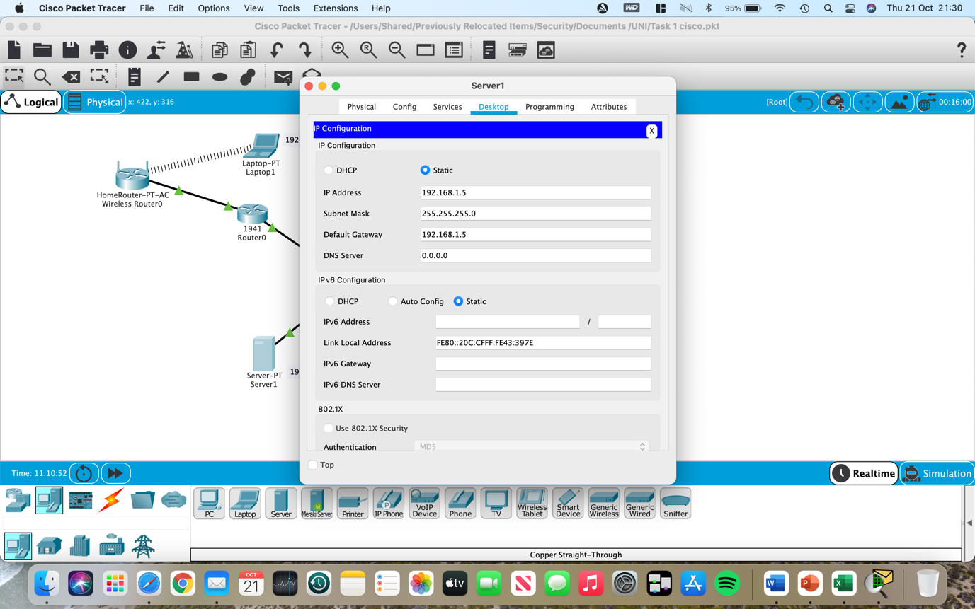

Check if the connection is successful

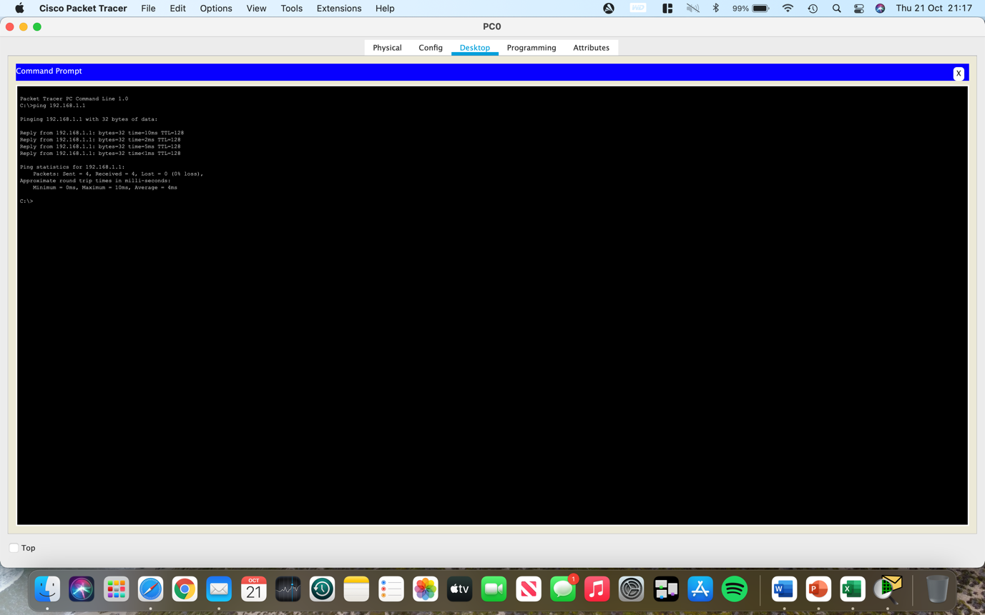
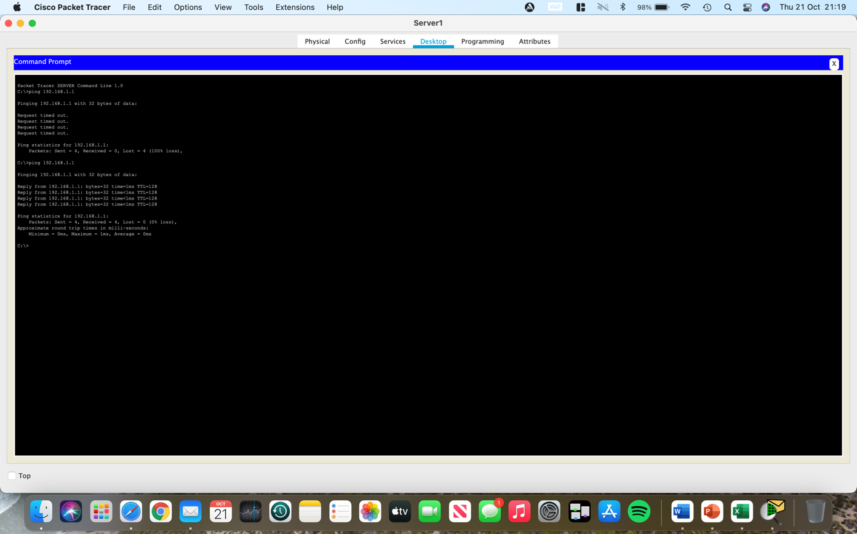
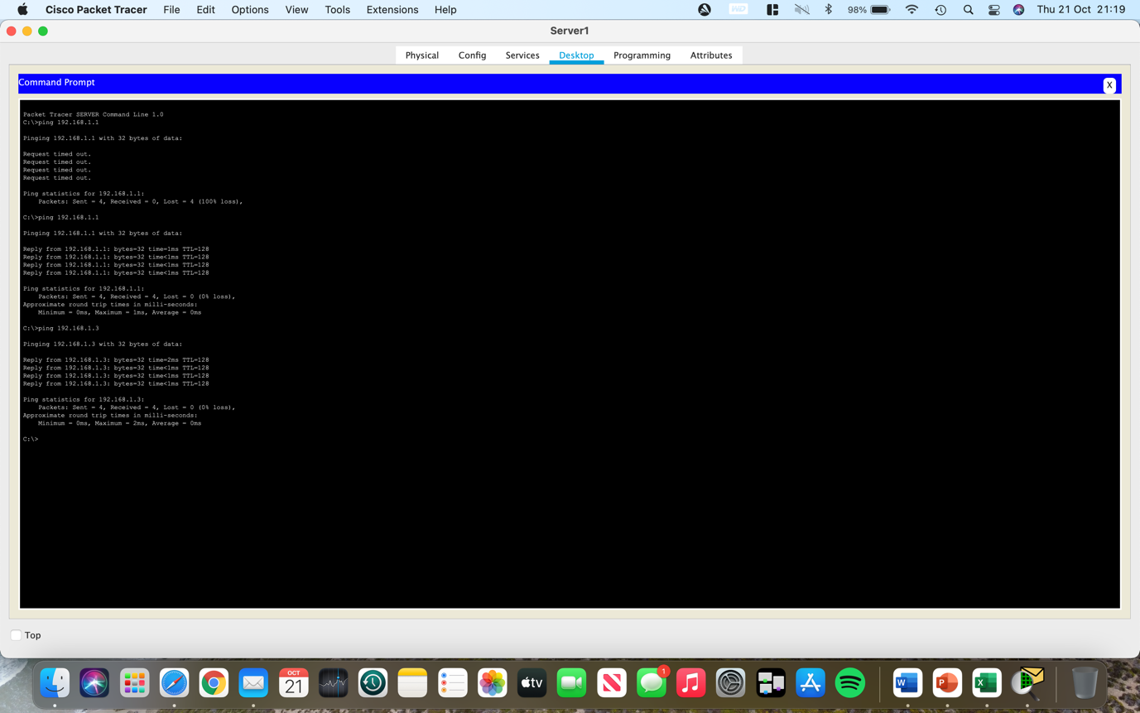

Physical and Logical Topology

Physical

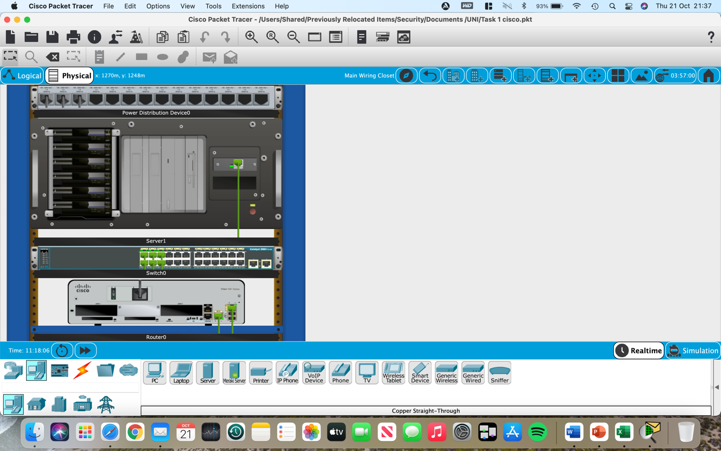

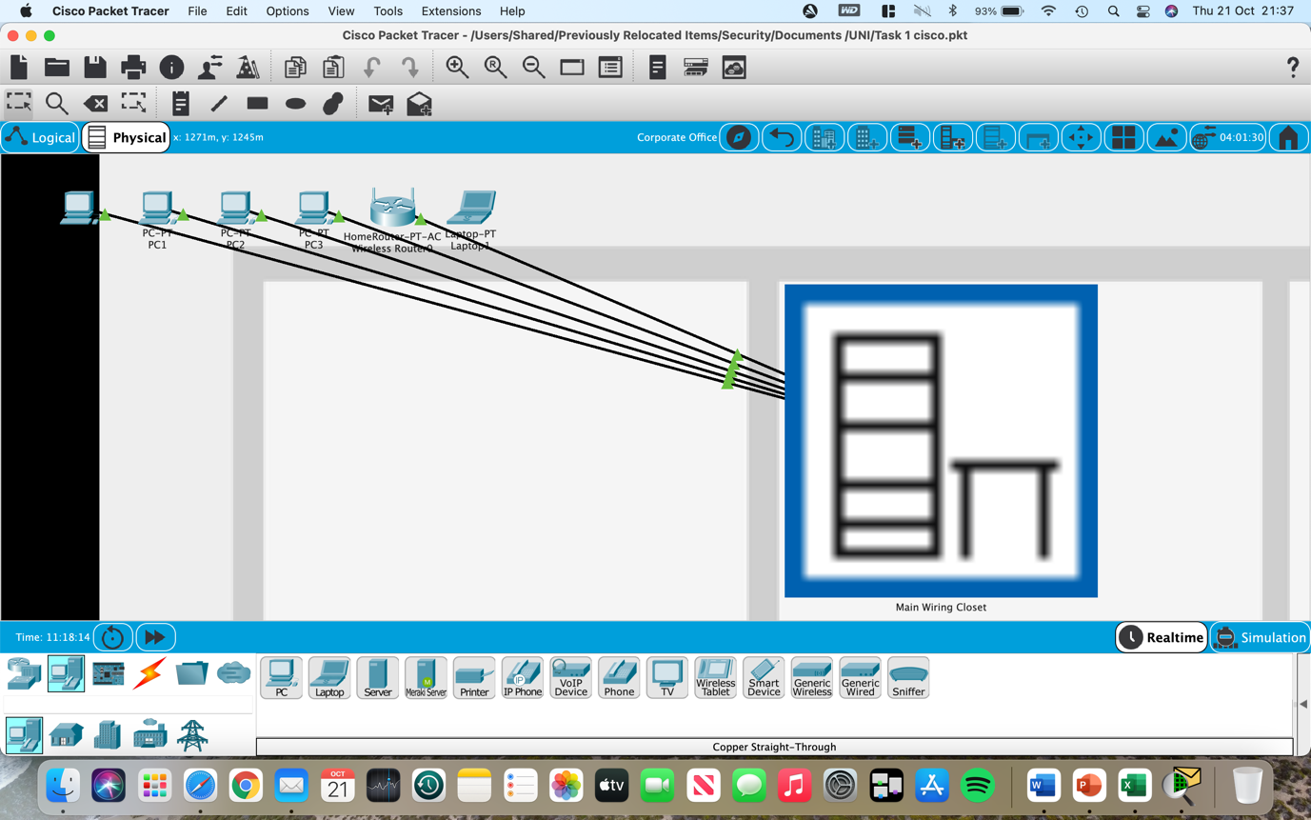

Logical



