OAT18838836 (Madison Oats)
DATE: MARCH 21 2022

HND APPLIED COMPUTING – DATA ANALYSIS & VISUALISATION
EXPERIMENTAL DATA ANALYSIS

Contents
INTRODUCTION 2
Descriptive Statistics 3
Hypothesis Testing 5

INTRODUCTION
In this report, I will be providing descriptions of different types of statistics, in relations to the data provided. I will also be declaring hypothesis, null and alternative. I will also test my hypothesis to different levels of significance. Finally, I will also be identifying outliers within the data set.

Descriptive Statistics
Within statistics, there are different ways in which you can find certain averages within a data set. Some of these are mean, mode and median.
Mean is used to find the main average, this is where you add up all the data and divide it by the quantity of numbers in the entire data set. Using the test data, I can find the mean of test scores prior and after using the app. This will allow for a better analysis regarding the improvement or regression of the students using the app. The data shows that after using the app, the average test score increased by 2.55, from 12.75 to 15.3.
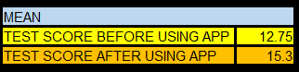

The median is when you order all numbers in a data set from lowest to highest and find which number is in the middle of the data set. The median can be more reflective of the numbers in the data set, than the average itself. Using the raw test data provided, I can identify for the median test score before and after students use this app. The result will be more descriptive than the mean.
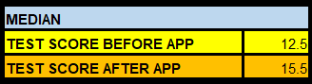

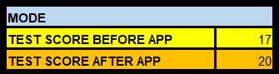
The mode is when you order all numbers from descending to ascending and identify which number appears the most within the provided data set. Using mode, I will identify that test scores that appear most, from before and after using the app. The results will then allow me to see if the mode has decreased or increased. The test score after using app is higher than prior scores, which means the mode has increased.

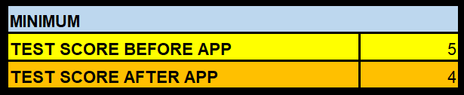
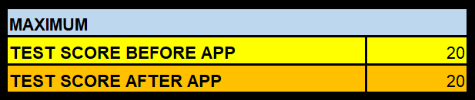
The maximum will allow me to identify what the highest mark achieved by a student, combined with minimum, which is the lowest mark achieved by a student, it gives me a broader view of how well students did before and after usage of the app. I completed tests to see what the minimum and maximum marks were, before and after using the app. The results showed that the minimum mark achieved, decreased after using the app. It also showed that the maximum mark achieved, also decreased after using the app.

Distribution is when you take a set of data and visualise the spread of the data, which can then help identify data outliers, which is removing pieces of data which are more than 2 standard divisions below the mean of the test score. For data such as this, bell curves are commonly used. A bell curve is a type of graph which the shape is like that of a bell, the peak of the curve will display the mean, mode, and median of the data set. The width of a bell curve is set by the standard deviation, to which the standard deviation is determined by the variation of results in the sample which surrounds the mean.
Using data distribution and standard deviation, I can now identify the outliers in the data set. An outlier is any data which falls beyond 2 standard deviations below the mean. Outlier data is then removed from the data set. I will be identifying the outliers from test scores before and after using the app. To identify outliers, I must find the median, the lower quartile range, and the upper quartile range. I can use formulas within excel to do so. I will first find the outliers for the test scores prior to using the app.
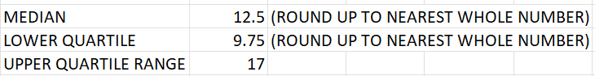

After I identified the median, lower, and upper quartile range, I was then able to identify and remove all outliers. After removing the outliers, I was left with 20 test scores.

I will now carry out the same formulas and process for the test scores of students after using the app. The median was 15.5, to make the process easier, I rounded the medium up to the nearest whole number which was 16.
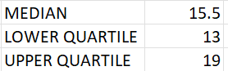
Using these results, I could identify where the outliers were and remove them. After removing the outliers, I was left with 24 test scores from the original 40. This is an improvement from the remaining 20 test scores out of 40 from before students using the app.

Hypothesis Testing
There are two kinds of hypothesis. The null hypothesis and alternative hypothesis. I will be presenting both a null and alternative hypothesis test and will be carrying out these tests to discover which one is true. A null hypothesis is when the data represents a true probability, while the alternative hypothesis is when there is chance variation, and the results of tests are of true effects.
My hypothesis is that I expect over half of the students to achieve a better test score after using the app.
My null hypothesis is that I expect more than half of the students will achieve a better test score before using the app. If this does not happen, then at least 40% of the class must achieve higher grades after using the app.
My alternative hypothesis is that I expect more than half of the students to achieve higher test scores before using the app.
For my tests, I will be using the raw data and completing observations of the test scores before and after using the app.

