Name: Easmin Khatoon
Student ID: 1711689
Learner group: 3
Lecturer: Dr Md Nazmul Hasan
Module Code: BMSK5006
Module: Knowledge and Information Management Skills for the Workplace
Assignment Title: Mid-Term Formative Assessment and End of Term Assessment

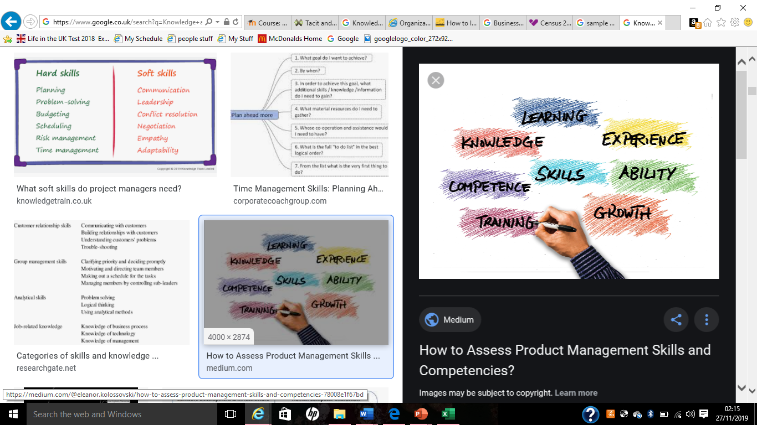

Assessment 1. Midterm formative assessment.

Question 1: Explain why the same set of data can be considered as useful information by some and useless data by others. Further, could this useful information be termed as “knowledge”? Why?
Data can be referred to the set of raw facts, figures, numbers etc which are not organized and don’t hold a complete meaning. According to the lecture slide of UWTSD (2019) ‘data are raw facts or observations that are considered to have little or no value until they have been processed and transformed into information’. For example, blue and pink colour. Where these are useless as don’t have the complete meaning or context. But if these data are processed to information that hold a complete meaning and will be useful to the others. Therefore, the information can be defined as processed data that are meaningful. For example, blue colour for boy’s birthday balloons and pink colour for girl’s birthday balloons which have a meaning and the information are useful to the users. Also, without data information it’s impossible as it won’t have complete meaning. That’s why, same set of data are useless to some but useful to others once those data are transmitted to the information. Where the data blue and pink had no complete meaning to the users before the transition to information.
Furthermore, this useful information can be termed as knowledge. Because, knowledge can be referred to the familiarity that are acquired from experience of a fact. According to Maund, A (2018) the knowledge can be acquired through various channels by an organisation can favour particular types of knowledge. As the knowledge relate to previous experiences and can be acquired through different channels that’s why the above useful information can be called as knowledge of someone or an organisation which is acquired. For example, in term of using the blue and pink colour for boy’s and girl’s birthday balloons the user acquired the knowledge of using both colours and knows which colour to use for boy’s and girl’s birthday balloons when a customer asked for, that’s why this information can be termed as knowledge.
Question 2: Describe the ways in which “knowledge” differs from “data” and “information.” Justify your answer with a relevant diagram.
The definitions of Data, Information and knowledge in the above discussion in answer 1, made it clear that the knowledge differs from data and information. However, in summary data refer to raw, information refers to meaning and knowledge refer to context. Which can be explained further by using DIKW model. According to Mikos, M, Tiwari, B, Yin, Y, Sassa, K (2017) DIKW represents the hierarchical order of particular important segments which constitute the foundation of many research and scientific activities and represents the logical array data, from information and knowledge towards wisdom. Following diagram 1 shows how the knowledge differs from data and information.

D
Data
Information
Knowledge
Wisdom
Past
Future
Raw: Blue and pink
Meaning: Blue colour for boy’s and pink colour for girl’s birthday balloons.
Context: Customer asked for boy’s birthday balloons.
Applied: Appropriate to show blue colour birthday balloons.

Diagram 1: DIKW model.

The above diagram clearly shows how Data, information, Knowledge and Wisdom are related to each other. Where the diagram shows that the knowledge is differs from the data and information. In the diagram data are raw fact which doesn’t create complete meaning by itself, but once its transmitted to the information it creates meaning for the users. Again, in the next stage the information become knowledge when its fall in a context or situation and in the last stage the user must apply the acquired knowledge which known as wisdom. Without data there will be no information and without information there will be no knowledge. Also, a person can’t obtain the knowledge about something without knowing about it which required the information about it.
Question 3: Does a player in a card game use tacit or explicit knowledge? Explain why. Define and explain the difference between the two.
In a card game a well experienced player uses tacit knowledge as the player use his/her previous experiences, assumptions and insights. Which will be clearer by the following discussion on tacit and explicit knowledge. Generally, there are two forms of knowledge such as tacit and explicit. Tacit knowledge refers to, gaining the knowledge from the perception, assumption, insights and previous experiences. And explicit knowledge refers to, gaining the knowledge from recorded documentations like books, memo, invoices etc. According to Coakes, E (2003) ‘Tacit knowledge is seen as being subjective, practical and analog. It is highly personal, hard to formalize and therefore difficult to communicate with others. Again, explicit knowledge is seen being objective, theoretical and digital. It is formal and systematic therefore can be easily communicated and shared with others.’ Furthermore, there are various differences between explicit and tacit knowledge which are presented by below table.
Explicit knowledge | Tacit knowledge
Objective, theoretical and digital | Subjective, practical and analog
Formal and systematic | Highly personal, hard to formalize
Can be easily communicated and shared with others | Difficult to communicate with others
Easy to record and document | Difficult to capture that’s why can’t be documented
Knowledge is transferable by documentations like, books, memo, services and products etc. | Knowledge is transferable by mentoring, coaching like face to face or one to one session.
Ability to teach and train others | Expertise as know how and why.

Table 1: Table of differences between explicit and tacit knowledge.
Furthermore, the dynamic theory of organizational knowledge creation by Nonaka, I (1994) shows that there are four patterns such as: socialization, combination, internalization and externalization are involved in creating the organizational knowledge through dialogue between tacit and explicit knowledge continuously. Which are presented in below figure 2 and 3. Socialization characterizes as communication between individuals via techniques such as observation, examination, or trainings. Combination represents the combining explicit knowledge via meeting, discussion, and conversation or using technology systems. In internalization explicit knowledge converted into tacit knowledge, where in externalization tacit knowledge converted into explicit knowledge.

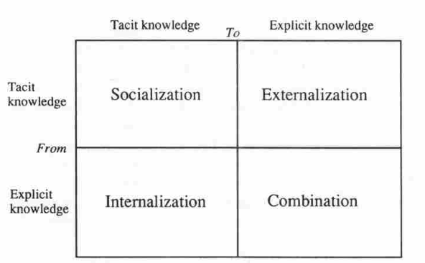

Figure 2: Modes of knowledge creation. Source Nonaka, I (1994).

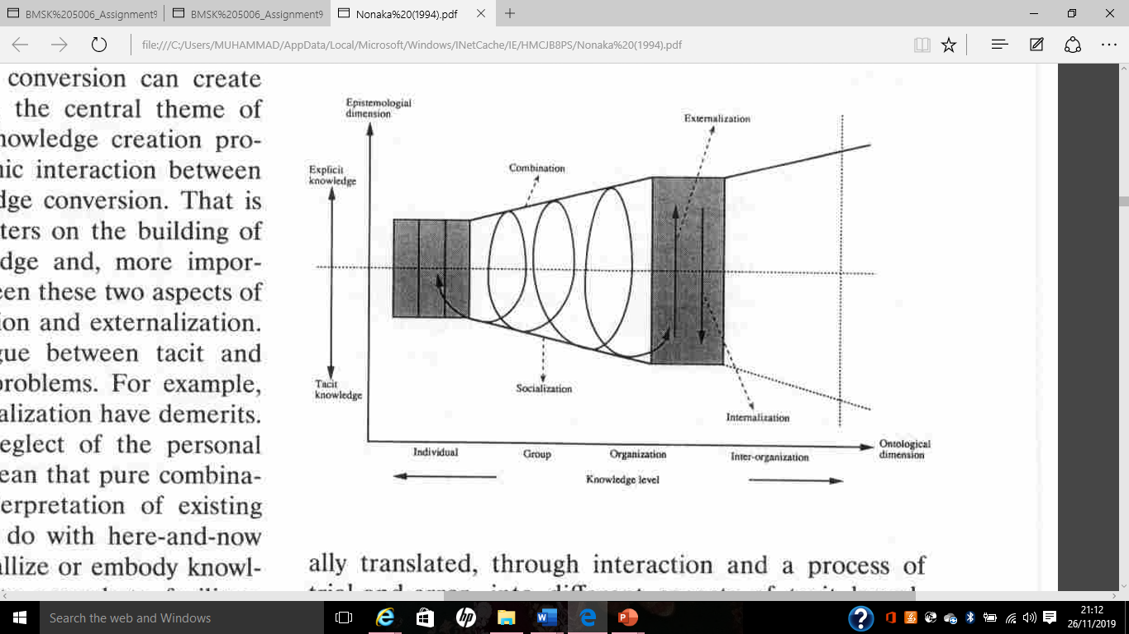

Figure 3: Spiral of organization knowledge creation. Source Nonaka, I (1994).
So, the above discussion made it clear that an experienced player in the card game use the tacit knowledge because the player uses previous experiences, assumption and practice, also being expertise as know how and why. Again, a none experience player uses explicit knowledge as the player plays by using the rules of books.
Question 4: Consider five decisions you have made today (they could be simple such as taking a turn while driving or even choosing a soda at a convenience store). In each case determine the data, information, or knowledge that were involved in the decision.
When we make decision, we always use data, information or our knowledge. Following are the five decisions that I have made today by using available data, information or my knowledge.
1. I took my house bins out and kept in the designated area for tomorrow collection. In here I have used the information provided by the council that every Wednesday they will collect the bins. Also, I have used my knowledge that time is not fixed when they come to collect the bins, where usually bins are being collected anytime between 5am to 12pm, therefore I have decided to put the bins in the designated are on Tuesday night.
2. I dropped my kids off to the school today before 8.45am. In here I have used the information provided by school that my kids need to be in the class by 8.45am. That’s why I had to decide to leave the house at 8.20am for avoiding the lateness. Also, I have used my knowledge of facing too much traffic at this hour.
3. I bought a pair of shoes for my son. Where I have used my knowledge of his feet size junior 10. Also, I have used the data and information written on the shoes label to choose the correct size and good quality.
4. I cooked curry today and used appropriate ingredients. Where I have used my knowledge of cooking for which and how much ingredients need to be added in the curry. I also used the information on the packaging to choose the right ingredients.
5. I have bought green apple today for my home. I have decided to buy the green apple because I know in my house everybody likes green apple rather than the red apple. I also used the information in the packaging to check the price, out of date and quantity.

Question 5: Now consider how those decisions would have been influenced by the lack of pre-existing data, information, or knowledge.
In general, we always use data, information and our knowledge before making any decision in our daily life, where an organisation does the same. That’s why pre-existing data, information and knowledge are crucial for a successful decision-making process either in personal life or for an organisation. According to Murugan, A. Asokan, A. Srinivasan A. C. (2012) Information become vital for the organization’s continuity and growth, where the organisation must effectively utilize the intangible resources like, data, information and knowledge. Now, if we look at the above 5 decisions where in every single decision information and knowledge are involve. All those decisions would be influenced negatively Without those information and knowledge and I would have been confused what to do for every decision. For example, if the council didn’t provide me the information when the bins will be collected, it would be very difficult for me to find out the day for bins collection and I would of waste my time to find out. Similarly, if the school didn’t provide me the time my kids would end up being late for the class or too early. Again, without knowing the right size of my son’s shoes and without the information label on the shoes I would buy the wrong size or wrong shoes. And if I didn’t have the knowledge of cooking and lack of information on the packaging for the ingredients, I would have used the wrong ingredients or wrong amount in the curry. Also, if I didn’t know that everyone in my family likes green apple I would have bought the red apple which mean wasting the money and if there was no price written on the packet I would have confused in term of the price. That’s why pre existing information is crucial for a successful decision making.
Question 6: You have recently invented a new product. Collect demographic data from a sample population, determine how you would use this data, and convert it into information and possibly knowledge for promoting the product.

To promote a new product, it is necessary to know the market, where it is crucial to segment the market. In here to answer this question, I will promote my new product handmade soft toys, which are suitable for children’s age between 1 to 4 years old in the consumer market. The following table represents the demographic data of Ladywood Constituency (Birmingham city council 2011) and the data was taken that are relevant to promote the product.

 |  | England |  | Birmingham |  | Ladywood constituency
 |  | percent |  | number | percent | number | percent
Age groups | 0-4 Years | 6.3 |  | 81,901 | 7.6 | 10,741 | 8.5
Age groups | 5-15 Years | 12.6 |  | 162,781 | 15.2 | 18,993 | 15.0
Age groups | 16-17 Years | 2.5 |  | 29,453 | 2.7 | 3,154 | 2.5
Age groups | 18-19 Years | 2.6 |  | 36,063 | 3.4 | 5,657 | 4.5
Age groups | 20-24 Years | 6.8 |  | 93,914 | 8.8 | 18,171 | 14.3
Age groups | 25-44 Years | 27.5 |  | 308,259 | 28.7 | 43,131 | 34.0
Age groups | 45-64 Years | 25.4 |  | 222,461 | 20.7 | 17,989 | 14.2
Age groups | 65-74 Years | 8.6 |  | 70,102 | 6.5 | 4,763 | 3.8
Age groups | 75-84 Years | 5.5 |  | 49,043 | 4.6 | 3,188 | 2.5
Age groups | 85-89 | 1.5 |  | 12,656 | 1.2 | 613 | 0.5
Age groups | 90+ | 0.8 |  | 6,412 | 0.6 | 293 | 0.2
Ethnic group | White British | 79.8 |  | 570,217 | 53.1 | 27,041 | 21.3
Ethnic group | White Irish | 1.0 |  | 22,021 | 2.1 | 1,673 | 1.3
Ethnic group | White Other | 4.7 |  | 29,398 | 2.7 | 5,914 | 4.7
Ethnic group | Mixed/Multiple ethnic groups | 2.3 |  | 47,605 | 4.4 | 7,478 | 5.9
Ethnic group | Asian - Indian | 2.6 |  | 64,621 | 6.0 | 12,799 | 10.1
Ethnic group | Asian - Pakistani | 2.1 |  | 144,627 | 13.5 | 19,484 | 15.4
Ethnic group | Asian - Bangladeshi | 0.8 |  | 32,532 | 3.0 | 9,244 | 7.3
Ethnic group | Asian Chinese | 0.7 |  | 12,712 | 1.2 | 4,391 | 3.5
Ethnic group | Black African | 1.8 |  | 29,991 | 2.8 | 10,092 | 8.0
Ethnic group | Black Caribbean | 1.1 |  | 47,641 | 4.4 | 12,572 | 9.9
Ethnic group | Other ethnic group | 3.1 |  | 71,680 | 6.7 | 16,005 | 12.6
Religion | Christian | 59.4 |  | 494,358 | 46.1 | 41,217 | 32.5
Religion | Muslim | 5.0 |  | 234,411 | 21.8 | 44,626 | 35.2
Religion | Sikh | 0.8 |  | 32,376 | 3.0 | 5,411 | 4.3
Religion | Hindu | 1.5 |  | 22,362 | 2.1 | 4,227 | 3.3
Religion | Other | 1.4 |  | 12,631 | 1.2 | 2,264 | 1.8
Religion | No Religion | 24.7 |  | 206,821 | 19.3 | 20,019 | 15.8
Religion | Question not answered | 7.2 |  | 70,086 | 6.5 | 8,929 | 7.0

Table 2; Table of demographic data of Ladywood Constituency (Birmingham city council 2011).

From above table the data that can be used need to transform into the information than knowledge. In the constituency 10741 people are age between 0-4 years old there for the target market is 10741, diverse ethnic group there for the toys can not represent a single diverse group, also the constituency consist of various religion that’s why the toys should not represents a specific religious view. By taking consideration of these data the product can be promoted in the Ladywood Constituency

References:
- Birmingham city council (2011), Census 2011 population and migration profile for wards and constituencies in Birmingham, https://www.birmingham.gov.uk/downloads/file/4616/census_2011_population_profile_for_small_areas_in_birminghamxls. Last access on 27/11/2019/
- Coakes, E (2003), Knowledge Management: Current Issues and Challenges, Idea Group Inc.
- Maund, A (2018), BA in leadership and management. Skills for the workplace student yearbook, 1st year. SAGE publications Ltd.
- Mikos, M, Tiwari, B, Yin, Y, Sassa, K (2017), Advancing Culture of Living with Landslides: Volume 2 Advances in Landslide Science. Springer 2017.
- Murugan, A. Asokan, A. Srinivasan A. C. (2012), Business Intelligence Techniques: A Perspective from Accounting and Finance, Springer Science & Business Media, 2012.
- Nonaka, I (1994), A dynamic theory of organisational knowledge creation. The Institute of management science. Vol.5 no.1. February 1994.
- UWTSD (2019), Lecture slides for the course: Knowledge and Information Management Skills for the Workplace, BMSK5006, week 1, session 1.

Assessment 2. End of Term Assessment
Part 1; case study.
Question 1: Describe how the overall approach adopted by American Airlines incorporated the basic competitive strategies of cost leadership and product differentiation
A business organisation always wants to take advantages over rivalry as many ways possible. To help the business organisation to find its possible competitive strategies in Michael E. Porter introduced three strategies that a business can attain for competitive advantages over competitors such as: Overall cost leadership, differentiation, and focus (Neil, B. John, M. 1999). Following figure 1.1 represents the Porter’s competitive strategies graphically.

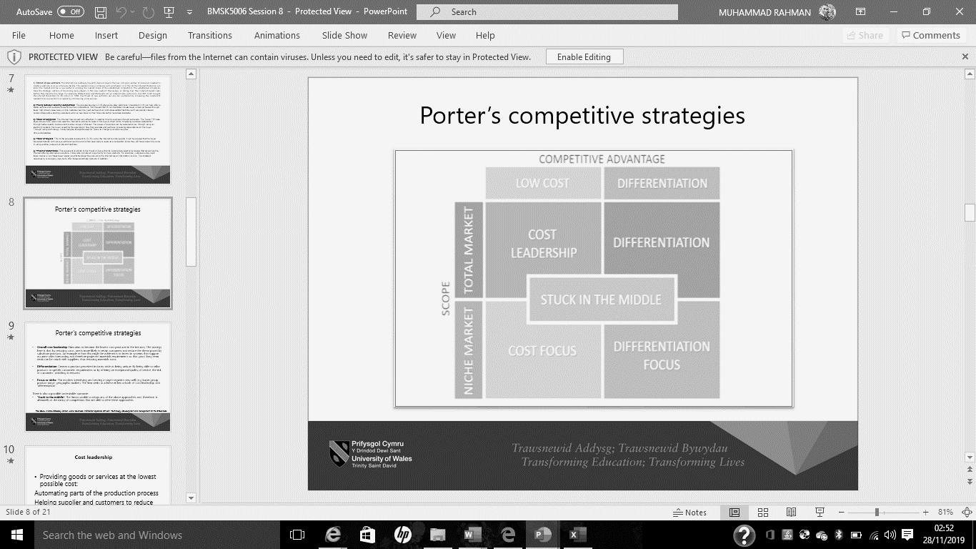

Figure 1.1: Porter’s competitive strategies. Source, UWTSD (2019).
In here the American airlines company was able to reduce the cost and differentiate the production which provided the company competitive advantages over its competitors. So, the company approached to the strategies such as: Cost leadership and differentiation.
- Cost leadership: Company wants to reduce the cost by reducing the price of production like raw material by buying a bulk amount, where they can offer a low price to the customer than its competitors. In the case study American airlines was able to save 30% of its investment by reducing the cost of making seat reservation. Where, reducing the cost provide the company the opportunity to offer a low price to the customer than its competitors.
- Differentiation: Firm creates a unique product that is different from the competitors where the firm can offer exceptional quality product or service that exceeds the customer demands. In here the American airline was able to offer customer other service like finding low price, hotel booking, and rental cars exceeded the customer demand that’s why the company service was unique than its competitors.

Question 2: In what ways did SABRE provide American Airlines with a competitive advantage? Your analysis should refer to concepts related to the strategic use of information systems, for example, entry barriers.
The concept of information systems opens the door for business firm to be more effective and efficiency in term of cost and product quality. To find out how the SABRE provide American airline a competitive advantage it is essential to analyse the Porter’s five forces. Where the concept of information system also create impact on the porter’s five forces such as:
The threat of new entrants: The risk of new entry always there in the industry where the existing firms are may not aware of someone planning to invest money in the industry. But the risk can be reduced by investing money heavily in IT. Because, if the new entrance sees the start-up cost is too high it will prevent them from investing.
Threat of substitutes: In the industry all the firms aim to prevent the advantages of providing alternative product by its competitors to the customers. By making the product special, unique a firm can prevent the treat of substitutes. Where technology allow the rapid differentiate of the product form its competitors.
The power of buyers: The power of buyers is high if the industry is dominated by a small number of customers. That why a firm should increase the number of customer available to sell the product and services. By using the information system and technologies a firm can increase the number of customers by selling the product and services online.
The power of suppliers: The power of suppliers will be high if there is less suppliers available where the supplier may charge extra price and provide low quality. That’s increasing the number of suppliers will give the opportunity to the firm to bargain over the price and choose high quality. Investing in information system will provide the opportunity to the firm to broaden the available suppliers there for low price and batter quality,
Rivalry between existing competitors: Customer will always look for low price and quality product and services. That’s why investing in information technology will allow the firm to provide batter quality and services than its competitors.
Now, the concept led to the 1st real-time business application by SABRE provided the competitive advantages such as:
- Reduced the risk of new entrance by creating barriers. Because, new investment cost would be higher than normal as American airline invested money on the new invented application which was widely accepted by the customers. For a new company the investment cost would be very high as extra money need to be invested to compete against the technology invented by American airline and SABRE.
- SABRE also reduced the treat of substitute as differentiated the product from other firms. Where the competitors need to invest high amount money to reach the same place as American air line.
- It also reduced the bargaining power of customer as the company was able reduce the domination of small amount of customer in the industry by offering online ticket reservation.
- It also provided advantages over existing rivalry as the company was able to offer low price by reducing the 30% investment cost.
Question 3: Although SABRE was undoubtedly successful, American Airlines was not able to maintain its competitive advantage beyond the late 1980s. What factors played a part in the erosion of the company’s lead over its competitors and how did the company react?
According to Marcella, R. Lily W. N. and Isaac, O. (2013) The challenges facing by airline industry players such as; Product Innovation by the Supplier, Fragility’ in Reputation, Powerful Customers, Intense Competition, Increased Costs. In here the American company couldn’t maintain the competitive advantages because of those external factors affected the company operations. Where factors like technology and innovation doesn’t remain always same rather it is changeable as the new technology and innovation being introduced regularly. Once new application come out the old application become infamous to the users. Like once iPhone 4/5 was very famous but upgraded version of 6/7 put the previous version demand down. Same way once the American company invented the application for ticket reservation its competitors were investing money to bring more competitive application in the industry. That’s why the external factors like technology played a vital role that the company couldn’t keep hold on its advantages.
Also, power of customer plays vital role for a firm’s success in the industry. Because, the customers have the choice to stay with the company or chose others company’s product in a highly competitive industry. When the rivals of American airlines attracted the customer through batter product and services the company couldn’t maintain its position in the industry as a player. So, the intense competition was increased that’s why the company lost its position in the industry. Furthermore, increasing cost also played a significant role as the price of fuel was increasing, cost of labour was increasing, and security measure also put the company to lose it position in the industry.
Part 2: Information System:
Question 1; Define an information System:
Information system can be defined as appliance or software that helps an organisation to organize, analyse and control the organizational information for the purpose of helping the managers to make strategic plan. According to Bagad, V.S. (2008) information system is defined as group of elements organized with the purpose of supporting management and operational decision making. For example: transaction processing system, database management system, data recording in the computer etc.
Question 2: Describe the categories of computer-based information systems, providing relevant business examples for each category identified;
According to Bocij, P. Greasley, A. Hickie, S. (2008), information systems are commonly divided in to two broad categories: operations information systems and management information system and these broad categories can be sub divided in to number of additional categories which are shown in below table 2.1, which also identified the six categories of computer based information system.
Operations information systems | Management information systems
Transaction processing systems | Decision support systems
Process control systems | Information reporting systems
Office automation systems | Executive information systems

Table 2.1: Categories of computer-based information systems.
Transaction processing systems: A set of information that involve in processing the data related to transaction including collecting, modifying and retrieving all the data transaction in a business organisation. These systems are useful for online buying and selling like. Amazon and eBay.
Process control systems: A set of information that involve in monitoring the industrial process or production through monitoring the variable like, pressure, temperature, timing etc. This system is useful for the organisation involve in production. Like: Heinz Ketchup producing using machine.
Office automation systems: It involve with communication technology and help to perform official or administrative task like writing letter, memo, sending massage and email etc. Like; most of the organisation use Microsoft word, email, excel and Power point for the communication purpose.
Decision support systems: These systems provide information for making the decision where the users or managers use the data and information that are stored electronically. Like; Bank manager check a person’s credit history to make decision on loan or credit card application.
Information reporting systems: A set of web-based information systems that provide information to the users in the form of statement or report. This system is useful for the organisation for providing quote, pricing etc. Like: Energy company provide the quote depending on the user circumstances.
Executive information systems: These systems are involved with giving the key information to the executive managers for the decision-making purpose. By providing then information in graphs, chart, table etc. Like; are managers of McDonald’s may see the net sales for the day of each branch instead of checking hourly sales for each branch to make any decision.
Question 3. Explain how computer-based information systems can support managers at each level of an organisation.
Computer based information systems support each level of managers to complete the task effectively. Each category computer-based information systems support different level of managers. Which are presented in the following figure 2.1, where in the pyramid six categories of computer-based systems are presented that support the level of management are presented on left hand side next to each category.
Executive information systems
Executive information systems
Information reporting systems and Decision support systems
Office automation systems and Process control systems
Transaction processing systems
Executives
Senior Managers
Middle Managers
Lower level managers/workers
Figure 2.1; Six categories of computer-based systems that support different level of management.
So, the transaction processing system support the workers/lower level managers to make bills, record day to day sales, inventory control etc. Similarly, middle level managers get support with the system of office automation to complete administrative task and process control system to set programming in the machine for production. Also, at senior level of management information reporting systems support to make decision by analysing information available like estimate, quotation, pricing etc. and decision support systems help by providing trends or likely to be for making the decision. At last, executives’ officers get the support through executive information system like key information or points to make the decision.

References:
- Bagad, V.S. (2008), Management Information Systems, Technical Publications, 2008
- Bocij, P. Greasley, A. Hickie, S. (2008), Business Information Systems: Technology, Development and Management. Pearson Education.
- Marcella, R. Lily W. N. and Isaac, O. (2013), Key Success Factors in Airlines: Overcoming the Challenges, European Journal of Business and Management Vol.5, No.30.
- Neil, B. John, M. (1999), Competitive Strategies for Service Organizations, Purdue University Press.
- UWTSD (2019), Lecture slides for the course: Knowledge and Information Management Skills for the Workplace, BMSK5006, week 8, session 16.

