MANAGEMENT IN practise
M5X02110
Alicia Hiles
1707152

Executive Summary
A 5000 word report will produced on the London Dungeons stating their managerial effectiveness and organisational performances of the business. The following task is to complete an environmental analysis and a performance management audit, research is key and will be thought about throughout and descriptive writing will be presented.

Table of Contents
Executive Summary 1
Introduction 3
Enviroemntal Analysis 4
PESTLE ANALYSIS 4
SWOT ANALYSIS 6
Ratios 9
Analysis and Key Performance Indicators 9
SMART objectives 13
Human Rescources 14
Reference List 18
Appendix 19

Introduction

In this report, it’s required to show an understanding of the business and what they do. A PESTLE and SWOT analysis will be made to suggest what both the internal and external risks they are currently facing. Also a performance management audit will be undertaken, meaning an evaluation of the effectiveness of current human resources and management systems will be looked upon and will be compared to Merlin Entertainments systems and what they expect off individuals. Finally, an evaluation to see whether the London Dungeons/Merlin Entertainments is successful by assessing their profit and loss account from previous years, this will help gain an understanding as of how well they are doing as a big company.

Environmental Analysis

PESTLE ANALYSIS

Political | Economic | Social | Technological | Legal | Environmental
Brexit  Government policies | Inflation Rate  Foreign exchange rate | Demographics and skill level of population  Structure in society  Culture  Leisure interests | Recent technological developments by competitors  Technology’s impact on product offering | Companies policies- safety standards  Government policies | Weather  Climate change

Political Factors determine the extent to which a government may affect the economy, for an example Brexit at the moment has a huge political impact as it can impact the performance in not only London Dungeons but the rest of the Merlin Entertainments attractions, for example the pound isn't so good at the moment meaning that tourists are getting more for their money by coming here, According to the Association of Leading Visitor Attractions (ALVA) in 2016 when Brexit first started happening the “visitor figures to UK attractions had increased — by 7.2 per cent” although it means it more expensive for us Britain's to go away which can be a negative and positive impacts. The negative is that Merlin Entertainments may not be getting the numbers they want and will decrease in their other attractions outside the UK. But the attractions in the UK will be benefiting as people won’t be able to afford going away so they’ll stay in the UK and more than likely visit attractions.
It’s important to follow government policies as they are put in place to achieve rational outcomes. In 2010 GOV stated that “Tourism is one of the UK’s biggest industries. It helps to create wealth and jobs throughout the country and can bring new life to run-down communities” and also stated that “we are also removing unnecessary rules that make it more difficult or expensive for tourism businesses to grow”. This was very beneficial for companies like Merlin Entertainments.

Economic factors conclude an economy’s performance that affects the company. A company like merlin entertainments have many factors to think about including: the economy, demand and supply (inflation, wages, interest rates, and exchange rates). It is believed by Parkin, M (1978) that “inflation: its causes, consequences and cures”, meaning it could be that demand is growing faster that aggregate supply which the price of demands and supply can become more than average. At the moment it has currently gone up 1.8% in the last 12 months, meaning that the price of goods and services has gone up overtime, this could be off putting for tourists as they can see things will be slightly more expensive as there are more demands and supplies. A rise in the inflation rate of any economy would affect the way businesses’ price their products and services and would affect the demands/supplies model for the economy.
At the moment the foreign exchange rate is bad for us Britain's but good for any inbound tourists that want to visit the UK. For people in the EU changing money- £100= 115 euro 100 euro= £86.30, this is actually quite a pretty good rate.
Social- Structure in society means that relationship between groups of individual in a society. It’s important that Merlin entertainments reach out to the society and promote their company to create more business for them. Cultures are another important part of social impacts as everyone is different and have different beliefs. Merlin entertainments do attract many visitors and there are many different attractions to choose from, there will be at least one that everyone will like and will suit the needs and wants of an individual.
Technological factors relate to improvements in technology that may affect the operations of the industry. Technology is a huge impact to both London Dungeons and Merlin Entertainments. Technology is used hugely for promoting their business and plus to operate their attractions. Without the technology most attractions would not be able to function so it is relied on. Recently, Disney made amazing changes to their online app that informed visitors of the queue times and even allowed you to have one free fast track pass. Now Merlin Entertainment have also brought in this new innovation and its beneficial for visitors as instead of walking to the ride and having to wait for an hour you can clearly see on your phone before heading to the rides.
Legal factors are for both internal and external. London dungeons have a few safety standards and these are put in place to keep visitors out of risk. Again government policies are important to follow. Shown below are some policies that the London Dungeons have:
- If 16 or below the individual must be accompanied with an adult.
- No food or drink is allowed inside the dungeons.
- It is not allowed to touch any actors working or any there staff.
Environmental factors include all those that effect or are determined by the surrounding environment. For an example weather can be off putting to visitors as if it is really bad then indoor attractions will be more looked upon, although due to London Dungeons being an indoor attraction it is suited for all types of weather and will not be effected whereas other attractions like Lego land is outdoors. Climate change is another impact as the climate in the UK is unpredictable, due to this it can be off putting for tourists. Bairstow, J (2018) stated that “the terms of the year-long agreement dictate the green energy supplier will use wind and solar power to generate electricity for sites and also will support Merlin’s sustainability and procurement specialists as they investigate building their own green energy generation and storage assets at a number of its locations”. This is showing Merlin entertainments are starting to become more efficient and green.

SWOT ANALYSIS

Strengths  - A well-known name/ brand  - Franchise (more than 1 location)  - Marketing (social media, leaflets)  - Group discounts (ticket deals online)  - International workforce/ different cultures | Weaknesses  - Popular times i.e. during half terms meaning busy and long queue times  - Surrounded by other Merlin entertainments attractions in which people may be more persuaded to go there
Opportunities  - Weather as if it’s bad then it won’t affect the attraction as its indoors  - Brexit (could possibly increase both domestic and inbound tourists figures  - Introduce more locations i.e. open one in Wales | Threats  - Competition (Disneyland)  - Brexit (may affect tourism numbers  - Terrorism

The London Dungeons of situated in the centre of London and is one of 6 dungeons in the UK. Merlin entertainments have recently just opened dungeons in one of their other famous attractions Alton Towers. The “London dungeons is a thrilling attraction that will whisk you back the capital's most perilous past”. In 2017, the dungeons were awarded a certificate of excellence off TripAdvisor. London Dungeons (2019)
The London dungeons have on offer spooky and thrilling adventures that’ll take you back to the scary past, many attractions in London do not offer this kind of attraction and neither does anywhere in the UK. All the dungeons are owned by Merlin entertainments meaning they have no competition really and that their only other competitions are from their theme park side of business. For an example Alton Towers is owned by Merlin Entertainments but merlin have to advertise and promote their theme park as other may be persuaded more to go to Disney. Although, due to London Dungeons being on the south bank of London it is very easy to get to within using public transport, the place is well infrastructure meaning it is a positive. Merlin entertainments have so many different attractions and each one provides so many jobs for individuals. In 2017, Merlin entertainments stated that they currently have 27,000 people employed working, and have plenty more on offer. After looking at the types of jobs Merlin entertainments have on offer there are currently over 100 jobs available on glassdoor.com, these include: rides and attraction assistant, commercial administrator, security guard, studio manager, food and beverage assistant, head of engineering, customer service executive and finally events manager so these are just a few that have been picked from online and there’s so many more. Not only is it helping the UK gross domestic product but also the local economy as Merlin Entertainments are bringing a number of tourists in and these tourists well be spending money within local restaurants, shops and hotels, also it’s the locals are able to get jobs at the different attractions. A big company like merlin entertainments have many factors to think about including: the economy, demand and supply (inflation, wages, interest rates, and exchange rates), completion, Brexit, government (laws& regulations), the weather, events, terrorism, changing consumer social trends and the internet. It is believed by Parkin, M (1978) that “inflation: its causes, consequences and cures”, meaning it could be that demand is growing faster that aggregate supply which the price of demands and supply can become more than average. At the moment it has currently gone up 1.8% in the last 12 months, meaning that the price of goods and services has gone up overtime, this could be off putting for tourists as they can see things will be slightly more expensive as there a demand on supplies.
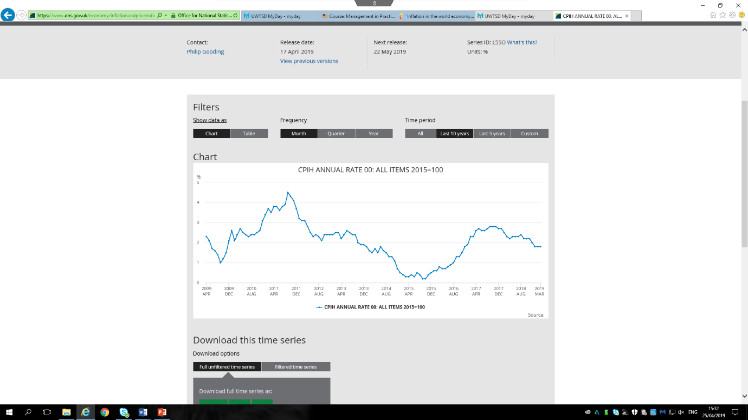

ONS.GOV (2019)
Visit Britain state that “Since 2010 tourism has been the fastest growing sector in the UK in employment terms. Britain is forecast to have a tourism industry worth over £257 billion by 2025.” In which this is just under 10% of the UKS’s GDP and it’s supporting 11% of jobs which is 3.8 million in numbers. In 2017, 39.2 million oversees tourists visited the UK last year and spent a record of 24.5 billion. The number will hopefully develop rapidly in the next couple of years as it’ll become cheaper for tourists to come over due to the exchange rate being cheaper for tourist. Gibson, N (2014) states that “Macroeconomic is the study of a national economy as a whole and Microeconomic is the study of economists at an individual, group or company level. As a whole microeconomic focuses on issues that affect individuals and companies”.

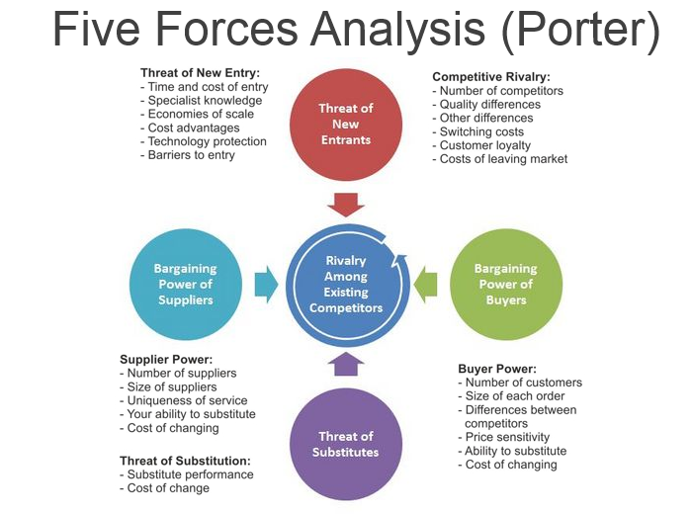
Dourado (2017)
The Porters five forces include- the threat of Substitution, threat of Established Rivals, Threat of New Entrants these are all horizontal and the two vertical include- Bargaining Power of Suppliers and Bargaining Power of Customers. By evaluating the industry with this model, it’ll benefit with grasping a clear picture of the environment, of current competitors and it helps to identify the company strengths and weaknesses.
In terms of London Dungeons and Merlin Entertainment it’ll determine whether it is successful and who the real competitors are. For example they are many competitors Merlin Entertainment like Disney and other famous attractions/ theme parks and these are a big threat. Although it is a huge opportunity for Merlin Entertainments to expand and open more attractions as there are only 5 Disney parks in the world whereas Merlin own a multiple amount. Also with Brexit occurring Brits are currently preferably travelling within the country and using attractions and most of these are owned by Merlin.

Ratios
This section is where you show your calculations.

Analysis and Key Performance Indicators
Merlin Entertainments- Profit and Loss accounts

Profitability Ratio’s

Gross Profit
2015 | 2016
1,085,000,000/ 1278,000,000 *100  = 85% | 1,230,000,000/1,457,000,000*100  =84%
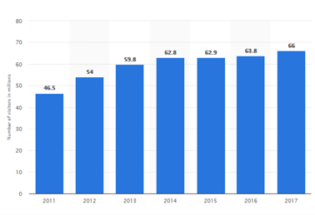
In 2016, the portion of sales slightly decreased by 1% meaning there isn’t much in between. Both numbers are quite big suggesting that they made a lot of money throughout the year ending with a big profit. This profit could be due to the number of sales and customers attending. In 2017, Merlin Entertainment attracted 66 million visitors worldwide which has increased from previous year, meaning that more money could have been spent on products and services.

Statista (2017)
NET Profit Margin
2015 | 2016
170,000,000/1,278,000,000*100  = 13.3 | 211,000,000/1,457,000,000*100  =14.4
The NET profit margin indicates how well the company has been running throughout the year. In 2016 it has slightly increased meaning that the company was doing better. The increase in 2016 is because they’ve spent more on things like marketing and salaries to create larger revenue than last year.

ROCE
2015 | 2016
174,600,000/2,478,000,000*100  = 7% | 215,600,000/2,959,000,000*100  =7.2%

ROCE for both years are similar, although in 2016, the result is 0.2%. It’s the total amount of capital spent for the acquisition of profit. A result of 20% is acceptable, although as you can see Merlin Entertainments are below meaning that the income has been low compared to the amount of assets owed.

Asset Turnover Ratio’s
Asset turnover
2015 | 2016
1,278,000,000/2,478,000,000  = 0.51 times | 1,457,000,000/2,959,000,000  =0.49 times
This is an efficient ratio that measures a company’s ability to generate sales from its assets. The result could be improved if Merlin Entertainments start using their assets efficiently to gain more sales. For every £1 worth of assets, merlin only earn 51p in revenues in 2015 and 49p in revenues in 2016.

Fixed Assets Turnover
2015 | 2016
1,278,000,000/2,475,000,000  =0.51 times | 1,457,000,000/2,958,000,000  =0.49 times
This result indicates to the management how well the organisation is using its fixed assets to generate sales. As you can see both results are low which could mean Merlin entertainments are having trouble getting business and visitors to go to the attraction, although they attract many visitors a year so it could be down to a business strategy on why they are so low. The result could also mean that Merlin have overspent or it could indicate the over investment in fixed assets

Working Capital Turnover
2015 | 2016
1,278,000,000/3,000,000  =426 | 1,457,000,000/ 1,000,000  =1457
This ratio is an efficiency ratio which tells the company how effectively the assets are being utilised. It has increased a large amount since 2015 which means the company is running a lot better as it has more than enough assets to meet all the short term financial duties. Or as these results are so high it could suggest they do not have enough capitals to support the growth.

Liquidity
Current Ratio
2015 | 2016
260,000,000/257,000,000  =1.0 | 340,000,000/339,000,000  =1.0
This ratio is to show how quickly cash can be obtained to pay expenses or settle debts, meaning that Merlin Entertainments current assets are sort of equal to the current liabilities and that they are just able to cover the payments.

Quick ratio
2015 | 2016
260,000,000- 30,000,000/ 257,000,000  =0.89 | 340,000,000-36,000,000/339,000,000  =0.89
This ratio is like the current ratio and it determined whether the company is able to generate cash to pay its debts within the 12 months. Due to the quick ratio being just below the average of 1.0 it can mean that they do not have enough liquid assets to pay current liabilities. It is important to potential investors and creditors as it means they are in less risk within being stunned due to the debt.

Debtor days
2015 | 2016
76,000,000*365/76,000,000  =365 days | 86,000,000*365/86,000,000  =365 days
An average for debtors to pay back fees is usually within 30-36 days but with Merlin Entertainment the time has increased largely compared to the average. Although this could be down to Merlin setting terms and conditions. For both 2015 and 2016 the debtor days has not changed, it could be down to the fact that they have Annual season pass holders. This can be worrying as they pay their creditors better than the average time period which is shown below and they have to wait a whole year. Merlin entertainment has 365 days before they get paid by their annual season pass holders meaning it has a knock on effect on the working capital cycle

Creditor days
2015 | 2016
41,000,000*365/1,278,000,000  =11.7 days | 63,000,000*365/1,457,000,000  = 15.7 days
This ratio shows how many days it takes Merlin to pay their creditors back, the average acceptable time period is up to 30 days. In which for both 2015 and 2016 Merlin Entertainment were under, this can be down to the agreed terms and conditions Merlin

Gearing
Debt Ratio
2015 | 2016
1,580,000,000/2,735,000,000  =0.57 | 1,857,000,000/3,298,000,000  =0.56
The debt ratio looks at how much the company finances itself through debt. Both results are really low and are below the average of 35% meaning that the Merlin’s using less help and is in a stronger impartiality position. The higher the percentage is the more the company is at risk so at the moment Merlin Entertainments have nothing to worry about.

SMART objectives

S- Use assets more efficiently to gain a bigger and better profits
M- By using the assets more efficiently, lots of money could be saved. As you can see the fixed assets ratio for Merlin Entertainments is extremely low, it can mean that they aren’t getting enough customers into their attractions as much as they’d like. It’s suggested to examine the attractions and to see whether there are ways they can improve and whether they can reduce labour costs to save thousands as money as this is one of the highest expenses of loss on the accounts. A goal could be to reduce cashier numbers as phones are very popular nowadays and it’s much easier to purchase tickets offline, meaning that employees aren’t needed there. By reaching this goal, it’s recommended that Merlin Entertainment promote online use and offer deals so that sales will increase. As they already have a good and known website, it should take around 6 months to reach the goal and an improvement should have been made from previous accounts.
A- After discussing with stakeholders, it will be agreed upon that it is a good aim and will definitely reduce queues getting into the park, although as discussed it was ensured that all the cashiers would be offered a new job within the business.
R- This goal is realistic as it can happen and will increase not only structure to the business but help investigate how many people they are actually visiting attractions. Also with all the technology Merlin Entertainments already have it’ll be easy.
T- This goal shouldn’t take too long to achieve, as phones are being used more effectively and it’s a day to day use for some individuals. An app for Merlin Entertainments should be developed with all the attractions inside the app, followed by all their events and discount deals. The first 4-6 months will be the time period where the app is being made, then there’ll be a trail run with less cashiers on the door seeing whether the app has developed and whether people are using it and within the year hopefully visitors will just rely on the app and website.

Human Resources
There are many definition’s used to describe recruitment, one including Barber (1998) stated that “recruitment includes those practises and activities carried on by the organisation with the primary purpose of attracting potential employers”. The most popular way of company’s advertising jobs to the general public is by the internet, as nowadays everyone goes online and has the internet. Many methods are used to entice and capture individuals and encourage potential candidates’ interest in the job role. The internet can both have advantages and disadvantages. The advantages of the advertising on the internet include: significant savings, millions of audience due to the numbers using online sites like Indeed.com and lastly it’s very easy and quick. During the selection process it’s important for the interviewer to decide which applicant is most suited to the role. A big part of this is experience as people with the mostly experience within the role will be more qualified. If the wrong person is chosen it can cost the organisation a lot of money. CIPD 2019 states that “Good recruitment is vital for every organisation - finding the right people for the right roles at the right time. It ensures that the workforce has the relevant skills and abilities for the organisation's current and future needs.”
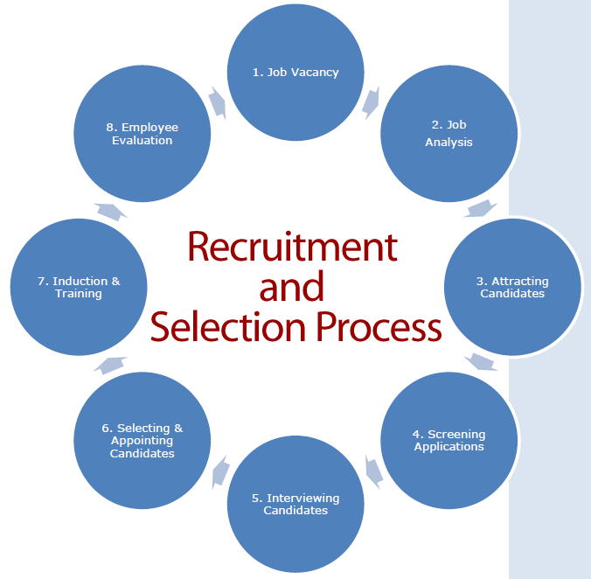

HRMP(2019)
Both Equality and diversity is currently used as a term ‘equal opportunities’. Some companies may discriminate some individuals as they have something against them, although the law is there to protect your rights and you from discrimination including: dismissal, employment terms and conditions, pay and benefits, promotion and transfer opportunities, training, recruitment, redundancy. All individuals are different and it’s important for employers to consider and understand that people will have: different beliefs, experiences, expectations, sex, culture, colour, personalities and languages, age and disabilities.

Working within a diverse workforce
There are many advantages from working in a diverse workforce including:
- Skills
It is known that individuals from a different diverse can offer different skills, experience and talent which can be very beneficial to organisations
- Innovation
Working with individuals that have different backgrounds and experience is advantageous as others are able to learn and gain more creative concepts as feedback can be given off the individual. Others are able to learn off strengths meaning an outstanding team is produced. When companies employ individuals it is known what is needed and will be considering what is best for the team and whether the individual will fit in.
- Better business
Hiring individuals with a different language and culture means that they can operate and advertise to their own and even help with any enquiries off the customers. The more diverse the company becomes means it could be possible for the company to work on a global basis. It can also get the company known as employee retention which means individuals are willing and wanting to work for the company as they know they are accepting all backgrounds and promoting equality. Employees are more likely to be comfortable working in an inclusively priority workplace.

Global diversity and inclusion goals- Merlin Entertainments
“All. Together. Individual talents. Collective strength.”
- Everyone to access and enjoy attractions
- To create an inclusive, engaging culture that creates strong and informed leaders.
- For everyone to work and create a workplace where everyone feels valued, no matter their age, race, gender, disability or sexual orientation.
- Create a nurturing culture, where everyone can be their truest self.
- Encourage the hiring of older workers and women returners, as they bring valuable skills and help us to better represent our customer base
- Gender balance in all teams- We seek out talented women and support their career development, leading by example with visible role-models from the top of the organisation and through mentorship programmes. We have also launched a “women returners” programme in relevant markets and actively encourage women into non-traditional roles and careers within Merlin.
- To encourage applications from people with disabilities, we identify and actively promote a range of accessible roles across our estate. We make work adjustments to accommodate people and have good relationships with a number of relevant organisations such as the Business Disability Forum.
Merlin Entertainments (2019)

Gender Pay
Gov.uk (2015) stated that women working full time are being payed less than 90% of men in the same sectors, and the research that was undertaken have proven that men are being paid on average 19% more than female colleagues. By a company paying less to a woman that is doing the exactly same job can be presented as discrimination.
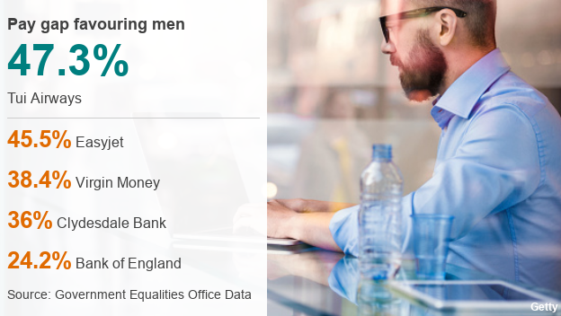
Here is statistic off BBC News (2018) and it states how much more both TUI and EasyJet are paying men more than women, Although Easyjet has said “its pay gap of 45.5% is down to the fact that most of its pilots are male, while most of its more modestly paid cabin crew are female”. TUI and all other airlines have the same issue.

BBC News (2018)
Walt Disney developed a gender pay report and it shows the mean and median, the mean is calculated by adding all the values and then dividing by the number of individuals there are, it showed that men value is 22% more. Although it states that men in the Walt Disney Company are currently getting more than women this can be due to that men undertake jobs like engineering.

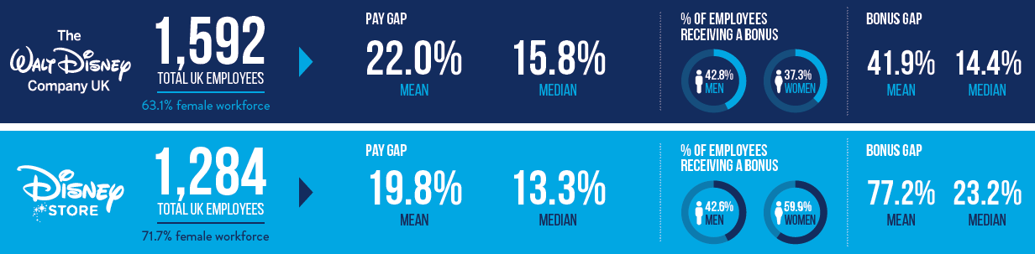

Walt Disney gender pay report (2017)

Management in practice
Performance management systems are put into place to improve organisational performance and to also encourage progresses of teams working together. As a manager it’s very important to identify how team members are developing and getting on.
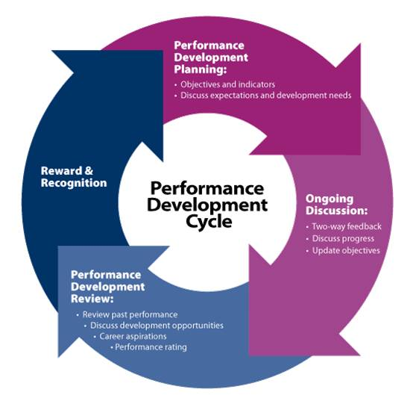
As an individual and team mate it is important to understand what is expected of you. For an example as an individual you’ll be required to demonstrate many skills including problem solving, potential you have within the company and of course experience from previous job or knowledge. As a team it is expected to have an understanding of the team role, have your individual contribution, support any other individuals in team so everything can achieve big. Managers and team leaders are there to give back performance feedback, it’s important that all individuals function as a team to end up with the best results and even could end up with big bonuses.
The Library Career Centre (2011)

The London Dungeons
After researching the London dungeons, a job application was discovered. The London dungeons offer a six month contract to begin to see if the individual is successful otherwise they are still able to use their theatrical abilities to get a steady wage, fun environment, experience and security. For those that are successful get to return after having a six month break. Due to the amount of foreign visitors London attracts it can be quite difficult for an actor. The average full time hours are between 30-40hrs over a period of 5 days and the hourly wage is £9.53. There are many benefits for working for a company like Merlin entertainments including: completive wage, Merlin magic pass, Childcare vouchers, 25% discount in the Merlin retail shops and restaurants, and many more. The following skills and experience that’s required includes
- Experience in working in a high pressured environment.
- Talent for the theatrical, and discipline to keep to scripts and direction for brand consistency.
- Love of entertainment through character acting.
- Line learning skills.
- The confidence to deal with challenging situations.
- Excellent communication skills,
- Excellent vocal knowledge with correct use of projection.
- Self-motivation, due to the high repetition nature of the role.
- Good time management skills.
- Stamina to perform physical characters for long durations.
“The London Dungeon is looking for talented actors to join its, fast-paced, dynamic and dedicated Performance Team on a guaranteed hour, fixed term 6 month contract. With stunning sets and costumes to match, we pride ourselves on giving our guests a truly memorable experience and it’s our actors who really bring The London Dungeon to life!” Merlin Entertainments (2019)
This is actually bad for individuals and actors looking for full time work as they only offer the 6 months jobs, although if they are after more work than they are able to work with other partnership jobs within other merlin entertainment attractions for the time being until they go back or the actors can take the whole 6 months off.

Recommendations
As there are a few Merlin Entertainment attractions nearby on the south bank of London, I believe it’d be a great opportunity to open a themed and creative restaurant. Like in alton towers they have many restaurants but one being the rollercoaster restaurant which is rated 10/10 on TripAdvisor. It’ll keep the tourists in the area longer and it’s an opportunity to create more money.
As London dungeons is aimed towards the higher age market, I believe they should set up something like a children's evening where the kids are able to have fun and it’s also educational due to the fact they’ll be learning about the past.

Conclusion
To conclude, I believe that Merlin entertainments as a whole is successful, although to reach bigger figures my suggested goals would be a big impact to them and if they went along with the Merlin phone app, it’ll reduce queues at park and will help merlin understand exactly how much custom they are getting. After looking at the PESTLE analysis its important to keep on track with up to date trends in which Merlin Entertainments are.

Reference List
Bairstow, J. (2018), Merlin Entertainment buys a ticket for renewable future, https://www.energylivenews.com/2018/12/10/merlin-entertainment-buys-a-ticket-for-renewable-future/ [Last accessed:16.04.2019]
Barber, A. E. (1998), Recruiting employers: individual and organisation perspectives, Thousand Oaks, CA: Sage.
BBC News. (2018), Gender pay gap: Men still earn more than women at most firms, https://www.bbc.co.uk/news/business-43129339, [Last accessed: 15.04.2019]
Brief, A.P. (2008), Diversity at work, New York: Cambridge University Press.
CIPD. (2019), Recruitment: an Intorduction, https://www.cipd.co.uk/knowledge/fundamentals/people/recruitment/factshetet, [Last accessed:15.04.2019]
Eventbrite. (2016), Industry Leaders on What Brexit Means for UK Event Profs, https://www.eventbrite.co.uk/blog/events-industry-brexit-reactions-ds00/ [Last accessed:16.04.2019]
GOV.UK. (2015), UK Gender Pay Gap, https://www.gov.uk/government/news/uk-gender-pay-gap [Last accessed: 15. 04.2019]
Gov.uk. (2019), Discrimination: your rights, https://www.gov.uk/discrimination-your-rights/discrimination-at-work, [Last accessed: 15.4.2019]
HRMP. (2019), Recruitment and Selection Prcoess, http://hrmpractice.com/recruitment-and-selection-process/ ,[Last accessed: 15.4.2019]
https://wp.nyu.edu/cts2015/wp-content/uploads/sites/657/2015/06/Loi-and-Kong.pdf
Merlin Entertainments. (2019), Diversity and Inclusion, https://www.merlinentertainments.biz/about-us/our-people/diversity-and-inclusion/, [Last accessed: 15.4.2019]
Roy, D (2011), Strategic Foresight and Porter's Five Forces, London: GRIN publisher
The Library Career Centre. (2011), The art and science of managing performance, http://thelibrarycareer.blogspot.com/2011/08/art-and-science-of-managing-performance.html, [Last accessed: 15.4.2019]
UKCES. (2012), UK Skill levels and international competitiveness, https://assets.publishing.service.gov.uk/government/uploads/system/uploads/attachment_data/file/304908/evidence-report-61-uk-skill-levels-and-international-competitiveness.pdf [Last accessed: 15.04.2019]
Undercover Recruitment. (2017), What Are the Benefits of Diversity in the Workplace?, https://theundercoverrecruiter.com/benefits-diversity-workplace/b [Last accessed:15.04.2019]
XE.com (2019), Live Market rates, https://www.xe.com/currencyconverter/convert/?Amount=100&From=GBP&To=USD [Last accessed:16.04.2019]

Appendix

