

Changemakers: Creativity and Value Creation
Professions (BMHP5014)
Assessment Name: Digital Exclusion in Health and Social Care: Innovation, Creativity, Value Creation and Change
Component 1: Online portfolio of set exercises
Student name: Blessing Ogieriakhi
Student number: 2416087
Lecturer’s Name: Laila Surani
Word Count:2169

Table of contents

Digital Exclusion in Health and Social Care: Innovation, Creativity, Value Creation and Change 3
Introduction 3
Task 1 – Defining Key Concepts in Practice 3
Innovation 3
Class group work 4
Creativity 4
Value Creation 5
Change 5
Task 2-Mind Map: Digital Exclusion in Health and Social Care 6
Mind Map Group work 7
Causes, Impacts, Who is affected and Solutions 8
Task 3 – Self-Reflection of Group Activity (Convergent and Divergent Thinking) 8
Group work case study using the divergent approach 10
Task 4 - Case Study Analysis of a UK Innovation 10
Task 5 – Research Task (Digital Exclusion) 11
Class group work- Research 12
Task 6 – Exploring Digital Innovation in Health and Social Care 12
1. Wearable Health Technologies and Chronic Disease Management 12
2. Electronic Health Records (EHRs) and Communication 12
3. Digital Technology in Preventive Care and Health Promotion 13
Class group work- Exploring digital innovation 14
Task 7 – Understanding the NHS Leadership Framework 14
1. Summary of the NHS Leadership Framework 14
2. Leadership Behaviour and Promoting Creativity 15
Class work- Leadership Framework 15
Task 8 – Self-Reflection Journal Entry 16
Reference 17

Digital Exclusion in Health and Social Care: Innovation, Creativity, Value Creation and Change

Introduction
Health and social care organisations operate in an increasingly digital world, requiring innovation, creativity and good leadership to improve the quality, accessibility and sustainability of services. The NHS is currently witnessing a digital transformation, such as the wearable technology, telehealth, electronic health records (EHRs), and the NHS App which have improved communication and boosted service efficiency throughout the UK (NHS England, 2024).
However, these developments have also resulted in digital exclusion, where people cannot access digital healthcare because of limited digital skills, financial difficulties, poor internet access, disability or language barriers (WHO, 2021). Consequently, digital transformation can improve healthcare but may also widen health inequalities if inclusive approaches are not adopted. This portfolio examines innovation, creativity, value creation and change within digital exclusion. It explores the causes and effects of digital exclusion, analyses NHS innovation, reviews research evidence, examines digital technologies and their limitations, considers leadership, and reflects on future professional practice in delivering equitable, person-centred care.

Task 1 – Defining Key Concepts in Practice

Innovation
Innovation means the evolution of new ideas, technologies or processes that improve services or outcomes (Rogers, 2003). Within health and social care, innovation enables organisations to respond to changing population needs, improve efficiency and enhance patient experiences. For example, the NHS App enables patients to access medical records, order repeat prescriptions and book appointments, reducing administrative pressures while improving convenience.
Rogers' Diffusion of Innovation Theory explains that new technologies are adopted progressively when users perceive them as useful and beneficial (Rogers, 2003). Although this theory helps explain patterns of technology adoption, it has limitations because it places considerable emphasis on individual willingness to adopt innovation while giving less attention to wider social determinants such as poverty, disability, digital literacy and unequal access to technology. Consequently, technological innovation alone cannot reduce healthcare inequalities unless accompanied by policies that address digital exclusion (Greenhalgh et al., 2020).

Class group work
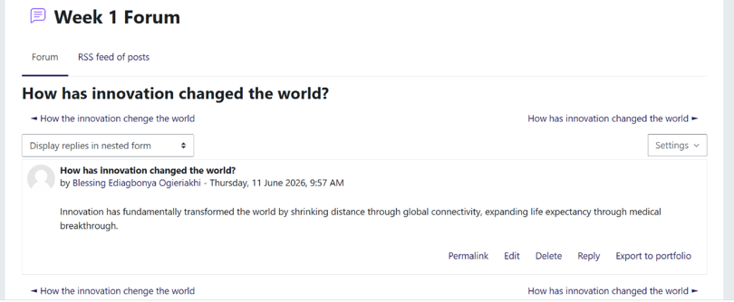

Creativity

Creativity means to create or generate original and useful ideas (Amabile, 1996). In health and social care, creativity supports the development of practical solutions to complex challenges such as digital exclusion. Examples include the introduction of Digital Champions and community-based digital skills programmes that help older adults and vulnerable groups access online healthcare services.
Amabile's Componential Theory suggests that creativity results from the interaction of knowledge, creative thinking skills and intrinsic motivation (Amabile, 1996). However, creative ideas alone rarely produce sustainable change. Their successful implementation depends upon organisational leadership, sufficient funding, workforce engagement and a culture that supports innovation. Financial pressures and workforce shortages within the NHS may therefore limit the successful implementation of otherwise effective creative solutions.

Value Creation
Value creation is the efficient use of available resources to increase health outcomes (Porter, 2010). In healthcare, value is achieved when services improve patient outcomes, enhance the patient experience, and reduce unnecessary costs. For example, providing digital support for individuals who struggle to access online healthcare may reduce missed appointments and enable earlier intervention. Porter's value-based healthcare model emphasises achieving better outcomes relative to cost (Porter, 2010). However, fairness, accessibility, and patient-centred care should be considered in addition to cost savings in order to safeguard those who are at risk and require more assistance.

Change
Change refers to the transition from existing practices to improved ways of working. Within health and social care, continuous change is essential to respond to technological advances, demographic pressures and increasing patient expectations. The transition from paper records to Electronic Health Records demonstrates how digital transformation can improve communication, continuity of care and clinical decision-making.
Lewin's Change Management Model describes successful change as a three-stage process involving unfreezing existing practice, implementing change and refreezing new behaviours (Burnes, 2017). While the model provides a clear and practical framework, critics argue that modern healthcare organisations experience continuous rather than linear change.

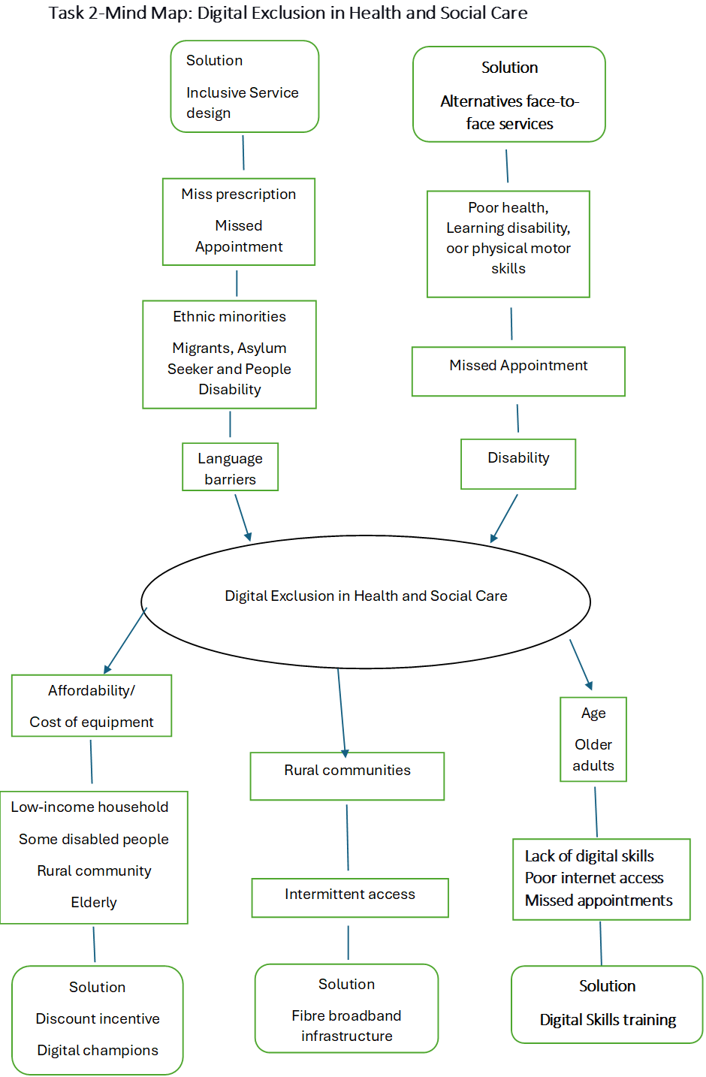
Task 2-Mind Map: Digital Exclusion in Health and Social Care

Mind Map Group work

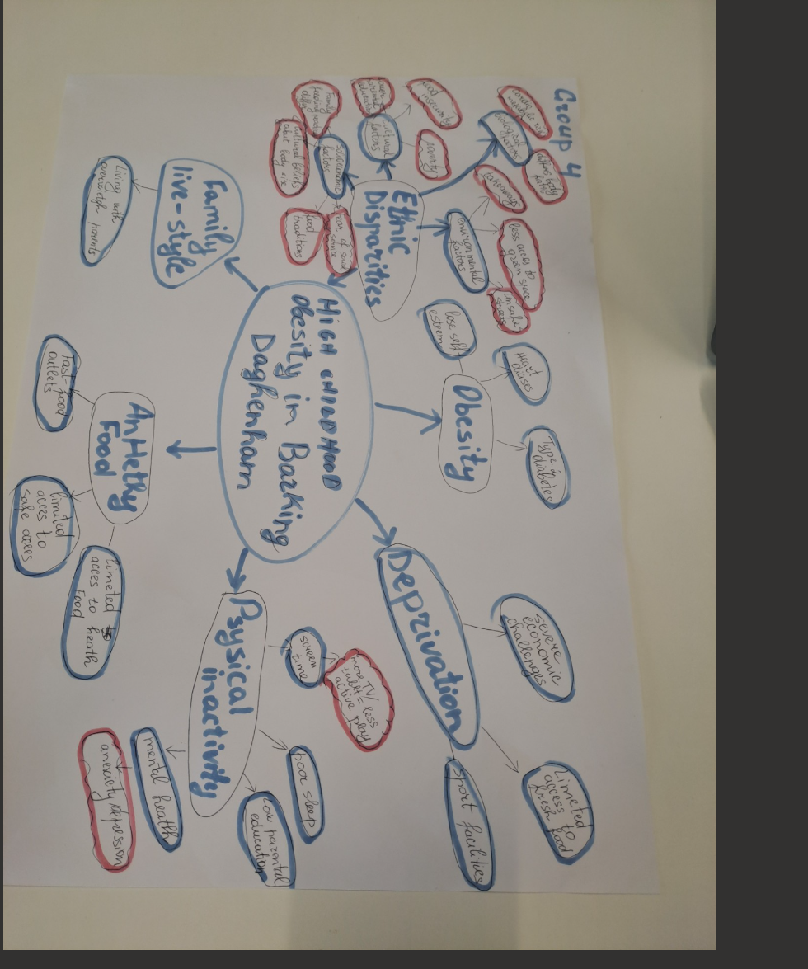

Causes, Impacts, Who is affected and Solutions
Digital exclusion is a process of limiting equitable access to healthcare and risks widening existing health inequalities.
As shown in the mind map, digital exclusion is caused by factors such as limited digital literacy, poor internet connectivity, financial constraints, disability and language barriers. These factors result in less involvement in preventative healthcare services (NHS England, 2024).
The populations most affected include older adults, people living in poverty, rural communities, individuals with disabilities and some ethnic minority groups. Proposed interventions include improving digital skills, increasing affordable internet access, expanding Digital Champion programmes, maintaining non-digital routes into healthcare and designing services using inclusive principles.
However, implementing these interventions presents several challenges. Effective inclusive digital programmes require involvement of health, social care and voluntary organisations, with avowed political commitment . In addition, it requires long-term funding and staff training
(WHO, 2020)

Task 3 – Self-Reflection of Group Activity (Convergent and Divergent Thinking)

A classroom group activity was undertaken to explore the application of convergent and divergent thinking when addressing digital exclusion in health and social care. Divergent thinking involves generating a wide range of creative ideas, whereas convergent thinking focuses on evaluating those ideas to identify the most practical and effective solution (Guilford, 1967). Both approaches are important in healthcare because professionals frequently balance innovation with evidence-based decision-making. During the activity, the group initially adopted divergent thinking by suggesting several strategies to improve access to digital healthcare, including digital skills training, community outreach programmes, simplified online systems and the use of Digital Champions. I contributed by recommending a strengths-and-limitations (pros and cons) approach to evaluate each proposal objectively. This enabled the group to prioritise digital skills training because it was considered achievable, cost-effective and capable of benefiting a wide range of service users. Using Gibbs' Reflective Cycle (1988), to reflect on my experience, the initial feeling was the uncertainty whether my ideas would add value to the discussion. As the activity progressed and my peers responded positively, my confidence increased, and I became more willing to contribute. In order to deliver more inclusive, person-centred health and social care in the future, I will use evidence-based methods to make better decisions, involve everyone, and encourage cooperation. This highlighted the importance of active listening, inclusive communication and shared decision-making within multidisciplinary teams.

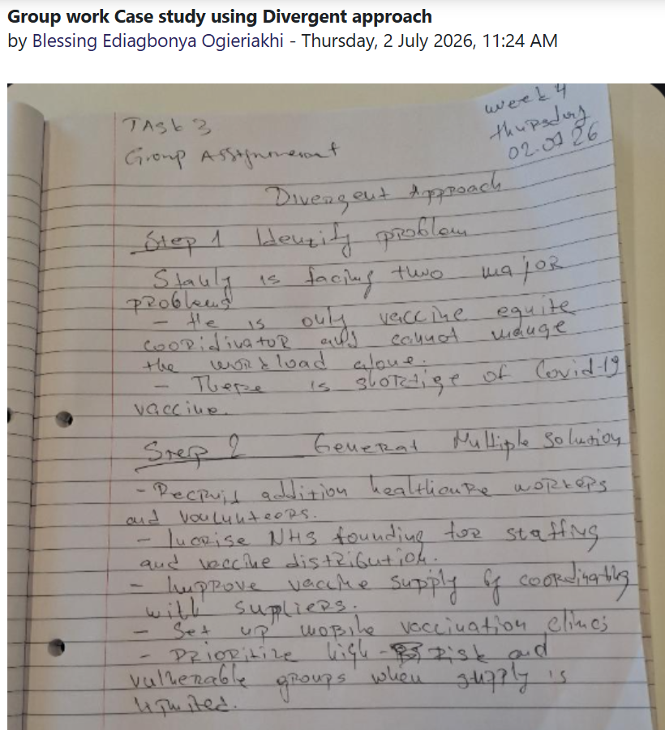
Group work case study using the divergent approach

Task 4 - Case Study Analysis of a UK Innovation
The innovation of the NHS App has brought about a decrease in demand for NHS services, while at the same time increasing access to healthcare. Patients can schedule visits, request repeat prescriptions, and obtain health information thanks to this innovation (NHS England, 2024).
It responded to increasing demand for primary care, workforce pressures and the need to maintain continuity of care while reducing unnecessary face-to-face contact.
Creativity transformed healthcare delivery through accessible digital platforms that promote patient self-management and improve communication. Assisted digital support and Digital Champion initiatives improved access for people experiencing digital exclusion, supporting Rogers' (2003) Diffusion of Innovation Theory, which explains that adoption depends on technology being perceived as useful, easy to use and compatible with users' needs. However, adoption remains unequal. Older adults, individuals with disabilities, people experiencing homelessness, and those in socioeconomically deprived communities are less likely to access digital healthcare because of limited digital skills, affordability or internet access (Greenhalgh et al., 2020).
Digital innovation also raises concerns about patient confidentiality, cybersecurity and workforce readiness. Healthcare organisations must invest in digital infrastructure, staff training and accessible alternatives. Although the NHS App demonstrates how innovation improves healthcare delivery, its long-term success depends on equitable access through inclusive service design rather than replacing traditional methods of care.

Task 5 – Research Task (Digital Exclusion)
Digital exclusion restricts fair access to health care and perpetuates health disparities, and it continues to be a major public health concern.
Smith and Magnani (2019) found that older people rely more on face-to-face consultations because limited digital literacy reduces confidence in using online healthcare services, highlighting the need for tailored digital skills support. Similarly, Ibrahim et al. (2021) argue that health data poverty increases digital inequality, making digital healthcare less equitable for disadvantaged groups and emphasising inclusive system design. The two studies show that the availability of technology alone does not guarantee that there won't be digital marginalisation. Ibrahim et al. (2021) highlight disparities in digital health data and system design, while Smith and Magnani (2019) focus on digital literacy. On their part, Greenhalgh et al. (2020) argued that successful digital innovation requires organisational readiness, workforce capability and patient engagement.
Digital exclusion is a multidimensional issue requiring coordinated action across health services, government and communities. Digital skills programmes, affordable internet access, inclusive service design and non-digital healthcare options are essential to ensure no individual is disadvantaged by digital transformation.

Class group work- Research
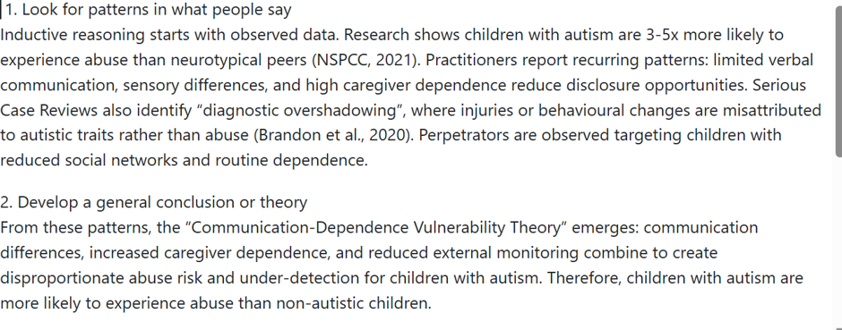

Task 6 – Exploring Digital Innovation in Health and Social Care

1. Wearable Health Technologies and Chronic Disease Management
Long-term conditions, including diabetes, hypertension and cardiovascular diseases, are managed through the support of wearable devices such as smartwatches and activity trackers. These devices help to monitor heart rate, blood pressure, physical activity and sleep patterns. These potentially reduce hospital admissions according to Topol (2019).
However, their effectiveness depends on users having digital skills, motivation and confidence in protecting their data. The Technology Acceptance Model suggests that technology becomes more meaningful and accepted when individuals are able to use these devices with ease. However, these assumptions largely depend if structural barriers such as poverty and digital exclusion are resolved (Davies, 1989).

2. Electronic Health Records (EHRs) and Communication
Electronic Health Records (EHRs) improve communication by providing healthcare professionals with secure, real-time access to patient information across hospitals, GP practices and community services. This supports continuity of care, reduces duplication of diagnostic tests and medication errors, and improves patient safety and multidisciplinary decision-making (Vest and Gamm, 2010).
However, successful implementation depends on interoperability between healthcare systems, staff training and robust cybersecurity. Furthermore, due to disparate NHS computer systems and limited digital literacy, information exchange becomes or remains very challenging. According to Greenhalgh et al., (2020), effective implementation would require not only new technologies but also training and inclusive services.

3. Digital Technology in Preventive Care and Health Promotion
Digital technologies contribute to disease prevention and health promotion by encouraging healthier lifestyles, supporting medication adherence and facilitating early intervention. Wearable technology, health apps and NHS quit-smoking initiatives enable individuals to manage their health, make informed decisions and reduce demand on healthcare services. These digital technology benefits, however, are not experienced equally because individuals without digital devices or access may be excluded. Therefore, the World Health Organisation (2021) recommends that digital health should complement conventional healthcare services to ensure equitable access, rather than replace them.

Class group work- Exploring digital innovation



Task 7 – Understanding the NHS Leadership Framework

1. Summary of the NHS Leadership Framework
The framework promotes effective leadership across health and social care by encouraging collaboration, continuous improvement, innovation and person-centred care. It identifies key leadership behaviours, including leading with care, inspiring shared purpose, evaluating information, engaging teams and influencing positive change to support service improvement and high standards of patient care.
The framework is particularly relevant during digital transformation because successful implementation requires leaders who balance innovation with patient safety, workforce wellbeing and service accessibility. However, leadership alone cannot overcome challenges such as financial constraints, workforce shortages and increasing service demand. Sustainable change, therefore, requires organisational commitment, adequate resources and collaborative working alongside effective leadership.

2. Leadership Behaviour and Promoting Creativity
Inspiring Shared Purpose is a key leadership behaviour that encourages leaders to communicate a clear vision, motivating staff towards shared organisational goals. This aligns with Bass and Avolio's Transformational Leadership Theory (1994), which argues that leaders inspire innovation by motivating individuals to achieve common goals.
However, transformational leadership alone cannot deliver sustainable change without adequate funding, workforce capacity, digital infrastructure and effective change management. Successful leaders must therefore combine vision with practical implementation strategies that address organisational and societal barriers to digital inclusion.

Class work- Leadership Framework

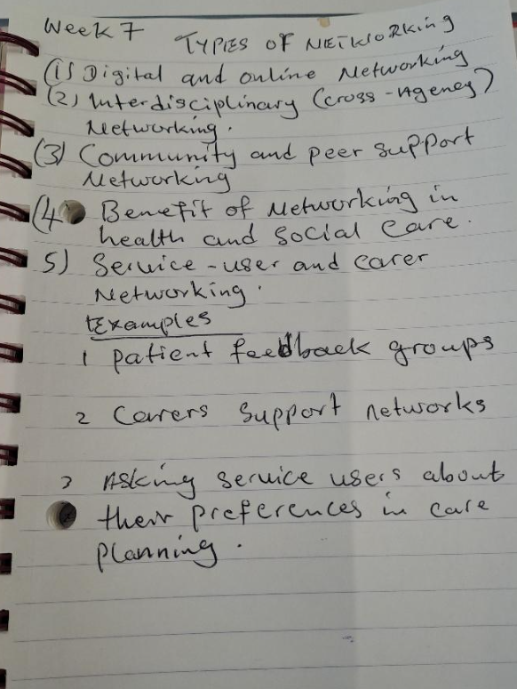

Task 8 – Self-Reflection Journal Entry

This module has enhanced my understanding of innovation, creativity, leadership and value creation within health and social care, particularly regarding digital exclusion. Before studying the module, I viewed innovation mainly as introducing new technology. Through the literature, classroom activities and case studies, I now recognise that successful innovation requires inclusivity, effective leadership and consideration of the wider social determinants of health. I also discovered that low computer skills, poverty and disability can restrict access to digital healthcare. This has further increased my awareness of healthcare professionals' ethical responsibility to promote equitable access rather than assuming digital solutions are compatible with all service users.
Group activities highlighted my strengths in generating creative ideas while reinforcing the importance of evidence-based decision-making, collaborative working, active listening and shared decision-making within multidisciplinary teams.
Going forward, I will assess each service user's digital capability before recommending technology-based interventions. This module has strengthened my interest in lifelong learning and reinforced the importance of combining innovation with compassion, inclusivity and evidence-based practice to improve health outcomes for all.

Reference
Amabile, T.M. (1996) Creativity in Context. Boulder, CO: Westview Press.
Bass, B.M. and Avolio, B.J. (1994) Improving Organisational Effectiveness Through Transformational Leadership. Thousand Oaks, CA: Sage.
Burnes, B. (2017) Managing Change. 7th edn. Harlow: Pearson.
Davis, F.D. (1989) ‘Perceived usefulness, perceived ease of use, and user acceptance of information technology’, MIS Quarterly, 13(3), pp. 319–340.
Greenhalgh, T., Wherton, J., Papoutsi, C., Lynch, J., Hughes, G., A’Court, C., Hinder, S., Fahy, N., Procter, R. and Shaw, S. (2020) ‘Beyond adoption: A new framework for theorising and evaluating non-adoption, abandonment, scale-up, spread and sustainability of health and care technologies’, Journal of Medical Internet Research, 22(11), e22104.
Guilford, J.P. (1967) The Nature of Human Intelligence. New York: McGraw-Hill.
Ibrahim, H., Liu, X., Zariffa, N., Morris, A.D. and Denniston, A.K. (2021) ‘Health data poverty: An assailable barrier to equitable digital health care’, The Lancet Digital Health, 3(4), pp. e260–e265.
NHS England (2024) What the NHS App Does. Available at: https://www.nhs.uk/nhs-app/ (Accessed: 24 July 2026).
Porter, M.E. (2010) ‘What is value in health care?’, New England Journal of Medicine, 363(26), pp. 2477–2481.
Rogers, E.M. (2003) Diffusion of Innovations. 5th edn. New York: Free Press.
Smith, A. and Magnani, J. (2019) ‘Digital health and older adults: barriers to engagement’, Journal of Health Informatics, 25(3), pp. 210–218.
Topol, E. (2019) Deep Medicine: How Artificial Intelligence Can Make Healthcare Human Again. New York: Basic Books.
Vest, J.R. and Gamm, L.D. (2010) ‘Health information exchange: persistent challenges and new strategies’, Journal of the American Medical Informatics Association, 17(3), pp. 288–294.
World Health Organization (2021) Global Strategy on Digital Health 2020–2025. Geneva: World Health Organization.

