UNIVERSITY OF WALES TRINITY ST DAVID
Application of Computer Aided Engineering Processes
ACHA6010 Structural Design and Fluid Analysis
BEng Motorsport Engineering
Harvey J. Britland
1902072
December 2022


[Type the abstract of the document here. The abstract is typically a short summary of the contents of the document. Type the abstract of the document here. The abstract is typically a short summary of the contents of the document.]

Table of Contents
1 Introduction ii
1.1 Aims ii
1.2 Objectives ii
1.3 Computer Aided Engineering ii
2 Validation iii
2.1 Cantilever Beam iii
2.1.1 Testing iii
2.1.2 Results iv
2.2 Bimetallic Strip Validation iv
2.2.1 Testing iv
2.2.2 Results iv
2.3 Mesh Independence v
2.4 Other Considerations vi
3 Methodology vii
3.1 Original Material Choice vii
3.2 Method vii
3.2.1 Rigid Dynamics Analysis vii
3.2.2 Static Structural Analysis viii
3.2.3 Steady-State Thermal Solver viii
3.2.4 Static Structural Retest viii
4 Results x
4.1 Initial Study – 6061-T6 Aluminium x
4.2 Improved Material Choice xi
4.2.1 4032 Forged Aluminium xi
4.2.2 2168A Aluminium xii
4.3 Design Improvement xii
5 Conclusion xiii
6 Further Work xiv
6.1 Further Material Investigation xiv
6.1.1 AK12 Aluminium xiv
6.1.2 SAE G2500 xiv
6.2 Topology Report xiv
7 Bibliography xv
8 Appendices xvi

Table of Figures
Figure 1: Cantilever Beam Validation Results iv
Figure 2: Bimetallic Strip Validation Results v
Figure 3: Percentage Error - Bimetallic Strip Graph v
Figure 4: 6061-T6 Aluminium Engineering Data vii
Figure 5: Material Investigation Results x
Figure 6: Initial Study Temperature x
Figure 7: Stress on 6061-T6 Piston xi
Figure 8: 4032 Material Properties xi

Introduction

Aims
The aim of this assignment is to critically analyse and evaluate a variety of techniques for solving structural and fluid challenges and validate the results that come from this. Using multiple software packages, several engineering problems will be investigated, analysed and then solved though a methodical process.

Objectives
In order to complete the aim, several objectives must be fulfilled. First, a validation of the software being used must be completed in order to assess its suitability for the role in which it needs to undertake. Once this has been complete, a brief investigation into mesh independence is needed to optimize the solvers compromise between speed and accuracy. From here, further materials will be investigated and then compared under the same boundary conditions to see which would be the most suitable. The limitation of software such as Ansys Workbench, a CAE software, must also be considered.

Computer Aided Engineering
The process of solving increasingly complex engineering problems has been dramatically improved through the implementation and use of computer-aided design (CAD) and computer-aided engineering (CAE) software. By using software such as Ansys Workbench, times for solving difficult mathematical problems are reduced considerably. It also allows designers to cut down the high costs and long development times associated with product development pre-CAE software. The software also allows designers to create, design and test components without having to build a destructive replica, saving time and money. The software that has also been developed to the level in which components can be tested rigorously with only time being a limiting factor. There are however limitations to software as such as this. There is still long times needed to solve calculations with small element sizes as well as a lot of computational power, which can be very expensive to both purchase and run.

Validation
To know that the software is accurate, or at least comparable, a validation study needs to take place. This will allow the engineer using the software to know that the results given from their own investigation will be reliable and repeatable. For a validation study, a simple case study is chosen with known values and then repeated in order to see whether the same values can be replicated. The margin error of this will then give the engineer an idea as to how accurate their results may be on the component or design investigation that they are conducting. This is so that the investigation work that the engineer is processing will have merit behind it.
The validation was completed comparing known values from a structural analysis and design software, developed by Dlubal, called RFEM 5. Through both of these validation studies, an investigation into the impact element(mesh) sizing was also undertaken to assess the point at which the mesh becomes independent from the results.

Cantilever Beam

Testing
The first validation study is tested using the static structural solver in Ansys. The aim for this validation study was to test the suitability of its solver when it analyses the elastic bending on a component when under continuous load. This will be one of the assessments that will take place on the tested assembly mentioned later into this report.
In order to conduct this assessment, a cuboid shape, representing a cantilever bar, was built with the given dimensions: 1000mm x 50mm x 5mm. The bar, under the conditions given, was subjected to a uniformly distributed load of 2750 Pa with one end of the test piece being fully fixed. The material had given properties of a Youngs Modulus of 210000 MPa, a Poisson’s Ratio of 0 and a Shear Modulus of 105000 MPa (Dlubal GmbH, 2019). The document used for reference for this is validation has been included at the end of this report. Within the Static Structural solver, it can calculate the Shear Modulus from the Youngs Modulus and the Poisson’s Ratio and so this was checked to be correct but not inputted manually.

Results
Element Sizing | Analytical Solution (mm) | Ansys Static Structural Solution (mm) | Average (mm) | Difference | Percentage
20 | 157.143 | 157.15 | 63.079 | 0.007 | 0.00445%
10 | 157.143 | 157.15 | 62.971 | 0.007 | 0.00445%
5 | 157.143 | 157.15 | 62.916 | 0.007 | 0.00445%
2.5 | 157.143 | 157.15 | 62.889 | 0.007 | 0.00445%
1 | 157.143 | 157.15 | 62.872 | 0.007 | 0.00445%
Figure 1: Cantilever Beam Validation Results

Figure 1 shows the results from this validation study. The expected result from the given case study was 157.143mm and as the table clearly shows, element sizing of the mesh had no effect on the static structural solution within Ansys. The results show that the error percentage was far under 1% which is more than accurate enough in this instance.

Bimetallic Strip Validation

Testing
A second validation study is needed to test the validity of Ansys’ thermal analysis solver. By using a simplified case study of a bimetallic beam, with simple geometry, the values seen in the given case study can be compared. Due to only one uniform temperature being applied to the assembly, and not applying different temperature conditions across the bar, the investigation was completed inside the static structural solver and not the steady state thermal solver.
For this study, two cuboid shapes, both representing a bar of differing metals, were built to the specifications of the case study. As it represents a bimetallic bar, both bars were built to the exact same dimensions as each other. The given dimensions were as follows; 100mm x 5mm x 1mm. Then, within SolidWorks, the bars were assembled and mated upon each other. The relevant loads and supports were then applied to the bar with the static structural solver. The two metals used were invar and copper. The invar has a given Youngs Modulus of 137000 MPa, a Poisson’s Ratio of 0.28 and a coefficient of thermal expansion of 1.2x10⁻⁶ $℃$. The copper has a given Youngs Modulus of 130000, a Poisson’s Ratio of 0.354 and a coefficient of thermal expansion of 2x10⁻⁵ $℃$ (Dlubal Software GmbH, 2019). The thermal loading applied evenly to the entire bar was 100$℃$.

Results
Element Sizing (mm) | Analytical Solution (mm) | Ansys Static Structural Solution (mm) | Average (mm) | Difference | Percentage Error
4 | 7.049 | 7.1198 | 2.4168 | 0.0708 | 0.9944%
2 | 7.049 | 7.1224 | 2.4019 | 0.0734 | 1.0306%
1 | 7.049 | 7.1233 | 2.3942 | 0.0743 | 1.0431%
0.5 | 7.049 | 7.123 | 1.8638 | 0.074 | 1.0389%
0.25 | 7.049 | 7.1213 | 2.3864 | 0.0723 | 1.0153%
0.1 | 7.049 | 7.1203 | 2.3845 | 0.0713 | 1.0014%
Figure 2: Bimetallic Strip Validation Results
As can be seen in Figure 2, the results show that by inputting the given values from the case study, the solution that is outputted is very close to the expected result of 7.049mm. This is the measure of deflection that the bar has had once the loads have been applied to the bar. The results show that no matter what the element sizing is, the percentage error compared to the expected result is approximately 1%. This is small enough of a percentage, in this particular case, to be considered a reasonable value. Interestingly, when conducting the analysis with different element sizes, the 4mm mesh had the smallest percentage error. This result could be due to the fact that because the distance between each element in so large, that it could not properly simulate the bending between each element. The mesh would be very coarse and so although it has the smallest percentage error, a smaller mesh will be used in order to ensure the data from analysis is as reliable as possible. It should also be noted that anything higher than 4.9mm element size caused multiple errors as the elements no longer fit on such a small structure. Solver pivot errors were also encountered and so the maximum element size investigated was 4mm.

Mesh Independence

Figure 3: Percentage Error - Bimetallic Strip Graph
Mesh independence, as previously mentioned, was investigated alongside the two validation studies that took place. The purpose for this was to ascertain whether the coarseness of the mesh had any real effect upon the results given. Examining the first validation study (cantilever beam) the results show that adjusting the element size had no effect on the data produced. With every run, the percentage error was 0.0045%, an incredibly low percentage error. As this number was repeated, this particular study can be concluded to say mesh sizing had no effect. The second validation study (bimetallic strip) showed some variation when mesh sizing was considered. As mentioned in section 3.2.2, there was some minute variation in the percentage error once each run was completed. The percentage error can be seen in the graph Figure 3. It shows that as the mesh sizing’s became smaller, the percentage error increased and then decreased. Ignoring the element sizing of 4mm, the general trend in the graph shows that as the mesh size decreases, so does the margin of error when compared to the expected findings of the case study. However, with the compromise of speed and accuracy, a mesh size of 1mm was chosen as the piston geometry is far more complex than the validation studies and so would take far longer to solve at a mesh smaller than this.

Other Considerations
With this project, there are other considerations. The data set for 6061-T6 Aluminium for Young’s Modulus has values over a range of temperatures which means the result produced using theses values are to be more accurate, when compared with the single value used for the Youngs Modulus on all other materials tested. The more data dets, the more accurate the data will be due to shorter gaps between each temperature and Youngs Modulus. It uses a linear interpolation to provide the data so it will look a little jagged if there are not enough data points. This is dependant on the data that is available. It would also be better if the Poisson’s Ratio used was a temperature dependant value for the temperatures used as this would further increase its reliability and repeatability.

Methodology
The purpose of this assignment is to investigate the use of CAD systems as well as assessing a the structural performance of a component. Therefore, the study completed has to have a baseline for improvements to be made. For the full study, once the validation was complete, an assembly of a crank shaft, piston, connecting rod and gudgeon pin was built. The piston was set using the material 6061-T6 aluminium, which is a standard aluminium alloy for a piston. After this study, which serves as a baseline for the study, different materials will be tested on the piston including other aluminium alloys as well as other materials tested by manufacturers.

Original Material Choice
6061-T6 Aluminium was chosen with the material properties as listed in Figure 4. The material was chosen with these properties from a spec sheet provided through the University of Wales TSD. The Poisson’s ratio was kept the same across the Youngs Modulus scale. This was done within the subsystem “Engineering Data” within the Ansys workbench.
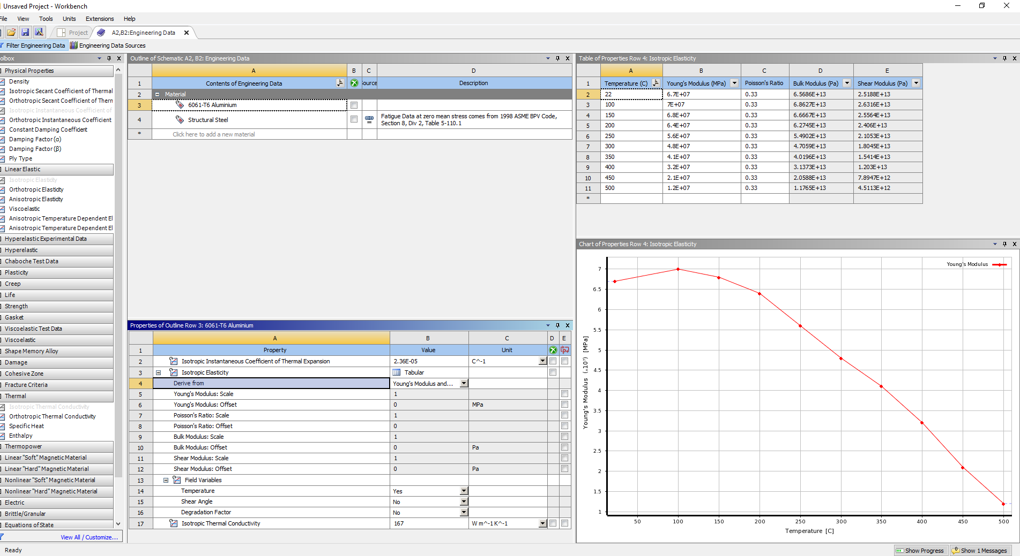
Figure 4: 6061-T6 Aluminium Engineering Data

Method

Rigid Dynamics Analysis
By first creating a rigid dynamics model, using the inputted material data, the model has a starting point where all components are fixed. This analysis system is used to assess the loadings on a component generated through inertia and so within the geometry of this system, all components are set to rigid. This system carries out a kinematic study of the piston under realistic operating conditions via the inputted loadings given within the software.
Once the connections between each component have been realised as revolute joints, so that they follow the normal movement, the system is set up to read the loadings between the gudgeon pin and piston and is then subsequently solved. From here, a graph showing the motion loads is produced. Due to the investigation considering the worst conditions that the component may be subjected to, the maximum forces are retrieved and then exported into the next analysis system.

Static Structural Analysis
The next analysis system is the static structural study. The solution cannot be shared from the transient study within the rigid dynamic analysis with the static structural study and so they only share the same engineering data, geometry and model. Within this analysis software, as the piston is the desired component to be investigated, the rest of the components within the assembly are suppressed, so that is the only component that is measured. It was also key to set the pistons geometry to flexible so that the deformation of the piston under load could be seen. The mesh is set for every run at 1mm. This is a compromise between solving time and data accuracy. Following from the mesh independence study as mentioned in section 3.3. The motion loads from the previous study are then inputted ad then is left until the steady-state thermal analysis has been completed.

Steady-State Thermal Solver
This analysis system takes the engineering data and geometry from the rigid dynamics solver and inputs it into the model section of the system. Within this system, the materials assigned to each component tends to be lost and so this is checked before hand for each run. The mesh will also need to be redone as this data isn’t transferred over from the static structural test. Once again, as the piston is the only component being investigated for these forces, the other components are suppressed. In this solver, 6 convections are applied to differing elements of the piston which act as boundary conditions for the piston to be operating under. The temperature solution is chosen here as it is to be investigated.

Static Structural Retest
The final part of the analysis takes the data from the steady-state thermal study and uses it to get the final results needed. In this section of the Workbench project, the solutions that need to be found are inputted. For this particular study, total deformation and equivalent total stress and strain are chosen as factors to have results created for. A pressure is also applied to the top of the piston for realistic conditions. Importantly, “weak springs,” an option within the analysis settings, need to be switched on. These hold the piston within a 3D space but don’t have a real effect on the measurements being taken. If a fixed joint was used then the deformation that would take place would not be as realistic and therefore the data unreliable. Once this system has been solved, the solution is linked to the setup section of the static structural test.

Results
Material | Mesh (mm) | Temperature (MAX) | Deformation (Total, m) | Equivalent Stress (Total, Pa) | Equivalent Strain (Total, m/m)
6061-T6 Aluminium | 1 | 305.06 | 0.00034265 | 2.20E+09 | X
4032 Aluminium | 1 | 309.14 | 0.00028217 | 2.47E+09 | 0.032974
2618A Aluminium | 1 | 310.25 | 0.00033302 | 2.89E+09 | 0.038787
Figure 5: Material Investigation Results

Initial Study – 6061-T6 Aluminium
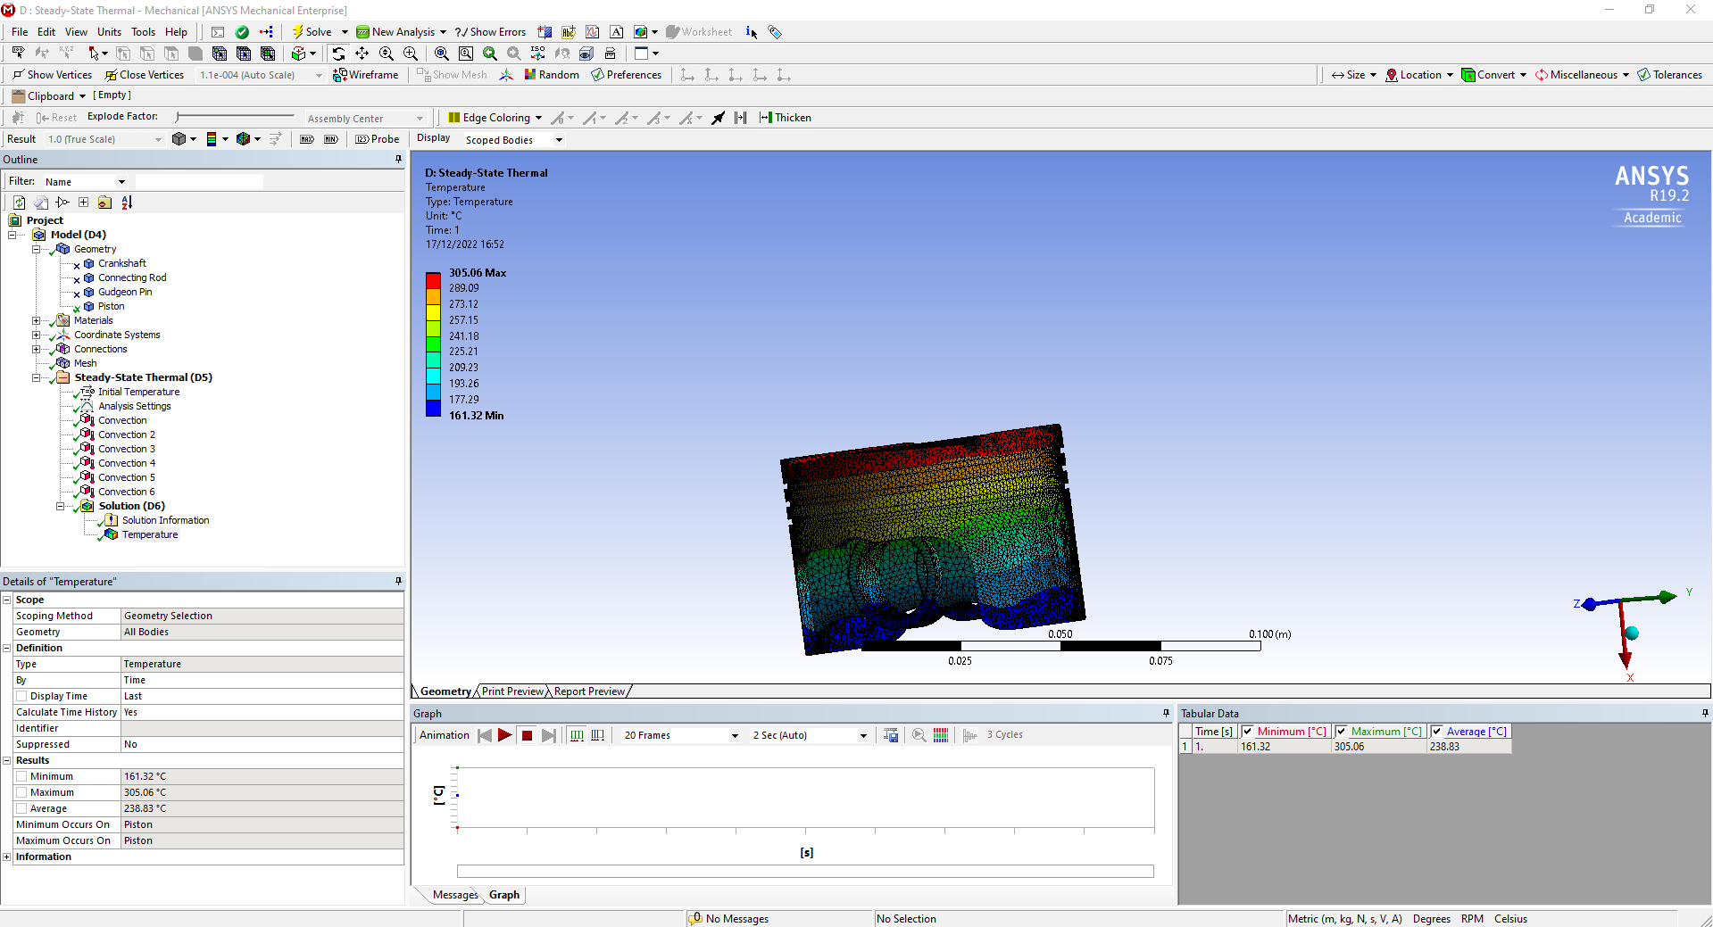
Figure 6: Initial Study Temperature
The initial study showed a result of a maximum temperature of 305.06$℃$ and a minimum of 161.32$℃$. Research suggests that this is an expected result and that it sits in between the normal values that a piston might reach within a passenger vehicle. The expected values for the centre of the piston crown are between 270$℃$ and 310$℃$ so this shows the crown works under a normal load cycle (MAHLE GmbH, 2012). This can be seen in Figure 6. The results from this also showed that it has a maximum total deformation of 0.000342 metres (0.3mm), seen mainly in the centre of the crown of the piston. This is also expected as this is where the bulk of the pressure will form. The maximum stress seen on the component was within the oil ring, which suggests that there could be design improvements to take this stress away from such a small area of the component. This can be seen in Figure 7.
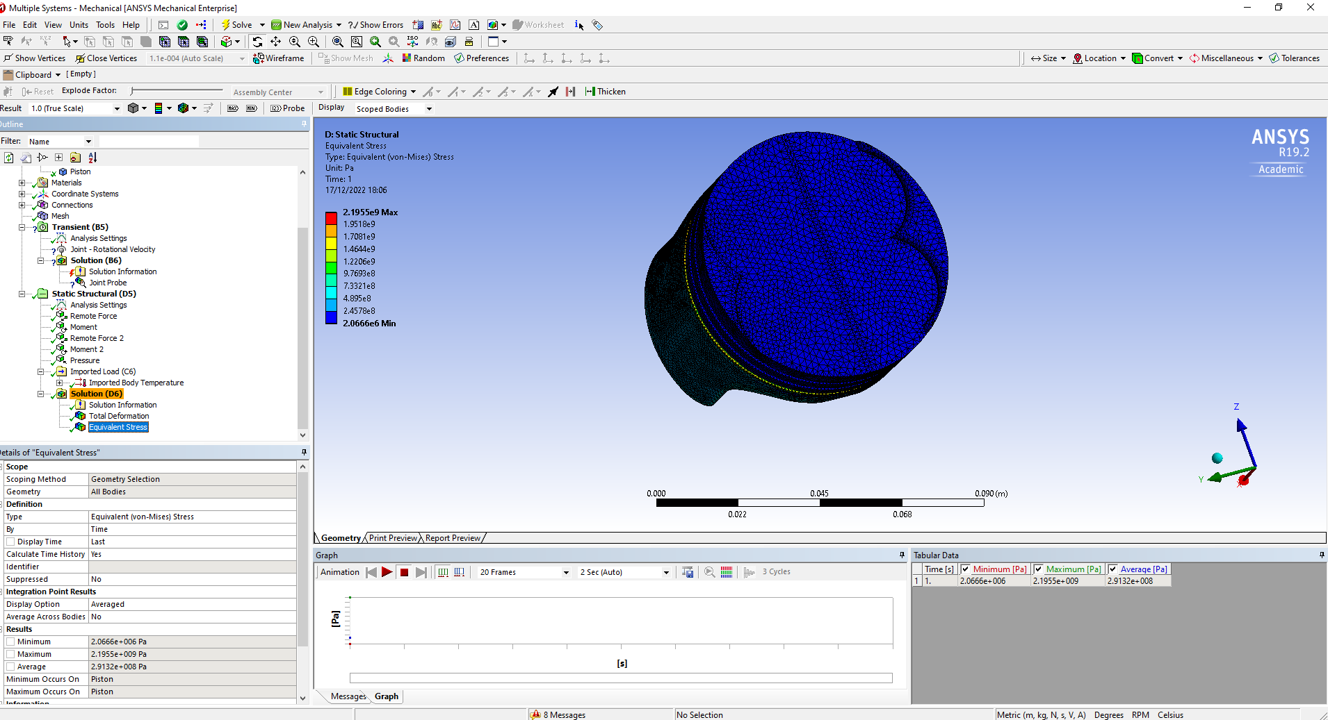
Figure 7: Stress on 6061-T6 Piston
There was also a noticeable increase in pressure, compared to the rest of the piston, where the gudgeon pin meets the connecting rod. This is where a lot of the forces are being exerted as the piston moves through its cycle at 4000 RPM.

Improved Material Choice

4032 Forged Aluminium
Other aluminium alloys, such as 4032 aluminium and 2168A, are commonly used for forged motorsport pistons amongst other applications (Smiths High Performance, 2020). The specifications of this alloy can be seen in Figure 8 (AZO Materials, 2012). This aluminium has a silicon content of 12.2%, allowing the pistons to be lighter and more durable, though it comes with the caveat of reduced ductility, meaning that under cycles of higher loads it has a reduced resistance to such high forces. The alloy can also have further heat treatment which well help increase its overall strength.
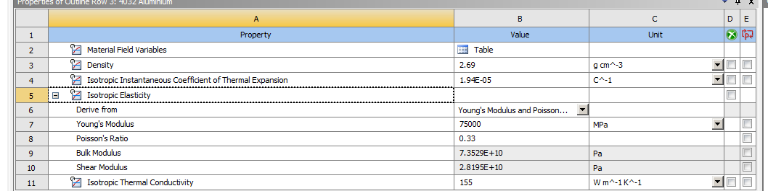
Figure 8: 4032 Material Properties
Once the solvers had run, the values produced were very similar to that of 6061-T6 aluminium. The maximum temperature produced was 309.14$℃$ seen on the top of the piston crown. This can be seen in Figure X. The maximum total deformation acted upon the piston was 0.282mm and the maximum stress was 2.49E09 Pa. Referring to Figure 5, it can be seen that both 6061-T6 and 4032 aluminium have very similar results, though it is surprising to see the 4032 aluminium performing slightly worse out of the two as this is a well known motorsport material used in high quality parts within this application sector.

2618A Aluminium
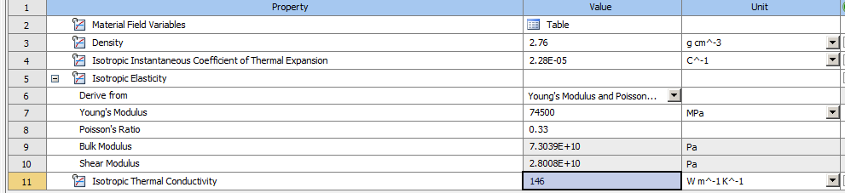
Figure 9: 2618A Aluminium
This particular aluminium alloy, in comparison with the 4032 aluminium, has a lower silicon content which means it has superior malleability – useful in both low and high stress applications. However, the thermal linear expansion of the alloy is far greater (Smiths High Performance, 2020). This alloy was given the material properties seen in Figure 9. The results from this, as seen in Figure 5, show that this performed slightly worse than both the 6061-T6 and 4032 aluminium. This could be expected due to the previously mentioned worse thermal properties. However, due to the alloy having motorsport applications, the material was still tested as it does have ideal properties. The temperature was recorded as 1 degree higher than the 4032 aluminium which could be a solver issue with the mesh not fine enough to capture enough data sets and make an accurate enough model of the temperature conditions. However it was expected that this material would not perform as well as the 4032 aluminium due to its inferior properties.

Conclusion
This investigation into FEA solvers has shown that although a validation study and research into supposedly more appropriate material choices has been completed, results may not be the same as the expected results. The assumption that 4032 aluminium would perform better due to having a well-known motorsport application has been proven to be wrong, though further investigative studies could look at why this result has been produced. The overall conclusion form this investigation is that many of the aluminium alloys have very similar properties and so within the three alloys chosen, all suit the particular application they were treated to. Results from the study were used to help inform the next design choice (material change) though this did not go as planned. Therefore, research into additional alloys and composites, such as the carbon composites pistons developed by Mercedes Benz in the 1980’s (Tingwall, 2014).

Further Work
There is a lot of further work that can be done with this project. For instance, a greater variety of alloys and other materials could be investigated to see how they perform under the same conditions as the three differing aluminium alloys. These include SAE G2500 steel and AK12 aluminium, both metals used within the automotive industry for pistons. As well as a more in depth material investigation, a topology report could be done on the component to see where either mass, volume or shape could be optimized to reduce the stress and temperatures that the piston reaches.

Further Material Investigation

AK12 Aluminium
A further material to be tested is the AK12 aluminium alloy (AL2). This alloy has been tested that, once cast and mixed with non metallic particles such as silicon carbide, produces a significant decrease in the temperature coefficient of linear expansion (Skyrabin & Kuklin, 2020). This aluminium alloy will be tested but because the data for the alloy with the inclusion of silicon carbide and boron fibres is not available, the analysis will instead be ran using the base material properties, when annealed at 290$℃$ to 310$℃$ with exposure between 2 to 4 hours.

SAE G2500
Another material used within the automotive industry for the construction of pistons is SAE G2500 low carbon steel. This is an industry standard material not used just for pistons, but also for small cylinder blocks, gear boxes and cylinder heads (Van Vlack, 1982). It’s properties are similar to that of the 6061-T6 aluminium, but it is a lot denser at 7.15 g/cm⁻³.

Topology Report
This could be done to greatly improve the effectiveness of the piston as well as reducing the fatigue that it develops after running through so many cycles. This would be an area of far greater investigation and could then continue to the rest of the components within the used assembly.

Bibliography
AZO Materials, 2012. Aluminium/Aluminum 4032 Alloy (UNS A94032). [Online]
Available at: https://www.azom.com/article.aspx?ArticleID=6622
[Accessed 08 December 2022].
Dlubal GmbH, 2019. 0016 - Elastic Bending - Continuous Load, Tiefenbach: s.n.
Dlubal Software GmbH, 2019. 0078- Bimetallic Strip, Tiefenbach: s.n.
MAHLE GmbH, 2012. Pistons and Engine Testing. 1 ed. s.l.:Vieweg+Teubner Verlag Wiesbaden.
MatWeb LLC, 1982. SAE J431 automotive gray cast iron, SAE grade G2500. Reading, MA(Massachusetts): Addison-Wesley Publishing Company.
Skyrabin, M. L. & Kuklin, S. M., 2020. Peculiarities of choice of materials for pistons of heat engines. s.l., IOP Publishing.
Smiths High Performance, 2020. 4032 Aluminium Alloy, Biggleswade: Smiths High Performance.
Tingwall, E., 2014. Everything You Ever Wanted to Know About Modern Pistons (and Probably Some Things You Didn't). [Online]
Available at: https://www.caranddriver.com/features/a15109982/everything-you-ever-wanted-to-know-about-pistons-feature/
[Accessed 12 December 2022].
Van Vlack, L. H., 1982. Materials for Engineering: Concepts and Application. Reading(Massachusetts): Addison-Wesley Publishing Company.

Appendices
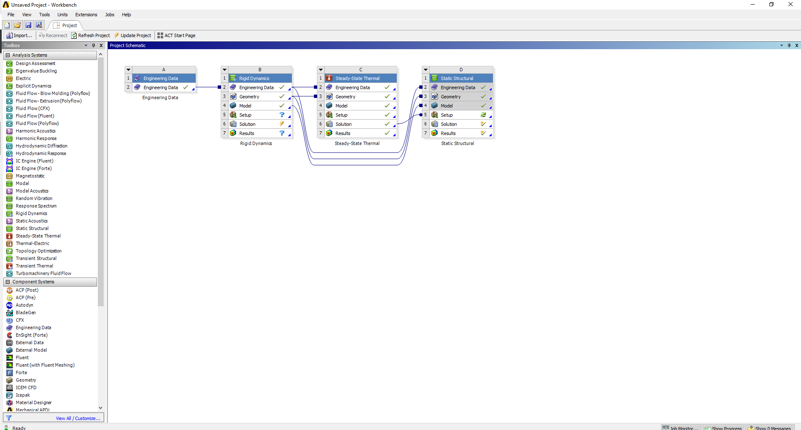
Figure 10: Layout of Workbench project
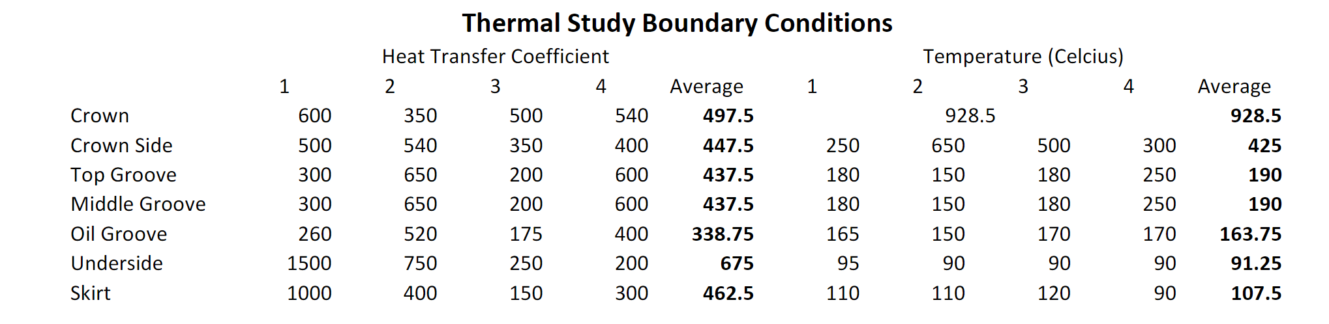
Figure 11: Thermal Boundary Conditions

