ABAQUS Exercise:

- Execute ABAQUS CAE
- Run with standard/explicit solver
- Set Working Folder:
- 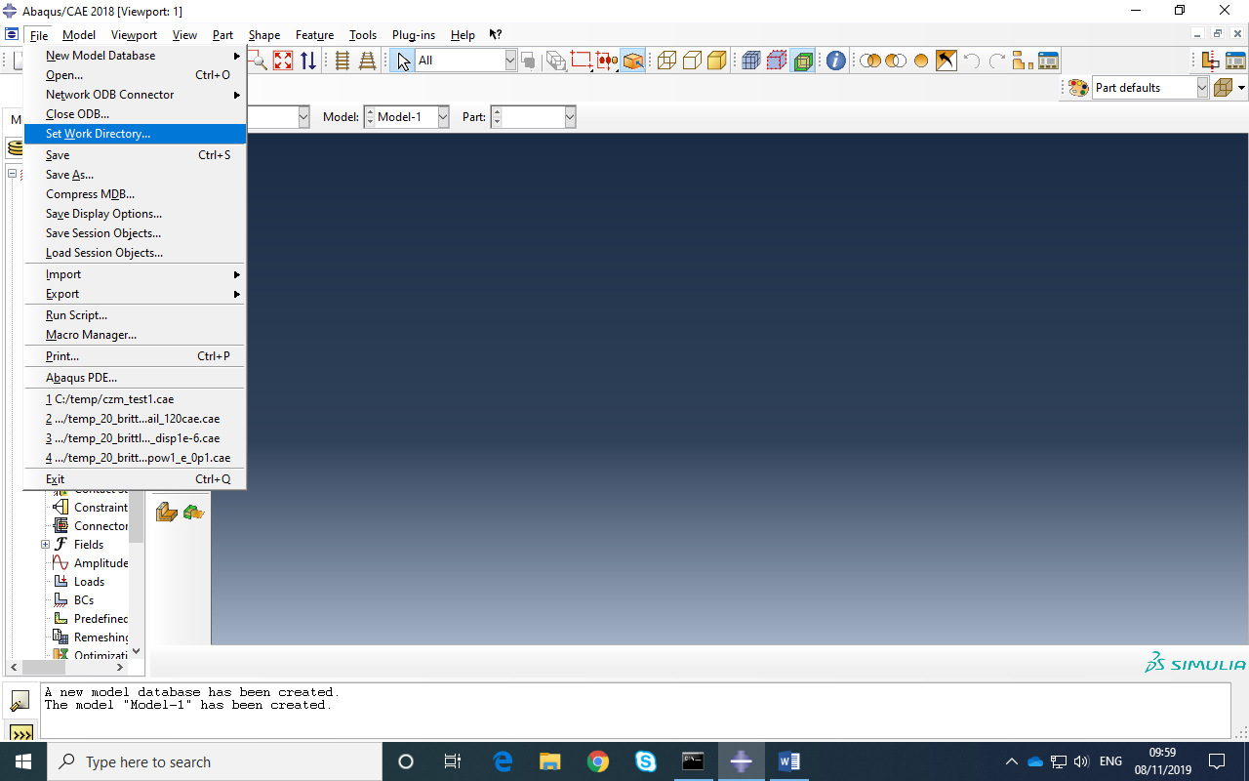

- In PART module: Create a simple cantilever with rectangular cross section :
- 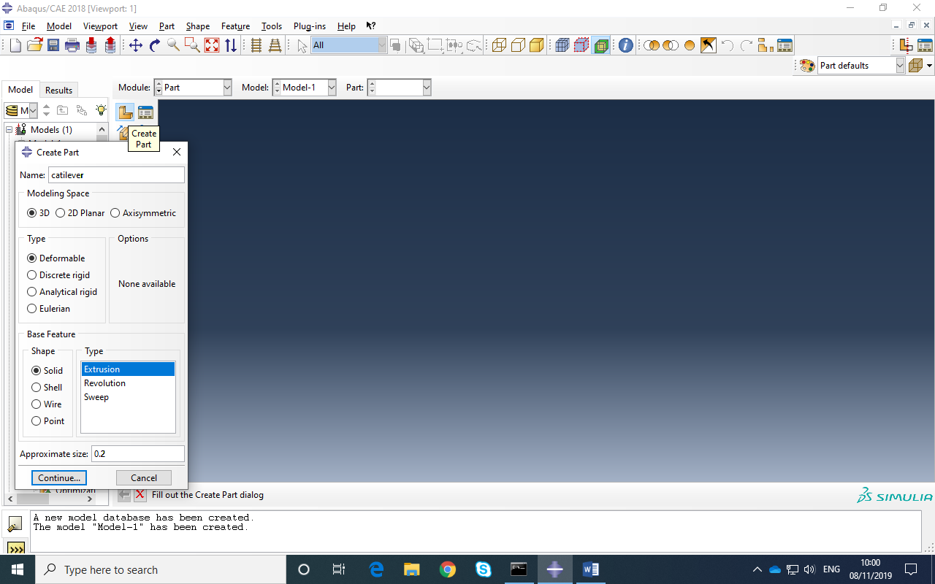

- Remember: Hold down Ctrl and Alt then Left Mouse button is Rotate and Middle Button is Pan. Middle Wheel is zoom at any time.

- Create a rectangular cross section:

- 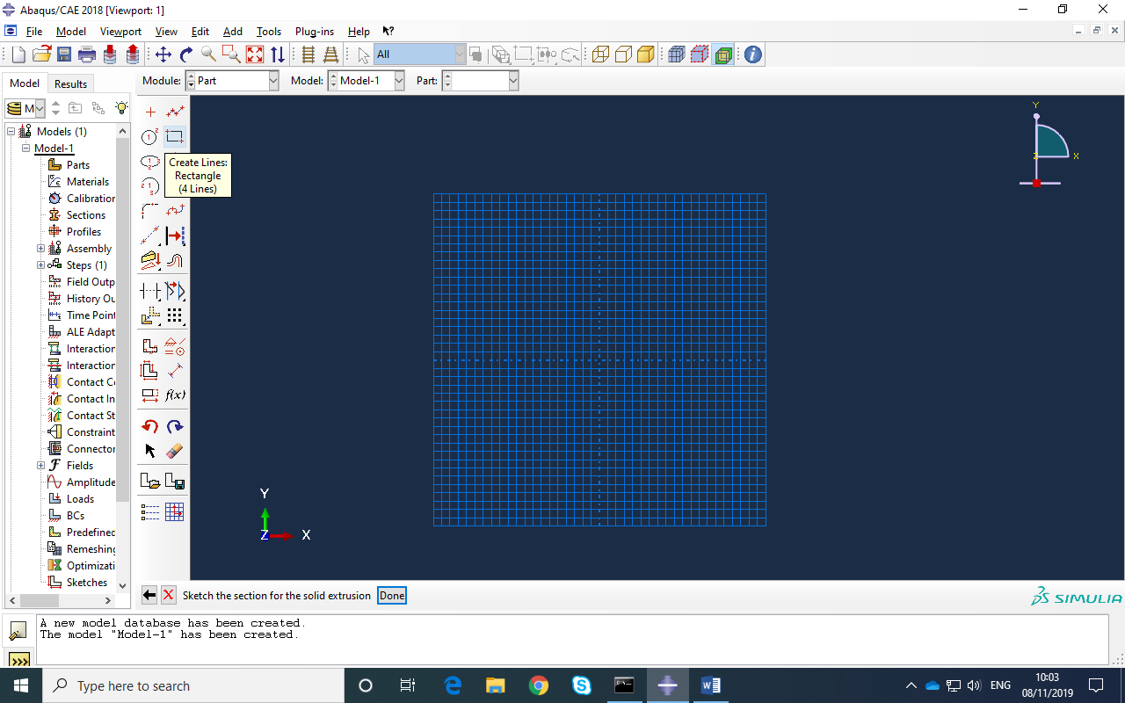

- Draw rectangle then DONE DONE (Middle button is DONE ). Then enter extrusion length of 1m

- 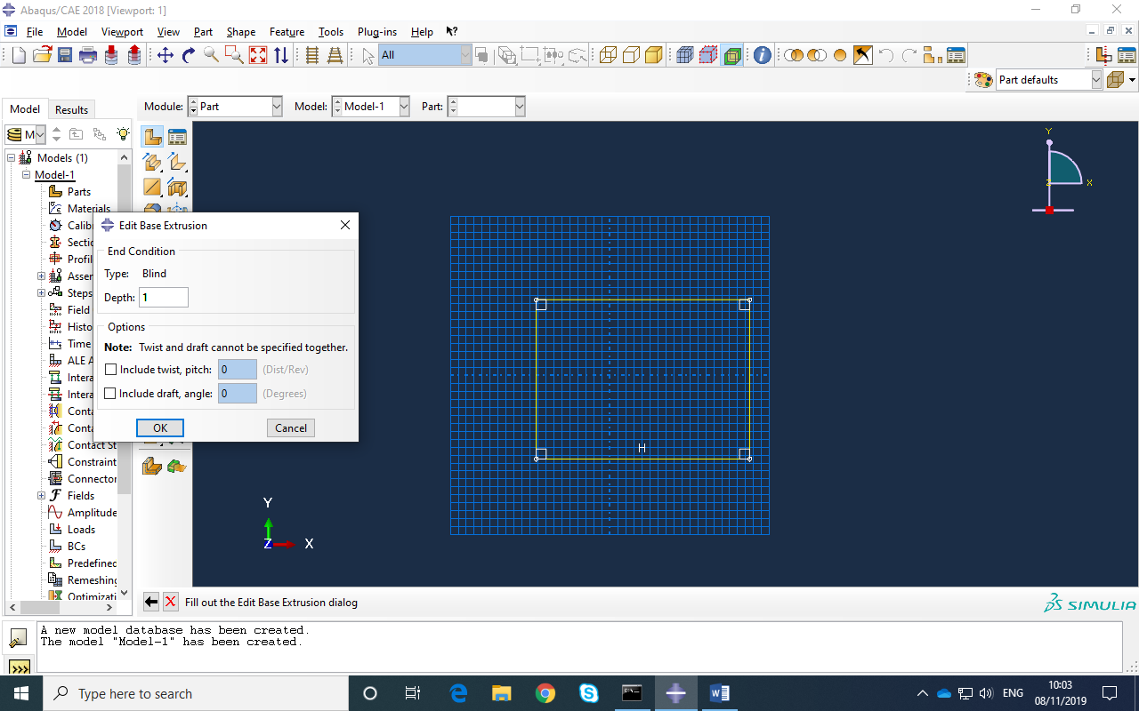

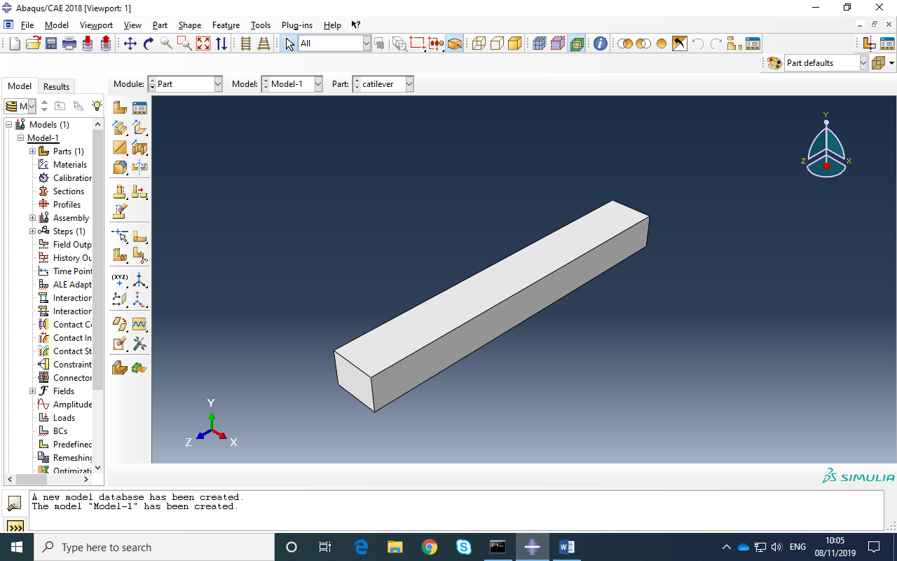

- In PROPERTY module create a new material for Steel. You need density, Youngs modulus and Poisson’s ratio. (Don’t click on OK until all values entered.)
Eg to enter E and ν:
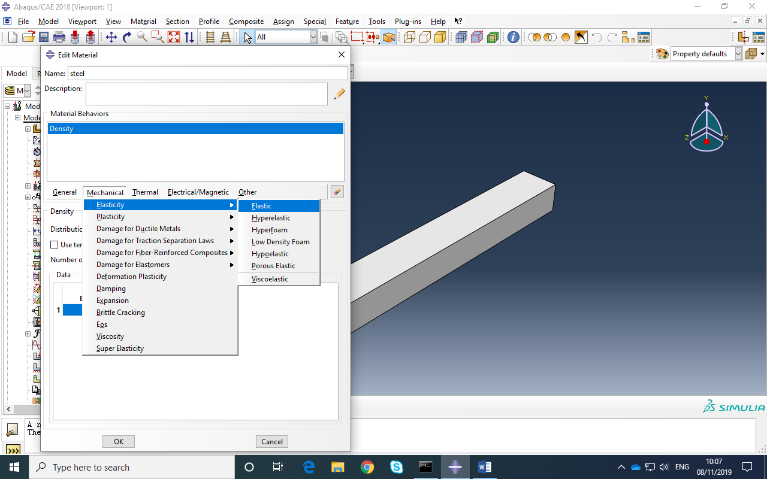

- Create a steel section:
- 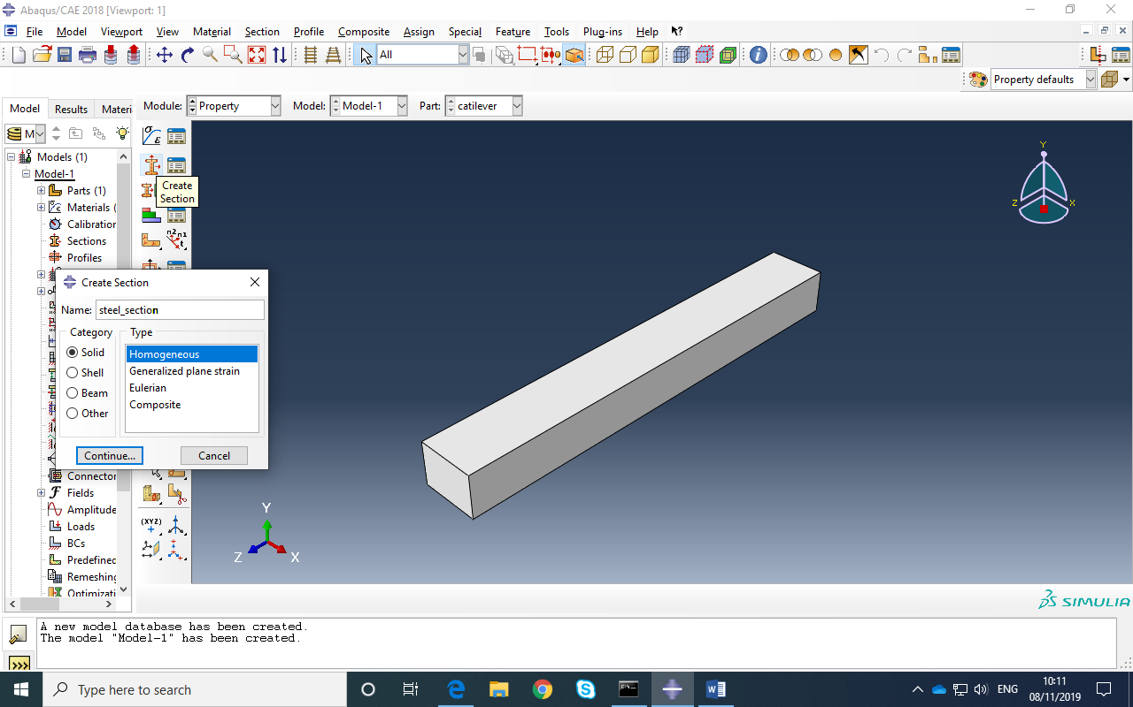

- Assign this steel section to the part on the screen: Follow instructions at bottom of window
- 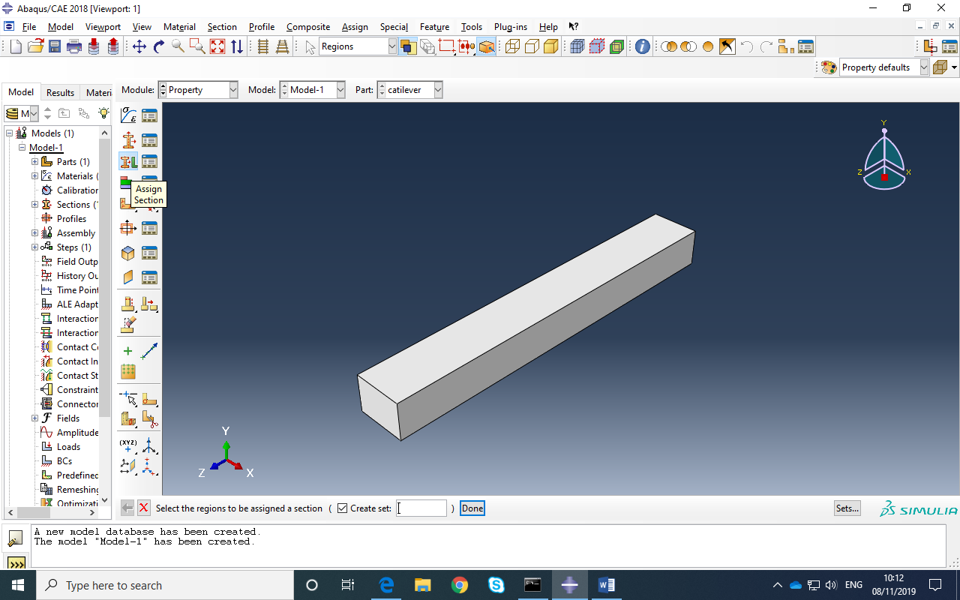
In ASSEMBLY Module: create an instance of the part :
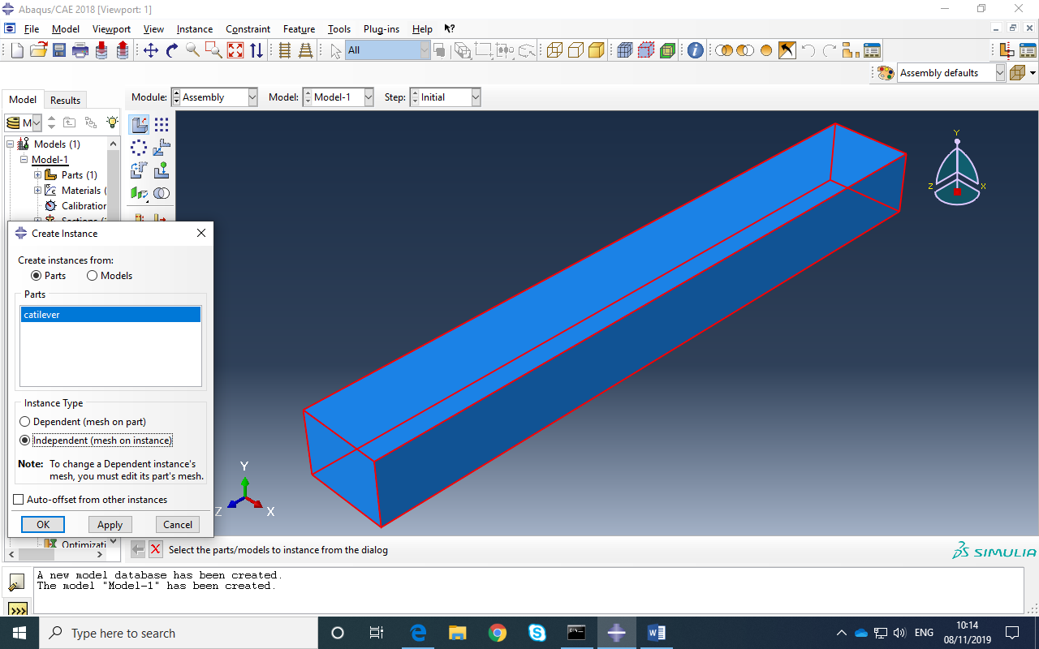

- In the STEP Module create a step that defines the solution type:
- 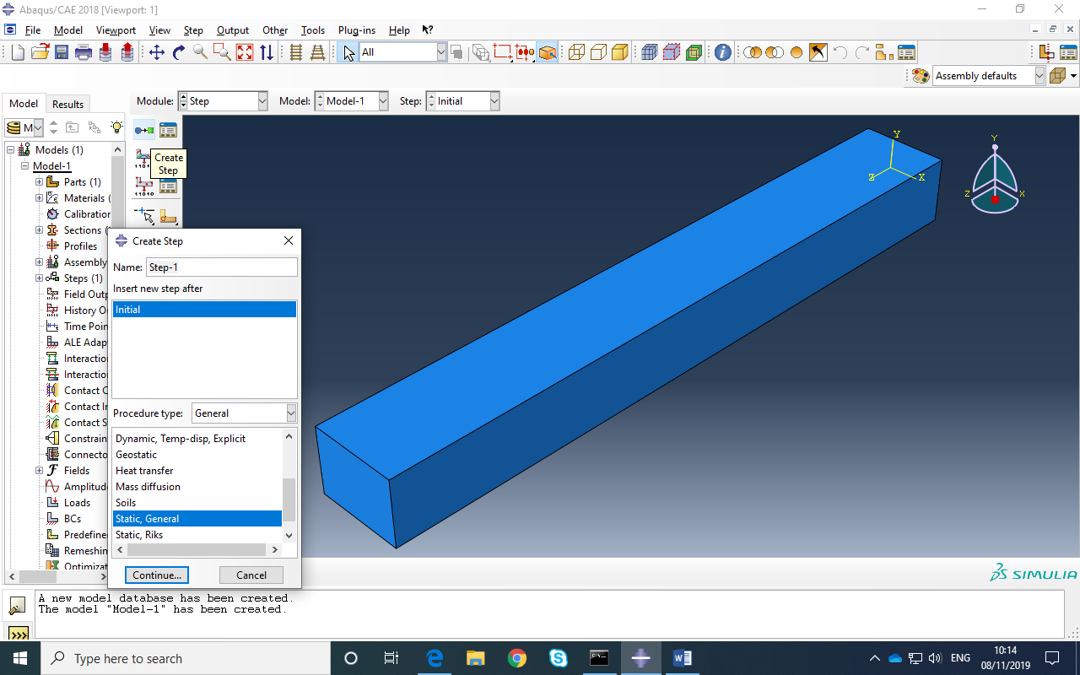

- 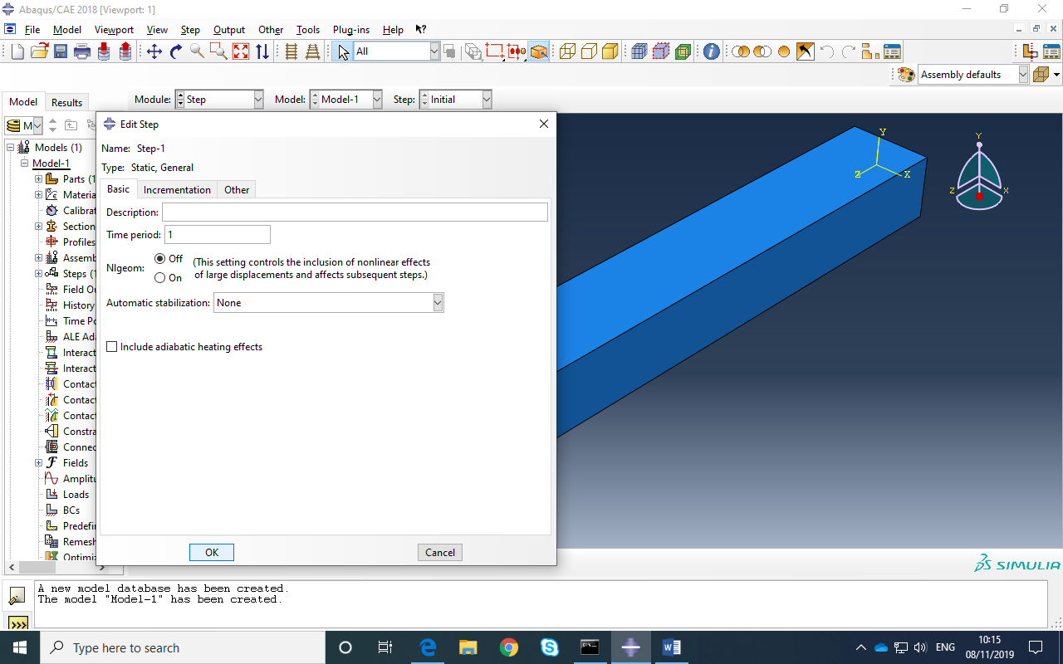

- In the LOAD Module: create a surface traction of 8000N applied perpendicular to the top surface of the cantilever:
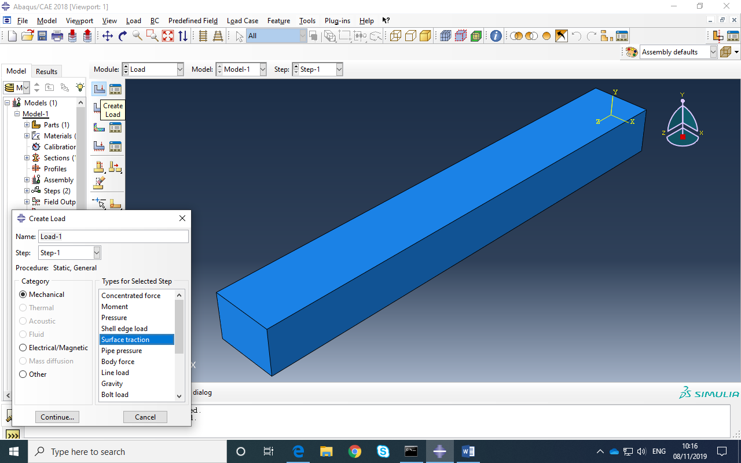

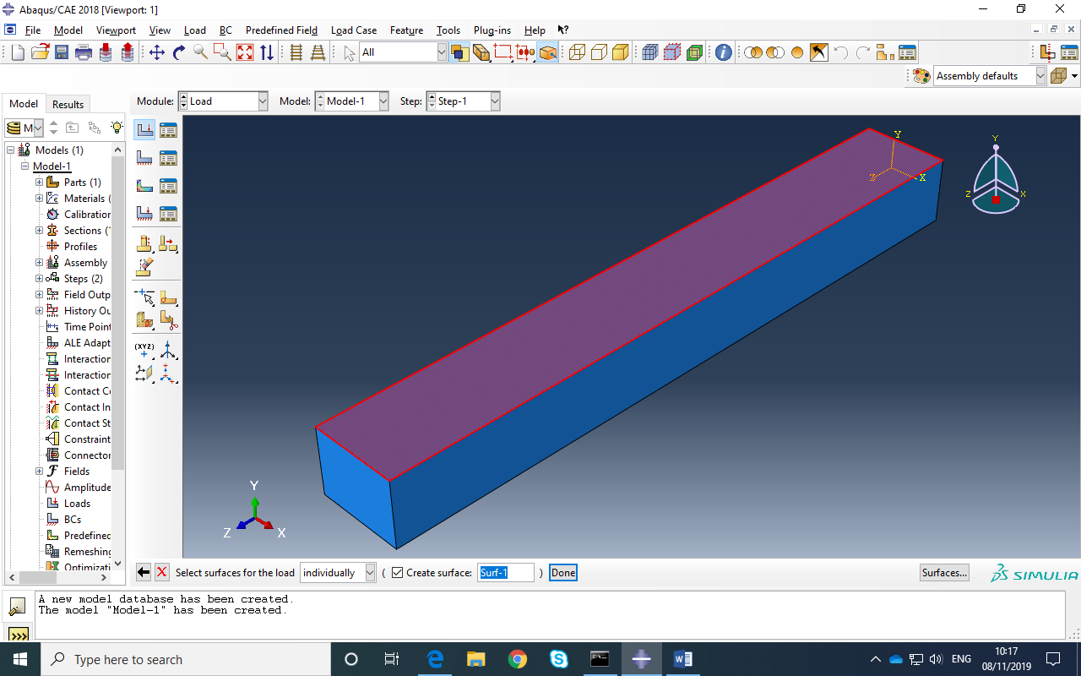

- Make sure you select general traction as shown below. Enter 8000 as magnitude and select two points to define perpendicular direction.
- 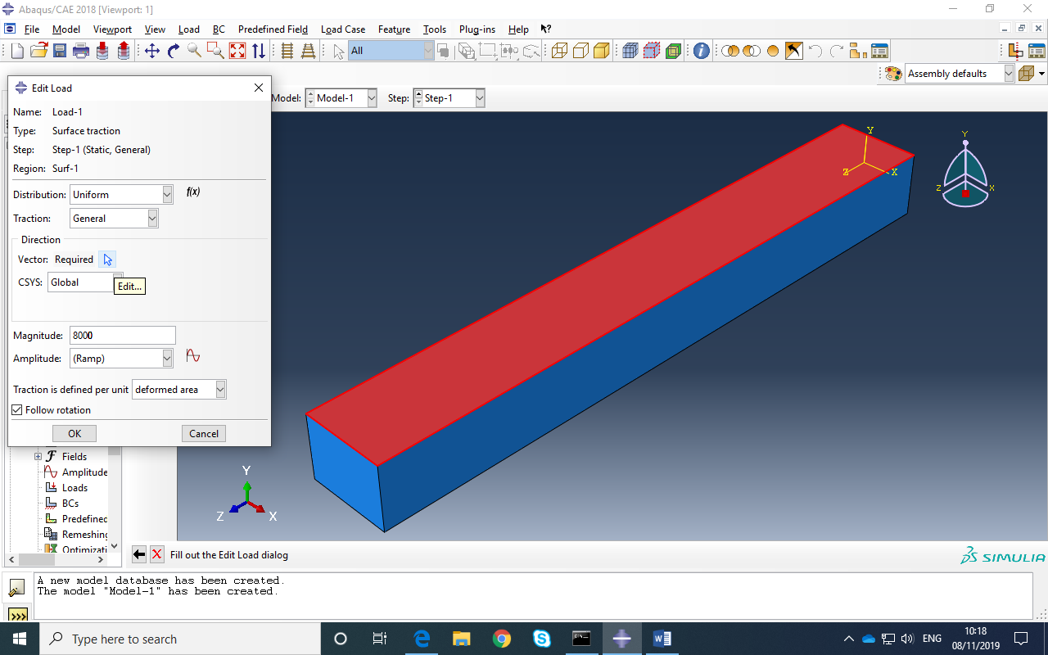
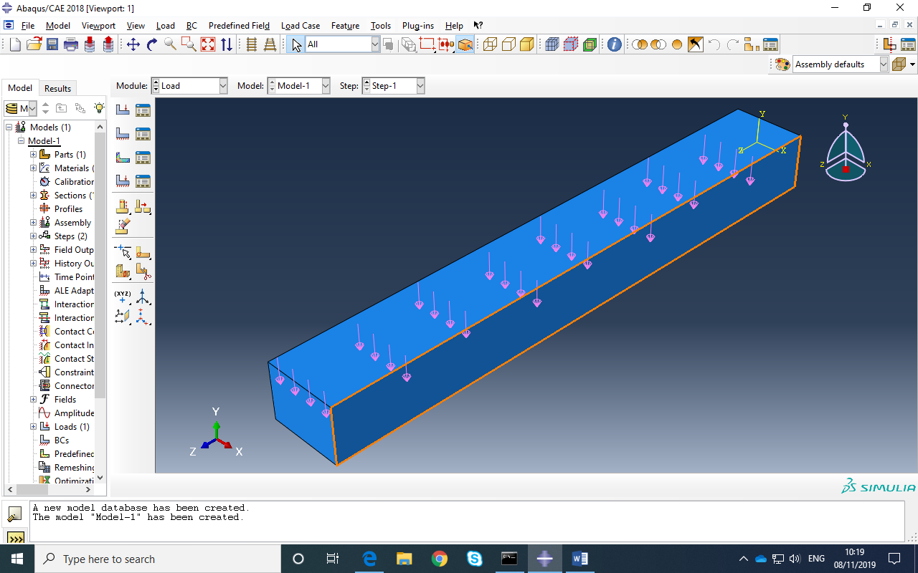

Now clamp one end face with an ENCASTER Boundary Condition:
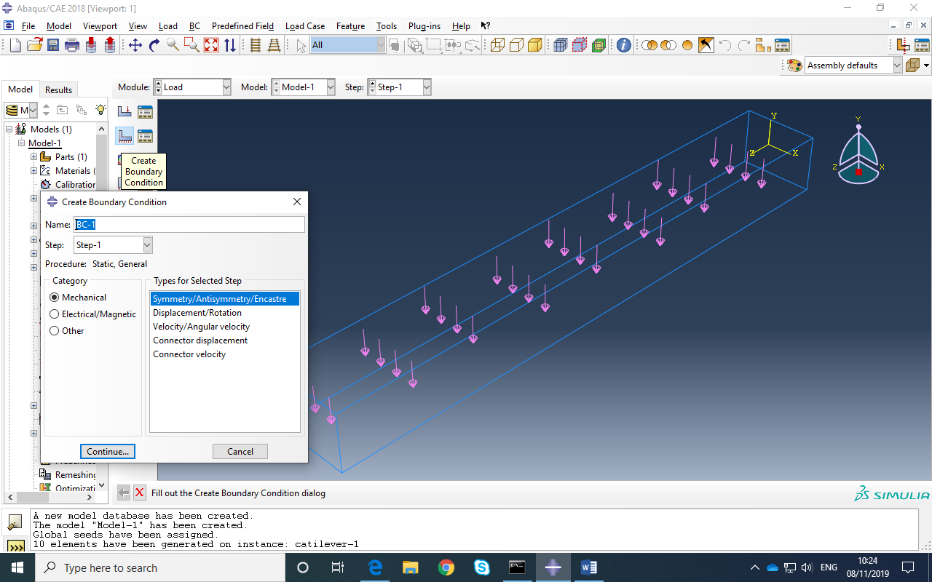

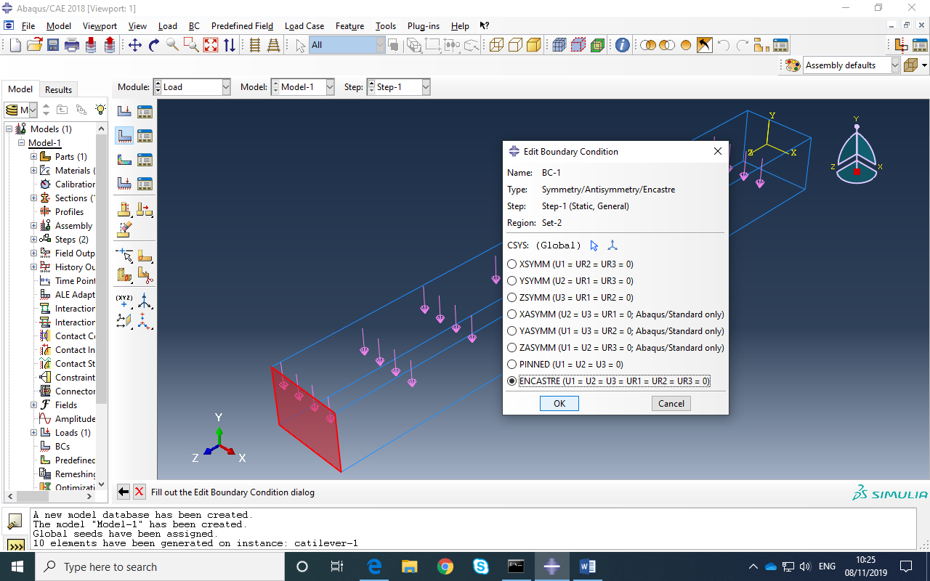

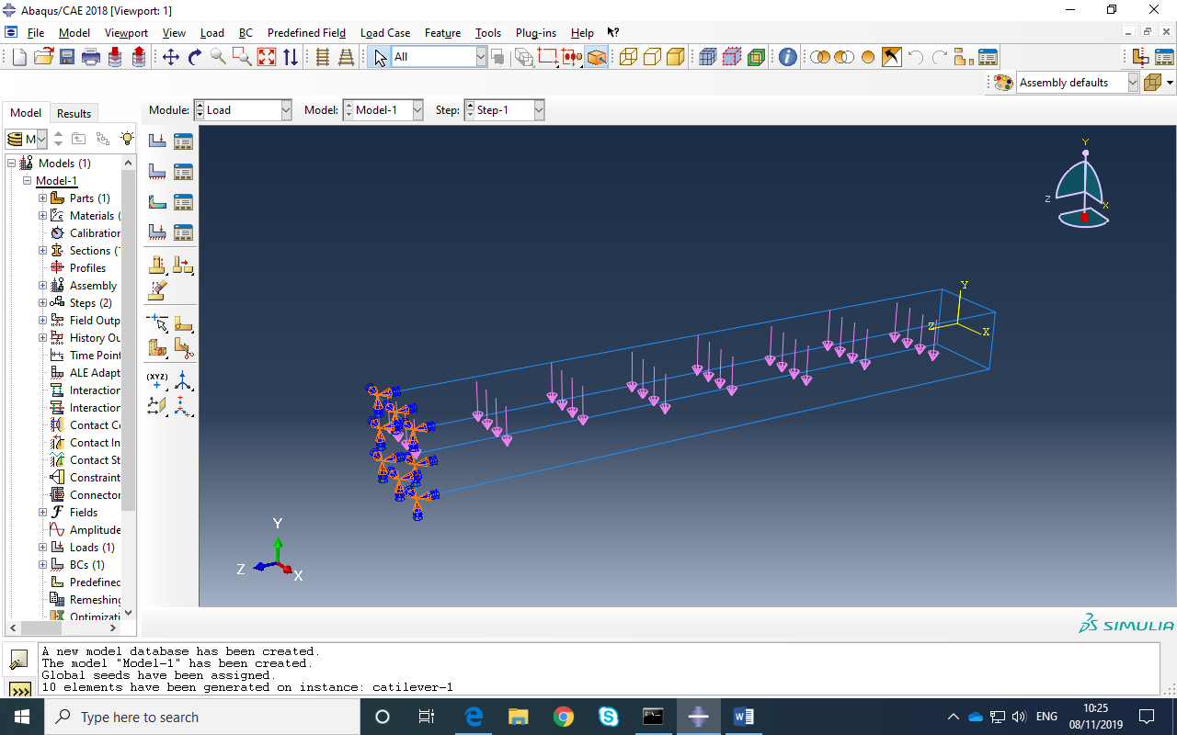

In the MESH Module:
SEED the Part with a global mesh size:
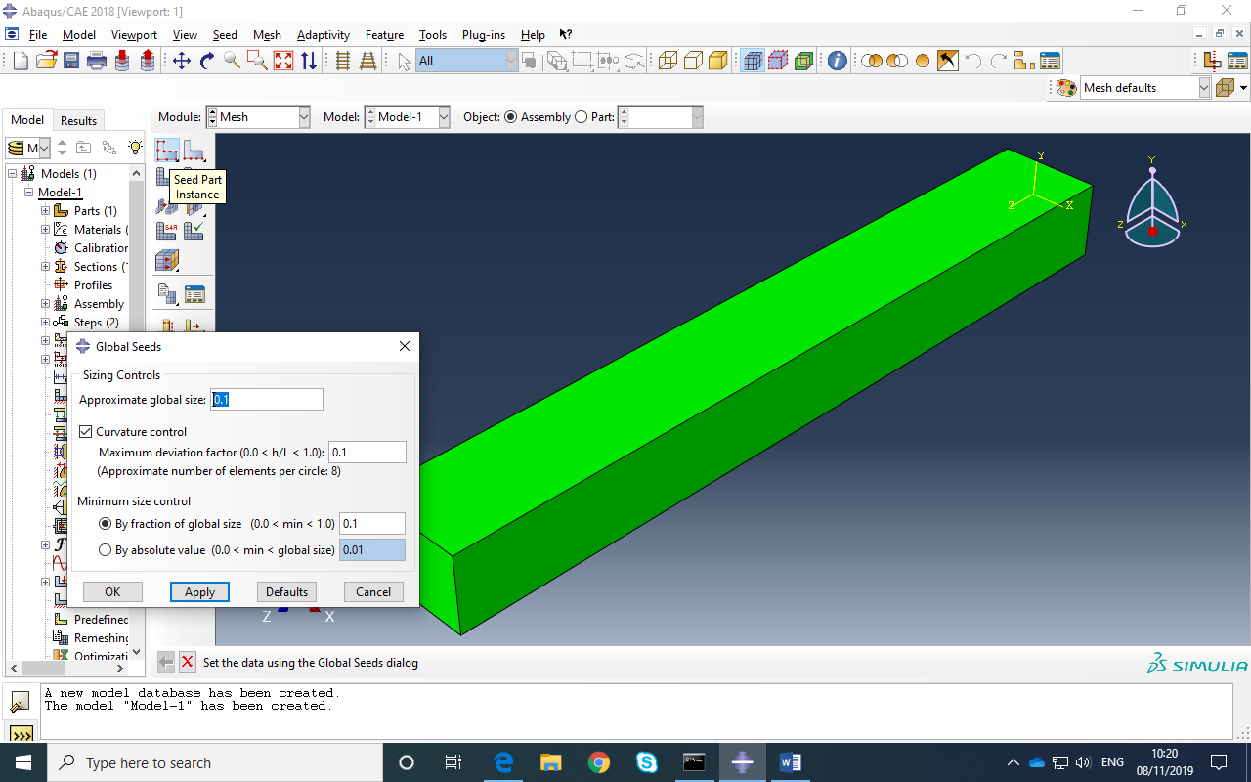
ASSIGN MESH CONTROLS :

ASSIGN ELEMENT TYPE:
MESH the PART:
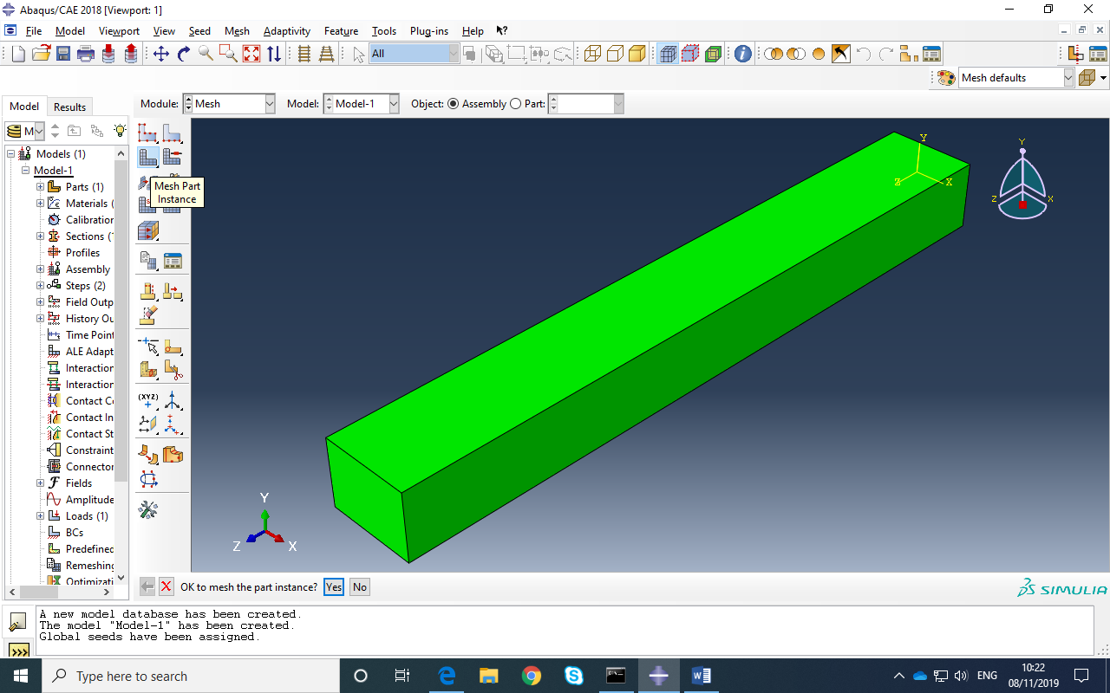

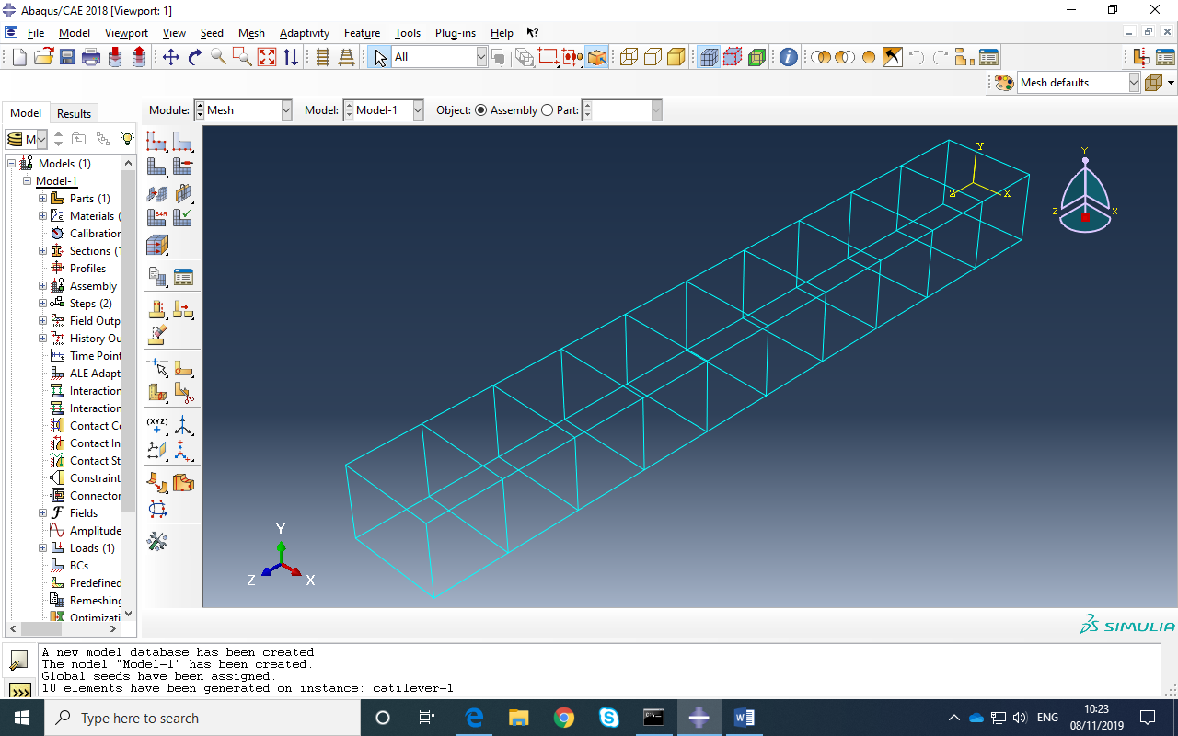

- In JOB module: create a new JOB:
- 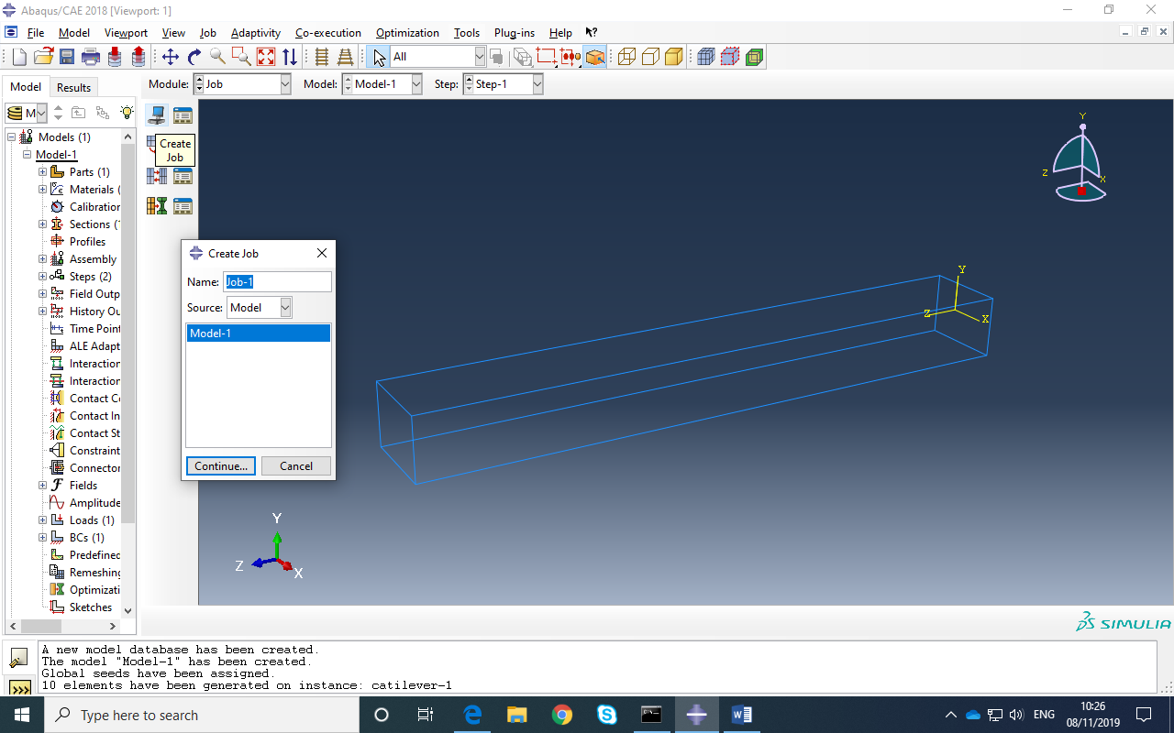
- Select JOB Manager to SUBMIT job and then MONITOR then RESULTS
- 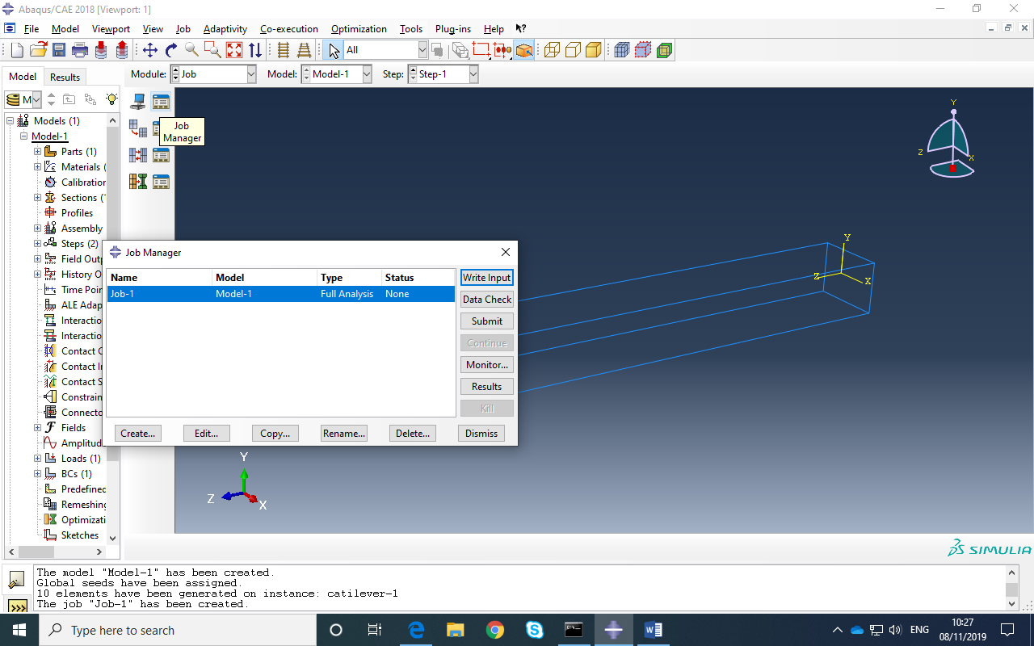

In VIZUALIZER module ( or select RESULTS from JOB MANAGER in JOB module) plot stress contours:


