Laura Monica Lojewski
laurmona17@gmail.com
Abstract
[Draw your reader in with an engaging abstract. It is typically a short summary of the document.
When you’re ready to add your content, just click here and start typing.]
[Document title]
[Document subtitle]

Abstract

Amazon, the global e-commerce giant, has proposed opening new warehouses in the major capitals of Europe, London, Paris, and Berlin, appointing Tom Jackson responsible for forming a team within which its members will have to fulfill their tasks and obligations allocated.
But there were disagreements between the team members and their leader Tom since the beginning of the project, conflicts due to lack of commitment, and differences that some could not overcome. An appropriate level of communication was not found, which led to the impairment of communication between all team members. Because Mihaela and Spencer, two of the team members, are not at all engaged in fulfilling the objectives, they are interested in what they can get from the project. In order not to compromise the project, Tom, responsible for creating a team to successfully complete the project, asked for advice from the consulting firm that offered him solutions on the formation of a successful team.
Introduction
To be considered a team, it must have some fundamental characteristics (Zaccaro & Klimoski, 2001). First, each member of the team has a specific role, and the performance of this role contributes to the collective success. Team members must synchronize and coordinate their individual contributions. Then, the team is asked to perform in a dynamic and complex environment, a characteristic that applies to the organizational team, as is the case with those at Amazon. Another characteristic of a high-performing team is team leadership (Zaccaro, Rittman & Marks, 2001). The team leader is primarily responsible for defining team goals and for developing and structuring the team to accomplish these missions. The skill of a leader in organizing and setting the team's tasks in order to achieve evolution in the accomplishment of the tasks is essential for the effectiveness of the team and is a major factor. The theory specifies the leader's role in creating performance expectations and valences for individual subordinates (House & Mitchell, 1974), not in developing and maintaining effective team interaction and integration.
Overview
According to Kozlowski and Bell (2003), a team is a group that exists to perform organizationally relevant tasks, share one or more common goals, interact socially, exhibit task interdependencies, maintain and manage boundaries, and are embedded in an organizational context that sets boundaries, constrains the team, and influences exchanges with other units in the broader entity’’ (p. 334).
In over half a century of study in the field, specialists have drawn up a set of rules that define a team:
- it is necessary for each member of the team to have an established task;
- everyone must understand how the decisions were made regardless of whether the decision was made by the team leader or democratically;
- team members need time to learn to work together to perform;
- avoiding resentment by awarding prizes to the entire team, in addition to the individual bonus;
- if the team members manage to focus on the assigned tasks and see beyond individual emotions and feelings, they work in a professional manner;
- to keep the team motivated, constant information is needed on the performance or deficiencies that have occurred and that must be corrected;
- to allow the team members to challenge the status quo - challenging the status quo is important because it can allow a company's leaders to evaluate the way the organization operates and consider new ideas. This can promote creativity in the workplace and encourage others to share their own ideas for innovations. challenging the status quo at a company can also help to improve leadership skills and show management the potential as an employee (Indeed Editorial Team, 2021);
- discovering and attracting new talent to the team is a beneficial process that must be learned and constantly improved;
Taking the Amazon Business team as an example, all team members are thought, leaders. The team is united in pursuit of a common goal of finding new solutions by combining passion, imagination, and individuality. Each team member is encouraged to explore new possibilities as a self-challenge combining work with passion (Amazon Business, 2022).
Tom Jackson, the team leader appointed by Amazon, encountered problems in creating a team due to poor communication with the team members, the lack of engagement in accomplishing the tasks, and the interest in obtaining benefits of two of the unmotivated team members, problems arising as a result of poor leadership.
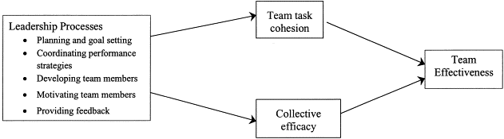
Figure 1 Influence of leader performance functions on team motivational processes.
https://ars.els-cdn.com/content/image/1-s2.0-S1048984301000935-gr3.gif
For a team to work effectively, the team should look at the group climate and the process by which they will complete their tasks. Here are some tips for effective teamwork (Top Tips for Effective Teamwork, 2017):
- Make teamwork a priority and reward teamwork
- Clarify roles, responsibilities, and accountabilities
- Set clear goals
- Communicate with each other
- Make decisions
- Build trust and get to know each other better
- Celebrate differences/diversity
- Examine and improve teamwork processes and practices


Figure 2 Teamwork
https://www.istockphoto.com/photo/stack-of-hands-showing-unity-gm625736338-110244281
Most of these studies demonstrated that team members are likely to display less emotional reaction to stressors if leaders provide clear team goals, clear specification of member roles, and unambiguous performance strategies (Isenberg, 1981, Mintz, 1951, Strauss, 1944, Sugiman & Misumi, 1988). If a leader manages, by whatever means, to ensure that all functions critical to both task accomplishment and group maintenance are adequately taken care of, then the leader has done his job well.

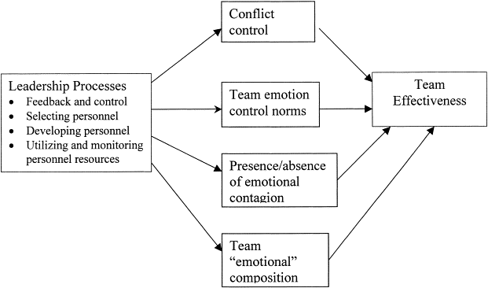
Figure 3 Influence of leader performance functions on team affective processes.
https://ars.els-cdn.com/content/image/1-s2.0-S1048984301000935-gr4.gif

Models of team development
According to Judith Stein (For a team to perform, it is necessary for the team members to understand their development as a team. Teams go through stages of development. The most commonly used model for the stages of team development was developed in 1965 by Bruce W. Tuckman. For 40 years, the model created by Dr. Tuckman provided psychological comfort to those who had to lead a team or who were trying to make a functional team that conflict is something normal in the process of forming a united team. It is about the classic model of FORMING, STORMING, NORMING, PERFORMING to which he added after a few years the fifth element ADJOURNING.

In the first stage within the group, bonds and relationships are formed between members and between them and the team leader, behavioral limits are tested and common or individual work standards are established.
The second stage is the conflict within the group characterized by the lack of unity and the appearance of individual problems when people want to express their value. It is the most dangerous stage in the formation of the team when certain people become isolated motivated by the fact that they feel in the wrong place. People must be encouraged to do things at their own pace. It is scientifically proven that the second stage can last several years.
In the third stage, roles and relationships are established, people focus on skills and important decisions can be made and implemented, risks are assumed and mistakes are seen as a step forward towards success. The leader asks his team members what solutions they have before offering his own solution.
In stage four we find a team that works at maximum parameters, the conflict is constructive and the success is complete. Everyone's contribution is recognized and resentment is anticipated, so the Storming internship can be difficult to avoid.
The last stage - Adjourning, is about the feeling of closure/finality of the team whose project is completed. People find out how far they have come and measure their contribution to the whole project. The way this final stage is managed can have consequences on the future team to which new members join. It is time to recognize individual and collective achievements (Course: Effective Team Working and Communication, 2022).
The Tuckman model is purely theoretical and can be referred to or used as a standard for small teams, but today's leaders are faced with more sensitive problems in practice and it is considered that they do not know exactly how to transition between stages, psychologically speaking, how to overcome people critical moments, for example, or if the transition between stages is really done, some teams remain in stage 1 or 2, the teamwork could also move backward, from performing back to storming, or skip a stage totally, mainly if there’s pressure from the company to succeed.
Wheelan advanced the Integrated Group Development Model that integrates earlier models of group development suggested by Tuckman (1965), Bion (1961), Bennis and Shepard (1956), and Bales (1965), among others, and describes how groups go through four distinct stages and a termination stage (Wheelan, 2005, 2016). According to Wheelan (2005) professor of Psychological Studies, most groups contain people who are trying to do a good job. They may not know how, and they may not be socially skilled, but they are trying.

Wheelan (2005) argued that groups evolve differently, even though some do not evolve at all, and those that evolve do so gradually based on previous stages. According to Wheelan, team members should examine factors other than behaviors that might block progress, not take things too personally, and not expect perfect harmony. The success of a group, Wheelan concludes, depends not on whether members like each other, but on resolving conflicts and focusing on common goals.
Susan Wheelan built on Tuckman's model and informed that groups reach development simply by working together. She claims that there is a significant relationship between the length of time that a group has been together and their behavioral patterns.
In many larger groups, the members have not had the opportunity to really get to know each other, as most groups do. This lack of traditional conflict would make it harder to tell if they have passed the first phase and entered the Storm phase. The Wheelan model would indicate that they have not yet achieved it due to the lack of a specified goal. So, in the stage of development, they are between the Forming and Storming stages.
According to Belbin (1996) team roles were designed to define and predict the potential success of management teams, recognizing that the strongest teams have a diversity of characters and personality types. Each member of the team is looking for a specific role in which they can perform easily.
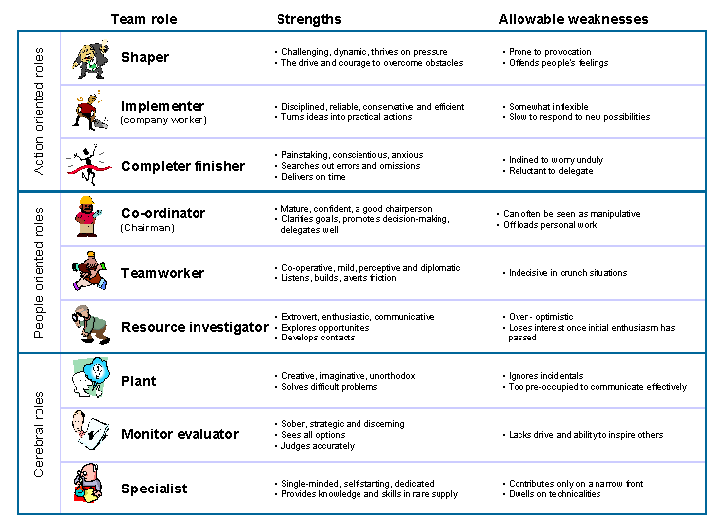

https://www.ifm.eng.cam.ac.uk/uploads/Research/Design_management/Belbin.gif

The nine Belbin Team Roles are: Resource Investigator, Teamworker and Co-ordinator (the Social roles); Plant, Monitor Evaluator and Specialist (the Thinking roles), and Shaper, Implementer and Completer Finisher (the Action or Task roles). A team should normally have a balance of all 9 team roles. Teams have a coordinator, a factory, an evaluator monitor, and one or more implementers, team workers, resource investigators, or finishers. A shaper should be an alternative to a coordinator, rather than having both. Using the Belbin reports can give people a greater understanding of their strengths, which leads to more effective communication in the team. Managers can put together great teams, enhance the performance of existing ones, and ensure that everyone feels that they are making a difference in the workplace.
As they say, many brains are better than one. "Behind every genius is a team", and "When people play off each other's skills and knowledge, they can create solutions that are practical and useful." (John J. Murphy, 2022). According to Murphy (2022), teamwork is essential to a company’s success.
The benefits of teamwork include, among others:
1. Better problem solving
2. Increased potential for innovation
3. Happier team members
4. Enhanced personal growth
5. Less burnout
6. More opportunities for growth
7. Boosted productivity
8. Smarter risk-taking
9. Fewer mistakes
10. Expanded creativity

In the case of Tom Jackson's team, the team must resolve their conflicts and focus on common tasks. At the same time, the leader can communicate effectively with the team by assigning each a specific task, making himself fully understood, and requesting the team's cooperation and support. Being in the Forming stage, the leader can create a close bond with the team and help create relationships between team members, motivate them to create a cohesive, dynamic team with a well-defined goal, able to complete the project assigned.

Reference List

- Zaccaro, S. J., Rittman, A. L., & Marks, M. A. (2001). Team leadership. The Leadership Quarterly, 12(4), 451-483.
Available at: https://doi.org/10.1016/S1048-9843(01)00093-5 Accessed: 12.10.2022

- Zaccaro, S. J., & Klimoski, R. (2001). The interface of leadership and team processes. Group and Organization Management. Special Issue

- House, R.J., Mitchell, T.R., (1974). Path-goal theory of leadership. Journal of Contemporary Business, 4, pp. 81-97

- Top Tips for Effective Teamwork – Uplift events blog
Available at: https://www.upliftevents.com.au/blog/top-tips-effective-teamwork/ Accessed: 12.10.2022

- Amazon Business Worldwide Careers (2022)
Available at: https://business.amazon.com/en/join-our-team Accessed: 12.10.2022

- Indeed Editorial Team (2021). Available at: https://www.indeed.com/career-advice/career-develop challenging-the-status-quo Accessed: 15.10.2022

- Stein, J. (2022). Using the Stages of Team Development. Human Resources Massachusetts Institute of Technology, Available at: https://hr.mit.edu/learning-topics/teams/articles/stages-development Accessed: 15.10.2022

- Course: Effective Team Working and Communication. Available at: https://moodle.uwtsd.ac.uk/course/view.php?id=5299 Accessed: 15.10.2022

- Åkerlund, M., Jacobsson, C., & Tilin, F. (2020). The Legacy of Susan Wheelan. 52(1) Available at: https://journals.sagepub.com/doi/full/10.1177/1046496420956713 Accessed: 16.10.2022

- Moultrie, J. Design Management Tools and Techniques. Belbin’s Team Role. University of Cambridge Available at: https://ifm.eng.cam.ac.uk/research/dmg/tools-and-techniques/belbins-team-roles/ Accessed: 16.10.2022

- The Nine Belbin Team Roles Available at: https://www.belbin.com/about/belbin-team-roles
Accessed: 16.10.2022

- Middleton, T. (2022). The importance of teamwork. Available at: https://www.atlassian.com/blog/teamwork/the-importance-of-teamwork Accessed: 16.10.2022

