Formulae Sheet

Ohms Law  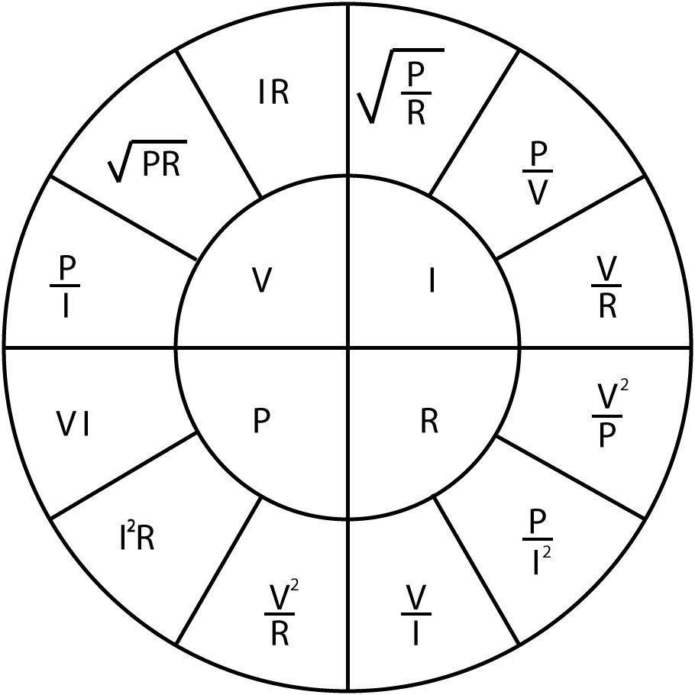 |  | Series Resistors  $$R_{T}=R_{1}+R_{2}+…+R_{n}$$  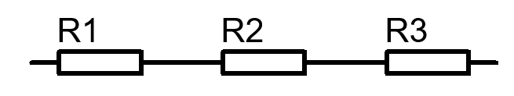 | Potential Divider  $$V_{Out}=V_{in}\frac{R_{B}}{R_{A}+R_{B}}$$  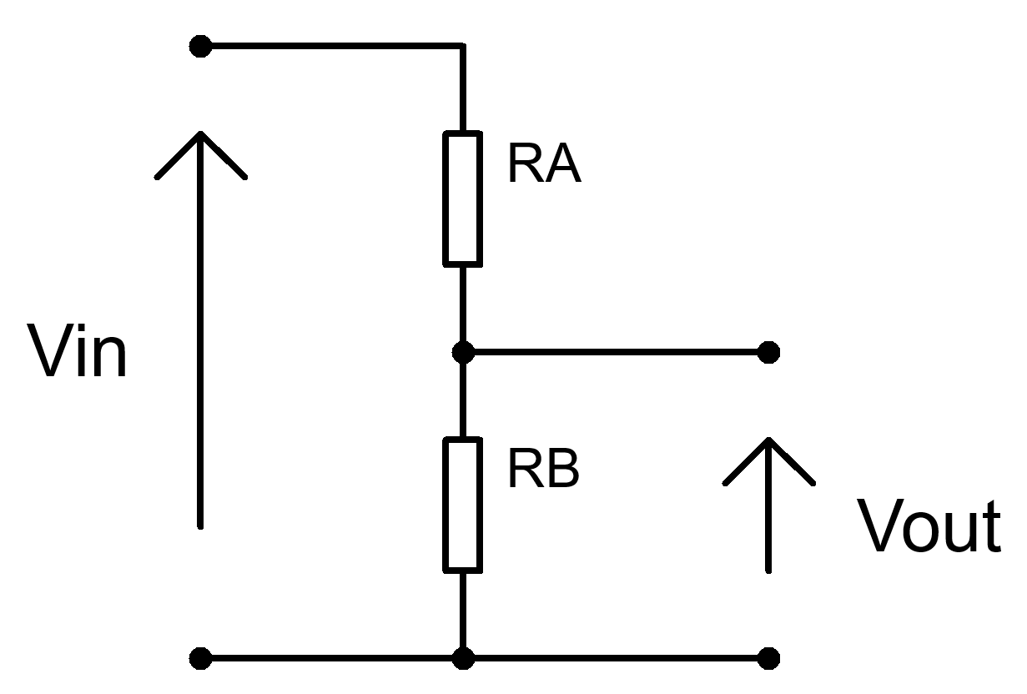
 |  | Parallel Resistors  $$\frac{1}{R_{T}}=\frac{1}{R_{1}}+\frac{1}{R_{2}}+…+\frac{1}{R_{n}}$$  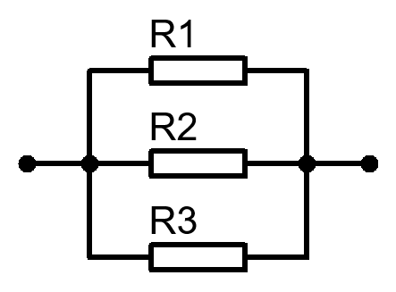 | Current Divider  $$I=I_{in}\frac{R_{B}}{R_{A}+R_{B}}$$  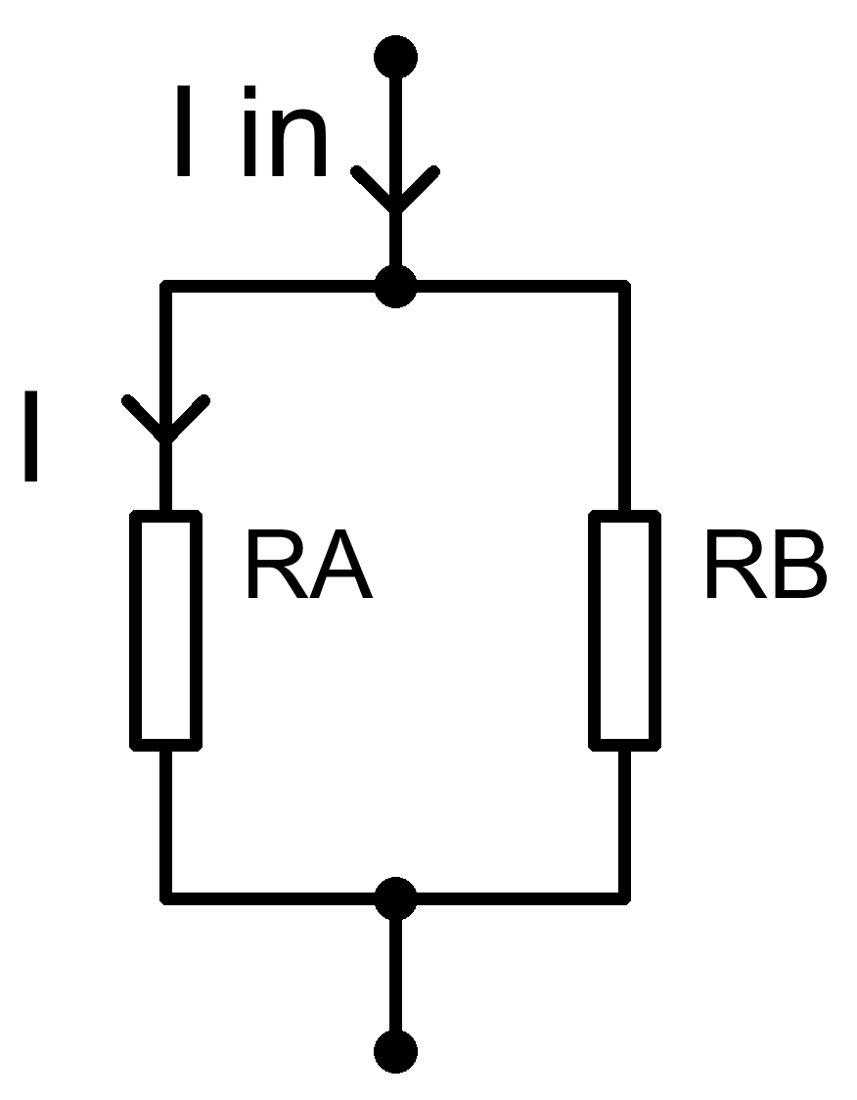
Capacitive Reactance  $$X_{C}=\frac{1}{2πfC}$$  $$X_{C}=-j\frac{1}{ωC}$$ | Inductive Reactance  $$X_{L}=2πfL$$  $$X_{L}=jωL$$ | Series Capacitors  $$\frac{1}{C_{T}}=\frac{1}{C_{1}}+\frac{1}{C_{2}}+…+\frac{1}{C_{n}}$$  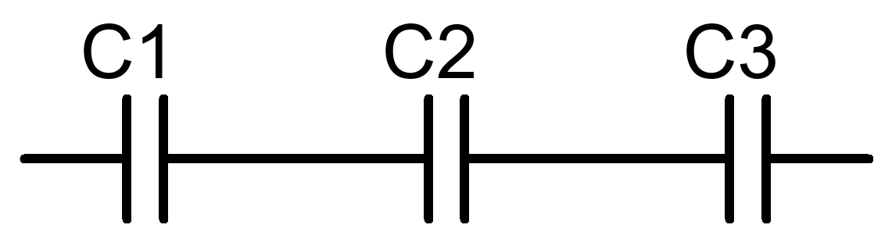 | Series Inductors  $$L_{T}=L_{1}+L_{2}+…+L_{n}$$  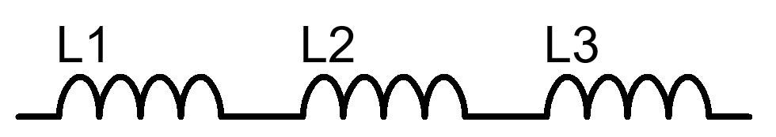
Impedance  $$Z=R+j\left(X_{L}-X_{C}\right)$$  $$\left|Z\right|=\sqrt{R^{2}+{\left(X_{L}-X_{C}\right)}^{2}}$$ | Total Reactance  $$X_{T}=X_{L}-X_{C}$$ | Parallel Capacitors  $$C_{T}=C_{1}+C_{2}+…+C_{n}$$  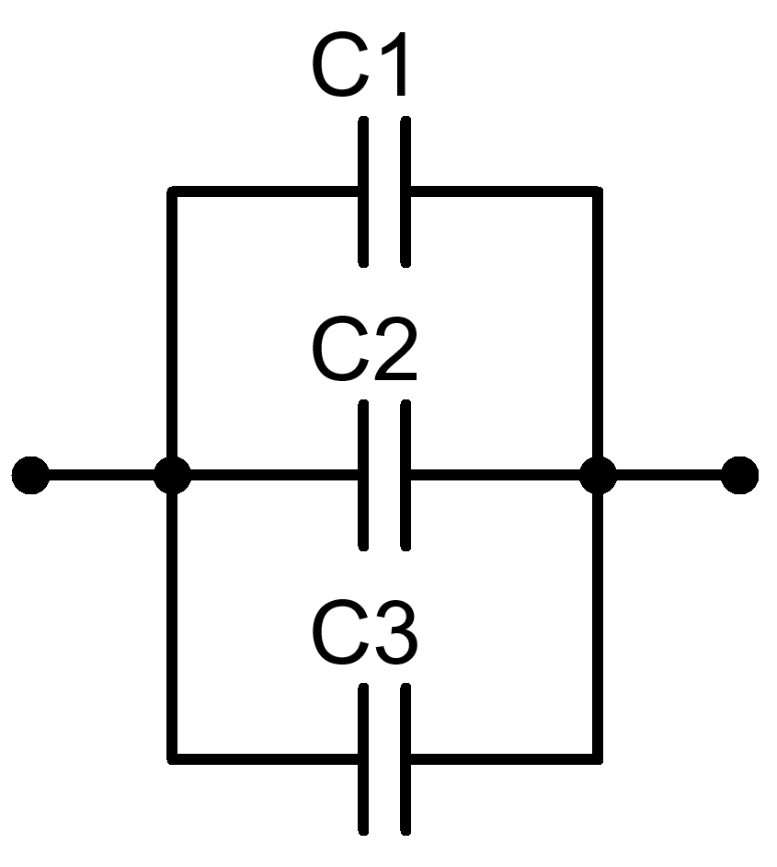 | Parallel Inductors  $$\frac{1}{L_{T}}=\frac{1}{L_{1}}+\frac{1}{L_{2}}+…+\frac{1}{L_{n}}$$  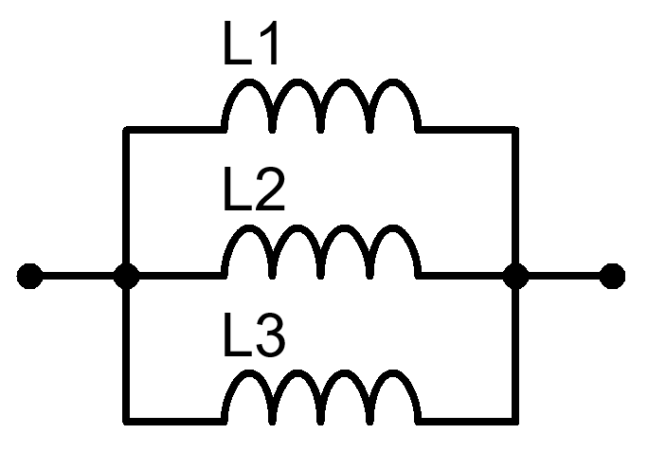
Angular Frequency  $$ω=2πf$$ | Phase Angle  $$φ=\tan^{-1}{\frac{X_{T}}{R}}$$ | Power Factor  $$pf=\cos{φ}$$ | Resonant Frequency  $$f_{res}=\frac{1}{2π\sqrt{LC}}$$

Capacitive Transients  Time Constant  $$τ=RC$$  Charging  $$V_{C}=V_{s}\left(1-e^{{-t}/τ}\right)$$  $$I_{C}=\frac{V}{R}\left(e^{{-t}/{RC}}\right)$$  Discharging  $$V_{C}=V_{0}\left(e^{{-t}/τ}\right)$$  $$I_{C}=-\frac{V}{R}\left(e^{{-t}/{RC}}\right)$$  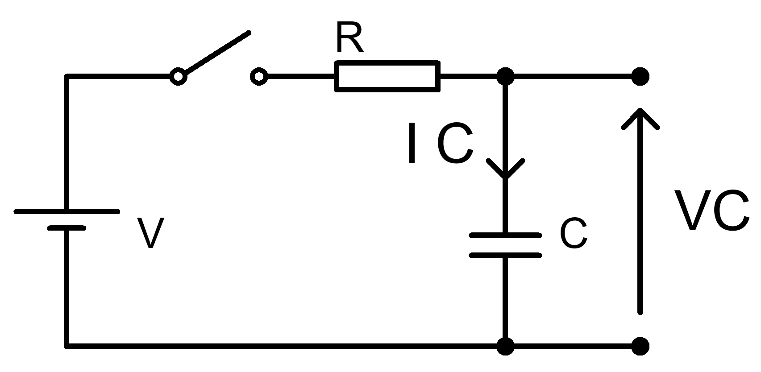 | Inductive Transients  Time Constant  $$τ=\frac{L}{R}$$  Charging  $$V_{L}=V\left(e^{{-Rt}/L}\right)$$  $$V_{L}=-V\left(e^{{-Rt}/L}\right)$$  Discharging  $$I_{L}=\frac{V}{R}\left(1-e^{{-Rt}/L}\right)$$  $$I_{L}=\frac{V}{R}\left(e^{{-Rt}/L}\right)$$  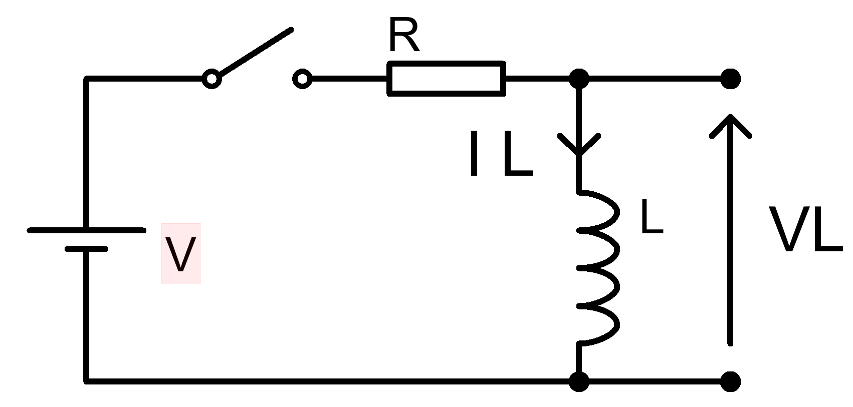 | Cut Off Frequency  $$f=\frac{1}{2πRC}$$  High Pass Circuit  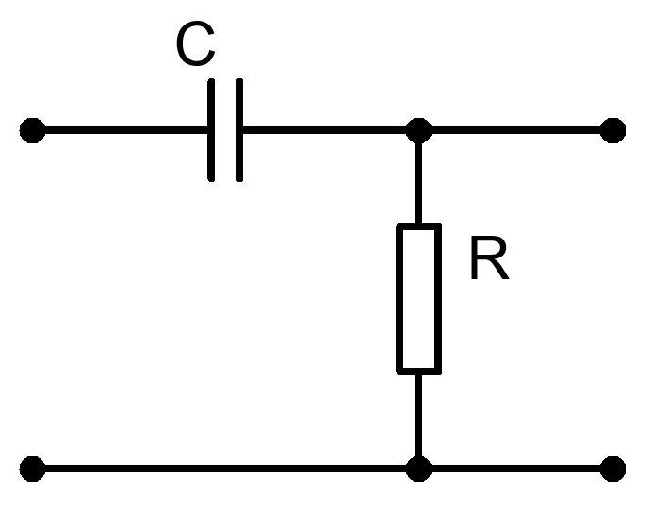  Low Pass Circuit  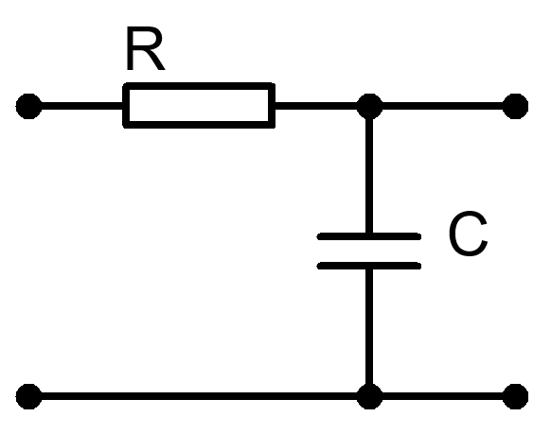  Voltage Gain (dB)  $$A_{V}=20\log{\frac{V_{out}}{V_{in}}}$$  Power Gain (dB)  $$A_{P}=10\log{\frac{P_{out}}{P_{in}}}$$ | Q Factor  $$Q=\frac{X_{L}}{R}$$  $$Q=\frac{X_{C}}{R}$$  $$Q=\frac{f_{R}}{f_{U}-f_{L}}$$  $$Q=\frac{1}{R}\sqrt{\frac{L}{C}}$$
Class A Common Emitter Transistor Amplifier Design Equations
$$V_{B} \text{=}\frac{\text{RB2}}{\text{(}\text{RB}\text{1 + }\text{RB}\text{2)}}\text{×} V_{CC}$$
$$V_{E}=V_{B}-0.7$$
$$I_{C}=I_{E}$$
$$V_{C}=V_{CC}-\left(I_{C}×R_{C}\right)$$
$$Av=\frac{v_{c}}{v_{b}}$$
$$V_{E}=10\%V_{CC}$$
$$R_{IN}=\frac{1}{\frac{1}{{RB}_{1}}+\frac{1}{{RB}_{2}}+\frac{1}{\left(h_{FE}×R_{E}\right)}}$$
$$R_{OUT}=R_{C}$$
$$A_{V}≈-\frac{R_{C}}{R_{E}}$$
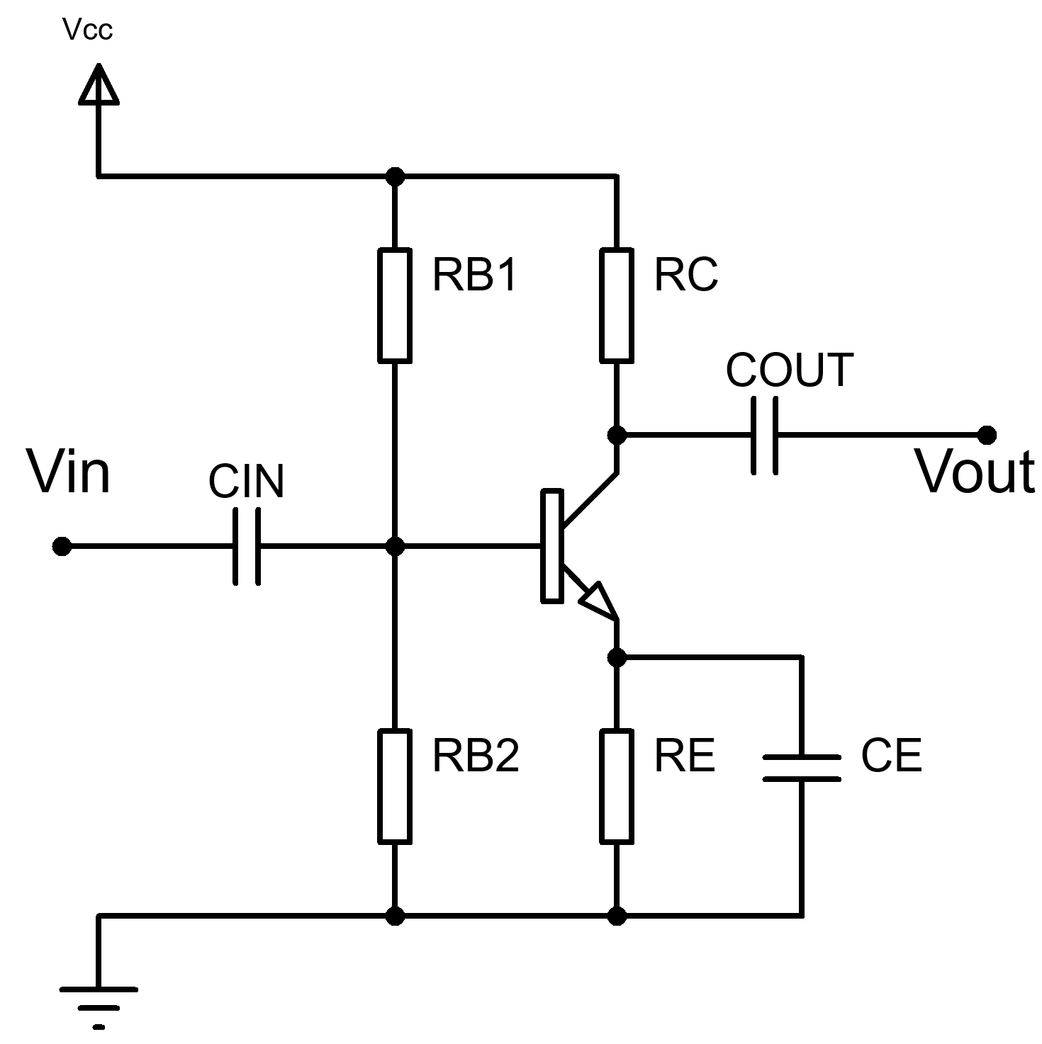

Operational Amplifier Design Equations
Inverting Amplifier  $$V_{out}=-\frac{R2}{R1}×V_{in}$$ | 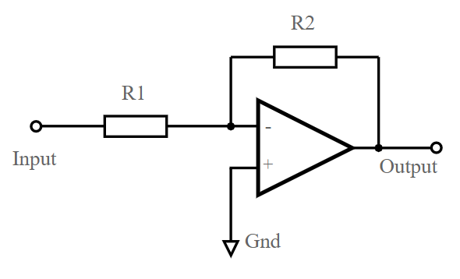
Non-Inverting Amplifier  $$V_{out}=\left[1+\frac{R2}{R1}\right]×V_{in}$$ | 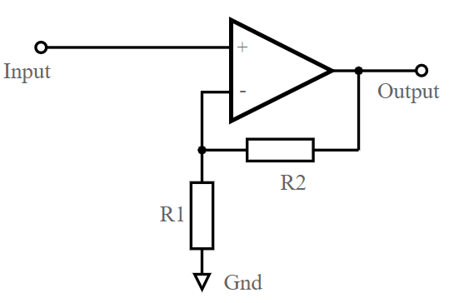
Difference (Differential) Amplifier  $$V_{out}=\frac{R2}{R1}×\left[V_{2}-V_{1}\right]$$ | 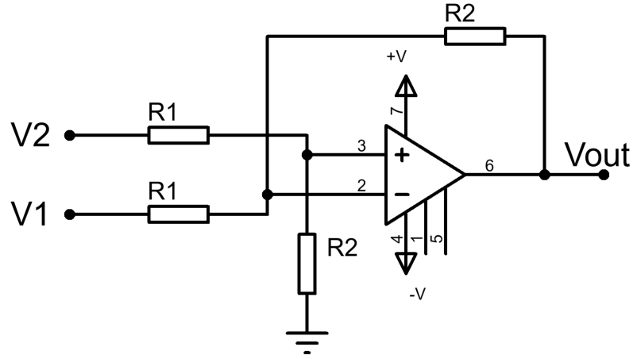
Summing Amplifier (Equal)  $$V_{out}=-\frac{R2}{R1}×\left[V_{1}+V_{2}\right]$$ | 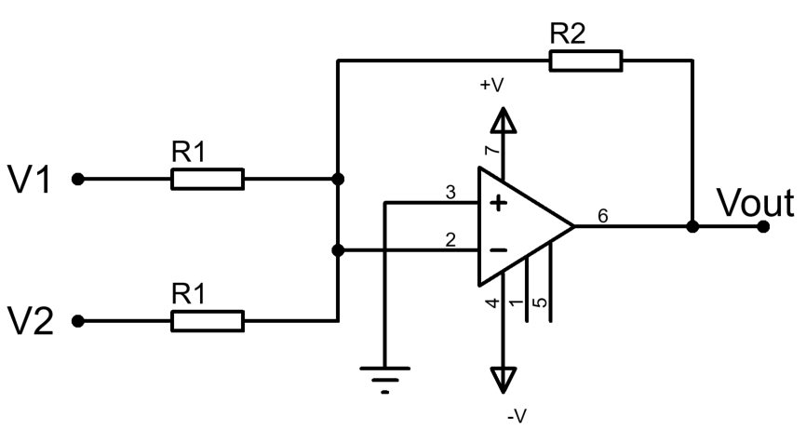
Summing Amplifier (not Equal)  $$V_{out}=-\left[\frac{R}{R1}×V_{1}+\frac{R}{R2}×V_{2}+…+\frac{R}{Rn}×V_{n}\right]$$ | 

