The Creature
Independent Project by Elise Turner
Surrounding the question ‘How Dangerous Can A Thought Be?’



Contents Page

Research and Initial development
Introduction.................................................................................................................3
My Proposal................................................................................................................4
Literary Review...........................................................................................................5

Creation and Stimuli
Story Structure and Brainstorming...........................................................................13
Character Creation...................................................................................................15
Musical Stimuli…......................................................................................................17
Choreographic Influences.........................................................................................18
Building The Creature...............................................................................................20
Script Writing….........................................................................................................22
Aria's Journal............................................................................................................25

Physical Application
Design Elements......................................................................................................27
Rehearsal Schedules...............................................................................................28
Rehearsal Process...................................................................................................32
Dress and Tech........................................................................................................35
The Performance…………………………………………..……………………………..37

Appendix……..………..............................................................................................39
Bibliography…………...............................................................................................43

Research and Initial development
Introduction
Through my independent project, entitled The Creature, I will be answering the question, ‘How dangerous can a thought be?’ by creating a piece of theatre including song, dance and script. This piece will be tackling an extreme view of this question, which will be portrayed through the perspective of an unreliable narrator. This narrator is a girl who has recently lost her boyfriend in a car accident, completely outside of her control. This leads to the worsening of her paranoid delusions and obsessive, compulsive thoughts, as a symptom of her paranoia and OCD. The Creature will follow the girls worsening mental condition as we learn how she has convinced herself that she was the one who killed her boyfriend. In The Creature, I will create a physical representation of my main character’s intrusive thoughts, the creature itself, that the girl believes to have murdered her boyfriend with.
As someone who experiences obsessive and compulsive thoughts, I feel passionate about shedding some light on what can be created inside someone’s head. I have also always had a fascination with the darker elements of theatre and the horror genre, so I want to effectively portray this concept in a style that will make the audience become uncomfortably involved in the girls warped and twisted perspective. To do this, I will be pushing this case of paranoia and OCD to the extremes, to create an effective shock factor that works for this genre.

My Proposal
My piece will to what extent the danger of thoughts can be portrayed after being diagnosed with a mental illness, particularly paranoia and OCD. Additionally, how these symptoms can cause second guessing and doubt to a degree that could result in someone believing an event or a fact about themselves that is objectively false.
I believe that creatives should explore their chosen genre to the fullest with the resources that they have. For me, this is the horror genre. After experiencing ‘The Woman in Black’ live at the New Theatre in 2013, it expanded my perspective of theatre and how creatively stories can be communicated onstage. I aim to realise this style by pushing the boundaries of paranoia and intrusive thoughts; making the audience second guess the real story of the show; not completely knowing whether the main character is conjuring the event in her head or if it actually occurred, similarly to how the main character questions the reality of her situation. My target audience is in an older range in order to understand the themes and message behind the piece, which is awareness of how people can with their thoughts. I intend to establish the genre and story using lights, sound, as well as experimenting with alternative styles of dance and song to create a more surreal musical performance. I will apply this exploration of styles to my subject matter, amplifying an experience that people with these mental health issues can live with to translate it for a stage setting.

Literary Review
Through this literary review, I intend to delve deeper into the topic area of my independent project, ‘The Creature’. The topics that I will contribute to this piece are the negative extremes of obsessive-compulsive disorder (OCD), paranoid delusions and the false reality and memory that can be created from these issues. In order to delve deeper into this subject, I intend to answer the pivotal question ‘How Dangerous Can A Thought Be?’. I will be using this question to enforce my points of research as an overarching theme throughout.
To assist me in answering this question, I will be exploring three central points of analysis. The first will be discussing the probability of someone having the ability to falsify an event or reality as a symptom of OCD, as this will govern whether a person’s corrupted thoughts and beliefs can affect how they perceive the world around them, establishing their danger. My next topic of deliberation will be built on the relationship between OCD and paranoia. This conclusion will dictate whether the symptoms of OCD and paranoid delusions can overlap and work in conjunction with each other to escalate the power of thought and perception, increasing its influence over an individual and adding to its danger when paired with negative emotion. My final research point will be investigating how OCD and paranoid behaviour might affect someone’s role in a relationship. This applies my main point of contention to people surrounding the OCD patient, exploring whether their negative thoughts can have a dangerous impact on people that they regard most intimately. By using relevant sources, primarily academic dissertations, surveys, academic journals, and the professional opinions of qualified psychologists, each of these points will aid me in validating or denouncing what the main character of ‘The Creature’ believes to be true, which I intend to reflect on throughout my project.
The possibility of convincing yourself of doing something wrong that is simply not true seems highly unlikely for an individual who has a very clear perception on what is true and what is false, whether that be their memories or their perception of reality itself. However, in the context of the disorders that the main character of ‘The Creature’ struggles with, distorted perceptions of events appear to be very likely based on the research that I will be discussing.
Dr Julia Shaw describes symptoms of False Memory OCD (a subtype of Obsessive-compulsive disorder that can be used to categorise main symptoms of an individual’s OCD diagnosis) as “believing inherently fictitious representations of reality”, going onto explain how these false events can cause very real positive emotions, negative emotions, and even real trauma [Shaw, J. 2017]. This validates the existence of false memory, but, referring back to our point of discussion, what is the likelihood of a person convincing themselves of doing something wrong or immoral, specifically? To answer this in more detail, I considered how people suffering with anxiety disorders such as OCD perceive themselves morally, to determine whether negative thoughts can be provoked by a distorted moral perception of oneself. The Journal of Obsessive-Compulsive and Related Disorders says that a person with OCD or related disorders are preoccupied with the fall of their moral status, allowing themselves to obsess over the smallest variations to it, causing their “moral concept” to be corrupted and prone to degradation [Giacomantonio, Cristofaro and Mancini, 2024]. Highlighting instability of a person with OCD’s moral concept of themselves suggests that this perception can play a part in how they would see an event that was created by their anxious thoughts alone, encouraging the patient to obsess and worry over moral status, doubting its integrity.
I wanted to become better acquainted with the idea of doubt in OCD, as this discussion point asks whether people can make themselves believe a false event, which can be done by doubting the reality of it. Johns Hopkins University School of Medicine hosted a survey involving 1128 patients with OCD to measure the severity of doubt as a pivotal symptom, with the results showing major connections, concluding doubt to be “associated with important clinical features of OCD” [Samuels, J. et al. 2017], thus confirming the relation between symptom and diagnosis. However, Psychologist Amy Marschall describes the link between doubt and OCD as the person having “more doubt and uncertainty about their memory than is typical or helpful, and they have a fear of what will happen if they are misremembering.” [Marschall, A. 2021]. Marschall mentioning the fear of misremembering an event implies that people with OCD can be aware of the possibility of remembering an event that never happened. This contradicts the theory that they can completely convince themselves of false belief. With the connection between doubt and OCD being so strongly enforced, this raises the notion that as much as doubt can create false memory, doubt can also demystify it, doubting the original memory’s accuracy while also doubting the false memory’s accuracy. Based on these findings, it is indicated that there is a likely possibility that someone suffering from OCD believes a false event or a false concept of themselves. However, the imperative role that doubt plays in the false memory subtype of OCD and the implications that it brings cannot be ignored, leading to reason that a person cannot wholeheartedly convince themselves of something untrue, as the doubt of that fact will always be present.
My next discussion topic is on the relationship between paranoia and OCD, asking whether they are related at all. This from the question of whether the main character in ‘The Creature’ could have paranoid delusions and Obsessive-Compulsive Disorder in relation to one another, which would strengthen the negative impact that her thoughts have on her reality and perception.
Casting our minds back to Dr Julia Shaw’s article on false memory OCD, she defines false memory as “recollections that feel like memories, but which are not based on any real occurrence.”, describing these occurrences as “inherently fictitious” [Shaw, J. 2017], strongly indicating that these events have no factual evidence behind them. Based on this and the book ‘Paranoia: A Study in Diagnosis’ that defines paranoia as being logically sustained (can be explained logically in some way) [Fried, Y. and Agassi, J. 2012], these differences in logic imply that the intrusive thoughts OCD create are not related to Paranoid Delusions.
However, there are also counter arguments that indicate the opposite. A professional at Australasian Psychiatry, Gangdev P.S, concludes in ‘the relationship between Obsessive Compulsive Disorder and Psychosis’ that an obsession has the possibility of becoming a paranoid delusion or vice versa, as well as obsession being a trigger for paranoid delusion. [Gangdev, P.S. 2002, pp. 405–410], establishing enough of a relationship between both disorders for a symptom of one disorder to be capable of transforming into a symptom of the other. Specialists at the Institute of Psychiatry, the Prison and Prohibition Administration and the University of Iceland also conclude in their study of 167 University students surrounding the relationship between anxiety, self-esteem, paranoid thinking, and anger that there is a positive correlation between anxiety, low self-esteem, paranoia, and suspiciousness [Gudjonsson, G.H. et al. 2002, pp. 145–153]. This also strongly suggests that paranoid thinking and doubts originating from OCD are, in fact, connected. Stemming from what we know about how people with OCD perceive themselves morally, hits to their status can catastrophised as more serious and frequent. This would in turn cause the low self-esteem that correlates with Paranoia.
The argument of symptoms of OCD and paranoia being intertwined with one another can be further supported by guilt linking directly with both paranoid delusions and obsessive thoughts/beliefs. Another statement that Gangdev made was based on how some delusions can be caused by guilt, identifying them as “a reactive delusion of guilt” [Gangdev, P.S. 2002, pp. 405–410]. This works in parallel to the OCD institute and Mclean Hospitals view on the relationship between OCD and guilt. They comment that fifteen common themes emerged from a study with OCD outpatients, and guilt was recognised as an interfering component of their OCD and brought guilt up in discussion when discussing several of these themes. They also went on to conclude that guilt “may precede, motivate, or be a consequence of OCD symptoms” [Shapiro, L.J. and Stewart, E. 2011]. Both of these sources correlate guilt as a key trigger for their respective symptoms, connecting paranoid delusions and obsessions found in OCD by the cause of guilt, which enables the possibility of both symptoms being present at the same time, and, as we know, to morph into one another interchangeably. Despite the discrepancy between delusions being built on logic and OCD symptoms being solely illogical; it is also evident that both are triggered by guilt frequently, and the evidence of them becoming one another. This demonstrates the connection between paranoia and OCD.
My last point of deliberation sets out to establish whether behavioural symptoms of OCD and paranoia can cause the patients symptoms to play a large role in toxic or even abusive relationships. I started by ascertaining the most common roles that people with these mental health issues play in relationship dynamics, which led me to discovering the ‘anxious attachment style’ in the academic literature review, ‘A link between obsessive compulsive disorder and attachment styles’ from a department of Biological Psychiatry and Psychopharmacology, Lithuania. This article identifies the relationship between OCD and the anxious attachment style as a frequent occurrence which can seemingly be attributed to many internal factors; “a need for approval, an ambivalent self-concept, position of control, and repetitive thinking.” [Kulaityte, D. Gutparakyte, G. and Steibliene, V. 2023.]. These factors reinstate the notion of an ‘ambivalent self-concept’, strengthening the idea that people with OCD have a more unstable perception of themselves. This can then be associated with how the OCD patient could influence a relationship dynamic.
Before I proceeded any further, to comprehend in more detail how a person with OCD or paranoia could influence the health of a relationship; I needed to understand the view of an anxious attachment style. The International Journal on The Biology of Stress illustrates this attachment style as being associated with the “preoccupation with the availability and responsiveness of the other, maximisation of negative experiences and hyper-vigilance of potential threat” [Smyth, N. et al. 2015]. This denotes that people with an anxious attachment style depend on how their partner is responding and will base their time on when their partner is available. It is also heavily indicated that people with this attachment style tend to overthink and ruminate on negative experiences in addition having heightened awareness to any threats, potentially making them have more potentially unfounded suspicion.
While it is recognised that this attachment style is associated with symptoms of OCD, I wanted to apply this attachment style to paranoia as well to determine whether there is any relation, as this would not only link paranoid behaviour to this relationship dynamic that could aid me in concluding its impact, but this could also strengthen the argument for the connection between OCD and paranoia even further. By conducting a systemic review of adult attachment, paranoia, and psychosis, aligning with PRISMA guidelines (Preferred Reporting Items of Systemic reviews and Meta-Analysis), the British Journal of Clinical Psychology discovered “significant associations” with insecure attachment (anxious attachment style) and paranoia, going on to conclude that “the strongest, most commonly reported relationship was between an anxious attachment style and paranoia.” [Lavin, R. et al. 2019]. This strongly acknowledges paranoia’s relation to this relationship style.
Contradictory to the relationship between OCD and the anxious attachment style, however, the Journal of Family Psychotherapy concludes based on patient focus groups that people with OCD experience mental and physical distance due to feeling monitored or pathologized by a partner’s support or accommodation [Walseth, L.T. et al. 2017]. Although this does go against what we know about an anxious attachment style, as distance would create a severity of independence rather than dependence, the link between paranoia and this dynamic in relationships can strengthen the argument of patients with OCD having a greater association with dependency rather than avoidance. This is due to the several intersecting links between both OCD and paranoia that we have identified, establishing both similar causes and effects that could also indicate the probability of these symptoms and disorders working in corresponding ways within the context of a relationship.
Now that we have identified both OCD and paranoia with the anxious attachment style, I will now utilise this to determine whether patients with OCD or paranoia can have a negative impact on their partners based on how an anxious attachment style can affect a relationship. Through this, I uncovered the association between not only OCD and paranoia with this attachment style, but Pathological Narcissism as well. In the article ‘Attachment insecurity and dysfunctional identity as contributors to pathological narcissism, and Mediators of Adverse Parenting’, it is said that attachment anxiety and dysfunctional identity were “significant predictors of Pathological Narcissism” [Kealy, D. and Ogrodniczuk, J.S. 2023]. The mention of dysfunctional identity can be related back to what we know of the moral identity of people living with OCD, which strengthens this association with narcissism, leading us to believe that these narcissistic traits within a relationship would cause toxic behaviour. However, in the academic article ‘Attachment styles and violence within couples’, it is stated that women with an anxious attachment style was a significant predictor for becoming victims of violence [Bond, S.B. and Bond, M. 2004]. I believe that this insight with prior knowledge of anxious attachment, OCD and paranoia outweighs the concept of someone with this attachment style having any inherently abusive traits or narcissism.
To conclude this point, I can determine that people suffering with OCD, or paranoid symptoms do not fundamentally cause abuse within their relationships or create a toxic atmosphere, but rather, they self-sabotage themselves, which can lead to them becoming more reserved or anxious around their partner.
Based on the outcomes of these arguments, I have concluded that someone with OCD could create a false memory and convince themselves of it almost completely. The research also identifies the strong connection between OCD and paranoia with similarities in both cause, triggers, and effects that could strengthen the power of a thought through negative emotion. And, despite finding gaps in my research regarding the possibility that people with OCD or paranoia frequently become abusive, due to lack of research available; I have determined that patients with OCD and paranoia can fall victim to themselves within relationships which can ultimately lead to a relationships ruin. When asked, ‘How Dangerous Can A Thought Be?’, based on the ability a thought has to provoke such vivid perception and negative action, I answer, ‘incredibly’.

Creation and Stimuli
Story Structure and Brainstorming
At the beginning of this process, I knew that I wanted the story to start with my main character introducing the event of her boyfriend’s death, then going back in time to tell her version that led to the event, completely twisted by her self-image and intrusive thoughts. I used my research into the behaviours of someone with manipulative tendencies within relationships as a stimulus for the timeline and events of my piece [see Appendix 1.A], such as creating distance or projecting guilt. My decision originates from wanting my main character to portray herself as quite a manipulating person toward her boyfriend, with the physical representation of her actions being the creature itself. This creates the unreliable narration, as she is painting herself to be the horrible person that drew her boyfriend to his death, when that is not true.
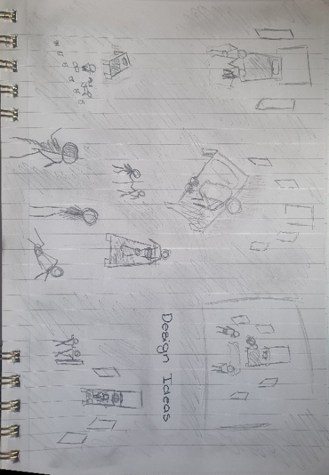
To keep track of the events in the piece I used my main characters journal as a focus point to come back to. I felt that this would keep the story grounded and methodical in structure. Using something as personal as journal entries also creates a 1st person narrative that intensifies the intimacy between my main character and the audience, as if she were telling a secret that only the audience were allowed to know. I was heavily influenced by Gecko Theatre during this process [See Appendix 1.B], not only regarding their performance techniques but also their own creative process. Gecko Theatre also uses a method of creative process that works really well for me, which is listing anything and everything about the piece whenever the thought arises, as well as drawing ideas in the initial stages of the creative process, which is what I have done. This list is categorised into moments that could be included, themes, characters and different languages of movement. This helped organise my initial ideas and create a cohesive storyboard mapping out the events of my piece.
Figure 3: My List of Moments
Figure 1: My Design Ideas
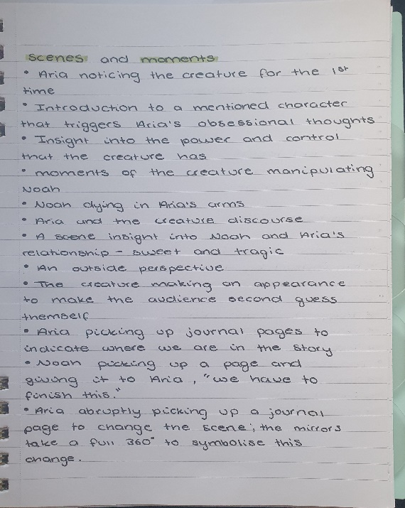
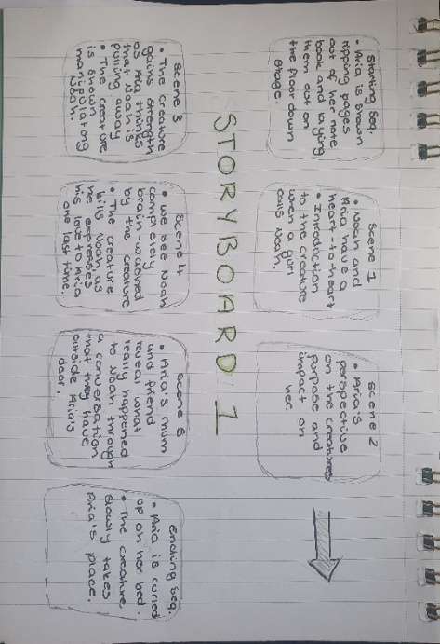
Figure 2: My Storyboard
Character Creation
When creating my characters for The Creature, I didn’t want to have many, as I felt that if the circle of characters were smaller, it would make the story that much more enclosed with an uncomfortable amount of intimacy. At first, I created the main character, Aria and her boyfriend, Noah, as two completely separate characters. however, as I continued to create them, much like the creature itself, I felt it more effective to depict Noah as a fragment of Aria’s mind rather than a concrete memory. By doing this, I had the freedom to include Aria’s biased narration into the creation of Noah, intensifying her version of how he acted around her and how he saw her before his death. This also gave me the opportunity for a more logical interaction between Noah and the creature, as both of these images belong to Aria’s imagination, rather than abiding to the laws of reality.
I envisioned Aria as someone who has already accepted her reality as truth. Aria in the context of the story represents the spectator, watching the story unfold without any means to stop it from continuing. She is very stubborn in her horrible self-image and fearful of the things that she is capable of doing; only feeding the creature inside of her further. She feels a sense of control over the story through her journal entries, while in denial about how the story is going to unfold, especially near the beginning where she manifests Noah into the space for the first time. I intend for there to be a point where Aria is given a choice of accepting Noah’s fate as being a freak accident using her objective logic or continuing on in her world of delusions. By choosing to continue to live in her delusions, it shows that she is passed the point of reasoning.
Noah, in Aria’s mind, is the only important thing in her life. He is the ideal image of what a partner should be, but there are still things that he does that she believes to be suspicious, when in reality they are not suspicious at all. By the end of the piece, I intend for Noah to take on the characteristics of Aria’s objective logic that she no longer has access to, where he assures her that she is loved and she was never a burden to him, as deep down she knows this, but hasn’t been able to unlock this truth.
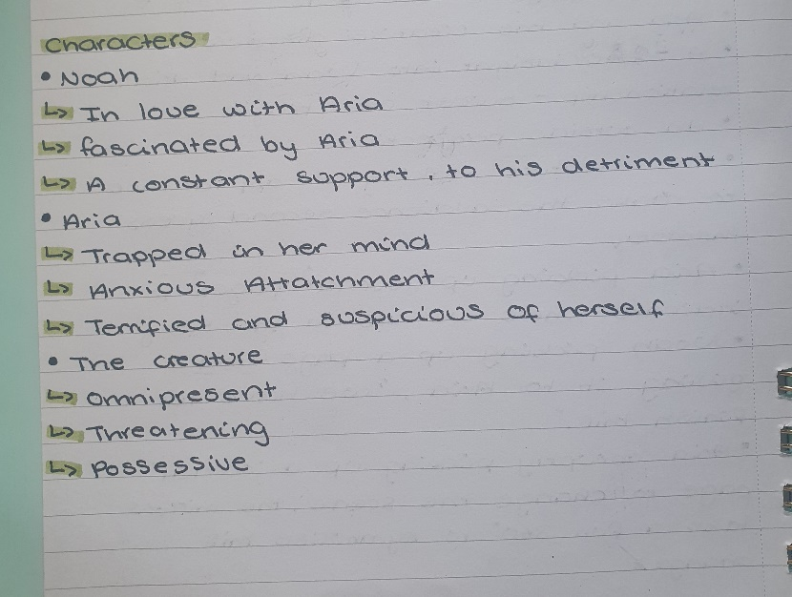
When creating the creature itself, I was also influenced by Gecko Theatre’s perspective on theatre making. Founder Amit Lahav describes his audiences experience as being “very much dependant on the individual audience member and their desire or ability to dive within themselves.” [Lahav, 2021]. This really spoke to me as, even though the creature at its foundation is built on Aria’s deepest and darkest opinions of herself, the world around her and intrusive thoughts as symptoms of paranoia and OCD, I also want the experience of the creature to be personal to every audience member in a way. So, by portraying the creature quite ambiguously, the audience may be able to find something within themselves that relates to the creature, as I feel that at every humans core, we all have some sort of creature living within ourselves. The part of the creature that makes it so dangerous for Aria is her constant need to distance herself in order to supress it, which ultimately led to her descent into delirium. By accepting the natural instinct of a creature, whether it be insecurity, jealousy or guilt, accepting it takes the power away from it, which Aria failed to do, resulting in her eventually being engulfed by it.
Figure 4: Character List
Musical Stimuli
I wanted to incorporate songs into my piece, as this gave me the opportunity to explore my love for choreography and to bring more surrealism to the piece, as it is happening inside Aria’s head. However, I didn’t want to rely solely on songs from musical theatre, but rather standalone songs that didn’t have a definitive context but could still be used for storytelling. I took great inspiration from songs written by Hozier, as I am fascinated by his poetic style of song writing that would fit in well with the style that I will write Aria’s journal entries in. These are the lyrics from the Hozier song, Talk, where Hozier references the tragedy of Orpheus and Eurydice from Greek Mythology. Aria and Noah have a similarly doomed relationship, as they both know that their journey is going to have an unhappy ending in my piece. I ended up using this song to introduce the creature, as the song identifies itself with the poor choices made and doubts that lead to Orpheus and Eurydice’s downfall. I changed some of the pronouns at the beginning of the lines to refer to Noah being the immediate forgiveness and the creature being the ‘it’:
Figure 5: Talk Lyrics
IT IS THE VOICE THAT URGED ORPHEUS WHEN HER BODY WAS FOUND
IT IS THE CHOICELESS HOPE IN GRIEF THAT DROVE HIM UNDERGROUND
IT IS THE DREADFUL NEED IN THE DEVOTEE THAT MADE HIM TURN AROUND
YOU ARE THE IMMEDIATE FORGIVENESS IN EURYDICE
IMAGINE BEING LOVED BY ME

The references to Orpheus and Eurydice led me to the musical Hadestown, where I found the song All I’ve Ever Known. With this song, I had the opportunity to foreshadow the fate of Aria and Noah with these lyrics:
Figure 6: All I’ve Ever Known Lyrics
I’M GONNA HOLD YOU FOREVER
THE WIND WILL NEVER CHANGE ON US
SO LONG AS WE STAY WITH EACH OTHER
THEN IT WILL ALWAYS BE LIKE THIS
Following from my exploration of Hozier, I encountered the songs Take Me To Church and Francesca, which I will use as an insight into how Aria thought Noah felt (Take Me To Church) and her logic knowing that deep down Noah always loved her (Francesca).
Figure 7: Take Me To Church Lyrics
TAKE ME TO CHURCH
I’LL WORSHIP LIKE A DOG AT THE SHRINE OF YOUR LIES
I’LL TELL YOU MY SINS SO YOU CAN SHARPEN YOUR KNIFE

Figure 8: Francesca Lyrics
DO YOU THINK I’D GIVE UP?
THAT THIS MIGHT HAVE SHOOK THE LOVE FROM ME?
OR THAT I WAS ON THE BRING?
HOW COULD YOU THINK, DARLING, I’D SCARE SO EASILY?

Choreographic Influences
I decided to include dance in my piece for a similar reason to why I have music in my piece, but also for me to explore my love of choreographing. First, I needed to find a way to portray Noah and Aria’s relationship in All I’ve Ever Known as this is the only time that we see their relationship in a stable state. My first instinct was the intimacy in a Waltz, which led me to discover Allemande. This is a type of Waltz formed between the eighteenth and nineteenth century using the intimacy of an embracing couple [Aldrich, E. 2000]. Categorised by its elegant and flowing movements, the Allemande is danced in a 2/4 beat time signature, fitting the time signature of All I’ve Ever Known, which is unusual for a Waltz as they are usually dance in a 3/4 time signature. A movement that stood out to me within this style was the position of arming, where one arm of each dancer is held side by side, their forearms parallel and connecting. Traditionally, the arms in this movement would be completely vertical, but I wanted to modernise this by creating more intimacy. This led me to having Noah and Aria’s arms interlocking with one another. This is what this looked like:
All I've Ever Known (Aria) All I've Ever Known (Noah)
I also took major influence from the physical theatre company Frantic Assembly for my choreography in All I’ve Ever Known. I especially liked the techniques of palm connection, where partners keep a balance of energy in each other’s palms, and round-by-through, where a partner moves around the other, near their partner, and then underneath or through their partner. I have utilised palm connection to raise the intimacy in certain moments just before Aria uses the round-by-through technique to move away from the intensity. I also used an adaptation of walking the grid; a Frantic Assembly technique where the cast moves at the same pace on a sort of invisible track. Usually, this technique is done with straight lines, but I adapted this into a curve that allowed Noah and Aria to arc toward each other. This is what these 2 components looked like:
Walking-The-Grid in All I've Ever Known
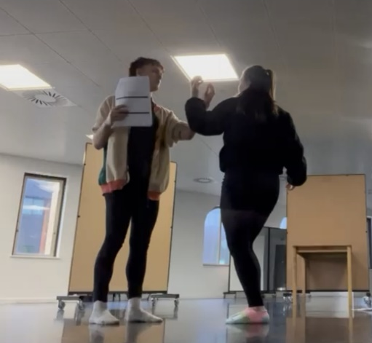
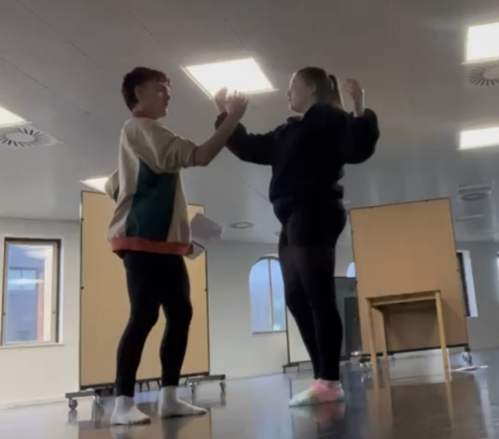

Figure 9: All I’ve Ever Known Rehearsal Image

Due to using Frantic Assembly as my primary influence for this number, I had to remind Lucy and Jona to constantly strip back the movement to its barest form, in order for it to be done naturally. This is because in Frantic Assembly rehearsals, “performers are encouraged to take a moment back to its simplest truth and build from there.” [Graham, S. 2019]
When working on Take Me To Church and Talk, I took elements from the theatre company Punchdrunk (a company that I was not aware of before this project). This company works in contemporary dance that is immersive and often quite dark, which fit with choreography for the creature itself very well. I created the structure of the routines; I focused on connecting the movement to the narrative in the way that Punchdrunk does. In Take Me To Church, I worked on finding movements that Aria and the creature could do at the same time, showing that they are two sides of the same person:
Take Me To Church Choreography

Building the Creature
Regarding movement and execution, the creature itself was an element that I was quite apprehensive about, as I have no experience in choreographing for this kind of character. When I was struggling with how to begin, Tori, who was my project tutor at the time, suggested that I create a language for the creature with a series of motifs to enforce what I’m envisioning.
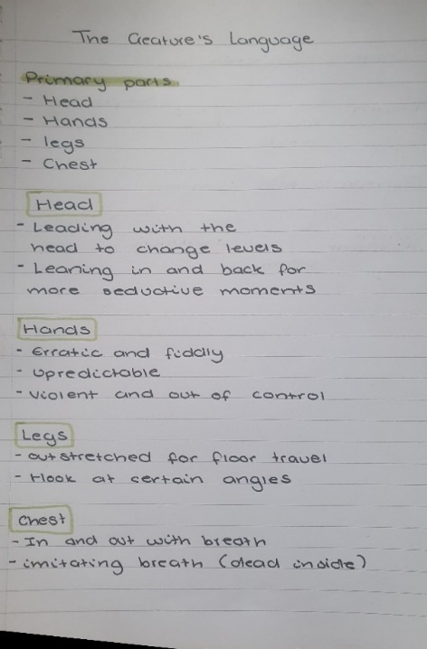
This is the list of movements I created to build the creatures language. As the creature is representing the darkest natural instincts in Aria; her fears, her paranoia, her anger, guilt and hatred toward herself; I wanted to make the creature resemble a feral animal. However, in the moments of the story where the creature is imitating Aria or mirroring her, the creatures movements would become a lot human but not quite natural. As if the creature was an animal attempting to imitate human behaviour. This also worked with the lyrics of Talk, as I interpreted the chorus as someone hiding ones darker emotion.
Figure 11: Talk Lyrics
I WON’T DENY I’VE GOT IN MY MIND NOW
ALL THE THINGS I COULD DO
SO, I TRY AND TALK REFINED FOR FEAR THAT
YOU FIND OUT HOW I’M IMAGINING YOU

Figure 10 The Creature’s movement list

I also took inspiration from the research that I did on Punchdrunk by taking mundane moments and physicalizing them in the way that the creature would do them to add to its language. I worked with my actress playing the creature, Liv, on how she would naturally walk and then converting those movements into mechanical ones, as if she were walking based on someone’s explanation of walking rather than her own natural instinct, adding to the uncomfortable horror aspect of my piece. Me and Liv also worked together to apply this to the way that she stands and sits as well, as these pictures portray [see Appendix 1.C]:
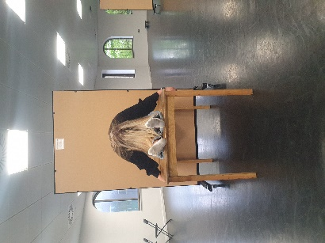
The Creature Walking
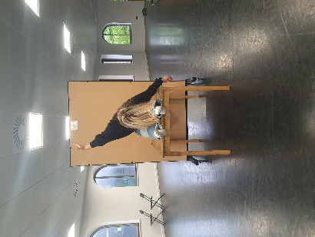
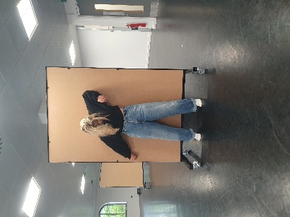
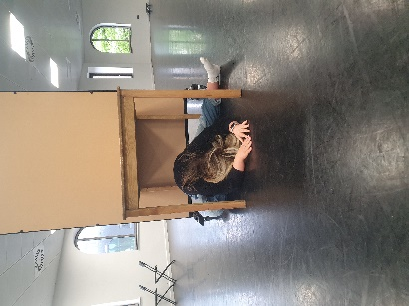

Figure 12: Creature Rehearsal Images

Script Writing
My final draft of the script for The Creature was the 5th draft [See Appendix 1.D]. Changes were made not only to the dialogue but the stage directions as well.
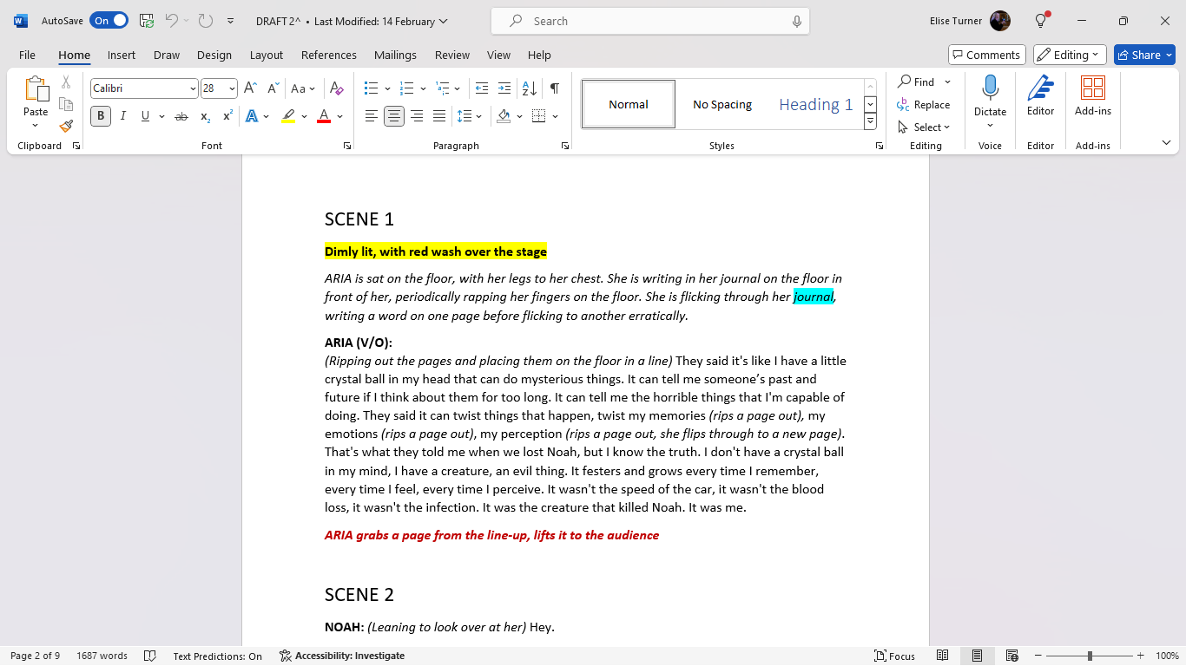
In my 1st draft, the journal entries that are being told through Aria’s voiceover monologues worked to guide the story forward, but I wasn’t getting the impression that they journal entries were dictating the story and Aria didn’t appear to have any control over the scenes, so I added transitions triggered by the journal pages to make the journal more fundamental to the story.

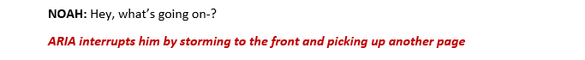
Figure 13: Stage Direction Changes (In Red)
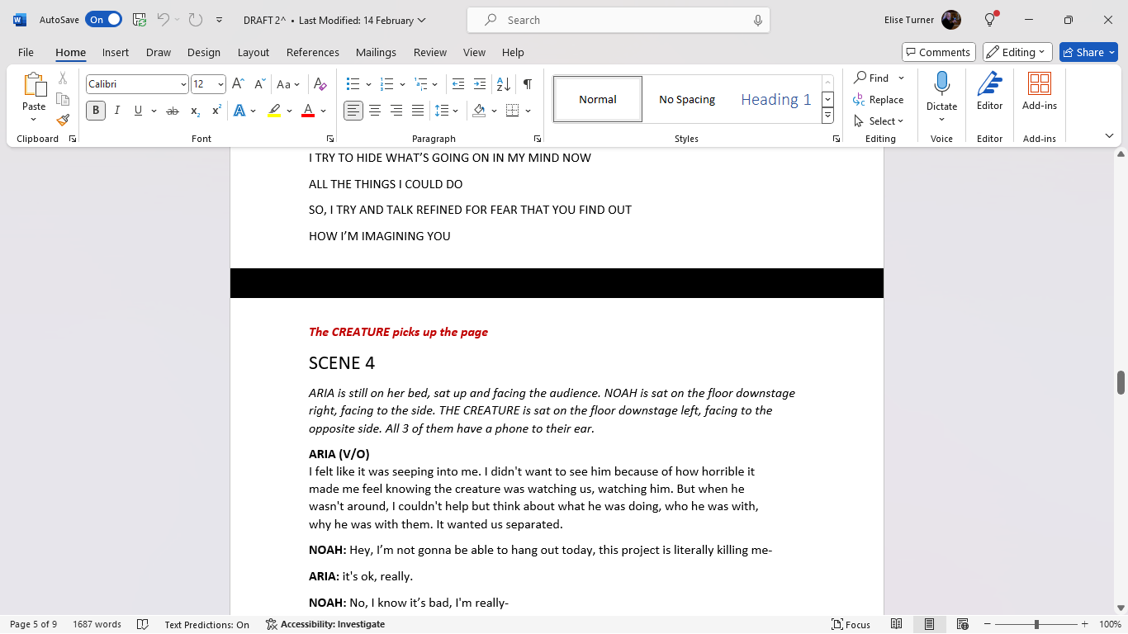

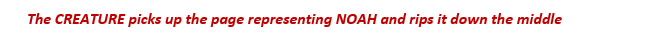
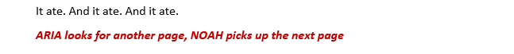

Though it was clearer that the pages had more power, I was no longer satisfied with the way that the entries were sounding. I have been told by past tutors that my writing sometimes lacks realism as there is too much thought behind the words for it to be natural. In this piece, I had the opportunity to use my embellished style of writing to my advantage, as Aria is explaining the timeline of events and how they made her feel, which can look more thought out and poetic. I wanted to play on this more in Aria’s monologues, while also increasing the cynicism of Aria’s character, as her bluntness was being communicated, but her hatred toward reality was not.
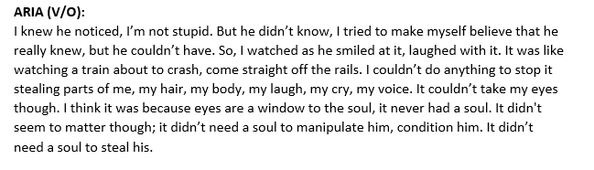
Figure 14: Draft 2 and Draft 4 of Aria’s Monologue Journal Entires

Draft 2

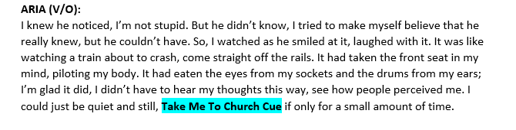
Draft 4

Draft 2

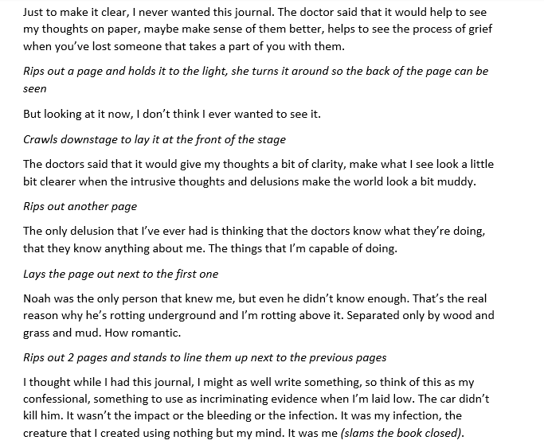
Draft 4

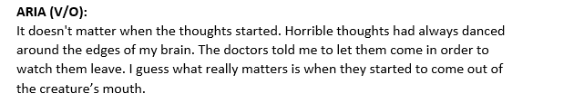
Draft 2

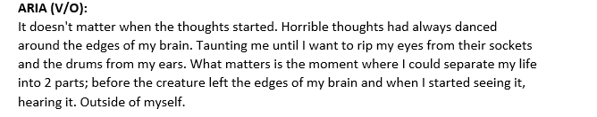
Draft 4

Draft 2

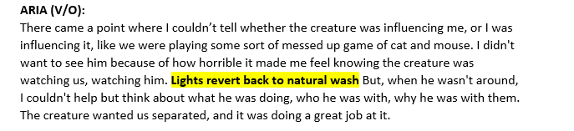
Draft 4

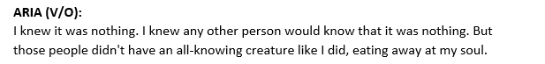
Draft 2

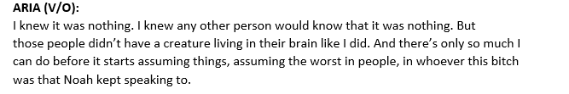
Draft 4

In my 4th draft, I still had lighting cues for some blackouts in between scenes. However, when blocking the scenes in the space, I felt that the blackouts took me out of the experienced, so I removed these blackouts for the audience to see the transitions happening. I edited the document of the 4th draft to create my 5th and final draft.
Final draft of the script: The Creature (Final Draft).docx

Aria’s Journal
As Aria’s journals are a crucial element to my narrative, I wanted to have this as a physical prop that would be accurate to how Aria writes. To do this, I started with a stream of consciousness exercise where I used the journal to write down anything that I could think of, using the given circumstances that are created in my story and in my research that has been exploring the thoughts that someone with OCD and Paranoia would potentially experience. I also had to think about making the writing exaggerated enough for it to be seen from onstage. This is what a select few looked like:

Figure 15: 1st Draft of Aria’s Journal Entires (Stream of Consciousness Exercise)
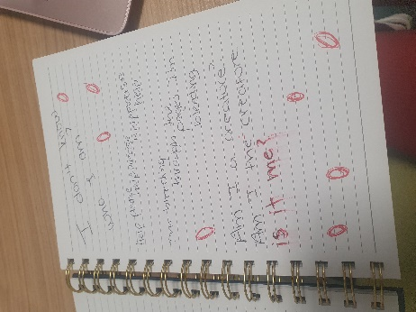
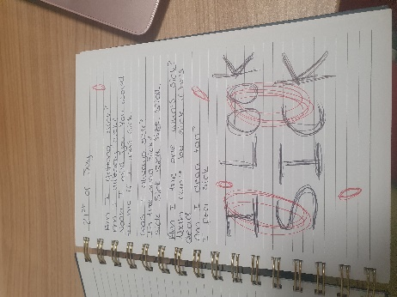
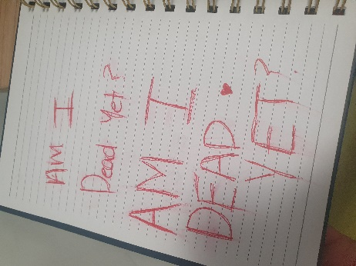
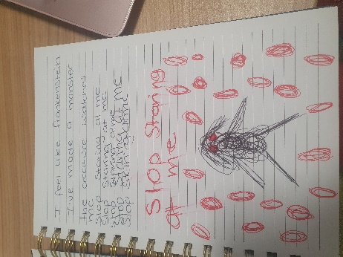
While doing this, I liked the phrasing motifs that I was using, but I couldn’t sustain this intense manner of writing for very long and I felt that the story of the pages was getting lost. So, I used some of these elements in my second draft, but added the journal entry monologues and made the descent into the manic writing more natural and subdued:
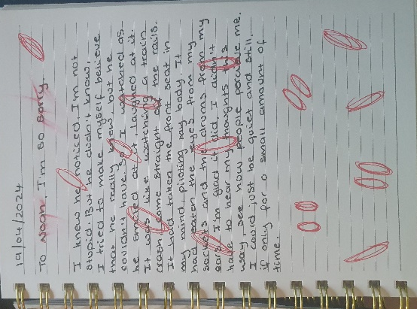
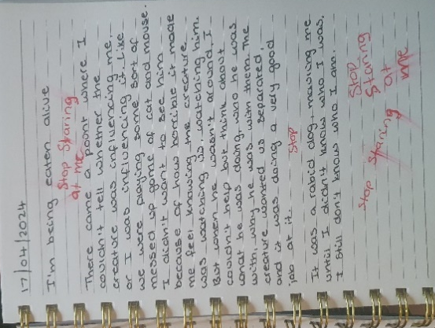
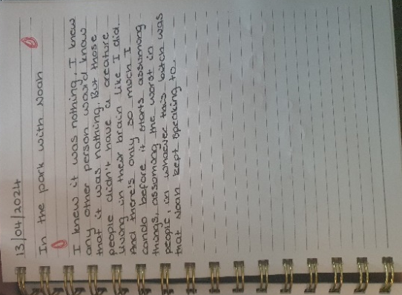
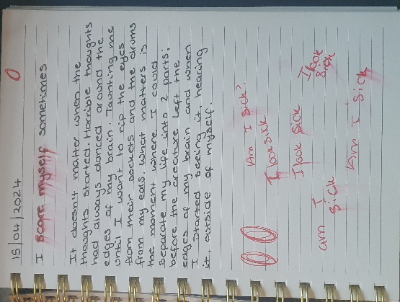
Figure 16: Final Draft of Aria’s Journal Entires (Stream of Consciousness Exercise)

Physical Application
Design Elements
When designing the set, I wanted to set it in Aria’s bedroom throughout the whole timeline, in order to keep the story from affecting the outside world. I used the back of 3 mirrors emulating as flats to create a more enclosed, claustrophobic space. This is what it looked like:
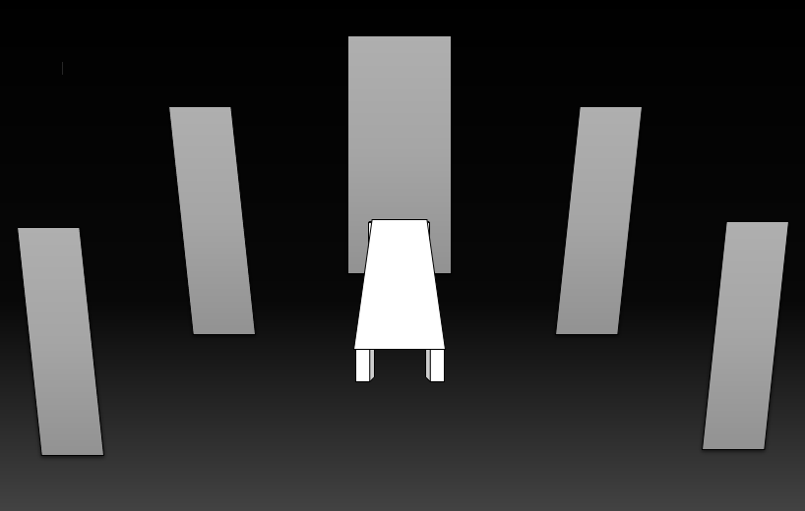

Figure 17: 1st Draft of Set Plan
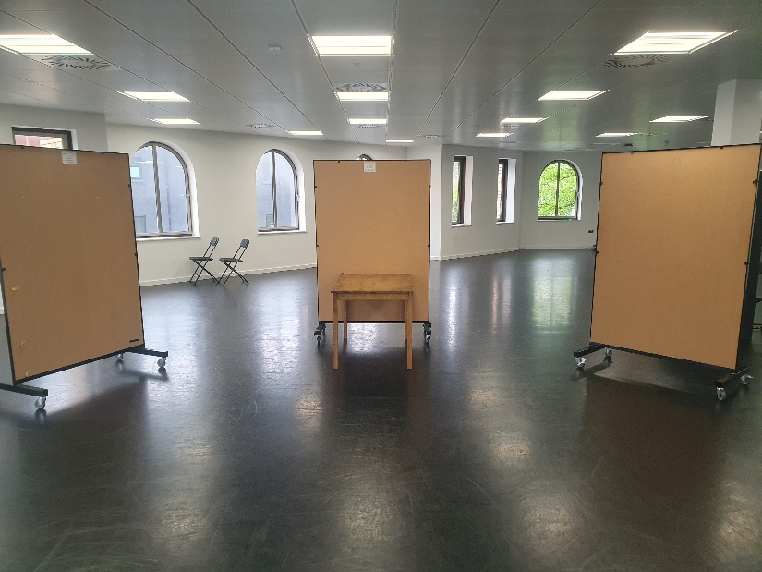

Figure 18: Final Draft of Set Plan

Regarding sound, I decided to have the monologues and lines of Aria’s Journal entries as voiceovers to keep the story within the confines of her head rather than being spoken out loud. It also creates an omnipresent feel that I intend for the audience to feel trapped by (double click to open audio files):

I also decided to record the dialogue that happens in scene 6, as I felt that having Aria’s mother and her friend visible in the scene would add an external element into the story. By using a voiceover for this scene, the action is still happening from Aria’s perspective, as she is the only character that we can see reacting:

Rehearsal Schedules
Before working with my cast on different elements of the show that I have mentioned in previous sections, I first needed to obtain a cast. To do this, I sent out an email to every course of 1st years in the University with audition packs for each character, as well as a synopsis of the plot and the style of the piece. I made sure to keep my tone light and approachable, while also making everything as clear as possible. In these audition packs, I outline the character, what will be required and the structure of the audition, what skills will be required of them when playing the role and what skills they might gain when playing these roles:
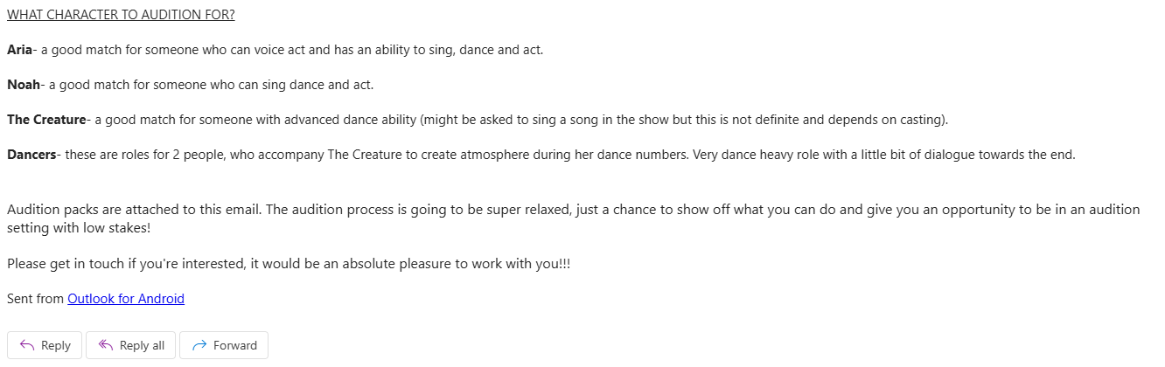
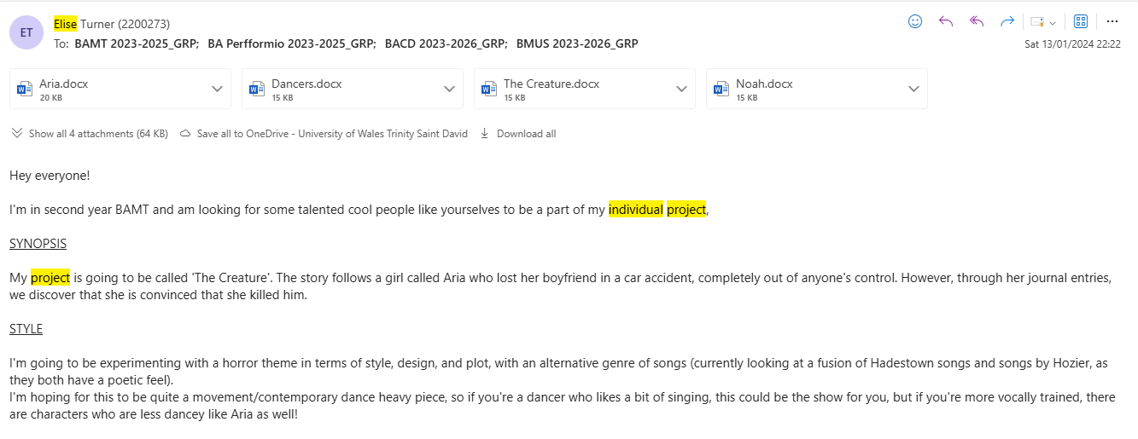
Audition Packs - Aria.docx Noah.docx The Creature.docx Dancers.docx
Figure 19: Email That I Sent To Students Advertising My Piece

Though I wanted to have an audition process, I found that I wasn’t making a lot of contact with performers and those that did show interest couldn’t commit to the shows before the auditions had begun. Due to this, I felt it would be the most useful for me to be more proactive and contact performers that I felt fit the roles myself. This ended up working in my favour, as all of these performers were available. This left me with a cast of 5; Jona Milone
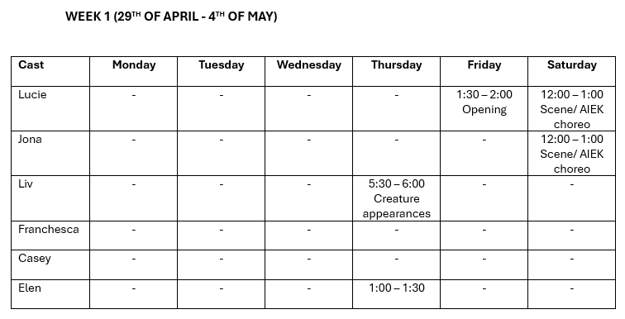
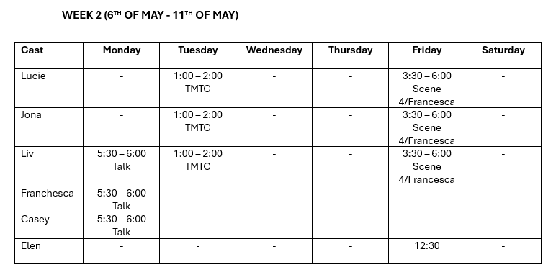
Olivia Owen, Franchesca Smith, Lucy-Jo Evans and Casey Bowen. 4 of these performers were scouted by me and one had previously shown interest (Casey). Now that I had a cast, I created rehearsal schedules for the month leading up to the final performance. I had to adapt these rehearsals to my casts schedules, as a lot of my cast were a part of multiple projects as well as working on projects for their usual courses. For the first 2 weeks of these schedules, I included a column for my 1 to 1 meetings with Elen as my project tutor. For the 3rd week, I replaced this column with one for myself in order for me to keep track of my admin work that needed to be done before Dress and Tech:
Figure 20: Rehearsal Schedules

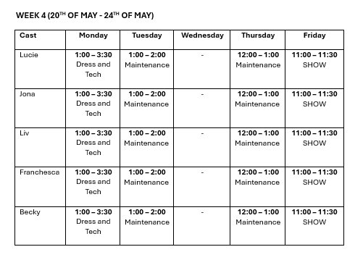
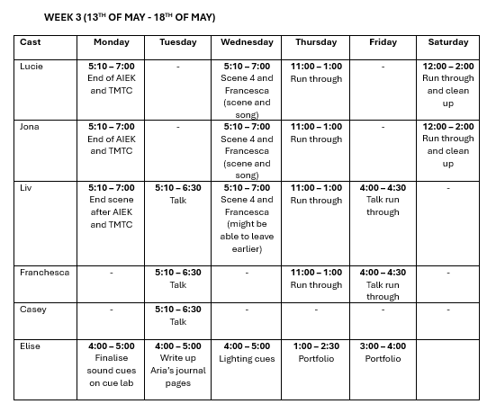
Rehearsal Process
I started the rehearsal process with Lucy, who was cast as Aria. In this 30 minute 1 to 1 rehearsal, I focused on directing her through the vocal delivery of the voiceover monologues. I guided her into delivering the lines with a numbness, to show Aria’s acceptance of what she believes is the truth.
During the 1st week, I also had a 1 to 1 session with Liv as we explored the language of the creature and the dance number, Talk. I explained to her the concept of the creature imitating a human but being quite animalistic. I used the methodology of Punchdrunk to enforce how I worked with Liv. Maxine Doyle, founder of the company, uses the dancer’s instinct to enforce the end result of the movement [See Appendix 2.A], which I also did by showing Liv the music and context of the moments she appears in as a stimulus, then we worked together to use the shape that came naturally to her and refined it [See Appendix 2.B]. We also used Punchdrunks technique of Real World Application, where the dancer uses real life body language to enforce a shape or movement, as body language is worth 55% of all forms of communication [Bridges, C. 2014]. This image is an example of this humanoid body language, where she is imitating human behaviour:
Figure 21: The Creature Rehearsal Image
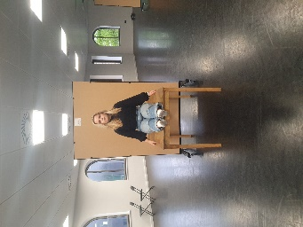

Liv is a very strong dancer, so I wanted to utilise her skills in this piece to give her the opportunity to challenge herself while also making the creature look visually provoking to the audience with uniqueness in shape and movement. To do this, Liv showed me her showreel and gave me a demonstration of some of the movements that she can do, which I worked into the original structure of my choreography. These videos include the choreography for Talk before adapting it to Liv’s advanced ability, and the final draft of the number:
First Draft of Talk Choreography
Final Draft of Talk Choreography
In my next set of rehearsals, I had Jona and Lucy in to teach All I’ve Ever Known, where I directed them through the choreography to have a push and pull with each other, as Aria is still overwhelmed by the power that her journal entries hold to manifest Noah back into her reality. These directions also bled into the scene leading up to the song, where Aria is trying to figure Noah out while Noah is acting as a version of himself inside Aria’s head. This was what these rehearsals looked like:
All I've Ever Known Rehearsal (Full Cast)
Scene 2 Rehearsal
In the 3rd week, I came across a big obstacle. Casey, who was playing a backing dancer to raise the stakes of Talk, was struggling to attend rehearsals on top of her own production week. I started by sending the video of the Talk choreography over, but she was struggling to find time to learn it. Due to this, I took the risk of pulling Casey out of my piece in order for her to focus on the other project she was in and her production week for her course. I knew that I needed 2 backing dancers in Talk in order to keep the symmetry, and I was not willing to pull out Franchesca as well, so I had to find someone else to take Casey’s place on very short notice. This is when I took another risk to invite a performer from outside of the University to dance in my project. Luckily, Becky was able to commit to the project, so I adapted my schedule to fit when she could come in to rehearse and taught her the choreography that she needed to know, which now looked complete with 3 people as can be seen in this rehearsal:
Talk Choreography (Full Cast)
When teaching Take Me To Church, me and Jona (playing Noah) sat down to do script work, annotating how Noah was feeling in the song and giving Noah his own perspective for the first time. I also taught Liv and Lucy the mirroring choreography in the number.
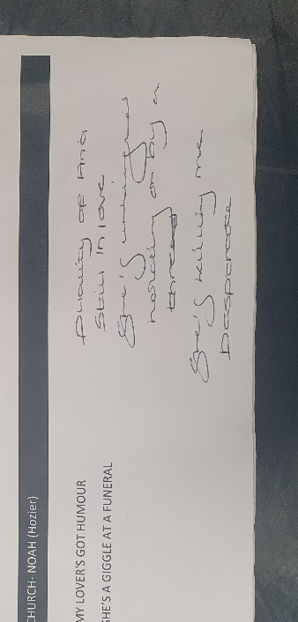
Take Me To Church Rehearsal
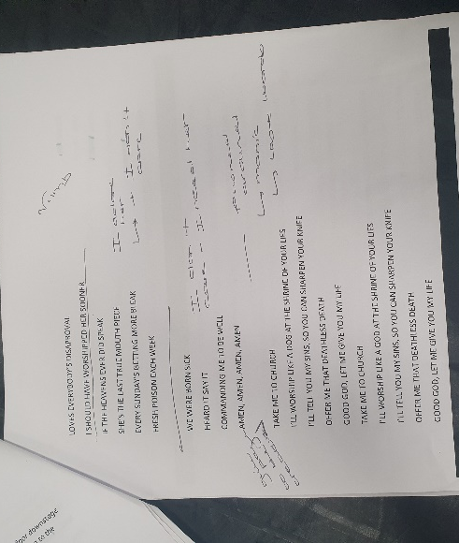
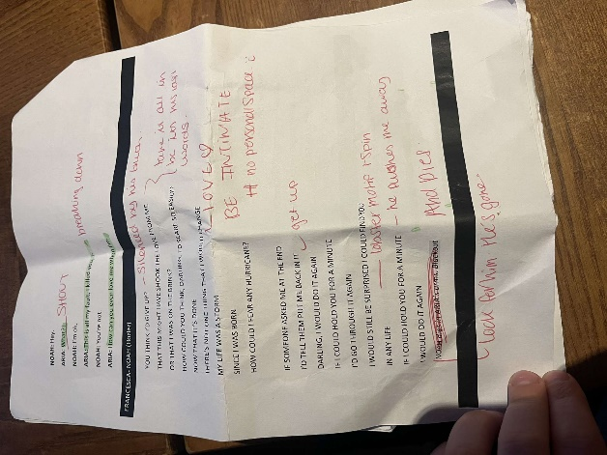
Figure 22: Jona’s Script Annotations
“Duality of Aria” “Numb” “Desperate” "I love her, I don't care" "She's killing me"

When directing the scene of Noah’s death just after Take Me To Church, I wanted it to be frantic and spontaneous, which Lucy and Jona were struggling to get into the mind-set of. To help with this, I used a form of long-form improvisation that I had done with Robbie Bowman in acting classes, where the actors start a conversation that matches the energy and then goes straight into the dialogue while maintaining that same energy. I told Lucy and Jona to start talking over each other, which got increasingly energised, then they could start the dialogue whenever they felt ready to. This created the manic mind-set that Aria needed to be in and Noah’s objective to make her hear him. We worked through this exercise a couple of times before they could reach the energy without additional dialogue, but I still had Lucy use improvised adlibbing in the show to get her to that level of energy and panic that she needed to get to in order to be calmed down by Noah.
In the final week, we worked through the transitions of the pages changing the scene. I had to make sure that all of the transitions were purposeful in order for the action to keep happening. I decided to create these transitions underneath most of the voiceover monologues which helped keep the transitions meaningful.
The last task that we did as a whole cast before going into the Dress and Tech was a full run through of the performance: Creature Run Notes.docx

Dress and Tech
The set that I brought into the space during the Dress and Tech was minimal, with my original set plan as well as additional blankets and pillows to make the table appear to be a bed. The Dress and Tech was a chance for me to explore how I can add to the horror element of the piece using lighting, as this is a very important design component when creating anything eerie or uncomfortable [see Appendix 2.C]. I used harsher tones of red to insinuate danger whenever the creature was prominent onstage, along with darker outlines to play with the absence of light while keeping the characters faces lit.
The closing transition was something that me and Nick, who was overseeing lighting and sound production, had to work out the practicalities of. I wanted to create the illusion of the creature consuming Aria, which resulted in me using a dark red light to show the positions, with blackouts in between to show them changing position until the creature has taken over Aria’s original position:
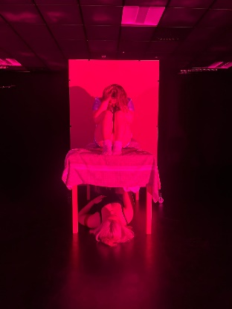
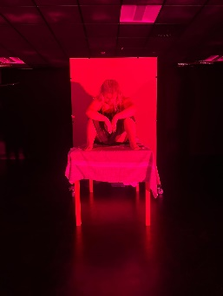
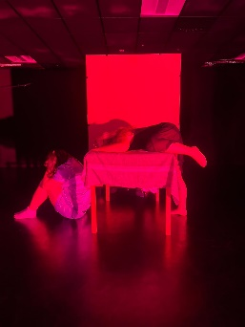
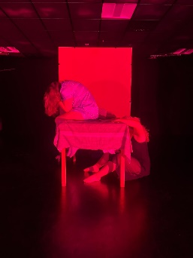

Figure 23: Closing Transition with Full Lights

Figure 24: Additional Dress and Tech Images
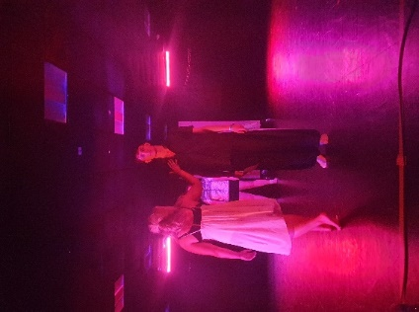
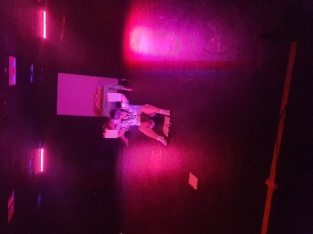
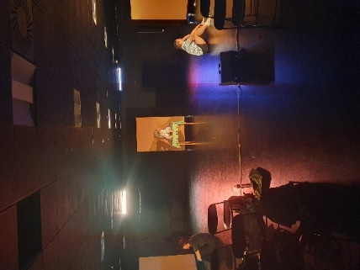

Opening Monologue
Scene 4
Transition before Take Me To Church

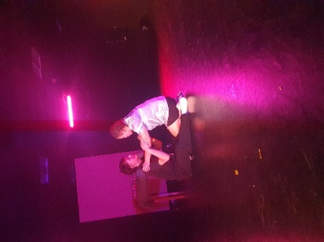
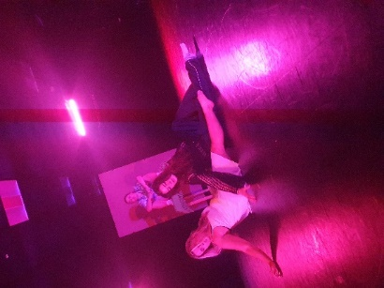
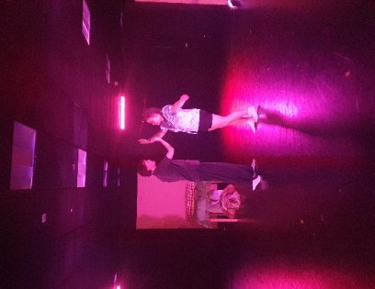

Francesca
Talk Choreography
Francesca

The performance’s lights were programmed first, before doing a staggered run for the Tech rehearsal while my tech team (Tyrion on sound and Lily on lighting) got used to the cues, and then a more seamless run with full sound and light for the Dress performance.

The Performance
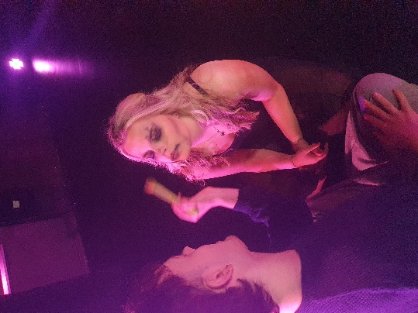
Before the performance started, I found that I was unsatisfied with the creatures look. Liv had changed the colour of her dress from white to black, as I didn’t feel as though white suited the character. However, to me, she still appeared more human like, when the creature isn’t a human at all. To help with this, I decided to do more elaborate makeup on Liv, with the help of Jona who has more advanced skills as a makeup artist than me. I guided him through darkening her eyes and lips, hollowing out her cheekbones and making the tips of her fingers black. I was very satisfied with the result, as I felt that it made the creature look more severe and frightening. We also did this under the stage lighting to ensure that the pigment was opaque enough to be seen in the performance.
Figure 25: The Creature’s Makeup Design
After watching the final performance of The Creature, I found that despite there being a lot of effective aspects that were translated in the piece, there were also some changes I would make given more resources, time and budget. These included more elaborate costumes, as I was limited by a small budget; I would have made the creature appear to be more threatening by having Liv in more exaggeratedly messy clothing in ashy greys as opposed to black to emphasise her better in Talk. I also would have had the backing dancers in identical black dresses similar to the costume that Liv had in the final performance, to add to the dynamic of movement within Talk. I also would have used more spotlights on Aria to accentuate her in a scenario where the spotlights could be moved around to more specific locations in the space than I had access to.
I also investigated audience response. In conclusion based on these responses, a lot of people found that they related to the creatures anatomy. Some related to the thoughts that the creature was built from in the way that I had originally crafted it from (paranoia or OCD), and some related in diverse ways, leaving the core of the creature to be personalised to the individual audience member as I had intended. The horror elements of the piece were translated very well, with some audience members physically jumping at certain moments in the performance.
Through this process, I have had the opportunity to explore many different new styles of choreography and devising that I had never discovered, create a bond with a professional cast of performers, collaborate with my cast as a director/choreographer, and explore how dangerous a thought can be by producing a finished theatre piece including songs, dialogue and dance.

Appendix

Appendix 1.A:
Additional research into manipulation tactics and the behaviours of someone who has manipulative tendencies:
In two studies conducted by 18 mental health professionals in the Greek Institute of Clinical Psychology and the Department of Clinical Psychology Research, there were 8 distinct manipulation tactics that overlapped across the first studies 610 participants and the second studies 609 participants. These were as follows; Threats of Abandonment, Induction to Guilt, Self-harm Threats, Induction to Jealousy, Coercive Distance / Silent Treatment, Dividing and Conquering, Use of Charm and Deflation of Self-esteem [Ioannidis, P. 2021].
According to Beverly Engel in The Emotionally Abusive Relationship, the warning signs of emotional blackmail in a romantic relationship can include:
- Your partner asks you to choose between something you want to do and them.
- Your partner tries to make you feel like you are selfish or a bad person if you do something they don’t want you to do.
- Your partner asks you to give up something or someone as a way of proving your love for them.
- Your partner threatens to leave you if you don’t do what they say.
- Your partner threatens to withhold money or access to money unless you do something they have requested.

She also states that if someone is guilty of using manipulative tactics, it does not inherently make them a horrible person, so people who are not abusers can still fall into emotionally manipulative habits. [Engel, B. 2023]
Appendix 1.B
Additional research into Gecko Theatre and drawing in the early stages like Gecko does:
Originally influenced by practitioners such as David Glass, Stephen Berkoff, Lindsay Kemp, and Ken Campbell, Gecko Theatre’s performances aim to portray a reflection or comment on an aspect of life. [Gecko Theatre Recourse Pack, 2021]. Techniques include:
- Using the breath to explore movement and emotion (holding your breath would symbolise extending or holding an emotion, for example).
- Exploring the connection between human emotion and physicality.
- Using any and all everyday stimulus as a starting point for devising.
- Filming short parts of a performance in rehearsals to look back on.

Appendix 1.C:
Additional images of building the creature in the closing transition:
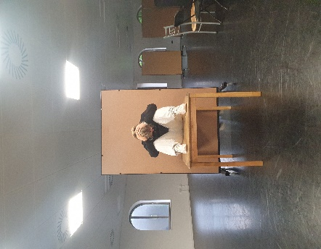
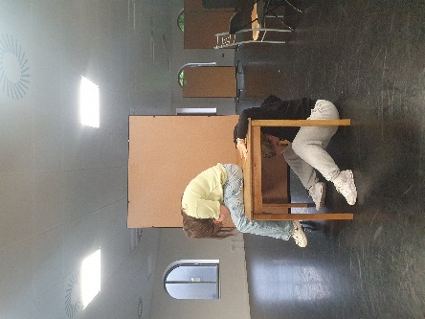
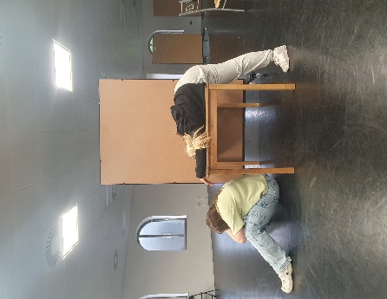
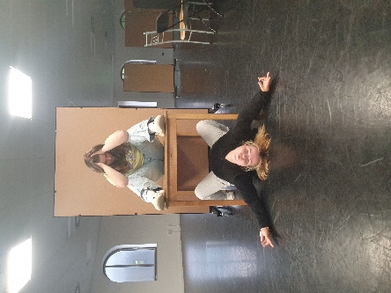

Appendix 1.D:
The Creature Script Draft 1: DRAFT 1.docx
The Creature Script Draft 2: DRAFT 2.docx
The Creature Script Draft 3: DRAFT 3.docx
Appendix 2.A:
Additional research into Punchdrunk:
Direct quote from Maxine Doyle (2023): “In creation I work with extended movement improvisations where I use music to manipulate and direct the atmosphere. I’m inspired by the dancers’ instincts and responses in the given moment, and I am constantly investigating ways in which the dancing connects the narrative and intention. I try and work from an emotional place.”
‌Additional techniques created and used by Punchdrunk
Abstraction: more open and figurative movement that is inspired by the space that has layers of expression, rather than relying on narrative tones.
Afterbeat: A contrast in the music after a major climax.
Contact Improvisation: An improvisational task that requires the performers to take each other’s weight in leans and lifts, following the energy and momentum of the performers themselves.
Appendix 2.B:
The Creature Appearance Cue sheet: The Creature cue sheet.docx
Appendix 2.C:
Additional research into how to create the horror genre:
- Taking advantage of lack of light and using harsher colours like reds to make the audience uncomfortable.
- Having the cast directly interact with the audience, which won’t work for my story, but I can set the characters furthest downstage and closest to the audience when the action is happening to give the same effect.
- Using irregular movements for The Creature itself to make the audience uncomfortable.
[Stagestudioprojects.co.uk, 2014] [Shelton, J. 2022]

Bibliography
Admin (2014) How to terrify your audience with sound and lighting!: PG stage, Stage & Studio Projects Limited. Available at: https://stagestudioprojects.co.uk/how-to-terrify-your-audience-with-sound-lighting/ (Accessed: 12 April 2024).
Aldrich, E. (2000). The extraordinary Dance book T B. 1826 : an anonymous manuscript in facsimile. Stuyvesant, N.Y.: Pendragon Press, Pg. 19.
Bond, S.B. and Bond, M. (2004) ‘Attachment styles and violence within couples’, Journal of Nervous &amp; Mental Disease, 192(12), pp. 857–863. doi:10.1097/01.nmd.0000146879.33957.ec.
Bridges, C. (2014). Punchdrunk reveal their secrets & storytelling techniques… - Now Go Create. [online] Available at: https://nowgocreate.co.uk/blog/punchdrunk-reveal-their-secrets-storytelling-techniques/ [Accessed 29 Jan. 2024].
contrafusion.co.uk. (n.d.). Allemandes, Hand Turns and Arming. [online] Available at: http://contrafusion.co.uk/Allemande.html [Accessed 17 May 2024].
Doumas, D.M. et al. (2008) ‘Adult attachment as a risk factor for intimate partner violence’, Journal of Interpersonal Violence, 23(5), pp. 616–634. doi:10.1177/0886260507313526.
Doyle, M. (2023) About - Vision | Maxine Doyle. https://maxinedoyle.com/about-vision.
Engel, B. (2023). The Emotionally Abusive Relationship. John Wiley & Sons.
Fried, Y. and Agassi, J. (2012) Paranoia: A study in diagnosis. Dordrecht, Holland: D. Reidel Pub. Co.
Gangdev, P.S. (2002) ‘The relationship between obsessive-compulsive disorder and psychosis’, Australasian Psychiatry, 10(4), pp. 405–410
Gecko Theatre (2021). Gecko Resource Pack. [online] Available at: https://static1.squarespace.com/static/61d4393c21979001ef027fab/t/620103baf3ed892bd41dfe35/1644233690906/Gecko+Resource+Pack+2021.pdf [Accessed 29 Jan. 2024].
Giacomantonio, M., Cristofaro, V.D. and Mancini, F. (2024) in/stability of moral sense of self and OCD, Journal of Obsessive-Compulsive and Related Disorders.
Graham, S. (2019). The Frantic Method - Frantic Assembly. [online] Frantic Assembly. Available at: https://www.franticassembly.co.uk/the-frantic-method
Gudjonsson, G.H. et al. (2002) ‘The relationship of compliance with anxiety, self-esteem, paranoid thinking and anger’, Psychology, Crime &amp; Law, 8(2), pp. 145–153. doi:10.1080/10683160208415003.
Ioannidis, P. (2021). The Development of the MATRRESS; A Multidimensional Scale of Manipulation Tactics in Romantic Relationships [Review of The Development of the MATRRESS; A Multidimensional Scale of Manipulation Tactics in Romantic Relationships]. International Journal of Science and Research (IJSR), 10(10). https://doi.org/10.21275/SR211026220830
Kealy, D. and Ogrodniczuk, J.S. (2023) ‘Attachment insecurity and dysfunctional identity as contributors to pathological narcissism, and Mediators of Adverse Parenting’, Discover Psychology, 3(1). doi:10.1007/s44202-023-00109-y.
Kulaityte, D., Gutparakyte, G. and Steibliene, V. (2023) A link between obsessive compulsive disorder and attachment styles: a narrative literature review, 25(2). doi:10.1097/01.nmd.0000146879.33957.ec.
Lavin, R. et al. (2019) ‘The relationship between insecure attachment and paranoia in Psychosis: A systematic literature review’, British Journal of Clinical Psychology, 59(1), pp. 39–65. doi:10.1111/bjc.12231.
Nurick, J. (2024) Heal your anxious attachment release past trauma, cultivate secure relationships, and nurture a... deeper sense of self.
O’Connor, K. and Aardema, F. (2013) Clinician’s Handbook for Obsessive-Compulsive Disorder: Inference-based therapy. Chichester: Wiley-Blackwell.
Pearse, E. et al. (2020) ‘The relationship between attachment and functioning for people with serious mental illness: A systematic review’, Nordic Journal of Psychiatry, 74(8), pp. 545–557. doi:10.1080/08039488.2020.1767687.
Punchdrunk techniques Flashcards | Quizlet
Rajaee, S. (2022) Relationship OCD: A CBT-based guide to move beyond obsessive doubt, anxiety, and fear of... commitment in romantic relationships.
Rowe, S., Gepp, K. and Marschall, A. (2021) ‘Doubt and Uncertainty in OCD - Why It Happens and What To Do’, PsychCentral, 14 September. Available at: https://psychcentral.com/ocd/obsessive-compulsive-disorder-and-uncertainty (Accessed: 20 January 2024).
Samuels, J. (et al.), Johns Hopkins University School of Medicine (2017) ‘An Investigation of Doubt in Obsessive-Compulsive Disorder’, Comprehensive Psychiatry.
Shapiro, L.J. and Stewart, E. (2011) Pathological Guilt: A persistent yet overlooked treatment factor in obsessive-compulsive disorder. Belmont, MA: Annals of Clinical Psychiatry.
Shaw, J. (2017) The memory illusion: Remembering, forgetting, and the science of false memory. London: Random House Books.
Shelton, J. (2022) 15 ways you didn’t even realize horror movies are manipulating you into fear, Ranker. Available at: https://www.ranker.com/list/horror-movie-tricks-for-scaring-the-audience/jacob-shelton (Accessed: 12 April 2024).
Smyth, N. et al. (2015) 'Anxious attachment style predicts an enhanced cortisol response to group psychosocial stress,' Stress, 18(2), pp. 143–148. https://doi.org/10.3109/10253890.2015.1021676.
Walseth, L.T. et al. (2017) ‘Obsessive-compulsive disorder’s impact on partner relationships: A qualitative study’, Journal of Family Psychotherapy, 28(3), pp. 205–221. doi:10.1080/08975353.2017.1291239.

