

Assessment 1 – Reading Task Template
PART 1: Upload your photo of your A3 in-class notes here:
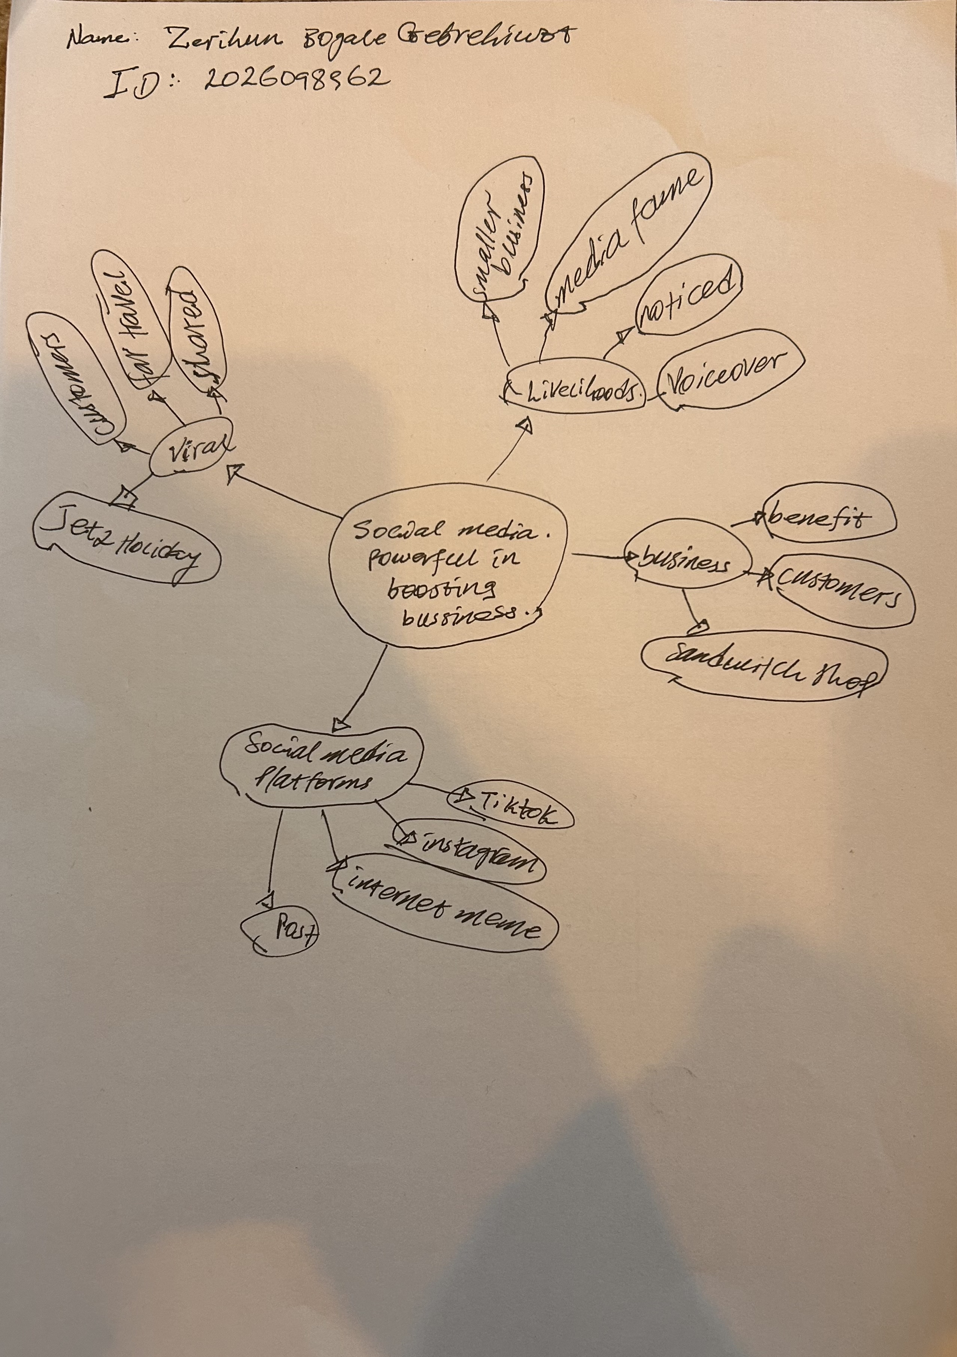

PART 2:
- Answer every question below in 1-3 full sentences.
- Use your own words. Do not use generative AI to answer these questions.
- Include a specific detail from the text when asked.
REMINDER
- The main idea is the overall message of the whole text.
- A key point helps to explain the main idea.
- A specific detail or example from the text shows that the key point is true.

- What is the main idea of the whole text?
Social media platforms like TikTok Instagram enable business to gain rapid widespread attention, go viral and attract customers from far place.

- What is one key point that supports the main idea, and which specific example from the text shows this?
The key point is social media platforms.

- What is a different key point that supports the main idea, and which specific example from the text shows this?
There are so many key points, those are business, fames, viral, livelihood and social media platforms.
- Which part of the text do you think is most important, and why?
Social media platforms such as TikTok and Instagram have made it easier than ever to get noticed by the world. Because it sums up the whole articles message social media is the powerful tool that helps small business grow quickly and reach people far away.
Reflection:
- What did you find difficult in this task (including in-class components), and why was it difficult?
The difficulty I find in this task are:
- separating main idea from examples, it takes careful thinking to see the difference.
- Everything feels relevant. Every paragraph gives useful information’s so, it’s hard to pick just one.
- Hidden core message. the big idea likes and online attention become real income is not written in one short sentence at the start.

- What helped you with this difficulty, and how did it help you?
- Asking myself what the main message is the writer wants to tell.
- Reading the titles again.
- Looking for the central statement.
- Checking what the examples do.
And it helps me like: -
- It stopped me getting distracted.
- I focused all parts together.
- I made choice clear.
- It gave confidence that I had found the truly key parts.

