  Component One:  What are the key skills required when working in the housekeeping team? 750 words (+/- 10%)  Contribution to Overall Module Assessment: 25% | Student No: | 2130491
 | Module Title: | Operating Hotel Facilities
 | Module Code: | BMIH4006
 | Lecturer: | Laurence Blake
“Housekeepers are an important part of maintaining the cleanliness of public and private facilities” Indeed Editorial Team (2020)
Housekeepers need a variety of skills to ensure they are able to meet the standards of each guest that stay in the hotel. They will have to ensure the room are clean and presentable ready for the guest. The hotels reputations and guest satisfaction depends on the cleanliness of the hotel, therefore housekeepers have to focus on all the little details in the room to ensure there won’t be any chances of complaints and any issues with the room to be reported to the maintenance team of front desk

Teamwork is an important role when working in housekeeping as if you are struggling with something in a room you should be able to ask for help to complete and set the room up properly. Although individuals have their own strengths and expertise, it’s the combined team effort that makes the hotel run smoothly as this is what hotels rely on to ensure they are meeting the needs of guests and keeping their reputation up. (Kellerman,A, 2023)

Being aware of the three S’s is essential in housekeeping. Strip is the first rule in the 3 step cleaning routine, once entering the room we have to open the windows to allow fresh air into the room before we start doing anything else, then remove all dirty towels and linen and empty the bin before beginning the next step. Sanitise is the second step in the cleaning routine ensuring each area is wiped down and cleaned, changing the cups, spoons and emptying the kettle and just ensuring each area has been cleaned. The last step is setup making sure the bedding is put on correctly, towels are placed in the bathroom, cups, glasses are placed properly after being sanitised and any other essentials or requirements are placed in the room ready for the guests to come in. It is essential housekeepers are aware of all the different chemicals needed to be used within the room and the correct way of using them to ensure their own safety and to avoid cross contamination across the rooms.

Appearance and manners are required when working as a housekeeper as you will be walking past guests and walking around the building, therefore making sure they are smart and well-dressed will continue to uphold the reputation of the hotel. Being well mannered and friendly will allow the guests to ask for any help or queries if they are to bump into a housekeeper. Housekeepers will need to consider the right clothing when working as they will need to such as versatility, comfort and style so they are able to stay productive and not worry about being restricted in moving they also need to consider being safe as they will be working with chemicals. (Shoes for crews, 2019)

Time management is paramount in housekeeping as there is a check in time in hotels housekeepers have to ensure all their rooms are complete by the check in times so there is no delays in guests checking into their room. Within the hotel I am carrying my placement out we have room checkers who will go round each room after house keepers to double check the rooms have been cleaned and setup properly ready for the next guest, therefore housekeepers will have to be done in time for the room checkers to check the rooms before check in time begins. It is essential for housekeepers to be able to multitask as they will be assigned with a range of room which need to be stripped and cleaned within the time allocated to them and before check in times begin. (Rode et al, 2018)

Aih.edu.in (2018) expresses that ‘housekeeping makes your hotel experience an enjoyable one.’ I also agree with this quote as having a clean environment to stay is makes you feel relaxed and is also a persuasive way of having a guest return to the hotel also will be worth the money, whereas if I hotel room was unclean and not well presented the guests would not be willing to return and would look for alternative hotels for the future also some guests may put in complaint demanding their money back or some type of compensation if the rooms are not up to their standards.

Word Count | 707

Component Two:
Contribution to Overall Module Assessment: 25%
In this scenario – You have just been promoted to team leader for a floor within the hotel. A guest complains that on their arrival, their room had not been properly cleaned. Create an action plan and answer the following questions.

Problem | Why did it happen? | What are you going to do? | How will you prevent this from happening in the future? | What measures would you introduce to improve  team effectiveness?
Upon entering the room, a guest complained about finding hair on their sheets. | Housekeepers missed it when putting the sheets on as it may have already been on there when took out of the bags so just an oversight in the cleaning process.  Sometimes when housekeepers are under pressure due to their times they are bound to miss little spots in the room as they will just quickly wipe over the room to make sure they finish cleaning all the rooms on time. | Follow the H.E.A.R.T. protocol, listen to their complaint, emphasise on their issue be understanding, acknowledge what they are expressing to you so guests feel as if they are being listened to, react to their complaint, try and compensate so they feel satisfied about the outcome of their complaint which will encourage them to come back to the hotel. Re clean the room and change the sheets. Lastly inform management about the issue and solution. | To prevent such incidents happening in the future arrange some training for housekeepers to give them a refresher of the policy and procedures and brand standards of the expectations of clean rooms  To prevent this from happening again ensure each room is thoroughly checked after the housekeepers are finished before allowing guests to check in. | To improve team effectiveness there would be some coaching to go over the requirements and procedures of cleaning and what is accepted and not accepted within the room.  Constructive criticism, confidently and gently emphasize what is going wrong in the rooms and what needs to be changed within the housekeeping team, express their strengths to give them a bit of praise and confidence as to things they are doing accurately.

Component Three:
Contribution to Overall Module Assessment: 50%
Your task is to create and prepare a presentation following the detailed scenario provided below.

As the floor housekeeping manager and given the recent guest complaints you need to put together a basic training presentation for your colleagues within the housekeeping team to get the best out of them, ensure that brand standard is being achieved and that Health and Safety procedures are also being followed.

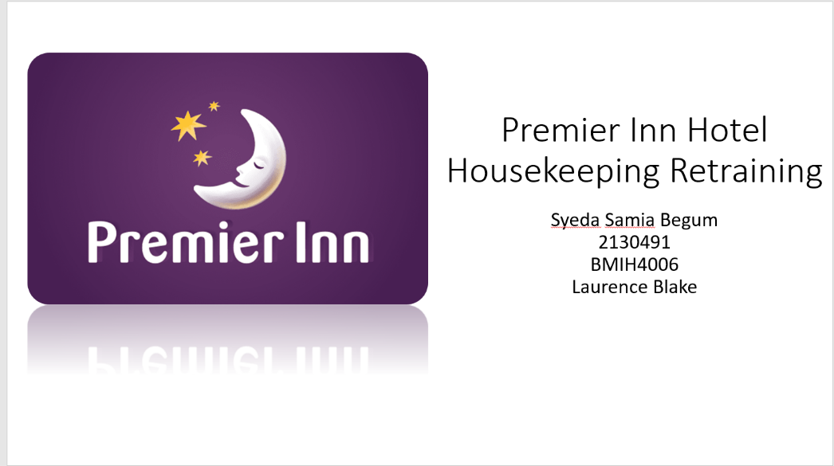

Training Notes:
Welcome
Due to recent guest complaints this presentation will give us all a quick retraining and overview of our hotel.

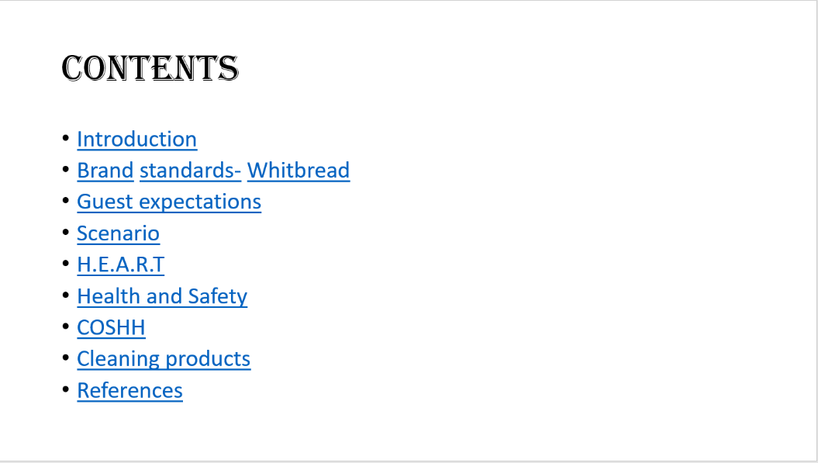

Training Notes:
These are the points we will be going through today
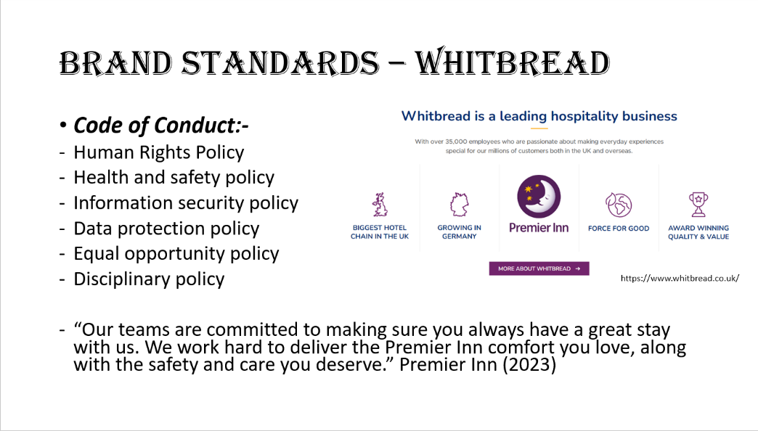

Training Notes:
Premier inn is operated by Whitbread
They follow brand standards within a premier inn setting, a brand standard is a “consistent approach to ensuring all Premier Inn
rooms are set up the same way and to highest standard to maximise guest satisfaction.” A. Mitoubsi (2023)
They follow a code of conduct to ensure everything runs smoothly
The Human rights policy is the basic standard of human rights everyone can expect
Health and safety policy is the procedure to keep everyone safe at work
Information security policy is to keep all information secure
Data protection policy is for looking after everyone's data
Equal opportunities is to ensure the provision of inclusive and respectful in the workplace
And the disciplinary policy is how to handle misbehaviour issues
Whitbread Code of Conduct - Updates 2020 | Our Policies / Summary

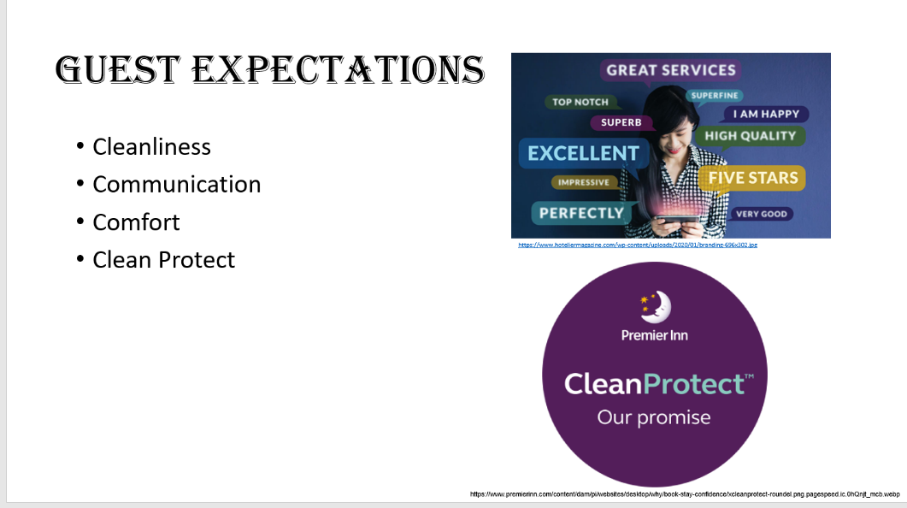

Training Notes:
The most important expectations of a guest in a hotel is cleanliness, communication and comfort.
If the rooms and environment are not clean guests will most likely leave a complaint or a review, the first thing guest notice is how clean everything is.
The last thing a hotel wants is guests to receive a unclean room and for them not to be comfortable.
“Premier Inn announces its rigorous new Premier Inn CleanProtect enhanced hotel hygiene promise to help guests stay with confidence” Whitbread (2020)
Since Covid Premier Inn launched the CleanProtect scheme, to ensure they have the top hygiene standards. Rooms are not allowed to be entered in to clean when there are guests present in the room due to Covid.

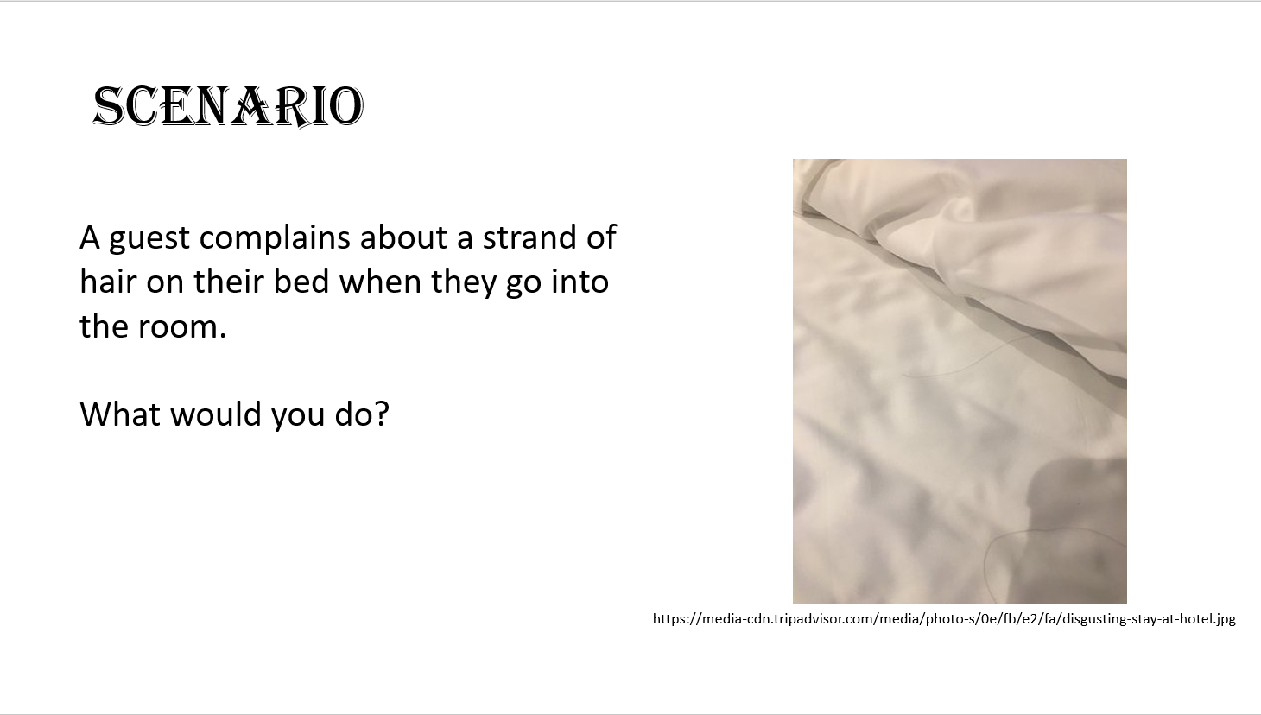

Training Notes:

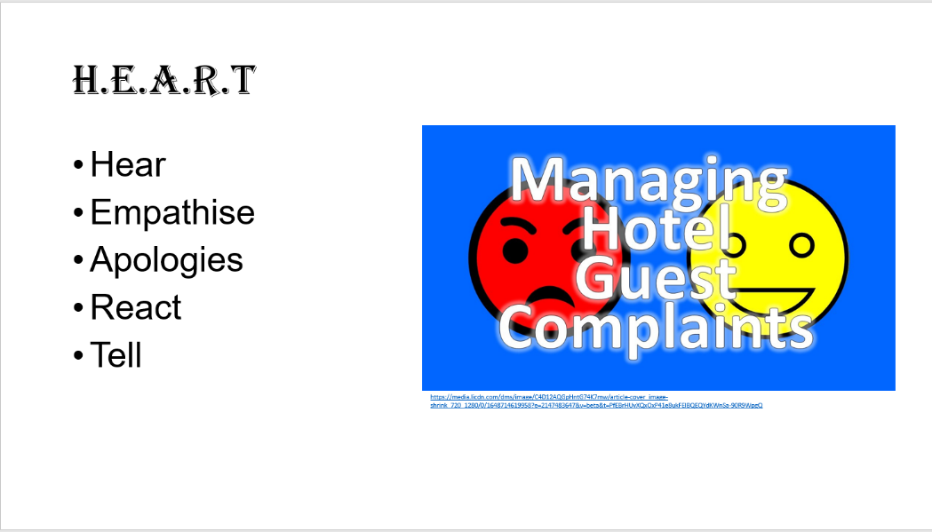

Training Notes:
There is a procedure that is followed when guests complain, this is called the HEART procedure,
You have to be patient with the guests, listen to the issue they have, show them that you understand what the issue is
apologies to them for the inconvenience, find a solution and tell them it will be resolved
and lastly inform the manager on duty or leave a shift note so they are aware of the issue when next in.

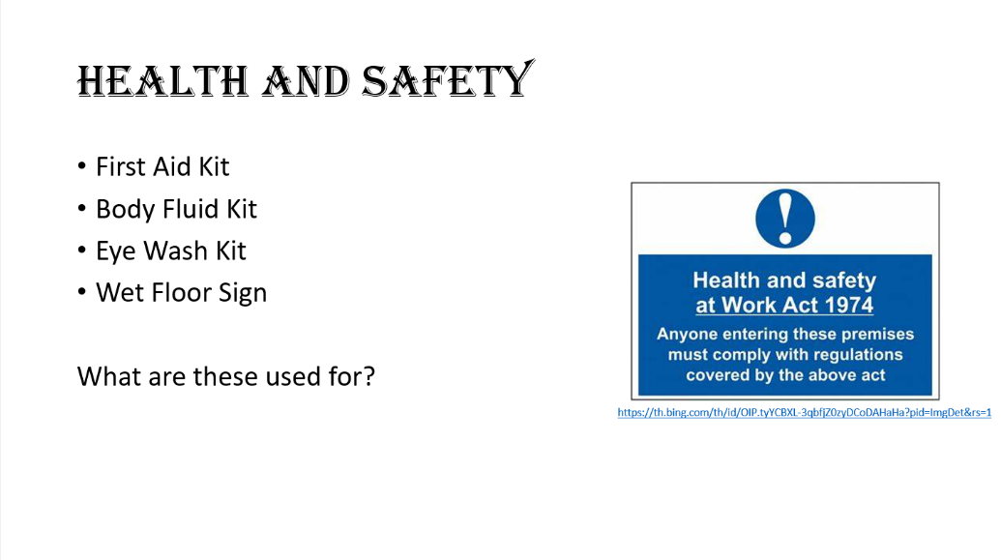

Training Notes:
The Health and Safety Work Act 1974 is a legislation framework for how health and safety should be managed at work, it is enforced by the EHO (environmental health officers) to see how the employers are managing. Health and Safety Level 2 for Whitbread - Part One
Both employees and employers must look after their own safety and safety of others around them.
Any accident must be reported to management and reported on the accident book.
First aid kit should have all the essentials in and should be supplied in all the main areas of the hotel
Body fluid kit is used for any body fluid spillages
eye wash kit should be used by a trained first aider
And a wet floor sign is to warn others of the floor being wet to avoid ant slips and accidents.

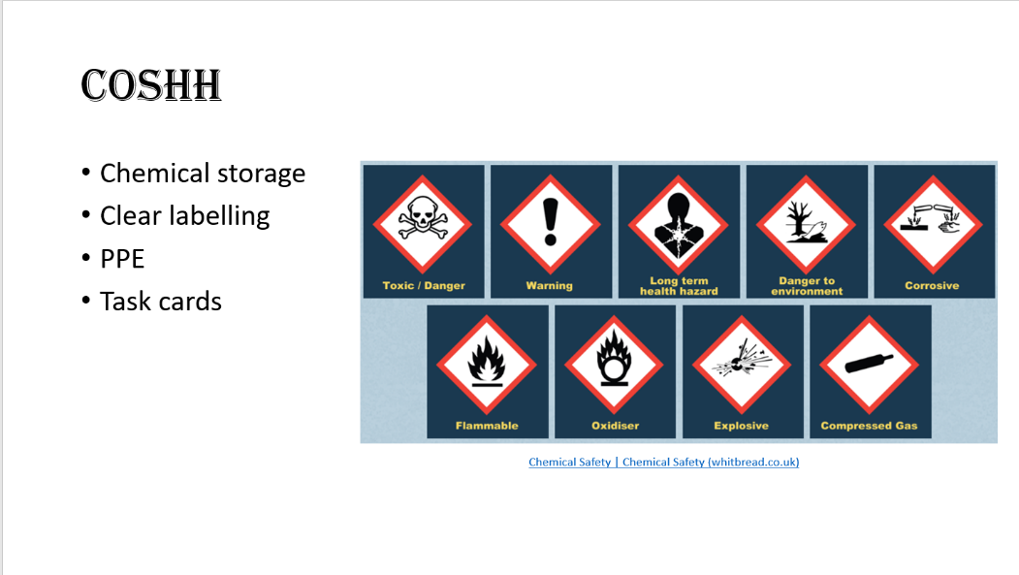

Training Notes:
COSHH stands for Control of Substance Hazardous to Health
“COSHH is the law that requires employers to control substances that are hazardous to health” Control of Substances Hazardous to Health 2002 (COSHH) (hse.gov.uk)
When working with chemicals you must ensure they are labelled clearly and use task cards when diluting the chemicals for use
You must ensure all chemical are stored away correctly and safely
PPE is important when handling chemicals as it will keep you safe from spillages.
There are 9 hazardous symbols to look out for which are shown on the slide.

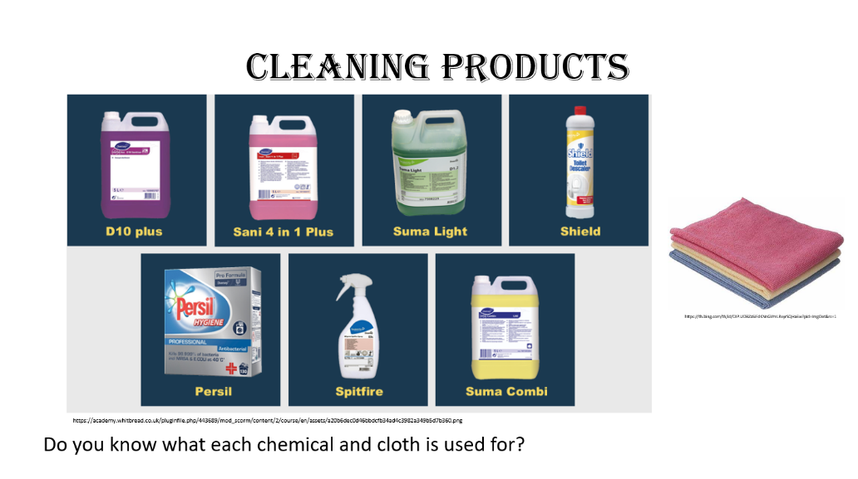

Training Notes:
There a various chemicals and cloths used for when cleaning around the hotel.
D10 is to be used for tables, desks and window
Sani 4 in 1 is used for bathroom, descaler and deodoriser
Suma Light is a washing up liquid
Shield is for the toilet
Persil is of course a detergent
Spitfire is used to remove marks
And Sumi Combi is used for the dishwasher
There are 3 different coloured cloths used yellow for the toilet only, red for the rest of the bathroom and blue is for the room. You have to be careful that we do not cross contaminate and clean accurately

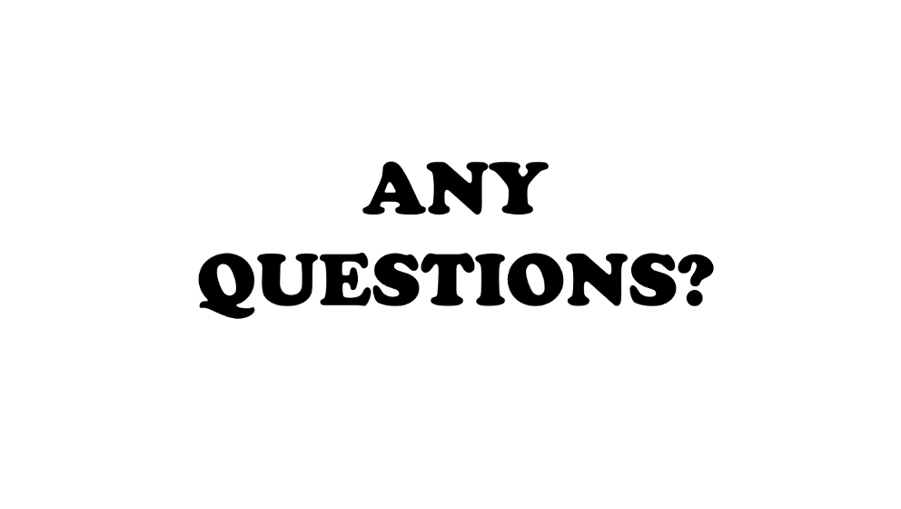

Training Notes:
Does anybody have any questions?
Thank you for your time.

References
Element 1
Indeed Editorial Team (2020) Guide to housekeeping tips (with tips and examples). Available at: https://www.indeed.com/career-advice/career-development/housekeeping-skills. (Accessed 15 February 2023)
Aih.edu.in (2018) ‘Importance of housekeeping in the hotel industry’. Apeejay industry of hospitality [blog]. 14 June. Available at: https://aih.edu.in/blogs/2018/06/14/importance-of-housekeeping-in-the-hotel-industry/. (Accessed 15 February 2023)
Rode, J.A. and Poole, E.S., 2018, May. Putting the gender back in digital housekeeping. In Proceedings of the 4th Conference on Gender & IT (pp. 79-90)
Kellerman, A (2023) The power of teamwork in the hotel industry. Available at: The Power of Teamwork in the Hotel Industry | HOTELIERS OF TOMORROW (hotelierinc.com) (Accessed 08 March 2023)
Shoes for Crews (2019) What should be included in a proper housekeeping uniform? Available at: What Should be Included in a Proper Housekeeping Uniform? | Blog (sfceurope.com) (Accessed 08 March 2023)

Element 3
- A, Mitoubsi (2023) Premier Inn Hotel
- Chemical Safety | Chemical Safety (whitbread.co.uk)
- Health and Safety Executive (No Date) Control of Substances Hazardous to Health 2002 (COSHH). Available at: Control of Substances Hazardous to Health 2002 (COSHH) (hse.gov.uk) (Accessed 06 March 2023)
- https://academy.whitbread.co.uk/pluginfile.php/443689/mod_scorm/content/2/course/en/assets/a20b6dec0d46bbdcfb34ad4c3982a349b5d7b360.png
- https://media.licdn.com/dms/image/C4D12AQGpHntG74K7mw/article-cover_image-shrink_720_1280/0/1648714619958?e=2147483647&v=beta&t=PfEBrHUvXQxOxP41e8ukFElBQEQYdKWnSa-90R9WpgQ
- https://media.licdn.com/dms/image/C4D12AQGpHntG74K7mw/article-cover_image-shrink_720_1280/0/1648714619958?e=2147483647&v=beta&t=PfEBrHUvXQxOxP41e8ukFElBQEQYdKWnSa-90R9WpgQ
- https://media-cdn.tripadvisor.com/media/photo-s/0e/fb/e2/fa/disgusting-stay-at-hotel.jpg
- https://th.bing.com/th/id/OIP.tyYCBXL-3qbfjZ0zyDCoDAHaHa?pid=ImgDet&rs=1
- https://th.bing.com/th/id/OIP.UDBZaSiFdKNnGVmLRxyrSQHaEw?pid=ImgDet&rs=1
- https://www.hoteliermagazine.com/wp-content/uploads/2020/01/branding-696x302.jpg
- https://www.premierinn.com/content/dam/pi/websites/desktop/why/book-stay-confidence/xcleanprotect-roundel.png.pagespeed.ic.0hQnjt_mcb.webp
- https://www.whitbread.co.uk/
- Premier Inn (2023) Available at: Stay with confidence | Premier Inn (Accessed: 01 March 2023)
- Whitbread (2020) Premier Inn CleanProtect hotel hygiene regime will help guests stay with confidence. Available at: https://www.whitbread.co.uk/premier-inn-cleanprotect-hotel-hygiene-regime-will-help-guests-stay-with-confidence/ (Accessed 02 March 2023)
- Whitbread (2020) Whitbread policies. Available at: Whitbread Code of Conduct - Updates 2020 | Our Policies / Summary (Accessed: 01 March 2023)
- Whitbread (2023) what is workplace health and safety. Available at: Health and Safety Level 2 for Whitbread - Part One (Accessed: 01 March 2023)

