Digital Skills and Research Methods
Executive Summary
Virtual Learning Environment is one of the most popular e-learning programs implemented by various universities. Furthermore, students, teaching staffs along with schools, colleges and universities are favoured towards this program as it is easy to adapt and beneficial for the students. The research report is focused to understand the impact of VLE among the students' towards their learning experience in the University. Moreover, the current pandemic situation has also encouraged the students and the educational institutions to opt for the learning program.

Table of Contents
Introduction 4
Research Methodology 6
Primary Data Analysis 8
Secondary Data Analysis 14
Reflection 16
Conclusion 18
Reference 19

Introduction
The virtual learning environment is an educational technology that can be further illustrated as a web-based platform to enhance the digital skills of the students through courses of study taught digitally which is usually done in educational institutes. The report will discuss the impact of Virtual Learning Environment (VLE) - Moodle on the learning experience of the students of the University of Wales Trinity Saint David London Campus. In order to derive the research outcome both primary and secondary data analysis will be performed.
Aim
To understand the impact of Virtual Learning Environment (VLE) - Moodle towards the online learning experience of the students at the University of Wales Trinity Saint David London Campus
Objectives
1. To explore the importance of VLE –Moodle among the students regarding their learning experience
2. To determine the potential benefits of implementing VLE – Moodle within the students of the University of Wales Trinity Saint David London Campus
3. To find out the challenges that the students face while incorporating VLE – Moodle in their learning process of the University
Research Questions
1. What is the importance of VLE- Moodle among the students of the University of Wales Trinity Saint David London Campus?
2. What are the potential benefits of implementing VLE – Moodle within the students?
3. What are the challenges that the students encounter while adapting to VLE – Moodle?
Rationale
The outbreak of the Covid-19 has caused a barrier towards the education of the students. Therefore, to remove the hindrance of the learning the University of Wales Trinity Saint David London Campus has implemented a Virtual Learning environment among their students through Moodle (Webb, McQuaid and Webster, 2021). The research report is conducted to understand the impact of VLE among the students of the University.

Research Methodology
Research Methods
The research methods state the appropriate methods that need to be followed in order to accomplish the research outcome effectively. Furthermore, in this research, mixed methods that are both qualitative and quantitative methods will be followed. This will help to determine the accurate results of the research (Methods, 2021).
Data collection tools & Techniques
In order to conduct a quantitative method, the primary analysis will be performed by using survey tools and techniques. Further, for the qualitative method, the secondary analysis will be performed by researching published materials on various online platforms where details about the research topic have been discussed along with articles and journals (Clark and Vealé, 2018).
Sample Size
The sample size constitutes the students of the University who will be selected by random sampling and an online questionnaire will be presented. Based on their answer, a primary analysis will be conducted where table and graphs will be derived to generate the appropriate outcome of the research (corporatefinanceinstitute, 2021).
Ethical considerations
The research has been conducted by following all the rules and regulations of data privacy and all the information are kept confidential as per the norms. Furthermore, to maintain the privacy of the participants of the survey the standards of anonymity and confidentiality has been applied. Moreover, the participants are kept anonymous in order to respect the information derived through the supply of the research.

Primary Data Analysis
1. Did you understand the use of VLE – Moodle for your coursework?
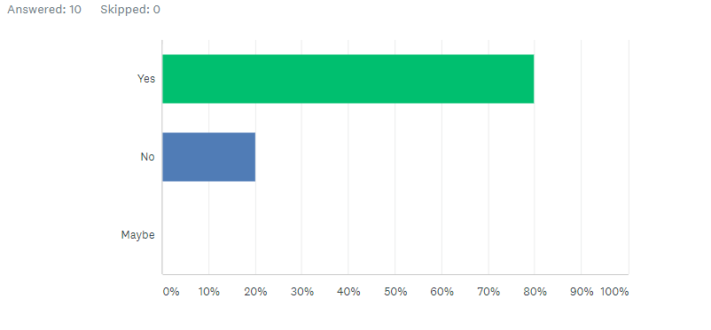
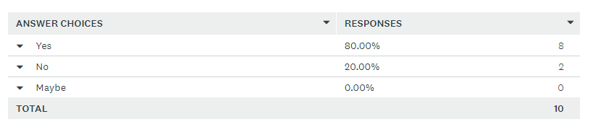
Source: (surveymonkey, 2021)
The survey was conducted among the students of the University of Wales Trinity Saint David London Campus to know the percentage of usage of the new learning program in their study course. As per the response, 80 percent of the respondents used the VLE program while 20 percent did not use the learning program. This depicts that the VLE is adapted by maximum respondents and students are moving towards digital up gradation in their learning experience.
2. Was it effective to use VLE – Moodle for your coursework?
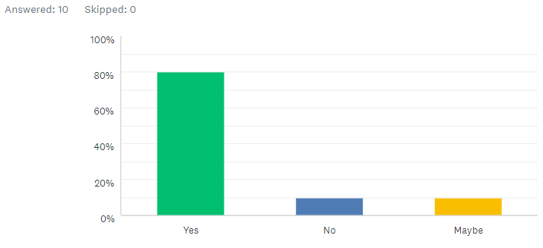
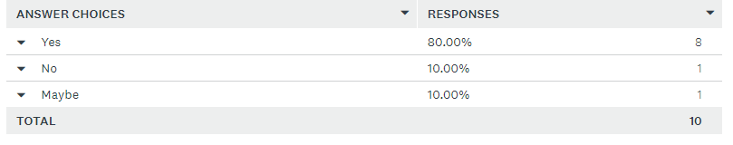
Source: (surveymonkey, 2021)
The above question is asked to know whether VLE was effective for them or not. The survey depicts a positive response as 80 % of the responses have agreed that the learning software was effective and support them to strengthen their knowledge. While 10 percent were not sure about the software because they are still not accustomed to digital learning and 10 percent does not find VLE to be effective enough for the coursework.
3. What is the key factor that emphasised you to use VLE for your coursework?
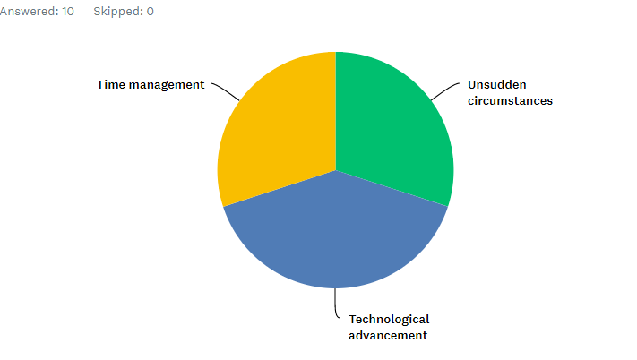
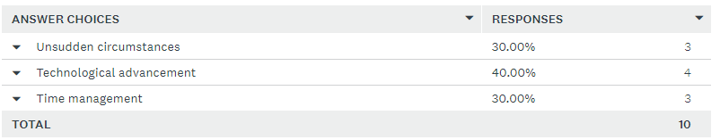
Source: (surveymonkey, 2021)
There are various factors that have enforced the participants to adapt to VLE- Moodle for their coursework. However, as per the survey, 40 percent of technological advancement is the main reason behind implementing VLE to enhance their learning experience. Furthermore, 30 percent agreed time management and unsudden circumstances being the reason behind this advancement. The outbreak of the pandemic has forced the government to impose lockdown, social distancing and other restriction which has affected the education all over the globe. Therefore, the Universities have adapted the digital learning software to enhance the digital skills of the students and also to accomplish their studies without any barriers.
4. Did you enjoy your learning experience through VLE?
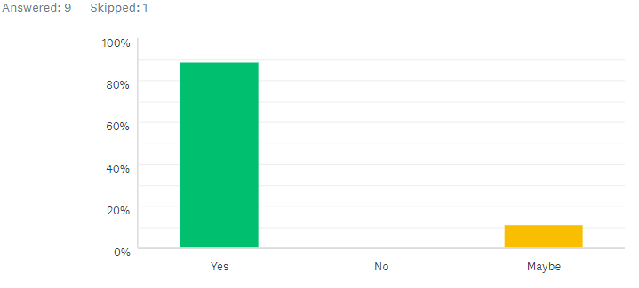
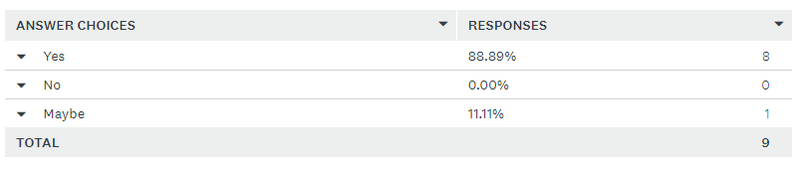
Source: (surveymonkey, 2021)
The students must adapt and get accustomed to the new learning program through Moodle. Furthermore, in the present scenarios, it is very significant to have strong technical skills and also to motivate the students to implement VLE for their career growth and enhanced knowledge. Therefore, this question is asked to determine how many students are enjoying their VLE learning experience. The survey states 88.89 percent have enjoyed their coursework through VLE while 11.11 percent are not sure about their opinion that is why selected may be. This depicts that VLE is very effective software and quite popular among the respondents.
5. What are the benefits you discovered by implementing the learning experience through VLE?
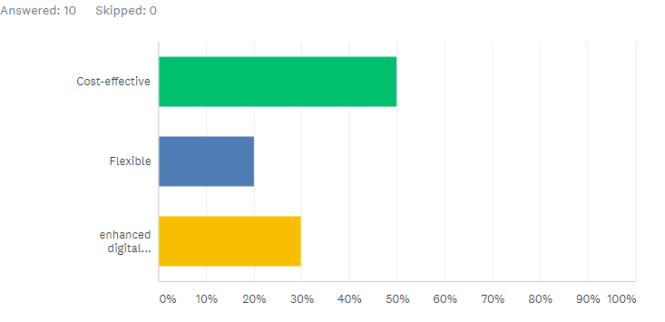
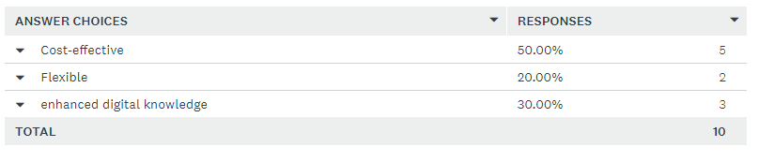
Source: (surveymonkey, 2021)
The above mentioned question was asked to the students to determine the potential benefits that the students have experienced while studying through VLE- Moodle. As per the survey, 50 percent of the respondents have stated cost-effectiveness as the key benefit as Moodle is free learning software provided by the University to their students. Furthermore, 30 percent stated enhanced digital knowledge is the potential benefits that the students are getting from the VLE. However, 20 percent has also selected flexibility of the time being the most effective benefit of the e-learning program. The online learning program provides the flexibility of time as students can focus and complete their course as per their liberty of schedule.
6. What are the issues you faced while incorporating VLE in your learning process?
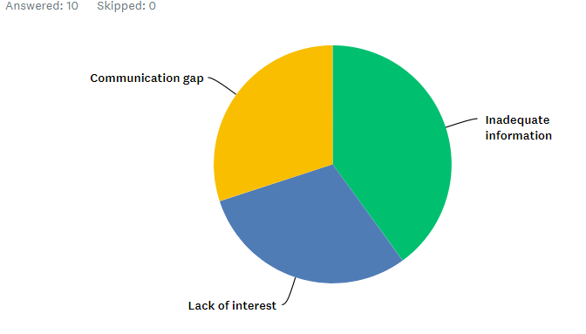
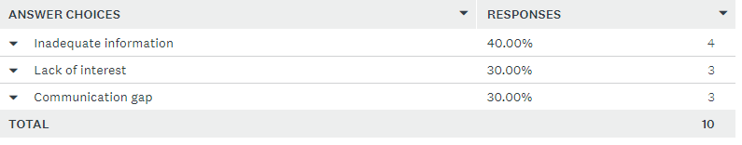
Source: (surveymonkey, 2021)
Every learning program or software has its advantages and disadvantages when an individual faced while implementing the techniques. The students must identify the challenges and proceed towards appropriate solution to mitigate the barrier in their course. According to the survey, the maximum number of respondents stated that inadequate information is the most common issue faced by them. Many times, the information is wrong or not properly stated which makes it difficult for the students to understand and they face difficulty in their course. While 30 percent have stated lack of interest being the most challenging situating as prolonged sitting in front of the laptop leads to health issues and students lose their interest in the subject matter. Furthermore, 30 percent also stated that e-learning creates communication gap as students cannot interact with the professors face to face and sometimes network issues also develops communication gap within the students.

Secondary Data Analysis
Impact of VLE among the students on their learning experiences
The secondary analysis is based on the journals, articles and online portals where the published materials regarding the impact of VLE on the learning experience of the students can be determined.
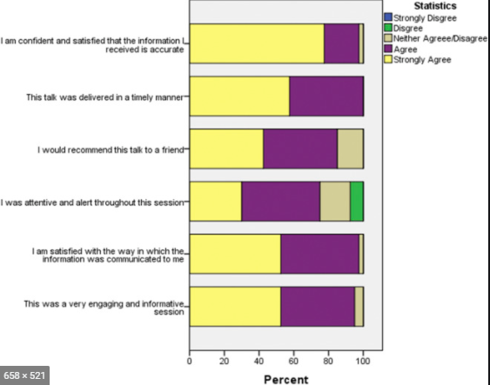
Source: (Ryan & Poole, 2019)
The journal article has stated the impact of the virtual learning environment (VLE) based on the satisfaction, retention, engagement of the students in their learning experience. Furthermore, the article states the progress of the students while implementing the VLE learning experience rather than classroom teaching (Herrera Mosquera, 2017). The above image demonstrates the research outcome that the teaching through VLE was quite valuable and could grab more attention of the students than the normal classroom studies. Furthermore, virtual learning has a lasting impact on the students and increases their learning capability.
Experience of VLE learning among students in the EFL classroom
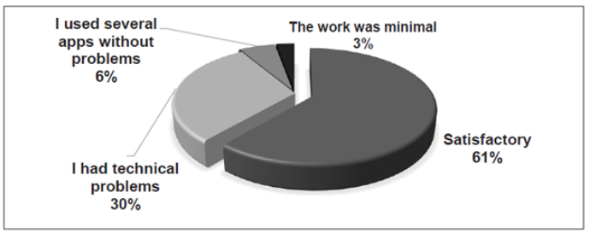
Source: (Mosquera, 2017)
The above graph has been generated from the article which states the learning experiences faced by the students while implementing the VLE learning experience within the students in the EFL classroom. Furthermore, the article has showcased their issues the student face while research also depicts that VLE is rapidly adapted as favourable learning software (Dayag, 2018). In addition to that, the article also focused towards the facts that VLE enhances the technological aspects among the students and also support their learning procedure in a fast and effective manner. It also depicts the interest of the students towards e-learning and the quick adaptability along with the flexibility of the schedule provided by the VLE is beneficial for the students.

Reflection
Gibbs reflective cycle is a reflective model developed by Graham Gibbs in the year 1988 to demonstrate the learning experience in a structured manner (mindtools, 2021). Furthermore, by using this model, I have established my learning experience while incorporating Virtual Learning Environment Moodle. Moreover, the use of the model will efficiently place the experience.
Description: I have attended the VLE through Moodle in order to gain knowledge about specific coursework. My overall experience about the whole learning experience was not too good at the initial stage. I was facing technical issue while the coursework was going on. However, my tutors were quite helpful regarding the matter.
Feelings: I had mixed feeling at the same time nervous when I started using the software for the first time. Later on, I gained confidence with the time and support of my peers and tutors. Online learning is flexible and saves a lot of time.
Evaluation: I had discussed my issues with my tutors and as per their feedback implemented changes in the adaptation of the learning process. In addition to that, I also believe that VLE has enhanced my technical capability and got hold of various other facts outside the classroom which will be beneficial for career growth.
Analysis: I want to overcome my issues and adapt the learning software for future endeavours. In addition to that, the advanced learning technology will help me to upgrade my skills and knowledge.
Conclusion: Virtual Leaning Environment is very significant in today’s education system and it has helped me to develop the skills and confidence within me. It has also helped me to learn quickly and got to know various interesting facts.
Action Plan: I should work on my shortcomings and need to concentrate more on the technicalities that I can encounter further in my VLE learning experience. Furthermore, I need to enhance my analytical and problem-solving skill and maintain a systematic timing in my course.

Conclusion
Virtual Learning Environment (VLE) is very significant for enhancing the digital skills of the students along with the most effective process as per the current circumstances. VLE is a learning software program that is essential for the educational institution to develop the quality and the current situation of the pandemic. The report has focused to understand the impact of the VLE-Moodle on the students of the University. Furthermore, the potential benefit and the challenges administered by the students while incorporating the digital learning experience rather than the classroom teaching. In addition to that, both primary and secondary analyses have been implied to derive the effective outcome. Moreover, a self-reflection using the Gibbs model has also been applied based on the experience of the student.

Reference
Books & Journals
Clark, K.R. and Vealé, B.L., 2018. Strategies to enhance data collection and analysis in qualitative research. Radiologic technology, 89(5), pp.482CT-485CT.
Dayag, J.D., 2018. EFL virtual learning environments: Perception, concerns and challenges. Teaching English with Technology, 16(4), pp.20-33.
Herrera Mosquera, L., 2017. Impact of implementing a virtual learning environment (VLE) in the EFL classroom. Íkala, revista de lenguaje y cultura, 22(3), pp.479-498.
Webb, A., McQuaid, R.W. and Webster, C.W.R., 2021. Moving learning online and the COVID-19 pandemic: a university response. World Journal of Science, Technology and Sustainable Development.
Website References
corporatefinanceinstitute, 2021. Random Sampling. [Online] Available at: https://corporatefinanceinstitute.com/resources/knowledge/other/random-sampling/.
Methods, R., 2021. skillsyouneed. [Online] Available at: https://www.skillsyouneed.com/learn/research-methods.html.
mindtools, 2021. Gibbs' Reflective Cycle. [Online] Available at: https://www.mindtools.com/pages/article/reflective-cycle.htm.
Mosquera, L.H., 2017. Impact of Implementing a Virtual Learning Environment (VLE) in the EFL Classroom. 22(3).
Ryan, E. & Poole, C., 2019. Impact of Virtual Learning Environment on Students’ Satisfaction, Engagement, Recall, and Retention. Journal of Medical Imaging and Radiation Sciences, 50(3), pp.408-15. Available at: https://www.sciencedirect.com/science/article/abs/pii/S1939865418304636.
surveymonkey, 2021. SurveyMonkey. [Online] Available at: https://www.surveymonkey.com/results/SM-W6PVDTZ89/.

