

Student Name :- Keval Hansraj Mange
Student ID :- 2240155
Programme :- MBA General Management
Module :- Marketing Management
Code :- LCMB7001
Lecturer : Tushara Balendran

Table of Content
- Introduction
- Communication Model
- Integrated Marketing Mix
- New Promotional Strategies
- Branding and Brand Equity
- Keller’s Brand Equity Model
- Customer Journey
- Customer Touchpoints
- Persona of the Company
- Total Engagement Model
- Recommendations
- References

- INTRODUCTION
Today it has become essential to be strategically sound to emerge from tough competition. Very few companies can do it successfully, HP can be stated as one of the companies to do so. It is renowned in the industry of technology. This report analyses HP’s communications with the Shannon and Weaver communication model, total engagement model, and integrated marketing mix used by HP, Promotional strategies used by HP, branding and brand equity, consumer journey map, touchpoints and recommendations. This report also analyses customer journey map.
HP Inc. Mission Statement
“We create technology that makes life better for everyone, everywhere. Our mission is to engineer experiences that amaze.” (Comparably)

HP Inc. Vision Statement
“From day one, HP broke new ground by refusing to accept the status quo. Bill Hewlett and Dave Packard created more than an audio oscillator in their Palo Alto garage. They built a way of doing business—the HP Way. What started in Bill and Dave’s garage still thrives today. We continue to change the world with our products, people, and business practices. Reinvention is the key. It is the accelerant to growth. It drives us to create experiences that amaze.” (Comparably)

- COMMUNICATION
  - Shannon and Weaver Communication Model
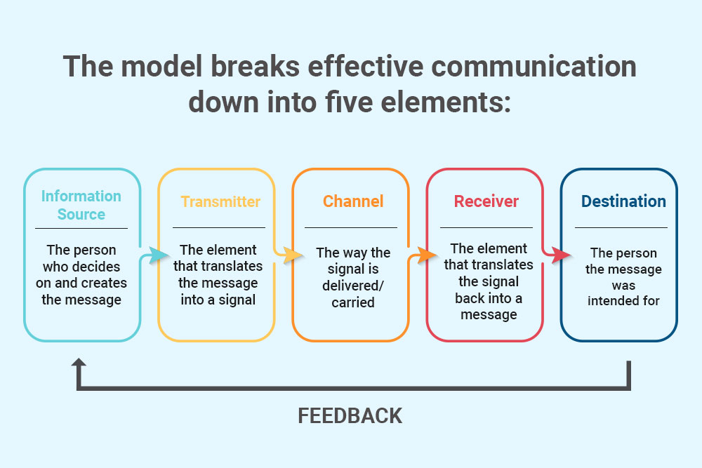
Source: Human Focus
In 1949, C.E. Shannon and W. Weaver introduced the Weaver Model, designed for electronic communication. This conceptual framework was developed to elucidate electronic technology, emphasizing its technical facets. The model elucidates that internal communication can occur in proportional mathematical terms through technological devices. It is also recognized as the Mathematic Model. (Gupta, 2022)

- INTEGRATED MARKETING COMMUNICATION
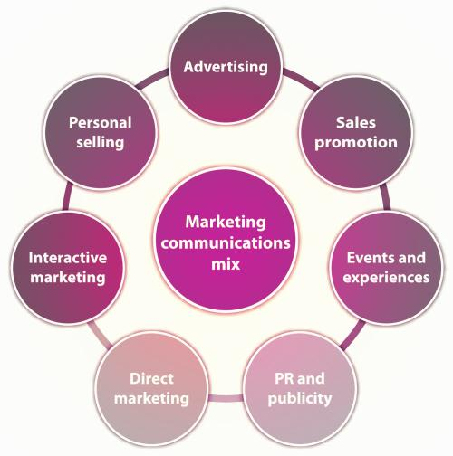
Source: MBA Skool

Integrated Marketing Communications (IMC) involves integrating, coordinating, and amalgamating diverse marketing and promotional elements to convey a consistent marketing message across various customers and channels. IMC guarantees that the message and positioning remain constant across delivery channels, ensuring cohesive branding. It encompasses the combination of channels such as email, social media, calls, TV, print, etc., and employs various methods like advertising, direct marketing, sales promotion, PR, etc. The fundamental tools within the IMC framework that aid in achieving an organization's communication objectives are known as the promotional mix. (Zigu, 2011)
Combination of IMC used by HP
HP uses communication tools that contain media like newspapers, TV, magazines, and digital media like social media, blogs, websites, and viral videos. Adding more, there are also other forms of marketing communication done by HP that are, billboards as outdoor marketing, and sponsorships. (UKEssays,2018).

- NEW PROMOTIONAL STRATEGY OF HP
  - Online Promotion
- Social Media Marketing
HP is actively engaged on various social media platforms including Instagram, Twitter, TikTok, and Facebook. Notably, Facebook stands out as the most popular platform for HP, boasting 4.5 million followers, followed by Instagram with 1.2 million followers and Twitter with 1.1 million followers.
Recognizing the user demographics of Instagram and Facebook align well with its target audience, HP has prioritized its efforts on these platforms. Additionally, HP maintains a presence on LinkedIn, garnering 5.1 million followers. The content predominantly comprises promotional and informative posts, offering tips, guidance, and insights into today's technology landscape. (Xaif, 2022)
- Search Engine Optimisation
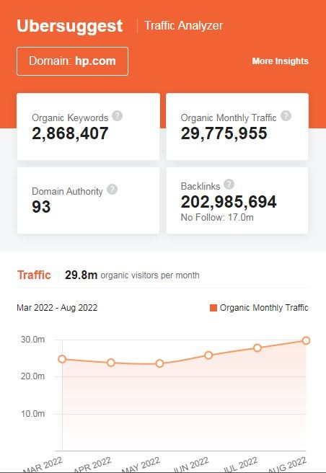
Source: The Digital School
SEO is crucial in HP's strategy, aiding in customer acquisition, retention, and market expansion. The majority of the website visitors come through organic traffic, underscoring the effectiveness of leveraging organic keywords over paid methods for driving website traffic. This underscores the significance of organic traffic in contributing to a substantial and diverse visitor base for the company's website. (Xaif, 2022)
- Search Engine Marketing
Search engine marketing (SEM) involves utilizing paid advertising to guarantee visibility for the business's products or services on search engine results pages (SERPs). By bidding on specific keywords, SEM allows the business to be displayed as a result when a user searches for those keywords. HP uses keywords like laptops, gaming, high specs, professional, etc. to optimize search engine results.

- Influencer Marketing
HP appoints influencers who align with its target demographic. HP has also tied up with various social media influencers in recent days to promote its products among GenZs. This helps HP to cope with youngsters, trends, and their preferences.
- E-commerce Strategies
HP maintains an informative website that serves as a valuable resource for obtaining extensive knowledge about the latest technology. While the site doesn't enable direct product sales, it provides detailed information on HP's products, specifications, pricing details, and more.
- Content Marketing Strategies
HP actively engages on social media platforms, with a focus on Facebook, Instagram, and X(Twitter). Their social media content revolves around updates on new product launches, marketing campaigns, and related information. In contrast, their press releases primarily cover safety advisories, financial updates, and changes in company structure, and are predominantly directed towards investors.

  - Offline Promotion
- Print Media
Print media is far from ineffective. Even though the public image is that everyone and everything is online now, people still prefer print.
-Print advertising (newspaper ads, magazine ads, catalogs, brochures, outdoor ads, etc.)
-Print collaterals (menus, flyers, price sheets, discount coupons, etc.)
-Stationary (business cards, envelopes, letterheads, notebooks, etc.)
- Partnerships
HP places significant emphasis on strategic partnerships within its marketing approach. By teaming up with retailers, the company extends its distribution network, enhancing the availability of its products in brick-and-mortar stores. HP's collaborations with educational institutions, offering advanced laptops to students, establish the company as a crucial supporter in fostering the tech enthusiasm of the upcoming generation.

- BRANDING AND BRAND EQUITY
  - Branding
Branding is the process of establishing a company’s brand identity. This process also provides materials that reinforce the brand, such as a logo, tagline, visual design, or tone of voice.
In simpler terms, branding is the process of researching, developing, and applying a unique feature or set of features to the organization so that consumers can begin to associate the brand with products or services.
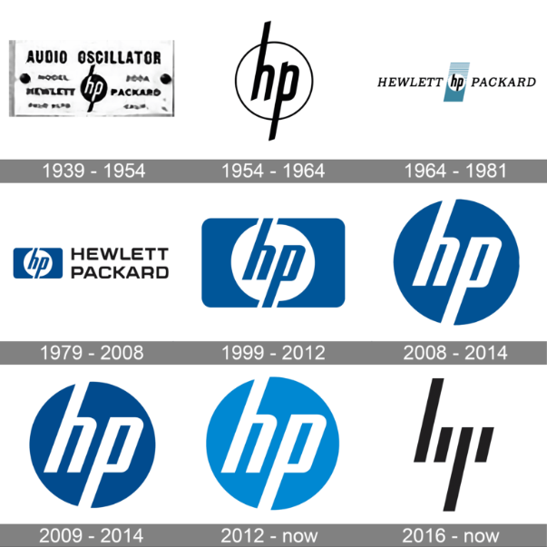
Source: 1000logos.net

Branding is the process of establishing a company’s brand identity. This process also provides materials that reinforce the brand, such as a logo, tagline, visual design, or tone of voice. Companies that create strong brands understand that their brand identity should be present in all aspects of their business, including social media captions, billboard colour palettes, and packaging materials. They know that their brand name extends beyond the label and can attract consumers to choose their products over other options.

  - Brand Equity
Hewlett Packard (HP) is a renowned American multinational IT corporation specializing in the provision of hardware and software solutions for businesses, both small and large. Additionally, the company engages in business-to-consumer marketing, manufacturing, and selling a diverse range of IT products. Established in 1939 in the United States, HP's global presence is marked by the widespread use of its products, including PCs, storage devices, software, printers, and imaging products. An intriguing aspect often overlooked is HP's pioneering introduction of a flex-time policy for employees, granting them the flexibility to work at their convenience, and developing increased creativity.
HP is undoubtedly one of those technology companies that enjoy very high brand equity and that is because it has been there in the market for so many decades now that even in much competitive market, its consumers still trust them. Other factors for this are:
- Brand Awareness
HP stands as a distinguished technology company, reaching consumers in more than 170 countries. This widespread availability contributes significantly to the firm's robust brand image, making it a trusted and reliable choice in the technology sector. HP's strong reputation is further fortified by its considerable investments in both innovation and standardization. This commitment provides the company with a competitive edge over rivals, elevating its value and global recognition.
- Brand Loyalty
HP is recognized for actively nurturing connections with its customers, employing diverse strategies in both business-to-business and business-to-consumer marketing. The incorporation of social media integration serves as a channel for consumers to engage with the company, enhancing their overall experience with HP. These elements collectively foster a strong sense of brand loyalty among customers.
- Brand Elements
Certain aspects of HP, such as its logo, give consumers a recognizable and easily recallable connection to the brand. The enduring consistency of their logo since the company's inception has ingrained it in the minds of consumers. Additionally, the logo's simplicity and clear representation of the company's name make it effortless for a majority of consumers to associate it with the HP brand.
- Perceived Quality
The evaluation of a company's success in shaping its image in the minds of consumers is crucial. In the case of HP, there is a perceived shortfall in technological aspects, particularly in today's highly competitive industry landscape, which somewhat diminishes its brand equity. However, the brand is strongly associated with other key attributes in consumers' memories. HP excels in performance, quality, after-sales services, design, customization, and reliability, which have been pivotal in retaining a loyal customer base over the years. These factors collectively define HP's position in the minds of consumers.

- KELLER’S BRAND EQUITY MODEL

According to Keller brand equity is "the differential effect of brand knowledge on consumer response to the marketing of the brand." (Yousaf, Amin, and Gupta, 2017)

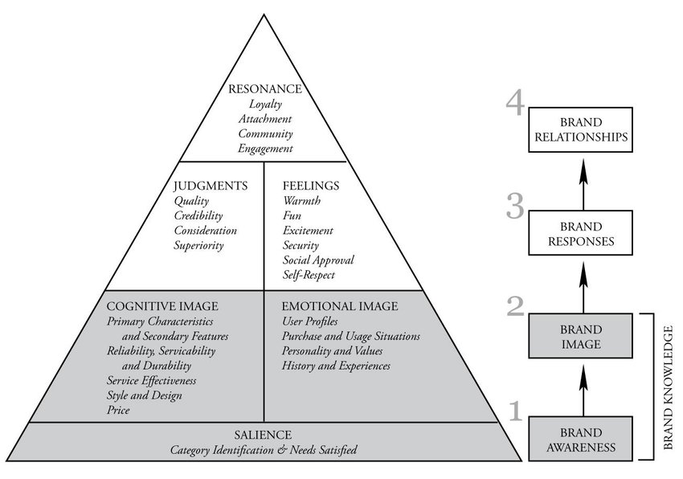
Source: ResearchGate

The concept behind the Brand Equity Model is to build a strong brand, it must be shaped by how customers think and feel about the product. The right type of experience must be built around the brand, so positive feelings, thoughts, beliefs, opinions, and perceptions about the brand.
Strong brand equity can lead to more loyal customers, word of mouth, recommendations, and a positive brand image.

  - Advantages:
One of a company's most invaluable assets is intangible yet profoundly influential—the brand. The success of a company hinges on its brand, encapsulating customer sentiments toward its products.

- A strong brand leads to the creation of substantial brand equity, enabling the company to command premium prices for its products.
- Products associated with brand equity gain good respect within the market.
- A sturdy brand facilitates seamless product expansion, instilling greater confidence in the market.
- Customer-centric brand equity contributes to elevated financial gains for the company.
- Marketing initiatives undertaken by a formidable Customer-Based Brand Equity (CBBE) brand are more likely to elicit a heightened response.
- Strengthened loyalty is cultivated, as customers are inclined to remain devoted to the company due to the trust instilled in the brand.
- A powerful customer-based brand equity translates into increased negotiating power with vendors and distributors, thereby reducing production costs.

  - Disadvantages
- This model is very old, and time-bound. Some of its implications may not be apply in today’s word
- This model’s accuracy cannot be measured.
- It is time consuming to apply this model
- It can be costly to teach staff to implement this model.

- CUSTOMER JOURNEY
A customer journey is the set of interactions that a customer has with a brand in buying a service or product. It considers the complete interaction roadmap – from brand discovery to purchasing and after-sales service.
The emphasis extends beyond mere transactions to encompass the overall customer experience after each interaction with the brand. In essence, utilizing the customer journey as a strategy allows for insights into the customer's experience throughout the purchasing process.
The primary goal of a customer journey is twofold: to assess and appraise how well the brand caters to its customers and to enhance and elevate their overall experience through measured strategies. While outstanding products, a commendable website, and a responsive customer service team create an enticing combination for attracting potential clients, any perceived lapse in communication may prompt customers to explore alternatives.
Enhancing the customer experience at every touchpoint in the customer journey places the customer at the core of the business. This approach cultivates a dedicated fan base, encouraging repeat business and fostering a robust connection throughout the entire customer journey. The ultimate result is brand loyalty, where satisfied customers consistently choose the brand, influencing their lives positively.
Brand loyalty, a favorable outcome, is achieved when brands exert influence over various aspects of their clients' lives. This outcome results from a multitude of variables, some controllable and others beyond our control. Understanding how these variables manifest in the market is a crucial initial step in comprehending the factors that contribute to brand loyalty.

- CUSTOMER TOUCHPOINTS
  - Pre-purchase
- Online ads
Commence with a strong approach by ensuring that the content directly aligns with online advertising links. If an ad promotes a sale, ensure that the link directs customers to a page providing comprehensive details or visuals of the sale items. While encouraging customers to navigate through website, it's not advisable to guide them to a sign-up form or the home page at this point. Optimize the customer experience (CX) by employing a landing page that offers pertinent content.
- Social media
It's unnecessary to be present on every social media platform, but it's essential to maintain a profile on the channels customers frequent. Keep pages dynamic with engaging and valuable content. Always acknowledge customer comments, as this interaction is the primary purpose of social media presence, and it's the beginning of establishing connections with potential customers.
- Referrals
Referral programs, accessible to current customers, provide rewards for both the referrer and the new customer. This dual benefit fosters satisfaction and augments the likelihood of subsequent purchases and additional referrals.
- Website
When prospective customers browse HP’s website, it should be effortless for them to promptly locate the information they seek. The navigation system should be straightforward and instinctive. Product pages need to feature precise images and descriptions that faithfully depict offerings. If the product or service is intricate to explain, contemplate incorporating videos. It's crucial to note that if visitors cannot easily access the information they are searching for on HP’s website, they will likely explore alternative sources. Gain insights into the customers' perceptions of the website by conducting a feedback survey.

  - During purchase
- Customer reviews
It should be kept in mind that the reviews customers are seeking should be incorporated into HP’s social media posts, web pages, and marketing materials.
- Point of sale
During the sales transaction, a sales representative or webpage will furnish all essential information, encompassing the needs the product will address. This marks the ultimate touchpoint preceding the finalization of a purchase.

  - Post Purchase
- Feedback surveys
This presents an opportunity to gather insights into the customer experience. Identifying challenges and areas of ease is achievable through a customer service feedback survey, guiding the identification of training needs or areas requiring improvement.
- Email lists
For customers who have enrolled to receive emails regarding new offers and products, the chance arises to engage in upselling or cross-selling initiatives.
- Community management
Vigilance on social media channels is imperative. In instances where individuals comment and share posts, the community manager needs to respond actively, fostering a positive and ongoing conversation.

- PERSONA OF HP CUSTOMER
The persona of HP's customers is diverse, encompassing a wide range of individuals due to the company's offering of products across various price points—from low to medium and high ranges. As a result, the customer base exhibits a broad spectrum of values, personality traits, communication preferences, visuals, and other characteristics, reflecting the diverse preferences and needs of a varied audience.
- Values
Affordable: HP's entry-level products can be considered budget-friendly or offer good value for the money.
High Specs: HP believes it should have products for everyone so, high-end products are also sold by HP.
- Personality Traits
Innovative: HP is labeled as an innovative brand. It may not be a pioneer but it makes way for doing old things in new ways such as cooling systems in laptops and PCs.
Stylish: HP’s products are stylish and always look professional for every product. For gaming laptops also, it gives RGB lights and looks.
- Communication Style
HP communicates itself as a technology and future-oriented brand that always works for an innovative approach.
- Visual Identity
HP’s visual identity is often found in its logo on laptops or PCs.
- Brand Promise
HP’ promises its customers that they will get highly efficient and innovative products and easy to use.
- Customer Experience
Customer experience is something that HP looks forward to very carefully as customers can make or break the business. Customer satisfaction is high priority for HP.

  - CUSTOMER JOURNEY MAP

Source: Self Developed

  - Analysis of HP’s Customer Journey Map.
HP’s customer journey map depicts touchpoints and the actions following them alongside the customer experience and pain points where there can be room for improvement. Lastly, it also shows solutions HP can follow to make the situation better. It shows pre-purchase, post-purchase, and during-purchase touchpoints. A customer before purchasing is hesitant and curious about the products after observing websites or advertisements and experiencing the product for once. During purchase, the customer is excited about the product also impressed but can be the opposite if not engaged well or with limited payment options. Lastly, the after-purchase, return policy, services, and warranty promise can make the journey smoother; whereas, sudden defects or malfunctions in the product can do the opposite. However, with proper training of employees it can be avoided.

- THE TOTAL ENGAGEMENT MODEL
The total engagement model is a comprehensive approach that integrates all aspects of a company’s activities into a cohesive and effective system. The key is to align all activities of the company on a unified plan for customer engagement, including advertising, service, products, and internal culture. The total engagement model provides an important benefit of synergy through total brand strategy alignment throughout the company. This means that the whole is greater than the sum of its parts, which may already be good or fragmented. The proposed model is fairly comprehensive and provides clear guidance on how to design and operationalize a growth plan driven by increasing customer engagement, with an emphasis on actionability.
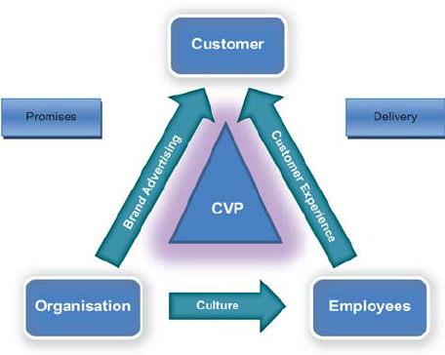
Source: ResearchGate
Organization to Employees:
HP as an organisation, has a responsibility to make an organizational culture that is employee-friendly. It is also important to engage staff. An engaged employee is not only efficient but also can understand organizational goals and targets. If an employee understands it, goal-oriented work can be done with little or less training and motivation. Training and motivation is also done for needful employees. This way HP engages its employees.

Organization to Customers:
A business also needs to engage its customers. HP uses its promotional strategy to engage customers. Specifically, offline promotions like billboards, newspapers, and magazines are used as per the availability of potential customers are located and online promotions like email marketing to make generalized promotion, SMS marketing, pay-per-click, and cookies tracking to make future paid ad attempts, these types of promotions are used by the brand to engage customers. The message while delivering these communications is of the promise that HP makes to customers. HP promises 1 year of warranty and in some products, a free subscription to Microsoft Office, and Windows.

Employees to Customers
Another communication to increase customer engagement is made from employees to customers of HP. The employees are the ones whom customers interact with. It becomes important to train and motivate employees to handle every customer in such a way that they come back to repeat the purchase.

- RECOMMENDATIONS & CONCLUSION

In conclusion, HP's strategic marketing efforts, encompassing effective communication models, brand equity building, and comprehensive customer engagement, position the company as a leader in the technology industry. The adaptive use of both online and offline promotional strategies, coupled with a diverse customer base, reflects HP's commitment to meeting a wide range of preferences. Moving forward, continuous adaptation to emerging trends, particularly in the online space, and further refinement of customer touchpoints can enhance HP's overall brand experience and maintain its position as an innovative and customer-centric technology brand.
Recommendation
HP should enhance its social presence
HP should focus more on influencer marketing.
HP should adapt to new customer trends.

Reference
Bajj, A. and Karthikeyan, A. (2023). Top Marketing Strategies of HP. [online] StartupTalky. Available at: https://startuptalky.com/hp-marketing-strategy/ [Accessed 22 Dec. 2023].
Comparably. (n.d.). HP Inc. Mission, Vision & Values. [online] Available at: https://www.comparably.com/companies/hp/mission [Accessed 1 Dec. 2023].
Decker, A. (2023). The Ultimate Guide to Branding in 2020. [online] Hubspot.com. Available at: https://blog.hubspot.com/marketing/branding.
Gupta, S. (2022). Business Communication According to National Educaton Policy-2020. SBPD Publication.
Kasi (2023). Brand Equity of Hewlett Packard(HP) | Marketing Mixx. [online] Marketingmixx. Available at: https://marketingmixx.com/brand-equity-of-hewlett-packardhp/.
Mind Tools (2022). Keller’s Brand Equity Model. [online] www.mindtools.com. Available at: https://www.mindtools.com/ajnlcxe/kellers-brand-equity-model.
QuestionPro (2018). Customer Journey: Definition, Journey Mapping Framework and Examples | QuestionPro. [online] QuestionPro. Available at: https://www.questionpro.com/blog/customer-journey-map/.
Roberts, C. and Alpert, F. (2010). Total customer engagement: designing and aligning key strategic elements to achieve growth. Journal of Product & Brand Management, 19(3), pp.198–209. doi:https://doi.org/10.1108/10610421011046175.
Sparrow, P. (2023). Brand Equity: Advantages of Strong Brand Equity. [online] TheSERPwire. Available at: https://www.ianswer4u.com/2017/09/brand-equity-benefits-advantages-develop.html?m=1 [Accessed 22 Dec. 2023].
Surveymonkey (2018). Identifying Your Customer Touchpoints | SurveyMonkey. [online] SurveyMonkey. Available at: https://www.surveymonkey.com/mp/identify-customer-touchpoints/.
www.manypixels.co. (2023). How Print Marketing Can Improve Brand Awareness. [online] Available at: https://www.manypixels.co/blog/print-design/brand-awareness [Accessed 22 Dec. 2023].
Xaif (2022). Extensive Marketing Strategy of HP - 2022 | IIDE. [online] The Digital School. Available at: https://iide.co/case-studies/marketing-strategy-of-hp/ [Accessed 1 Dec. 2023].
Yousaf, A., Amin, I. and Gupta, A. (2017). Conceptualising tourist based brand-equity pyramid: an application of Keller brand pyramid model to destinations. Tourism and hospitality management, 23(1), pp.119–137. doi:https://doi.org/10.20867/thm.23.1.1.
Zigu (2011). Integrated Marketing Communications (IMC) Definition | Marketing Dictionary | MBA Skool-Study.Learn.Share. [online] MBA Skool-Study.Learn.Share. Available at: https://www.mbaskool.com/business-concepts/marketing-and-strategy-terms/10937-integrated-marketing-communications.html [Accessed 1 Dec. 2023].

