
Operating Hotel Facilities
BMIH4006
Component Three

Student name : Ramona Barna
Student number: 2234369
Lecture`s name : Scott James

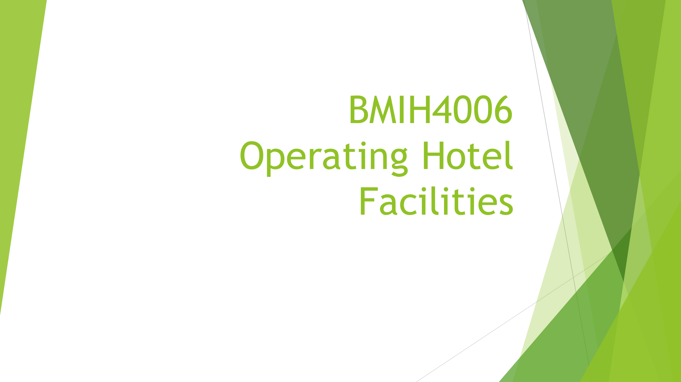
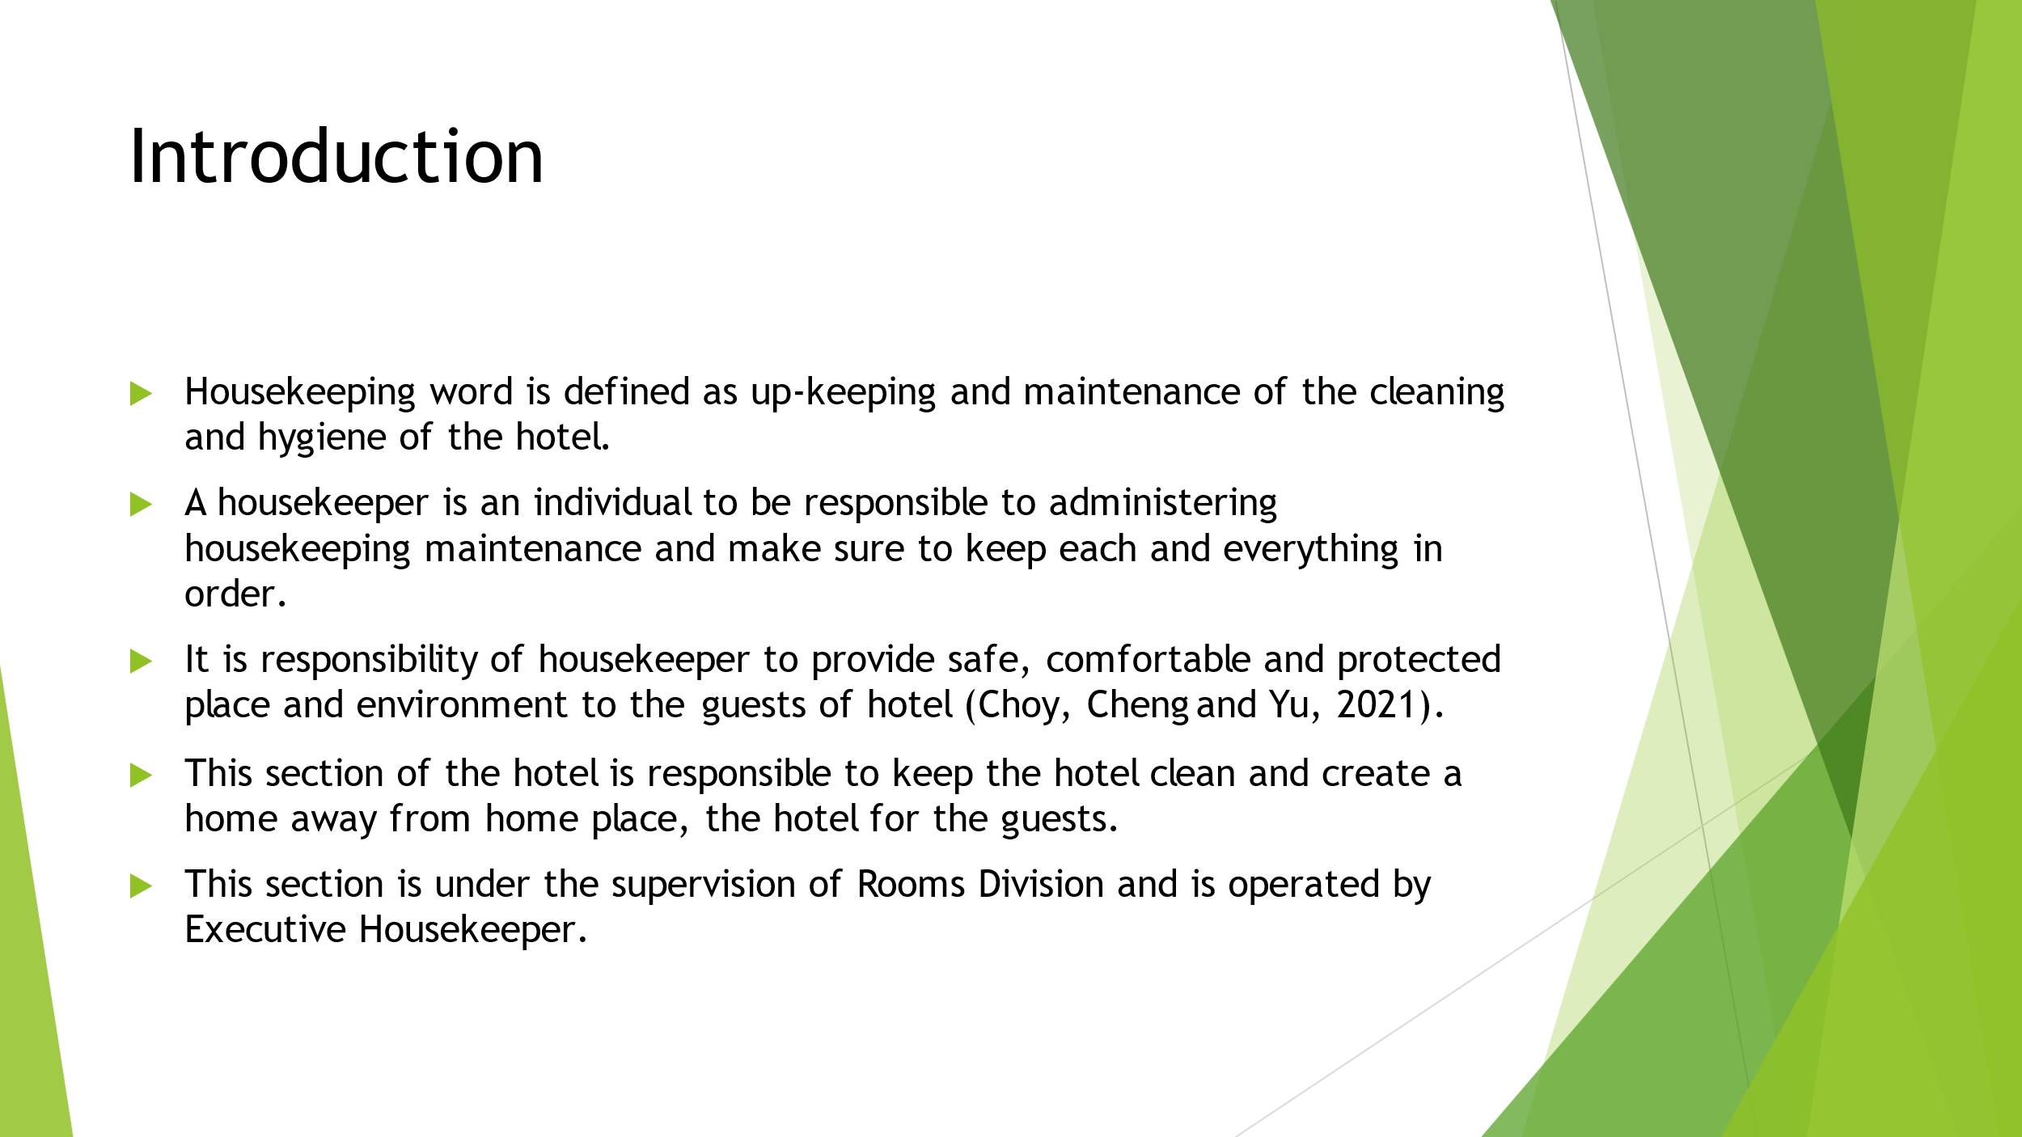
Training Notes: Housekeeping refers to perform all the duties in accordance such as polishing maintaining orderliness, sweeping vacuuming, and discarding all the waste materials of paper and cardboard away from the property of Hotel.
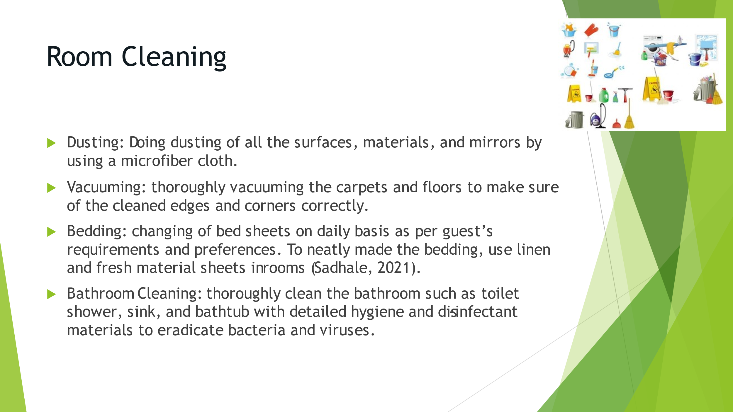
Training Notes: In the hospitality representation is being played a crucial role by the cleaning room service department as they are in direct contact of the guests by cleaning and vacuuming rooms with full attention and care to convey the message of being special to the hotel’s guest.

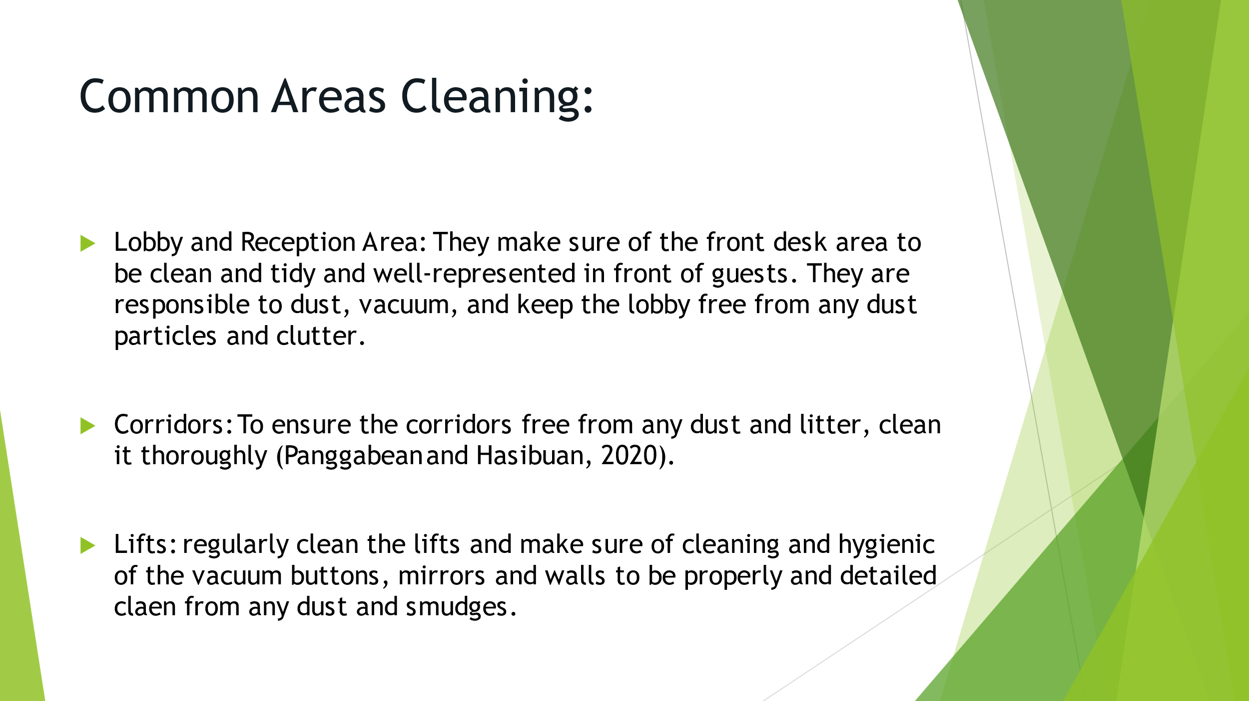

Training Notes: It is very essential to bring proper organization to the lobby. The reception desk and neighboring workstation to be organized. Generate a defined and distinct path for the guests in the lobby to avoid any kind of mis-management and rush.
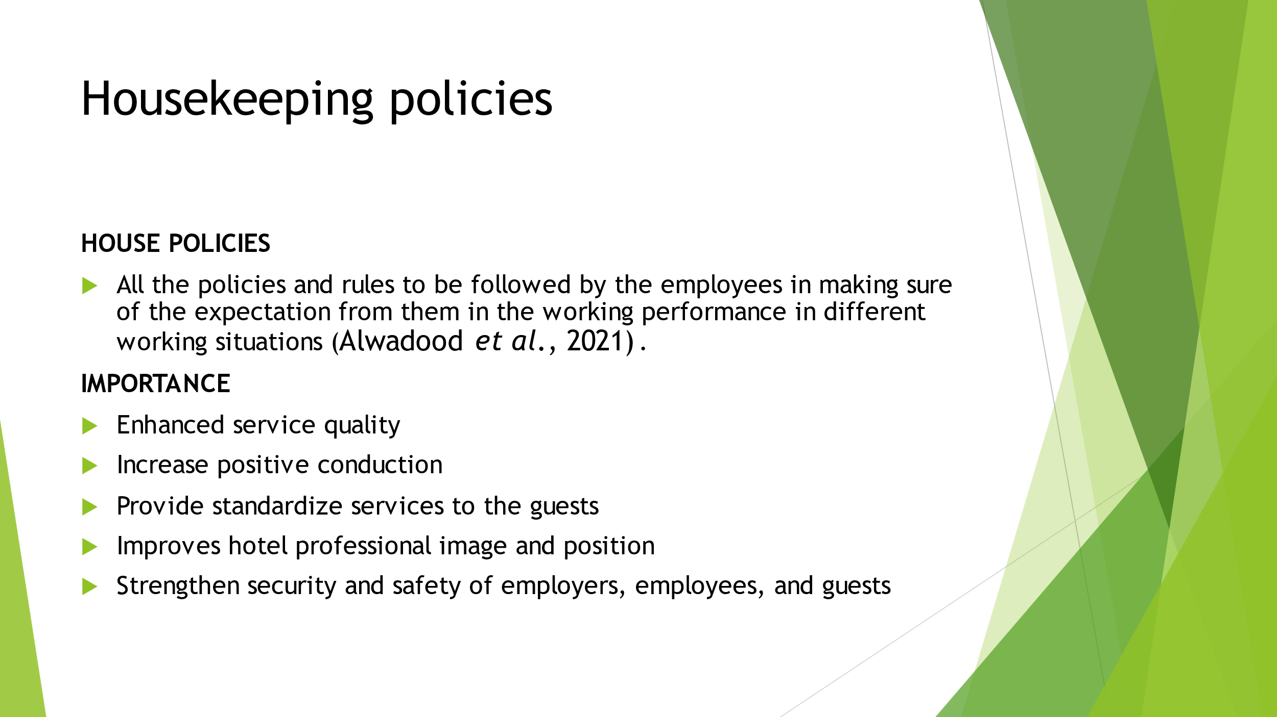

Training Notes: Internal rules regarding employees behavior as food, chewing gums, smoking and personal calls attending.
- Theft and destruction of hotel property
- Uniform
- Incentives and privileges of meals, discounts and bonuses

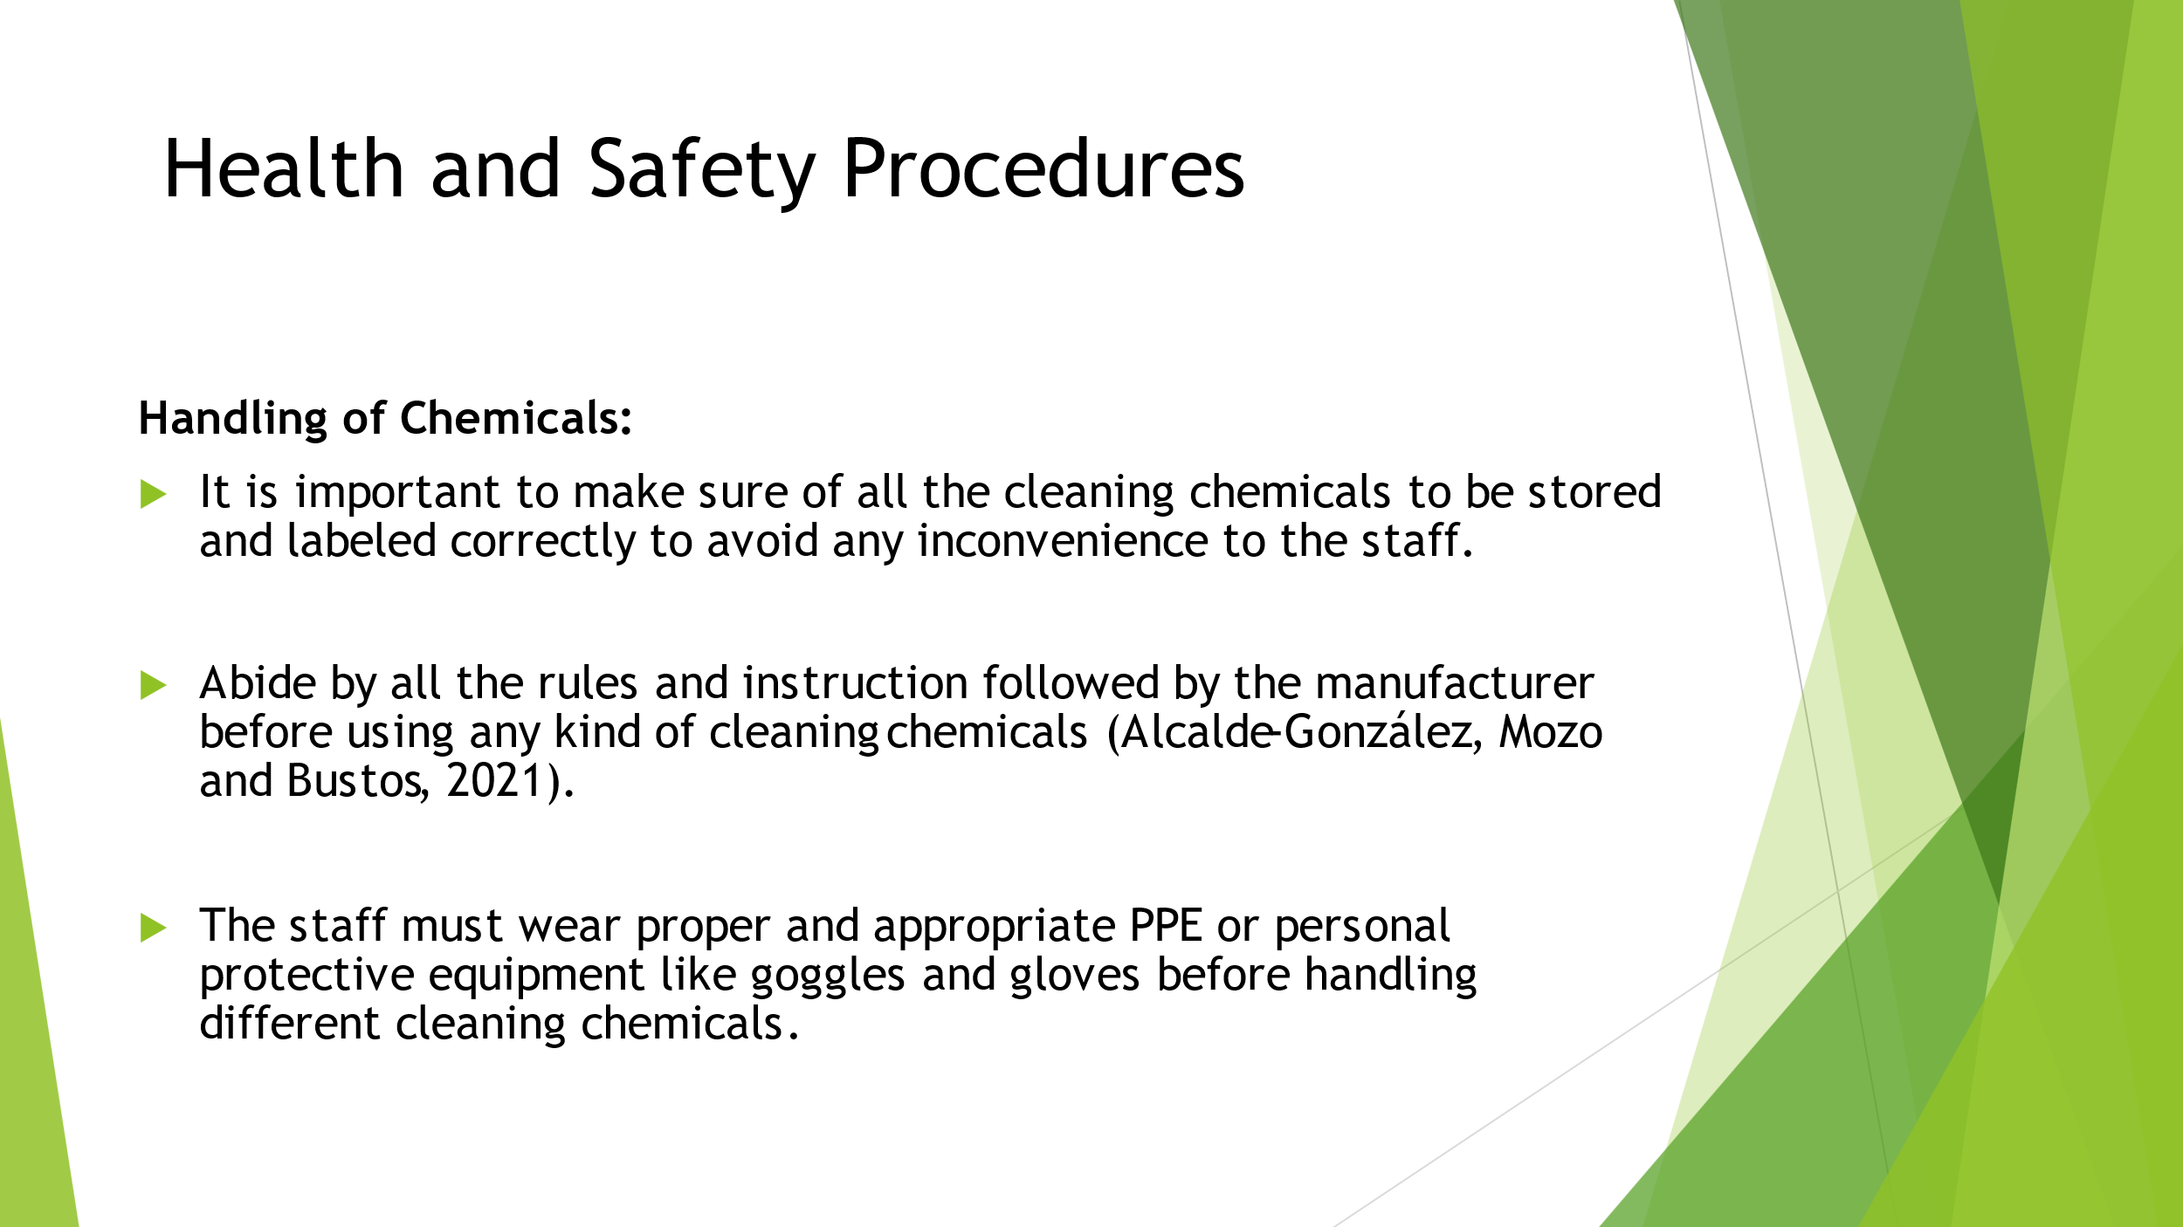

Training Notes: The hotel must eliminate all kinds of hazardous chemicals.
The working culture must be according to the country’s legal standards.
The tools and equipment's used by the employees in cleaning must be used under supervision and safe to be performed.

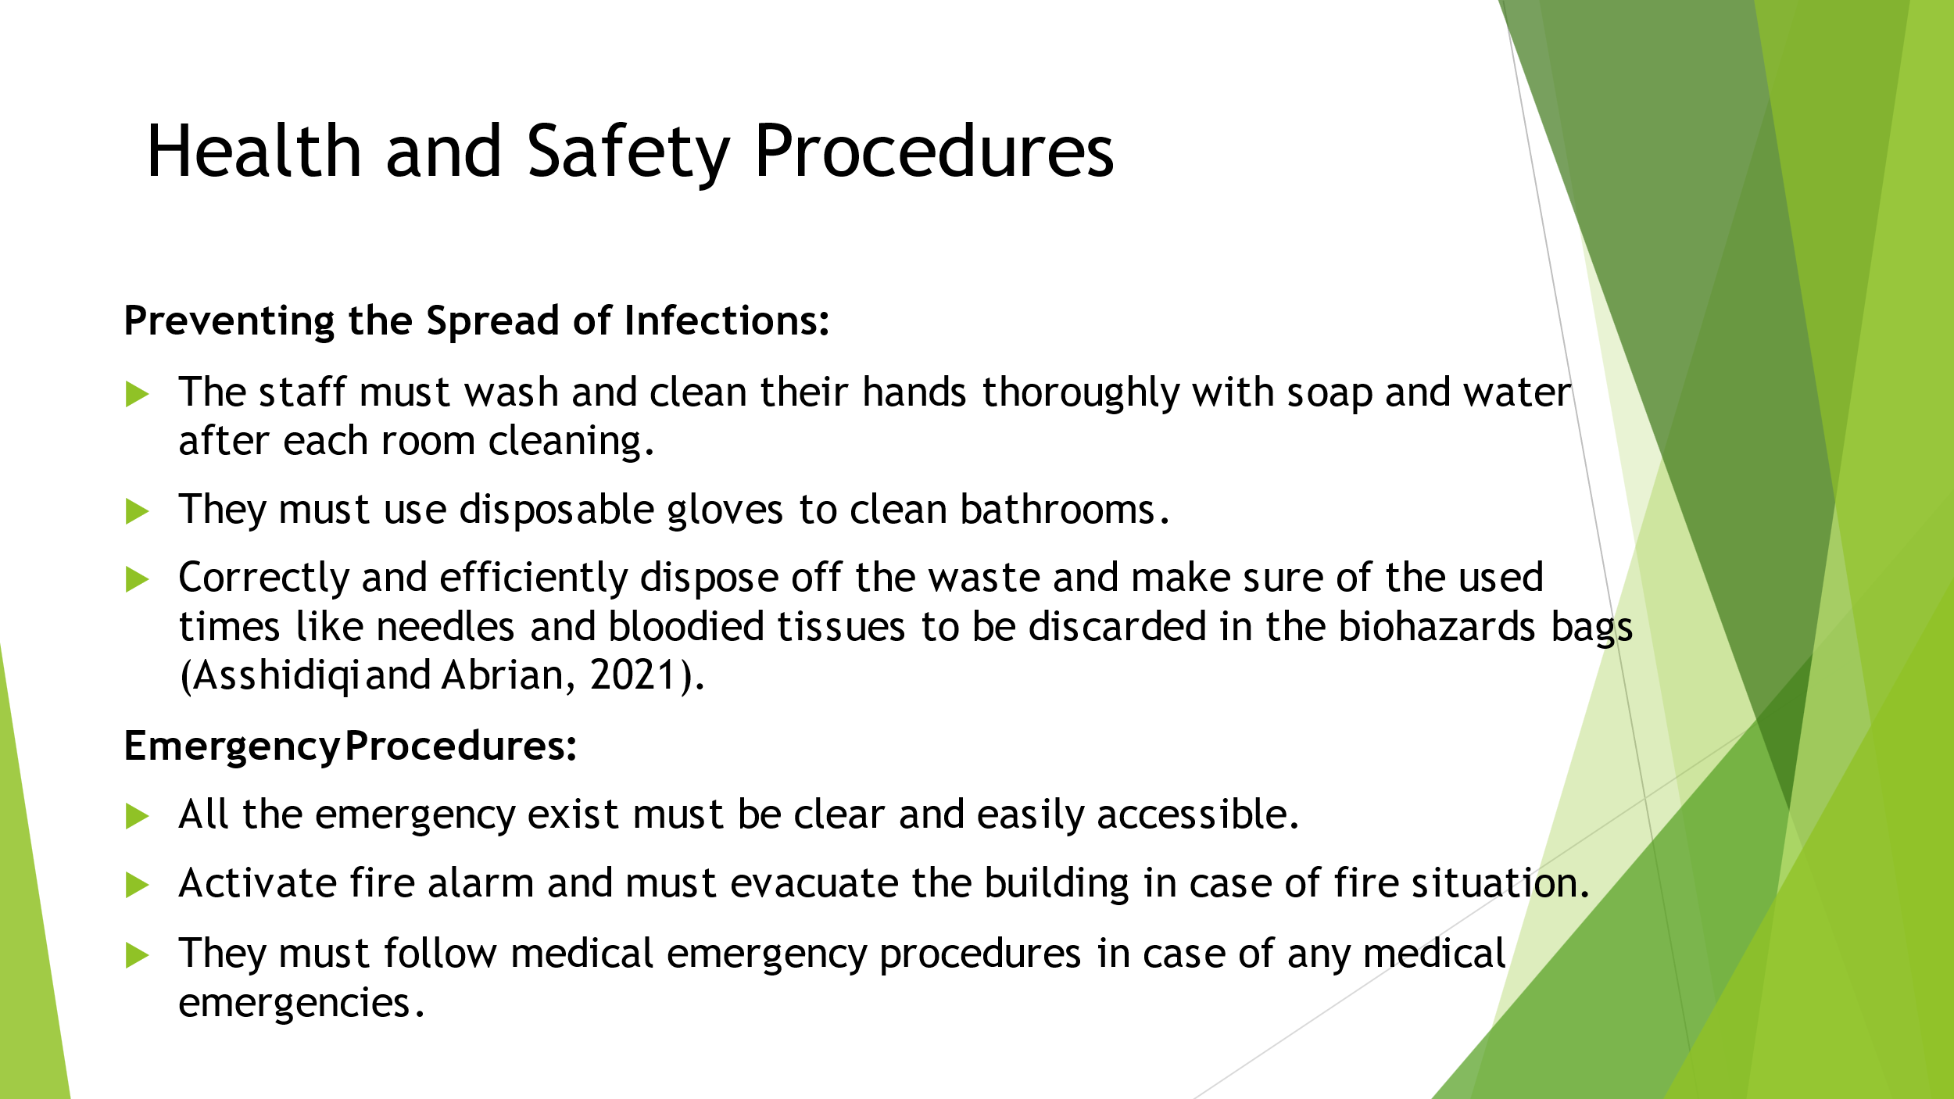
Training Notes: To make sure of the person to be safe on your accessibility in simplest manner is by carrying out risk assessment. In the risk assessment, you will be instructed to follow important steps to protect employees along with abiding all the company standard laws and rules. As a business owner, risk assessments will help to focus on the risk anywhere and anyhow associated with the premises and identification of any kind of serious nature of these hazards to seriously harm the individual.
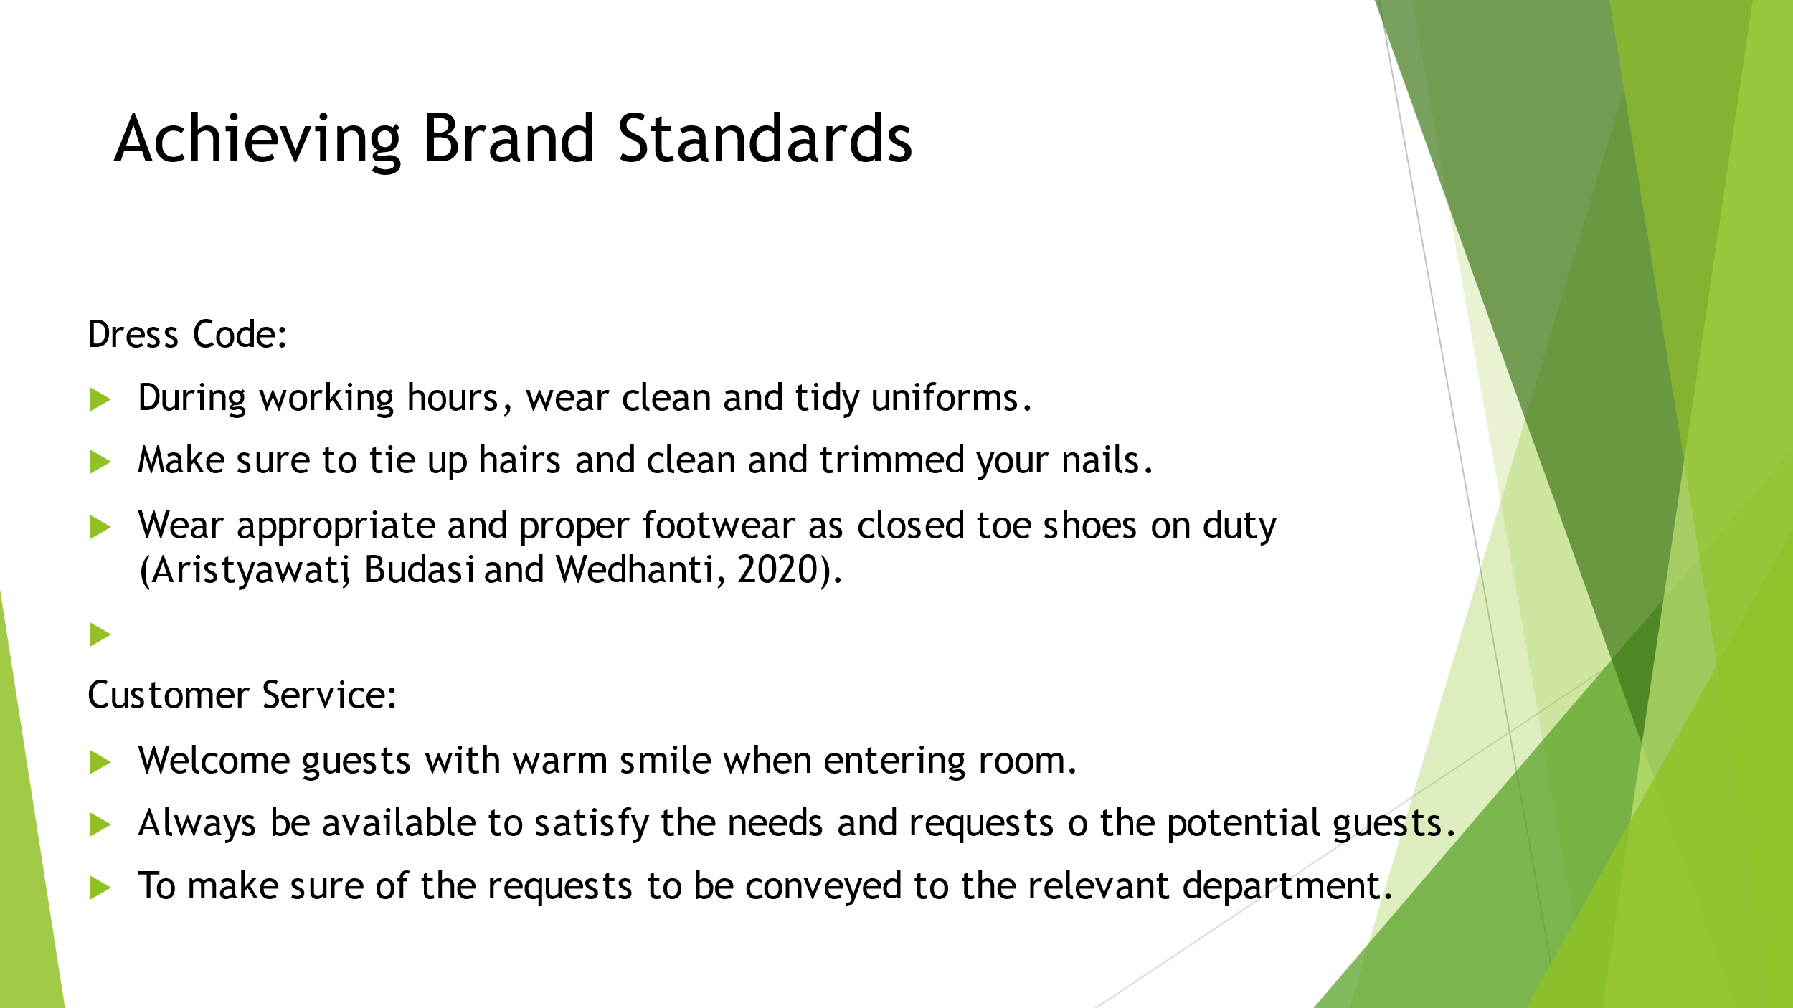
Training Notes: In each and every competitive brand, the business startegy and customer-centric approach is of great importance to identify and highlight the universal touchpoint of the experiences.

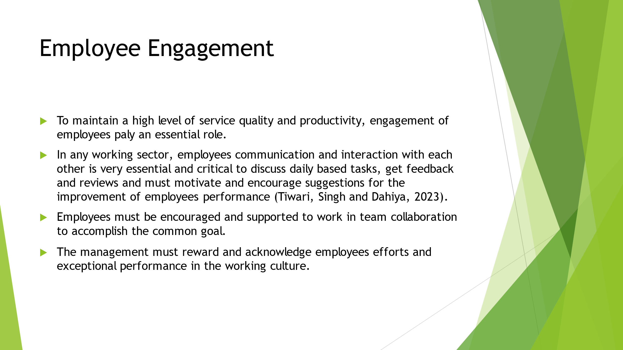

Training Notes: Hotel can also generate a motivated and dedicated staff by motivating and promoting engagement among the staff members of housekeeping to provide high-quality services.

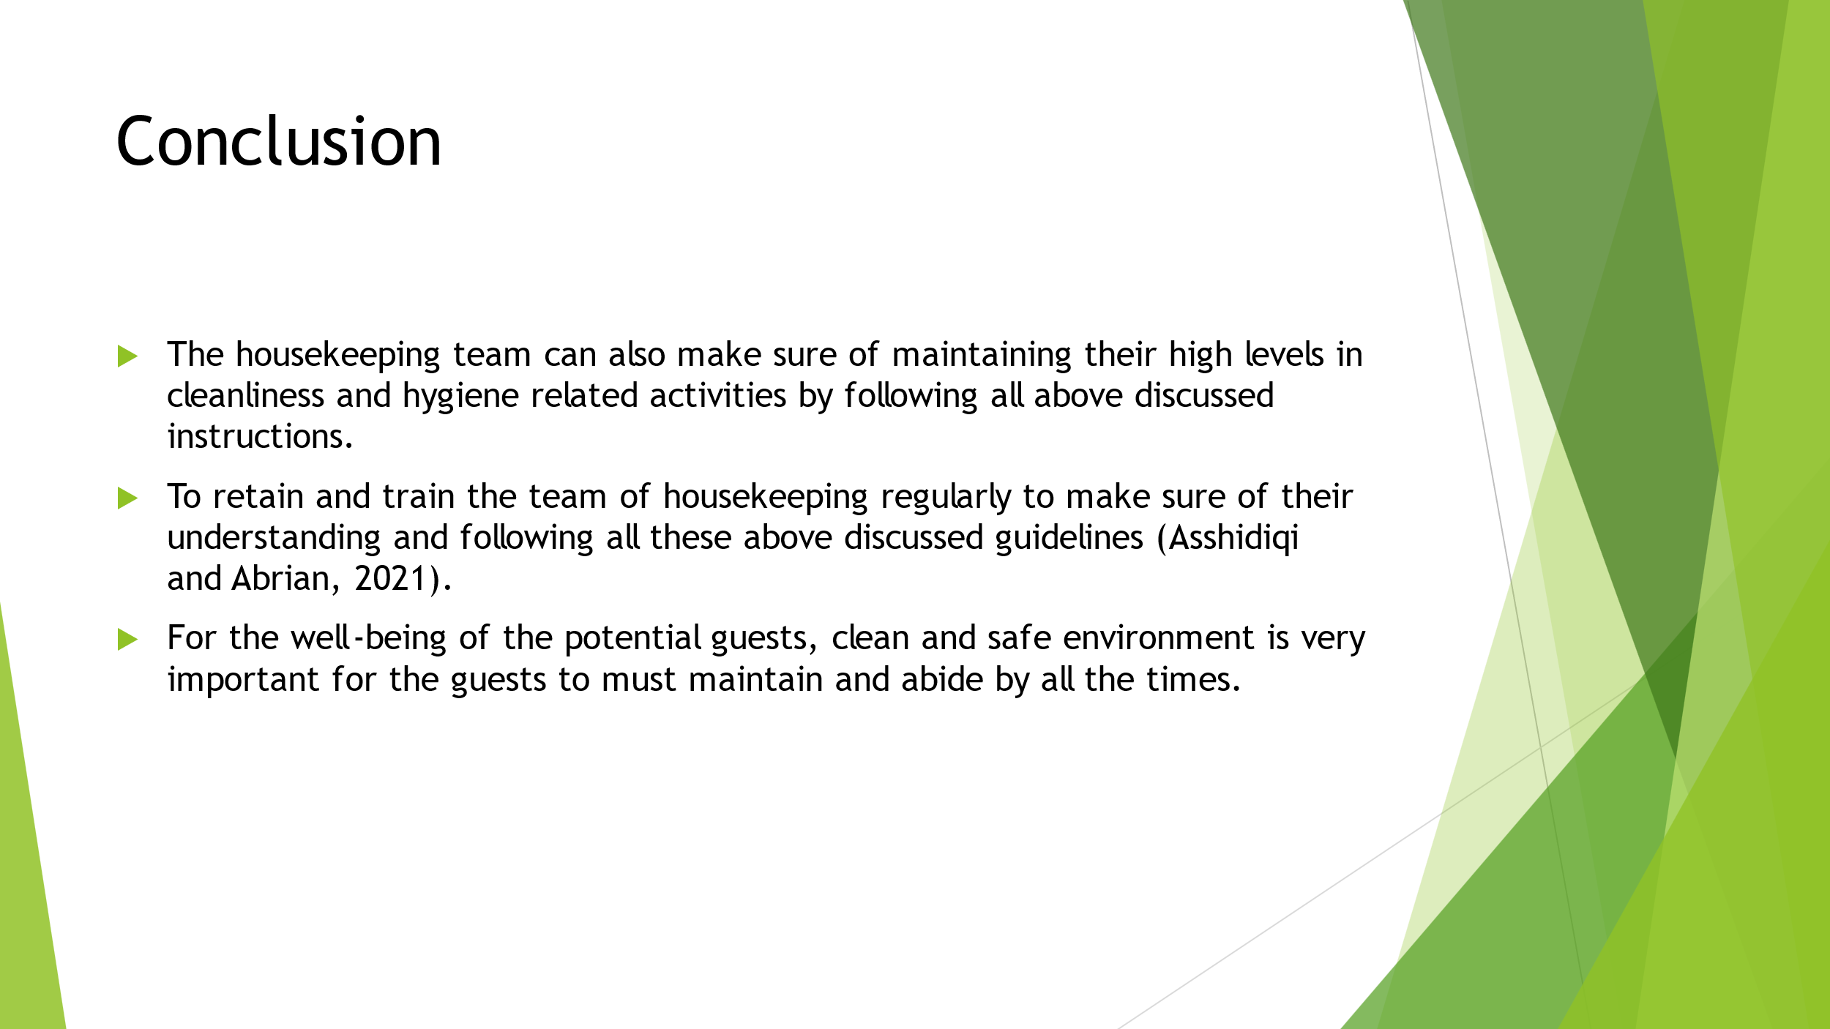

Training Notes: In inference, being a housekeeping member, it is our utmost responsibility to provide best and utmost services to our potential guests in adhering brand standrads and Health and Safety procedures. In this presentation, by following guidelines, employees can work together in collaboration and establish a clean and safe environment for the potential guests. Thank you so much for your time and let’s continue to improve our services.

References
Alcalde-González, V., Mozo, A.G. and Bustos, A.V., 2021. No clean rooms, no hotel business: Subversion tactics in Las Kellys’ struggle for dignity in hotel housekeeping. Annals of Tourism Research, 91, p.103315.
Alwadood, Z., Noor, N.M. and Mainor, N.A., 2021. An optimization model for hotel housekeeping personnel scheduling in pandemic outbreak. Menemui Matematik (Discovering Mathematics), 43(2), pp.83-92.
Aristyawati, N.L., Budasi, I.G. and Wedhanti, N.K., 2020. An Analysis Of Jargons Used By The Housekeeping Department At The Lovina Bali Hotel. Indonesian Journal of Educational Research and Review, 3(2), pp.72-80.
Asshidiqi, M.H. and Abrian, Y., 2021. WORKLOAD ANALYSIS ROOMBOY AT HOUSEKEEPING DEPARTMENT DAIMA HOTEL PADANG DURING PANDEMIC (COVID-19). International Journal of Tourism and Hospitality Management Studies, 1(1), pp.34-39.
Bhatnagar, E. and Nim, D., 2019. Impact of housekeeping services and practices on customer satisfaction and repeat business. Prabandhan: Indian Journal of Management, 12(8), pp.46-57.
Choy, M., Cheng, J. and Yu, K., 2021. Evaluating the environmental sustainability strategies of the housekeeping department: the case of an international hotel chain in Hong Kong, China. Tourism Critiques: Practice and Theory, 2(1), pp.115-132.
Panggabean, R. and Hasibuan, N.A., 2020. Penerapan Preference Selection Index (PSI) Dalam Sistem Pendukung Keputusan Pengangkatan Supervisor Housekeeping. Resolusi: Rekayasa Teknik Informatika dan Informasi, 1(2), pp.85-93.
Sadhale, M., 2021. The Changing Role of Housekeeping Department in Hotels Post COVID-19 Pandemic. Eureka Publications.
Tiwari, A., Singh, M. and Dahiya, A., 2023. The Impact of Outsourcing of Hotel Housekeeping Services on Hotel Performance: a Study on 5-Star Hotels of Delhi NCR. International Journal of Professional Business Review, 8(1), pp.e0905-e0905.

