

BA (HONS) BUSINESS MANAGEMENT

DISSERTATION COMPONENT 2: (LCBB6000_BIRM)
STRATEGIC BUSINESS MANAGEMENT IN TESCO’S
BUSINESS GROWTH
STUDENT NAME: MARIAN GIANI JIANU
STUDENT ID: 2231436
SUPERVISED BY : DR. BENTIL ODURO
Abstract
Strategic management is impactful as it helps in the overall business reputation. Retail businesses are able to develop their business growth by following the SBM process. Tesco adapted different types of business practices, such as the reduction of the overall cost of operations in business. Innovation management is also followed as a key practice that helped in the overall business growth and development of Tesco. Tesco also decided to focus on customer management as it helps in business success. Issues such as lack of proper communication and coordination in the business have created major threats in the business. Lack of resources has also created major threats in the business process regarding SBM. There needs to be a focus on strategies such as resource management and better leadership to develop the business strategy. The Tesco case study has been followed in this study, and secondary resources have been applied in this research. The thematic analysis process is followed to analyse the outcomes and understand the results. This research faced limitations such as a lack of primary source application, which affected the research quality.

Table of Contents
Chapter 1: Introduction 7
1.1 Chapter Overview 7
1.2 Background of the Research 7
1.3 Research aim 7
1.4 Problem Statement 7
1.4 Research Objectives 8
1.5 Research Questions 8
1.7 Research Significance 9
1.8 Research Rationale 9
1.9 Dissertation Structure 10
1.10 Summary 10
2.0 Literature Review 11
2.1 Introduction 11
2.2 Conceptualising the study variables. 11
2.2.1 Strategic Business Management 11
2.2.2 Business Growth 11
2.3 Theoretical Framework 12
2.3.1 Contingency Theory 12
2.3.2 Resource-based View Theory 13
2.4 Identifying the significance of strategic business management for the business growth. 14
2.5 Exploring the strategic management practices that can be adopted for business growth and success. 14
2.6 Analysing the challenges businesses face nationally and internationally regarding their strategic business management processes. 15
2.7 Strategies can help business in optimising its success and growth. 16
2.8 Literature Gap 17
2.8 Conceptual Framework 17
2.9 Summary 17
3. Chapter 3: Methodology 18
3.1 Introduction 18
3.2 Research Design 18
3.3 Saunder’s Research Onion 18
3.3.1 Research Philosophy 19
3.3.2 Research Approach 19
3.3.3 Research Method 20
3.3.4 Research Strategy 20
3.3.5 Time Horizon 20
3.3.6 Data Collection 21
3.4 Data Analysis 21
3.5 Ethical Consideration 21
3.6. Methodological limitations 22
3.7 Summary 22
Chapter 4: Data Analysis and Discussions 23
4.1 Introduction 23
4.2 Findings 23
4.3 Discussion 28
4.4 Summary 29
Chapter 5: Conclusion, General Limitations & Recommendations 31
5.1 Conclusion 31
5. 2 Linking with objectives 31
5.3 Recommendations 32
5.4 Limitations 32
References 34

List of Figures
Figure 1.1: Dissertation Structure 10
Figure 2.1: Contingency Theory 12
Figure 2.2: Resource-based View Theory 13
Figure 2.3: Conceptual Framework 17
Figure 3.1: Saunders’ Research Onion 19
Figure 4.1: Tesco’s business growth 24
Figure 4.2: Six strategic factors of Tesco 25
Figure 4.3: SBM issues 27
Figure 4.4: Tesco’s sustainability report 28

Chapter 1: Introduction

1.1 Chapter Overview
This chapter presents details on strategic business management that assist in business development. This will include a brief discussion on the origin of this study, along with the aim, study questions, and objective that will be responded to by the investigator. The reason for choosing the study topic will be narrated.

1.2 Background of the Research
Strategic management facilitates the leaders and managers with effective solutions by which issues faced by their firms can be solved through contingent, holistic, provident, and dynamic principles (Kurniati et al. 2021). This element also enables managers to grow better methods by which their organisation can survive by taking advantage of logical and regular methods. It has the aim of making businesses able to adapt to current environmental situations, which achieve several variable features gradually (Alharbi, 2024). The important thing about strategic management is that it does not repeat past successes of businesses, but it helps businesses cope with environmental issues and unexpected situations. When managers and leaders facilitate their firms with all these strategies for fighting current market issues, businesses can attain institutional solidity in future-oriented business success. Businesses can forecast and make strategies for future success through the implementation of strategic business management (Gandrita, 2023).

1.3 Research aim
The aim of this study was to understand the importance of strategic business management and its role in the growth of Tesco.

1.4 Problem Statement
In the research, the challenges that could be faced by businesses due to the absence of strategic business management or an effective process regarding strategic business management are identified. It is going to discuss the facilities that could be offered by managers through the implementation of strategic business management (Fuertes et al. 2020). It will also highlight that in the absence of proper strategic business objectives; businesses might not be able to understand what tasks need to be prioritised. It will discuss that businesses should prioritise strategic business management to bring development in their business operations. Without keeping an eye on its strategic management, businesses can face several usual adverse and assertive situations (Bubenik et al. 2022).

1.4 Research Objectives
- To identify the significance of strategic business management for the business growth of Tesco
- To explore the strategic management practices that Tesco adopted to cater to its growth and success over time.
- To analyse the challenges Tesco faced nationally and internationally regarding its strategic business management processes.
- To recommend strategies that can improve Tesco’s growth and success in the dynamic retail market.

1.5 Research Questions
- What is the importance of strategic business management and its role in Tesco’s business growth?
- What are the strategic management practices adopted by Tesco for its growth and development?
- Which kind of challenges are being faced by Tesco on a national and international level due to its strategic business management of SBM processes?
- Which strategies can help Tesco in optimising its success and growth in the dynamic retail market?

1.7 Research Significance
Research and development on procedures of strategic planning for business sectors can assist in generating methods to survive in the business world, which is becoming complex day by day and changing rapidly. This type of research can make managers and leaders able to determine whether to make an investment in the application of other modern technologies or bring changes in their current business strategies (Sarpong et al. 2022). Through this study, an investigator can define the reality that strategic planning is not for enhancing the performance of an organisation, but it can show a path in which the organisation achieves success (Elbanna et al. 2020).

1.8 Research Rationale
Strategic business management is a concept that has gained attention from researchers over the past decades. As a field of research, this topic has become more essential as during research various types of research methodologies are being utilised and an array of topics regarding this field have emerged (Charles et al. 2015). The reason behind choosing this as a research topic is to analyse theories related to strategic business management or SBM and evaluating its contribution in the growth of business organisations. This study might lack focus on effective integration of strategic business planning with modern methodologies and tools. Furthermore, through this, the investigator will try to redefine the reasons that make SBM as a key to bring success and a competitive edge to enterprises (Alharbi, 2024).

1.9 Dissertation Structure
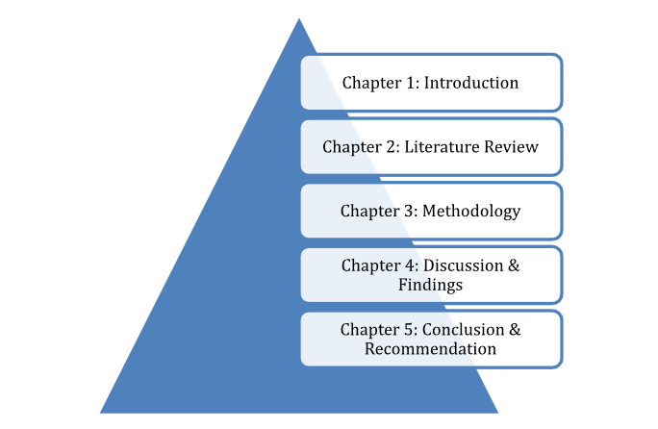

Figure 1.1: Dissertation Structure
(Source: Self-generated)
Chapter one reflects the overall introduction of the study and gives ideas about business management strategically for business development. Chapter two provided review of the literature about the topic and in chapter three there is a description of methodologies. Chapter four evaluates the results and findings and in chapter five there is conclusion and recommendations.

1.10 Summary
This chapter has presented details on strategic business management that assist in business development. This also includes a brief discussion on the origin of this study, along with the aim, study questions, and objectives that will be responded to by the investigator in LR. The reason for choosing the study topic has been narrated.

2.0 Literature Review

2.1 Introduction
In a dissertation, the literature review acts as a 2nd section that includes essential data regarding the study variables such as strategic business management & business growth and theories such as contingency theory & resource-based theory which are related to the variables. This will present a critical evaluation of the theories that will be included. This is the major section in which the investigator will present the responses regarding the study objectives from different types of journal articles such as ScienceDirect, MDPI, Springer, & TandFonline, which will be selected from reliable databases. Furthermore, a literature gap as well as a conceptual framework will also be added.

2.2 Conceptualising the study variables.

2.2.1 Strategic Business Management
Strategic business management of SBM is described as the procedure of planning, assessment, and application designed to manage or enhance competitive edge. The procedure of this assessment is concerned with the evaluation of the internal and external environments. This type of planning includes the development of business models, competitive tactics, collaborative activities, acquisitions, and corporate decisions (Zinchenko et al. 2022). The application of strategic business planning needs effective leadership and management to foster an adequate organisational structure, control the entire strategic procedure, develop a culture of management, and lead the enterprise through righteous corporate governance. The outcomes of this process are usually visible through market share, ROI, profits, and revenues (Abbasov and Sain, 2025).

2.2.2 Business Growth
Growth or development is leveraged as a business strategy. When the sales, assets, and net profits of an organisation increase significantly, and the business begins to see the chances of gaining a competitive edge, then it could be stated that it is being developed or having growth. If the business begins to take chances of getting advantages of reducing its production cost per unit of its products, then it could be stated that the products of the business are increasing. Business growth is usually indicated through qualitative indicators, business outputs, capacity, and business outcomes (Funk, 2022).

2.3 Theoretical Framework

2.3.1 Contingency Theory
This theory is described as a model that states that the structure of an organisation requires to be aligned with different elements, such as size and strategy, to attain optimal business performance, with the efficiency of the business structure being dependent upon all these elements. As per the focus of this theory, the organic system becomes more reliable when it comes under ‘condition of change’ (Pacheco-Cubillos et al. 2024). It has been stated that organic systems become significant when they operate in an unpredictable environment, in which the needs of the market are shifting constantly, as well as the enterprise managing several business relations and relying on external actors and factors. This theory has defined that usually the processes of decision-making in organisations have become time-taking, which is an issue that is faced by several enterprises (Shala et al. 2021).
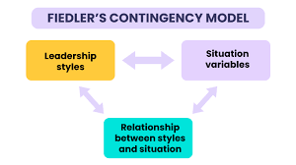

Figure 2.1: Contingency Theory
(Source: Pacheco-Cubillos et al. 2024)
Alternatively, the key weakness of this theory is that its application could be highly complex, that makes it challenging to recognise the most adequate practices of management for a certain circumstance. Furthermore, this framework is unable to provide a transparent framework for deciding the proper practices of management for certain circumstances. This is highly rigid and asks for giving up leadership if the leaders are unable to bring change during a challenging situation (Shenkar and Ellis, 2022).

2.3.2 Resource-based View Theory
As per the argument of the presenter of this theory, the competitive edge of a business comes from its inner resources, which are rare, non-substitutable, valuable, and inimitable. This is narrated as a framework of SM or strategic management that highlights the necessity of internal abilities and resources in attaining excellent performance of businesses and a sustainable competitive edge (Cho and Linderman, 2020). This asserts that enterprises can attain a competitive edge from the business resources which are rare, non-substitutable, valuable, and difficult to imitate. This explains the reasons behind the development of businesses, and they differentiate themselves from each other through their products, which cannot be imitated by their competitors (D’Oria et al. 2021).
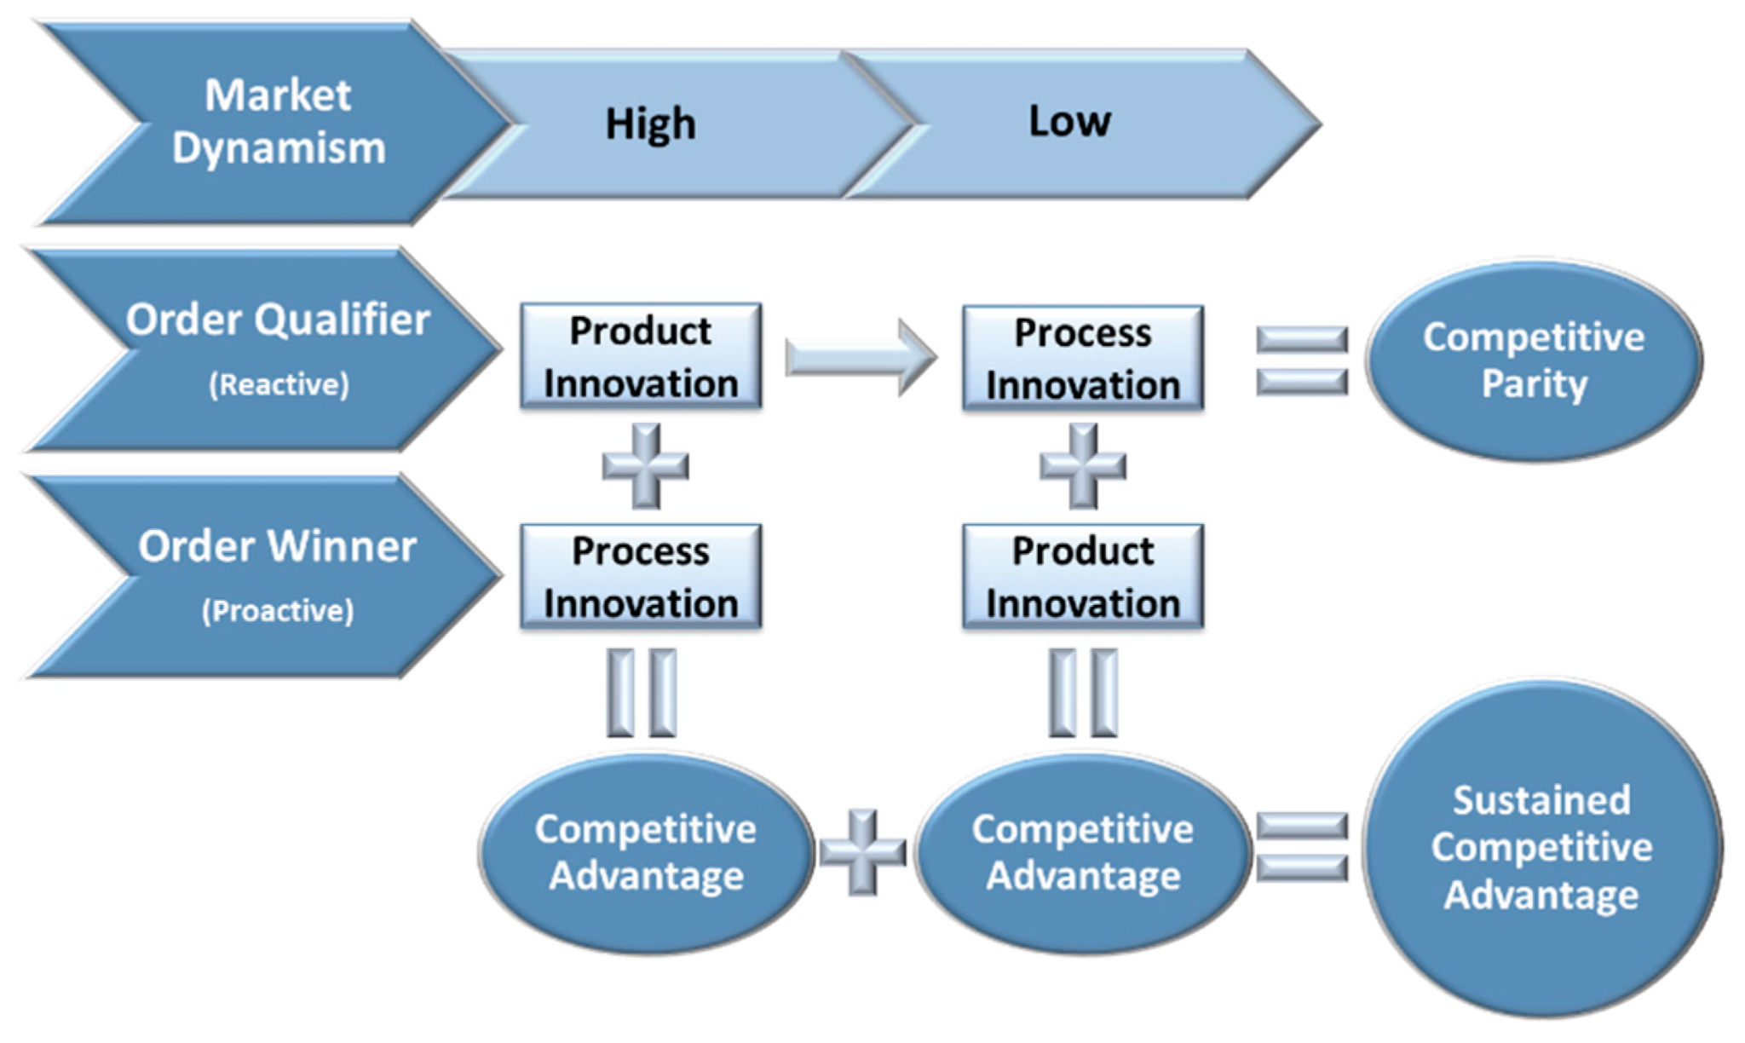

Figure 2.2: Resource-based View Theory
(Source: Cho and Linderman, 2020)
On the other hand, critics have complained that the vagueness of languages is related to the theory as well as it is quite unable in adequate recognition and evaluation of firm resources. It could be highly crucial to address all resources which can have valuable contributions to the competitive edge of a firm, specifically intangible business resources like stakeholder relationships, business culture, and knowledge. The tendency of this model is to avoid unfamiliar resources, and its assumption regarding the avoidance of unfamiliar elements to drive competitive edge is not that accurate (Holz, 2024).

2.4 Identifying the significance of strategic business management for the business growth.
Strategic business management of SBM offers a systematic framework that assists companies towards the future situation that is desired by the businesses. Through the articulation of a captivating direction, mission, and vision, conduction of environmental business assessment, setting strategic business aim and objectives, plans for strategic application, resource allocation, strategy development, and performance evaluation. Enterprises become able to navigate complexity and attain sustainable success. The business world is too volatile and can be disrupted; the strategies of business management can cater like a clarity beacon and offer direction during the chaos of transformation (Joyce, 2022).
This also plays a necessary role in making the pathways for bringing long-term success to the enterprises through aligning with their inner abilities with external opportunities available in the market. Through assessing competitive environments systematically and the application of strategic business frameworks, enterprises can become able to gain a sustainable and long-lasting competitive edge in their specific business sector, which is a major determinant of profitability and growth. This also helps in the formulation, application and assessment of business strategies, which can bring a business competitive positioning (Emma, 2025).
Furthermore, strategic business management is known for playing an essential role in the process of operation of contemporary and modern organisations. This facilitates businesses with effective planning that optimises the process of decision-making. This is done by the involvement of enduring business strategies within a competitive business environment to attain optimal allocation of business resources. Efficient and calculated decision-making permits organisations in adjusting the direction of their operations (Pu et al. 2025).

2.5 Exploring the strategic management practices that can be adopted for business growth and success.
One of the key practices of strategic business management is external business environmental analysis, which is known as a strategic technique that helps enterprises to address external elements that affect the performance of the businesses after the consideration of both micro and macro forces. Business usually utilises the PESTLE analysis and SWOT framework by which they evaluate political, environmental, legal, technological, social, and economic elements as well as evaluate market threats and opportunities by which they measure external and internal business circumstances effectively (Ruwanika and Massyn, 2024).
Another practice of strategic management is fostering innovation and adaptability, as it helps in cultivating a circumstance in which businesses can create modern approaches and concepts by which they drive competitive edge and gain growth as well as success. Embracing innovation and creativity through strategic management is assisting businesses in gaining long-lasting success and growth through product differentiation in a competitive environment (Munir, 2024).
Furthermore, the adoption of the practice of continuous monitoring and evaluation is able to build a culture of consistent enhancement and creativity. Through continuous assessment of business performances and results, businesses recognise several opportunities for business optimisation and further experimentation. Adoption of these types of practices motivates teams to investigate new concepts and innovate services and products. Through reviewing and adjusting regular mobilisation of strategies, businesses can innovate more creative products (Issifu and Agyapong, 2023).

2.6 Analysing the challenges businesses face nationally and internationally regarding their strategic business management processes.
At the national level, businesses usually face the issues of technological disruption, as during the adaptation of modern technologies, higher management can face internal resistance. Employees might show their unwillingness to adopt these technologies, and they might think that, due to a lack of knowledge and skills in these technologies, they might lose their employment, and workflows could be disrupted. Businesses need to employ expert and skilled employees, as well as have to make arrangements for L&D for their existing employees (Sewpersadh, 2023).
Resource management and allocation are also an issue that acts as barriers to the implementation of strategic business management. This can have an adverse impact on the ability of firms in attaining differentiation of cost strategies, which might have a direct effect on the growth and development of an organisation. Usually, aggressive or conservative are the ways that are adopted by leaders and managers. A conservative approach might delay or reduce investments, which can interrupt the firms ' adoption in an evolving environment (Cristofaro et al. 2025).
Furthermore, at the international level, businesses experience an issue which appears due to globalisation and market competition. For various firms, internationalisation has become a major corporate strategy in the current international financial environment. While MNCs try to expand themselves in several destinations across the world, they face new challenges such as fierce competition from other MNCs in their industry (Dabic et al. 2014).

2.7 Strategies can help business in optimising its success and growth.
Fostering a culture of innovation and learning can help businesses at the national level to resolve the issues regarding technological disruption. Through this expertise, skills can be enhanced among employees, which can increase competitiveness and productivity among them. Additionally, they can become able to share creative ideas and solutions, which can enable them in embracing modern processes and strategies. Integration of an innovative culture within an enterprise helps it to stay competitive in the market (Ahsan, 2025).
To enhance resource management and allocation issues, businesses can utilise effective techniques of resource allocation, which are known as resource levelling and smoothing. Resource levelling helps in attaining an effective project schedule in which companies can appropriately distribute their resource usage. Through this, fluctuations in resource allocation can be reduced as this instructs managers and leaders to utilise previous successful projects as examples before beginning resource allocation (Elkliny et al. 2023).
The global level issue of globalisation and market competition faced by MNCs can be enhanced through innovation and investing in technology, as through this, unique types of products and services can be created. Additionally, the application of modern digital technologies can reproduce the acquisition and development of new knowledge, competencies, and skills. Digitalisation processes and their efficiency can help businesses in generating unique products through the use of big data analytics (Radicic and Petković, 2023).

2.8 Literature Gap
In this chapter, the investigator has included a brief discussion on the impacts of strategic business management as well as the practices adopted by businesses. Yet the investigator has not highlighted some contexts, such as it does not include adequate information by which the linkage between development and growth could be understood. This literature has shown the gap between concepts and the practical implementation of these strategies by managers & lack of focus on effective integration of strategic business planning with modern methodologies and tools which has also been addressed as a literature gap by researchers.

2.8 Conceptual Framework

Business Growth
Strategic Business Managment
Systematic Framework
Long-lasting Success
Market Competition
Technological Disruption

Figure 2.3: Conceptual Framework
(Source: Self-generated)

2.9 Summary
In collusion, the literature review acted as a 2nd section that involved important data regarding the study variables and theories related to them. This has presented a critical evaluation of the theories that have been included. This major section has presented the responses regarding the study objectives from different types of journal articles, which have been selected from reliable databases. Furthermore, a literature gap and a conceptual framework have also been added.

3. Chapter 3: Methodology

3.1 Introduction
In every research, the role of the methodology chapter is to represent all the procedures through which these types of detailed studies are conducted. Layer by layer, the steps of data extraction will be shown through the employment of the research onion that was introduced by Saunders. This will be a brief yet in-depth collection of data, and the method through which extracted details will be analysed and assessed, along with the introduction of ethical considerations.

3.2 Research Design
A detailed roadmap or methodology needed for the completion of any study with success is considered a research design. It is regarded as the backbone or support for any kind of scientific research that guides investigators in the entire procedure for the formulation of hypotheses to the analysis of data (Stewart, 2025). The investigation will highlight an exploratory research design that is basically deployed for investigating the issue that is not described transparently (Dubey and Kothari, 2022). The selection of this research design will help the investigator acknowledge the significance of the processes regarding strategic business management for business development in Tesco.

3.3 Saunder’s Research Onion
One of the most used systematic procedures, which is deployed by scrutinisers for offering definition to various types of determinations for the growth of the research methodology, is highlighted as a research onion (UK Academic, 2025). The creation of an array of series through the layers of this framework, under which various types of ways for data extraction can be performed and understood. This has assisted in the illustration of the steps through which research methodologies could be defined (Thesismind, 2019).
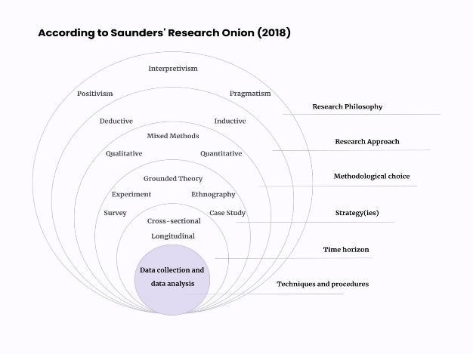

Figure 3.1: Saunders’ Research Onion
(Source: Kumar and Praveenakumar, 2025)

3.3.1 Research Philosophy
The underlying system of belief that impacts the point of view of an investigator while looking at the world and guides the investigator to get engaged with the world is considered as research philosophy. It is narrated as the root of achieving details for a study (Mauthner, 2020). The identification of the subjective meaning regarding any study topic can be done through the deployment of an interpretivism philosophy (Kumar and Praveenakumar, 2025). Through focusing appropriately on the subjective findings about Tesco Plc, a qualitative study has been conducted with the support of this philosophy. Yet, the responses that have been included in the literature review could not be addressed as interpretivism, as that data was only descriptive data. This philosophy is appropriate for the research as it helped in the subjective information collection.

3.3.2 Research Approach
The usual techniques that are used by investigators while performing an investigation are addressed as research approaches. The selection of an approach is done through analysing the nature of a study (Kankam, 2020). The adoption of an inductive approach can be noted in this assessment, that is addressed as a reversed approach that begins through monetisation, as well as leads investigators in the evolution of theories and frameworks regarding a subject (Ocaña-Fernández and Fuster-Guillén, 2021). Relevant details regarding the key variable of this study in relation to Tesco Plc will be accumulated and assessed for the evolution of making existing theories regarding strategic business management stronger.

3.3.3 Research Method
This layer makes investigators choose between the methods, such as mono methods, which are either quantitative or qualitative, and mixed methods that mention the utilisation of both methods for accumulating data. The employment of mono-methods refers to the selection of one type of process for the accumulation of data (Taherdoost, 2022). The aim was to deploy a qualitative process for gaining exploratory details for presenting the responses regarding the objectives and translating the outcomes (Bazen et al. 2021). The qualitative process will complement the decision of choosing an inductive approach and interpretivism philosophy. This will act as the key assistant during the accumulation of subjective data regarding the management of strategic businesses at Tesco Plc, yet it has not assisted in the development of objective-related data.

3.3.4 Research Strategy
Strategy in a study mentions the plan and procedure of how details will be extracted, and if addressed through practical terms, it mentions the procedure through which a study will take place (Taherdoost, 2022). Advocacy toward the case study strategy can be seen for the accomplishment of this assessment, which mentions the deep scrutiny of one and only case. Here, the case study that is chosen is about Tesco Plc. (Quintão et al. 2020) This process has assisted in searching for responses to the study question associated with the assessment of real-life situations. This has also highlighted the ways through which the creation of themes in the findings chapter has been done easily.

3.3.5 Time Horizon
This is the layer in which the investigator requires to determine the time span that will be needed for accomplishing the investigation. These might be longitudinal or cross-sectional. Usually, a cross-sectional time horizon is deployed in most studies, as well as in this specific assessment, it has been used (The PhD Club, 2025). For the accomplishment of all chapters, a specific time point was determined before beginning the research work. This study has focused on the cross-sectional time horizon as it focused only on the single time data collection about Tesco Plc’s variable-based information. The cost-efficient nature of this method has inspired the investigator to choose this as a timeline (Liu et al. 2024).

3.3.6 Data Collection
Relatable, reliable, and accurate details are extracted through a way which is addressed as data collection. In this process, investigators scrutinise the associations, trends, and patterns regarding the extracted details (Baker, 2023). The adoption of the procedure of secondary data accumulation for exploring and revealing various sources to conceptualise the variables of a study (Habu and Henderson, 2023). This has permitted the investigator to accumulate necessary details regarding Tesco Plc’s strategic business management. On the basis of the criteria of exclusion and inclusion, the extraction of details has been done from different types of sources.

3.4 Data Analysis
This is a highly significant part of a study that makes the outcomes of the research more efficient. This mentions the method of accumulating, cleansing, adapting, and data modelling to fulfil the aim of exploring the needed information (Alem, 2020). Data will be assessed through the creation of themes related to the responses presented regarding the study objectives. Collection of data sources and generation of different themes are useful steps for the completion of this research. For the evaluation of extracted qualitative information, the conduction of thematic analysis can be undertaken (Ahmed et al. 2025). This has guided the investigator in categorising all information adequately and presenting it against the questions regarding this specific study.

3.5 Ethical Consideration
Ethical consideration guides an investigator to walk on the appropriate path through aligning with the regulations and rules throughout the activities of research (Dzwigol, 2022). After receiving the approval from the ethical committee, the entire process has begun, and the investigator has only leveraged the sources of accessible secondary data which has already been published by the authors. The external sources of information have been appropriately cited to offer recognition to the authors and to avoid the risks of plagiarism.

3.6. Methodological limitations
The imposition of the limitation of not being adapt the primary research procedure can make an intense impact on the data analysis section of the dissertation project. The alternative methods have not been possible to analyse wit detail, and the scope for critical evaluation of different methodological procedures has not been possible to be accumulated here.

3.7 Summary
In this research, this chapter of methodology has represented each procedure through which these types of detailed and exploratory studies are conducted. Layer by layer, the steps of data accumulation have been highlighted through the utilisation of the research onion that was introduced by Saunders. This can be addressed by a brief yet in-depth collection of data and the method through which extracted details have been analysed, as well as ethical considerations have been presented.

Chapter 4: Data Analysis and Discussions

4.1 Introduction
Findings and discussion helped in the evaluation and outcome analysis of the research topic. This section focused on the data analysis process that helped in the analysis of the SBM of Tesco. Impact of the practices and their positive impact on the business growth will be understood, and the current adapted practices of Tesco will also be focused on. This chapter will evaluate the main challenges presented in the SBM with the strategies that could help in the better business growth of Tesco. In the discussion section, themes are going to be discussed and linked with the LR.

4.2 Findings
Theme 1: Strategic business management (SBM) practices are important as they make a positive impact on the business growth of Tesco
In the Retail business, SBM follows the retail business, and it made a significant impact on the positive business impact of Tesco. Tesco focused on the SBM for the business practices development, and it helped in the organisational creativity development. Financial performance of the companies is also influenced through SBM and the creativity of the business, and overall innovation development is enhanced with this process. All resources under these practices helped in the human resources development and innovation of the business areas (Vuong, 2025). Tesco focused on the differential process, and it focused on the value and the quality that helped in the business growth. The company has aimed to be convenient, and the quality perception of the company has improved. 1000 products are launched by Tesco, and a 24/7 service is provided by the company, they are available to customers through the SBM process. 600 products are improved in Tesco and Finest sales of the company have increased by 15% in the UK, and £2.5bn annual sales are generated (Tesco PLC, 2025a).
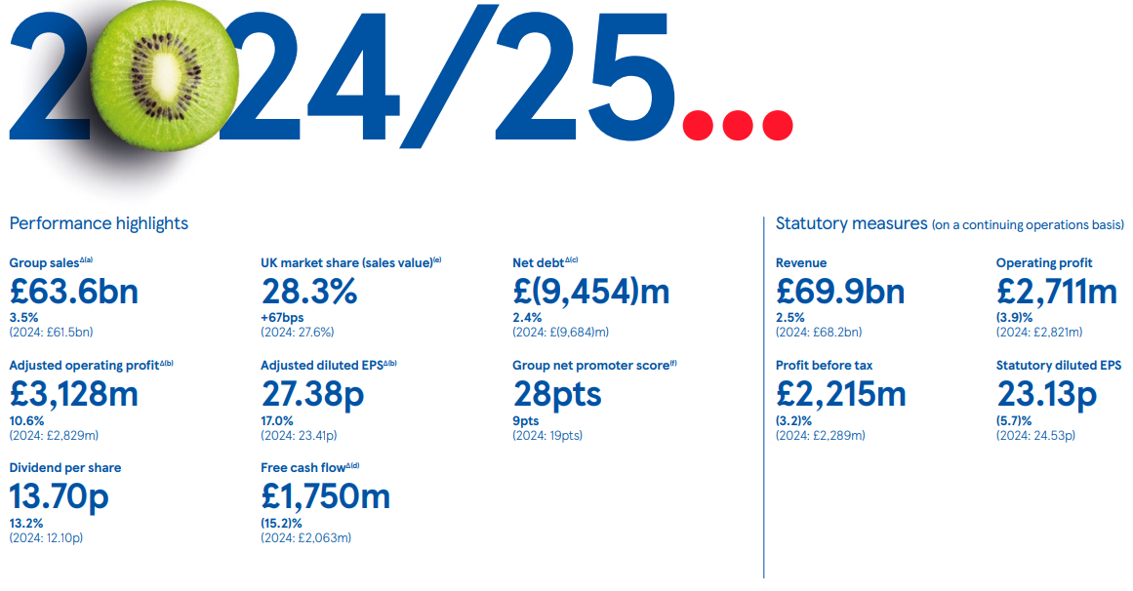

Figure 4.1: Tesco’s business growth
(Source: Tesco PLC, 2025a)
Big decisions have been made easily, and the company has completed the long-term goals that led towards business success. Tesco’s distinctive leadership approach helped in the business success as a transformational vision with democratic participation was presented in the company. A hybrid approach is followed, by the leaders and employees are guided properly to the business growth and it enhances business growth (Bouttell, 2025).
Theme 2: SBM practices such as clear vision, differentiation, operation cost reduction, innovation and operational planning are helpful for growth and success in the business of Tesco
SBM makes a positive impact on the business performance of Tesco as plans of the company have been put into action. Tesco adapted the SBM process, such as clear vision and guiding the employee to the clear vision. The differentiation process is also a key strategic management practice of the company, and shoppers have been served a little better by Tesco. The operation cost of the company has been reduced by almost £1.5bn, and meaningful savings-based opportunities are being followed by Tesco. Cash generation from the operation is also a unique SBM practice, and from the operations, it generated almost £9bn cash (Tesco PLC, 2025b). Operational management practices are also followed by Tesco for better growth. Inventory management and better customer service and experience, and omnichannel retailing have followed in the business process. Sustainable operations have been followed in the business by Tesco to enhance business growth (Meng, 2024).
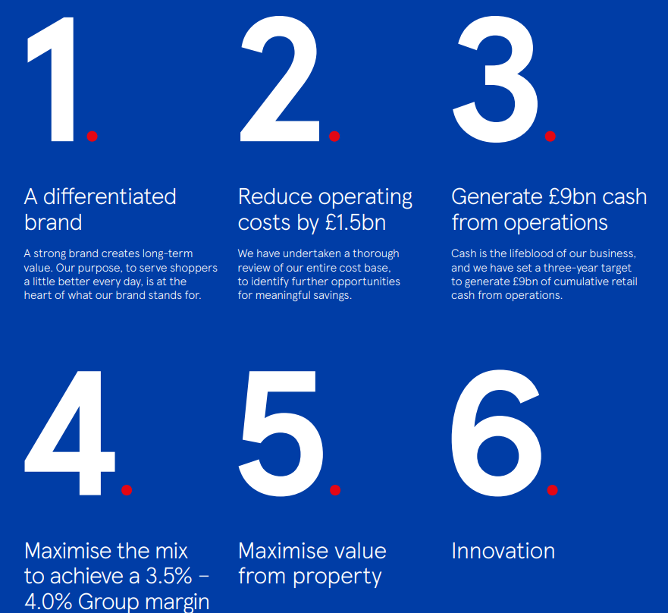

Figure 4.2: Six strategic factors of Tesco
(Source: Tesco PLC, 2025b)
Value from the property has been maximised by the company, and this has also become a key practice. Innovation has followed Tesco as SBM, and the range of the company has been innovated, and customers have gotten good quality products. Broader customer trends have followed, and trend adoption helped the company to achieve success in UK retail (Tesco PLC, 2025c).
Theme 3: Lack of awareness and coordination, poor communication, technology issues, and failure in the change resistance are affecting the strategic management of Tesco
During the SBM implementation by Tesco in its business, there are many threats faced by the company. There has been a lack of awareness among employees, which has created threats in the business process. Lack of coordination among staff leads towards a threat to business management strategically. Communication challenges are presented for Tesco, and they affect the strategic management process overall. The communication team of the company has faced challenges, which resulted in the fall of the company from the stock market (Wain, 2025). IT problems are faced by the company, and they affect the SBM process. Software issues of the company have impacted the websites and apps of the company negatively. Customers have not been able to alter the orders online, and digital versions have not been accessed by the company (McMahon, 2025).
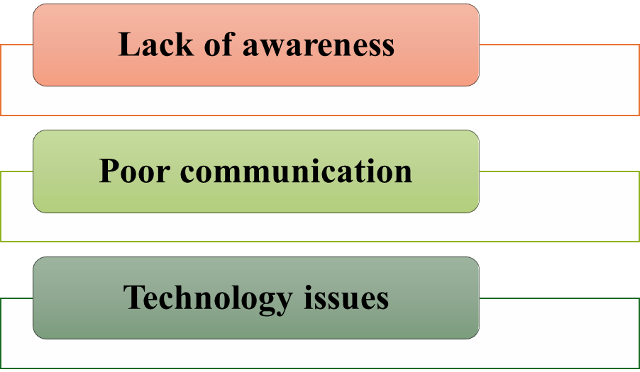

Figure 4.3: SBM issues
(Source: Self-created)
In the retail sector, there have been consistent changes presented, and Tesco is not able to resist the rapid change. Inability of the resources and low efficiency have affected the entire business process. New modern technologies have been adopted by Tesco, but it has not fulfilled the demand of the customers, and it has become a serious threat (Tokhirov and Abdurakhimjanov, 2021).
Theme 4: Technological innovation, customer-centric approach, sustainability focus and online presence boosting can help in the business success of Teso in the retail market
Technological innovation needs to be followed by Tesco as it could be useful for business success in the retail industry. Technology innovation can be useful for meeting the consumers' demands and identifying the customers' needs easily. Innovation focusing more can be useful for the overall business success. The company needs to focus on a customer-centric approach, and it could be useful for the business. Customer-centric business strategies can be followed by Tesco as that impacts positively on the business relationship (Azeem et al. 2022). Tesco should focus more on the sustainability approach, and sustainable resources need to be used more by the company. Waste reduction and recycled products have to be followed by the business for better business success. Tesco in 2024 has reduced almost 65% operational emissions, and 87% of the packaging process is recyclable in Tesco (Tesco PLC, 2025d).
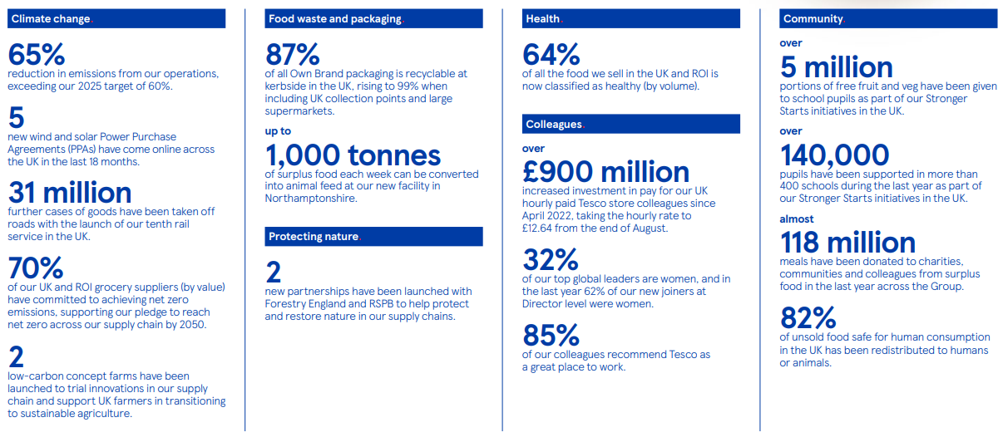

Figure 4.4: Tesco’s sustainability report
(Source: Tesco PLC, 2025d)
The company needs to focus more on the online presence for its strategic management development. Better leaders need to be hired in the company as the SBM could be improved in Tesco. Better communication among workers and the leaders needs to be followed in Tesco. Strategic leadership is important in the process, and that could be followed for the enhancement of the innovation process in companies, and businesses can be improved (Cortes and Herrmann, 2021).

4.3 Discussion
According to theme 1, it has been discussed that strategic management makes a positive impact on the business process of Tesco. The financial performance of Tesco has been improved through SBM practices, and the resources of the company have also been developed. Tesco also, through its hybrid leadership, became able to manage business strategically. Tesco focused on SBM and provided all-time services to the customers, and the quality of the products and consumer value are followed by the company (Tesco PLC, 2025a). The LR section evaluated that business growth is secured through the application of SBM in business. Clear visions and business direction are useful for the business growth enhancement of companies. Long-lasting competitive edge is also provided through SBM, and companies gain profitability and growth in the market. Modern organisations, through SBM, have developed the decision-making process of the companies. Calculated decision-making in organisations improved the growth process and made the business more profitable (Pu et al. 2025).
Theme 2 elaborated on the main practices that were adopted by Tesco in managing the business strategically. Secondary information gives the description that Tesco focused on the differentiation strategy and made the brand different from others. Operating costs of the company have also been reduced, and it has also followed value maximisation from the property. Innovation strategy has been followed for the service process development in the business, and the company has also reduced the operating costs (Tesco PLC, 2025b). According to the LR section, innovation and adaptability are followed in the business for strategic management. Innovation and creativity are embraced by businesses as they are helpful for long-lasting business success. Continuous monitoring is also followed by the business as an SBM practice that helps in solving business issues. Companies also followed regular mobilisation and review for production development (Issifu and Agyapong, 2023).
Secondary data about theme 3 reflected key challenges that were presented in Tesco related to business management. There has been a lack of coordination among the leaders, and team members have created threats. Communication challenges have been presented in the national market, and it has become a serious threat to the company. Software issues of the company have created serious problems in the business management strategically, and it has created major business threats. Customer demand in the international market has not been fulfilled by the company, and it has also enhanced threats in SBM (McMahon, 2025). The LR section mentioned that resource management is a crucial threat to the business, and a lack of knowledge and skills has created major business threats. Globalisation and high competition in the market have created threats for companies to manage their strategic resources, and it has affected the business (Cristofaro et al. 2025).
Theme 4 discussed that Tesco needs to focus on a better leadership style that is useful for the development of the business's strategic planning. Proper innovation focus through technology could be helpful for the SBM development of the companies. There needs to be a focus on the approach based on the customers, and that could be effective for business development. Sustainable policies need to be developed further, and recycling and waste reduction processes could be followed by the business. Tesco could focus on the better leaders in the business to manage the business strategy (Cortes and Herrmann, 2021). The LR section needs to focus on fostering an innovative culture, and technological disruption needs to be reduced. There could be a focus on effective resource management and resource levelling that needs to be followed. The digitalisation process should be followed in the business, and the generation of unique products should be followed (Elkliny et al. 2023).

4.4 Summary
It has been summarised that SBM practices are useful in the retail sector for better business management. Tesco, by focusing on the SBM process, has been able to improve its business growth. There are practices such as innovation, resource management and operational cost reduction presented in the business that helped in the overall business development. Issues such as improper communication and a lack of leadership practices have created major threats in the business process of Tesco. Tesco can focus on the better leadership process and sustainable policies, following which it can develop the strategic management process.

Chapter 5: Conclusion, General Limitations & Recommendations

5.1 Conclusion
Based on the above topic analysis, it has been concluded that in business, strategic management is important. SBM has been adopted by Tesco, which developed the overall business planning and execution and decision-making process is also developed. Tesco followed practices such as operational cost reduction and innovation management that helped in the business growth. During the business process, the company faced threats such as a lack of communication among staff and leadership issues. Better leadership and resource management need to be followed in the business. This study has adopted a secondary method to collect information about SBM, and Tesco’s case study has been followed.

5. 2 Linking with objectives
Objective 1
This objective focused on the positive impact of the SBM practices on the business. Secondary information has reflected that Tesco, through following these practices, enhances consumer satisfaction and develops business processes. This process enhances the business growth and decision-making of Tesco, which has become better (Vuong, 2025).
Objective 2
According to this objective, different types of SBM practices help in the business growth of companies. Tesco focused on practices such as innovation and reduction of the business operations cost, and it helped in the business success. Customer trends are also followed by Tesco, and their needs are fulfilled in the business (Tesco PLC, 2025c).
Objective 3
As per objective 3, retail companies have faced various challenges regarding the SBM application. Tesco, as per secondary resources, faced issues such as communication errors and technological problems. Customers, due to software and technological threats, have not been getting the orders properly online (McMahon, 2025).
Objective 4
Objective 4 suggested the strategies that companies followed to develop business success. Tesco can focus on its online presence and technological infrastructure development for better business. The company should prefer customers first, and this approach could be helpful for the business success enhancement (Azeem et al. 2022).

5.3 Recommendations
Strategy team creation and the right people's involvement
Dedicated and skilled team creation could be useful for Tesco and other teams, as that could be helpful for business development. A communication strategy should be followed, and that can be aligned with the organisation. The right people should be involved in the business process for better management of the strategy. Strategic conversation is useful for companies like SBM and Tesco by following the way that they become able to develop better relationships with the workers. Digital transformation needs to be followed, and the communication process has to be developed for better business management (Rêgo et al. 2022).
Strategy evaluation and control with continuous monitoring
Progress needs to be evaluated properly, and the strategic management needs to be controlled properly. A specialist team should be hired in the business that could control and manage the strategy implementation process. Tesco needs to focus on the continuous monitoring process in the business, which could be helpful for better SBM. Continuous planning should be followed by the company, as that helps in the overall business process development. Management process development could be an important sign of good governance in the business (Tokhirov and Abdurakhimjanov, 2021).

5.4 Limitations
Limited resources have been used in this study, so there has been an issue regarding its quality. This study lacks information from the participants, as there has not been any primary research conducted. This research lacked the view of customers or company officials who could give information about SBM and its importance. Budget issues are also presented in this research, and subscribing to articles and journals has not been possible. This research was completed in a tight schedule, and it affected its quality.

References
Abbasov, R. and Sain, Z.H., (2025). Strategic Business Management in the 21 St Century: Trends, Challenges, and Future Directions in Digitalization, Sustainability, and Organizational Agility. Link: https://papers.ssrn.com/sol3/papers.cfm?abstract_id=5241457
Ahmed, S.K., Mohammed, R.A., Nashwan, A.J., Ibrahim, R.H., Abdalla, A.Q., Ameen, B.M.M. and Khdhir, R.M., (2025). Using thematic analysis in qualitative research. Journal of Medicine, Surgery, and Public Health, 6, p.100198. Link: https://www.sciencedirect.com/science/article/pii/S2949916X25000222
Ahsan, M.J., (2025). Cultivating a culture of learning: the role of leadership in fostering lifelong development. The learning organization, 32(2), pp.282-306. Link: https://www.emerald.com/tlo/article/32/2/282/1244831/Cultivating-a-culture-of-learning-the-role-of
Alem, D.D., (2020). An overview of data analysis and interpretations in research. International Journal of Academic Research in Education and Review, 8(1), pp.1-27. Link: https://d1wqtxts1xzle7.cloudfront.net/78408562/Dawit-libre.pdf?1641730757=&response-content-disposition=inline%3B+filename%3DAn_Overview_of_Data_Analysis_and_Interpr.pdf&Expires=1760617203&Signature=Q91ioq9XfTwnZRaHTvJR9HpizqRYx0PdWgYW7O7ian00tLupcHc2gMoxMyMF-XlyK~KPNwpVJxhAyMt6zs7YfkCRKFOin-yYsyX4Vt6q0~4czQ93L2JZs6jJdRT7NBlDqdhhiXNsGQ7118qUorfuKLvYd24qmPwsaaZ2YihHdYRBzcI1HaB5xpCKS7kAyM4Z3kohAPz8PYnC3TXXaTSfzpreRhCyraYXyx5p~QDPHUjJN5VFh-mhJ~GoTNv50Rcg2-Gle2sBL30YiK-~MdQy5QR9fhSf~~Dj9MzSnAtVm-gVbgtB8ZNfNvNQZhYVH9-oNVg4DRP2wFApbr5J9exV5w__&Key-Pair-Id=APKAJLOHF5GGSLRBV4ZA
Alharbi, I.B., (2024). Strategic management: A comprehensive review paper. International Journal of Professional Business Review: Int. J. Prof. Bus. Rev., 9(3), p.8. Link: https://dialnet.unirioja.es/servlet/articulo?codigo=9399293
Alharbi, I.B., (2024). Strategic management: A comprehensive review paper. International Journal of Professional Business Review: Int. J. Prof. Bus. Rev., 9(3), p.8. Link: https://dialnet.unirioja.es/servlet/articulo?codigo=9399293
Azeem, M., Aziz, S., Shahid, J., Hayat, A., Ahmed, M. and Khan, M.I., (2022). The impact of customer-centric business strategies on customer relationship management: pharmaceutical field-force perspective. International Journal of Pharmaceutical and Healthcare Marketing, 16(1), pp.138-154. Link: https://www.researchgate.net/profile/Aamir-Hayat/publication/357225368_The_impact_of_customer-centric_business_strategies_on_customer_relationship_management_pharmaceutical_field-force_perspective/links/61d5d331da5d105e551d9490/The-impact-of-customer-centric-business-strategies-on-customer-relationship-management-pharmaceutical-field-force-perspective.pdf
Baker, N. (2023) What is the main purpose of data collection? Savanta. Available at: https://savanta.com/knowledge-centre/view/what-is-the-main-purpose-of-data-collection/ (Accessed: 16 October 2025).
Bazen, A., Barg, F.K. and Takeshita, J., (2021). Research techniques made simple: an introduction to qualitative research. Journal of Investigative Dermatology, 141(2), pp.241-247. Link: https://www.sciencedirect.com/science/article/pii/S0022202X20324064
Bouttell, L. (2025) What leadership style does Tesco use: Complete Analysis, World Class Leadership Training. Available at: https://quarterdeck.co.uk/articles/what-leadership-style-does-tesco-use (Accessed: 03 November 2025).
Bubenik, P., Capek, J., Rakyta, M., Binasova, V. and Staffenova, K., (2022). Impact of strategy change on business process management. Sustainability, 14(17), p.11112. Link: https://www.mdpi.com/2071-1050/14/17/11112
Charles, N.A., Ojera, P.B. and David, O., (2015). Factors influencing choice of strategic management modes of small enterprises. Journal of Innovation and Entrepreneurship, 4(1), p.4. Link: https://link.springer.com/article/10.1186/s13731-014-0016-y
Cho, Y.S. and Linderman, K., (2020). Resource-based product and process innovation model: Theory development and empirical validation. Sustainability, 12(3), p.913. Link: https://www.mdpi.com/2071-1050/12/3/913
Cortes, A.F. and Herrmann, P., (2021). Strategic leadership of innovation: a framework for future research. International Journal of Management Reviews, 23(2), pp.224-243. Link: https://www.academia.edu/download/97759935/ijmr.1224620230124-1-1drib8j.pdf
Cortes, A.F. and Herrmann, P., 2021. Strategic leadership of innovation: a framework for future research. International Journal of Management Reviews, 23(2), pp.224-243. Link:
Cristofaro, M., Hristov, I., Cimini, R. and Lovallo, D., (2025). From start to stardom: The impact of resource allocation strategies on new venture survival and growth. Long Range Planning, 58(2), p.102513. Link: https://www.sciencedirect.com/science/article/pii/S0024630125000160
D’Oria, L., Crook, T.R., Ketchen Jr, D.J., Sirmon, D.G. and Wright, M., (2021). The evolution of resource-based inquiry: A review and meta-analytic integration of the strategic resources–actions–performance pathway. Journal of Management, 47(6), pp.1383-1429. Link: https://journals.sagepub.com/doi/full/10.1177/0149206321994182
Dabic, M., González-Loureiro, M. and Furrer, O., (2014). Research on the strategy of multinational enterprises: key approaches and new avenues. BRQ Business Research Quarterly, 17(2), pp.129-148. Link: https://journals.sagepub.com/doi/full/10.1016/j.brq.2013.09.001
Dubey, U.K.B. and Kothari, D.P., (2022). Research methodology: Techniques and trends. Chapman and Hall/CRC.
Dzwigol, H., (2022). Research methodology in management science: Triangulation. Virtual Economics, 5(1), pp.78-93. Link: https://www.virtual-economics.eu/index.php/VE/article/view/145
Elbanna, S., Al Katheeri, B. and Colak, M., (2020). The harder firms practice strategic management, the better they are. Strategic Change, 29(5), pp.561-569. Link: https://onlinelibrary.wiley.com/doi/full/10.1002/jsc.2365
Elkliny, A.F., Sanad, H.M. and Etman, E.E., (2023). Time-cost-quality tradeoff considering resource-scheduling problems. Ain Shams Engineering Journal, 14(11), p.102524. Link: https://www.sciencedirect.com/science/article/pii/S2090447923004136
Emma, L., (2025). Strategic Management Approaches for Enhancing Competitive Advantage in the Digital Economy. Link: https://www.researchgate.net/profile/Lawrence-Emma/publication/388678693_Strategic_Management_Approaches_for_Enhancing_Competitive_Advantage_in_the_Digital_Economy/links/67a231ba96e7fb48b9b458c5/Strategic-Management-Approaches-for-Enhancing-Competitive-Advantage-in-the-Digital-Economy.pdf
Fuertes, G., Alfaro, M., Vargas, M., Gutierrez, S., Ternero, R. and Sabattin, J., (2020). Conceptual framework for the strategic management: a literature review descriptive. Journal of engineering, 2020(1), p.6253013. Link: https://onlinelibrary.wiley.com/doi/full/10.1155/2020/6253013
Funk, P., (2022). Business Growth. Figshare. https://doi. org/10.6084/m9. figshare, 20861410, p.v1. Link: https://www.researchgate.net/profile/Philippe-Funk/publication/363255945_Business_Growth/links/631372a961e4553b95611955/Business-Growth.pdf
Gandrita, D.M., (2023). Improving strategic planning: The crucial role of enhancing relationships between management levels. Administrative Sciences, 13(10), p.211. Link: https://www.mdpi.com/2076-3387/13/10/211
Habu, A.A. and Henderson, T., (2023). Data subject rights as a research methodology: A systematic literature review. Journal of Responsible Technology, 16, p.100070. Link: https://www.sciencedirect.com/science/article/pii/S2666659623000136
Holz, H.F., (2024). The Resource-Based View of the Firm. Link: https://www.sciencedirect.com/science/article/abs/pii/B9780443137013003832
Issifu, R. and Agyapong, D., (2023). Monitoring and evaluation practices and project outcome of tech start-ups in Ghana: The moderating role of the Business environment. Cogent Business & Management, 10(3), p.2279793. Link: https://www.tandfonline.com/doi/full/10.1080/23311975.2023.2279793
Joyce, P., (2022). Strategic Management and Governance: Strategy Execution Around the World. Routledge.
Kankam, P.K., (2020). Approaches in information research. New Review of Academic Librarianship, 26(1), pp.165-183. Link: https://www.tandfonline.com/doi/abs/10.1080/13614533.2019.1632216
Kumar, A. and Praveenakumar, S.G., (2025). Research methodology. Authors Click Publishing.
Kurniati, A., Pradana, F.A. and Pratama, O., (2021). ASSISTING THE IMPLEMENTATION OF THE LEAN WASTE SYSTEM THROUGH THE LOGISTICS SERVICE INDUSTRY. International Journal of Social and Management Studies, 2(1), pp.99-105. Link: https://www.ijosmas.org/index.php/ijosmas/article/view/284
Liu, L., Wang, Y. and Xu, Y., (2024). A practical guide to counterfactual estimators for causal inference with time‐series cross‐sectional data. American Journal of Political Science, 68(1), pp.160-176. Link: https://onlinelibrary.wiley.com/doi/full/10.1111/ajps.12723
Mauthner, N.S., (2020). Research philosophies and why they matter. In How to keep your doctorate on track (pp. 76-86). Edward Elgar Publishing. Link: https://www.elgaronline.com/edcollchap/edcoll/9781788975629/9781788975629.00018.xml
McMahon, L. (2025) Tesco Resolves ‘Software Issue’ after customers Flag App Problems, BBC News. Available at: https://www.bbc.com/news/articles/c8re57856jmo (Accessed: 03 November 2025).
Meng, S., (2024). Operation Management of Grocery Retailer in the UK: A Case of Tesco. Pacific International Journal, 7(2), pp.136-142. Link: https://rclss.com/pij/article/download/586/391
Munir, M., (2024), February. The Success of a Start-Up: Examined from Creativity, Innovation, and Knowledge. In Prosiding Seminar (pp. 81-91). Link: https://www.prosiding.pasca.uniska-kediri.ac.id/index.php/prosidingseminar/article/view/89
Ocaña-Fernández, Y. and Fuster-Guillén, D., (2021). The bibliographical review as a research methodology. Revista Tempos e Espaços em Educação, 14(33), pp.e15614-e15614. Link: https://ufs.emnuvens.com.br/revtee/article/view/15614
Pacheco-Cubillos, D.B., Boria-Reverter, J. and Gil-Lafuente, J., (2024). Transitioning to agile organizational structures: A contingency theory approach in the financial sector. Systems, 12(4), p.142. Link: https://www.mdpi.com/2079-8954/12/4/142
Pu, Y., Li, H., Hou, W. and Pan, X., (2025). The analysis of strategic management decisions and corporate competitiveness based on artificial intelligence. Scientific Reports, 15(1), p.17942. Link: https://www.nature.com/articles/s41598-025-02842-x
Quintão, C., Andrade, P. and Almeida, F., (2020). How to improve the validity and reliability of a case study approach?. Journal of Interdisciplinary Studies in Education, 9(2), pp.264-275. Link: https://ojed.org/jise/article/view/2026
Radicic, D. and Petković, S., (2023). Impact of digitalization on technological innovations in small and medium-sized enterprises (SMEs). Technological Forecasting and Social Change, 191, p.122474. Link: https://www.sciencedirect.com/science/article/pii/S0040162523001592
Rêgo, B.S., Jayantilal, S., Ferreira, J.J. and Carayannis, E.G., (2022). Digital transformation and strategic management: A systematic review of the literature. Journal of the Knowledge Economy, 13(4), pp.3195-3222. Link: https://www.researchgate.net/profile/Bruno-Rego-6/publication/356191007_Digital_Transformation_and_Strategic_Management_a_Systematic_Review_of_the_Literature/links/61db2475d4500608169d3794/Digital-Transformation-and-Strategic-Management-a-Systematic-Review-of-the-Literature.pdf
Ruwanika, E.Q.F. and Massyn, L., (2024). Rethinking External Environmental Analysis for Sustainable Development: The Case of a Beverage Manufacturing Industry in a Southern African Country. Sustainability, 16(16), p.6759. Link: https://www.mdpi.com/2071-1050/16/16/6759
Sarpong, D., Boakye, D., Ofosu, G. and Botchie, D., (2022). The three pointers of research and development (R&D) for growth-boosting sustainable innovation system. Technovation, 122, p.102581. Link: https://research.aston.ac.uk/en/publications/the-three-pointers-of-research-and-development-rampd-for-growth-b
Sewpersadh, N.S., (2023). Disruptive business value models in the digital era. Journal of Innovation and Entrepreneurship, 12(1), p.2. Link: https://link.springer.com/article/10.1186/s13731-022-00252-1
Shala, B., Prebreza, A. and Ramosaj, B., (2021). The contingency theory of management as a factor of acknowledging the leaders-managers of our time study case: The practice of the contingency theory in the company Avrios. Open Access Library Journal, 8(9), pp.1-20. Link: https://www.scirp.org/journal/paperinformation?paperid=111736
Shenkar, O. and Ellis, S., (2022). The rise and fall of structural contingency theory: A theory’s ‘autopsy’. Journal of Management Studies, 59(3), pp.782-818. Link: https://onlinelibrary.wiley.com/doi/abs/10.1111/joms.12772
Stewart, L. (2025) What is a research design? Definition, Types & Guide, ATLAS.ti. Available at: https://atlasti.com/research-hub/research-design (Accessed: 16 October 2025).
Tesco PLC (2025a) 2 25. value. quality. service. Tesco PLC Annual Report and financial statements. Available at: https://www.tescoplc.com/media/ky0bfwpo/tesco_ar25_interactive.pdf (Accessed: 03 November 2025).
Tesco PLC (2025b) The six strategic drivers. Available at: https://www.tescoplc.com/media/392349/tesco_ar17_6drivers.pdf (Accessed: 03 November 2025).
Tesco PLC (2025c) Innovation at Tesco, Tesco PLC. Available at: https://www.tescoplc.com/contacts/innovation-at-tesco (Accessed: 03 November 2025).
Tesco PLC (2025d) Making a positive impact. Tesco plc Sustainability Report 2024/25 May 2025. Available at: https://www.tescoplc.com/media/wvkj1yic/tesco-sustainability-report-2025.pdf (Accessed: 03 November 2025).
Taherdoost, H., (2022). What are different research approaches? Comprehensive review of qualitative, quantitative, and mixed method research, their applications, types, and limitations. Journal of Management Science & Engineering Research, 5(1), pp.53-63. Link: https://hal.science/hal-03741840/document
Thesismind (2019) Analysis of Saunders Research Onion, Thesismind. Available at: https://thesismind.com/analysis-of-saunders-research-onion/ (Accessed: 16 October 2025).
Tokhirov, R. and Abdurakhimjanov, A. (2021). The Issue Of Modern Strategic Management In Enterprises Or Firms. The American Journal of Management and Economics Innovations, 3(08), pp.9-14. Link: https://inlibrary.uz/index.php/tajmei/article/download/12284/12708
UK Academic (2025) What is research onion? structure, methods, & uses, UK Academic Help. Available at: https://ukacademichelp.co.uk/saunders-research-onion-explained-by-experts/ (Accessed: 16 October 2025).
Vuong, T.K., (2025). The impact of strategic management on organizational creativity and its influence on the financial performance of SMEs. Journal of Entrepreneurship, Management and Innovation, 21(1), pp.43-57. Link: https://ww.jemi.edu.pl/vol-21-issue-1-2025/the-impact-of-strategic-management-on-organizational-creativity-and-its-influence-on-the-financial-performance-of-smes
Wain, R. (2025) Communication challenges for Tesco Amid Accounting Mess, Deep South Media. Available at: https://www.deepsouthmedia.co.uk/communication-challenges-tesco-amid-accounting-mess/ (Accessed: 03 November 2025).
Zinchenko, O., Privarnikova, I. and Samoilenko, A., (2022). Adaptive strategic management in a digital business environment. Baltic Journal of Economic Studies, 8(3), pp.78-85. Link: https://cyberleninka.ru/article/n/adaptive-strategic-management-in-a-digital-business-environment

