Bethan Moyle
1707952@student.uwtsd.ac.uk
Module Code: ACCA4022

Operating systems
Computer Architecture and Operating Systems

Table of Contents
1 Introduction 3
2 Task 1: What is an Operating System? 4
3 Task 2: Windows CLI Commands 6
3.1 Process Management 6
3.1.1 Tasklist: 6
3.1.2 Taskkill 7
3.2 File and Directory Management 7
3.2.1 Directory (dir) 7
3.2.2 Mkdir 8
3.2.3 Rmdir 9
3.3 Network Testing and Monitoring 9
3.3.1 Ipconfig 9
3.3.2 Ping 10
3.3.3 Netstat 10
3.3.4 Tracert 11
3.4 User Management 11
3.4.1 Whoami 11
3.4.2 Netuser 12
3.5 Task Scheduling 13
3.5.1 Schtasks 13
4 Task 3: Linux CLI Commands 14
4.1 Process Management 14
4.1.1 Ps 14
4.2 File and Directory Management 14
4.2.1 Ls 14
4.2.2 Mkdir 15
4.2.3 Cd 15
4.2.4 Echo 15
4.2.5 Cat 16
4.3 Network Testing and Monitoring 16
4.3.1 Ifconfig 16
4.3.2 Arp -a 17
4.3.3 Netstat 17
4.4 User Management 18
4.4.1 Adduser 18
4.4.2 Addgroup 18
4.5 Task Scheduling 19
4.5.1 Contrab -l 19
5 Task 4: Windows Batch Script 20
5.1 Variables 20
5.2 GoTo 21
5.3 User Input 22
5.4 Array 23
5.5 If Statement 24
5.6 For Loop 25
5.7 Call 26
6 Task 4: Bash Linux 27
6.1 Variables 27
6.2 User Input 28
6.3 If Statement 29
6.4 Until Loop 30
6.5 Array 31
6.6 Case Statement 32
6.7 Function 33
7 Conclusion 34
8 References 34
9 Appendices 37
9.1 Tutorial tasks: 37
9.2 Lecture Notes: 38
9.3 Additional Course 39

Introduction
An operating system is the backbone of any computing environment acting as the essential bridge between hardware and the software applications users interact with daily. Without an OS, the raw components of a computer such as its processor, memory and storage would be inaccessible and unmanageable. This report explores the fundamental role of operating systems with a particular focus on the two most widely used platforms Microsoft Windows and Linux. Defining what an operating system is and outlining its core functions, including process management, memory management, file management, and security and access control. It then moves into a practical examination of command-line interface (CLI) commands across both Windows and Linux environments, covering key areas such as process management, file and directory management, network testing and monitoring, user management, and task scheduling. Finally, the report demonstrates scripting capabilities on both platforms exploring Windows Batch scripting and Linux Bash scripting covering essential programming concepts such as variables, user input, conditional statements, loops, arrays, and functions. Together, these sections provide a comprehensive overview of how operating systems are used and managed at both a conceptual and practical level.

Task 1: What is an Operating System?
An operating system (OS) acts as the core software layer between a computer’s hardware and its users. A general purpose OS is designed to run a wide range of applications across a variety of hardware, allowing users to execute multiple programs or tasks at the same time [1]. The three most widely used examples are Microsoft Windows, Apple macOS and Linux.
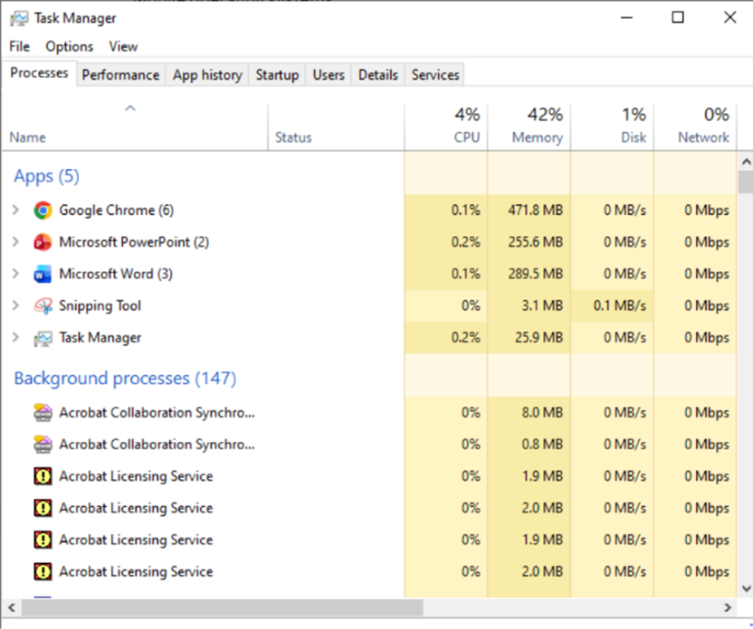
Process management is an essential function in an OS. It involves creating, scheduling and terminating processes to ensure the CPU is utilised efficiently, with multitasking allowing multiple applications to run simultaneously without conflict [1][2].
Figure 1: Windows Task Manager showing current processes running
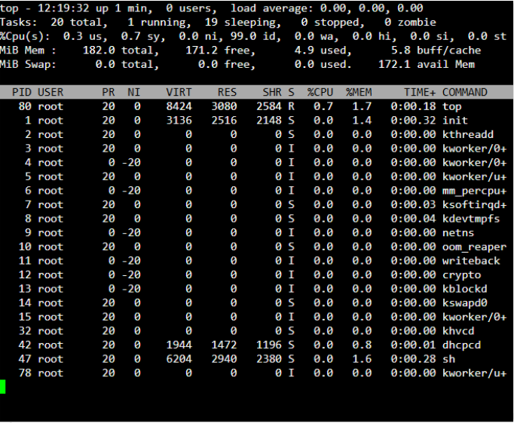
Figure 2: Linux Nautilus showing list of running processes
Memory management ensures programs have the resources they need to run. The OS uses techniques like virtual memory and paging to optimise memory usage which is essential for preventing memory leaks and ensuring the system runs smoothly when multiple applications are open [1][2].
File management controls how data is stored and accessed on a computer. The operating system is responsible for organising, naming and managing files on storage devices, ensuring that users can easily locate and work with their data.[1][2].
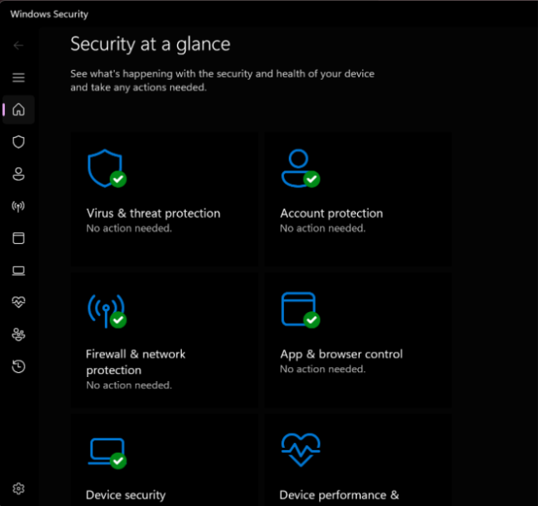
Security and access control protects the system from unauthorised access. The OS limits user and process permissions through access control and verifies users through authentication credentials [1][2].
Figure 3: Windows Security

Task 2: Windows CLI Commands

Process Management

Tasklist:
The tasklist command displays all currently running processes on a local or remote machine, providing detailed information including the process name, process ID (PID), session name and number, and memory usage. It can also be filtered to target specific tasks. Making it a useful tool for troubleshooting performance issues caused by high memory consumption [3].
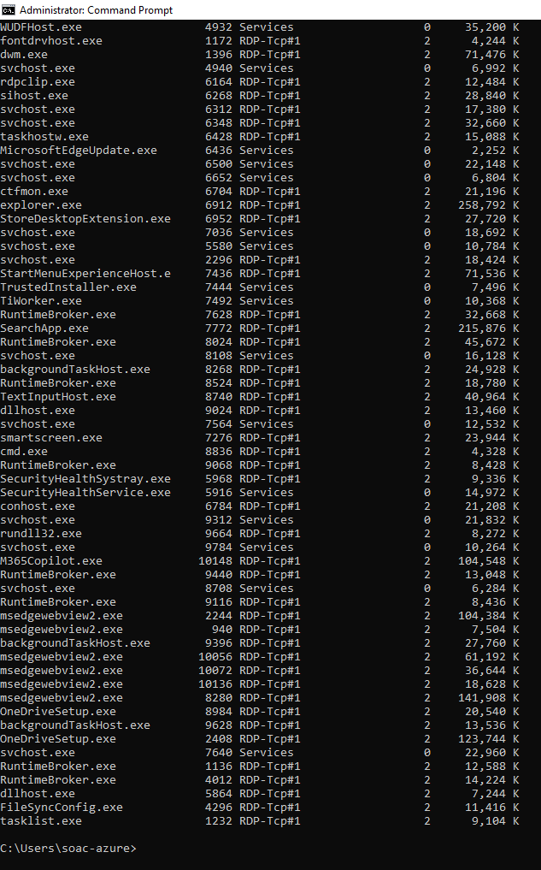
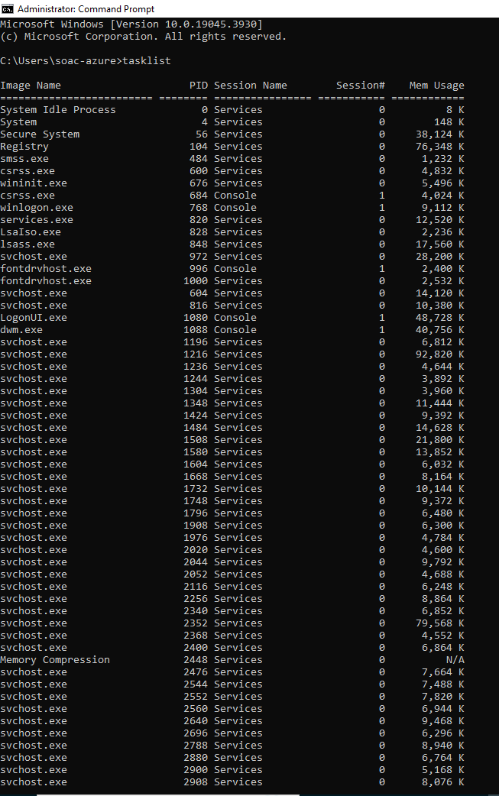
Figure 4 and Figure 5: tasklist command

Taskkill
The taskkill command terminates running Window processes by name or process ID making it particularly useful for forcefully closing frozen or unresponsive applications [4].
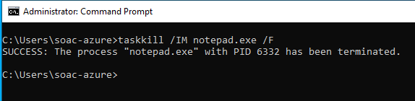
Figure 6: CLI command taskkill

File and Directory Management

Directory (dir)
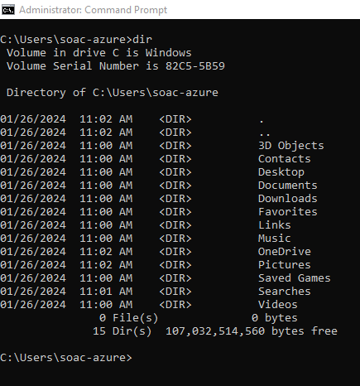
The dir command displays the files and subdirectories within a directory making it a helpful tool for navigating the file system, managing or troubleshooting file organisation [5].
Figure 7: CLI command dir

Mkdir
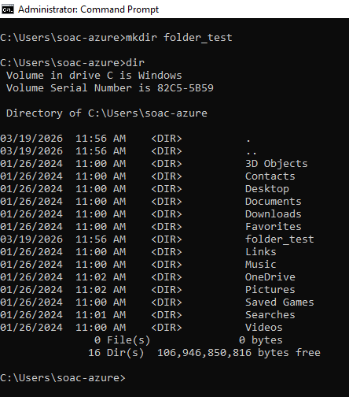
The mkdir command creates a new empty directory, helping to keep files organised across multiple folders rather than storing everything in one location [6].
Figure 8: Windows CLI command mkdir

Rmdir
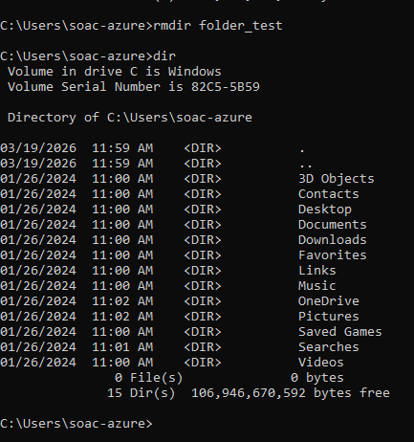
The rmdir command removes a specified directory, though it only works on empty directories making it a safe option for cleanup without the risk of accidentally deleting files that are still in use [7].
Figure 9: Win CLI Command rmdir

Network Testing and Monitoring

Ipconfig
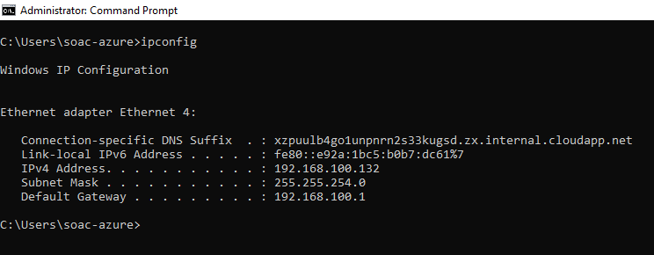
The ipconfig command displays network configuration details such as the IP address and subnet mask, making it a useful first step when troubleshooting network connectivity issues [8].
Figure 10 : Win CLI ipconfig

Ping
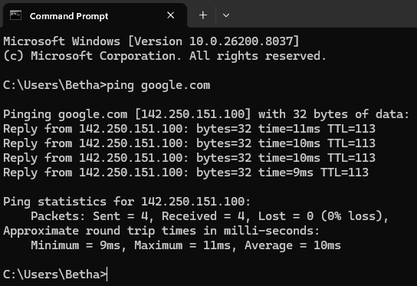
The ping command sends packets to a specified network host to test connectivity providing a quick way to check whether a networked device is reachable [9].
Figure 11: Win CLI Command ping

Netstat
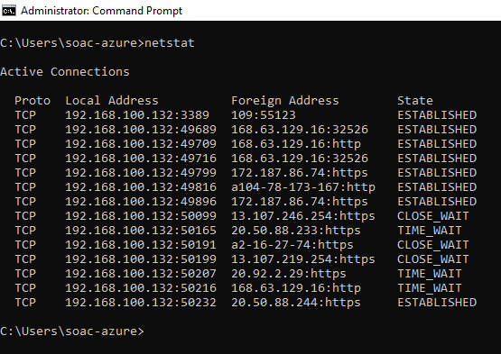
The netstat command monitors both incoming and outgoing network connections, displaying information such as routing tables and protocol types (TCP/UDP). It is a versatile troubleshooting tool useful for analysing active connections, monitoring traffic, identifying open ports, verifying service listening ports and detecting potential security threats [10].
Figure 12: Win CLI Command Netstat

Tracert
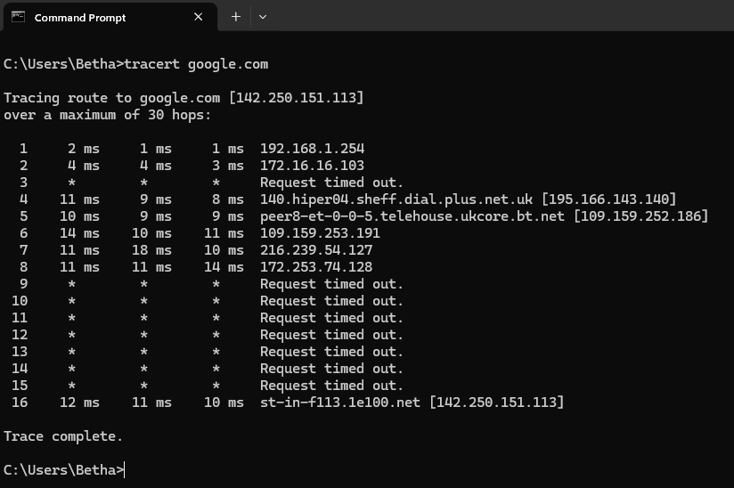
The tracert command diagnoses network connectivity issues by mapping the path data packets take to reach a destination, helping to identify where connections fail and where high latency points occur [11].
Figure 13: Win CLI command tracert

User Management

Whoami
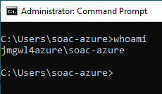
The whoami command displays the current user, making it useful when switching between accounts and helping debug permission issues by confirming the correct privileges are in effect [12].
Figure 14: Win CLI Command whoami

Netuser
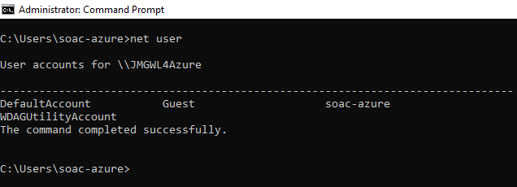
The net user command creates, manages, and modifies user accounts quickly whether on a local machine or within a domain [13].
Figure 15: Win CLI Command Netuser

Task Scheduling

Schtasks
The schtasks command schedules commands and programs to run at specific times or on a recurring basis and allows tasks to be added, removed or started and stopped on demand [14].
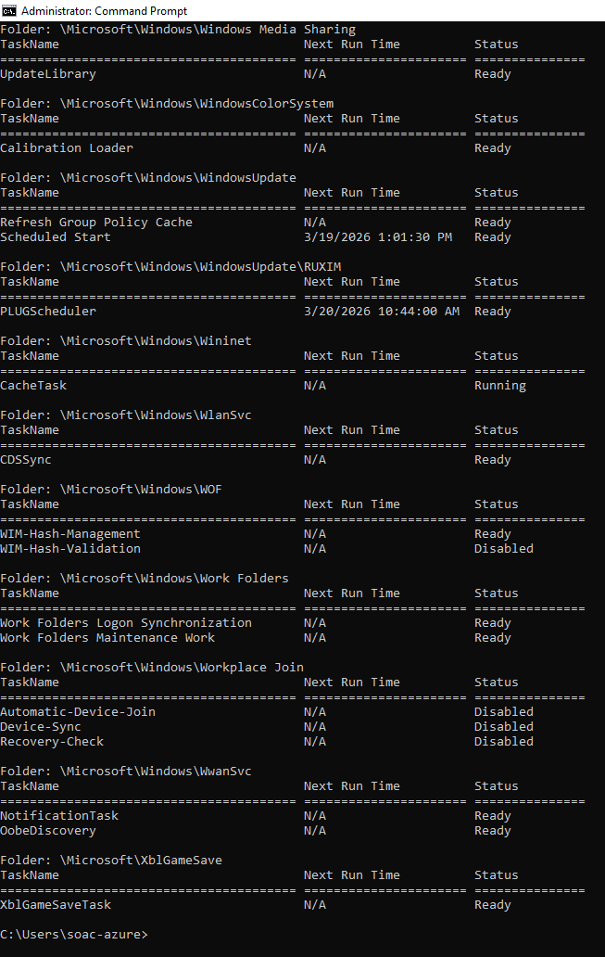
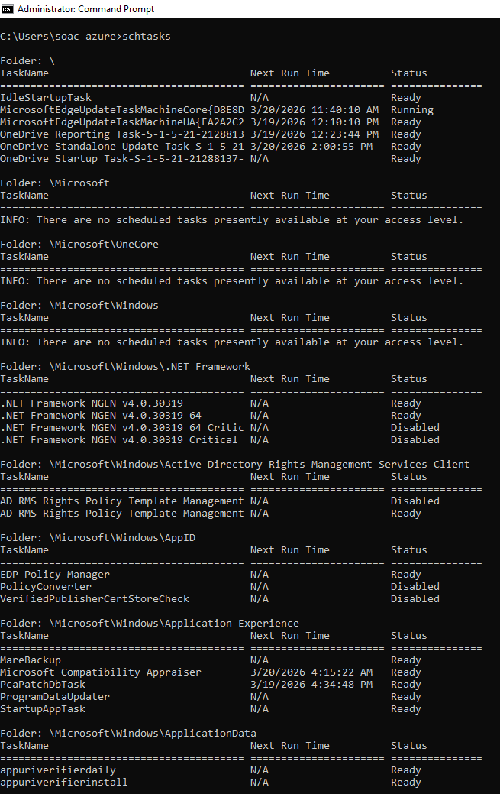
Figure 16: Win CLI Command schtasks

Task 3: Linux CLI Commands

Process Management

Ps
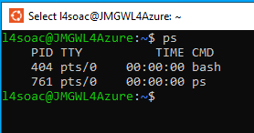
The ps (process status) command displays a list of all processes currently running on the system [15].
Figure 17: Linux CLI command ps

File and Directory Management

Ls
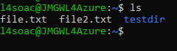
The ls command lists files and directories within the file system, providing a quick overview of contents of a given location [16] .
Figure 18: Linux CLI Command ls

Mkdir
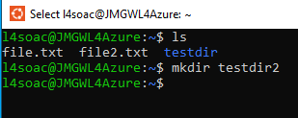
The mkdir command creates new directories directly from the command line. It is useful for organising files and preparing paths for scripts and configurations [16].
Figure 19: Linux CLI Command

Cd
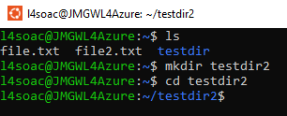
The cd (change directory) command changes the current working directory of the terminal, which by default opens in the home directory [16].
Figure 20: Linux CLI Command cd

Echo
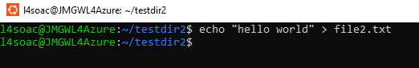
The echo command displays lines of text or strings, passed as arguments on the command line. It is commonly used in scripts to produce output or debug variable values [16].
Figure 21: Linux CLI Command echo

Cat
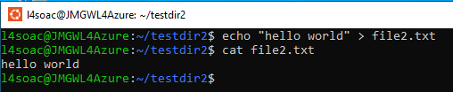
The cat (concatenate) command is used to read, display and concatenate the contents of text files [16].
Figure 22: Linux CLI Command cat

Network Testing and Monitoring

Ifconfig
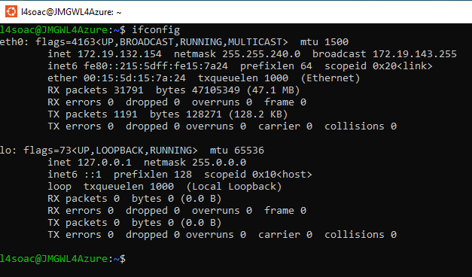
The ifconfig (interface configuration) command displays and configures network interfaces in Linux. While largely replaced by the IP command in modern distributions, it remains widely used in older systems and tutorials [17].
Figure 23: Linux CLI Command ifconfig

Arp -a
The arp – a commend uses the Address Resolution Protocol to identify the MAC address of devices within a local area network [15].
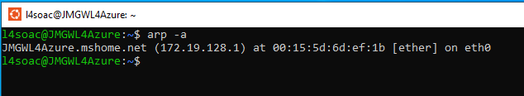
Figure 24: Linux CLI Command arp -a

Netstat
Netstat (network statistics) is a networking tool used for troubleshooting, configuration, and monitoring. It provides visibility into connections that are outgoing and incoming, routing tables, listening ports and network usage statistics [17].
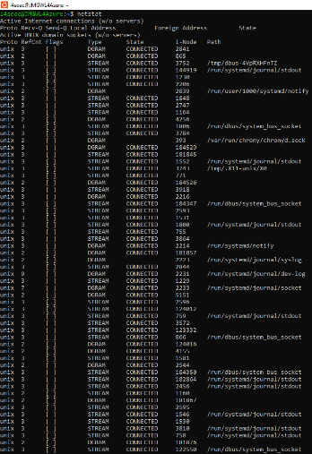
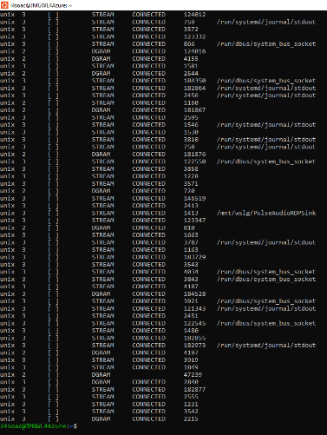
Figure 25: Linux CLI Command netstat

User Management

Adduser
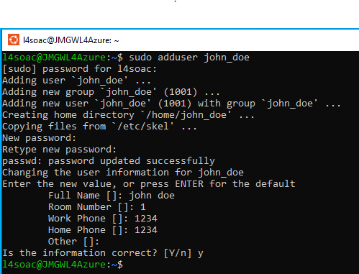
the adduser command creates a new user on the system and is typically used alongside the sudo (superuser DO) prefix, which grants privileges to execute commands that require elevated permissions [18].
Figure 26: Linux CLI Command adduser

Addgroup
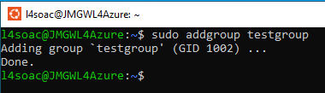
the addgroup command creates and manages user groups in Linux with additional configuration options such as specifying a group ID and shell assignment [19].
Figure 27: Linux CLI Command addgroup

Task Scheduling

Contrab -l
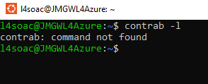
The crontab command creates, edits and manages scheduled tasks (cron jobs) in linux, allowing repetitive system and administrative tasks to be automated and run at specified times or intervals without manual intervention[20].
Figure 28: Linux CLI Command contrab -l

Task 4: Windows Batch Script

Variables
Variables in batch scripting are named storage locations that hold a value which can be referenced or changed during execution. In windows batch, variables are defined with set and accessed using percentage signs (e.g. %name%) [21][22]. Unlike typed languages, batch variables are untyped, meaning they store everything as a string with numeric evaluations handled separately via SET /A [21][22]. This makes them flexible but requires careful handling to avoid empty or undefined values at run time [21].
INPUT:
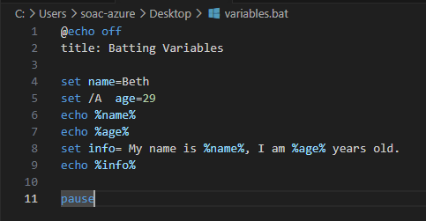
Figure 29: Windows Batch Script Variable example

Result:
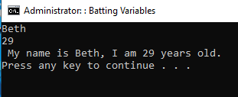
Figure 30: Windows Batch Script Variable result example

GoTo
Goto is an unconditional branch statement that redirects script execution to a names label (eg GoTo :menu)[23]. Labels are defined with a colon prefix on their own line. Whilst useful for creating simple loops or menu structures, GoTo is considered a low-level control mechanism, overuse leads to hard to follow[23]. In modern batch scripting it is often paired with an IF statement or replaced with functions using CALL to keep scripts readable [23].

Input:
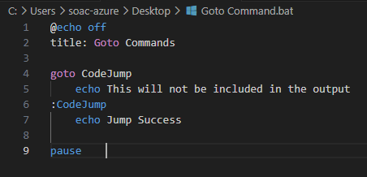
Figure 31: Windows Batch Script Goto example

Result:
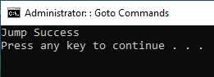
Figure 32: Windows Batch Script Goto Result example

User Input
User input in Windows batch is captured using SET /P which displays a prompt and pauses execution until the user types a value and presses ENTER [24]. The entered value is stored in the named variable [24]. This enables interactive scripts that can be used to ask for things such as filename or a menu choice. Because input is stored as a raw string, scripts should validate the value before using it, such as, checking it is not empty or that it falls within the expected options [24].
Input:
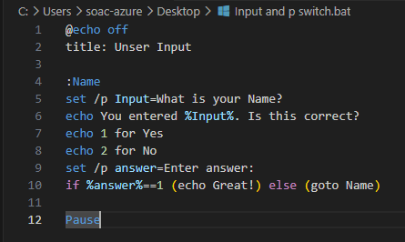
Figure 33: Windows Batch Script example of User Input

Result:
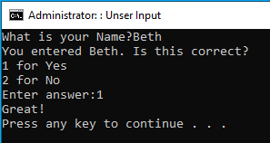
Figure 34: Windows Batch Script example of User Input Result

Array
Batch scripting does not have native array support [25]. Arrays are simulated by creating multiple variables with indexed names such as SET arr[0]=value, SET arr[1]=value, and so on [22]. These can then be accessed using delayed expansion inside a loop. While functional, this approach is verbose compared to arrays in higher-level languages, and index management must be done manually by the programmer [25] [22].
Input:
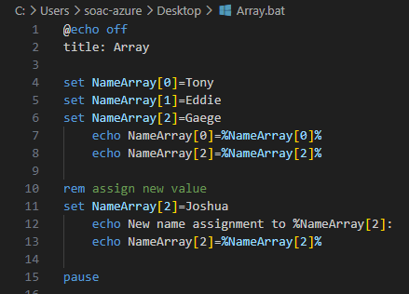
Figure 35: Windows Batch Script example of Array

Result:
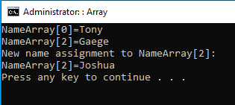
Figure 36: Windows Batch Script example of Array result

If Statement
The IF statement is a conditional control structure that evaluates an expression and executes a command block only when the condition is met [26]. Batch scripting supports several forms of IF statement conditions, such as, string comparison, numeric comparison, file existence and error level testing [26]. IF statements also support an ELSE clause that defines what runs when the condition is false. Together these allow scripts to branch based on user input, file state or the outcome of the previous command [26].
Input:
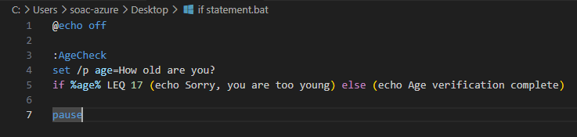
Figure 37: Windows Batch Script example of if statement

Result condition not being met:
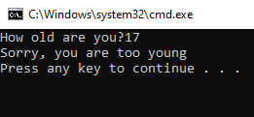
Figure 38: Windows Batch Script result of if statement condition

Result of condition being met:
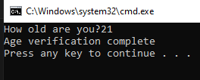
Figure 39: Windows Batch Script result of if statement condition

For Loop
The FOR loop iterates over a defined set of items and executes a command block for each one [26]. Batch offers several loops variations. A loop variable holds the current item on each iteration. This makes FOR loops essential for tasks like bulk file processing, reading config files or repeating calculations [26].
Input:
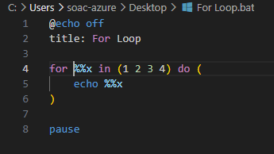
Figure 40: Windows Batch Script for loop example

Result:
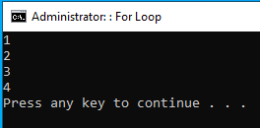
Figure 41: Windows Batch Script for loop result

Call
Batch scripting does not have a dedicated function keyword, instead functions are simulated using labelled sections and the CALL command [27]. When called, the program execution jumps to the label and runs the command there, once finished it returns to the calling point and continues [27][28]. This CLI command promotes code reuse and keeps scripts condensed, the labelled block of code can be called multiple times at different points in the program without needing to duplicate code [28].
Input:
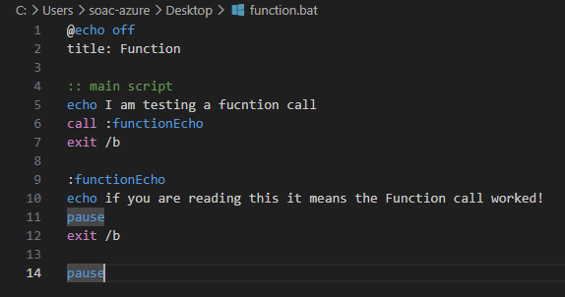
Figure 42: Windows Batch Script Call command

Result:
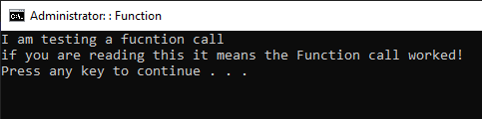
Figure 43: Windows Batch Script Call command Result

Task 4: Bash Linux

Variables
in bash a variable is assigned without spaces around the equal sign (for example, name=Liam) and is referenced by prefixing a dollar sign ($name) [29]. As Bash is untyped, therefore all variables are stored as strings by default. Variables are local to the current shell session unless exported with export which makes them available to child processes [29]. Bash has read only variables which are determined using the readonly, well as a set of built in environment variables such as $home, $user and $path that are automatically available at runtime [29].
Input:
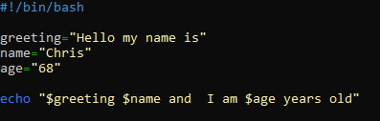
Figure 44: Linux Batch Script Variables Example

Result:
Figure 45: Linux Batch Script Variables result

User Input
In bash, user input is captured using built in read command which pauses the script execution and waits for the user to type a response before pressing enter [30][31]. The value entered is then stored in a named variable making it available for later use in the script [30][31].
Input:
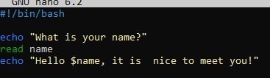
Figure 46: Linux Batch Script user input example

Result:
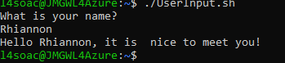
Figure 47: Linux Batch Script user input result

If Statement
The If statement evaluates a condition and executes a block of commands only when the condition is met, to which it then exists. Conditions are placed inside single brackets [] or double brackets [[]] [32]. Bash If statements support Elif and Else which allow for multiple conditions to be set under one statement [32]. Each block of if statements must be closed with FI [32].
Input:
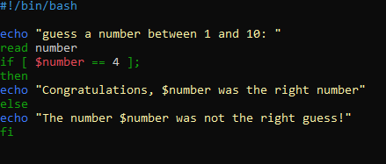
Figure 48: Linux Batch Script if Statement

Result of condition not met:
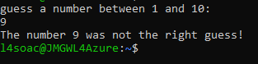
Figure 49: Linux Batch Script if statement result

Result of condition met:
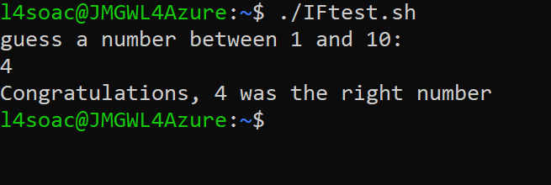
Figure 50: Linux Batch Script if statement result

Until Loop
The Until Loop executes a section of code repeatedly as long as the condition evaluates to false (i.e. repeats until user has entered a valid input), a loop is close with done [33]. As the loop will run indefinitely until the condition is met, it is good practice to add a counter or timeout mechanism to prevent infinite loops [33].
Input:
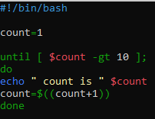
Figure 51: Linux Batch Script Until Loop example

Result:
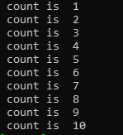
Figure 52: Linux Batch Script Until Loop result

Array
Arrays are used to store multiple values under a single variable name [34]. Arrays are particularly useful when a script needs to store and work with a collection of related values such as lists of file names or menu options and can be iterated over using a loop to process each element one by one [34].
Input:
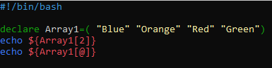
Figure 53: Linux Batch Script Array example

Result:
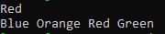
Figure 54: Linux Batch Script Array Result

Case Statement
The case statement matches a variable or expression against a series of patterns and executes the block associated with the first match [35]. Each pattern ends with closing parenthesis and terminates with ;; [35]. Compared to a chain of If/Elif statements, case is more readable when branching on a single variable with many possible values [35].

Input:
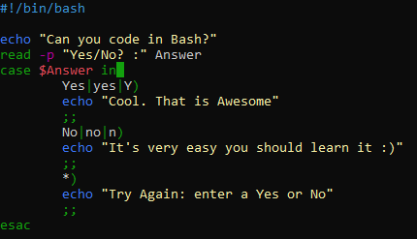
Figure 55: Linux Batch Script case statement

Result for yes:
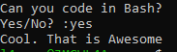
Figure 56: Linux Batch Script case statement result
Result for no:
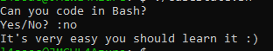
Figure 57: Linux Batch Script case statement result
Result for invalid input:
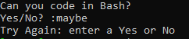
Figure 58: Linux Batch Script case statement result

Function
Function is a named block of commands that can be called by name {} from anywhere in the script after it has been defined [36]. Functions improve maintainability by allowing a logical operation to be written once and called multiple times, as well as making script easier to test and debug [36].

Input:
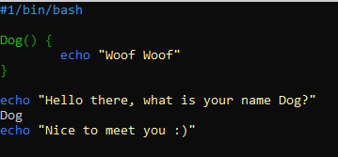
Figure 59: Linux Batch Script function

Result:
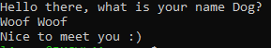
Figure 60: Linux Batch Script function result

Conclusion
The comparison of Windows and Linux CLI commands highlights how both systems achieve similar outcomes managing processes, files, networks and users but differ significantly in syntax, tooling and underlying philosophy. Windows commands such as tasklist, ipconfig and schtasks offer straightforward functionality suited to a GUI-oriented environment, while Linux commands like ps, ifconfig and crontab reflect a system designed with flexibility and script ability at its core.
The scripting sections further demonstrate this distinction. Windows Batch scripting, while functional, requires workarounds for features such as arrays and functions that Bash handles natively and more elegantly. Bash scripting, with its support for typed control structures, built-in environment variables and readable syntax, proves to be a more powerful tool for automation and system administration tasks.
Overall, both platforms offer robust capabilities for system management, and an understanding of both equips users with versatile, transferable skills applicable across a wide range of computing environments.

References
[1] Siberschatz, Galvin, and Gagne, Operating System Concepts, 8th ed. John Wiley & Sons, 2009.
[2] GeeksforGeeks, “Functions of Operating System,” GeeksforGeeks. [Online]. Available: https://www.geeksforgeeks.org/operating-systems/functions-of-operating-system/
[3] Microsoft, “tasklist | Microsoft Learn,” Microsoft Learn. Accessed: Apr. 28, 2026. [Online]. Available: https://learn.microsoft.com/en-us/windows-server/administration/windows-commands/tasklist
[4] “taskkill | Microsoft Learn,” Microsoft. Accessed: Apr. 28, 2026. [Online]. Available: https://learn.microsoft.com/en-us/windows-server/administration/windows-commands/taskkill
[5] “dir | Microsoft Learn,” Microsoft . Accessed: Apr. 28, 2026. [Online]. Available: https://learn.microsoft.com/en-us/windows-server/administration/windows-commands/dir
[6] “mkdir | Microsoft Learn,” Microsoft . Accessed: Apr. 28, 2026. [Online]. Available: https://learn.microsoft.com/en-us/windows-server/administration/windows-commands/mkdir
[7] “rmdir | Microsoft Learn,” Microsoft . Accessed: Apr. 28, 2026. [Online]. Available: https://learn.microsoft.com/en-us/windows-server/administration/windows-commands/rmdir
[8] “ipconfig | Microsoft Learn,” Microsoft . Accessed: Apr. 28, 2026. [Online]. Available: https://learn.microsoft.com/en-us/windows-server/administration/windows-commands/ipconfig
[9] “ping | Microsoft Learn,” Microsoft . Accessed: Apr. 28, 2026. [Online]. Available: https://learn.microsoft.com/en-us/windows-server/administration/windows-commands/ping
[10] “netstat | Microsoft Learn,” Microsoft . Accessed: Apr. 28, 2026. [Online]. Available: https://learn.microsoft.com/en-us/windows-server/administration/windows-commands/netstat
[11] “tracert | Microsoft Learn,” Microsoft . Accessed: Apr. 28, 2026. [Online]. Available: https://learn.microsoft.com/en-us/windows-server/administration/windows-commands/tracert
[12] “whoami | Microsoft Learn,” Microsoft . Accessed: Apr. 28, 2026. [Online]. Available: https://learn.microsoft.com/en-us/windows-server/administration/windows-commands/whoami
[13] “net user | Microsoft Learn,” Microsoft . Accessed: Apr. 28, 2026. [Online]. Available: https://learn.microsoft.com/en-us/windows-server/administration/windows-commands/net-user
[14] “schtasks commands | Microsoft Learn,” Microsoft . Accessed: Apr. 28, 2026. [Online]. Available: https://learn.microsoft.com/en-us/windows-server/administration/windows-commands/schtasks
[15] M. Kerrisk, The Linux Programming Interface. 2010.
[16] W. E. Shotts Jr, The linux Command Line. 2009.
[17] W. E. Shotts Jr, “Networking,” in The Linux Command Line, San Francisco, 2009, pp. 184–185.
[18] GeeksforGeeks, “adduser command in Linux,” GeeksforGeeks. [Online]. Available: https://www.geeksforgeeks.org/linux-unix/adduser-command-in-linux-with-examples/
[19] Ubuntu Manpage, “adduser, addgroup - add a user or group to the system,” Canonical ltd. [Online]. Available: https://manpages.ubuntu.com/manpages/focal/man8/addgroup.8.html
[20] IBM, “crontab Command - IBM Documentation,” IBM. [Online]. Available: https://www.ibm.com/docs/en/aix/7.1.0?topic=c-crontab-command
[21] Microsoft, “Windows Environment Variables - Windows CMD,” Microsoft. [Online]. Available: https://ss64.com/nt/syntax-variables.html
[22] Tutorials point, “Batch Script - Variables,” Tutorials point. [Online]. Available: https://www.tutorialspoint.com/batch_script/batch_script_variables.htm
[23] Microsoft Learn, “goto,” Microsoft. [Online]. Available: https://learn.microsoft.com/en-us/windows-server/administration/windows-commands/goto
[24] ss64.com, “Set - Environment Variable command - Windows CMD,” ss64.com. [Online]. Available: https://ss64.com/nt/set.html
[25] GeeksforGeeks, “Batch Script - Arrays,” GeeksforGeeks. [Online]. Available: https://www.geeksforgeeks.org/linux-unix/batch-script-arrays/
[26] The Crazy Programmer, “Batch File Operators, If Else, Goto and For Loop,” The Crazy Programmer. [Online]. Available: https://www.thecrazyprogrammer.com/2015/06/batch-file-operators-if-else-goto-and-for-loop.html
[27] A. Listek, “Learning the Powerful Goto Batch Command,” TA Learning. [Online]. Available: https://adamtheautomator.com/goto-batch/
[28] SS64, “Call command - Windows CMD,” SS64. [Online]. Available: https://ss64.com/nt/call.html
[29] C. Ramey and B. Fox, “Shell Variables,” in Bash Reference Manual, 5.3., 12th Media Services, 2025, ch. 5.
[30] ryanstutorial.net, “User Input - Bash Scripting Tutorial,” ryanstutorial.net. [Online]. Available: https://ryanstutorials.net/bash-scripting-tutorial/bash-input.php
[31] GeeksforGeeks, “Bash Script - Read User Input,” GeeksforGeeks. [Online]. Available: https://www.geeksforgeeks.org/linux-unix/bash-script-read-user-input/
[32] C. Ramey and B. Fox, “3.2.5.2 Conditional Constructs,” in Bash Reference Manual, 5.3., 12th Media Services, 2025, ch. 3. [Online]. Available: https://www.gnu.org/software/bash/manual/html_node/Conditional-Constructs.html
[33] M. Cooper, “Loops and Branches,” in Advanced Bash-Scripting Guide:, The Linux Documentation Project, 2019, ch. 11.
[34] Aalto Scientific Computing, “Arrays, input, Here Documents,” Linux shell tutorial documentation. [Online]. Available: https://aaltoscicomp.github.io/linux-shell/arrays-inputs-here-documents/
[35] M. Garrels, “Using Case Statement,” Bash Beginners, 2004.
[36] L. Reynolds, “Handle User Input in Bash Scripts Easily,” LinuxCofig.org, 2025. [Online]. Available: https://linuxconfig.org/handling-user-input-in-bash-scripts

Appendices

Tutorial tasks:
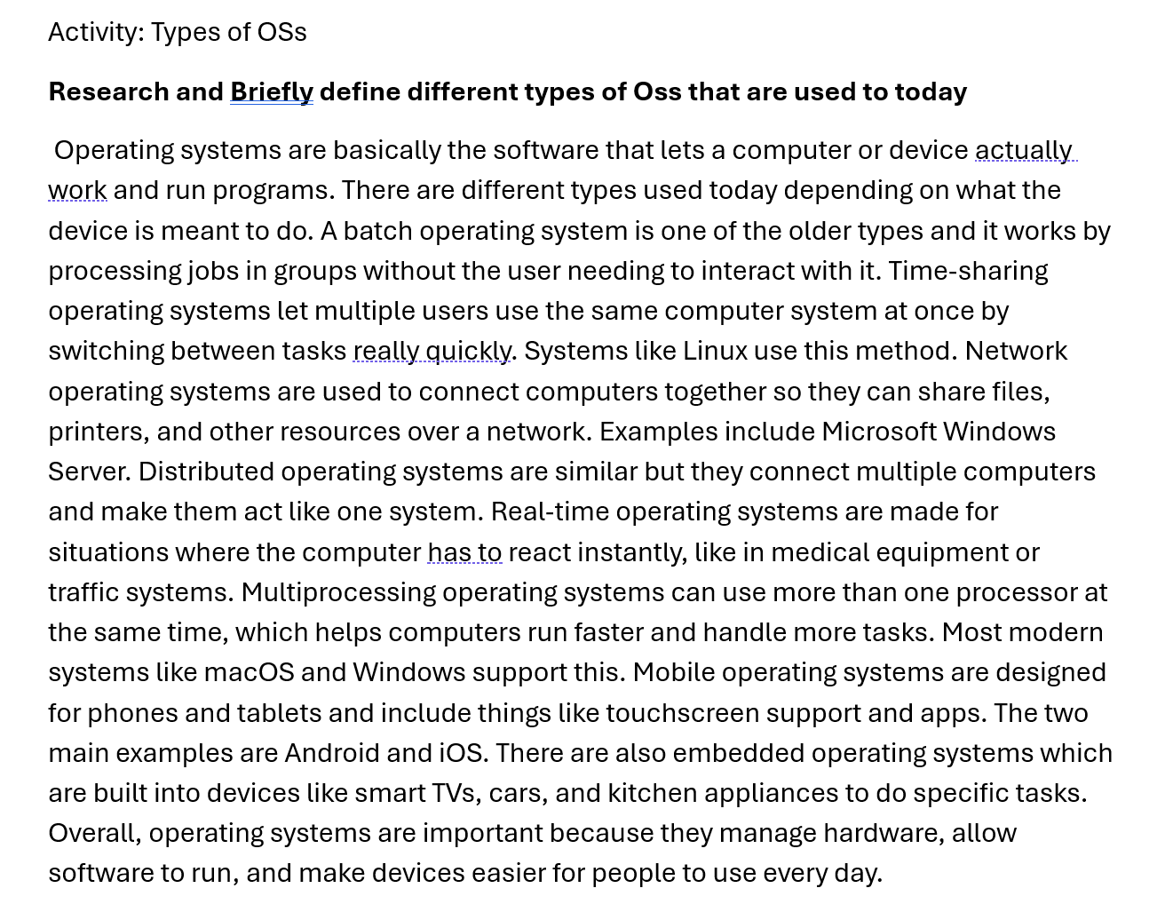
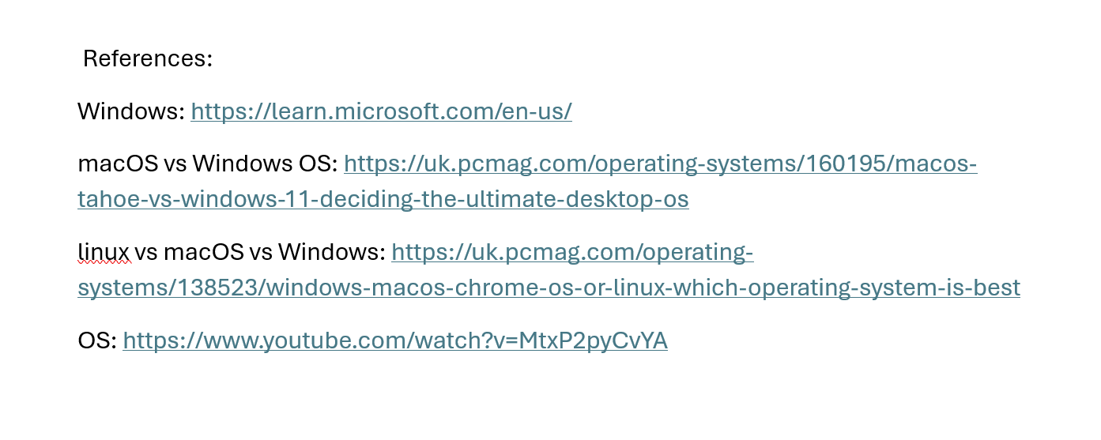

Lecture Notes:
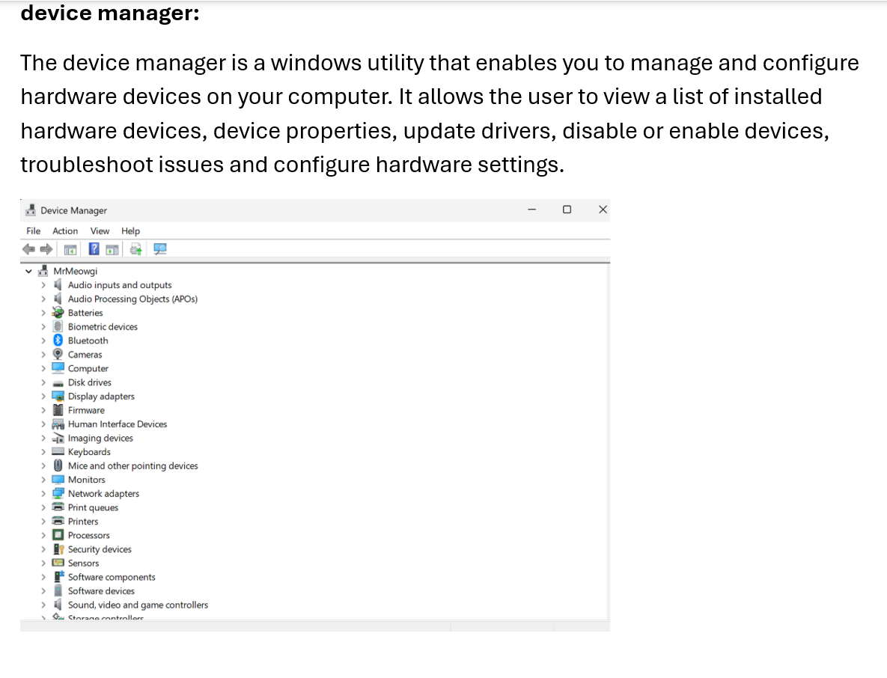
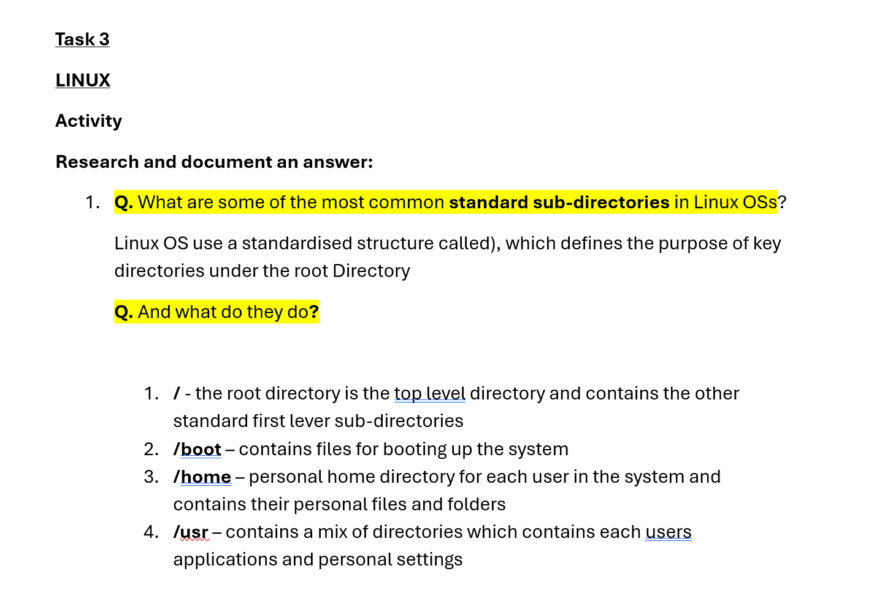

Additional Course



