BMHP5021 PSFHSC C2 May 2026
An examination and analysis of how the ‘Early Help’ system is signposted to UK families by their local authority website.
Mariam Karim
(2407469)

a) Introduction
In contemporary British child welfare policy, the Early Help framework represents a shift from crisis-led statutory intervention to preventative, multi-agency support. Based on the principle that family difficulties often worsen when left unaddressed, Early Help aims to provide coordinated assistance as soon as vulnerabilities emerge (Department for Education [DfE], 2026). Effective early intervention can prevent the escalation of risk, strengthen family resilience, and reduce demand on statutory social care services (Action for Children, 2023).
The effectiveness of Early Help, however, depends heavily on accessibility. For many families, local authority websites are the primary source of information and routes to support. If online services rely on complex terminology, unclear navigation, or bureaucratic processes, families may struggle to access help when it is needed most, creating barriers to timely self-referral (Corliss et al., 2022). Consequently, digital signposting should be viewed as an essential safeguarding function rather than an administrative task.
This report examines how Early Help is communicated and signposted through the websites of Leicestershire County Council, Staffordshire County Council, and Southwark Council. Drawing on Working Together to Safeguard Children 2023 (DfE, 2026) and The Early Help System Guide (Department for Levelling Up, Housing and Communities [DLUHC] & DfE, 2022), it explores the statutory and multi-agency foundations of Early Help before critically evaluating each council’s digital approach. The report concludes with a comparative analysis and recommendations for improving online accessibility and user engagement.
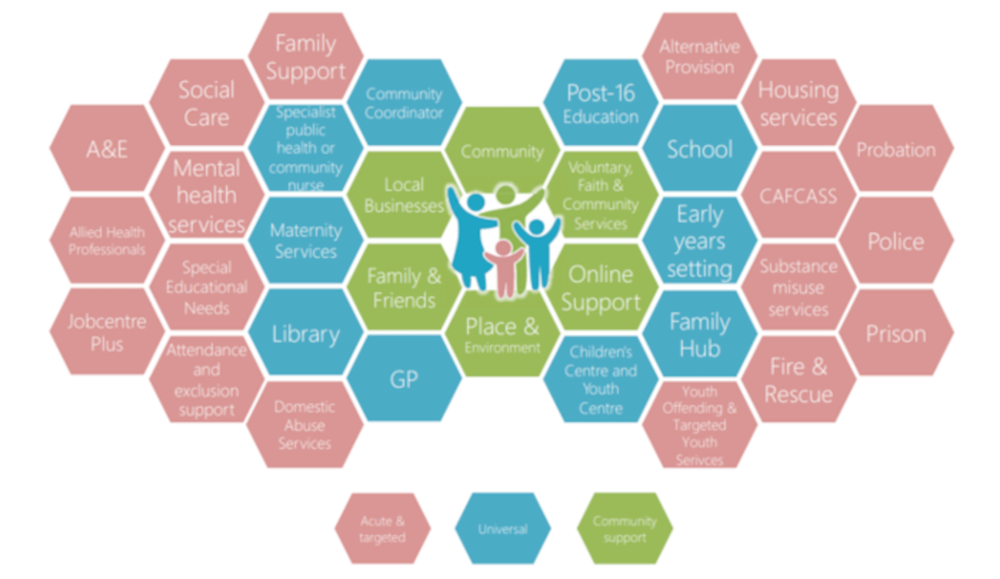
Figure 1: The Early Help System Guide
Source: https://ssslearning.co.uk/safeguarding-articles/earlyhelp

b) Explanation of the Early Help System
The UK Early Help system is a non-statutory, voluntary framework designed to support children and young people (aged 0–19, or up to 25 for those with Special Educational Needs and Disabilities) and their families when difficulties begin to surface (DfE, 2026). Legally, the framework is underpinned by Section 17 of the Children Act 1989, which places a general duty on local authorities to safeguard and promote the welfare of children "in need" within their area. However, early help is strategically positioned further upstream, operating before a family reaches the formal, statutory threshold of a "Child in Need" (Munro, 2011).
To manage resources and target interventions appropriately, local safeguarding partnerships utilize a graduated continuum of need, typically conceptualized as a four-tier threshold model:
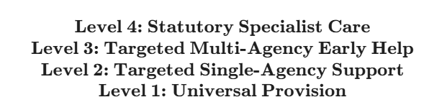
While Level 1 and Level 2 are characterized by universal or low-level targeted support, Level 3 is where the formal Early Help system operates. Here, a child or family experiences multiple, interlinked vulnerabilities that cannot be resolved by a single service provider alone, requiring a structured, multi-agency team to step in (DfE, 2026).
Importantly, scholars draw a conceptual line between "early help" which refers broadly to preventative activities offered at any point in a child's life and "early intervention", which often targets highly specific, pre-identified risk factors (Juffer et al., 2023). The Early Help System Guide (DLUHC & DfE, 2022) provides a framework for developing effective early help services through three key pillars. First, the Family Perspective focuses on accessible, strengths-based support that is co-designed with families and free from the stigma often associated with social work intervention. Second, the Strategic Partnership promotes collaboration among education, health, policing, housing, and voluntary sectors. Third, the National Framework ensures local services contribute to wider outcomes, including improved school attendance, reduced domestic abuse, and increased parental employment.
Ultimately, the primary goal of this framework is to foster long-term family independence and prevent localized challenges from escalating into generational crisis states (Thomas et al., 2020).

c) Explanation of Multi-Agency Working
At the center of contemporary safeguarding policy is the statutory principle that "safeguarding is everyone's responsibility" (DfE, 2026, p. 14). Because the vulnerabilities that families face are highly interconnected such as parental mental ill-health alongside housing insecurity or adolescent substance misuse coupled with school exclusion a single agency working in a vacuum cannot provide effective resolution. Multi-agency working refers to the collaborative alignment of multiple professional bodies, including schools, health services (health visitors, child and adolescent mental health services), local police, housing associations, and the voluntary, community, and social enterprise (VCSE) sector.
The historical mandate for integrated multi-agency practice is rooted in systemic lessons from high-profile safeguarding failures. Serious case reviews, from the seminal Gorczowska, (2022) to the more recent findings of the Child Safeguarding Practice Review Panel [CSPRP] (2022), have consistently highlighted communication breakdowns, fragmented service directories, and defensive organizational boundaries as primary factors leaving children at risk. Consequently, current national frameworks mandate localized multi-agency arrangements to ensure collective accountability and shared information.
The delivery of multi-agency Early Help is supported by three key mechanisms. The Early Help Assessment (EHA) is a strengths-based tool used with families to identify needs, goals, and available resources (DfE, 2026). The Team Around the Family (TAF) brings together families and practitioners to create and implement a coordinated action plan. A Lead Professional is appointed to coordinate services, manage the plan, and act as the family’s main point of contact (DLUHC & DfE, 2022).
While the benefits of this model are clear, sharing personal data across diverse organizational databases remains a significant practical challenge. Under the Data Protection Act 2018 and the General Data Protection Regulation (GDPR), practitioners must share information lawfully and proportionately. Crucially, Working Together to Safeguard Children 2023 stresses that data protection frameworks should never be used as a barrier to early information sharing where a child’s safety or wellbeing is concerned (DfE, 2026). However, navigating professional cultures and localized structural "silos" continues to complicate complete integration (Purcell, et al., 2025).

d) Evaluation of Three Local Authority Websites

1. Leicestershire County Council
Leicestershire County Council has recently rebranded its Early Help division, transitioning from the "Children and Family Wellbeing Service" to the "Family Help Service" (Leicestershire County Council, 2026). This shift in terminology mirrors the national policy focus on simplifying family support.
From a user perspective, the website's landing page is clearly organized, with sub-sections targeting specific issues such as domestic abuse, mental health, and parenting programs. Crucially, it highlights their network of localized "Family Hubs," which act as physical, one-stop shops for family services. The language is accessible, describing the service as support for "difficulties that can’t be supported by universal services alone" (Leicestershire County Council, 2026).
However, the digital pathway to access this support has design limitations. To self-refer, families must use an online "Request for Services" form. This portal is capped by a strict 60-minute session limit, which can cause significant anxiety and cognitive strain for a parent trying to articulate complex family challenges under a countdown. Furthermore, all incoming requests are routed through the "First Response Children's Duty team" (the council’s statutory social work intake team) to check for child protection risks (Leicestershire County Council, 2026). While legally sound, routing Early Help requests directly through a statutory social care portal can create anxiety for families who fear social work intervention.

2. Staffordshire County Council
Staffordshire County Council presents its Early Help framework through the Staffordshire Safeguarding Children Partnership (SSCP) and a public directory called "Staffordshire Connects" (Staffordshire County Council, 2026).
A unique aspect of Staffordshire's digital presence is its focus on the "Family Star Plus™" model a visually engaging, strengths-based assessment tool. The website provides clear, reassuring explanations of how this tool helps families identify their strengths and track their progress over time, which helps demystify the assessment process.
The primary limitation of Staffordshire's approach is the fragmentation of its digital layout. A parent looking for help is met with a split digital footprint. Information about general early help groups is hosted on the main council site, but searching for specific, localized services requires navigating "Staffordshire Connects," a separate, external database. Additionally, targeted one-to-one family support requires a formal referral through the "Staffordshire Families Integrated Front Door" phone line (Staffordshire County Council, 2026). For parents in a crisis, having to navigate multiple directories and phone options to access support can feel overwhelming.

3. Southwark Council
Southwark Council operates a centralized "Family Early Help (FEH) Service", structured as a voluntary, multi-agency team designed to step in before social care intervention is required (Southwark Council, 2026).
The website's strengths lie in its clear organization. It lists specific, relatable triggers for early help such as poor school attendance, behavioral issues, or parental relationship strain making it easy for families to identify if the service is right for them. Southwark also offers a dedicated "FEH Duty" phone line with a clear four-option menu, including options for general advice and direct parenting support (Southwark Council, 2026).
However, Southwark's digital intake process is heavily dependent on traditional document downloads. To request support, both parents and professionals are directed to download a large Word document (.docx) referral form and email it to a central inbox (Southwark Council, 2026). Relying on downloadable documents creates significant accessibility barriers, especially for users who rely on mobile phones or lack compatible software. This approach lacks the ease of a modern, responsive online form.

e) Comparative Analysis of Strengths and Weaknesses
To evaluate the comparative effectiveness of these three portals, their digital signposting can be assessed against key principles of digital accessibility, readability, and user-centered design, as recommended in The Early Help System Guide (DLUHC & DfE, 2022).
Evaluation Criterion | Leicestershire County Council | Staffordshire County Council | Southwark Council
Tone & Empathy | Good; uses clear, non-stigmatizing "Family Help" terminology. | Excellent; emphasizes a supportive, restorative approach. | Good; clear and direct, though somewhat clinical.
Intake Accessibility | Moderate; online form available but limited by a 60-minute timeout. | Moderate; split between directories and phone lines. | Weak; relies on downloading and emailing a Word document.
Clarity of Pathway | Clear; centralized online form, but routed through "First Response." | Complex; split between main site and "Staffordshire Connects." | Clear; features a dedicated phone line with a clear menu.
Technical Accessibility | Good; modern interface and mobile-responsive layout. | Moderate; navigating between separate directories can be confusing. | Weak; document-heavy intake process is hard to use on mobile.

Analysis of Findings
The comparative analysis shows that while all three councils have established clear service structures, their digital execution varies significantly. Leicestershire stands out for its modern, mobile-responsive layout and its adoption of "Family Help" branding, which helps reduce the stigma of seeking help. However, its online self-referral system is undermined by a 60-minute session limit and the routing of requests through a statutory social care portal, which can deter families who fear statutory intervention (Bennett et al., 2024).
Staffordshire's use of the restorative "Family Star Plus™" model is highly supportive and family-friendly. However, its fragmented digital structure requiring users to navigate between the main council site and the "Staffordshire Connects" directory increases the cognitive load on families.
Southwark offers a highly integrated multi-agency team and a clear phone-based entry point. However, its reliance on downloadable Word documents for email submissions is a significant digital barrier. This document-heavy intake process is difficult for mobile-only users to navigate, making self-referral harder for families in need of immediate support.

f) Conclusion and Recommendations
An evaluation of Leicestershire, Staffordshire, and Southwark local authority websites shows that while multi-agency frameworks are robust, digital gateways still present significant barriers for families in need of support. To bridge the gap between statutory expectations and family accessibility (DfE, 2026), local authorities should implement the following targeted, digital-first improvements:
- Optimize Online Self-Referral Forms: Councils utilizing online forms (such as Leicestershire) must remove artificial time limits (like the 60-minute timeout) and implement "save-and-return" features. This reduces the pressure on families sharing sensitive and complex personal challenges.
- Implement Responsive, Mobile-First Web Portals: Local authorities must replace outdated, downloadable Word referral forms with mobile-friendly web forms. This ensures that families can easily request support on any device without needing external software.
- Consolidate External Service Directories: To improve navigation, councils (such as Staffordshire) should integrate external service directories directly into their main website. Providing a single, searchable portal helps families find local support without having to navigate multiple external databases.

Reference List
Action for Children (2023) New Ofsted research: Evidence the early help system isn't working. Available at: https://www.actionforchildren.org.uk/blog/evidence-early-help-system-isnt-working/ (Accessed: 25 June 2026).
Bennett, D.L., Wickham, S., Barr, B. and Taylor-Robinson, D., 2024. Poverty and children entering care in England: A qualitative study of local authority policymakers’ perspectives of challenges in Children’s Services. Children and Youth Services Review, 162, p.107689.
Child Safeguarding Practice Review Panel (CSPRP) (2022) Child Safeguarding Practice Review Panel: annual report 2022 to 2023. London: Department for Education. Available at: https://www.gov.uk/government/publications/child-safeguarding-practice-review-panel-annual-report-2022-to-2023
Corliss, C., Addis, S., El-Banna, A., Maxwell, N., Scourfield, J., Warner, N. and Williams, A., 2022. The views of local authorities in England on how to prevent children being in care. Child Care in Practice, 28(4), pp.576-592.
Department for Education (DfE) (2026) Working Together to Safeguard Children 2023: Statutory guidance on multi-agency working to safeguard and promote the welfare of children. London: HM Government. Available at: https://www.gov.uk/government/publications/working-together-to-safeguard-children--2
Department for Levelling Up, Housing and Communities (DLUHC) and Department for Education (DfE) (2022) The Early Help System Guide. London: HM Government. Available at: https://assets.publishing.service.gov.uk/government/uploads/system/uploads/attachment_data/file/1078299/Early_Help_System_Guide.pdf
Gorczowska, J., 2022. The Child Protection System in England and Wales. In Child protection system–just think differently? (pp. 97-122). Wydawnictwa Uniwersytetu Warszawskiego.
Juffer, F., Bakermans-Kranenburg, M.J. and Van Ijzendoorn, M.H. eds., 2023. Promoting positive parenting: An attachment-based intervention. Taylor & Francis.
Leicestershire County Council (2026) Help for children and families. Available at: https://www.leicestershire.gov.uk/education-and-children/social-care-and-supporting-families/help-for-children-and-families (Accessed: 25 June 2026).
Munro, E. (2011) The Munro Review of Child Protection: Final Report, A Child-Centred System. London: Department for Education. Available at: https://www.gov.uk/government/publications/munro-review-of-child-protection-final-report-a-child-centred-system
Purcell, C., Baginsky, M. and Steils, N., 2025. No quick fixes: Multi-agency working to improve information-sharing on men and keep children safe. The British Journal of Social Work, p.bcaf249.
Southwark Council (2026) Family Early Help (FEH). Available at: https://localoffer.southwark.gov.uk/education/specialist-services-offered-by-the-council/family-early-help-feh/ (Accessed: 25 June 2026).
Staffordshire County Council (2026) Early Help - Helping children and families early. Available at: https://www.staffordshire.gov.uk/children-young-people-and-families/family-hubs/early-help-helping-children-and-families-early (Accessed: 25 June 2026).
Thomas, P., Grossman, M., Christmann, K. and Miah, S., 2020. Community reporting on violent extremism by “intimates”: emergent findings from international evidence. Critical Studies on Terrorism, 13(4), pp.638-659.

