


Cyber Security (CS)

Lab - Authentication, Authorization, and Accounting

Faculty of Architecture, Computing & Engineering
School of Applied Computing
Mount Pleasant Campus
Swansea
SA1 6ED

Objectives
- Given a scenario, select the appropriate authentication, authorization, or access control
- Install and configure security controls when performing account management, based on best practices
Part 1: Adding Groups, Users, and Passwords on a Linux System
Part 2: Verify Users, Groups, and Passwords
Part 3: Using Symbolic Permissions
Part 4: Absolute Permissions

Background / Scenario
You will be conducting host security practices using the Linux command line by performing the following tasks:
- Adding Groups, Users, and Passwords
- Verifying Groups, Users, and Passwords
- Setting Symbolic Permissions
- Setting Absolute Permissions

Required Resources
- PC with Ubuntu 16.0.4 LTS installed in a VirtualBox or VMware virtual machine.
- Adding Groups, Users, and Passwords on a Linux System
In this part, you will add users, groups, and passwords to the local host machine.
  - Open a terminal window in Ubuntu.
    - Log in to Ubuntu using the following credentials:
User: cisco
Password: password
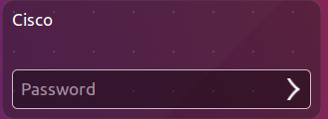
    - Click on the terminal icon to open a terminal.

  - Escalate privileges to the root level by entering the sudo su command. Enter the password password when prompted.
cisco@ubuntu:~$ sudo su

  - Add a new group named HR by entering the command groupadd HR.
root@ubuntu:/home/cisco# groupadd HR
- Verify Users, Groups, and Passwords
  - Verify the new group has been added to the group file list by entering cat /etc/group.
root@ubuntu:/home/cisco# cat /etc/group
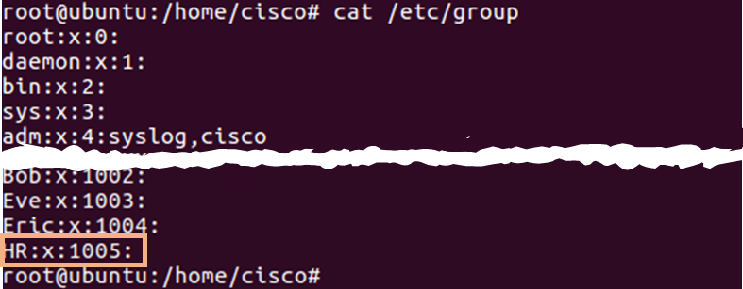
The new group HR will be added to the bottom of the /etc/group file with a group ID of 1005.
  - Add a new user named jenny.
root@ubuntu:/home/cisco# adduser jenny
    - When prompted for a new password, type lasocial. Press Enter.
    - When prompted again, type lasocial. Press Enter.
    - When prompted for a full name, type Jenny. Press Enter.
    - For the rest of the configurations, press Enter until when asked is the information correct.
    - Type Y for yes and press Enter.
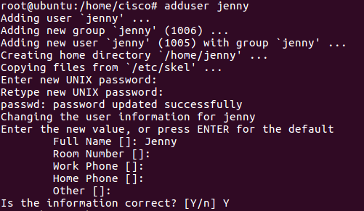
  - Place the user jenny in the HR group.
root@ubuntu:/home/cisco# usermod –G HR jenny
  - Add another new user named joe.
root@ubuntu:/home/cisco# adduser joe
    - When prompted for a new password, type tooth. Press Enter.
    - When prompted again, type tooth. Press Enter.
    - When prompted for a full name, type Joe. Press Enter.
    - For the rest of the configurations, press Enter until when asked is the information correct.

