Question one
Through the use of a theoretical diagram show a negative externality of production and its welfare loss. Below are the bulleted conditions in which a market suffers from this: -
- Occurs when the production of a product creates external costs that are harmful for third parties. Examples include environmental problems.
- Happens when marginal social cost (MSC) > marginal private cost (MPC)

Answer
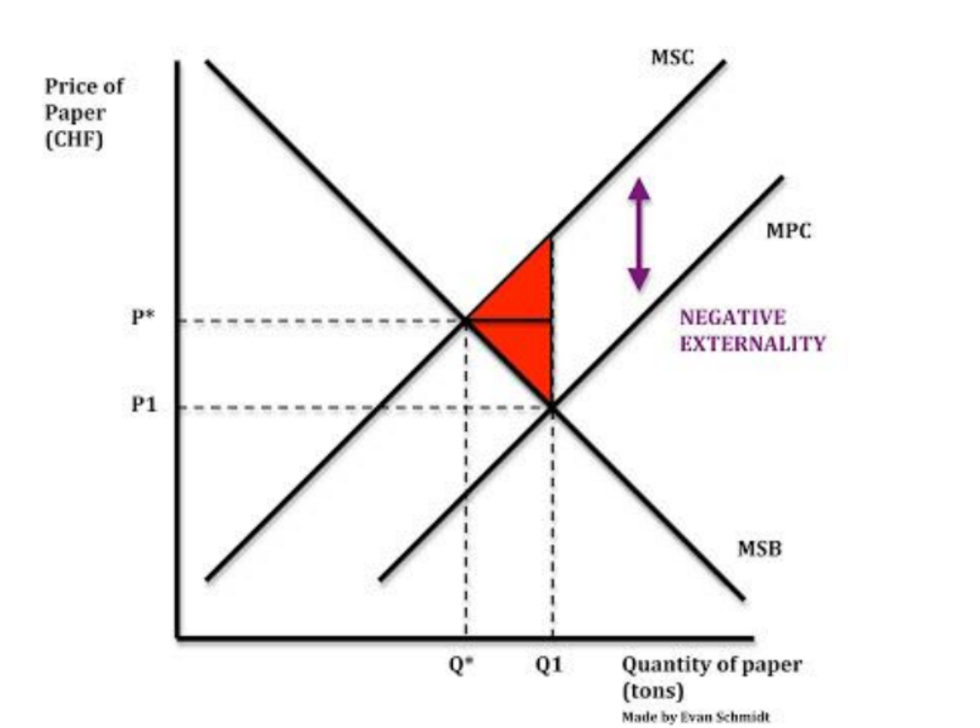
● MPC is below MSC because of the extra cost to society caused by things like pollution.
● The space between Q* and Q1 is a welfare loss to society because MSC > MSB

Question two
Provide an example of a market that is suffering from negative externality of production.
Answer
Steel industry – release of CO2
Water companies release of raw sewage into rivers and seas (at times)

Question three
Through the use of a theoretical diagram show a negative externality of consumption and its welfare loss. Below are the bulleted conditions in which a market suffers from this: -
● ‘Bad’ effects suffered by third parties due to consumers consuming the product.
● Examples include cigarettes, cars, loud music and noise pollution.
● Happens where marginal social benefits (MSB) < marginal private benefits (MPB)

Answer
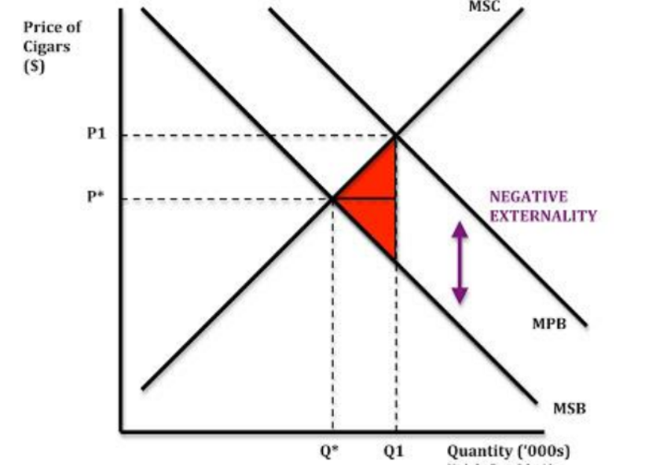
There is a welfare loss to society because MSB < MPB

Question four
Provide an example of a market that is suffering from negative externality of consumption.
Answer
Over consumption of sugar
Smoking
Alcohol consumption

Question five
Through the use of a theoretical diagram show a positive externality of consumption and its welfare gains.
Answer
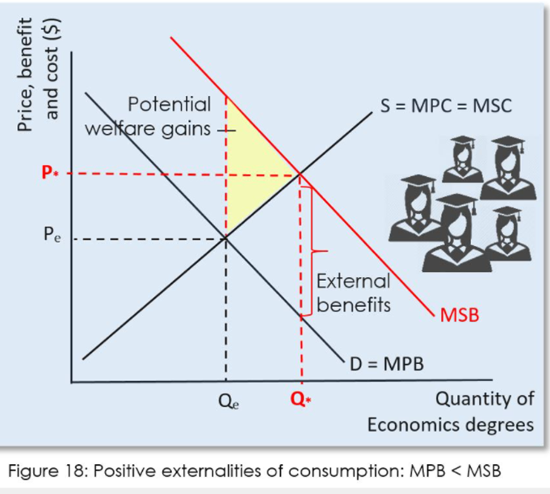
Question six
Give some examples of a market where this happens
Answer
University Education, Electric Cars, Solar panels for houses etc. etc.

