

Task 1 – Reading Task
A3 in-class notes:
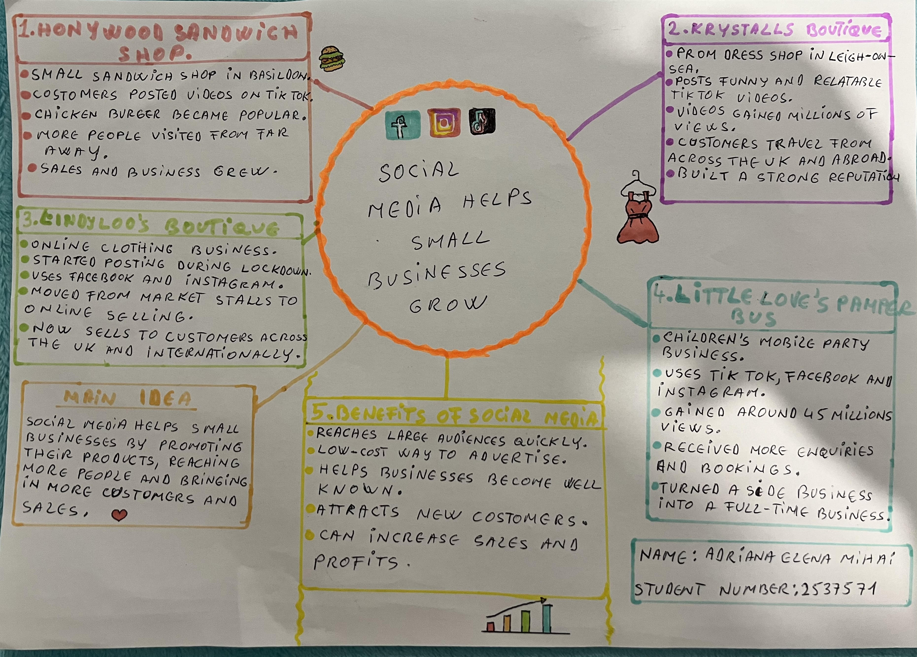

1. Answer these questions using the sentence starters below
a. What is the main idea of the text?
The main idea is that social media helps small businesses grow by reaching more customers and increasing sales.
b. What are two key points?
One key point is that businesses can become popular when customers share their content online.
Another key point is that social media helps businesses attract new customers from different places.
c. What part of the text did you find most important? Why?
The most important part is how social media helped small businesses get more customers because it shows the real impact social media can have on a business
d. Was anything unclear or difficult to understand?
I was not sure about how social media algorithms work to make some posts go viral.
e. How did your group help you understand the text better?
My group helped me by discussing the examples in the article and explaining ideas that I did not fully understand.
3. One sentence reflection
Question: What did you find challenging about this task?
The hardest part was choosing the most important information from the article and putting it into my own words.

