- 
Skills for the Workplace
Module Assignment Submission
Student Name: | Gareth Griffin
Student Number: | 1916182
Module No: | BMSK4005
Module Title: | Professional Career Development

Statement of Confirmation of Authenticity
By the act of making this submission, the student declares that this is the work of the student named above. The work has not, in whole or in part, been knowingly presented elsewhere for assessment, or where assessment has been built on a previous assessment, this has been identified. Where materials have been used from other sources it has been properly acknowledged. If this statement is untrue, the student acknowledges that an assessment offence has been committed.
Attention is drawn to the plagiarism and unfair practice policies of both the University and of ILM.

Table of Contents
Section 1: Know how to identify development needs 3
1.1 Identify learning styles for self and another 3
1.2 Use a simple technique for identifying development needs for self & another 4
1.3 Identify potential barriers to learning for self and another. 5
1.4 Explain how these barriers to learning can be overcome. 6
Section 2: Know how to develop self & others to achieve organisational objectives 6
2.1 Analyse learning/development options to meet needs of self & another. 6
2.2 Identify support mechanisms for the development of self & another 6
2.3 Prepare development plans for yourself and another person 7
2.4 Method used to monitor the development of self & another. 8
Section 3: Know how to prepare for the recruitment process 8
Reflection on the recruitment process 8
3.1 Description 8
3.2 Feelings 9
3.3 Evaluation 9
3.4 Analysis 9
3.5 Conclusion 9
3.6 Action Plan 9
References 10
Appendix A 10
Appendix B 10
Appendix C 10
Appendix D 10

Introduction

In this paper I am going to give an honest assessment of my Learning skills and also be working with another student in the class to go over her learning skills. I will be using an array of simple techniques and models to help me throughout this paper. Once the breakdown of the skills has been completed, I will then be writing a reflection on the entire process.

Section 1: Know how to identify development needs

1.1 Identify learning styles for self and another

To identify the learning styles for both myself and my colleague we have undertaken two questionnaires. First questionnaire coming from Mumford and Honey, the second questionnaire being the VARK questionnaire. The results from the questionnaires are in the appendices.
After Completing the Mumford and honey questionnaire I found that the style of learning from this questionnaire was THEORIST.

(Honey and Mumford — University of Leicester, 2020) The theorist
Means that I would like to understand the theory behind the actions and uses Model, Statistics, background information in order to better understand the process. I have read the other learning styles in order to make sure that I have given the correct data and that the result given is the most reflective one. Upon reading this I have to say I do agree with this result. I do prefer a hands-on approach and it is more about seeing the information in forms of charts. The visual aspects help me retain information.
The other Learning styles according to the Honey and Mumford questionnaire are: -
- Activist – People who Learn by doing
- Pragmatist – People who need to be able to see how to put the learning into practice in the real world.
- Reflector – People who learn by observing.
The one learning style I believe that I lean more to is the activist. I do like learning through practicality. I would say that I can see a little bit of myself within all the learning styles. I believe this to be a good thing and a bad thing. As I might tend to lose confidence in myself if I have failed at one point and try reverting to different methods.

Onto the Second questionnaire (VARK). The results are in the Appendices.
This Questionnaire is broken down into the following learning styles: -
- Visual Learning
- Auditory Learning
- Reading and writing
- Kinaesthetic
My scores were as followed: -
- Visual – 7
- Auditory – 4
- Reading and writing – 2
- Kinaesthetic – 3
Analysing these numbers, you can tell that the two learning styles do not match up. Whilst I believe these are two very good tools to use. They do lack the specificity. I believe that the VARK results line up more with the Pragmatist learning style of the Honey and Mumford questionnaire. I had previously stated that I believe that I hold skills in each learning style. I do Believe that putting students into labelled boxes in a bad thing because they focus more on the forcing themselves to learn a certain way other than doing what comes naturally and makes you most comfortable.

The third and final method used was Dantec. The results are in the Appendix A. After completing the Dantec questionnaire the results are as follows.

CE – 21
RO – 29
AC – 16
AE – 24

On analysing the results from the questionnaire, you can see that my least effective learning style is AC (Abstract Conceptualization) and my most effective learning style is RO (Reflective Observation) I agree with this outcome as I do tend to prefer to sit back observe and break issues down in my own mind before having a go at it myself.

I do believe that once I have a level of understanding I do move towards the other two learning styles of CE (Concrete Experience) and AE (Active Experimentation).

1.2 Use a simple technique for identifying development needs for self & another

There are many Techniques to choose from in order to identify people’s strengths and weaknesses.
(Lannon and Lannon, 2020)
VMOST / SWOT / PEST are a few of the stated techniques.
The simple technique that I have chosen to use to identify the skills that would need development. I have also partnered up with Louise and we will be working together throughout this assignment. SWOT 1 in the appendix is my SWOT analysis and SWOT person 2 is Louise’s SWOT analysis.
Using the SWOT analysis allows us to look at the strengths and weaknesses and see if there are opportunities to use our strengths to help build up the weaknesses, then assess the threats.
SWOT analyse in the appendix. SWOT person is related tro My SWOT analyse. SWOT Person relates to Louise analyse.
Upon comparing the two SWOT analysis you can see that Louise has been way more in depth and as I have already passed on my information to her I am unable to change it. So this could be added to my SWOT under weakness and opportunity, I could be more critical of myself and break it down further.

From these SWOT analyses I will construct an action plan. See Section 2.

1.3 Identify potential barriers to learning for self and another.

UKEssays. November 2018. Barriers to Adult Learners. [online].
Looking at this online article I believe it gives a great breakdown of barriers to learning. There are 6 categories of barriers.
- Situational Barriers
- Institutional Barriers
- Dispositional Barriers
- Academic Barriers
- Employment training Barriers
- Cultural Barriers.
Looking at these categories of barrier you can quickly begin to build up a picture of what the potential barriers to learning are in every situation. As an adult learner there are a lot of barriers to learning.
- Situational Barriers – Busy work schedule / Family and children
- Institutional Barriers – Location / lack of necessary qualifications
- Dispositional Barriers – Negative attitude towards learning (thinking they are too old) / health issues.
- Academic Barriers – Lack of language skills / lack of numerical skills
- Employment training barriers – no support from employer
- Cultural barriers – Difference in cultural beliefs between peers
I believe that the barriers I associate most with are the situational and dispositional barriers. Having children and a busy work schedule is hard for me to find the time and motivation. I believe the dispositional barrier applies to me because I did think that I was too old to start again and it was a big hurdle to adjust my mindset.
I do not believe that the other barriers apply to me as the course is currently over Microsoft teams, so the location is not a barrier. I do not believe that I lack in Language or numerical skills. Cultural barrier I do not see as an issue either as I have served in the armed forces and dealing with people of all races and backgrounds was not an issue.
I have attached Louise’s barrier in the appendix and as you can see, she has very similar barriers to myself. I believe that due to our age we are likely to encounter many of the same barrier regarding work and family commitment. Although there are going to be similarities in the barriers there is also going to be distinct differences, I think this is down to people’s backgrounds and experiences.

1.4 Explain how these barriers to learning can be overcome.

These barriers that I have explained in the previous section are easily avoided. They are easily avoided as long as there is prior planning, now I understand that there are going to be times that are unexpected and unavoidable but that is human nature, and these occurrences should be very few and far between.
With regards to the other barriers to learning such as lack of knowledge you could lean on your peers and tutors for added help. As long as you have a positive mental attitude and willing towards the subject matter you should be able to find help and succeed in your endeavours.
With regards to having a negative attitude towards learning once you make the first step and commit to learning then its up to you to put the effort in. If you believe that you lack in a specific area, then when it comes to doing that specific task you need to put in twice the effort and get feedback to know what you are doing right and what you are doing wrong. Once you have done this numerous times you will become more confident in your abilities.
Once you have made the adjustments to overcome these barriers you can then give better focus to learning and accomplishing your goal.

Section 2: Know how to develop self & others to achieve organisational objectives

2.1 Analyse learning/development options to meet needs of self & another.

Regarding development in a work capacity myself and Louise could ask for appraisal meetings whether that be monthly or yearly. This way you would be able to sit down with your superiors and discuss where you are lacking in knowledge and then begin to build a clear plan to make sure you are developing in the way that helps both ourselves and the company. We can have our own opinions about where we are in work but having a feedback session would benefit us because we could be potentially developing on an area, we thought we were strong in.
Regarding Development in a learning capacity, we could also take the same approach as above with the tutor but also, we could also be critical of ourselves using SWOT analysis like we did above. Ultimately though it is a case of getting out what you put in and being completely honest with yourself and what you want to achieve no matter how small.
In order to analyse the learning/development of someone you must first understand what it is that person is trying to accomplish, once you have that information you are then able to point them in the right direction. (Career and Personal Developmental Needs: Developing Employees to Maximize Performance, 2020)

2.2 Identify support mechanisms for the development of self & another

One support mechanism for myself and Lou is our tutor. Whilst studying this module we would be able to lean on our academic tutor for help and would be able to guide through what is needed in each module. In the article found online at the Glasgow university it outlines the support mechanisms of the student – tutor (Support Mechanisms for Students and Mentors | Health and Life Sciences, 2020)
Another support mechanism is that we would be able to use each other and other people in the course to bounce ideas off of. As we are on the same journey and would like to be encountering the same sort of barrier to learning and the same type of issues with the assignment. We would be able to advise how we are each overcoming those issue that would then enable us to form our own decisions and methods to help with our own development.
The last mechanism I would suggest is that we would ask students in the year above, students that have been in our position and see what avenues and paths they undertook to help inspire our own ideas and perspectives of the task in hand.

2.3 Prepare development plans for yourself and another person

Part 1: Personal Analysis
See SWOT Analysis in 1.2

Part 2: Setting Goals
Goals for Gareth.
What do I want to learn? | What do I have to do? | What support and resources will I need? | How will I measure success? | Target Date for Review
Learn how to overcome barriers to learning | Research methods to better understand barriers | Feedback from peers and research through the internet | Creating a plan and ways to counteract these barrier | End of each module using reflection models
Learn how to create a development plan | Understand the end goal and create a plan to achieve that goal | Feedback from peers / tutor on how to achieve this  Appraisals within work capacity | Use reflection models at the end of each model  Feedback meetings with management  Gantt charts | Monthly reviews
Having a more positive attitude towards learning | If topic is unknown do not cower into the background.  If lack of knowledge, do more research | Research of the topic.  Be open with tutor | Hold feedback meetings with peers and tutor. | Monthly reviews

Goals for Louise.
What do I want to learn? | What do I have to do? | What support and resources will I need? | How will I measure success? | Target Date for Review
How to structure / present an assignment | Use the template given on Moodle.  Follow the guide of the assignment also on Moodle. | Moodle  Ask peers for assistance  Ask Tutor for assistance | Hold feedback meetings with tutor. | End of the assignment
Having a more positive attitude towards learning | If topic is unknown do not cower into the background.  If lack of knowledge, do more research | Research of the topic.  Be open with tutor | Hold feedback meetings with peers and tutor. | Monthly reviews
Workload management | Need to structure days and weeks better.  Use charts to help me with deadlines. | Planning tools  Charts  Notice of deadlines | Hitting deadlines without a mad rush to get them finished | Weekly reviews  Feedback meetings with work

Above I have created two goal setting tables for both myself and Louise. I have based these tables on the SWOT analysis completed by us in section 1.
As you can see there are similarities in the tables, this is due to myself and Louise having relatively similar SWOT analysis. We also have similar barriers to overcome when it comes to learning and development.
I believe this is down to having similar lifestyles. We both have children and work full time jobs as well as trying to complete this Outreach course in our free time. It might seem a lot of juggle but with the right planning and the right attitude it is manageable. By setting these targets and actually doing what is needed to hit those targets we would only be making our lives easier in the long run.
With these tables we are able to create a clear path for development and by failing to adhere to the path that we have created for the development we would only be doing ourselves an injustice; they are for our own benefit nobody else’s.

Part 3: Personal Objectives

Short Term Goals (next 12 months)
Complete Level 4 and move onto Level 5.
Continue to monitor my own progression with the new tools and techniques learned in Level 4.
Progress in work in the way of promotion into the management team if possible.
Medium Term Goals (2-3 years)
Complete the degree in leadership and management
Look to start up own business (Side hustle)

Long Term Goals (3-5 years)
Turn side hustle into actual primary job.
Look for the next logical step in my education path.

Above I have indicated what my Short / Medium- and Long-term goals are. These are going to change the goals could be moved forward or back depending on situations. They might be achieved sooner, or they might be achieved later but the main focus is to achieve them.

2.4 Method used to monitor the development of self & another.

After researching ways to monitor developments I came across Gantt Charts. This would be a great tool for both myself and Lou to use to make sure we are hitting targets on our way to the end goal.
By creating a Gantt chart, we are able to break down what small tasks we can undertake, the resources we need to help us with these tasks, give each task a scheduled time on the way the to completing the development process. (5 Advantages of Using Gantt Charts in Project Management, 2020)
Using this comprehensive breakdown, we would be able to monitor our development very closely and to see if we are hitting deadlines and targets. This level of information would allow us to see if what we are doing is working for us and if it is not, we would be able to change the chart to help give us the best opportunity of completing our development.

Section 3: Know how to prepare for the recruitment process

(Morgan, 2017) After reading through the chapter “Understanding employee selection” I have a better understanding of how the recruitment process works both from an employers and potential employee standpoint. Once you understand what the employer is looking for you can then have a better idea of how to structure the documentation you need for the recruitment process.
In order for me to prepare for the recruitment process I had written up a CV and cover letter for the specified job that I was looking to apply for (Job Advert in Appendix D). The job I had chosen was within the current company I work for. I was looking to apply for the role of Assistant Lab Manager. I had chosen to apply for this role as it would be the next logical step in my progression within the company.
By this I mean that I have been in all the department within the company and the managerial role would be the next step for me to take.
After composing my CV and covering letter I sent them over to my tutor in order to receive some feedback on the documents. I have attached the first drafts of both the CV and covering letter in the appendices (Appendix D). In the coming days I received the feedback from my tutor.

(Maund, Schriek and Tinkler, 2017) I used this chapter of the book to help me with the recruitment process. Breaking the process down into six stages.
Stage 1 – Exploring
This involves self-exploration and career exploration. Identifying the skills, you have and matching them to the job you wish to have.
Stage 2 – Researching
Stage 3 – Applying
Stage 4 – Interviewing
Stage 5 – Following up
Stage 6 – Negotiating

Disregarding stage 6 I used these stages to better understand the process and how to build a positive picture of myself through a CV and covering letter. Also helping me understand what is to come and how to prepare myself.

Reflection on the recruitment process

To demonstrate the use of a reflection model I have chosen to use Gibbs. I have highlighted one specified moment in the recruitment process. That specific moment will be the interview that was done with my tutor then I will elaborate on the feedback given by my tutor.
(Gibbs' Reflective Cycle, 2020) By using this breakdown of the Gibb’s reflective model I am able to systematically breakdown the scenario into small chunks which will help me better understand the scenario what went well, what went not so well, how I was feeling and then an overall evaluation of the scenario. Whilst using Gibbs reflective model I have been brutally honest with myself otherwise there I’m not going to learn from this situation and be better for the next time I’m put in this situation.
The part of the recruitment process I am going to use is the interview stage of the process.
After the Gibbs reflection model, I will do a brief reflection on all the stages of the process.

3.1 Description

An interview was undertaken with my tutor, this interview was a mock interview about a role I would be applying for. Job advert in the appendix.
The interview took place over Microsoft teams and there was only one other person in attendance. That other person in attendance was only an on looker and was not actually a part of the interview.
Once the interview was concluded feedback would be given about my performance.

3.2 Feelings

Before the interview started, I did have slight nerves as I knew there was other people in attendance. There were also nerves regarding my own apprehensions about the level of knowledge and research I had done and was it going to be enough.
I felt that once the interview had started the nerves were really getting to me, but I was able to compose myself, thinking about the answers I was given. Also, once the interview had begun, I had totally forgotten about the other person in attendance.
Once the interview had concluded I believed that the interview went well but was worried about the answers I had given, were they informative enough and were they delivered well.

3.3 Evaluation

Having the mock interview was a good experience as it will only help me for the next time, I’m in an interview situation.
I believe that there will still be nerves but I should have more confidence in the knowledge and research I have done prior.
I was apprehensive about the feedback that was going to receive but tutor said that the interview went well and would send feedback in the coming day or two.

3.4 Analysis

I think the answers that I gave were good informative answers this was down to the knowledge I had of the company and the role.
I think the delivery did not come of well due to the nerves.
Overall, I believe that the interview went well as I did not have to hesitate when asked questions.
Feedback given by the tutor will confirm on deny the feelings I have about how the interview went.

3.5 Conclusion

What I learned from this situation was that I should have more confidence in myself and that I should not second guess myself as I have put in the work to put myself in a good light before the interview.
I believe that if I had asked questions at the end of the interview the process would have been more including for everyone involved and it was not just one sided. One person asking questions and one person answering.
I need to develop on my public speaking skills.

3.6 Action Plan

Objective | Current Position | Deficiency | Action
What do I want to do? | What can I already do? | What am I lacking? | How do I fix this?
Work on public speaking skills | I can talk in front of other people. | Lack confidence in the delivery. | Practice  Research
Work on assignment planning | Whenever I get time, I get on with university assignments.  Attend module lessons each week. | Planning and organisation | Creating planning charts and making sure I give adequate time to completing each assignment.
Work on research skills | I am fine with using the internet for research purposes | I lack in using literature such as books and journals. | Allocate time for reading and not rely on the internet.

Through this Gibbs reflection I have gone through my experiences through the interview process then to finish off I have created an action plan based on the entire process not just the interview situation.
After receiving feedback from my tutor on the documentation I had written up to go through the recruitment process I then set about rectifying those issues raised.
I believed that I had to over sell myself therefore making long winded paragraphs which was pointed out by my tutor as the wrong thing to do. The paragraphs needed to be more direct and purposeful.
One feedback I had was to mention the course that I am currently enrolled in which I did not mention. I did not do this is I thought that until I had completed year 1 of my degree, I did not see much benefit. I thought that if I mentioned it after completing year 1 and then putting progressing to year to would have more impact.
Interview Feedback in the appendices.
Moving on to the feedback received from the tutor after the interview phase was complete, I can say that I agree with what the tutor has written for the various subject matters in the interview.
The only part I would disagree with is the part where the tutor mentions about when asked about my weaknesses, I stated it would be my relationships. The tutor had stated that I should have said I was working on that.
I believe that relationships are ever evolving from one day to the next and they are worked on every day. Every relationship has its highs and lows good times and conflicts. This could be a difference in perspectives between the two of us.
I do take the feedback into consideration and will be better going forward.

Synopsis

Throughout this assignment I have look at my learning style through a range questionnaire. Then gone onto look at the learning barriers for me and Louise. Done critical breakdowns for both of us and creating plans for development.
Finally moving on to a reflection of the whole process of the module. This was eye opening as it gives you a chance to be very critical of yourself and figure out a way forward for my own development.

References

Www2.le.ac.uk. 2020. Honey And Mumford — University Of Leicester. [online] Available at: <https://www2.le.ac.uk/departments/doctoralcollege/training/eresources/teaching/theories/honey-mumford> [Accessed 16 November 2020].
VARK - A Guide to Learning Styles. 2020. VARK Learning Style Questionnaire. [online] Available at: <https://vark-learn.com/the-vark-questionnaire/> [Accessed 16 November 2020].
Medium. 2020. 5 Advantages Of Using Gantt Charts In Project Management. [online] Available at: <https://medium.com/hygger-io/5-advantages-of-using-gantt-charts-in-project-management-9ed5a6f21466> [Accessed 2 December 2020].
Lannon, R. and Lannon, R., 2020. Strategy Spotlight: 8 Tools & Techniques To Apply To Strategic Analysis & Planning. [online] BA Times. Available at: <https://www.batimes.com/articles/8-tools-and-techniques-to-apply-to-strategic-analysis-and-planning.html> [Accessed 16 November 2020].
Morgan, P., 2017. Business Student's Guide To Study And Employability. 2nd ed. Sage, pp.328-337.
Maund, A., Schriek, M. and Tinkler, P., 2017. Certificate In Higher Education: Skills For The Workplace Student Yearbook. Sage, pp.282-308.
UKEssays. November 2018. Barriers to Adult Learners. [online]. Available from: https://www.ukessays.com/essays/education/barriers-to-adult-learners.php?vref=1 [Accessed 1 December 2020].
Gcu.ac.uk. 2020. Support Mechanisms For Students And Mentors | Health And Life Sciences. [online] Available at: <https://www.gcu.ac.uk/hls/studentmentorzone/supportmechanismsforstudentsandmentors/> [Accessed 1 December 2020].
The University of Edinburgh. 2020. Gibbs' Reflective Cycle. [online] Available at: <https://www.ed.ac.uk/reflection/reflectors-toolkit/reflecting-on-experience/gibbs-reflective-cycle> [Accessed 2 December 2020].
Mindtools.com. 2020. Career And Personal Developmental Needs: Developing Employees To Maximize Performance. [online] Available at: <https://www.mindtools.com/pages/article/newLDR_06.htm> [Accessed 21 November 2020].

Appendix A

GARETH GRIFFIN’s RESULTS
Honey & Mumford Questionnaire Results – Theorist

VARK questionnaire Results – V = 7, A=4, R=2, K=3

Dantec Results
CE = 21
RO = 29
AC=16
AE=24

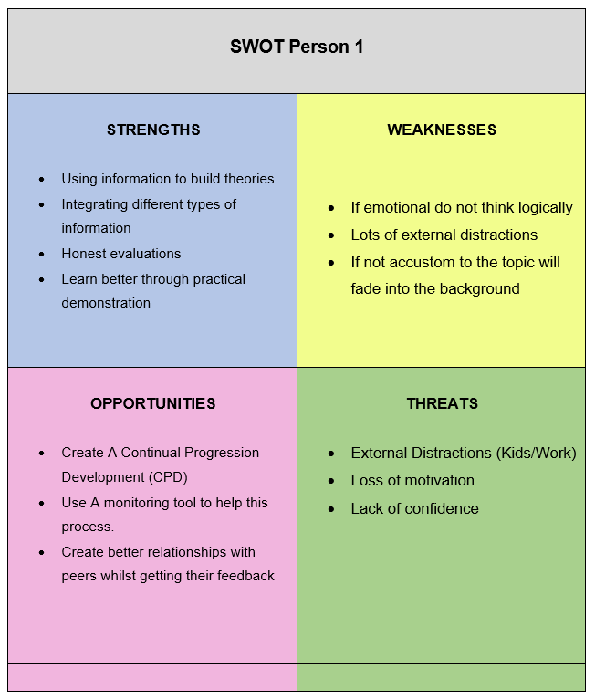
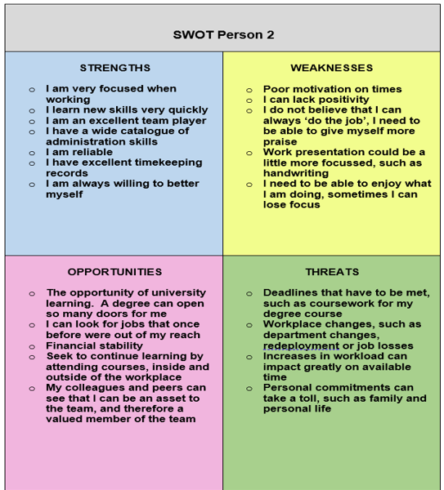
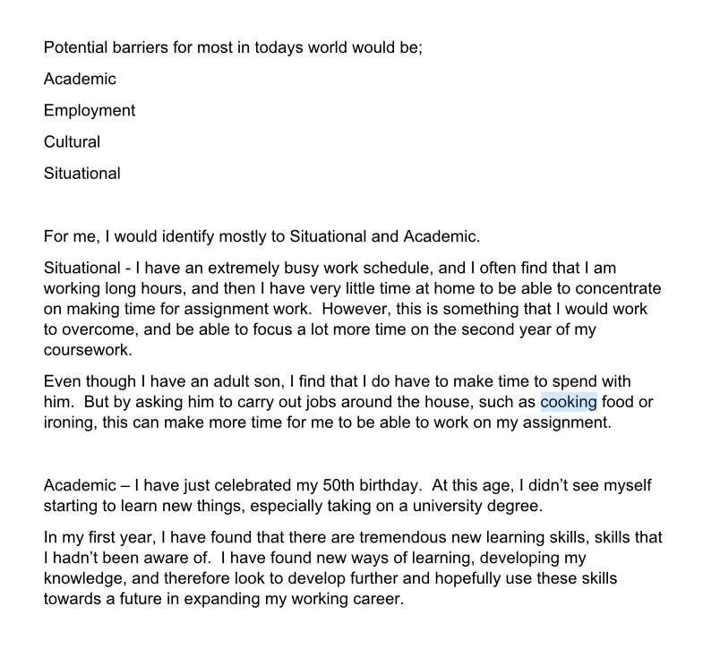

Appendix B

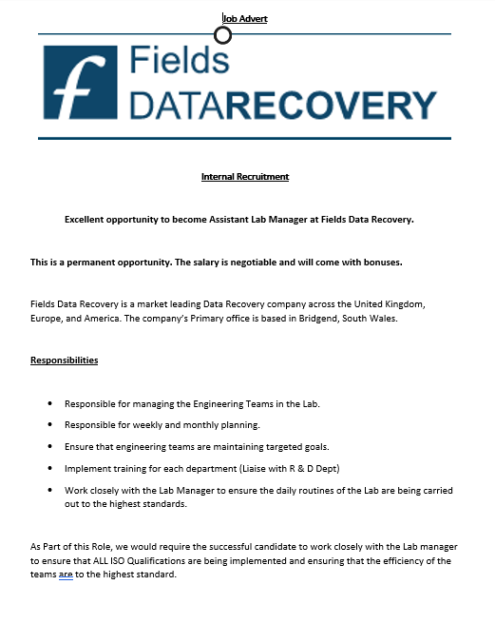

Appendix C

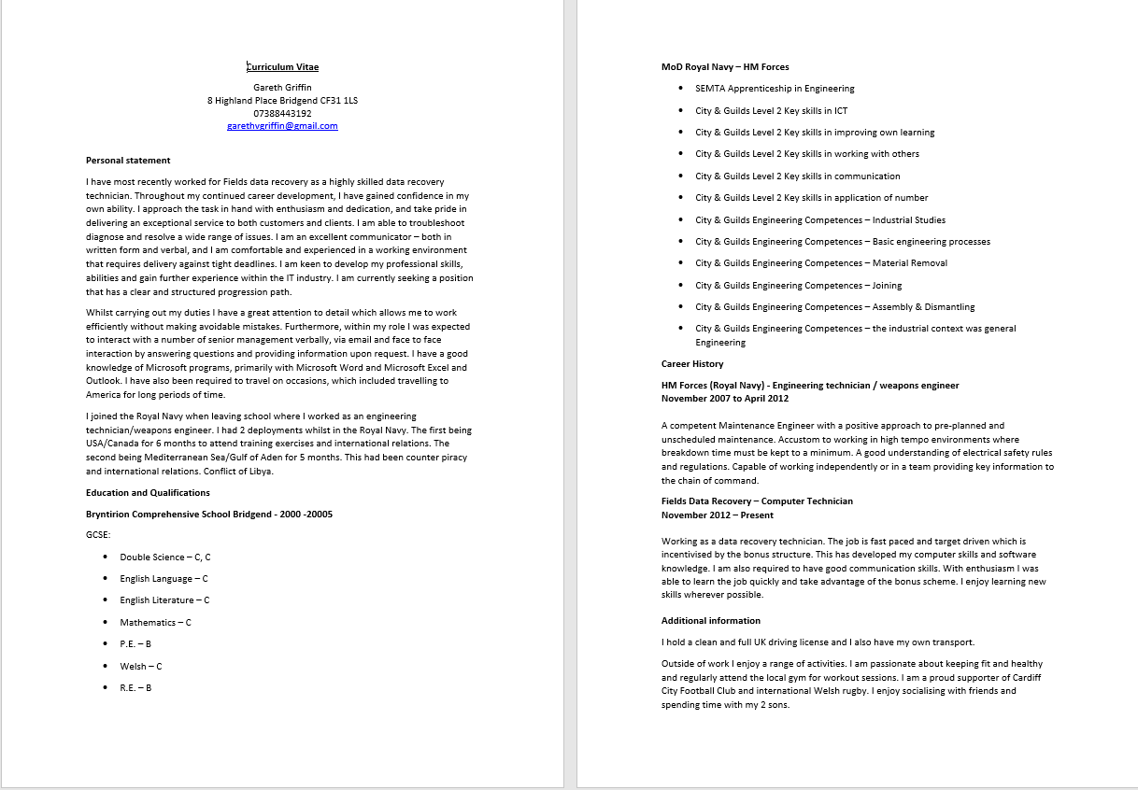

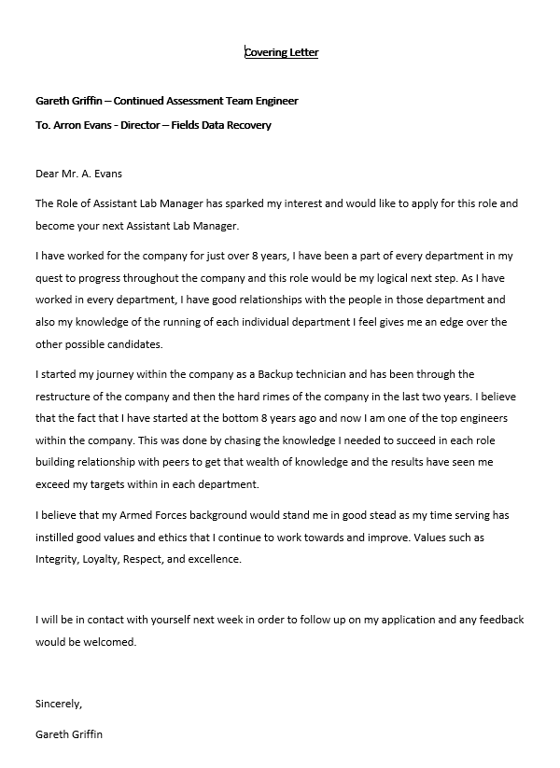

Appendix D

Covering Letter

Feedback from Tutor
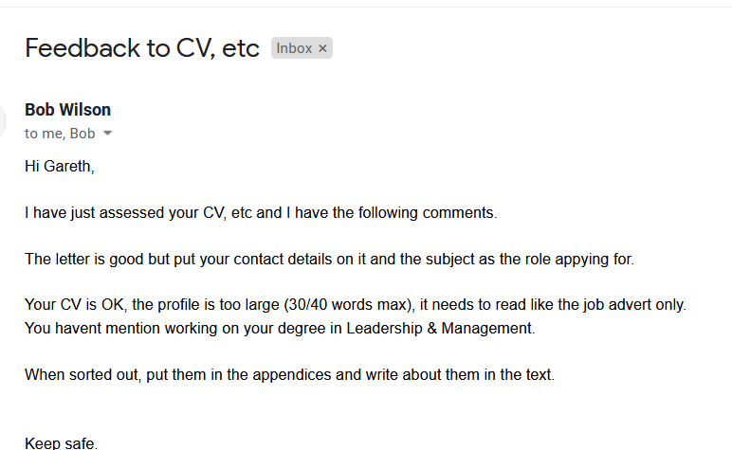
CV after Feedback
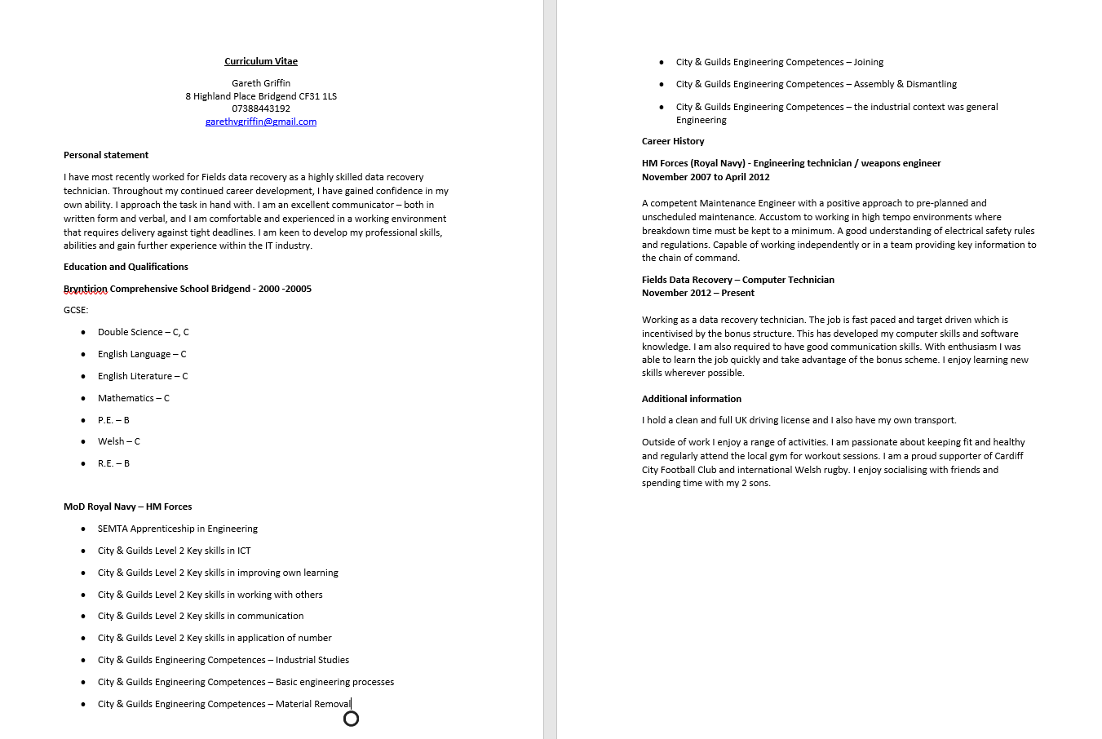

Covering Letter after feedback
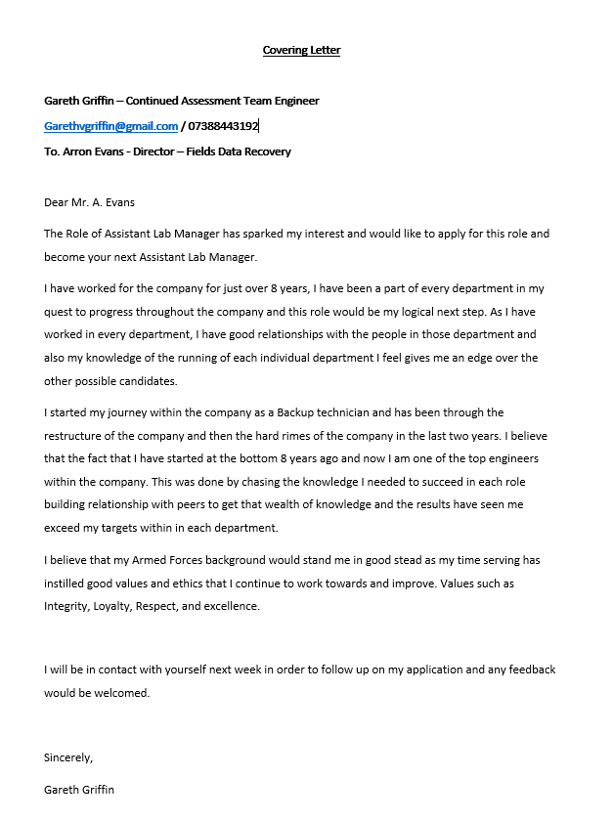

Feedback from Interview
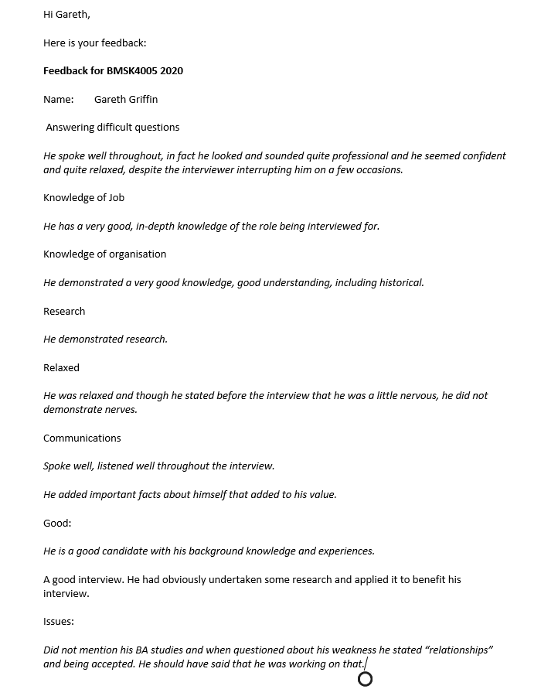

Bibliography

Www2.le.ac.uk. 2020. Honey And Mumford — University Of Leicester. [online] Available at: <https://www2.le.ac.uk/departments/doctoralcollege/training/eresources/teaching/theories/honey-mumford> [Accessed 16 November 2020].
VARK - A Guide to Learning Styles. 2020. VARK Learning Style Questionnaire. [online] Available at: <https://vark-learn.com/the-vark-questionnaire/> [Accessed 16 November 2020].
Medium. 2020. 5 Advantages Of Using Gantt Charts In Project Management. [online] Available at: <https://medium.com/hygger-io/5-advantages-of-using-gantt-charts-in-project-management-9ed5a6f21466> [Accessed 2 December 2020].
Lannon, R. and Lannon, R., 2020. Strategy Spotlight: 8 Tools & Techniques To Apply To Strategic Analysis & Planning. [online] BA Times. Available at: <https://www.batimes.com/articles/8-tools-and-techniques-to-apply-to-strategic-analysis-and-planning.html> [Accessed 16 November 2020].
Morgan, P., 2017. Business Student's Guide To Study And Employability. 2nd ed. Sage, pp.328-337.
Maund, A., Schriek, M. and Tinkler, P., 2017. Certificate In Higher Education: Skills For The Workplace Student Yearbook. Sage, pp.282-308.
UKEssays. November 2018. Barriers to Adult Learners. [online]. Available from: https://www.ukessays.com/essays/education/barriers-to-adult-learners.php?vref=1 [Accessed 1 December 2020].
Gcu.ac.uk. 2020. Support Mechanisms For Students And Mentors | Health And Life Sciences. [online] Available at: <https://www.gcu.ac.uk/hls/studentmentorzone/supportmechanismsforstudentsandmentors/> [Accessed 1 December 2020].
The University of Edinburgh. 2020. Gibbs' Reflective Cycle. [online] Available at: <https://www.ed.ac.uk/reflection/reflectors-toolkit/reflecting-on-experience/gibbs-reflective-cycle> [Accessed 2 December 2020].
Mindtools.com. 2020. Career And Personal Developmental Needs: Developing Employees To Maximize Performance. [online] Available at: <https://www.mindtools.com/pages/article/newLDR_06.htm> [Accessed 21 November 2020].

