sOFTWARE ENGINEERING
Gemma Dunlop (1801285)
8 January 2021

University of Wales Trinity Saint David
Software Engineering Principles and Practice

Table of Contents
1. Aim 2
2. Discussion of the Connect 4 Design 2
2.1. Written Plan of User Story Maps 2
2.1.1. Primary Goal of the Connect 4 Game 2
2.1.2. User Activities 2
2.1.3. User Tasks 3
2.1.4. User Stories 3
2.2. User Sequence Diagram 6
2.3. Wireframe 7
2.4. Advantages of the Team using User Story Maps 8
2.5. Disadvantages of the Team using User Story Maps 9
2.6. Evaluation of the User Story 9
3. CRC cards 11
3.1. CRC Modelling 11
3.2. CRC Card Design Approach 11
3.3. Evaluation of the CRC cards 12
3.4. Acceptance Criteria for the Connect 4 Game 13
4. Importance of Software Testing 14
4.1. Techniques of Software Testing 15
4.1.1. Black-Box Testing 15
4.1.2. White Box Testing 16
5. Testable code 18
5.1. What makes code testable? 19
5.2. Benefits of Testable Code 19
6. Version control software 20
6.1. Collaboration 20
6.2. Storing Versions 20
6.3. Backups 20
6.4. Experimenting and Testing 20
Bibliography 22
Appendix 25
Group Project Logs 25
First meeting – 30/11/2020 25

Second meeting – 4/12/2020 25
Third meeting – 7/12/2020 25
Fourth meeting – 9/12/2020 26
Fifth meeting – 10/12/2020 26
Sixth meeting – 14/12/2020 26
Seventh meeting – 15/12/2020 27
Git Logs 28
Code 34
Grid.cs 34
Program.cs 38
UnitTest1.cs 38

Table of Figures
Figure 1: Primary Goal of the Connect 4 Game. 2
Figure 2: Plan of User Activities. 2
Figure 3: Plan of User Tasks. 3
Figure 4: User Story Structure. 3
Figure 5: User Stories Plan. 4
Figure 6: User Story Map Design Plan. 4
Figure 7: User Story Map. 5
Figure 8: User Sequence Diagram. 6
Figure 9: Wireframe. 7
Figure 10: Choose Counter and Player Connects 4 User Stories. 8
Figure 11: Choose Game Settings User Stories. 9
Figure 12: Player Captures Opponent's Counter User Story. 9
Figure 13: User story for logging into the application. 10
Figure 14: Choose Opponent User Story. 10
Figure 15: Template for a CRC card. 11
Figure 16: Connect 4 Game CRC Cards. 13
Figure 17: Black Box and White Box Testing Diagram. 15
Figure 18: White Box Testing Branch Coverage Example. 17
Figure 19: White Box Testing Path Coverage Example. 17
Figure 20: White Box Testing Test Harness Diagram. 18
Figure 21: White Box Testing Test Harness Example. 18

Aim
The aim of this assignment was to design a two-player game of Connect 4, which can be played online with amendments to the traditional rules.

Discussion of the Connect 4 Design

Written Plan of User Story Maps
A written plan of the user story map was drawn to assist the team to understand how the Connect 4 game worked and every feature of the game, required to be included. Whilst the team understood the traditional rules of Connect 4, time was spent initially, discussing understanding of the additional rules. Every team member had strengths and weaknesses and working together meant a design was developed based on a common understanding of the additional rules.
The team created a draft plan of each section of the user story map including the primary goal, and the process of the Connect 4 game to plan the activities, tasks, and user stories before creating the final user story map.

Primary Goal of the Connect 4 Game
The primary goal to be reached to meet the needs of the user was identified by the team, as shown in figure 1.
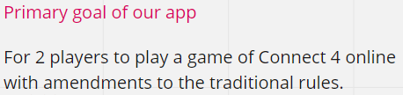
Figure 1: Primary Goal of the Connect 4 Game.

User Activities
The team outlined the activities the player would undertake whilst using the Connect 4 software. The basic stages were defined by envisaging what actions were required to reach the primary goal in figure 1. The process involved writing small tasks which when combined, describe steps the player will follow whilst using the software.
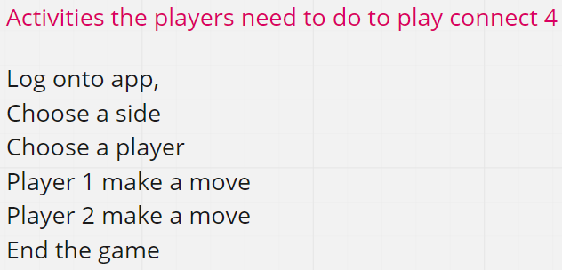
Figure 2: Plan of User Activities.

User Tasks
The team developed a list of user tasks based on each user activity. Creating user tasks enhanced creativity and helped identify as many features as possible. The user tasks were an unprioritized collection of ideas, designed to help solve the user's requirements.
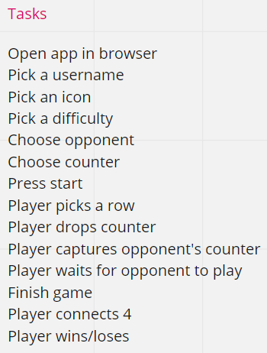
Figure 3: Plan of User Tasks.

User Stories
The team created user stories which are clear descriptions of a system told from the user’s perspective. They follow a structure known as the Connextra template [1][2] shown below:
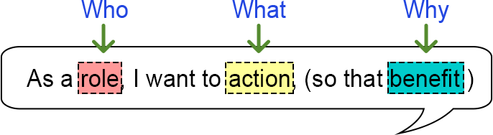[3]
Figure 4: User Story Structure.
This helped outline the tasks the user will undertake whilst using the application, adding more detail to each task, and predicting what would happen if things went wrong. The plan of the user stories is shown in figure 5.
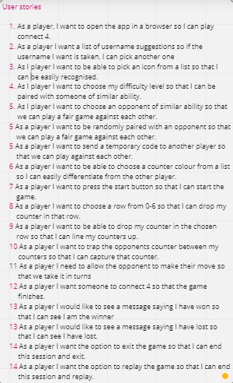
Figure 5: User Stories Plan.
The complete design plan of the user story map is shown in figure 6.
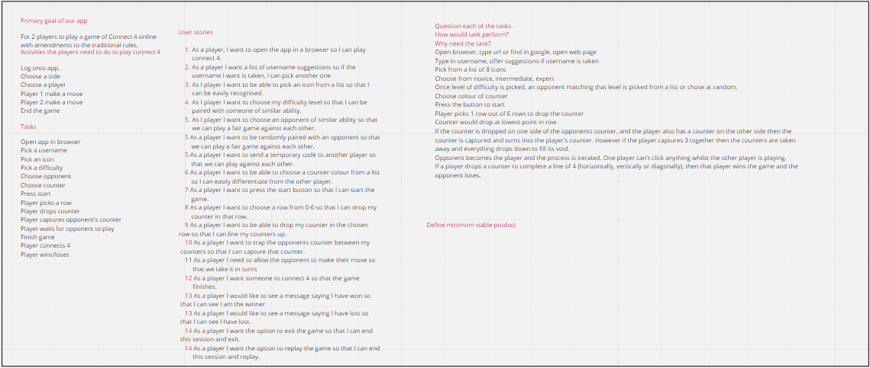
Figure 6: User Story Map Design Plan.
Once the basic plan was outlined, more time was spent creating a final user story map. Converting the ideas to a user story map layout helped finalise the ideas, as detail was added or removed.
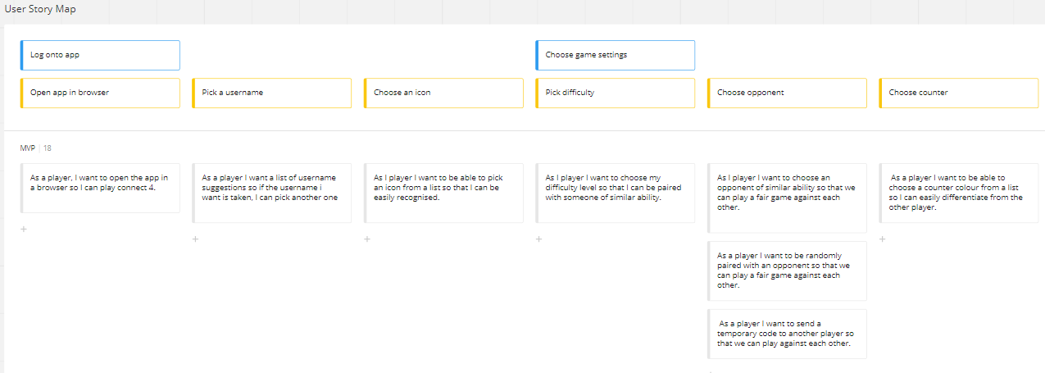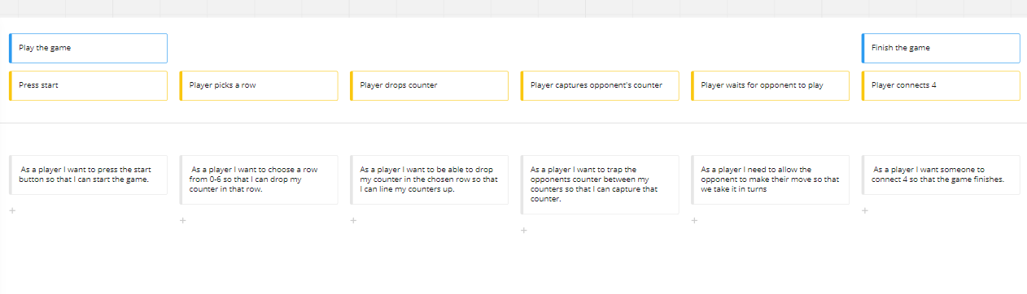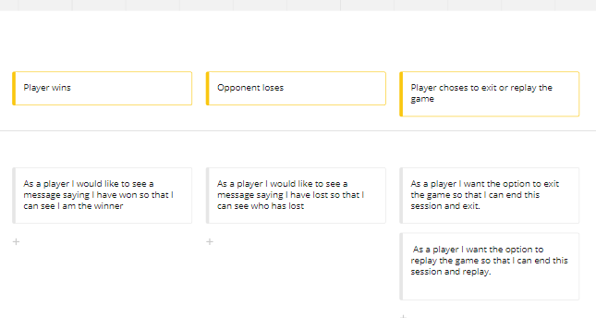
Figure 7: User Story Map.

User Sequence Diagram
The team created a sequence diagram of the Connect 4 game which helped describe communications passed between the player, the game, the counter and the grid. The sequence diagram helped display the interractions of the objects in a time sequence.
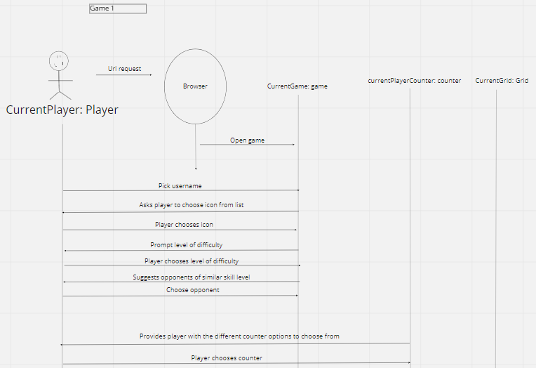
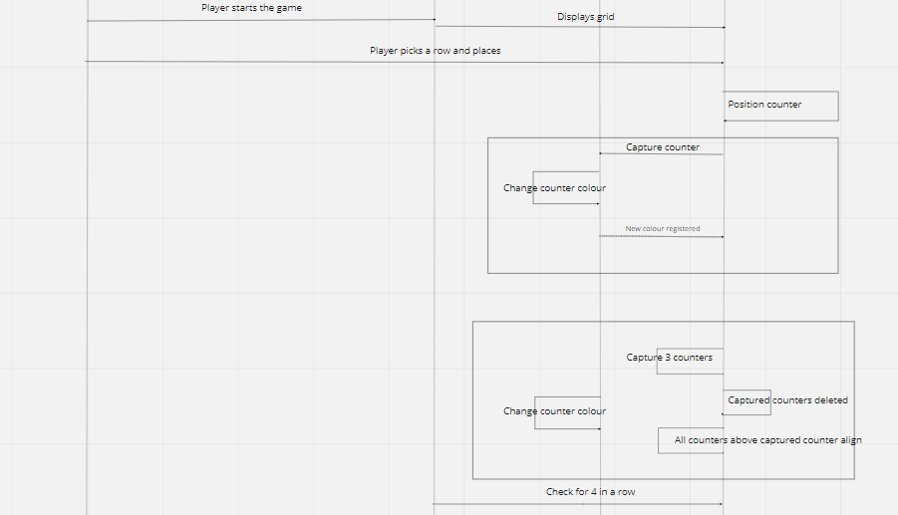
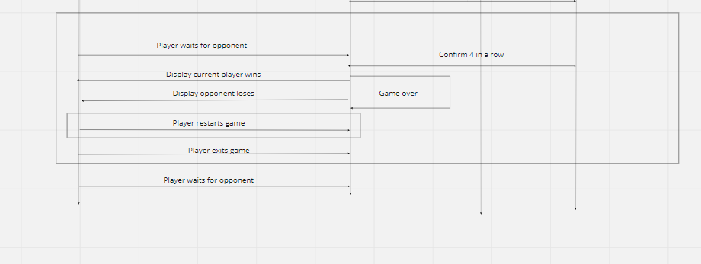
Figure 8: User Sequence Diagram.

Wireframe
A wireframe was created by the team to design the website containing the Connect 4 game at a structural level. It helped lay out the features and the content of the Connect 4 website, considering the user stories and the requirements. Wireframes helped to define the basic layout of the Connect 4 game before design and content would be introduced.
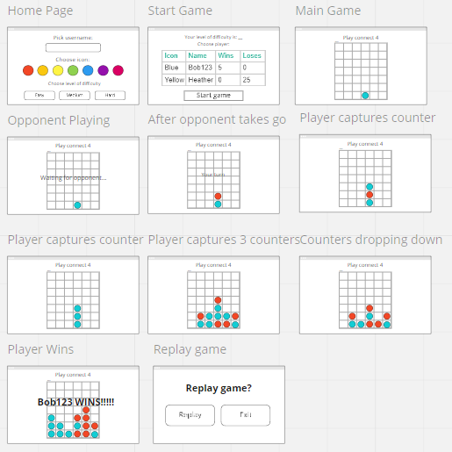
Figure 9: Wireframe.

Advantages of the Team using User Story Maps
- Clear priorities – The general approach of how a story map is designed made it easier to prioritise each story, while retaining the relation between large and small problems. e.g., a large problem such as being able to Connect 4 counters or a small problem such as counter colour.
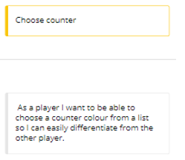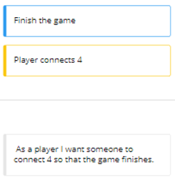
Figure 10: Choose Counter and Player Connects 4 User Stories.
- Communication – Story maps were created by the whole team which made it easy to analyse the product right from the start and it encouraged constructive conversations within the team. During the team meetings, team members asked questions like, "What is your understanding of the additional Connect 4 rules?", "Why do we need this user story ", "Do we need a difficulty level?", "Will the player play against the computer or another player online?" This provided a shared awareness of the development project and the meaning of each story.

- Visible product goals and vision – A user story map is a document of a dynamic nature that can be expanded as the product develops. Having an overall view of the Connect 4 project and understanding where it begins and where it finished meant the team understood the concept of the game and how it could be created as a web application. In addition, the user story map helped to demonstrate all additional product specifics and share this information around the team. People perceive things differently so including clearly written requirements helped introduce a single solution to the Connect 4 game functionality.

- Breaking down large criteria into small items – the requirements for the Connect 4 game, particularly the additional rules, contained explanations that were difficult to comprehend. User story maps made it easy to break down the large tasks of designing the overall game into smaller parts, which meant they were easier for the team to understand. For example, the game settings as shown in figure 9:

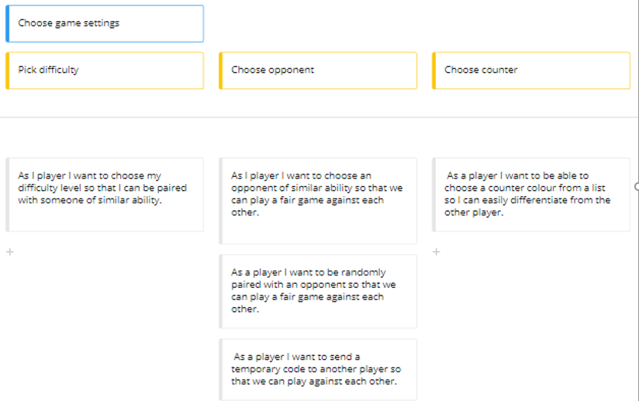
Figure 11: Choose Game Settings User Stories.

Disadvantages of the Team using User Story Maps
- Less focus on non-functional requirements: The team's user stories focused primarily on the functional requirements i.e., how end-users directly interact with the online game. Non-functional requirements such as usability, fault tolerance, performance and reliability were not captured.
- Difficult to scale with more complicated projects: The Connect 4 project was relatively straightforward so the simple format of user stories suited the project. However, if the project was more complex, it may have been difficult to scale up.
- Produced vague requirements: The user stories were written in an informal language which meant the requirements were a bit too vague for coding the Connect 4 game in C#. For example, when player captures opponent’s counter in figure 10:
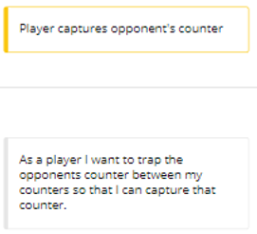
Figure 12: Player Captures Opponent's Counter User Story.

Evaluation of the User Story
The user stories were created by the team with the INVEST criteria in mind [4].
The author considers that each user story created was ‘independent’ from the others. If any changes needed to be made to one particular user story, the other user stories will be unaffected and each user story can be worked on in any order. This meant some user stories could be prioritised over others.
The user stories created were ‘negatiable’. The aim of a project is to meet the user requirements, rather than sticking rigidly to the user stories. The user stories can be implemented in different ways which allowed the team to create the code for the Connect 4 game individually and in a way they chose.
The user stories aimed to be ‘valuable’ by providing a separate unit of value to end users. Including the “so that” clause in every user story helped the team write down a reason as to why each story is valuable for the user. The team perhaps created too many user stories (18 in total) as the recommended amount is 5-15 [5]. However, since this was a plan for a web application, the project naturally required more user stories. In hindsight, some stories were unnecessary for the implementation of the Connect 4 code such as the one shown in figure 8:
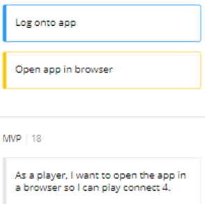
Figure 13: User story for logging into the application.
Each user story was brief enough that the amount of time it would take to implement each story was ‘estimable’. This meant the user stories could be prioritised, taking into consideration the length of time a user story takes to complete and how important the user story is to the functionality of the game.
The team aimed to write user story as a ‘small’ one sentence description of the user’s requirements. This provided the team with a focus and makes it easy to adapt and respond to any future changes. Two of the user stories, circled in figure 8, could possibly have been made into one user story to simplify the story.
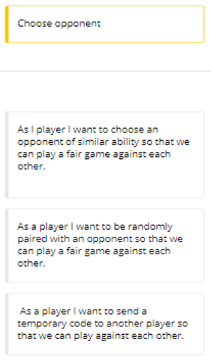
Figure 14: Choose Opponent User Story.
The user stories were ‘testable’ meaning acceptance criteria could be written for each story. Having testable stories ensured the creation of a good quality application, and facilitated Test Driven Development once the application started being implemented.
An additional improvement to the user story map is the team could have included the minimal viable product.

CRC cards

CRC Modelling
CRC (Class-Responsibility-Collaboration) modelling is an easy, low-tech approach for developers and users to work with each other to define and grasp the requirements of a business.
A CRC card [6] is a basic index card that has been broken down into three parts, as seen in Figure 10.
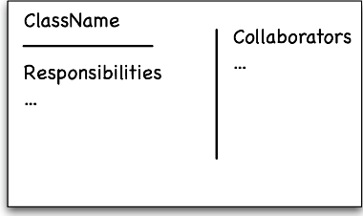[7]
Figure 15: Template for a CRC card.
A class is a set of related objects. The class name of an object provides a language to discuss a design. The name of the class appears at the top of the card.
An object is a person, location, item, activity, or idea that is important to the device at hand. The object's responsibilities are represented by a handful of short verb sentences, each representing an active verb, such as position, task, or if statements.
Occasionally the class may have a responsibility to perform, but it does not have enough details to do so. Thus, it needs to collaborate with other classes to complete the responsibility. Collaborators are objects which, in the process of fulfilling responsibilities, can accept or send messages, and defines relationships with other classes [7].

CRC Card Design Approach
CRC cards are useful when teams are getting weighed down in too many specifics too early, or if they appear to create classes that are cluttered and do not have specific definitions.
CRC cards help decompose a problem – a key component of computational thinking – which can be challenging to implement, and they are deliberately short [7].
Whilst working as a team, it became apparent that different people see the same problem from a different perspective. Collaborating on the CRC cards helped bring different ideas together to understand the requirements of the Connect 4 game and create it. For example, the team were unsure how players would play the game with other people; whether it was 2 players using the game device, two players on different devices playing against each other online or a player playing against a computer. Discussing ideas helped the team decide that one player was going to play against another player online, as many online games follow this format.
The team was also unsure about whether the game would allow a user account to be made, or whether a temporary username and icon should be made instead. On discussion, the team decided to simplify it by only allowing the user to create temporary user details – “Pick a username”, “Choose an icon” on the CRC cards. However, if the game were a real-life application, an option for creating a username and password would encourage users to return to the game and would record long term player progress.
After discussing the settings of the game, the rules of the game were discussed. The team were aware of the classic rules of the game, so were able to instantly write responsibilities, however it took the team longer to understand the additional rules and eventually apply those to the classes. The CRC cards allowed the game process to be understood, so when the team started individually creating the code for the application, the rules of the game were clear to each member.
The main benefit of CRC cards was it made it easier for the team to step away from the procedural way of thinking and to embrace object technology more thoroughly. Creating the CRC Cards encouraged all project team members to contribute to the design. The team involved 4 people but the more people who help design the framework, the higher the number of good ideas would be produced.
The CRC cards helped the team to combine thought and consider the game from an overall perspective to complete the project. Individual cards helped subdivide details and logic.
Using CRC cards meant that on looking at a single card the team focused on the point of view of that class and consider how it would be coded.
A disadvantage of creating the team CRC cards was the author considered they provide a lack of detail about the code. CRC cards only define the user requirements of the Connect 4 game which led to a lack of detail when implementing the code later. However, they did provide a blueprint of the user requirement which ensured nothing was overlooked when creating the code and valuable time was not wasted writing unnecessary code. Creating UML diagrams would have complimented the CRC cards, leading to a more detailed design overall.
The greatest drawback the author found using the CRC cards was the lack of feedback. It would be easy to convince yourself that the code is going to turn out right. It was only when the game was coded that the CRC cards were confirmed.

Evaluation of the CRC cards
In hindsight, the author considers that two of the CRC cards had too many responsibilities. The recommendation is that each class should have at most three or four responsibilities [8]. The CRC cards with too many responsibilities could have been split. The cards containing too many classes indicates low cohesion [9]. Ideally, a cohesive class should have just one responsibility.
The Connect 4 CRC cards should have contained only one responsibility for each class, as most of the cards contained more than one responsibility. As there are no restrictions on the number of responsibilities permitted within a given class, it is possible to overwhelm a class with so many responsibilities resulting in a low degree of cohesion within the model. Ideally, a coherent class can have only one responsibility [10]. Excessive responsibilities may also contribute to the need for a significant number of collaborators to assist them. Too many class partnerships will result in a high coupling that will needlessly increase the sophistication of the system. In software design, the aim is strong cohesion and the lowest possible coupling.
Having too many responsibilities may contribute to the development of macho classes. The macho class instantiates an object that does most of the work, leaving all small operations to a collection of effectively meaningless classes [9]. Ideally, the intelligence of the system should be spread as equally as possible in the application and the function should be distributed universally. When all the responsibilities are focused in one or two classes, it raises the complexity of making alterations.
The CRC cards created by the team did not include a class role for each card. The lack of a class role can contribute to the assignment of incorrect, pointless, or even lacking responsibilities. Although the role appears very unimportant, it serves a rather important function. If a class plays more than one role, there may be generalizations where each role is simply a subclass of a superclass [9].
For the team to validate whether the CRC cards contained sufficient detail, the team roleplayed the Connect 4 game with different scenarios. The CRC cards had strengths which helped with the coding however, further roleplay could be undertaken to make detect any weaknesses in the CRC card technique and ensure any problems were addressed [11].
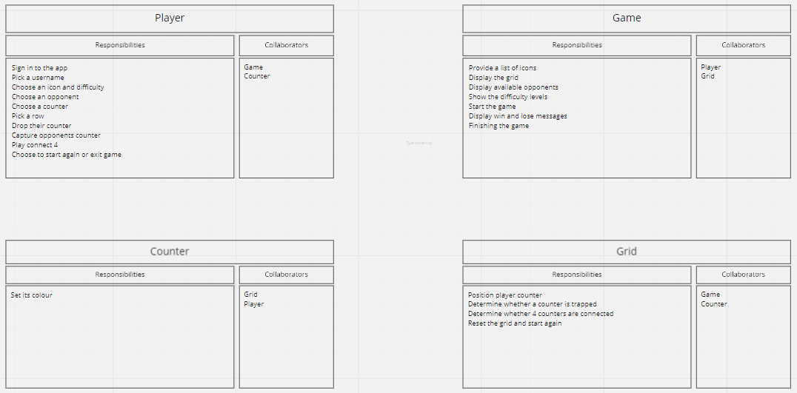
Figure 16: Connect 4 Game CRC Cards.

Acceptance Criteria for the Connect 4 Game
When the user stories were written, the team included testable acceptance criteria which helped to accurately check that all the required criteria had been met. If the criteria cannot be tested, then there would be no means of verification. These conditions should either be met or not be met.
The acceptance criteria were written in a clear and concise way so anyone who read it would understand it. The criteria were written avoiding the use of jargon and without being longwinded to avoid the key points being misunderstood.
The desired characteristics such as conciseness, clarity, and comprehension are subjective, but the author considers the CRC cards to reflect the user stories as they were clear and concise, testable and the team members were all in agreement.
Clearly written acceptance criteria introduced a single solution to the Connect 4 game functionality. It helped the team set the user story boundaries and helped to validate the Connect 4 application functions. Acceptance criteria are the core of positive and negative tests aimed at testing whether the system performs as intended.
Having created CRC cards, the team role-played a variety of scenarios to verify if the system performed on paper: if not, the design could be changed before entering the time-consuming phase of programming a defective design.
The author considers that the CRCs reflected the acceptance criteria identified in the user stories in figure 7.

Importance of Software Testing
Software testing is the method of examining a software system or its component(s) with a view to deciding whether it meets defined specifications, according to ANSI/IEEE 1059 Standard [12]. As such, testing is running a system to find any defects, gaps or incomplete requirements that are inconsistent to the specific requirements.
Software testing guarantees the consistency of the product and satisfies both consumers and users [13]. It also offers improved market optimisation (less maintenance costs), stability and excellent user experience. Software testing is a necessary part of the design and development process.
Testing has become a very important part of the IT field due to [14]:
- Quality of the product
Software Testing aims to improve the reputation of a business by providing the consumer with a product that is of a high standard as set out in any specifications. Due to this, software testing is becoming a necessary part of the development process of software.
- Cost-efficiency
Design faults for any complex structure can never be fully ruled out. If faults in the design are not detected, it becomes harder to find errors and fix them, so it could be more costly to repair. Often, when repairing one bug, we can unknowingly add another. If vulnerabilities are found at the start of the software development process, it would cost a lot less to repair them. For this reason, it is essential to identify flaws as early as possible and in addition to carry out frequent testing.
- Security
Security Testing identifies any risks to the system and measures the possible weaknesses, so that threats can be encountered, and the system does not stop working or cannot be abused. A breach in customer security means customers will not trust the company.
- Satisfaction of the client
The primary aim of every company is to have the highest customer satisfaction to maximise sales and software testing helps achieve this.
There are many examples where insufficient software testing leads to bugs resulting in monetary and human loss [15]:
- Nissan cars had to recall more than one million cars because of a software flaw in the sensory airbag detectors. Due to this software malfunction, two injuries were reported.
- Amazon's third-party sellers noticed that their products’ prices were lowered to 1p due to a technical bug, resulting in several sellers losing money..

Techniques of Software Testing
Two commonly used techniques of software testing are:
- White-box testing
- Black-box testing.
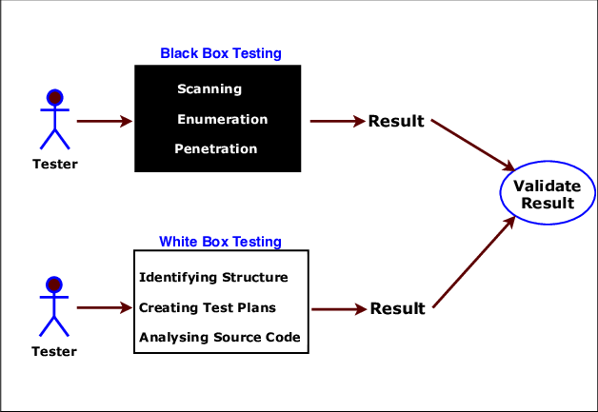[16]
Figure 17: Black Box and White Box Testing Diagram.

Black-Box Testing
Black-box testing is a method in which the tester is unaware of the internal workings of a program [17]. It is designed as a complementary approach to White-box testing to identify entirely different errors.
Black-box testing will uncover the following error types:
- Incorrect or incomplete functions
- Errors in interface
- Errors in the data structure
- Performance related errors
- Errors in initialization or termination.
Black-box testing can be either functional or non-functional testing [18].

Functional Testing
Functional testing tests the unique functionality of a program which is being tested. E.g., verifying that a user can log in with the right user ID and cannot with an ID which is incorrect.
Functional testing may concentrate on:
- Smoke test or sanity test
- Integration test
- System test.

Non-functional Testing
Non-functional testing tests non-functional aspects of a program. It tests whether a system is ready for use and is important to ensure customer satisfaction.

Black Box Test Techniques

Equivalence Partitioning
Equivalence Partitioning tests will separate potential input data into categories, testing only one category per group [18]. For instance, when the program needs the date of birth of a user who is learning to drive; it accepts the date of birth for all users under 17 years of age but rejects users over 17 years of age. If tests validate that one value over 17 is accepted, then all values over 17 are classed as accepted.

Boundary Value Analysis
Boundary Value Analysis may test whether the program has a special answer to a particular boundary value. For instance, when only values between 1 and 6 should be accepted in a particular field then testers should concentrate on boundary values (0, 1, 6 and 7) to see whether the program accepts and rejects inputs correctly.

Combinatorial testing
Combinatorial testing tests input values that are dependent on each other. It tests whether setting one would alter the impact of the other. For example, to test whether distance increases as speed increases.

White Box Testing
White box testing is a test based on a close review of the internal structure of the program [19].
The test cases in white box testing are to:
- Examine all the individual pathways within the module.
- Exercise all rational paths with the true and false sides.
- Execute every loop within the ranges and operating limits.
- Exercise the internal data systems ensuring they are valid.
There are three key purposes for performing white box testing:
- Programmers may make certain conclusions which are incorrect when planning or integrating certain functions. Consequently, there are risks of logical faults in the program. Procedural information must be reviewed to detect and correct specific logical errors.
- Certain assumptions about data and flows can mean programmers make design errors. To identify the logical path faults, white box checking must be completed.
- To identify some typographical errors which were undetected by type-checking mechanisms and syntax.

Branch Coverage
Branch coverage is an approach intended to guarantee every potential branch is ran at least once from each point.
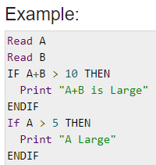 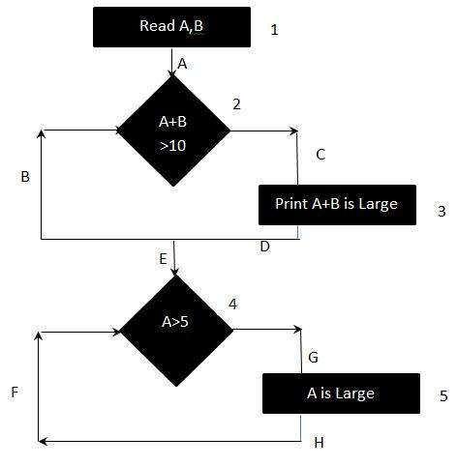 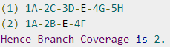[20]
Answer:
Figure 18: White Box Testing Branch Coverage Example.

Path coverage
Path coverage covers all routes that a test case may take. For example:
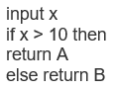
Figure 19: White Box Testing Path Coverage Example.
To accurately follow all the paths for path coverage testing, the two test cases are run, where:
- x is greater than 10 and
- x is less than or equal to 10.
The goal of path coverage is to recognise pathways that are broken, repetitive or inefficient.

Test Harness
A Test Harness refers to a set of applications, test drivers, test data and other supporting tools that are designed for testing and analysing the performance of an application by executing it in various environments and evaluating the performance. It uses test libraries to run tests and produce a report.
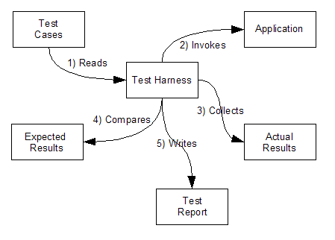[21]
Figure 20: White Box Testing Test Harness Diagram.
For example: a testing tool for functional testing, organizes and handles all test data, scripts, runs, and results. The test harness for this would be:
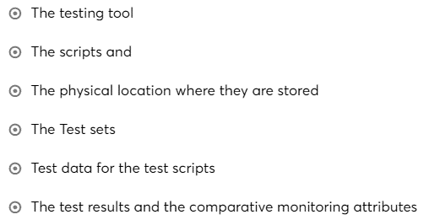[21]
Figure 21: White Box Testing Test Harness Example.

Testable code
The strength of well-written code is that it generally tends to be robust to modification. Such that, where there is a modification in the requirements it is desirable if the change in the code is proportionate. Although this is not always achieved the use of testable code helps the developer get closer to this target.
Unit testing tests one section of the program separately to the other sections. Unit testing consists of three phases:
- Arrange – Setting up the unit testing.
- Act – Executing the tests.
- Assert – Verifying the result of the test by comparing it to the expected result.
Unit testing will check the various behavioural components of a program being tested. Unit testing is either [22]:
- State-based, which checks whether the software being tested outputs results which are correct or whether the outcome is correct
- Interaction-based which verifies that each method works well as a whole.

What makes code testable?
It is important to distinguish the testable code from the non-testable code. Merging them together contributes to a code mix-up that cannot be tested [23].
Writing Cleaner Functions
If a function is written that just does one thing, the code will result in being fully testable. Unit tests should be written for all the functions separately.
‘SOLID’ Principles
- Single Responsibility Principle – A class is expected to have just one purpose for being altered.
- The Open/Closed Principle – New features can be implemented without needing to modify the original code,
- The Liskov Substitution Principle – “Derived classes should be substitutable for their base classes” [24].
- The Interface Segregation Principle – Interfaces should be broken down into small interfaces, ensuring no interfaces exist that users will not use.
- The Dependency Inversion Principle – The developer should "depend upon abstractions, [not] concretions." In other words, modules that are high-level must not rely on modules that are low-level. The user module, for example, must not know how to execute the login [24].

Benefits of Testable Code
It is important for testable code to be well-written in order not to complicate unit testing.
Writing testable code ensures the smallest components can be independently verified. To achieve this, each part must have its own dependencies injected into it. This ensures that the code cannot reference global variables or use read/write singletons or service locators, etc. Writing testable code can be a highly powerful and reliable way of building software and can be verified programmatically [25].
Testable code simplifies the verification process so that the software is always maintained in a ready-to-release state. Testable code enables last-minute improvements to be made on a project, in a way which are cost-free and trivial, the same kind of improvements that are commonly extremely costly to implement late in a software process that does not use automatic regression testing.
Testable code is high quality code. It is loosely coupled, coherent, well encapsulated and in charge of its own state. In brief, it is uniquely defined in its proper position, such that it is simple to retain and expand.
For example, if a time calculation must use a different time due to different time zone, testable code means the time can be passed in without needing to make any changes to the code. If the current time needs to be used rather than passing in a particular time a default argument can just be used. The code is robust to change since it is testable.

Version control software
Version control is a mechanism that enables developers solve certain daily issues, such as monitoring code updates, helping to preserve code, and allowing them to work on the same source code files without disrupting each other's workflow [26].
Git is the most popular version control software used by millions of developers and programmers around the world today.

Collaboration
If a team is working together on the same files in a shared folder then Version Control Software means anyone on the team can work freely-on any file at any time. The VCS helps combine every change into one common version. It is easy to find where the current version of a file is or where the whole project is as the version control system means it is in a common, central location.

Storing Versions
The Version Control System demands a short explanation of what has been changed every time a new version of the project is saved. Furthermore, for code or text files, precisely what has been modified in the file can be seen. Keeping a record of changes to a particular code file can help the developer and new contributors understand how a specific aspect of the code was created, i.e., how it started and evolved over time to get to the current version. In addition, if the introduction of a new feature creates problems in expanding or extending the project over time, the use of version control enables developers to monitor that feature and modify it or delete it without impacting the design of the project.

Backups
A useful advantage of using a version control system is that whenever a contributor clones a repository, a backup of the existing version is created, meaning a full-blown version of the project is on each team member’s disk – including the full history of the project. Having several copies on separate computers is useful as it means files can be recovered if data is lost due to server failure.

Experimenting and Testing
Source code is always under production in today's world, whether that is due to new features, a fresh demographic to be reached, or new software applications to be created. Multiple project copies are usually made whilst a team works on a development project to create new features, validate them, and ensure that they perform correctly so this new feature can be applied to the main project. This could save time as it is possible to create various aspects of the code concurrently.
The author agrees that there are many advantages of version control systems as they allow comparing files, identifying differences, and merging changes if appropriate before any commit code is committed. Versioning is a means of keeping record of program changes as it allows the version which is presently under development or production to be distinguished. New developers can use the version control system to quickly update the latest application version to the local environment, thus keeping track of the version they are running. It is possible to have fully individual code versions during development if multiple development activities are required to be kept apart. VSC also allows merging of files to create a final working version.
Versioning is useful when troubleshooting a problem, different versions of files can be compared, and discrepancies tracked. The last running file should be compared with the defective file, minimizing the time taken finding the source of the error. If the user wishes to roll back the modifications, the last operating file will be applied using the correct version.

Bibliography
[1] G. Lucassen, F. Dalpiaz, J. M. E. M. van der Werf, and S. Brinkkemper, “The use and effectiveness of user stories in practice,” in Lecture Notes in Computer Science (including subseries Lecture Notes in Artificial Intelligence and Lecture Notes in Bioinformatics), 2016, vol. 9619, pp. 205–222, doi: 10.1007/978-3-319-30282-9_14.
[2] “User Story Template Advantages.” https://www.mountaingoatsoftware.com/blog/advantages-of-the-as-a-user-i-want-user-story-template (accessed Dec. 16, 2020).
[3] “What is User Story?” https://www.visual-paradigm.com/guide/agile-software-development/what-is-user-story/ (accessed Dec. 16, 2020).
[4] B. Hartman, “New to agile? INVEST in good user stories - Agile For All,” May 14, 2009. https://agileforall.com/new-to-agile-invest-in-good-user-stories/ (accessed Jan. 04, 2021).
[5] A. Fuqua, “User Stories Rule of Thumb: How Much is too Many?,” May 29, 2015. https://www.leadingagile.com/2015/05/how-many-user-stories-per-sprint-rules-of-thumb/ (accessed Jan. 04, 2021).
[6] W. C. Kent Beck, “A Laboratory For Teaching Object-Oriented Thinking,” Oct. 1989, Accessed: Dec. 31, 2020. [Online]. Available: http://c2.com/doc/oopsla89/paper.html.
[7] Ewan Klein, “OOP Tutorial Week 4: Class, Responsibilities, Collaborators,” Feb. 03, 2009. https://www.inf.ed.ac.uk/teaching/courses/inf1/op/Tutorials/2008/crc.html (accessed Dec. 31, 2020).
[8] M. Felici, “Validation: CRC Cards,” 2004.
[9] E. Yourdon and L. L. Constantine, Structured design. Fundamentals of a discipline of computer program and systems design. Englewood Cliffs: Yourdon Press, 1979.
[10] M. S. H. H. S. Fayad, “A Pattern Language for CRC Cards,” Jan. 2004, Accessed: Jan. 03, 2021. [Online]. Available: https://www.researchgate.net/publication/215593186_A_Pattern_Language_for_CRC_Cards.
[11] S. Kendal, Object Oriented Programming using C#. 2011.
[12] IEEE, “1059-1993 - IEEE Guide for Software Verification and Validation Plans,” Apr. 1994. Accessed: Jan. 01, 2021. [Online]. Available: https://ieeexplore.ieee.org/document/838043.
[13] K. Wali, “A Guide To Software Testing: A Primer To Three Types of Testing.” https://rezaid.co.uk/software-testing-regimes/ (accessed Jan. 04, 2021).
[14] Rajkumar, “What Is Software Testing - Definition, Types, Methods, Approaches,” Dec. 04, 2020. https://www.softwaretestingmaterial.com/software-testing/ (accessed Jan. 01, 2021).
[15] G. 99, “What is Software Testing? Definition, Basics & Types.” https://www.guru99.com/software-testing-introduction-importance.html (accessed Jan. 01, 2021).
[16] M. Moniruzzaman, F. Chowdhury, and M. S. Ferdous, “Measuring Vulnerabilities of Bangladeshi Websites,” Apr. 2019, doi: 10.1109/ECACE.2019.8679426.
[17] “Black Box Testing: An In-depth Tutorial with Examples and Techniques.” https://www.softwaretestinghelp.com/black-box-testing/ (accessed Jan. 04, 2021).
[18] Imperva, “What is Black Box Testing.” https://www.imperva.com/learn/application-security/black-box-testing/ (accessed Jan. 01, 2021).
[19] “White Box Testing: A Complete Guide with Techniques, Examples, & Tools,” Software Testing Help, Nov. 13, 2020. https://www.softwaretestinghelp.com/white-box-testing-techniques-with-example/ (accessed Jan. 04, 2021).
[20] “Branch Testing,” Tutorialspoint. https://www.tutorialspoint.com/software_testing_dictionary/branch_testing.htm (accessed Jan. 08, 2021).
[21] TestBytes, “What is a Test Harness in Software Testing.” https://www.testbytes.net/blog/test-harness/ (accessed Jan. 01, 2021).
[22] S. Kolodiy, “Unit Testing and Coding Best Practices for Unit Tests: A Test-Driven Perspective,” Toptal. https://www.toptal.com/qa/how-to-write-testable-code-and-why-it-matters (accessed Jan. 08, 2021).
[23] “Follow These Guidelines to Write Testable Code That Can Scale | with Examples — Soshace • Soshace.” https://soshace.com/follow-these-guidelines-to-write-testable-code-that-can-scale-with-examples/ (accessed Jan. 01, 2021).
[24] R. C. Martin, Design Principles and Design Patterns. 2000.
[25] “Writing Testable Code - DZone Agile.” https://dzone.com/articles/write-testable-code (accessed Jan. 01, 2021).
[26] “Why Use Version Control? | Learn Version Control with Git.” https://www.git-tower.com/learn/git/ebook/en/command-line/basics/why-use-version-control/ (accessed Jan. 04, 2021).

Appendix

Group Project Logs

First meeting – 30/11/2020
All team members were present in this meeting.
We started developing our user story map.
Define the main goal for us
- “To create a two-player game of connect 4”
Define the main goal for the users
- “To be the first to get 4 in a row”

Questions we’ve come across
- Are you looking for the design to be web application or console?
- If you capture 3 in one go is there a hole?
- The counter drops into the hole, or does it stay empty to be filled by next dropped counter?
- If there’s 2 counters above, do both counters drop down?

Plan of action
Come up with a list of what we think we need to do and compare next week to come up with a group list.

Second meeting – 4/12/2020
Mark, Ewan and Gemma were present at this meeting but Lowri wasn’t.
This is the meeting I missed.
The full plan was developed for the activities and user tasks.
The primary goal was also updated to the following.
“For 2 players to play a game of Connect 4 online
with amendments to the traditional rules.”

Plan of action for next meeting
To look back over the plan created today and see if there’s anything else to add.
Start to look at user stories.

Third meeting – 7/12/2020
All team members were present in this meeting.
We firstly went over the full plan developed last week.
At this point we were able to create a full list of the user stories needed.

Plan of action for next meeting
To look back over the list of user stories to see if there’s anything else to add.
Look at creating CRC cards.

Fourth meeting – 9/12/2020
All team members were present in this meeting.
We all looked over the user stories created and all team members were happy with the list and nothing needed to be changed.
CRC cards
- We all firstly went through the user stories and picked out the classes we identified.
- From this we started to develop our CRC cards with responsibilities and collaborators.
- We managed to finish the majority of the CRC cards in this meeting

Plan of action for next meeting
Finish CRC cards
Look at the CRC cards created and see if there is anything missing

Fifth meeting – 10/12/2020
All team members were present in this meeting.
During this meeting we all looked through the CRC cards we had started last week and had a discussion on it.
We had decided that we needed to alter some of the collaborators as they didn’t all suit.
After this had been done, all of the CRC cards were finished during this meeting.
Once the CRC cards had been finished, we all had a discussion about sequence diagrams ensuring all team members understood what we were doing.
We then started the sequence diagram.
Plan of action for next meeting.
Finish the sequence diagram
Start wire frame diagrams

Sixth meeting – 14/12/2020
All team members were present in this meeting.
In this meeting we completely finished the sequence diagram and discussed it ensuring we were all happy.
We also started our wire frame diagrams in this meeting.

Plan of action for next meeting
Finish wire frame diagrams
Go over everything to make sure we are all happy with what we have done.

Seventh meeting – 15/12/2020
All team members were present in this meeting.
In this meeting we finished the wire frame diagrams as a team.
We all went over the whole finished design we had created and had a deep discussion and decided we were all happy with what we had done.

Git Logs

gemma@LAPTOP-KD31BV52 MINGW64 ~/Documents/Year 3/Soft Dev/AssignmentGit (master)
$ git config --global user.name "Gemma Dunlop"

gemma@LAPTOP-KD31BV52 MINGW64 ~/Documents/Year 3/Soft Dev/AssignmentGit (master)
$ git config --global user.email "1801285@student.uwtsd.ac.uk"

gemma@LAPTOP-KD31BV52 MINGW64 ~/Documents/Year 3/Soft Dev/AssignmentGit (master)
$ git config --global --list
user.name=Gemma Dunlop
user.email=1801285@student.uwtsd.ac.uk

gemma@LAPTOP-KD31BV52 MINGW64 ~/Documents/Year 3/Soft Dev/AssignmentGit (master)
$ mkdir gitdir

gemma@LAPTOP-KD31BV52 MINGW64 ~/Documents/Year 3/Soft Dev/AssignmentGit (master)
$ cd gitdir

gemma@LAPTOP-KD31BV52 MINGW64 ~/Documents/Year 3/Soft Dev/AssignmentGit/gitdir (master)
$ ls -1

gemma@LAPTOP-KD31BV52 MINGW64 ~/Documents/Year 3/Soft Dev/AssignmentGit/gitdir (master)
$ ls -l
total 0

gemma@LAPTOP-KD31BV52 MINGW64 ~/Documents/Year 3/Soft Dev/AssignmentGit/gitdir (master)
$ git init
Initialized empty Git repository in C:/Users/gemma/Documents/Year 3/Soft Dev/AssignmentGit/gitdir/.git/

gemma@LAPTOP-KD31BV52 MINGW64 ~/Documents/Year 3/Soft Dev/AssignmentGit/gitdir (master)
$ touch text.txt

gemma@LAPTOP-KD31BV52 MINGW64 ~/Documents/Year 3/Soft Dev/AssignmentGit/gitdir (master)
$ echo "This is a line of text" > text.txt

gemma@LAPTOP-KD31BV52 MINGW64 ~/Documents/Year 3/Soft Dev/AssignmentGit/gitdir (master)
$ cat text.txt
This is a line of text

gemma@LAPTOP-KD31BV52 MINGW64 ~/Documents/Year 3/Soft Dev/AssignmentGit/gitdir (master)
$ git add text.txt
warning: LF will be replaced by CRLF in text.txt.
The file will have its original line endings in your working directory

gemma@LAPTOP-KD31BV52 MINGW64 ~/Documents/Year 3/Soft Dev/AssignmentGit/gitdir (master)
$ git status
On branch master

No commits yet

Changes to be committed:
(use "git rm --cached <file>..." to unstage)
new file: text.txt

gemma@LAPTOP-KD31BV52 MINGW64 ~/Documents/Year 3/Soft Dev/AssignmentGit/gitdir (master)
$ git add .

gemma@LAPTOP-KD31BV52 MINGW64 ~/Documents/Year 3/Soft Dev/AssignmentGit/gitdir (master)
$ git commit -m "Files committing"
[master (root-commit) 2a2f4b7] Files committing
1 file changed, 1 insertion(+)
create mode 100644 text.txt

gemma@LAPTOP-KD31BV52 MINGW64 ~/Documents/Year 3/Soft Dev/AssignmentGit/gitdir (master)
$ touch index.html

gemma@LAPTOP-KD31BV52 MINGW64 ~/Documents/Year 3/Soft Dev/AssignmentGit/gitdir (master)
$ git status -s
?? index.html

gemma@LAPTOP-KD31BV52 MINGW64 ~/Documents/Year 3/Soft Dev/AssignmentGit/gitdir (master)
$ git add index.html

gemma@LAPTOP-KD31BV52 MINGW64 ~/Documents/Year 3/Soft Dev/AssignmentGit/gitdir (master)
$ git status -s
A index.html

gemma@LAPTOP-KD31BV52 MINGW64 ~/Documents/Year 3/Soft Dev/AssignmentGit/gitdir (master)
$ git commit -am "webpage says hello"
[master 8726261] webpage says hello
1 file changed, 0 insertions(+), 0 deletions(-)
create mode 100644 index.html

gemma@LAPTOP-KD31BV52 MINGW64 ~/Documents/Year 3/Soft Dev/AssignmentGit/gitdir (master)
$ touch cats.txt

gemma@LAPTOP-KD31BV52 MINGW64 ~/Documents/Year 3/Soft Dev/AssignmentGit/gitdir (master)
$ vi cats.txt

gemma@LAPTOP-KD31BV52 MINGW64 ~/Documents/Year 3/Soft Dev/AssignmentGit/gitdir (master)
$ cat cats.txt
cats yaya

gemma@LAPTOP-KD31BV52 MINGW64 ~/Documents/Year 3/Soft Dev/AssignmentGit/gitdir (master)
$ git add cats.txt
warning: LF will be replaced by CRLF in cats.txt.
The file will have its original line endings in your working directory

gemma@LAPTOP-KD31BV52 MINGW64 ~/Documents/Year 3/Soft Dev/AssignmentGit/gitdir (master)
$ git status -s
A cats.txt

gemma@LAPTOP-KD31BV52 MINGW64 ~/Documents/Year 3/Soft Dev/AssignmentGit/gitdir (master)
$ git commit -m "added some text in cats.txt"
[master 2f52fa1] added some text in cats.txt
1 file changed, 1 insertion(+)
create mode 100644 cats.txt

gemma@LAPTOP-KD31BV52 MINGW64 ~/Documents/Year 3/Soft Dev/AssignmentGit/gitdir (master)
$ vi cats.txt

gemma@LAPTOP-KD31BV52 MINGW64 ~/Documents/Year 3/Soft Dev/AssignmentGit/gitdir (master)
$ cat cats.txt
cats yaya
and some more cats

gemma@LAPTOP-KD31BV52 MINGW64 ~/Documents/Year 3/Soft Dev/AssignmentGit/gitdir (master)
$ git add cats.txt
warning: LF will be replaced by CRLF in cats.txt.
The file will have its original line endings in your working directory

gemma@LAPTOP-KD31BV52 MINGW64 ~/Documents/Year 3/Soft Dev/AssignmentGit/gitdir (master)
$ git status -s
M cats.txt

gemma@LAPTOP-KD31BV52 MINGW64 ~/Documents/Year 3/Soft Dev/AssignmentGit/gitdir (master)
$ cat cats.txt
cats yaya
and some more cats

gemma@LAPTOP-KD31BV52 MINGW64 ~/Documents/Year 3/Soft Dev/AssignmentGit/gitdir (master)
$ git checkout cats.txt
Updated 0 paths from the index

gemma@LAPTOP-KD31BV52 MINGW64 ~/Documents/Year 3/Soft Dev/AssignmentGit/gitdir (master)
$ vi cats.txt

gemma@LAPTOP-KD31BV52 MINGW64 ~/Documents/Year 3/Soft Dev/AssignmentGit/gitdir (master)
$ git status -s
MM cats.txt

gemma@LAPTOP-KD31BV52 MINGW64 ~/Documents/Year 3/Soft Dev/AssignmentGit/gitdir (master)
$ git checkout cats.txt
Updated 1 path from the index

gemma@LAPTOP-KD31BV52 MINGW64 ~/Documents/Year 3/Soft Dev/AssignmentGit/gitdir (master)
$ git status -s
M cats.txt

gemma@LAPTOP-KD31BV52 MINGW64 ~/Documents/Year 3/Soft Dev/AssignmentGit/gitdir (master)
$ cat cats.txt
cats yaya
and some more cats

gemma@LAPTOP-KD31BV52 MINGW64 ~/Documents/Year 3/Soft Dev/AssignmentGit/gitdir (master)
$ vi cats.txt

gemma@LAPTOP-KD31BV52 MINGW64 ~/Documents/Year 3/Soft Dev/AssignmentGit/gitdir (master)
$ git status -s
MM cats.txt

gemma@LAPTOP-KD31BV52 MINGW64 ~/Documents/Year 3/Soft Dev/AssignmentGit/gitdir (master)
$ cat cats.txt
cats yaya
and some more cats
and some more

gemma@LAPTOP-KD31BV52 MINGW64 ~/Documents/Year 3/Soft Dev/AssignmentGit/gitdir (master)
$ git checkout cats.txt
Updated 1 path from the index

gemma@LAPTOP-KD31BV52 MINGW64 ~/Documents/Year 3/Soft Dev/AssignmentGit/gitdir (master)
$ git status -s
M cats.txt

gemma@LAPTOP-KD31BV52 MINGW64 ~/Documents/Year 3/Soft Dev/AssignmentGit/gitdir (master)
$ cat cats.txt
cats yaya
and some more cats

gemma@LAPTOP-KD31BV52 MINGW64 ~/Documents/Year 3/Soft Dev/AssignmentGit/gitdir (master)
$ git log --oneline
2f52fa1 (HEAD -> master) added some text in cats.txt
8726261 webpage says hello
2a2f4b7 Files committing

gemma@LAPTOP-KD31BV52 MINGW64 ~/Documents/Year 3/Soft Dev/AssignmentGit/gitdir (master)
$ git log cats.txt
commit 2f52fa1c0e7662dd7e74073ec00415d3a48fa100 (HEAD -> master)
Author: Gemma Dunlop <1801285@student.uwtsd.ac.uk>
Date: Fri Jan 8 19:00:55 2021 +0000

added some text in cats.txt

gemma@LAPTOP-KD31BV52 MINGW64 ~/Documents/Year 3/Soft Dev/AssignmentGit/gitdir (master)
$ vi cats.txt

gemma@LAPTOP-KD31BV52 MINGW64 ~/Documents/Year 3/Soft Dev/AssignmentGit/gitdir (master)
$ git commit -am "Added 'maybe some dogs' to the text file"
[master c2bbf0c] Added 'maybe some dogs' to the text file
1 file changed, 2 insertions(+)

gemma@LAPTOP-KD31BV52 MINGW64 ~/Documents/Year 3/Soft Dev/AssignmentGit/gitdir (master)
$ git log --oneline
c2bbf0c (HEAD -> master) Added 'maybe some dogs' to the text file
2f52fa1 added some text in cats.txt
8726261 webpage says hello
2a2f4b7 Files committing

gemma@LAPTOP-KD31BV52 MINGW64 ~/Documents/Year 3/Soft Dev/AssignmentGit/gitdir (master)
$ git checkout 219eb8f cats.txt
error: pathspec '219eb8f' did not match any file(s) known to git

gemma@LAPTOP-KD31BV52 MINGW64 ~/Documents/Year 3/Soft Dev/AssignmentGit/gitdir (master)
$ git checkout 219eb8f cats.txt
error: pathspec '219eb8f' did not match any file(s) known to git

gemma@LAPTOP-KD31BV52 MINGW64 ~/Documents/Year 3/Soft Dev/AssignmentGit/gitdir (master)
$ git checkout 2f52fa1 cats.txt
Updated 1 path from c22848e

gemma@LAPTOP-KD31BV52 MINGW64 ~/Documents/Year 3/Soft Dev/AssignmentGit/gitdir (master)
$ cat cats.txt
cats yaya

gemma@LAPTOP-KD31BV52 MINGW64 ~/Documents/Year 3/Soft Dev/AssignmentGit/gitdir (master)
$ git status
On branch master
Changes to be committed:
(use "git restore --staged <file>..." to unstage)
modified: cats.txt

gemma@LAPTOP-KD31BV52 MINGW64 ~/Documents/Year 3/Soft Dev/AssignmentGit/gitdir (master)
$ vi cats.txt

gemma@LAPTOP-KD31BV52 MINGW64 ~/Documents/Year 3/Soft Dev/AssignmentGit/gitdir (master)
$ git commit -am "changes made to cats.txt"
[master ab8d850] changes made to cats.txt
1 file changed, 1 insertion(+), 2 deletions(-)

gemma@LAPTOP-KD31BV52 MINGW64 ~/Documents/Year 3/Soft Dev/AssignmentGit/gitdir (master)
$ cat cats.txt
cats yaya
start again.

gemma@LAPTOP-KD31BV52 MINGW64 ~/Documents/Year 3/Soft Dev/AssignmentGit/gitdir (master)
$ mkdir TestRespo

gemma@LAPTOP-KD31BV52 MINGW64 ~/Documents/Year 3/Soft Dev/AssignmentGit/gitdir (master)
$ cd TestRespo

gemma@LAPTOP-KD31BV52 MINGW64 ~/Documents/Year 3/Soft Dev/AssignmentGit/gitdir/TestRespo (master)
$ git init
Initialized empty Git repository in C:/Users/gemma/Documents/Year 3/Soft Dev/AssignmentGit/gitdir/TestRespo/.git/

gemma@LAPTOP-KD31BV52 MINGW64 ~/Documents/Year 3/Soft Dev/AssignmentGit/gitdir/TestRespo (master)
$ git add .

gemma@LAPTOP-KD31BV52 MINGW64 ~/Documents/Year 3/Soft Dev/AssignmentGit/gitdir/TestRespo (master)
$ git commit -am "first commit"
On branch master

Initial commit

nothing to commit (create/copy files and use "git add" to track)

gemma@LAPTOP-KD31BV52 MINGW64 ~/Documents/Year 3/Soft Dev/AssignmentGit/gitdir/TestRespo (master)
$ git remote add origin https://github.com/gembreaker/TestRespo.git

gemma@LAPTOP-KD31BV52 MINGW64 ~/Documents/Year 3/Soft Dev/AssignmentGit/gitdir/TestRespo (master)
$ git clone origin https://github.com/gembreaker/TestRespo.git
fatal: repository 'origin' does not exist

gemma@LAPTOP-KD31BV52 MINGW64 ~/Documents/Year 3/Soft Dev/AssignmentGit/gitdir/TestRespo (master)
$ vi dog.txt

gemma@LAPTOP-KD31BV52 MINGW64 ~/Documents/Year 3/Soft Dev/AssignmentGit/gitdir/TestRespo (master)
$ vi rabbit.txt

gemma@LAPTOP-KD31BV52 MINGW64 ~/Documents/Year 3/Soft Dev/AssignmentGit/gitdir/TestRespo (master)
$ git add .
warning: LF will be replaced by CRLF in dog.txt.
The file will have its original line endings in your working directory
warning: LF will be replaced by CRLF in rabbit.txt.
The file will have its original line endings in your working directory

gemma@LAPTOP-KD31BV52 MINGW64 ~/Documents/Year 3/Soft Dev/AssignmentGit/gitdir/TestRespo (master)
$ git commit -m "First changes prior to remote repo"
[master (root-commit) 6693768] First changes prior to remote repo
2 files changed, 2 insertions(+)
create mode 100644 dog.txt
create mode 100644 rabbit.txt

gemma@LAPTOP-KD31BV52 MINGW64 ~/Documents/Year 3/Soft Dev/AssignmentGit/gitdir/TestRespo (master)
$ git remote -v
origin https://github.com/gembreaker/TestRespo.git (fetch)
origin https://github.com/gembreaker/TestRespo.git (push)

gemma@LAPTOP-KD31BV52 MINGW64 ~/Documents/Year 3/Soft Dev/AssignmentGit/gitdir/TestRespo (master)
$ git branch -M main

gemma@LAPTOP-KD31BV52 MINGW64 ~/Documents/Year 3/Soft Dev/AssignmentGit/gitdir/TestRespo (main)
$ git push -u origin main
To https://github.com/gembreaker/TestRespo.git
! [rejected] main -> main (fetch first)
error: failed to push some refs to 'https://github.com/gembreaker/TestRespo.git'
hint: Updates were rejected because the remote contains work that you do
hint: not have locally. This is usually caused by another repository pushing
hint: to the same ref. You may want to first integrate the remote changes
hint: (e.g., 'git pull ...') before pushing again.
hint: See the 'Note about fast-forwards' in 'git push --help' for details.

gemma@LAPTOP-KD31BV52 MINGW64 ~/Documents/Year 3/Soft Dev/AssignmentGit/gitdir/TestRespo (main)
$ ls -l
total 2
-rw-r--r-- 1 gemma 197609 6 Jan 8 19:11 dog.txt
-rw-r--r-- 1 gemma 197609 8 Jan 8 19:11 rabbit.txt

gemma@LAPTOP-KD31BV52 MINGW64 ~/Documents/Year 3/Soft Dev/AssignmentGit/gitdir/TestRespo (main)
$ git pull
remote: Enumerating objects: 7, done.
remote: Counting objects: 100% (7/7), done.
remote: Compressing objects: 100% (4/4), done.
remote: Total 7 (delta 0), reused 7 (delta 0), pack-reused 0
Unpacking objects: 100% (7/7), 564 bytes | 1024 bytes/s, done.
From https://github.com/gembreaker/TestRespo
* [new branch] main -> origin/main
There is no tracking information for the current branch.
Please specify which branch you want to merge with.
See git-pull(1) for details.

git pull <remote> <branch>

If you wish to set tracking information for this branch you can do so with:

git branch --set-upstream-to=origin/<branch> main

gemma@LAPTOP-KD31BV52 MINGW64 ~/Documents/Year 3/Soft Dev/AssignmentGit/gitdir/TestRespo (main)
$ ls -l
total 2
-rw-r--r-- 1 gemma 197609 6 Jan 8 19:11 dog.txt
-rw-r--r-- 1 gemma 197609 8 Jan 8 19:11 rabbit.txt

gemma@LAPTOP-KD31BV52 MINGW64 ~/Documents/Year 3/Soft Dev/AssignmentGit/gitdir/TestRespo (main)
$ git commit -m "more changes made"
On branch main
nothing to commit, working tree clean

gemma@LAPTOP-KD31BV52 MINGW64 ~/Documents/Year 3/Soft Dev/AssignmentGit/gitdir/TestRespo (main)
$ git push
fatal: The current branch main has no upstream branch.
To push the current branch and set the remote as upstream, use

git push --set-upstream origin main

gemma@LAPTOP-KD31BV52 MINGW64 ~/Documents/Year 3/Soft Dev/AssignmentGit/gitdir/TestRespo (main)
$ git remote
origin

gemma@LAPTOP-KD31BV52 MINGW64 ~/Documents/Year 3/Soft Dev/AssignmentGit/gitdir/TestRespo (main)
$ git remote -v
origin https://github.com/gembreaker/TestRespo.git (fetch)
origin https://github.com/gembreaker/TestRespo.git (push)

Code

Grid.cs
using System;

namespace Connect4
{
class Grid
{
private readonly int sizeOfRows = 7;
private readonly int sizeOfcolumns = 6;
private readonly int connect4 = 4;
private readonly int[,] sizeOfGrid;
private int playerWins = -1;
public Grid()
{
sizeOfGrid = new int[sizeOfRows, sizeOfcolumns];
ResetBoard();
}

public int DropCounter(int columns, int player)
{
// drop into columns, return rows or -1 if fail

columns -= 1;
int rows;
int success = -1;

if (columns > sizeOfcolumns - 1)
{
Console.Write("Please choose a number between 1-6!\n");
return -1;
}

if (columns < 0)
{
Console.Write("Please choose a number between 1-6!\n");
return -1;
}

for (rows = 0; rows < 6; rows++)
{
if (sizeOfGrid[rows, columns] == 0)
{
sizeOfGrid[rows, columns] = player;
success = rows;
break;
}
}
if (rows == sizeOfRows)
{
Console.Write("This columns is full :( Try again!\n");
success = -1;
}
return success;

}

public bool CheckForWin(int columns, int rows, int player)
{

columns -= 1;
int[] checkForConnect4 = { -1, 1, -2, 2, -3, 3 };

//wins counts along each direction, forward and backward flags
int wins, forwards, backwards;

//4 directions (h,v,d1,d2)
for (int connect4Direction = 0; connect4Direction < 4; connect4Direction++)
{
switch (connect4Direction)
{
case 1: //Horizontal
forwards = 0;
backwards = 0;
wins = 1;
for (int i = 0; i < 6; i++)
{
int currentColumn = columns + checkForConnect4[i];

if (currentColumn < 0 || currentColumn >= sizeOfcolumns) continue;

if (sizeOfGrid[rows, currentColumn] == player)
{
wins++;
}
else
{
if (checkForConnect4[i] < 0) backwards = 1;
else forwards = 1;
}
if (backwards == 1 && forwards == 1) break;

}

if (wins == connect4)
{
Console.Write("Player connected 4 horizontally!!!\n");

playerWins = player;
return true;
}
break;

case 2: //Vertical
forwards = 0;
backwards = 0;
wins = 1;

for (int i = 0; i < 6; i++)
{
int currentRow = rows + checkForConnect4[i];

if (currentRow < 0 || currentRow >= sizeOfRows) continue;

if (sizeOfGrid[currentRow, columns] == player)
{
wins++;
}
else
{
if (checkForConnect4[i] < 0) backwards = 1;
else forwards = 1;
}
if (backwards == 1 && forwards == 1) break;

}

if (wins == connect4)
{
Console.Write("Player connected 4 vertically!!!\n");
playerWins = player;
return true;
}
break;

case 3: // == Diagonal

forwards = 0;
backwards = 0;
wins = 1;

for (int i = 0; i < 6; i++)
{
int currentRow = rows + checkForConnect4[i];
int currentColumn = columns + checkForConnect4[i];

if (currentRow < 0 || currentRow >= sizeOfRows) continue;
if (currentColumn < 0 || currentColumn >= sizeOfcolumns) continue;

if (sizeOfGrid[currentRow, currentColumn] == player)
{
wins++;
}
else
{
if (checkForConnect4[i] < 0) backwards = 1;
else forwards = 1;
}
if (backwards == 1 && forwards == 1) break;

}

if (wins == connect4)
{
Console.Write("Player connected 4 diagonally \n");
playerWins = player;
return true;
}
break;

case 4: // != Diagonal

forwards = 0;
backwards = 0;
wins = 1;

for (int i = 0; i < 6; i++)
{
int currentRow = rows - checkForConnect4[i];
int currentColumns = columns + checkForConnect4[i];

if (currentRow < 0 || currentRow >= sizeOfRows) continue;
if (currentColumns < 0 || currentColumns >= sizeOfcolumns) continue;

if (sizeOfGrid[currentRow, currentColumns] == player)
{
wins++;
}
else
{
if (checkForConnect4[i] < 0) backwards = 1;
else { forwards = 1; }
}
if (backwards == 1 && forwards == 1) break;

}

if (wins == connect4)
{
Console.Write("Player connected 4 diagonally!!!\n");

playerWins = player;
return true;
}
break;

}

}

return false;

}

public void ResetBoard()
{
playerWins = -1;
for (int rows = 0; rows < sizeOfRows; rows++)
{
for (int columns = 0; columns < sizeOfcolumns; columns++)
{
sizeOfGrid[rows, columns] = 0;
}

}

}

public void DisplayGrid()
{
Console.WriteLine("----GRID----");
for (int rows = sizeOfRows - 1; rows >= 0; rows--)
{
string rowStrings = "";

for (int columns = 0; columns < sizeOfcolumns; columns++)
{
rowStrings += "|" + sizeOfGrid[rows, columns];
}

Console.Write(rowStrings + "|" + "\n");

}
Console.Write("\n");

if (playerWins != -1) { Console.Write("Winner = Player " + playerWins + " :)\n"); }
}

}
}

Program.cs
using System;

namespace Connect4
{
class Game
{
static void Main(string[] args)
{
Grid current_board = new Grid();

Console.Write("Welcome to Connect 4!!!!\n");
Console.Write("This is a two player game, where to win a player must connect 4 of their counters either " +
"horizontally, vertically or diagonally.\nEnjoy!!! \n\n");

bool win = false;
int current_player = 1;
while (!win)
{
Console.Write("Player " + current_player + "'s turn!!!!\n");
Console.Write("Please choose a column between 1 and 6 to drop your counter.\n");
string stringColumns = Console.ReadLine();
Console.Clear();

int columns;
while (!int.TryParse(stringColumns.ToString(), out columns))
{
Console.Write("Player " + current_player + "'s turn!!!!\n");
Console.Write("Please choose a column between 1 and 6 to drop your counter.\n");
stringColumns = Console.ReadLine();
}

int rows = current_board.DropCounter(columns, current_player);
if (rows == -1) continue;

win = current_board.CheckForWin(columns, rows, current_player);

current_board.DisplayGrid();

current_player = (current_player == 1) ? 2 : 1;
}
Console.WriteLine("Press any key to exit...");
Console.ReadLine();
}
}
}

UnitTest1.cs
using System;
using Xunit;
using Connect4;

namespace XUnitTesting
{
public class UnitTest1
{
Grid board = new Grid();
[Fact]
// Should return 'rows' if column within the range
public void PassingDropCounterTest()
{
Assert.Equal(0, board.DropCounter(2, 1));
}

[Fact]
// Should return -1 if column is out of the range 1-7
public void PassingOutofBoundsTest()
{

Assert.Equal(-1, board.DropCounter(8, 1));
}

[Fact]
// Should not return -1 if column is within the range (test should fail)
public void FailingDropCounterTest()
{
Assert.Equal(-1, board.DropCounter(2, 1));
}

[Fact]
// Should not return 'rows' if column within out of the range (test should fail)
public void FailingOutofBoundsTest()
{
Assert.Equal(0, board.DropCounter(8, 1));
}

[Fact]
// Returns false because no players have won yet
public void CheckForWin()
{
Assert.False(board.CheckForWin(2, 0, 1));
}

[Fact]
// Returns true because players 1 has won
public void CheckForWinner()
{
board.DropCounter(2, 1);
board.DropCounter(2, 1);
board.DropCounter(2, 1);
board.DropCounter(2, 1);
Assert.True(board.CheckForWin(2, 0, 1));
}
}
}

