Ilisha jones 1602199
ADDITIONAL LEARNING NEEDS
2019

Contents

- Section one (a) Importance of early intervention on autism with reference to children’s rights.

- Section two (b) one or two barriers a child with autism may experience and what impact this will have on the child.

- Section three (c) one example of how a child with autism can be supported.

- Importance of early intervention on autism with reference to children’s rights.
For this assignment the main area of discussion will be based on autism spectrum disorder. According to the NHS (no date) autism spectrum disorder is a name for a range of similar conditions these come in different forms depending on severity. Autism can affect a person’s social interactions, behaviour and interests. One way to assist this is through early intervention which has many forms, one of which being medical intervention and diagnosis another being changes made to the child’s environment to help assist and improve quality of life. The most effective forms of intervention vary and must be tailored to the individual child and families (crutchley 2018). the decisions made should be inclusive of multiple people and agencies and should ensure the child and parent is also included, (CPIR 2017) . Jones and walker (2011) agree and state ‘children are agents of their own lives not passive responders’ however in the event of the child having communication difficulties, there should be an advocate appointed to speak on their behalves and voice their opinions (National Autistic Society 2015).
There is ongoing debate whether early diagnosis is beneficial, some believe it is non-beneficial for children at a young age to be diagnosed with autism there is a study by cox et all (1999) which found incidents of misdiagnosis, where children being assessed at 20 months and then revaluated at 42 months and some of the clinical diagnosis previously given being incorrect. On the other hand, the medical model of disability children would need early diagnosis as they perceive ALNS as a problem that needs to be cured (Brisenden 2007). However, Some would say it’s better to wait until the child is older as according to mencap (no date) some parents find the emotional turmoil of diagnosis and treatment difficult, therefore prefer to allow the child to display childhood attributes. (which also links to uncrc children’s right article 31, the right to play and rest (unicef 2010) as play is an instinctive behaviour for all children (Santer et all 2007). however, in (2001) the national research council urged families not to use the ‘wait and see’ method as children can benefit greatly from intervention at the earliest stage (National Academies Press 2001). Bancroft et al (2012) agree that an early diagnosis is beneficial, they stated in NAS report ‘the way we are: autism’(2012) that being diagnosed is a critical milestone. article 3 in uncrc states adults should make decisions in the child’s best interests and the effects it will have on them(unicef 2010), which incorporates both opinions which should be evaluated and thought of.
When referring to children’s rights according to jones (2000) children with ALN are usually associated with the ‘right to special care’ under article 23 (unicef 2010) but are rarely taken into consideration under article 28 the right to an education (unicef 2010), in relevance to this a report done by UN Genral Assembly (1996) the report consisted of 65 countries providing information and 34 of them stated disabled children are excluded from education. However, article 4 of the uncrc, also emphasises the importance of education. It states the government have a responsibility to provide, create and protect an environment where you can grow and reach your full potential, regardless of the requirements (unicef 2010) . This being mainstream schools or special educational unit, Highlighting the need for early intervention. when referring to the child’s environment in article 4, it would incorporate home environment, which is important according to bronfronbrenner ecological systems theory in which he also emphasises the importance of parents being the main support for a child (darling 2007). which links to article 18 the right to remain in the care of parents (if possible) (unicef 2010). if this is not an option article 20 states the right to special care and help if you cannot live with parents (unicef 2010), and the government are responsible for ensuring they get the right care for them. However if the child is unable to live at home due to the parents being overwhelmed, early intervention helps the family by giving parents the tools and understanding to deal with a trait for example agitated outburst in behaviour and being able to not only calm the child but being able to differentiate between the reasons behind it i.e. over stimulation, tiredness etc. . The parents receive help and support on how to care for their child and provide them with the best outcome and how best to support them (network autism 2016) .
However, The medical model of disability sees autism as ‘a problem’ that should rest on the shoulders of the individual not the community as a whole (University of Leicester no date). Some use positive and negative reinforcements to change autistic traits (Arnold 2018) which is encompassed within B.F Skinners and pavlovs theory. which links to Article 8- right to an identity and no one can take it away from you (unicef 2010) as being autistic is an integral part of who a person is. whereas the social model of disability disagrees with the medical model and thinks that it is a social issue which should be all encompassing, as barriers could include buildings and attitudes (disability wales no date).
In 1930, early intervention was associated with being institutionalised education to help elevate or eliminate their traits. Julian Huxley stated that ALN is a burden and requires illumination (historic England no date). However, some believed that this was in inhumane and goes against child’s rights as children are being deprived from aspects of the uncrc (Barriga et al 2017). this links to Article 19- the right to be protected from mistreatment and also Article 23- You have the right to special education and care if you have a disability, so that you can live a full life(unicef 2010) .
today stigmas associated with ALN can affect the parents willingness for early diagnosis (barriga et al 2017) however by not diagnosing the child the child’s needs are being neglected. Which also links to article 19 as above. According to maslow hierarchy to achieve self-actualization certain needs need to be met (Kremer and Hammond 2013) and without support gained through early intervention the individual needs of a child on the autistic spectrum would have difficulty being met. This is incorporated in article 27, the child’s basic needs are to be met and shouldn’t be disadvantaged in comparison to their peers (unicef 2010).
the children society published practiced guidance for safeguarding disabled children 2009 which set out guidelines tailored to the additional needs of the autistic child where higher standards of practice and attention should be adhered to (Murray and Osborne 2009). Early intervention and diagnosis are necessary for these guidelines to be put into practice, which links to article 34 all children should be protected from abuse and exploitation (unicef 2010). according to Berglund (1997) children with a disability are at higher risk than non-disabled children. The risk to the child is increased if the child has more than one ALN present (HM Government 2006 ). according to jones (2000) there is a happy home centre in Lebanon that aim to work with children with ALN and their families to provide help and support. Some are refugees, internally displaced because of Israeli attacks, amongst those were some children with ALN seeking help after being harmed during sexually orientated attacks. Unfortunately, as there were no early interventions in place there were no safeguarding procedures in place increasing the risks to the individuals. These examples link to article 37 and 39 the right to protection from harm and help if conflict has occurred. And article 38- protection and freedom from war (unicef 2010).

b)one or two barriers a child with autism may experience and what impact this will have on the child.
One barrier children with autism may face on a daily basis is educational exclusion and discrimination. Historical treatments of ALN were based on exclusion and discrimination as they were institutionalised, which lead to them being excluded from society which in turn influenced people’s attitudes towards them and lead to discrimination (barriga et al 2017). these views were passed on through generations and some are still prevalent today, this shows connections between banduras booboo doll experiment which children are influenced by their interactions (Clay 2017). However Not all negative opinions and generational views have remained as attitudes have changed towards ALN over the course time.
An example of children with ALN facing discrimination was being excluded from mainstream education. the massachuessetts school established in 1848 by Dr. Samuel gridley howe, in these schools the children were isolated and received physical training, academic training and help with social skills(Hall no date). This provided extra help and support to the children along with an education, however they were still isolated and still excluded from mainstream education. The education system changed In 1978 when the Warnock report was published which influenced the education act 1981. Mary Warnock believed in a concept of education that would comply to all children no matter of their abilities, and a way to enable children with ALN to be educated in mainstream schools integrated into classrooms (Gillard 2007). However, marry Warnock’s further research contradicts herself as in 2005 she stated that mainstream school may not be suited to all children with ALN as their needs were not fully being met and impacting on other children’s education, which causes pressure and disruption for everyone involved, Marry requested a radical review on previous reports (bbc news 2005).
This causes ongoing debate between benefits mainstream education and special educational unit when it comes to exclusion (devarakonda 2013). In a mainstream setting as there are limited funds available according to Denbighshire council (2016) the majority of the ALN budget has been spent on teaching assistant’s salary. However, research done by sutton trust concluded that the number of T.A supporting pupils on a 1:1 basis is limited and the use of short term staff is inadequate as they are not trained adequately (Collins 2015). Funding links to Bronfronbrenner’s theory as the government would be placed in the child’s macrosystem, and they’d provide funds to the exsosytem, for example school boards, which would follow through into the centre circle being the child (Paquette and Ryan 2001). By there being a lack of teaching assistance in the school board to support children with ALN’s this would leave the children that are in mainstream schools with little/no support, the effect this then has on the child is that they are put into a daunting environment with no support or understanding and being excluded from activities, for example a child with autism would become unhappy and perhaps display challenging behaviour this could lead to the child developing poor mental health (child protection resource 2017). This may then cause the teachers to have an eversion to teaching children with ALN all of which could be avoided with preparation and adequate training. which links to floran & rouse (2009) they say there is to many inadequately prepared teachers to support children with ALN. A child with ALN that has been placed with a one to one support in mainstream and being surrounded with their peers would benefit greatly as they’d be learning from other children which links to Vygotsky more knowledgeable other (Affine 2012). However, according to bbc news (2005) and stated by mary wornock in 2005 mainstream education would not suit every child with ALN and a special education unit may be more suitable for a child at the higher end of the autistic spectrum. However, there are also Waiting lists to attend these units as explained by Holden (2013) where she writes about a mum who has been placed on a two-year waiting list for her son to attend.
Therefore, both mainstream education and special educational unit have downfalls as there is an element in both that excludes children with ALN. According Clough & clough (2013) “no such thing as a fully inclusive society” (nutbrown et all 2013). However both mainstream education and special educational unit are meeting the Salamanca statement published in 1994 as it declared that each child is diverse in their abilities and every child has a right to education, schools should also accommodate for those with special needs and provide them with the support they need to meet their individual needs in order to reach full learning capability(Centre for Studies on Inclusive Education 2018) It’s important for schools to ensure activities and the premises are fully inclusive for children with ALN. This shows connections to Barnes (2009) ‘social model of disability’ –disabling environment, inaccessible buildings and sociological opinions on children with ALN. For teachers to create an inclusive activity they have to take into consideration the needs of everyone without discrimination. The discrimination can be indirect as they can be delivering the same education for all however accidently leaving someone out based on disability, gender or ethnicity(stephensons no date). According to Pijl & Meijer (1991) some countries such as Belgium, west Germany, Netherlands still segregate children with ALN into special education units instead of mainstream whereas counties such as Italy and Sweden believe in mainstream education for all. Therefore this debate is on gong worldwide however the final decision comes down to the parents, who are influenced by the abilities and needs of their child. If their child has a complex ALN then they may prefer them to go to a special educational unit however if the child has less complex needs the parent may prefer a more mainstream approach for the child. Research done by flewitt and nid (2007) suggests that the overall more favourable choice for parents is mainstream schools with a special educational unit (devaraknonda 2013).
Some children with autism may need to attend appointments like gp, referral, therapy diagnostic assessments etc (national autistic society 2018). the higher you are on the spectrum the more support you require therefore they may be pulled out of schools to attend these, leading them to fall behind in school work and social interactions. As early years professionals we need to remember when working with children and children under the autistic spectrum that they come from diverse backgrounds, more advantaged families can access private health care, alternate treatments and can avoid lengthy waiting times for appointments as well as being able to purchase any additional aids needed.

c) one example of how a child with autism can be supported.
One example is to incorporate the child’s interest into activities and learning as it sparks engagement in the task (lanekids 2013) An excellent way to achieve this is to follow the motessori method and this style of learning is an individualised form of education where children can follow their own interests at their own pace of learning . The teacher’s role in this style of learning is to help them in which way they require (Montessori 2013) this also links to the zone of proximal development by Vygotsky, where the adult and child work together for the child to reach their full potential (Kozulin et all 2003). The motessori method allows everyone to not only be included but allows everyone to undertake a task that is age and stage appropriate- DAP developmentally appropriate practice (Gestwicki 2013). A child that requires more help for an example an autistic child would be able to receive the correct help from the teacher, peers and materials. On the other hand, for a child that is more advanced beyond their years this style of learning would enable them to show their full potential, this style is ideal when an autistic child conducts this form of activity as its more child-led learning. This method is like the reggio emilias method of following the child’s interests as a theme and they have no set curriculum they follow this until the children are bored and then move on to something else that interests them. Both the practitioner and child meet in the middle of what interests them (Edwards 1998). Children with autism usually have a high level of focus on things that interest them and they become fixated on these for a long period of time ( LePage and Courey 2013) therefore using the reggio emilia’s method of following the child’s interests can be a beneficial, as it can be daunting and difficult for both the child and practitioner to attempt to engage in new activities and new learning experiences. NHS(2015) states that children with autism can be supersensitive to change. one way to engage a child with autism In the 7 core areas of the foundation phase framework, is by incorporating their interests in these tasks for example a child with autism may have an interest in dinosaurs and according to devarakonda (2013) practitioners can use stories art and music to stimulate learning. Therefore, using a child’s interests such as dinosaurs is a perfect way to use these methods and stimulate learning for example activities like
A Dinosaur swamp
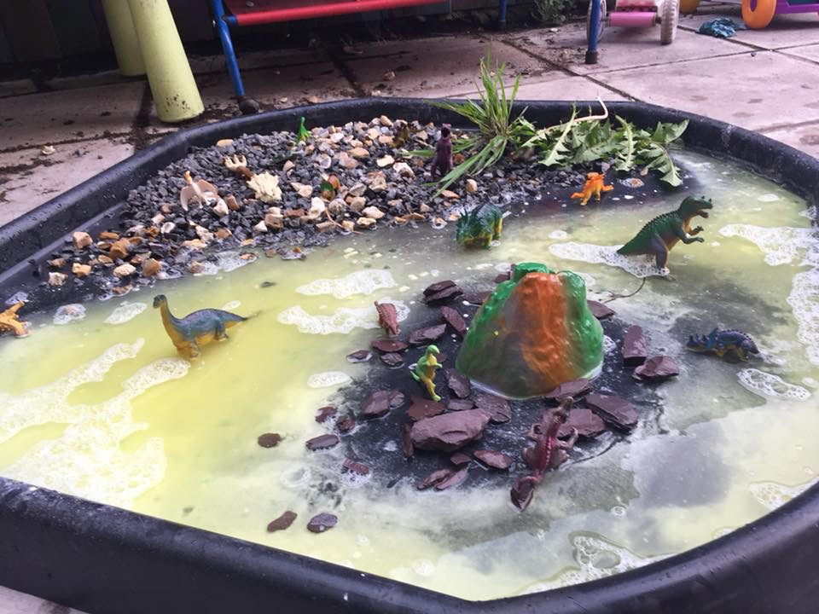
(my own photograoph 2018)
Conducting an activity like this provides the child with sensory opportunities, creative development, language literary and communication, personal and social development, mathematic, it’s also meeting the knowledge and understanding of the world criteria as the child explores historical figures.
Sensory difficultly is one of the core symptoms of autism. Children may have trouble dealing with their sensory input (rudy 2018) therefore and activity like this is a good way to introduce more opportunities to them.

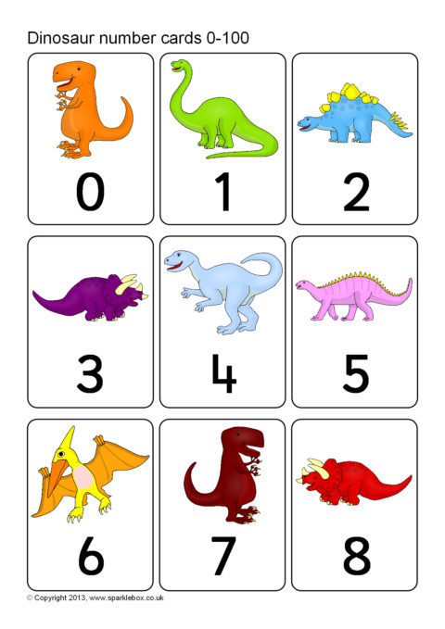
(sparklebox 2013)
Autistic children have difficulty staying engaged in things therefore this is a good way to have them join in to a math lesson whilst keeping them interested, children learn in different ways some are visual learners, some audio, and some are more hands on, therefore a task like this is more hands on will be more appealing to a child which links to Devarakonda (2013) ‘ the child’s abilities can be impaired through learning styles’ therefore its important practitioners supply a range of activities and teaching styles.
However, it is important that when undertaking these tasks that the children can make their own games and forms of learning as children with autism have difficulty following structured plans and prefer a more child led approach according to autism NI (no date) autistic children love their usual structure of play and prefer practitioners to imitate them. It’s important that practitioners don’t display Adultism by making all the decisions on activities as a form of power, as this may make the child feel scared to speak up about what they want. According to fletcher (2013) adultism means that teaching styles are usually based on the adult’s morals and values and not on what the child wants. But On the other hand, by planning structured activities for the child to undertake it will help with schooling as following a structure/ routine gradually can help them be more accepting to school activities/routine.
But also, its important ensure that their peers are able to participate to avoid exclusion also the autistic child wouldn’t feel singled out. Although this is an effective style of inclusive learning there are barriers in the way of all practitioners being able to conduct this style of teaching, one being parents attitudes towards play led learning They may want their child to be taught in a more academic manor (ferry no date) . however, Smillth and Pellegrini (2008) disagree they discovered the important role play has in education and development.

References
(National Academies Press (2001) educating children with autism https://infiniteach.com/wp-content/uploads/2015/07/National-Research-Study-.pdf
Affine, T, A. (2012) The zone of proximal development in early childhood education. Laurea University of Applied Sciences Otaniemi.
Arnold, A. (2018) Reinforcement. NEBRASKA AUTISM SPECTRUM DISORDERS NETWORK. https://www.unl.edu/asdnetwork/virtual-strategies/reinforcement
Bancroft, k. batten, a. lambert, s. madders, t. (2012) the way we are: autism in 2012, national autistic society [PDF].
Barnes, E. (2009) Disability, Minority, and Difference. journal of applied philosophy.
Barriga, SH, R. and Buchanan, J. and Ćerimović, E. and Sharma, K. (2017) Children with disabilities: Deprivation of liberty in the name of care and treatment. Protecting Children Against Torture in Detention: Global Solutions https://www.hrw.org/news/2017/03/07/children-disabilities-deprivation-liberty-name-care-and-treatment
bbc news (2005) Special needs' education queried http://news.bbc.co.uk/1/hi/education/4071122.stm
Berglund, A-K. (1997) A Matter of Social Context ... the Sexual Abuse of Children with Disabilities. Radda Barnen: Stockholm.
Brisenden, S (2007) Independent Living and the Medical Model of Disability Handicap & Society, 1:2, 173-178
Centre for Studies on Inclusive Education (2018) The UNESCO Salamanca Statement http://www.csie.org.uk/inclusion/unesco-salamanca.shtml
child protection resource 2017 Autistic Children In Care – uninformed decision making leading to poor outcomes. http://childprotectionresource.online/autistic-children-in-care-uninformed-decision-making-leading-to-poor-outcomes/
Clay, CH. (2017) Ethics in the Bobo Doll Experiment https://www.ehow.co.uk/info_8493066_ethics-bobo-doll-experiment.html
Collins, K. (2015) assistance for assistance, Sutton trust https://www.suttontrust.com/newsarchive/assistance-for-assistants/
Cox, A. and klein, K. and charman, t. baird, g. and baron-cohen, s. and Swettenham, j. and drew, a. wheelwright, s. (1999) autism spectrum disorders at 20 months and 42 months of age: stability of clinical and ADI-R diagnosis: the journal of child psychology and psychiatry and allied disciplines 40(5), 718-732
CPIR (2017) Parent Participation in Early Intervention. Center for Parent Information and Resources. https://www.parentcenterhub.org/parent-participation-ei/
Crutchley, r. (2018) special needs in the early years partnership and participation. :sage publications.
Darling, N (2007) Ecological Systems Theory: The Person in the Center of the Circles. Research in Human Development. The Official Journal of the Society for the Study of Human Development
Denbighshire council (2016) primary school funding and children with aln in mainstream schools https://www.denbighshire.gov.uk/en/resident/education/Primary-School-Funding-and-Children-with-ALN-in-Mainstream-Schools.pdf?fbclid=IwAR3HRpVSyjLdAun5AK02NAfAxMDdHuPoNWDfJCTaJT7XypgIlM1D6W02xO4 [assessed 6/1/19].
Devarakonda, CH. (2013) diversity & inclusion in early childhood an introduction.:sage
Disability wales (no date) social model http://www.disabilitywales.org/rights/social-model/
Edwards,C. Gandini,L and Forman, G. (1998) The Hundred Languages of Children: The Reggio Emilia Approach--advanced Reflections. Greenwood Publishing Group
Ferry, J (no date ) "Parents Attitudes Toward Learning Through Play in The Foundation Stage" https://studentshare.org/education/1393098-exploring-parents-attitude-towards-learning-through-play-in-the-foundation-play.
Fletcher,A (2013) Adultism in Schools. http://www.ethosconsultancynz.com/profiles/blogs/adultism-in-schools
Flewitt, R. and Nind, m. (2007) parents choosing to combine special and inclusive early years settings: the best of both worlds?. europian journal of special needs education.
Florian, L., & Rouse, M., (2009). The inclusive practice project in Scotland: Teacher education for inclusive education, Teaching and Teacher Education.
Gestwicki, C. (2013) Developmentally Appropriate Practice: Curriculum and Development in Early Education. Cengage Learning
Gillard, D. (2007) The Warnock Report (1978) Special Educational Needs http://www.educationengland.org.uk/documents/warnock/
Hall, E, M. (no date) Biographical Highlights: Howe, Dr. Samuel Gridley. https://www.learningtogive.org/resources/howe-dr-samuel-gridley
Historic England (no date) Disability in the Early 20th century 1914-1945 https://historicengland.org.uk/research/inclusive-heritage/disability-history/1914-1945/
HM Government (2006) A guide to inter-agency working to safeguardand promote the welfare of children. Crown.
Holden, L. (2013) Off the spectrum. The irish times https://www.irishtimes.com/news/education/off-the-spectrum-1.1352995
Jones, h(2000) disabled children’s rights and un convention on the rights of the child. disability studies quarterly.: vol 20 no.4
Jones, PH. and walker, G. (2011) Children's Rights in Practice. SAGE Publications Ltd
Kozulin, A. Gindis, B. Ageyev, V. and Miller, S. (2003) Vygotsky's Educational Theory in Cultural Context. Cambridge University Press.
Kremer,W. and Hammond, C. (2013) Abraham Maslow and the pyramid that beguiled business. Bbc. https://www.bbc.co.uk/news/magazine-23902918
lanekids (2013) Encouraging Your Child’s Interests https://www.lanekids.org/encouraging-your-childs-interests/
LePage, P. and Courey, s. (2013) Teaching Children with High-Level Autism. Routledge
Mencap (no date) the voice of learning disability. dealing with a diagnosis : https://www.mencap.org.uk/advice-and-support/diagnosis/dealing-diagnosis?fbclid=IwAR3yqdzqJCq1idhyh_0kdMUbN1Y3rCKaTg8t7qNfAddC6yl7U6BKtYg0GMM [assessed 4/1/19]
Montessori, M. (2013) The Montessori Method. Transaction Publishers.
Murray, m and Osborne, ch (2009) Safeguarding disabled children Practice guidance. The Children’s Society. Crown.
National Autistic Society (2015) Advocacy and autism https://www.autism.org.uk/advocacyandautism
National autistic society (2018) Diagnosis for children https://www.autism.org.uk/about/diagnosis/children.aspx
Network autism (2016) why the wait? Autism diagnosis in the uk. https://network.autism.org.uk/good -practice/evidence-base/why-wait-autism-diagnosis-uk
Nhs (2015) Children with autism may be supersensitive to change https://www.nhs.uk/news/neurology/children-with-autism-may-be-supersensitive-to-change/
NHS (no date) https://www.nhs.uk/conditions/autism/
Nutbrown,C and Clough,P. and Atherton,F. (2013) Inclusion in the Early Years; sage publications
Paquette, D and Ryan, J (2001) Bronfenbrenner’s Ecological Systems Theory http://www.floridahealth.gov/alternatesites/cms-kids/providers/early_steps/training/documents/bronfenbrenners_ecological.pdf
Pijl, j.s. and Meijer, c. j. w. (1991) does intergration count for much? An analysis of the practices of intergration in eight countries. Europian journal of special needs education
Rudy, L, J (2018) Sensory Integration, Sensory Processing Disorder and Autism. https://www.verywellhealth.com/what-is-sensory-processing-disorder-260517
Santer, j. and Griffiths,c. and Goodall, d. (2007) Free Play in Early Childhood A literature review. Play England making space for more play http://www.playengland.org.uk/media/120426/free-play-in-early-childhood.pdf
Smith, p, k. and Pellegrini, a. (2008) learning through play. goldsmith university of London :university of Minnesota. :encyclopaedia on early childhood development.
Sparklebox (2013) Dinosaur Number Cards 0-100 https://www.sparklebox.co.uk/previews/9826-9850/sb9842-dinosaur-number-cards.html
Stephensons (no date) Discrimination in schools https://www.stephensons.co.uk/site/individuals/education/discriminationasagroundforappeal/
unicef (2010) A summary of the UN Convention on the Rights of the Child https://www.unicef.org.uk/wp-content/uploads/2010/05/UNCRC_summary-1.pdf
United nations education, scientific and cultural orginisation (unesco) (1994)the Salamanca statement and framework for action on soecial needs education: paris.
University of Leicester (no date) social and medical model of disability. https://www2.le.ac.uk/offices/accessability/staff/accessabilitytutors/information-for-accessability-tutors/the-social-and-medical-model-of-disability

