ECIE4003

Additional Needs in Context

Portfolio
Ieuan Morgan
Student Number: 2022 1407 71

Element 1

Poster – Outlining good practice in terms of supporting learners with a specific learning need
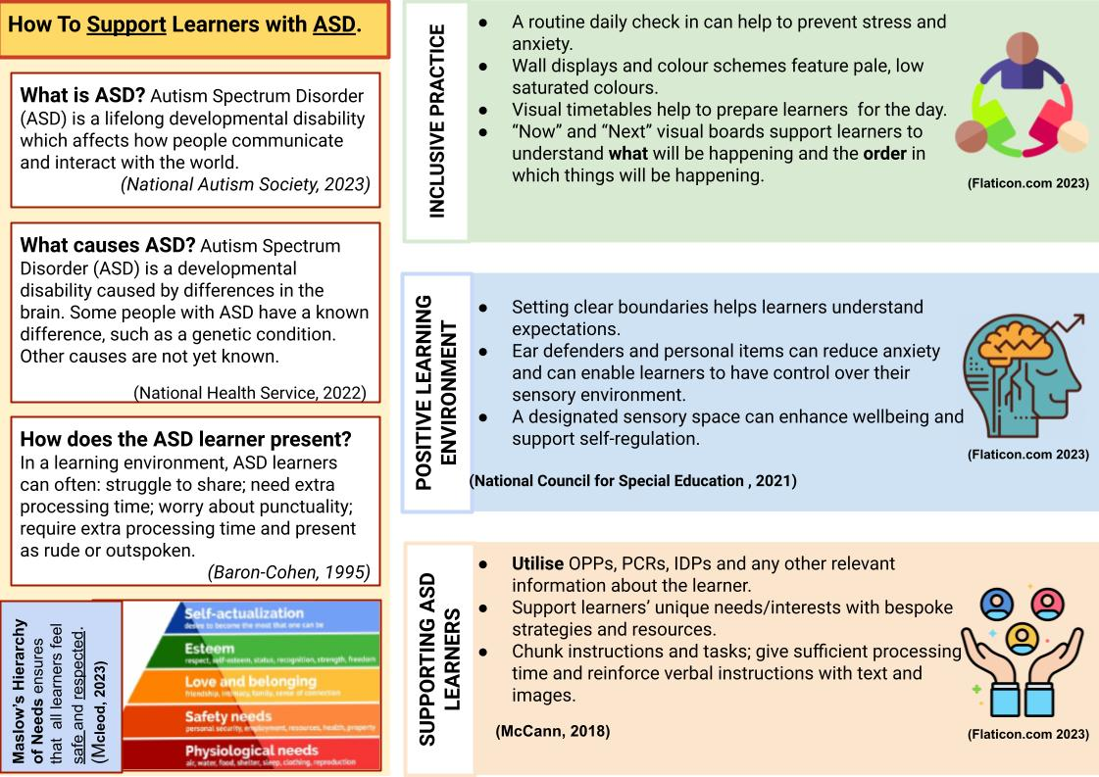

References
Baron-Cohen, S. (1995). Mindblindness: An Essay on Autism and Theory of Mind. Cambridge: The MIT Press.
Flaticon.com (2023) Color fill icons. Available: https://www.flaticon.com/color-fill-icons Accessed:27/10/2023
McCann, L. (2018). Teaching secondary school autistic students. Retrieved 10 28, 2023, from National Autistic Society: https://www.autism.org.uk/advice-and-guidance/professional-practice/top-tips-secondary
Mcleod, S. (2023, July 26). Maslow’s Hierarchy Of Needs. Retrieved September 26, 2023, from https://www.simplypsychology.org/: https://www.simplypsychology.org/maslow.html
National Autism Resources. (2023). nationalautismresources.com. Retrieved September 26, 2023, from https://nationalautismresources.com/calming-sensory-room/
National Council for Special Education . (2021, 10 26). Sensory Spaces. Retrieved 10 28, 2023, from National Council for Special Education : https://ncse.ie/wp-content/uploads/2021/10/NCSE-Sensory-Spaces-in-Schools-2021.pdf
National Health Service. (2022). What is autism? Retrieved September 23, 2023, from https://www.nhs.uk/conditions/autism/what-is-autism/
The National Autistic Society. (2023). What is autism. Retrieved September 23, 2023, from https://www.autism.org.uk/advice-and-guidance/what-is-autism

Element 2

Essay- Exploring the wide and complex spectrum of additional needs

By Ieuan Morgan

Additional Learning Needs (ALN) is a term which can often be misunderstood. An individual who is not familiar with ALN may mistakenly believe the term is used specifically for learners who have disabilities/neurodiversity. However, the spectrum of ALN is vast and complex. For example, learners going through periods of grief or financial hardship may come under the umbrella of ALN if they require extra learning resources or support throughout their educational journey SNAP Cymru (2023). Previously, the term SEN (Special Educational Needs) was used in educational policies and legislation until the term ALN was created in the Additional Learning Needs and Education Tribunal (Wales) Act 2018. This change was made with the intention of being more inclusive towards children who may not necessarily have a disability but have additional needs to that of the average learner Welsh Government (2018). The Welsh government states that a person has ALN if he or she has a learning difficulty or disability (whether the learning difficulty or disability arises from a medical condition or otherwise) which calls for additional learning provision The Additional Learning Needs Code for Wales (2021).This essay will aim to explore the wide and complex spectrum of ALN by comparing different models of disability and identifying best practice in supporting those needs within a learning environment.

To develop an understanding of ALN, it is necessary to discuss the social and medical models of disability. The social model was created by disabled people and states that individuals are typically disabled by barriers in society rather than their biological differences or impairments (Scope, 2023). The medical model puts more of an emphasis on treatment and cures rather than creating adaptations that lead to co-existing with a disability (Ombudsman, 2015).
A typical comprehensive school with several ASD learners on roll can be used to illustrate these two concepts. Schools that follow the social model of disability may support students by offering them the opportunity to receive the same qualifications, if wanted, alongside mainstream students but with specialist support put in place to accommodate and support them (National Educational Union, 2022). However, those who adhere to the medical model may suggest that these students are sent to a specialist school to study alternative qualifications and life skills; in contrast to the medical model, the social model aims to support students by treating them holistically. It is the author’s belief that understanding both the Medical and Social model enables a practitioner to have a broad repertoire so that they can identify and implement effective support strategies that are tailored to individual pupils’ needs.
Many companies and establishments will aim to incorporate the social model as this model is proactive in its care and is inclusive of those who have impairments; whereas the medical model is less inclusive and less reflective of an individual’s unique needs (Woodhams & Corby, 2003). Research suggests that the medical model may be damaging to an individual's self-esteem as it generalises and conceptualises disability as an individual health issue, opening the possibility for the individual to view themselves as damaged or abnormal (Albert, 2004).
It is important to recognise that each model has specific advantages and disadvantages for individuals with ALN. However, in the context of a learning environment, it can be argued that the social model allows practitioners to meet individuals’ needs more effectively and is therefore more inclusive (National Educational Union, 2022). In the context of a classroom, the social model enables practitioners to tailor their practice and environment specifically to pupils’ needs, thus disabling barriers. It emphasises the importance of creating an accessible, equitable and accommodating learning environment for individuals with disabilities.
Examples of best practice while using the social model of disability may include adapting pupils’ timetables to be visual rather than worded. This change is especially helpful to ASD learners who may find it easier to visualise and plan for their day in this manner. Another example is to make sure that all resources and learning materials are accessible to learners with different needs. Resources may be adapted to include larger print, Braille and digital versions so that learners who stay at home can access them online. Best practice may also be displayed when offering sensory rooms for children who need a quiet space within the learning environment. While this is common practice in ASD units, this provision can be extended to students who struggle with a range of issues such as anxiety, sleep deprivation or anger issues.
Within schools, the social model of disability is used for several important reasons which benefit the learner. It ensures that inclusive and equitable learning and educational experiences are provided for every learner. Multi-agency working, Individual Development Plans (IDPs) and relevant staff training are all examples of effective support and best practice which enable learners with disabilities to engage and thrive. Examples may include speech and language therapists and counsellors which play a key role in helping children with Adverse Childhood Experiences (ACES) (Waite & Ryan, 2020).
Implementing Maslow’s Hierarchy of needs in the school eliminates potential barriers to a child's well-being and education (Mcleod, 2023). At the base of this pyramid of needs, are the physiological aspects of a person’s well-being such as shelter, warmth food and safety. In education, if a student is hungry or tired then they may not be able to focus on their work or may even become agitated and upset. In this case, offering breakfast clubs as a service as an example of best practice as it has the potential to aid the student in their education and day to day needs.

In recent years, the Welsh and British government has released legislation which has allowed teaching and supporting staff to become more equipped in aiding those with ALN in education. The Additional Learning Needs and Education Tribunal Act 2018 is one of the most recent examples of this, outlining and putting emphasis on supporting all children with additional needs regardless of disability (Welsh Government, 2018). This act has played a key role in promoting best practice in education as it follows the same ethos as Maslow’s Hierarchy of Needs and provides inclusive and holistic guidelines in supporting learners with different needs.
In conclusion, those who are on the spectrum of ALN within education are greatly aided by practitioners and establishments which incorporate the social model of disability as practitioners who incorporate inclusive strategies in their support actively seek to disable barriers to an individual’s education and well-being.

References

Albert, B. (2004, October 13). Disability KaR Research Project. Retrieved October 10, 2023, from https://assets.publishing.service.gov.uk/media/57a08ca8e5274a31e0001356/RedPov_social_model_briefing.pdf
Department for Education. (2014, January). Special educational Needs and disability code of practice: 0 to 25 years. Retrieved 10 21, 2023, from https://assets.publishing.service.gov.uk/media/5a7dcb85ed915d2ac884d995/SEND_Code_of_Practice_January_2015.pdf
Mcleod, S. (2023, July 26). Maslow’s Hierarchy Of Needs. Retrieved September 26, 2023, from https://www.simplypsychology.org/: https://www.simplypsychology.org/maslow.html
National Educational Union. (2022, May 24). Disability equality toolkit: Social model of disability. Retrieved 10 2023, 29, from National Educational Union: https://neu.org.uk/latest/library/social-model-disability#:~:text=The%20social%20model%20of%20disability,result%20of%20other%20people's%20attitudes.
Ombudsman.org.uk. (2015, April 20). Introduction to the Social and Medical Models of Disability. Retrieved October 10, 2023, from https://www.ombudsman.org.uk/sites/default/files/FDN-218144_Introduction_to_the_Social_and_Medical_Models_of_Disability.pdf#:~:text=The%20medical%20model%20looks%20at%20a%20person%E2%80%99s%20impairment,or%20being%20able%20to%20participate%20fully%20in%20
Scope. (2023). Social model of disability. Retrieved October 10, 2023, from https://www.scope.org.uk/about-us/social-model-of-disability/
SNAP Cymru. (2023). What is ALN? Retrieved 10 22, 2023, from SNAP Cymru: https://www.snapcymru.org/get-support/what-is-aln/
Waite, R., & Ryan, R. A. (2020). Adverse childhood experiences : what students and health professionals need to know. Abingdon: Routledge.
Welsh Government. (2021). The Additional Learning Needs Code for Wales . Retrieved 10 17, 2023, from https://www.gov.wales/sites/default/files/publications/2022-06/220622-the-additional-learning-needs-code-for-wales-2021.pdf
Welsh Government. (2018). Additional learning needs (ALN) transformation programme. Retrieved 10 21, 2023, from https://www.gov.wales/sites/default/files/publications/2018-09/additional-learning-needs-aln-transformation-programme-v2.pdf
Woodhams, C., & Corby, S. (2003). Defining disability in theory and practice: a critique of the British Disability Discrimination Act 1995. Journal of Social Policy , 32 (2), 159–178.

Element 3
Explore and summarise the additional learning needs of a pupil using a person centred planning approach.
(Based upon Section 1C IDP : Profile (About me)
and
2A IDP : Description of the child or young person’s additional learning needs (ALN))

Section 1C: Profile (About me)
• What is important to the learner

When I go to school in the morning I need to have my breakfast because when I do not eat anything, I find it very hard to focus.

It helps to have enough time to walk to my next lesson because when the corridors get busy I find it hard to move through the crowds especially on stairs.

• What is important for the learner

Child A forgets that they cannot hear very well at the back of the classroom so they will need to be reminded to sit closer to the front of the class. Child A usually finds it hard to move because their friends sit at the back of the classroom but they know they work a lot better when they can hear the teacher.

When Child A gets really stressed, they find it hard to ask for help. It is important for the TA or staff member to check up on them regularly during class, especially if they have their head on the desk or their hood up. This is an indication that Child A is overwhelmed and needs support.

• What is working and should be built on

Child A is getting much better at controlling their frustration when they get confused in class.

The green, amber and red cards given to Child A help them show the TA how they are feeling when they do not want to speak. This is especially important as Child A finds it very difficult to articulate their emotions. Using these cards has enabled Child A to communicate their feelings effectively in times of stress.

Child A has had more practice at working in groups so they can become more confident when working in a team. Inclusion staff believe that continuing this may also aid their social development.

• What is not working and needs to change.
Child A has an anxiety diagnosis and mobility issues which make it harder for them to travel in the corridors to get to the next lesson. To accommodate for this, the teaching staff and ALNCO have agreed that Child A may leave class five minutes early to avoid crowds. Due to missing this time in class, Child A has gained extra work to catch up on. To fix this issue, we will ask Child A if they would agree to intervention sessions where they would sit with their one to one TA and complete missing work.

Section 2A: Description of the child or young person’s additional learning needs (ALN)
Cognition and Learning

- Child A has an ASD diagnosis which makes learning independently very difficult. Child A will often struggle to stay focused which makes it hard to take in information and remain on task.
Communication and Interaction

- Child A struggles to communicate verbally due to their ASD diagnosis. This has made it hard to make friends and express emotions to others.

Sensory and/or Physical

- Child A has a diagnosis of Dyspraxia which impacts the development of fine motor skills. This has made it difficult to develop sufficient grips and techniques when doing hand written tasks. Poor coordination and undiagnosed mobility issues have also made physical activities such as sport significantly harder.

Behaviour, Emotional and social development

Element 4
Discuss the potential support provided to your chosen pupil (utilising the key principles, approaches and policies that guide inclusive practice).
Based upon Section 2B IDP : Description and delivery of the child or young person’s additional learning provision (ALP)

I have provided 4 section boxes in this template 2B1, 2B2, 2B3, 2B4.
This will provide space for 4 ALPs

If you require more, copy and paste the section box as needed – each ALP should be contained in its’ own individual section box.

n.b. Each section box contains 858 title words – these do not count towards your word count for this element

Section 2B1: Description and delivery of the child or young person’s additional learning provision (ALP)
2B1.1) Intended outcome:  These outcomes should be SMART (Specific, Measurable, Achievable, Realistic,  Time-bound). | For Child A to catch up on any work which is missed out on during regular intervention sessions. Progress will be measured by how far behind Child A may be during class lessons and activities. This target will be made achievable by implementing intervention sessions into their timetable two or three times a week. These sessions will replace drama lessons which are missed out on anyway due to anxiety and stress. ALNCO, TA and Child A will review progress at the end of term.
2B1.2) ALP to be provided:  This should include how often (daily, weekly); the type of support; who provides the support. The description of the Additional Learning Provision (ALP) should be very clear and precise, the above could then be split into smaller goals and targets. |  | 2B1.3) Should the ALP be provided in Welsh? | 2B1.4) Organisation/  Service to provide the ALP, (e.g. NHS, Inclusion Service, Specialist Teacher, etc.): | 2B1.5) Start date: | 2B1.6) End / Review date:
Child A is to receive one to one intervention sessions with their designated Teaching Assistant to catch up on any work which is missed out on due to leaving class early. These sessions will replace drama lessons which cause Child A anxiety due to noise and working in large groups. The designated TA will ensure that progress is documented in a booklet by co-operating with teaching staff to create necessary targets. Positive reinforcement will be given upon completion of tasks by TA and staff members to boost confidence as Child A is increasingly anxious about letting teachers down by not being caught up in lessons.  Depending on the size of the tasks, Child A should be encouraged to stick to one piece of work per session as Child A struggles to remain focused for prolonged periods of time. |  | No | Inclusion Teaching Assistant | 06. 09. 23 | 23. 12. 23
2B1.7) Rationale for the ALP listed above:  If there is a difference of opinion it should be recorded here e.g. a difference of opinion between the child, child’s parent or young  person and professionals. The section could explain how different opinions have been taken into consideration before a particular decision was reached. |  | N/A
Section 2B2: Description and delivery of the child or young person’s additional learning provision (ALP)
2B2.1) Intended outcome:  These outcomes should be SMART (Specific, Measurable, Achievable, Realistic,  Time-bound). | For Child A to improve handwriting and other tasks surrounding fine motor skills and hand-eye co ordination. This target will help Child A to develop and improve their written work in preparation for mock exams next year.
2B2.2) ALP to be provided:  This should include how often (daily, weekly); the type of support; who provides the support. The description of the Additional Learning Provision (ALP) should be very clear and precise, the above could then be split into smaller goals and targets. |  | 2B2.3) Should the ALP be provided in Welsh? | 2B2.4) Organisation/  Service to provide the ALP, (e.g. NHS, Inclusion Service, Specialist Teacher, etc.): | 2B2.5) Start date: | 2B2.6) End / Review date:
Child A will use pen and pencils with special grips when writing to improve grip. This may help to develop letter formation. TAs and teaching staff are to remind Child A to use these grips during writing tasks as they will take time to adjust to this change. During spare time, Child A is to sit with their TA to complete handwriting tasks to improve letter spacing, size and formation.  Child A will also take part in other activities with their TA to improve fine motor skills such as completing jigsaw puzzles, practicing using cutlery in the dinner hall and games such as catch which Child A enjoys.  Progress will be monitored and documented by teaching staff across the school as they will witness any improvements in written work. |  | No | Teaching Assistant | 10. 09. 23 | 22.12.23
2B2.7) Rationale for the ALP listed above:  If there is a difference of opinion it should be recorded here e.g. a difference of opinion between the child, child’s parent or young  person and professionals. The section could explain how different opinions have been taken into consideration before a particular decision was reached. |  | N/A
Section 2B3: Description and delivery of the child or young person’s additional learning provision (ALP)
2B3.1) Intended outcome:  These outcomes should be SMART (Specific, Measurable, Achievable, Realistic,  Time-bound). | For Child A to improve social and verbal communication skills. This will involve engaging in games and activities which encourage them to voice opinions and be a part of discussions. Progress will be monitored by familiar TA/Inclusion staff and reviewed alongside Child A on a weekly basis.
2B3.2) ALP to be provided:  This should include how often (daily, weekly); the type of support; who provides the support. The description of the Additional Learning Provision (ALP) should be very clear and precise, the above could then be split into smaller goals and targets. |  | 2B3.3) Should the ALP be provided in Welsh? | 2B3.4) Organisation/  Service to provide the ALP, (e.g. NHS, Inclusion Service, Specialist Teacher, etc.): | 2B3.5) Start date: | 2B3.6) End / Review date:
Child A will join in social games alongside classmates within the ALN unit to improve verbal communication skills. These games will be led and supervised by the TA which usually supports this group and progress in communication skills will be measured by increasing the level of vocabulary used in these games. The sessions will only include children which Child A interacts with daily to begin with so that Child A feels more comfortable communicating in this environment. Progress will be monitored by the leading TA and will be verbally reviewed weekly alongside Child A, to see how they think the sessions are going. A formal review with parents, staff and Child A to be held at end of half-term.  During these sessions, Child A is allowed fidget toys and small breaks to help remain focused and reduce stress. |  | No | Inclusion Teacher | 05. 09. 23 | 27. 10. 23
2B3.7) Rationale for the ALP listed above:  If there is a difference of opinion it should be recorded here e.g. a difference of opinion between the child, child’s parent or young  person and professionals. The section could explain how different opinions have been taken into consideration before a particular decision was reached. |  | - Parents would prefer Child A to interact with new children however ALNCO and inclusion staff feel it would be best to begin with familiar faces and slowly build up to interacting with others outside of ALN unit.  - Child A feels more comfortable with friends within unit
Section 2B4: Description and delivery of the child or young person’s additional learning provision (ALP)
2B4.1) Intended outcome:  These outcomes should be SMART (Specific, Measurable, Achievable, Realistic,  Time-bound). | For Child A to improve emotional communication and self-regulation this school year by incorporating new strategies in and out of school environment. This is a long-term goal which will be built upon slowly. The school aims to work alongside Mum and Dad to implement this provision.
2B4.2) ALP to be provided:  This should include how often (daily, weekly); the type of support; who provides the support. The description of the Additional Learning Provision (ALP) should be very clear and precise, the above could then be split into smaller goals and targets. |  | 2B4.3) Should the ALP be provided in Welsh? | 2B4.4) Organisation/  Service to provide the ALP, (e.g. NHS, Inclusion Service, Specialist Teacher, etc.): | 2B4.5) Start date: | 2B4.6) End / Review date:
Staff will incorporate a 5 point scale for Child A into day to day practice which Child A will use to communicate how they are feeling. Numbers will represent levels of emotional states in which 1 may refer to happy and 5 may refer to angry.  This scale will be created and personalised by Child A so that they feel comfortable using this provision. This scale will evolve over time to include more specific and ambitious vocabulary as this is a long-term provision to be used in school and at home.  Red, amber and green cards have been effective however improved emotional literacy will help to identify specific emotions which can aid staff in providing support and will encourage Child A to communicate rather than shut down.  Inclusion staff will communicate with Mum and Dad regularly to ensure consistency for Child A in and out of school. A review will be set at the end of the school year to evaluate effectiveness and practicality outside of school use. |  | No | Inclusion staff (with support from Mum and Dad at home) | 05.09.23 | 20.07.24
2B4.7) Rationale for the ALP listed above:  If there is a difference of opinion it should be recorded here e.g. a difference of opinion between the child, child’s parent or young  person and professionals. The section could explain how different opinions have been taken into consideration before a particular decision was reached. |  | N/A

