Intro to electronics lab
Ohms law
Resistance = 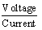
R =
Note that the symbol used for the value of a current is I. (C is used for another electrical quantity, capacitance.)
The formula can be shown three ways, depending on what you already know and what you want to find out.
R =
I =
V = RI
This formula is probably the most important and significant one that you will ever meet in electronics. It keeps coming up. Learn it.
There is a useful little aid to memory, the resistance triangle:
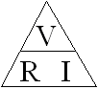
To find the formula for resistance, cover the “R” in the triangle with the tip of your finger and the other side of the formula is seen.
In the same way, covering the I (for current) exposes , and covering the V shows R.I.

If you know the applied voltage and the current through a resistor, then you can calculate the value of the resistor in Ω.

If a current of 4 mA flows when a supply voltage of 10 V is applied, then the resistance,
R = = 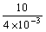= 2500 Ω (2.5 kΩ) correct

Question 1
Calculate and enter the value of a resistor (in kΩ) which allows a current of 3 mA to flow when a voltage of 12 V is applied.

Answer
Voltage/current
12/3000=4kΩ
Question 2
Calculate and enter the current (in mA) expected if a supply voltage of 11 V is applied to a 2.2 kΩ (2200 Ω) resistor.
Answer
Voltage/resistance
11/2.2=5ma
Question 3
Calculate and enter the voltage across a 2.2 kΩ resistor when a current of 4 mA flows through it.
Answer
Resistance*current
2.2*4=8.8v
Question 4
Enter the current through the 680 Ω resistor (in mA).
Answer
14.7ma
Question 5
Enter the voltage measured across the 2.2 kΩ resistor (in V).
Answer
8.80v

Question 6
Enter the measured value of the lamp resistance (cold) in Ω
11.2 Ω
Question 7
Enter the calculated value of the lamp resistance (hot) in Ω
Answer
111.5Ω
Question 8
For a given circuit and supply, if the resistance is increased, then the:

Answer
Current decrease

Question 9
If the supply voltage to a circuit is increased, then the:

Answer
Voltage across it increases.
- 10

Question 10
If the current flowing through a resistor is increased, then the:

Answer
Voltage across it increases.

Investigating a Characteristic Graph for a Resistive Component

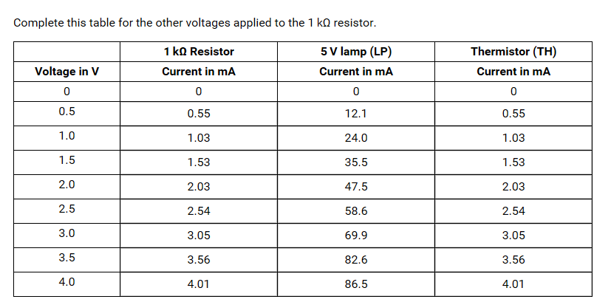
- Draw graphs of these results, clearly identifying which graph relates to which component.
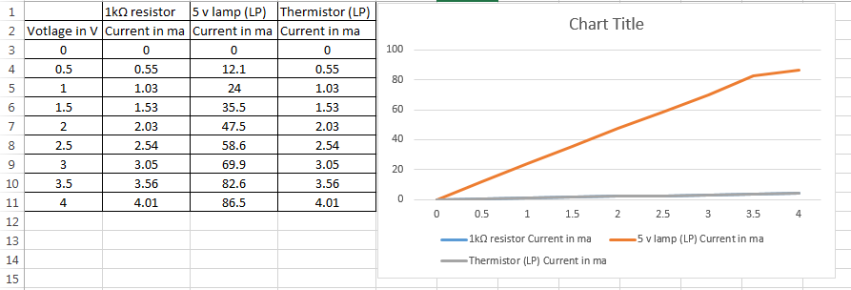
- Use the graph to calculate the resistance of the 1 kΩ resistor. Explain your calculation.

1.5/1.5*10-3 = 1,000

- Comment on the shape of the graph for the lamp (LP). Calculate its minimum and maximum resistance.

Min 0.5/12.1*10-3 = 41.32ohms
Max 4/86.5*10-3 = 46.24ohms

d) The thermistor (TH) is given the nominal value 4.7 kΩ. Is this justified by these results?

Investigation of a Wheatstone Bridge

Enter the value of unknown resistor A (in kΩ).
Answer
5.60kΩ

Enter the value of unknown resistor B (in kΩ).
Because the values of R2 and R4 are not equal, the formula R1 = R2/R4 x R3 will be required to calculate the value of unknown resistor B (R1).
Answer
27.4kΩ

Which of the following statements is not true?
Answer
To accurately measure a small unknown resistance, you can increase the value of R2.

Resistance Measurement using a Wheatstone Bridge
Unknown resistor | R24 | R25 | R26 at balance | Resistance
Ra | 12kΩ | 12kΩ | 1.752 kΩ | Ra=1.752
Rb | 12kΩ | 12kΩ | 7.99 kΩ | Rb=7.99
Rc | 12kΩ | 12kΩ | 5.46 kΩ | Rc=5.46

Ra = kΩ
Rb = kΩ
Rc = kΩ

Capacitor Discharge Curve
Complete the table with voltage readings taken every 10 seconds from when the press switch is released.
Time in S | Voltage in V
0 | 4.99
10 | 4.33
20 | 3.50
30 | 2.83
40 | 2.28
50 | 1.85
60 | 1.49
70 | 1.21
80 | 0.98
90 | 0.80
100 | 0.65

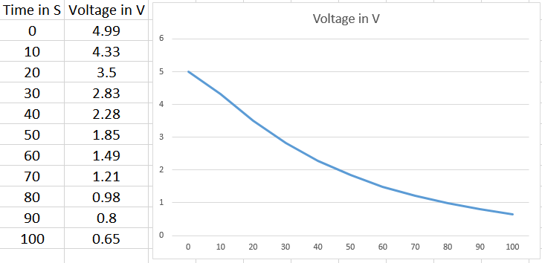
- What is the purpose of the 1 kΩ resistor in series with the capacitor?

b) The voltage should drop to 37 % of the initial voltage in one time constant. Calculate 37 % of the initial voltage.
37 x 4.99/100
= 1.8463
c) Use your graph to find the time taken for the voltage to drop to 37 % of the initial voltage.
- seconds
- Use the time constant equation to calculate the resistance of the resistor the capacitor has discharged through. The capacitance of the capacitor is 100 × 10⁻⁶ F.
e) How does the calculated value of resistance compare with the stated value of 470 kΩ? Explain any discrepancy.

Bipolar Transistor Characteristics (circuit board)
Base Current I_{B}  in µA  (Multimeter 1) | Collector Current I_{C}  in mA  (Multimeter 2)
0 | 0.00
10 | 3.02
20 | 6.09
30 | 9.07
40 | 12.06
50 | 15.00
60 | 17.89
70 | 21.00
80 | 24.00

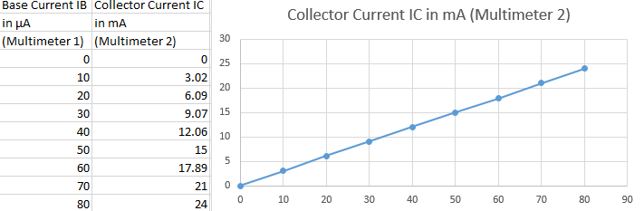
- Which region of the transfer characteristic is shown by your graph?

- Find the change in collector current that occurred when the base current was increased from 0 µA to 80 µA, and use this to calculate the current gain of the transistor.

24/80=0.3

The AC Performance of a Non-Inverting Amplifier
- What do you expect to see on CH.2?
An 8 volt p-p sine wave in phase with CH.1.

Ri  kΩ | Rf  kΩ | Calc  Gain | Input  Vp-p | Output Vp-p | Measured  Gain | Phase Change
10 | 10
10 | 100
1 | 100

- What do you conclude from this experiment?
The gain changes by the ratio of 1+Rf/Ri and the phase is not inverted relative to the input.
- Which of the following statements is true?
The phase shift does not change with gain.

The AC Performance of an Inverting Amplifier
What do you expect to see on CH.2?
An 8 volt p-p sine wave inverted (phase shifted by −180°).

Ri kΩ | Rf kΩ | Calc  Gain | Input vp-p | Output vp-p | Measured Gain | Phase change
10 | 10 | 1 | 8 | 8 | 1 | -180
10 | 100 | 10 | 0.77 | 8 | 10.4 | -180
1 | 100 | 100 | 0.079 | 8 | 101.3 | -180

What do you conclude from this experiment?
The gain changes by the ratio of Rf/Ri and the output is inverted relative to the input.

Which of the following statements is true?
The phase shift does not change with gain.

